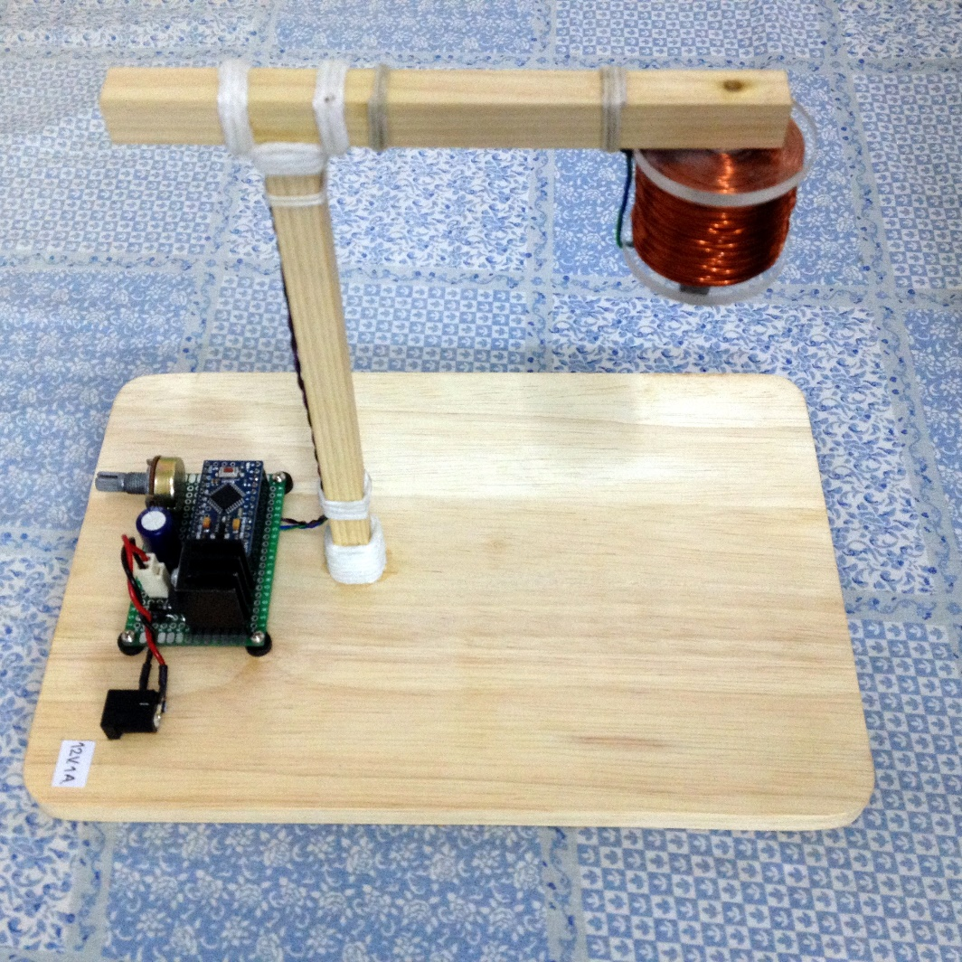

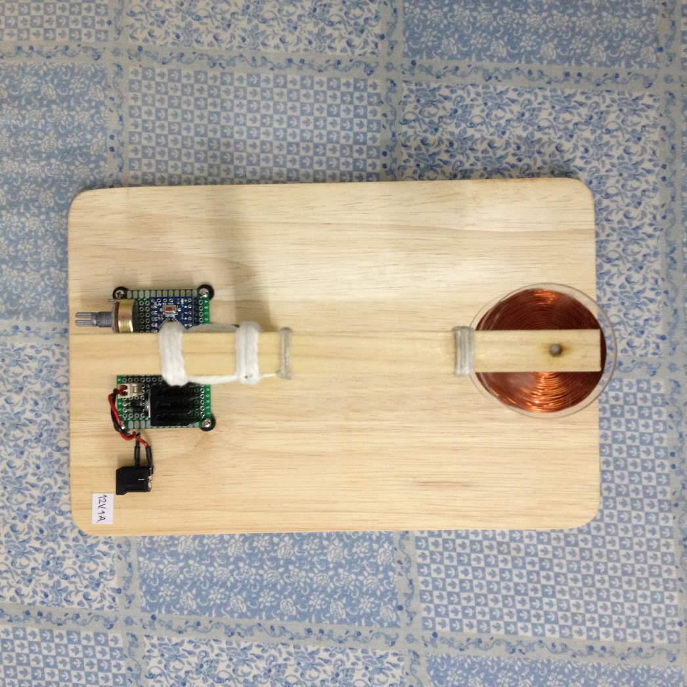

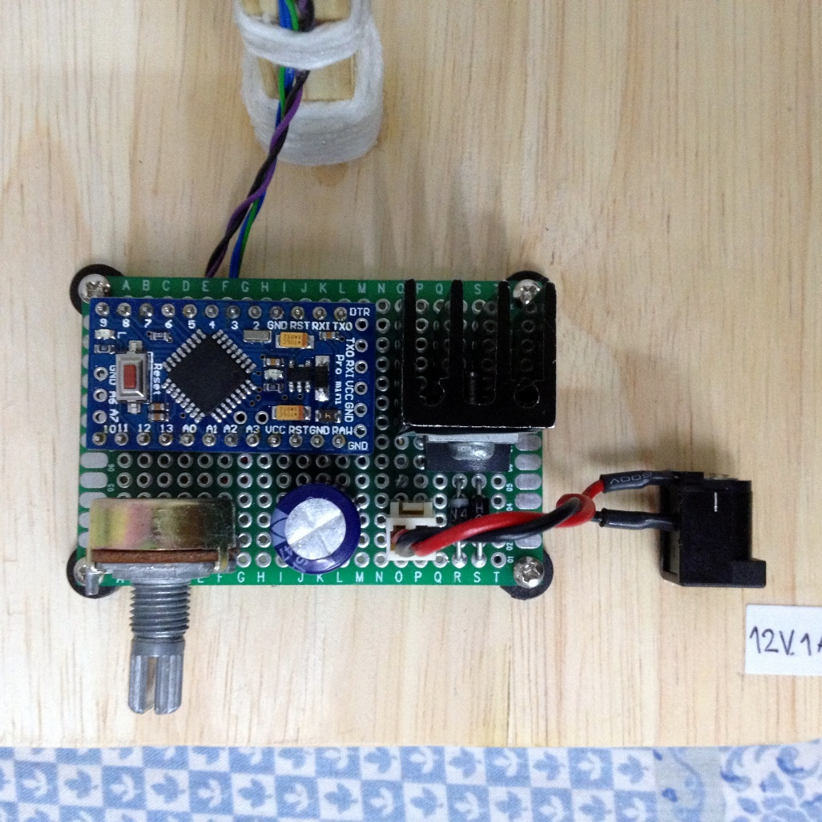

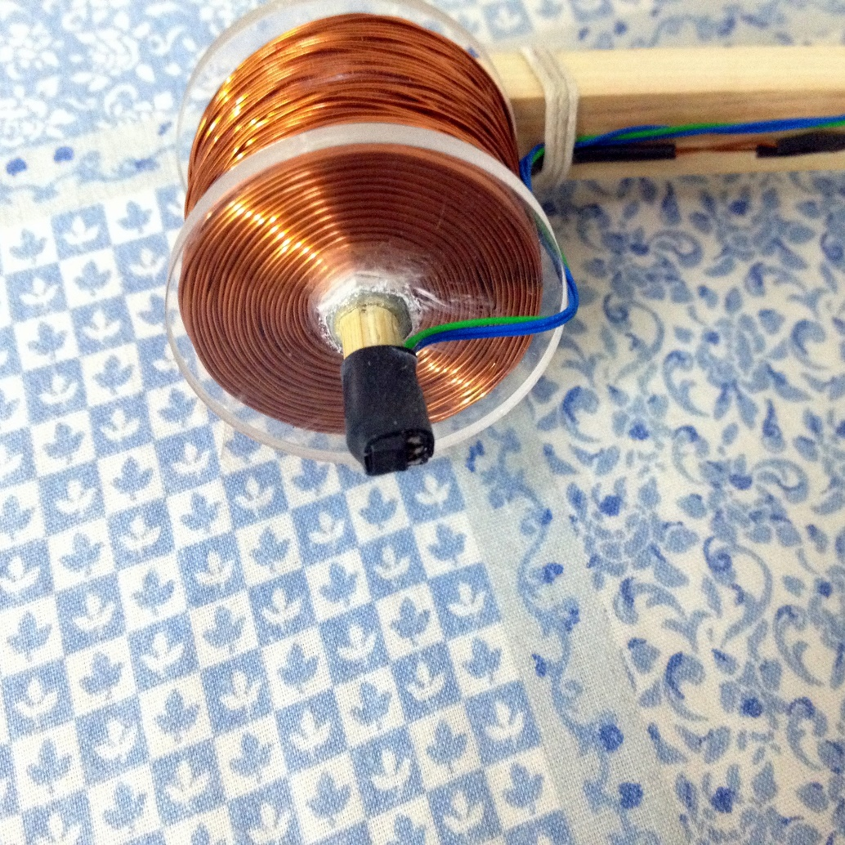

P

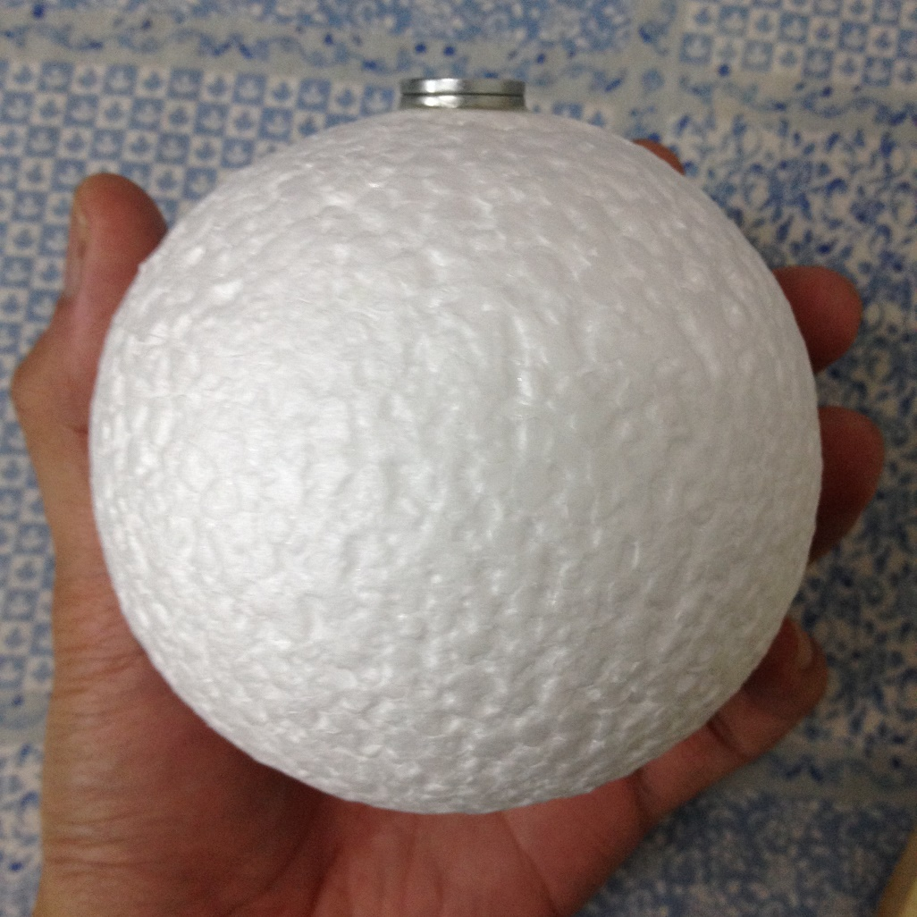

[Source Code](https://www.google.com/search?es_sm=93&q=Source+Code&spell=1&sa=X&ei=1PKKVKniNc_kuQTPqoLIDA&ved=0CBoQvwUoAA)

/*

magnetic levitation

Chiangmai Maker Club

modified 05-12-2014

by wasin wongkum

*/

#include <TimerOne.h>

#define ref_in A2

#define hall A0

#define magnetic 5

#define filter 0.30f

#define sampling 1000.0f

//float state_g = 0;

//float prev_state_g = 0;

float state = 0;

float state_f = 0;

float prev_state = 0;

float prev_state_f = 0;

float ref = 7;

float error =0;

float prev_error =0;

float error_dot = 0;

float error_sum =0;

float kp =500;

float ki =30;

float kd =3.65;

float output = 0;

void setup()

{

Serial.begin(115200);

pinMode(ref_in, INPUT);

pinMode(hall, INPUT);

pinMode(output, OUTPUT);

pinMode(12, OUTPUT);

Timer1.initialize(1000); // sampling rate 1 kHz

Timer1.attachInterrupt( PID );

}

void loop()

{

delay(200);

Serial.print("Ref ");

Serial.print(ref);

Serial.print(" ");

Serial.print("State ");

Serial.print(state);

Serial.print(" ");

Serial.print("Error ");

Serial.print(error);

Serial.print(" ");

Serial.print("Error_sum ");

Serial.print(error_sum);

Serial.print(" ");

Serial.print("Error_dot ");

Serial.print(error_dot);

Serial.print(" ");

Serial.print("Output ");

Serial.println(output);

}

void PID(void)

{

digitalWrite(12,1);

prev_state_f = state_f ;

state_f = prev_state_f + (0.05*(((float)(analogRead(ref_in))/100.0f)-prev_state_f));

ref = state_f/3.3f ;

/* Update Kd gain */

kd =3.65 + ref*3.6f ;

ref = 6.3f + ref;

prev_state = state ;

state = prev_state + (filter*(((float)(analogRead(hall))/100.0f)-prev_state));

prev_error = error;

error = ref - state;

error_dot = (error - prev_error)*sampling;

error_sum = error_sum + error/sampling;

output = kp*error + ki*error_sum + kd*error_dot + 220;

if(output<0) output = 0; if(output>255) output = 255;

if(state < 6)

{

output = 0;

error_sum=0;

}

analogWrite(magnetic,output);

digitalWrite(12,0);

}