Introduction to Graphics in R
Class Notes

Reading in the data
> dat <-read.table(
file="http://csde.washington.edu/courses/statcore/RGraphics/thedata.txt",
header=T)
> head(dat)
region age gender income
1 AA 28 F 6621
2 AA 41 F 6030
3 AA 55 N 7178
4 AA 56 F 5152
5 AA 57 N 4859
6 AA 56 M 7720
> tail(dat)
region age gender income
495 EE 29 N 6025
496 EE 55 M 6906
497 EE 39 M 8562
498 EE 44 M 5894
499 EE 35 F 9028
500 EE 51 F 8623
>

Exploring the data
> table(dat$region)

AA BB CC DD EE
100 100 100 100 100

> barplot(table(dat$region))
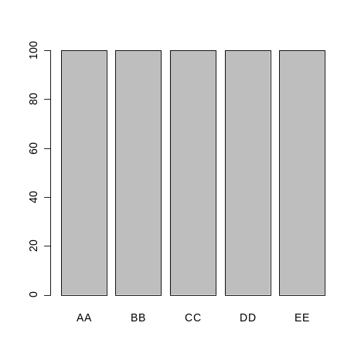
> hist(dat$age)
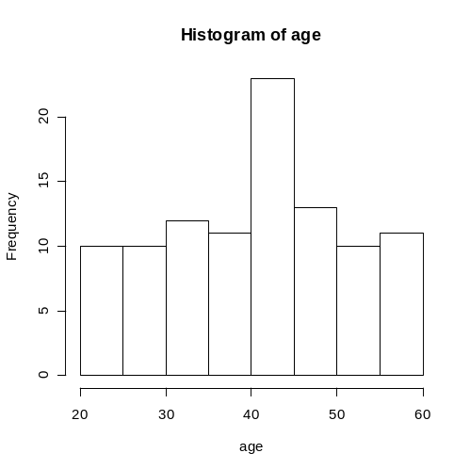
> table(dat$gender)

F M N
172 165 163

> barplot(table(dat$gender))
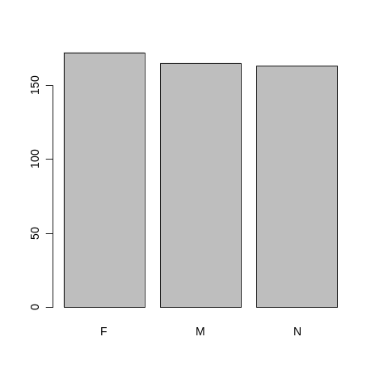
> hist(dat$income)

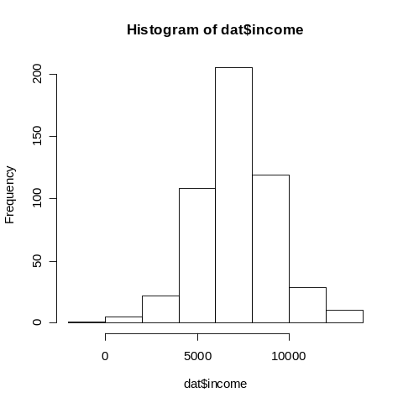
> sum(dat$income < 0)
[1] 1
> sum(dat$income == 0)
[1] 0
> min(dat$income)
[1] -1786
>
> boxplot(income ~ region,data=dat)
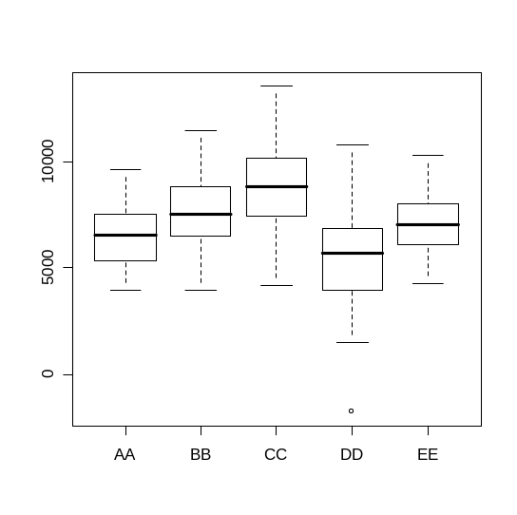
> boxplot(income ~ gender,data=dat)
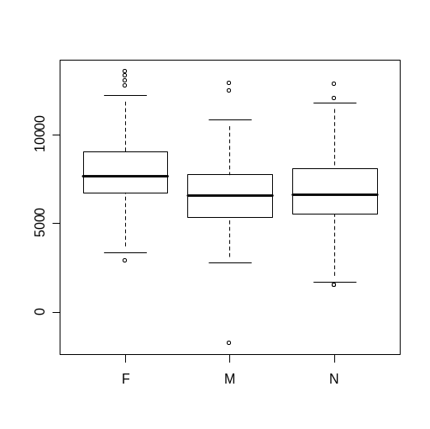
> plot(dat$age,dat$income)
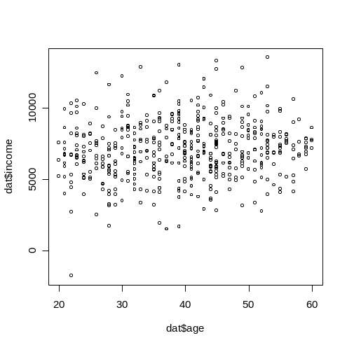

> fit.age <- lm(income~age,data=dat)
> summary(fit.age)

Call:
lm(formula = income ~ age, data = dat)

Residuals:
Min 1Q Median 3Q Max
-8519.53 -1280.99 -76.84 1284.08 6183.60

Coefficients:
Estimate Std. Error t value Pr(>|t|)
(Intercept) 6260.262 361.873 17.300 <2e-16 ***
age 21.512 8.858 2.429 0.0155 *
---
Signif. codes: 0 ‘***’ 0.001 ‘**’ 0.01 ‘*’ 0.05 ‘.’ 0.1 ‘ ’ 1

Residual standard error: 2062 on 498 degrees of freedom
Multiple R-Squared: 0.0117, Adjusted R-squared: 0.00972
F-statistic: 5.898 on 1 and 498 DF, p-value: 0.01551

> fit.all <- lm(income~region + age + gender,data=dat)
> summary(fit.all)

Call:
lm(formula = income ~ region + age + gender, data = dat)

Residuals:
Min 1Q Median 3Q Max
-6501.64 -1120.04 -30.25 1062.93 5405.79

Coefficients:
Estimate Std. Error t value Pr(>|t|)
(Intercept) 5392.602 410.702 13.130 < 2e-16 ***
regionBB 1648.380 254.463 6.478 2.26e-10 ***
regionCC 2436.669 242.136 10.063 < 2e-16 ***
regionDD -724.182 242.184 -2.990 0.00293 **
regionEE 645.909 237.956 2.714 0.00687 **
age 36.315 7.773 4.672 3.85e-06 ***
genderM -751.708 185.886 -4.044 6.10e-05 ***
genderN -829.452 186.518 -4.447 1.08e-05 ***
---
Signif. codes: 0 ‘***’ 0.001 ‘**’ 0.01 ‘*’ 0.05 ‘.’ 0.1 ‘ ’ 1

Residual standard error: 1664 on 492 degrees of freedom
Multiple R-Squared: 0.3638, Adjusted R-squared: 0.3548
F-statistic: 40.2 on 7 and 492 DF, p-value: < 2.2e-16

Customizing a scatter plot
help(plot.default)
help(par)

Two useful graphics functions
x11() ### opens another graphics window
graphics.off() ### closes all graphics devices

Default plot
plot(dat$age,dat$income)

Adding axis labels and title using xlab, ylab, main tags
plot(dat$age,dat$income,xlab="Age",ylab="Income",
main="Relationship between Age and Income")

Adding axis ranges and tic mark label orientation using xlim, ylim, las tags
plot(dat$age,dat$income,xlab="Age",ylab="Income",
main="Relationship between Age and Income",
ylim=c(-5000,15000), xlim=c(15,70),las=1)

Changing the plotting symbol and its color using pch and col tags
plot(dat$age,dat$income,xlab="Age",ylab="Income",
main="Relationship between Age and Income",
pch=20,col="red")

See document pch.pdf for the different plotting symbols
colors() ### will list the colors

Adding the regression line using the abline function
plot(dat$age,dat$income,xlab="Age",ylab="Income",
main="Relationship between Age and Income",
pch=20,col="red")

abline(fit.age)

Adding an arbitrary straight line using the segments function
Tag lty is the line type and lwd is the line width see help(par) for more information
This example adds a vertical wider dotted blue line at the median of age
help(segments)

plot(dat$age,dat$income,xlab="Age",ylab="Income",
main="Relationship between Age and Income",
pch=20,col="red")
abline(fit.age)

segments(x0=median(dat$age),y0=-5500,x1=median(dat$age),y1=15500,
lty="dotted",lwd=2,col="blue")

Adding points to the plot using the points function
In this example, we’re actually writing over existing points, coloring the points from region CC green
help(points)

plot(dat$age,dat$income,xlab="Age",ylab="Income",
main="Relationship between Age and Income",
pch=20,col="red")
abline(fit.age)
segments(x0=median(dat$age),y0=-5500,x1=median(dat$age),y1=15500,
lty="dotted",lwd=2,col="blue")

points(dat$age[dat$region=="CC"],dat$income[dat$region=="CC"],
col="green",pch=20)

Adding a legend to the plot using the legend function
help(legend)

plot(dat$age,dat$income,xlab="Age",ylab="Income",
main="Relationship between Age and Income",
pch=20,col="red")
abline(fit.age)
segments(x0=median(dat$age),y0=-5500,x1=median(dat$age),y1=15500,
lty="dotted",lwd=2,col="blue")
points(dat$age[dat$region=="CC"],dat$income[dat$region=="CC"],
col="green",pch=20)

legend(45,1000,col=c("green","red"),pch=20,
legend=c("CC region","All other regions"))

Saving this plot into a pdf document using the pdf function and the dev.off function
help(pdf)
help(Devices)

pdf(file="scatter.pdf",height=8,width=10)

plot(dat$age,dat$income,xlab="Age",ylab="Income",
main="Relationship between Age and Income",
pch=20,col="red")
abline(fit.age)
segments(x0=median(dat$age),y0=-5500,x1=median(dat$age),y1=15500,
lty="dotted",lwd=2,col="blue")
points(dat$age[dat$region=="CC"],dat$income[dat$region=="CC"],
col="green",pch=20)
legend(25,500,col=c("green","red"),pch=20,
legend=c("CC region","All other regions"))

dev.off()

EXERCISE A

Adding text to a plot using the text function
First create the vectors with the information I wish to add to plot
region <- unique(dat$region)
mean.age <- NULL
for (i in 1:length(region))
{
mean.age <- c(mean.age, mean(dat$age[dat$region==region[i]]))
}

> region
[1] AA BB CC DD EE
Levels: AA BB CC DD EE
> mean.age
[1] 45.40 33.13 39.03 38.85 41.11
mean.income <- NULL
for (i in 1:length(region))
{
mean.income <- c(mean.income, mean(dat$income[dat$region==region[i]]))
}

> mean.income
[1] 6536.10 7650.51 8857.31 5461.30 7045.14

> dat2 <- data.frame(region=region,mean.age=mean.age,mean.income=mean.income)
> dat2
region mean.age mean.income
1 AA 45.40 6536.10
2 BB 33.13 7650.51
3 CC 39.03 8857.31
4 DD 38.85 5461.30
5 EE 41.11 7045.14
>
Now the plot
help(text)

plot(dat$age,dat$income,xlab="Age",ylab="Income",
main="Relationship between Age and Income",
pch=20,col="red")

text(x=mean.age, y=mean.income, labels=region, col="blue")

Making the text smaller and bold using the cex and font tags (see help(par))
plot(dat$age,dat$income,xlab="Age",ylab="Income",
main="Relationship between Age and Income",
pch=20,col="red")

text(x=mean.age, y=mean.income, labels=region, col="blue", cex=0.8, font=2)

Customizing the y axis using the yaxt tag and the axis function

Plot before customizing y axis
plot(dat$age,dat$income,xlab="Age",ylab="Income",pch=20)

Finding the y axis range
> min(dat$income)
[1] -1786
> max(dat$income)
[1] 13584
>

help(axis)

Plot after customizing y axis
plot(dat$age,dat$income,xlab="Age", xlim=c(20,60),pch=20,
ylim=c(-2000,14000), ylab="Income in Thousands",yaxt="n")

axis(side=2,at=seq(from=-2000,to=14000,by=2000),
labels=seq(from=-2,to=14,by=2),las=1)

EXERCISE B

Spacing and page layout
Set placement on page via margin sizes using mai tag in par function
Order is bottom,left,top,right
mai
A numerical vector of the form c(bottom, left, top, right) which gives the margin size specified in inches.
from (help(par))
par()
> par()$mai
[1] 0.95625 0.76875 0.76875 0.39375
First look at default
pdf(file="mean.plot.default.pdf",height=8, width=10)

plot(dat$age,dat$income,xlab="Age", xlim=c(20,60),pch=20,
ylim=c(-2000,14000), ylab="Income in Thousands",yaxt="n")

axis(side=2,at=seq(from=-2000,to=14000,by=2000),
labels=seq(from=-2,to=14,by=2),las=1)

text(x=mean.age, y=mean.income, labels=region, col="blue", cex=0.8, font=2)

dev.off()

Now change margins
pdf(file="mean.plot.margins.pdf",height=8, width=10)

### bottom is 2, left is 2, top is 1.5, right is 1
par(mai=c(2,2,1.5,1))

plot(dat$age,dat$income,xlab="Age", xlim=c(20,60),pch=20,
ylim=c(-2000,14000), ylab="Income in Thousands",yaxt="n")

axis(side=2,at=seq(from=-2000,to=14000,by=2000),
labels=seq(from=-2,to=14,by=2),las=1)

text(x=mean.age, y=mean.income, labels=region, col="blue", cex=0.8, font=2)

dev.off()

Customizing barplots
help(barplot)

> barplot(table(dat$gender,dat$region))

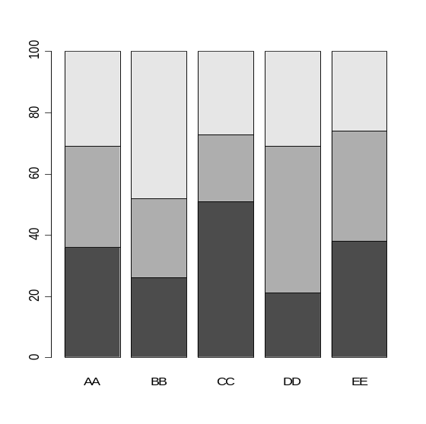

> table(dat$gender,dat$region)

AA BB CC DD EE
F 36 26 51 21 38
M 33 26 22 48 36
N 31 48 27 31 26
> temp <- table(dat$gender,dat$region)
> temp

AA BB CC DD EE
F 36 26 51 21 38
M 33 26 22 48 36
N 31 48 27 31 26
> dim(temp)
[1] 3 5
> colnames(temp)
[1] "AA" "BB" "CC" "DD" "EE"
> rownames(temp)
[1] "F" "M" "N"
>

Looking at the gender distribution by region
Using the beside tag
> barplot(table(dat$gender,dat$region),beside=T,las=1,xlab="Region")
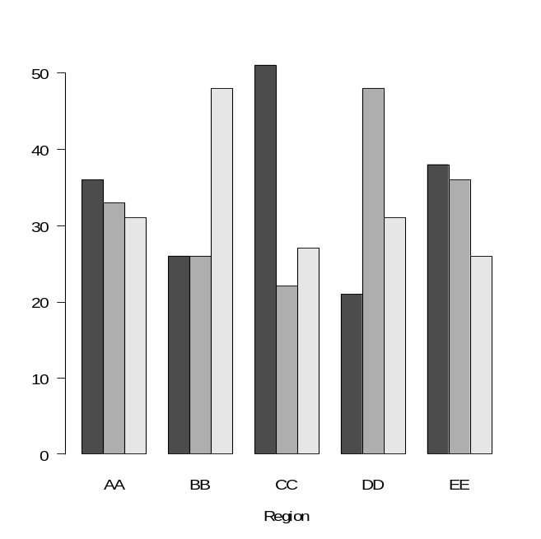

Customizing the bars using col, angle, density tags
barplot(table(dat$gender,dat$region),beside=T,las=1,xlab="Region",
col=c("red","green","blue"), angle=c(45,135,0), density=c(4,8,12))

Adding the legend using legend.text tag
pdf(file="barplot.pdf",height=8,width=10)
barplot(table(dat$gender,dat$region),beside=T,las=1,xlab="Region",
col=c("red","green","blue"), angle=c(45,135,0), density=c(4,8,12),
legend.text=c("Female","Male","None") )
dev.off()

Customizing the legend using the legend function
help(legend)

pdf(file="barplot2.pdf",height=8,width=10)
barplot(table(dat$gender,dat$region),beside=T,las=1,xlab="Region",
col=c("red","green","blue"), angle=c(45,135,0), density=c(4,8,12),
ylim=c(0,70))

legend(3,70, fill=c("red","green","blue"), angle=c(45,135,0), density=32,
legend= c("Female","Male","Nux") )

dev.off()

Moving the legend and adding a title using text function
pdf(file="barplot3.pdf",height=8,width=10)

barplot(table(dat$gender,dat$region),beside=T,las=1,xlab="Region",
col=c("red","green","blue"), angle=c(45,135,0), density=c(4,8,12),
ylim=c(0,70))

legend(18,60, fill=c("red","green","blue"), angle=c(45,135,0), density=32,
legend= c("Female","Male","Nux") )

text(1,65,"Distribution of Gender by Region",pos=4)

dev.off()

Multiple plots on the same page using par(mfrow)
mfcol, mfrow
A vector of the form c(nr, nc). Subsequent figures will be drawn in an nr-by-nc array on the device by columns (mfcol), or rows (mfrow), respectively.
In a layout with exactly two rows and columns the base value of "cex" is reduced by a factor of 0.83: if there are three or more of either rows or columns, the reduction factor is 0.66.
If either of these is queried it will give the current layout, so querying cannot tell you the order the array will be filled.
Consider the alternatives, layout and split.screen.
(from help(par))

pdf(file="multiple1.pdf",height=5,width=10)

### one row by two columns
par(mfrow=c(1,2))

### left plot
plot(dat$age,dat$income,xlab="Age",ylab="Income",
main="Relationship between Age and Income",
pch=20,col="red")
text(x=mean.age, y=mean.income, labels=region, col="blue", cex=0.8, font=2)

### right plot
barplot(table(dat$gender,dat$region),beside=T,las=1,xlab="Region",
col=c("red","green","blue"), ylim=c(0,70))
legend(1,60, fill=c("red","green","blue"),
legend= c("Female","Male","Nux"), cex=0.7 )
text(1,65,"Distribution of Gender by Region",pos=4)

dev.off()

Using a loop
Plot each region separately: age vs. income with regression line
pdf(file="multiple2.pdf",height=8,width=10)

### two rows by three columns
par(mfrow=c(2,3))

### get the five regions "AA" thru "FF"
region <- unique(dat$region)

### use loop to do the same thing for each region
for (i in 1:length(region))
{
### get data for just one region and store in "temp"
temp <- dat[dat$region==region[i],]

### get the regression line fit
fit <- lm(income~age,data=temp)

### plot data points
plot(temp$age,temp$income,xlab="Age", xlim=c(20,60),pch=20,
ylim=c(-2000,14000), ylab="Income in Thousands",yaxt="n",
main=paste("Region ",region[i],sep=""))

### custom y-axis
axis(side=2,at=seq(from=-2000,to=14000,by=2000),
labels=seq(from=-2,to=14,by=2),las=1)

### add regression line
abline(fit$coef,col="red")
}

### close pdf file
dev.off()

Using the lattice package
library(lattice)

Scatter plot, income by age, for each region

xyplot(income ~ age | region, data=dat)

Changing the plot symbol and color

xyplot(income ~ age | region, data=dat, pch=20, col="black")

Adding the regression line for each region

xyplot(income ~ age | region, data=dat,
panel=function(x,y)
{panel.xyplot(x,y,pch=20, col="black")
panel.abline(lsfit(x,y))})

Changing the color of the regression line

xyplot(income ~ age | region, data=dat,
panel=function(x,y)
{panel.xyplot(x,y,pch=20, col="black")
panel.abline(lsfit(x,y),col="red")})

Put series of plots into pdf

pdf(file="lattice.pdf",height=8,width=10)

xyplot(income ~ age | region, data=dat)

xyplot(income ~ age | region, data=dat,pch=20, col="black")

xyplot(income ~ age | region, data=dat,
panel=function(x,y)
{panel.xyplot(x,y,pch=20, col="black")
panel.abline(lsfit(x,y))})

xyplot(income ~ age | region, data=dat,
panel=function(x,y)
{panel.xyplot(x,y,pch=20, col="black")
panel.abline(lsfit(x,y),col="red")})

dev.off()

EXERCISE C

Drawing on a blank canvas and the polygon function
pdf("demo.drawing.pdf",width=10,height=10)

### blank canvas
plot(NULL,NULL, type="n", xlim=c(0,10), ylim=c(0,10), xlab="", ylab="", yaxt="n", xaxt="n", frame.plot=FALSE)

### black vertical line
segments(x0=0,x1=0,y0=0,y1=10)

### black triangle (outline)
polygon(x=c(2,4,3),y=c(3,3,5))

### dotted darkgreen sine wave
x <- seq(1,1+3*pi,0.1)
y <- sin(x) + 7
lines(x,y,col="darkgreen",lty="dotted",lwd=3)

### blue circle shaded with diagonal lines
x1 <- seq(7-sqrt(3),7+sqrt(3),.1)
x2 <- seq(7+sqrt(3),7-sqrt(3),-.1)
y1 <- sqrt(3 - (x1 - 7)^2) + 2
y2 <- -sqrt(3 - (x1 - 7)^2) + 2
polygon(x=c(x1,x2),y=c(y1,y2),density=16,col="blue")

### square, outline in black, fill in red
polygon(x=c(4,5,5,4),y=c(7.5,7.5,8.5,8.5),col="red")

dev.off()

Resources
R website
http://www.r-project.org/

Class webpage
http://csde.washington.edu/courses/statcore/RGraphics/

An Introduction to R
file:///C:/Program%20Files/R/R-2.6.1/doc/manual/R-intro.html#Graphics

Chris Adolph’s class
CS&SS 594: Visualizing Data

Murrell, Paul (2006). R Graphics. Chapman & Hall/CRC

Sarkar, Deepayan (2008) Lattice: Multivariate Data Visualization with R. Springer.

Cleveland, William S. (1993) Visualizing Data. Hobart Press.

Tufte, Edward R. (2001) The Visual Display of Quantitative Information. Graphics Press.

