Cori Mar

11/30/2017

#### Using the Human Mortality Data

1. Go to www.mortality.org
2. Create a user name and password
3. Login
4. Choose country: Australia
5. Choose data: Births
6. Download file: Australia_Births_Raw.txt
7. Strip header from file and save: Australia_Births.dat

### read data file  
dd <- read.table(file="Australia_Births.dat", header=TRUE)

#### Plot Australia births

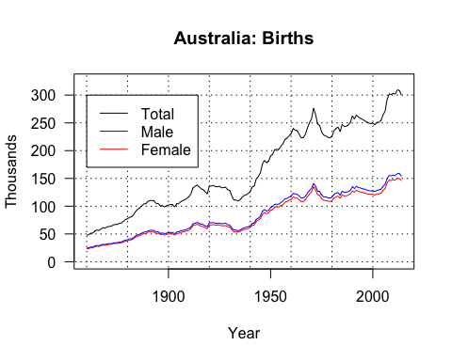 #### Read table of Australia Life expectancy at birth

dd.le <- read.table(file="Australia_LifeExpBirth_1x10.dat", header = TRUE)

#### Print table of Australia Life expectancy at birth

##### Raw output

dd.le

## Year Female Male Total  
## 1 1921-1929 64.66 60.73 62.55  
## 2 1930-1939 67.42 63.48 65.34  
## 3 1940-1949 69.77 65.49 67.54  
## 4 1950-1959 72.86 67.10 69.85  
## 5 1960-1969 74.29 67.73 70.86  
## 6 1970-1979 76.09 69.14 72.49  
## 7 1980-1989 78.91 72.27 75.54  
## 8 1990-1999 81.08 75.26 78.16  
## 9 2000-2009 83.23 78.38 80.82  
## 10 2010-2014 84.45 80.28 82.38

##### Raw output without hashtags using comment=’’

dd.le

Year Female Male Total  
1 1921-1929 64.66 60.73 62.55  
2 1930-1939 67.42 63.48 65.34  
3 1940-1949 69.77 65.49 67.54  
4 1950-1959 72.86 67.10 69.85  
5 1960-1969 74.29 67.73 70.86  
6 1970-1979 76.09 69.14 72.49  
7 1980-1989 78.91 72.27 75.54  
8 1990-1999 81.08 75.26 78.16  
9 2000-2009 83.23 78.38 80.82  
10 2010-2014 84.45 80.28 82.38

##### Prettier output using kable

library(knitr)  
kable(dd.le, caption="Australia Life Expectancy at Birth")

Australia Life Expectancy at Birth

|  |  |  |  |
| --- | --- | --- | --- |
| Year | Female | Male | Total |
| 1921-1929 | 64.66 | 60.73 | 62.55 |
| 1930-1939 | 67.42 | 63.48 | 65.34 |
| 1940-1949 | 69.77 | 65.49 | 67.54 |
| 1950-1959 | 72.86 | 67.10 | 69.85 |
| 1960-1969 | 74.29 | 67.73 | 70.86 |
| 1970-1979 | 76.09 | 69.14 | 72.49 |
| 1980-1989 | 78.91 | 72.27 | 75.54 |
| 1990-1999 | 81.08 | 75.26 | 78.16 |
| 2000-2009 | 83.23 | 78.38 | 80.82 |
| 2010-2014 | 84.45 | 80.28 | 82.38 |