**Supporting Information to “The effect of international travel restrictions on internal spread of COVID-19”**

Table S1: Median and 95% intervals for expected daily number of imported cases, estimated daily number of new local cases, and ratio of these two quantities. Countries are divided by region and sorted by increasing ratio of imported to local cases, for all countries with median ratio at least 0.01.

|  |  |  |  |  |  |
| --- | --- | --- | --- | --- | --- |
| Region | Country | iso3c | Expected imported cases | Local cases | Imported cases per local |
| Africa | Burkina Faso | BFA | 0.1 (0.0, 0.2) | 9 (3, 28) | 0.011 (0.002, 0.059) |
|  | Angola | AGO | 1.2 (0.5, 2.6) | 70 (21, 221) | 0.017 (0.002, 0.121) |
|  | Morocco | MAR | 4.8 (2.3, 10.9) | 226 (125, 398) | 0.021 (0.006, 0.087) |
|  | Tunisia | TUN | 2.0 (0.9, 4.5) | 11 (4, 40) | 0.181 (0.023, 1.000) |
| Americas | Canada | CAN | 50.8 (23.3, 108.5) | 4348 (2101, 8422) | 0.012 (0.003, 0.052) |
|  | Venezuela | VEN | 2.9 (1.4, 6.2) | 233 (121, 469) | 0.013 (0.003, 0.051) |
|  | Dominican Republic | DOM | 15.2 (6.9, 35.1) | 1138 (533, 2341) | 0.013 (0.003, 0.066) |
|  | USA | USA | 2019.2 (900.9, 4842.7) | 91808 (43224, 187810) | 0.022 (0.005, 0.112) |
|  | Paraguay | PRY | 2.3 (1.1, 4.6) | 46 (25, 89) | 0.051 (0.012, 0.189) |
|  | Guyana | GUY | 0.6 (0.3, 1.4) | 11 (3, 45) | 0.054 (0.006, 0.475) |
|  | Puerto Rico | PRI | 13.6 (6.1, 32.4) | 243 (132, 438) | 0.056 (0.014, 0.245) |
|  | Costa Rica | CRI | 9.1 (4.2, 19.9) | 107 (58, 198) | 0.085 (0.021, 0.343) |
|  | Uruguay | URY | 3.5 (1.7, 7.0) | 18 (6, 55) | 0.196 (0.030, 1.000) |
|  | Cuba | CUB | 8.7 (4.0, 18.4) | 28 (14, 69) | 0.307 (0.058, 1.000) |
|  | Jamaica | JAM | 6.9 (3.1, 16.4) | 10 (5, 32) | 0.682 (0.097, 1.000) |
| Asia | Uzbekistan | UZB | 2.9 (1.4, 5.5) | 253 (138, 454) | 0.011 (0.003, 0.040) |
|  | Turkey | TUR | 31.5 (15.1, 65.4) | 2555 (1294, 4805) | 0.012 (0.003, 0.051) |
|  | Singapore | SGP | 10.0 (4.8, 21.5) | 737 (395, 1423) | 0.014 (0.003, 0.055) |
|  | UAE | ARE | 21.8 (10.8, 43.5) | 1058 (586, 1805) | 0.021 (0.006, 0.074) |
|  | Sri Lanka | LKA | 2.4 (1.2, 5.9) | 57 (30, 111) | 0.041 (0.010, 0.195) |
|  | Israel | ISR | 20.1 (9.0, 47.1) | 364 (197, 655) | 0.055 (0.014, 0.239) |
|  | Malaysia | MYS | 5.5 (2.8, 11.6) | 80 (44, 144) | 0.069 (0.019, 0.265) |
|  | Lebanon | LBN | 4.6 (2.2, 10.2) | 40 (19, 96) | 0.116 (0.023, 0.525) |
|  | Japan | JPN | 42.2 (19.2, 99.0) | 253 (100, 616) | 0.166 (0.031, 0.988) |
|  | Georgia | GEO | 2.5 (1.2, 5.1) | 15 (7, 41) | 0.167 (0.030, 0.744) |
|  | South Korea | KOR | 25.6 (11.6, 60.0) | 96 (50, 207) | 0.265 (0.056, 1.000) |
|  | Cyprus | CYP | 3.2 (1.5, 6.3) | 4 (2, 13) | 0.735 (0.119, 1.000) |
|  | Thailand | THA | 8.8 (4.4, 18.7) | 9 (4, 24) | 0.941 (0.188, 1.000) |
|  | China | CHN | 68.7 (31.7, 159.9) | 39 (21, 151) | 1.000 (0.210, 1.000) |
| Europe | Portugal | PRT | 12.7 (5.8, 27.8) | 791 (374, 1612) | 0.016 (0.004, 0.074) |
|  | Belgium | BEL | 9.9 (4.5, 23.0) | 608 (277, 1260) | 0.016 (0.004, 0.083) |
|  | Hungary | HUN | 4.6 (2.1, 10.4) | 178 (76, 401) | 0.026 (0.005, 0.137) |
|  | Germany | DEU | 43.9 (20.4, 99.4) | 1507 (723, 2953) | 0.029 (0.007, 0.138) |
|  | Montenegro | MNE | 1.0 (0.4, 2.1) | 33 (9, 110) | 0.030 (0.004, 0.225) |
|  | Netherlands (the) | NLD | 16.4 (7.6, 36.7) | 497 (223, 1050) | 0.033 (0.007, 0.164) |
|  | Czechia | CZE | 5.4 (2.5, 11.7) | 134 (66, 285) | 0.040 (0.009, 0.178) |
|  | Estonia | EST | 0.8 (0.4, 1.8) | 20 (7, 58) | 0.041 (0.006, 0.269) |
|  | Ireland | IRL | 7.6 (3.4, 17.7) | 175 (69, 424) | 0.044 (0.008, 0.256) |
|  | Austria | AUT | 6.8 (3.1, 15.4) | 128 (45, 369) | 0.053 (0.009, 0.339) |
|  | Denmark | DNK | 6.4 (2.9, 15.1) | 109 (48, 247) | 0.059 (0.012, 0.315) |
|  | Slovenia | SVN | 0.7 (0.3, 1.7) | 11 (3, 41) | 0.065 (0.008, 0.511) |
|  | Finland | FIN | 2.9 (1.3, 6.4) | 44 (21, 103) | 0.066 (0.013, 0.302) |
|  | Luxembourg | LUX | 0.9 (0.4, 2.2) | 13 (6, 33) | 0.071 (0.013, 0.394) |
|  | Lithuania | LTU | 2.7 (1.3, 5.5) | 34 (13, 88) | 0.078 (0.014, 0.443) |
|  | Norway | NOR | 3.2 (1.4, 8.0) | 39 (16, 122) | 0.081 (0.011, 0.508) |
|  | Latvia | LVA | 0.9 (0.4, 2.0) | 10 (3, 32) | 0.091 (0.014, 0.609) |
|  | Slovakia | SVK | 0.7 (0.3, 1.6) | 8 (4, 19) | 0.095 (0.018, 0.439) |
|  | Greece | GRC | 7.8 (3.5, 17.8) | 61 (22, 171) | 0.127 (0.021, 0.819) |
|  | Switzerland | CHE | 8.6 (3.8, 19.7) | 67 (29, 151) | 0.127 (0.025, 0.685) |
|  | Croatia | HRV | 3.4 (1.5, 7.5) | 15 (6, 41) | 0.228 (0.038, 1.000) |
|  | Iceland | ISL | 1.0 (0.5, 2.5) | 2 (1, 5) | 0.594 (0.099, 1.000) |
| Oceania | Australia | AUS | 15.9 (7.8, 34.2) | 28 (15, 55) | 0.560 (0.141, 1.000) |
|  | New Zealand | NZL | 3.8 (1.7, 8.8) | 2 (1, 9) | 1.000 (0.200, 1.000) |

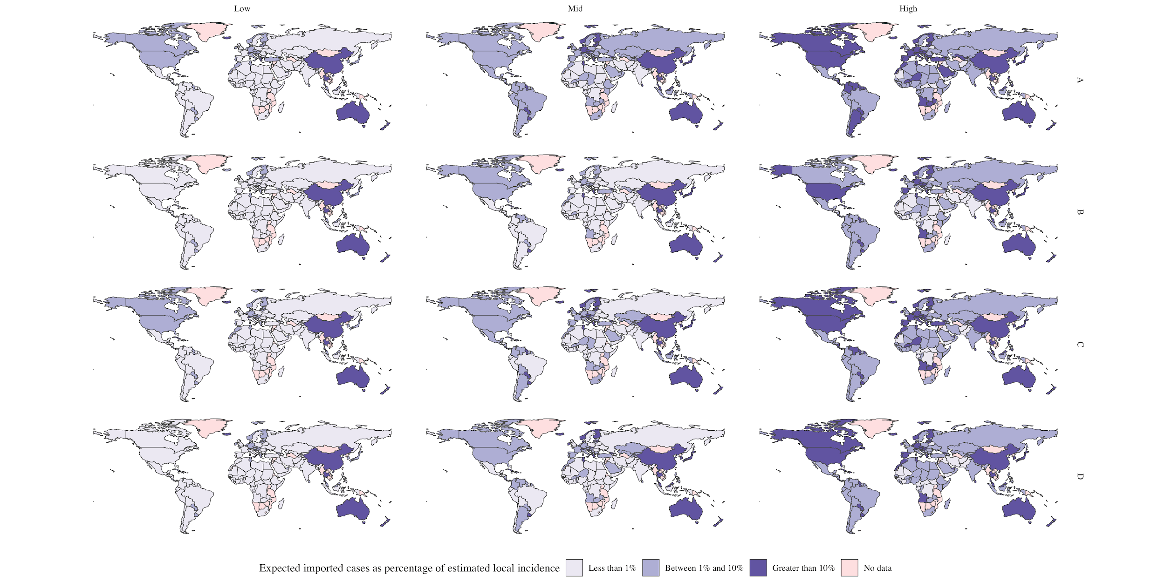

Figure S1: Risk rating by country, in the absence of international travel restrictions, in each of the four scenarios about international travellers in May 2020. (A) Travel assumed to be at the same levels as May 2019. (B) Traveller numbers scaled downwards based on the reduction in flights in May 2020 reported by OpenSky. (C) Traveller numbers scaled down by 25%. (D) Traveller numbers scaled down by 50%. Columns correspond to low, mid and high values of uncertainty interval for daily imported cases per local daily case.

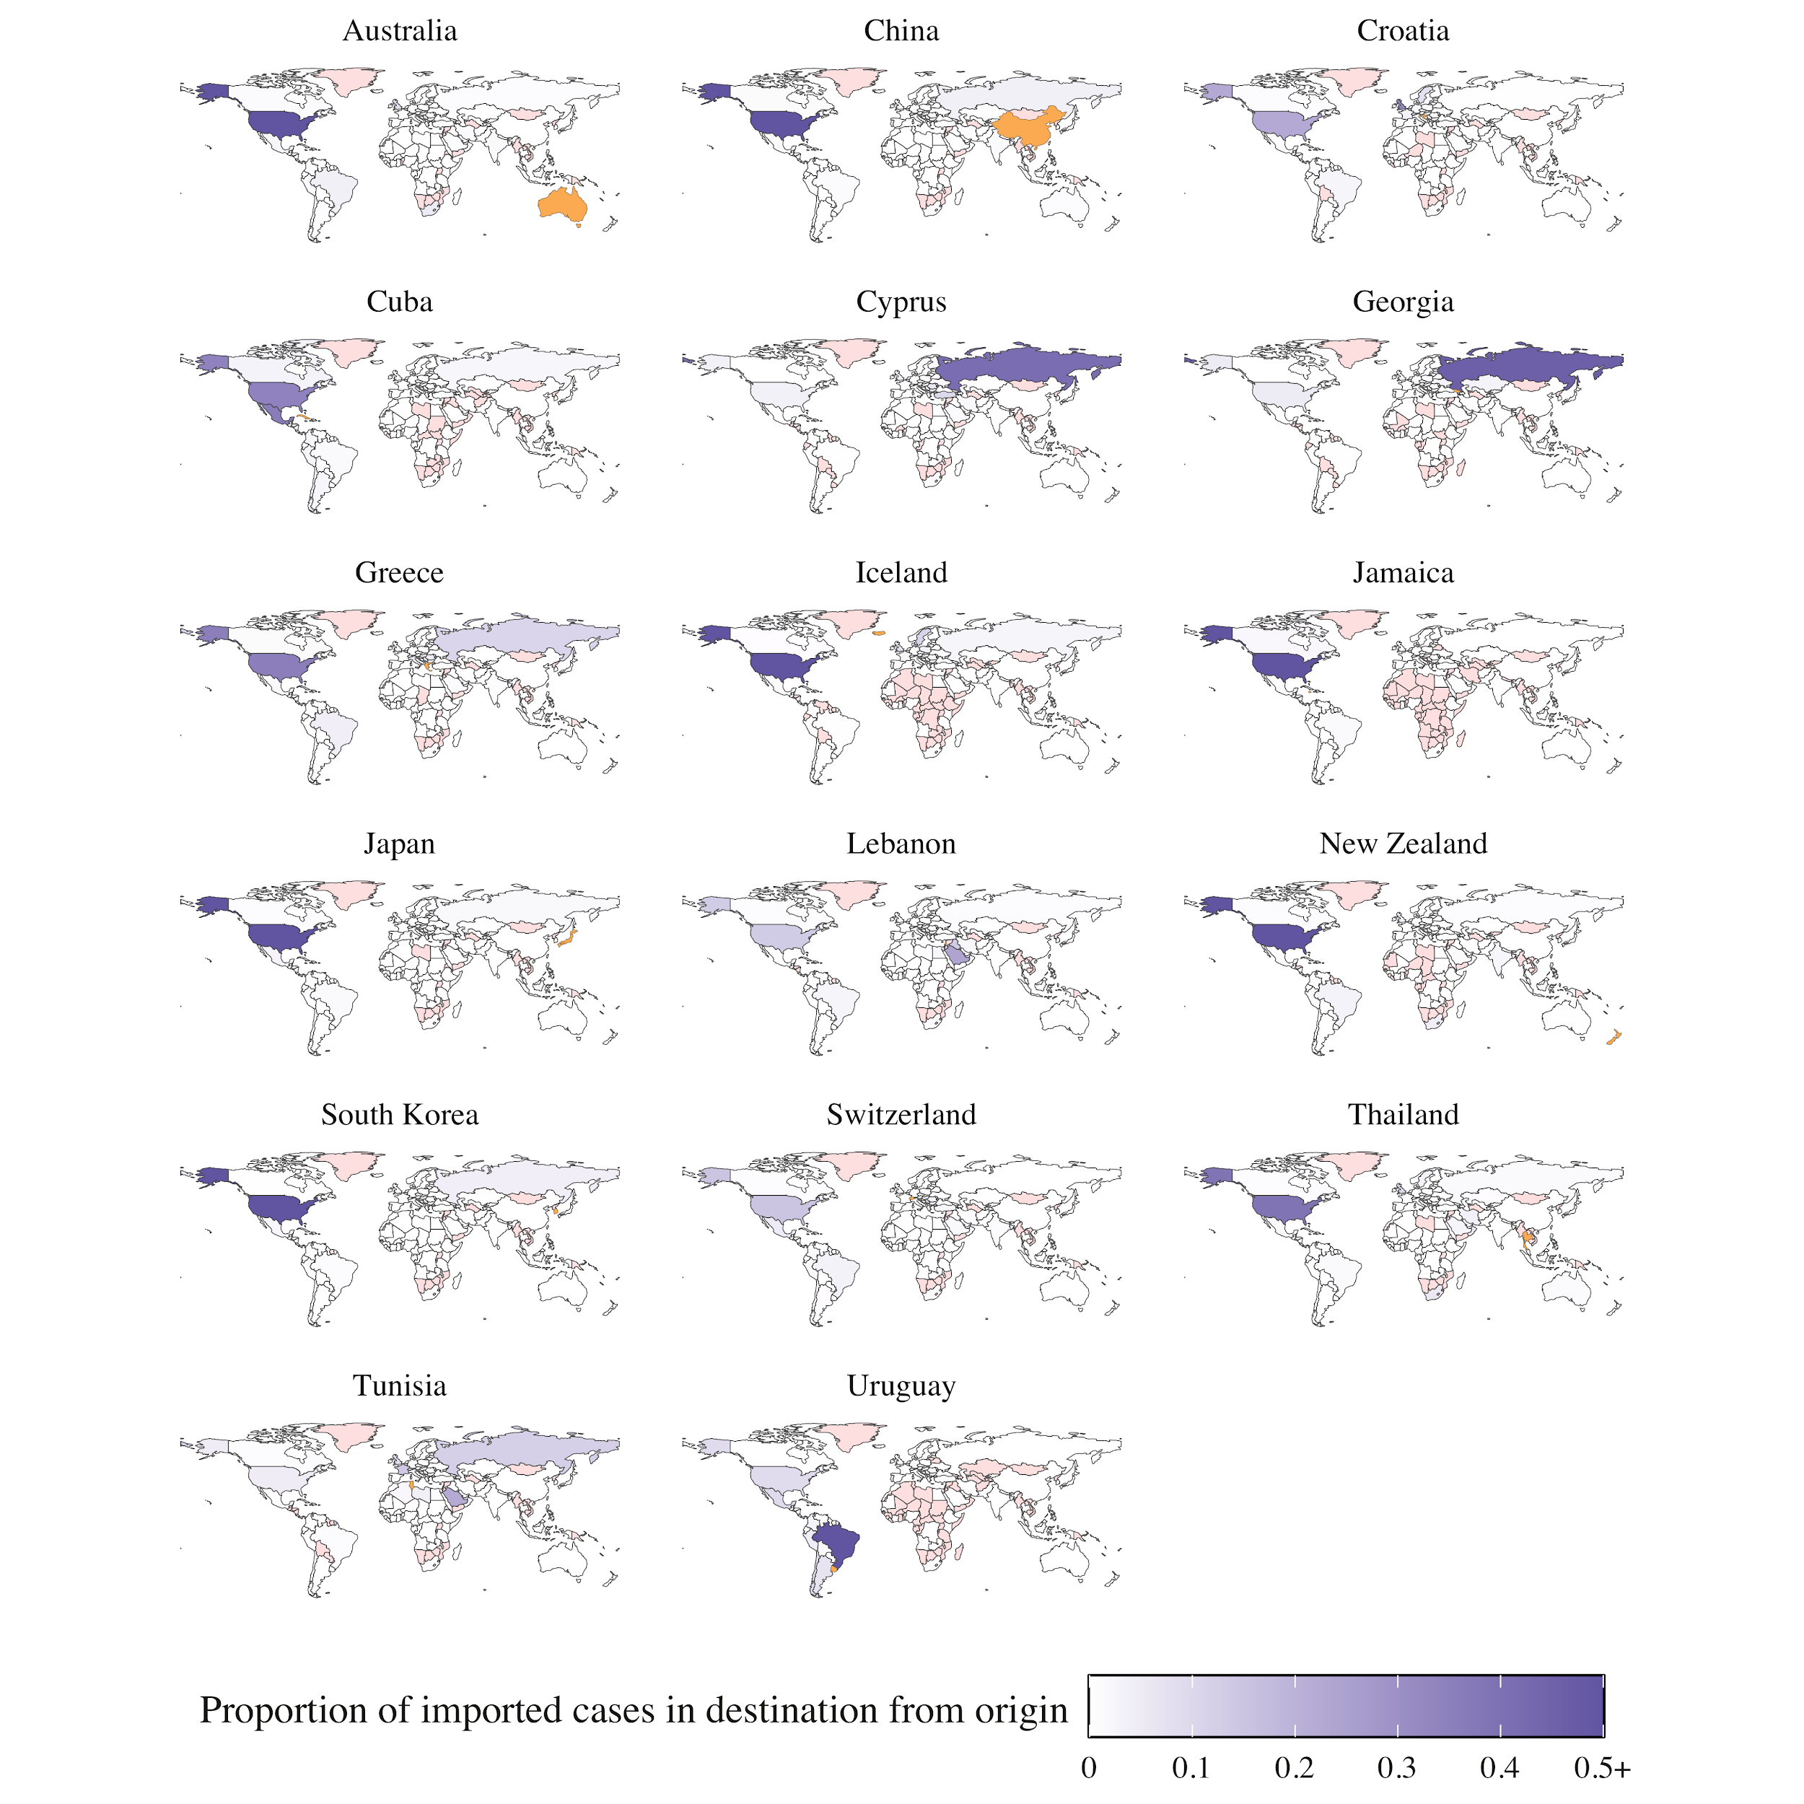

Figure S2: Proportion of estimated imported cases in destination (orange) imported from each origin (purples). Countries with no data (pink) either have missing prevalence estimates and/or there is no data on international flights between this origin-destination pair.