

Corporate Sponsorship Packet

for

“Oozeball” Philanthropic Event

Phi Kappa Sigma International Fraternity

Alpha Nu Chapter at Georgia Tech

To whom it may concern:

Through this packet, you have the opportunity to help sponsor what has become a tradition of Phi Kappa Sigma – Alpha Nu, and Georgia Tech as a whole, over the past twenty years. The annual “Oozeball” philanthropic event has created both a fun experience for all involved and an excellent source of donations to go towards the discovery of new treatments and preventive measurse for blood cancers.

“Oozeball” consists of a knockout bracket-style mud volleyball tournament held in the front yard of the Phi Kappa Sigma fraternity house at Georgia Tech. It is held every year during the spring, usually during late March or early April. The participants compete for prizes which are predetermined through donations from our corporate sponsors.

All of the money raised from this event goes to the Leukemia and Lymphoma Society which then uses the money to help fund treatments for some of the almost one million Americans living with leukemia, Hodgkin and non-Hodgkin lymphoma, NHL, or myeloma. Also, they are funding the research to help reduce the number of new cases that are diagnosed, which is close to one-hundred and fifty thousand every year and rising. That is why this event, and its success, is so important.

Every year this event is a huge success. We have many of our alumni come back to participate, along with other students from Georgia Tech and Georgia State, each person donating a set amount to enter into the tournament. This year however we are planning to aggressively expand the event to reach more people not only on Georgia Tech’s and Georgia State’s campuses, but also from other Atlanta colleges, such as Agnes Scott College and Emory University. This expansion is where our corporate sponsors come into play. We, as a fraternity, do not have the means to advertise across such a wide area, nor do we have the ability to support such an event by ourselves, but we believe strongly in the goals of this event, and hope that you will help us to achieve them.

In exchange for your donations, whether they are monetary, services, or goods, your company’s logo will be placed on the event shirts and/or on banners outside of the Phi Kappa Sigma fraternity house a week before the event and during the event depending on the level of donation, which is discussed on the “Donation Tiers” page of this packet. The Phi Kappa Sigma fraternity house is in a prime location on the east side of Georgia Tech’s campus near the Fifth Street bridge, meaning that these types of advertisements will expose your company to a grand majority of Georgia Tech’s student population, along with all of the participants and spectators at the event.

This event is not only an excellent way to expose your company to a large population, but also a way to show that you as a company are willing to give back to society and help those in need. Because of these reasons, I hope you will consider helping us towards our goal.

Sincerely,

Zachary Meeks

Oozeball Committee Chair

The Phi Kappa Sigma – Alpha Nu Property

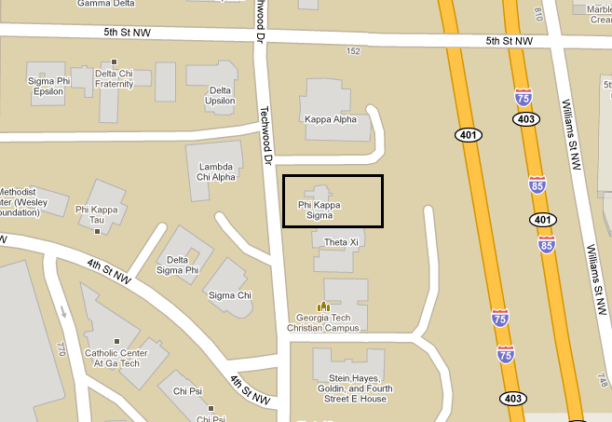

The Phi Kappa Sigma house is located on Techwood Dr. one block from the 5th Street bridge in the middle of Georgia Tech’s east campus

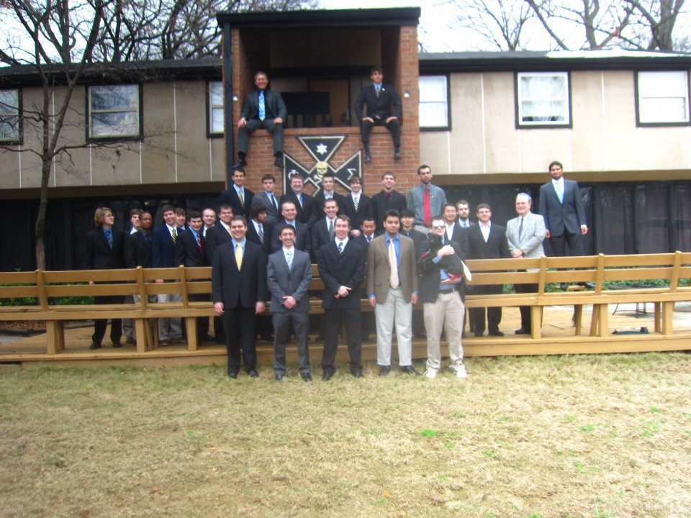

The brothers of Phi Kappa Sigma outside of our house

The Oozeball Pit

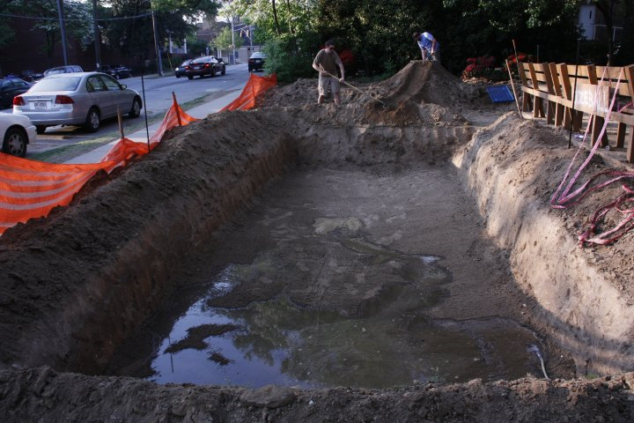

The Oozeball pit is approximately 20ft x 10ft and is filled with 3ft of water during the tournament.

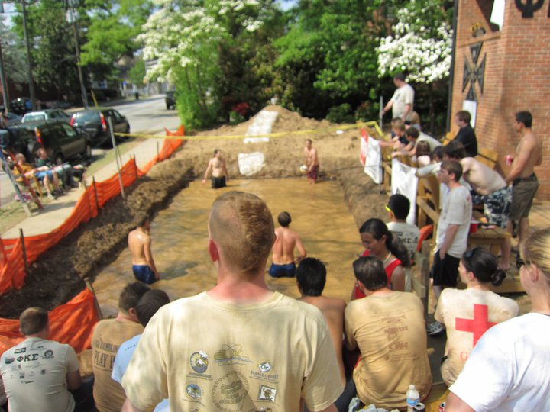

Four competitors enjoying the tournament and the crowd

Donation Tiers

Tier 1 – Platinum Level – $500

For a Platinum Level Donation, your company will receive a **Personalized Banner** to be displayed outside of the Phi Kappa Sigma House during the event and a week before the event, will have a **Large Icon** of your company’s choice placed on the back of the event t-shirt, and will be announced as an **Official Sponsor** of the event.

Tier 2 – Gold Level – $250

For a Gold Level Donation, your company will have a **Large Icon** on the sponsorship banner that will be displayed outside of the Phi Kappa Sigma House during the event and a week before the event, will have a **Large Icon** of your company’s choice placed on the back of the event t-shirt, and will be announced as an **Official Sponsor** of the event.

Tier 3 – Silver Level – $100

For the Silver Level Donation, your company will have a **Small Icon** placed on the sponsorship banner that will be displayed outside of the Phi Kappa Sigma House during the event and a week before the event, and will have a **Large Icon** of your company’s choice placed on the back of the event t-shirt.

Tier 4 – Bronze Level – $50

For the Bronze Level Donation, your company will have a **Small Icon** of your company’s choice placed on the back of the event t-shirt.

Non-Monetary Donations

All non-monetary donations will also qualify for the different Donation Tiers based on the value of the items donated.

**Corporate Sponsored Teams**

**If your company would like to sponsor a team(s), please fill out the attached form!**

Donation Form

Please include this form with any Donation

Company Name:\_\_\_\_\_\_\_\_\_\_\_\_\_\_\_\_\_\_\_\_\_\_\_\_\_\_\_\_\_\_\_\_\_\_\_\_\_\_\_\_

Donation Type: □ Money □ Other:\_\_\_\_\_\_\_\_\_\_\_\_\_\_\_

Donation Amount:\_\_\_\_\_\_\_\_\_\_\_\_\_\_\_\_\_\_\_\_\_\_\_\_\_

Donation Tier

* Tier 1 – Platinum Level – $500
* Tier 2 – Gold Level – $250
* Tier 3 – Silver Level – $100
* Tier 4 – Bronze Level – $50

Contact Information

This information will only be used for discussing the requirements for Donation Incentives, such as a high resolution monochrome logo, full color logo, or both.

Name:\_\_\_\_\_\_\_\_\_\_\_\_\_\_\_\_\_\_\_\_\_\_\_\_\_\_\_\_\_\_\_\_\_\_\_\_\_\_\_\_\_\_\_\_\_\_\_\_\_\_\_\_\_\_\_\_\_\_\_\_\_

Address:\_\_\_\_\_\_\_\_\_\_\_\_\_\_\_\_\_\_\_\_\_\_\_\_\_\_\_\_\_\_\_\_\_\_\_\_\_\_\_\_\_\_\_\_\_\_\_\_\_\_\_\_\_\_\_\_\_\_\_

City:\_\_\_\_\_\_\_\_\_\_\_\_\_\_\_\_\_\_\_\_\_\_\_\_\_\_\_\_\_\_\_\_\_\_\_\_\_\_\_\_\_\_\_\_\_\_\_\_\_\_\_\_\_\_\_\_\_\_\_\_\_\_

State:\_\_\_\_\_\_\_\_\_\_\_\_\_\_\_\_\_\_\_\_\_\_\_\_\_\_\_ Zip:\_\_\_\_\_\_\_\_\_\_\_\_\_\_\_\_\_\_\_\_\_\_\_\_\_\_\_\_\_\_

Telephone:\_\_\_\_\_\_\_\_\_\_\_\_\_\_\_\_\_\_\_\_\_\_\_\_\_\_\_\_\_\_\_\_\_\_\_\_\_\_\_\_\_\_\_\_\_\_\_\_\_\_\_\_\_\_\_\_\_

Email Address:\_\_\_\_\_\_\_\_\_\_\_\_\_\_\_\_\_\_\_\_\_\_\_\_\_\_\_\_\_\_\_\_\_\_\_\_\_\_\_\_\_\_\_\_\_\_\_\_\_\_\_\_\_\_

To Donate

By Mail: Please send to Phi Kappa Sigma Fraternity

783 Techwood Drive

Atlanta, GA 30313

At Your Company: Please call (678) 910-2288 or email zcm11@aol.com to set up a time for Donation Pick-Up

Corporate Sponsored Team

Team Name: \_\_\_\_\_\_\_\_\_\_\_\_\_\_\_\_\_\_\_\_\_\_\_\_\_\_\_\_

Player 1:

Name: \_\_\_\_\_\_\_\_\_\_\_\_\_\_\_\_\_\_\_\_\_\_\_\_\_\_\_\_

Phone: \_\_\_\_\_\_\_\_\_\_\_\_\_\_\_\_\_\_\_\_\_\_\_\_\_\_\_\_

Email: \_\_\_\_\_\_\_\_\_\_\_\_\_\_\_\_\_\_\_\_\_\_\_\_\_\_\_\_

Player 2:

Name: \_\_\_\_\_\_\_\_\_\_\_\_\_\_\_\_\_\_\_\_\_\_\_\_\_\_\_\_

Phone: \_\_\_\_\_\_\_\_\_\_\_\_\_\_\_\_\_\_\_\_\_\_\_\_\_\_\_\_

Email: \_\_\_\_\_\_\_\_\_\_\_\_\_\_\_\_\_\_\_\_\_\_\_\_\_\_\_\_

Player 3:

Name: \_\_\_\_\_\_\_\_\_\_\_\_\_\_\_\_\_\_\_\_\_\_\_\_\_\_\_\_

Phone: \_\_\_\_\_\_\_\_\_\_\_\_\_\_\_\_\_\_\_\_\_\_\_\_\_\_\_\_

Email: \_\_\_\_\_\_\_\_\_\_\_\_\_\_\_\_\_\_\_\_\_\_\_\_\_\_\_\_

For $15/player, your team will receive an Oozeball T-shirt for each player, lots of food, and the opportunity to win tons of raffle prizes throughout the event!

If you would like to sponsor a team for the open event, please just include the team’s charge in your donation and attach this sheet.

We hope to see you there!

**Last Year’s Sponsors**

 C:\Users\Zachary\Desktop\School Stuff\Phi Kappa Sigma\Offices\Oozeball Chair '11\Sponsor Pics\Bussey_Brittle_Logo.001.tiff

 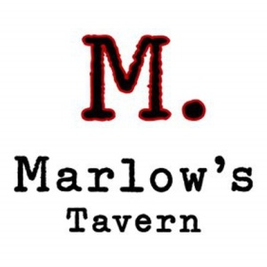

 

**Last Year’s Sponsors**

 

 

 