ecodive: Fast Implementations of Ecological Diversity Metrics in R

04 August 2025



Ecodive package logo

# Summary

In the context of ecology, diversity measures the distribution of different species within in a community. This calculation may include the number of species present, relative abundances, evolutionary relationships, or a combination thereof. Alpha diversity metrics consider a single community in isolation, whereas beta diversity metrics compute the dissimilarity between two communities.

Applying diversity metrics to large collections of communities, for instance thousands of gut microbiome samples, can offer insights into how specific disease states may be predicted or diagnosed based on ecological “fingerprints”.

# Statement of Need

Some diversity metrics, such as Faith’s PD (Faith 1992) and UniFrac (Lozupone and Knight 2005), require complex integration species counts with evolutionary distances. Furthermore, processing thousands of communities is computationally intensive and best implemented with parallel processing and compiled libraries. For these reasons, the ecodive R package was developed to handle these challenges so that R users don’t have to.

## Related Works

There are currently five other R packages that can calculate alpha and beta diversity metrics: abdiv (Bittinger 2020), ampvis2 (Andersen et al. 2018), GUniFrac (Chen et al. 2023), phyloseq (McMurdie and Holmes 2013), and vegan (Oksanen et al. 2025). However, ecodive provides an implementation which is both faster and more memory efficient.

The bench R package (Hester and Vaughan 2025) was used to compare abdiv, ampvis2, ecodive, GUniFrac, phyloseq, and vegan. The benchmarking runs are detailed in the benchmark vignette, which is available from within R with vignette('benchmark') and online at <https://cmmr.github.io/ecodive/articles/benchmark.html>.

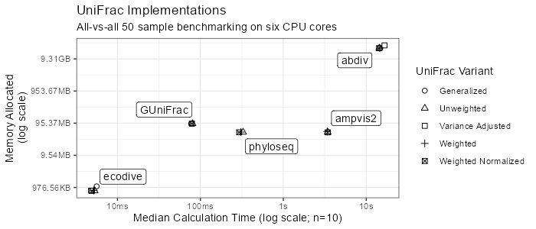

UniFrac benchmarks. Ecodive is 15x to 2800x faster and uses 60x - 25000x less memory.

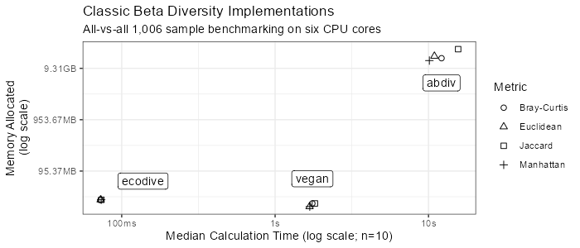

Classic beta diversity benchmarks. Ecodive is 23x to 160x faster and uses 0.8x to 640x less memory.

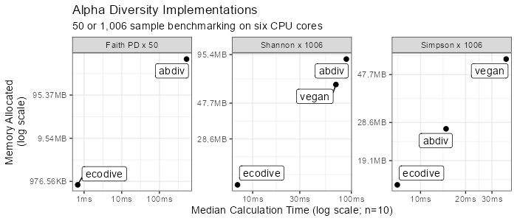

Alpha diversity benchmarks. Ecodive is 10x to 40x faster and uses 5x to 25x less memory.

# Acknowledgements

# References

Andersen, Kasper S., Rasmus H. Kirkegaard, Soren M. Karst, and Mads Albertsen. 2018. “Ampvis2: An r Package to Analyse and Visualise 16S rRNA Amplicon Data.” *bioRxiv*. <https://doi.org/10.1101/299537>.

Bittinger, Kyle. 2020. *Abdiv: Alpha and Beta Diversity Measures*. <https://doi.org/10.32614/CRAN.package.abdiv>.

Chen, Jun, Xianyang Zhang, Lu Yang, and Lujun Zhang. 2023. *GUniFrac: Generalized UniFrac Distances, Distance-Based Multivariate Methods and Feature-Based Univariate Methods for Microbiome Data Analysis*. <https://doi.org/10.32614/CRAN.package.GUniFrac>.

Faith, Daniel P. 1992. “Conservation Evaluation and Phylogenetic Diversity.” *Biological Conservation* 61 (1): 1–10. <https://doi.org/10.1016/0006-3207(92)91201-3>.

Hester, Jim, and Davis Vaughan. 2025. *Bench: High Precision Timing of r Expressions*. <https://doi.org/10.32614/CRAN.package.bench>.

Lozupone, Catherine, and Rob Knight. 2005. “UniFrac: A New Phylogenetic Method for Comparing Microbial Communities.” *Applied and Environmental Microbiology* 71 (12): 8228–35. <https://doi.org/10.1128/AEM.71.12.8228-8235.2005>.

McMurdie, Paul J, and Susan Holmes. 2013. “Phyloseq: An r Package for Reproducible Interactive Analysis and Graphics of Microbiome Census Data.” *PloS One* 8 (4): e61217. <https://doi.org/10.1371/journal.pone.0061217>.

Oksanen, Jari, Gavin L. Simpson, F. Guillaume Blanchet, Roeland Kindt, Pierre Legendre, Peter R. Minchin, R. B. O’Hara, et al. 2025. *Vegan: Community Ecology Package*. <https://doi.org/10.32614/CRAN.package.vegan>.