**COMPS267F (2023) Operating Systems  
Tutorial 0**

**Stage 1: Warm Up Discussions**

1. Name some common operating systems.
2. Where are these operating systems "operating" on?
3. Operating systems are software. Do you agree? Give any evidence?
4. Most people should have experience in using two or more operating systems (OS), for instance, a desktop computer at work and a smartphone for personal matters. Identify and discuss some common functions shared between a mobile OS and a desktop OS.  
   *Hint: consider from the users' perspective and from the application programs' or programmers' perspective.*

**Stage 2: Concepts and Keywords of Chapter 1**

* An operating system (OS) is a _____ that manages the computer hardware.
* An operating system provides a basis for application programs and acts as an ______ between the computer users and computer hardware.
* A modern general-purpose computer system consists of one or more CPUs and a number of device ________ connected through a common bus that provides access to shared memory.
* _______ is nonvolatile, which retains its contents even when power is off.
* _______ is the core component of OS and the first program of OS to be loaded.
* _______ program is the initial program that runs when a computer is powered up. It must locate and load into memory the OS Kernel.
* In simple batch systems, a program called ___________ handles the loading of user program, job sequencing, and input interpretation.
* ____________________ is the term that describes a system capable of running multiple programs at the same time.
* A _____ ____________ system has an operating system or monitor that interleaves the execution of multiple programs in a quick manner.
* __________________ ______________________ manages effective execution of programs and resources on the computer systems.
* Privileged instructions can only be executed in __________ mode.

**Stage 3: Try the little man computer (LMC).**

<https://peterhigginson.co.uk/lmc>

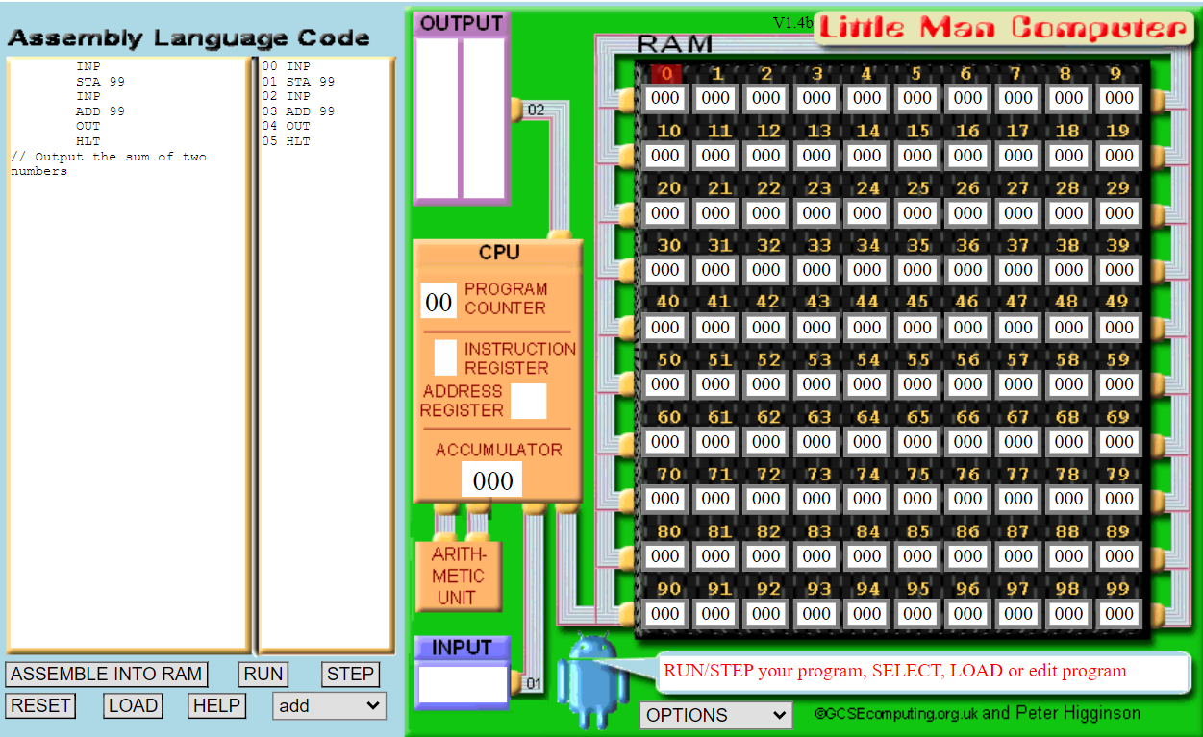

* Try to understand the following concepts:

Assembly language, Assembler, Program counter, Instruction registers, Accumulator

* Finish the following exercise with assembly language

1. Write a program to input four numbers, and add them all. Output the results.
2. Write a program to input three numbers, add them all and then multiply them by two. Output the results.