**Tutorial 1**

**Introduction to Programming**

Week 1

Note:

1. Please do all the exercises in this tutorial on the desktop computers in PC Lab
2. Make sure you select EWIN10 as boosting system
3. Download the Python file lab1.py from OLE
4. We have some exercises and questions for you. Just have fun with coding and exploring.

**Topic 1: Command-line Interface (CLI)**

Command Prompt is an interface that we can directly communicate with the Windows operating system. Before a user-friendly graphical interface was created, this black window is the only way that a user can interact with his/her computer.

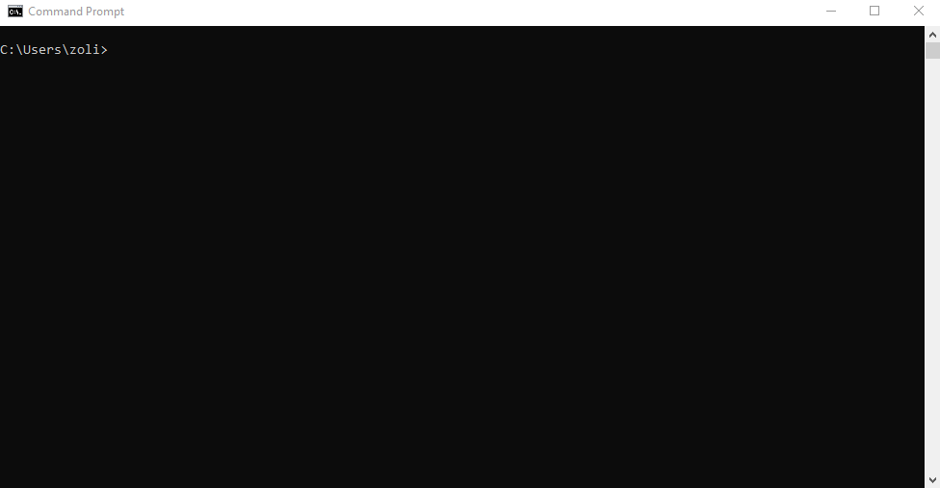

We briefly talk about some basic actions that you can use in the Command Prompt.

***Activity 1.1: Open the Command Prompt (Work together!)***

For Windows user:

Option 1: Click the Windows icon, and search “command prompt”

Option 2: Press Windows key + R key together, and input “cmd” , click OK



***Activity 1.2: Working Directory (Work together!)***

The “C:\Users\zoli” (you will see a similar but not identical text on your computer, zoli is my username) is the current working directory of the CLI. At each time, we can only access the files that are under the current working directory.

dir command will list all the files/programs/folders that are under the current working directory.

TODO: Type dir and press Enter

TODO: Open the File Explorer, type the current working directory (C:\...) in the address bar, and press Enter.

TODO: Compare the shown files/programs/folders with those listed in CLI, and see if they are the same.

cd + foldername will change the working directory to another child directory.

TODO: In the previous step, check if Desktop and Downloads are there.

TODO: Type cd Desktop and press Enter

TODO: Type dir and press Enter, and see if files and folders on Desktop are listed.

cd + .. will change to working directory to the parent directory.

TODO: Type cd Downloads and press Enter, check the error message displayed and think why

TODO: Type cd .. and press Enter, check what the current directory is

TODO: Type cd Downloads again and press Enter,

mkdir + foldername will create a new folder with the name “foldername”.

TODO: Change the working directory to Desktop

TODO: Type mkdir Lab01, and observe the change on the Desktop

**Topic 2: Python Basics**

***Activity 2.1: Run your first Python program (Work together!)***

TODO: Download the file “lab1.py” from OLE

TODO: Put the Python file in the previously created folder, Lab01.

TODO: Open the Anaconda prompt

1. Click the Windows icon or press the Windows key
2. Search “Anaconda prompt”
3. Open Anaconda Prompt (Anaconda3)

TODO: Change the working directory to the folder Lab01

TODO: Type python lab1.py, and press Enter

What is the output?

***Activity 2.2: Edit your first Python program (Work together!)***

TODO: Open lab1.py with VS Code (installed in PC Lab computers)

TODO: Remove the hashtag symbol (#) at Lines 7 and 8

TODO: Save the file with Control-S

TODO Type python lab1.py in Anaconda Prompt again, and press Enter

Will you have the same output?

What is the function of #? What is the meaning of \n? Have a guess first, as sometimes programming is all about imagination.

***Activity 2.3: Explore the print() function in IDLE (Try it by yourself!)***

IDLE is the integrated development environment for Python.

TODO: In Anaconda Prompt, type idle and press Enter, a new window pops out.

TODO: We have some codes in five groups for you to play with. Please type them in IDLE and execute one-by-one by pressing Enter. Write down your observation for each group!

**Make sure you type every letter and symbol exactly as the follows:**

Group1:

print("Hello world!")

print('Hello world!')

Any difference between single quotation mark (') and double quotation mark (") in python print()?

Group 2:

print('Hello world!")

print("Hello world!)

print 'Hello world!'

print(hello world!)

Can these quotation marks not appear in pair? What else can you conclude?

Group 3:

Print("Hello world!") #P is uppercase P

print("Hello world!") #p is lowercase p

#print("Hello world!")

print#("Hello world!")

print(“#Hello world!")

Can you conclude the function of # in Python? Is print() the same as Print()?

Group 4:

print("Hello\nworld!")

print("Hello\tworld!")

What changes can you observe? Search Google to understand the usage of \n and \t.

Group 5:

astring = "Hello world!"

print(astring)

What the output is? Why we do not need a quotation mark in print() for this time?