**COMP S320F/3200SEF/8200SEF Lab 01a: Introduction to Oracle Database**

**[Part I] Student Oracle Account**

**Connection Name:** OracleAcademy

**Username:** i.e. s1234567 *(7-digit of your Student ID)*

**Password:** i.e. 12345678 *(8-digit of your Student ID)*

**Hostname:** oracleacademy.ouhk.edu.hk

**Port:** 8998

**SID:** db1011

***[Note]***

1. **Pls note that your *account will be locked after six consecutive times of incorrect password input.***
2. *You can send your requests or enquires of the Oracle account i.e. unlock account, grant rights for table/view creations, database server is down or unavailable, etc. directly to the following email address:*

[***ora_support@hkmu.edu.hk***](mailto:ora_support@hkmu.edu.hk)

*The related staff from ITU will handle your request directly after receiving your email.*

**[Part II] Download the Installers**

***If you are using your own PC/Laptop at home, refer below:***

1. If the operating system of your computer is ***window 64-bit***, refer below:
2. go to <https://drive.google.com/drive/folders/1KsLPD6CkWByADlYMcmjq3_9cGoHgJ2FD?usp=share_link>

1. download and unzip all the files to your desktop *(ignore the installers’ version no.)*. i.e.

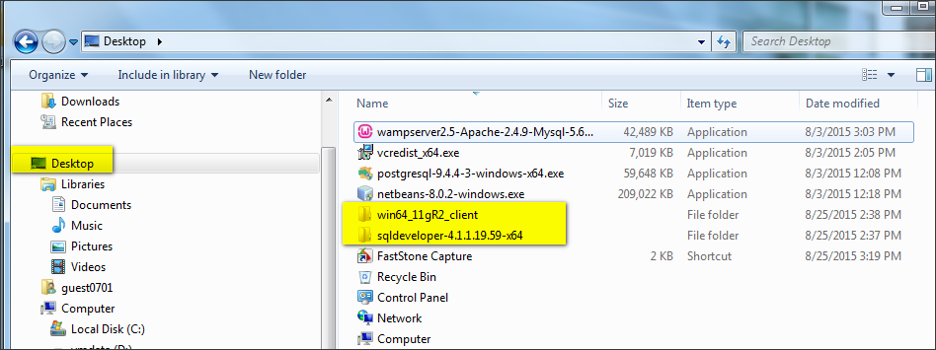

1. If the operating system of your computer is ***NOT*** window 64-bit, please install a virtual Win64 partition for the installation using VMware or VirtualBox, etc,.

***If you are using PC in the school lab, refer below:***

1. Boot up the workstation with partition **VMOS**

* *Note: the partition VMOS is used only in this lab to facilitate the demonstration of a typical Oracle client installation, we will switch to use partition* ***Ewin10*** *starting next week in which all the oracle client and other related applications have already been installed and configured properly.*

1. Go to **Drive D (VMdata) -> comps358f**, and locate the following two highlighted files:

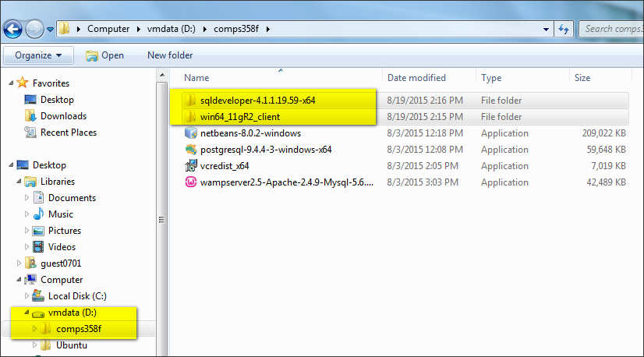

**Copy** the two directories ***win64_11gR2_client*** and ***sqldeveloper-4.1.1.19.59-x64*** to your **desktop:**



*Once you’ve downloaded the required installers (either using home PC or school lab PC), then refer to installation details on next page.***[Part III] Installation of Oracle Database Client**

1. Install the Oracle Client, now go to ***Desktop -> win64_11gR2_client -> client,*** and double click the “**setup.exe**” file start the installation package:

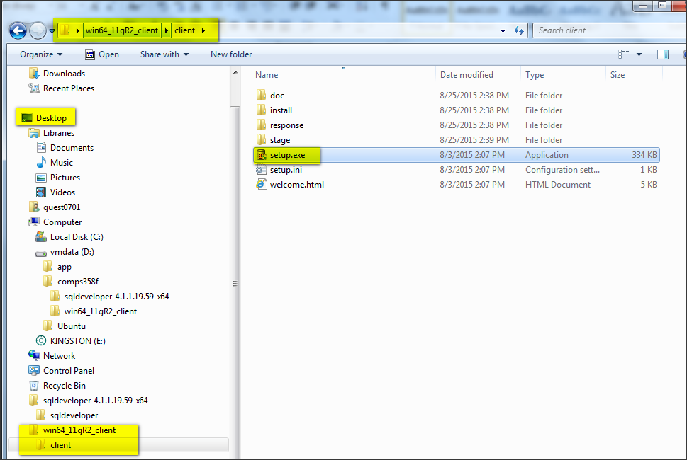

1. In the “Select Installation Type” view, select “Runtime”. Click “Next”.

*Note: if there is a window prompts up showing an error message like “...does not meet the minimum requirement...”, then simply click “Yes” to continue the installation and ignore this error.*

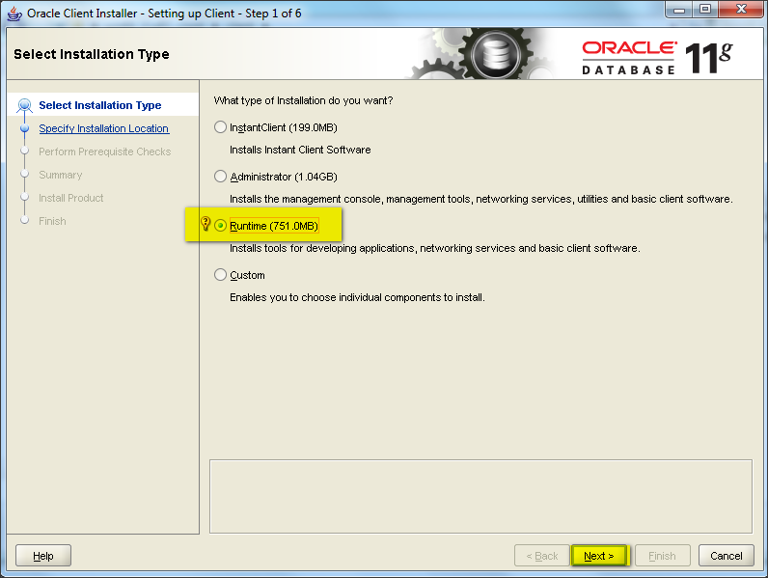

1. In the “Select Product Languages” view, *keep default (English).* Click “Next”.

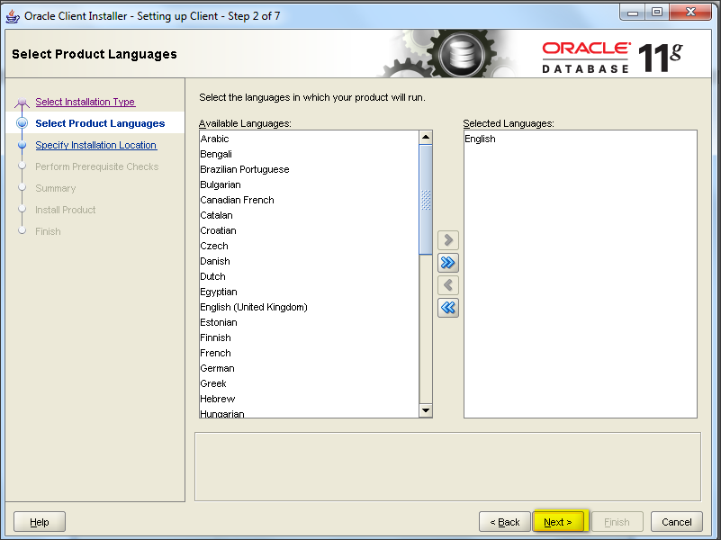

1. *Keep the default path* in the “Specify Installation Location” view. Click “Next”.

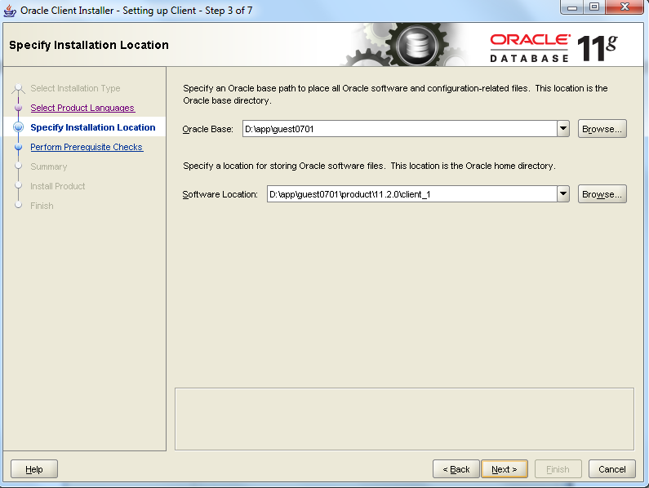

1. The “Prerequisite Checks” will be run automatically, enable the **Ignore All Errors** checkbox *(this page may or may not appear, if it prompts up, follow this step mentioned here)*.

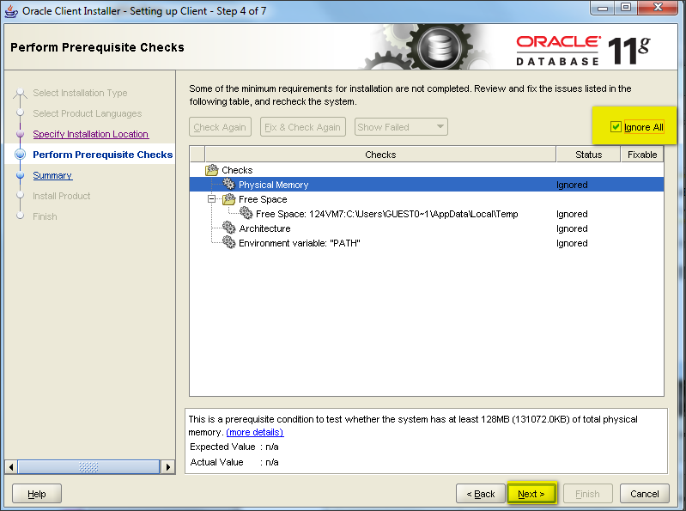

1. A Summary will be displayed showing the installation details, click “Finish”.

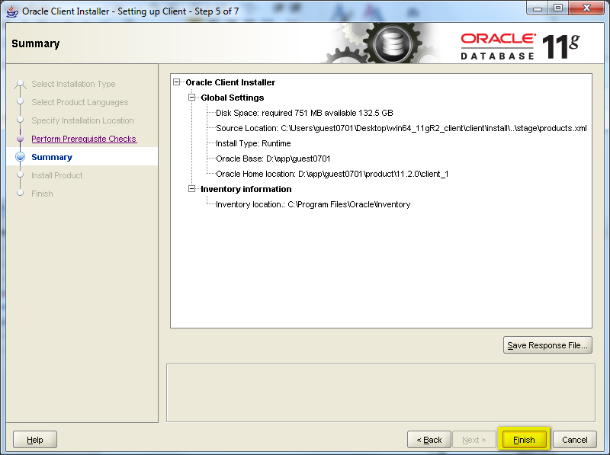

1. The Installation starts right now.

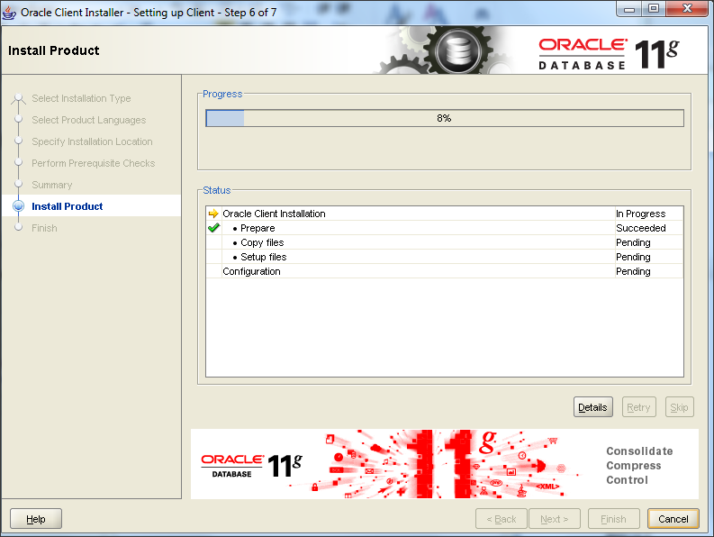

1. Choose the required network setting for windows security alert: *(this page may or may not appear, if it prompts up, follow this step mentioned here)*.

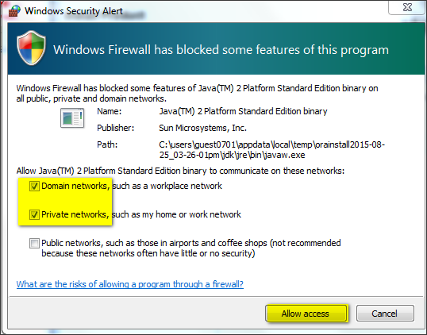

1. The installation of Oracle Client was successful.

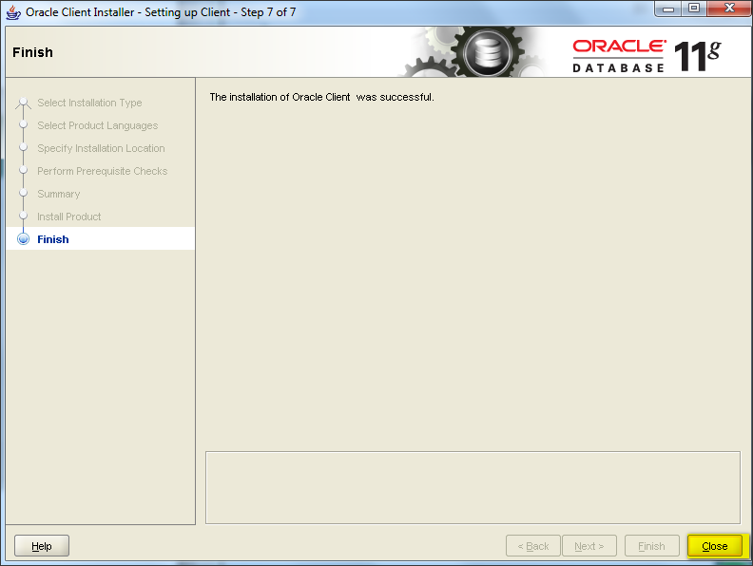

**[Part IV] Connect to the Oracle Academy Server using Oracle SQL Developer (database client)**

***[Note] this database client requires Internet connection to connect to the Oracle Database server***

1. Start the Oracle SQL Developer in the following path:

Go to ***Desktop -> sqldeveloper-***-x64 -> sqldeveloper -> sqldeveloper.exe***

*[Note: the exact version no. of sqldeveloper-***-x64 could be varied, simply choose the one you installed.]*

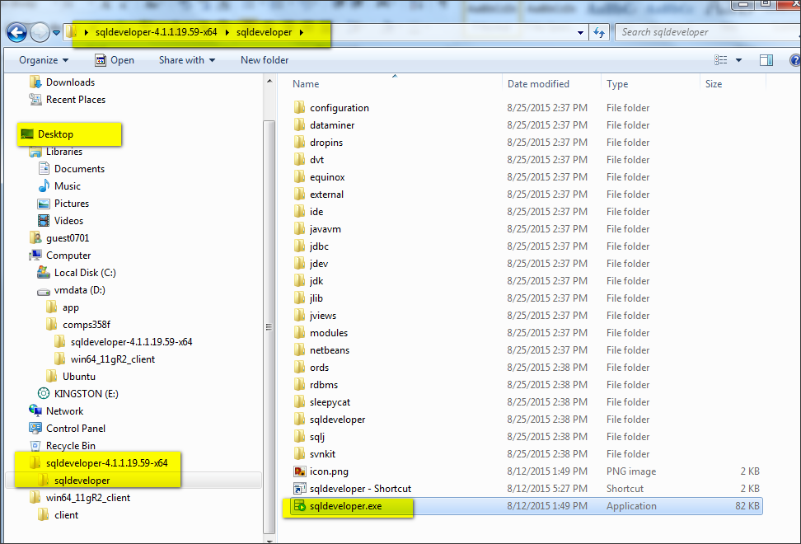

*(The following two pages may or may not appear, if it prompts up, follow this step mentioned here)*.

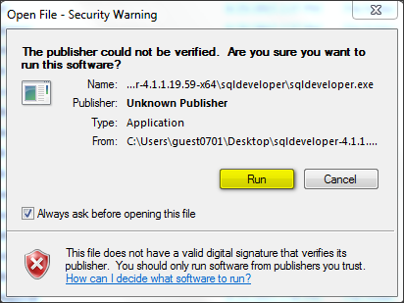

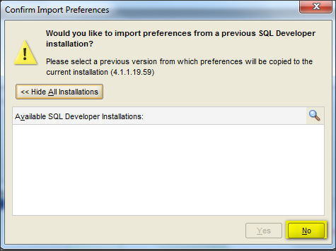

3. You should find the following screen:

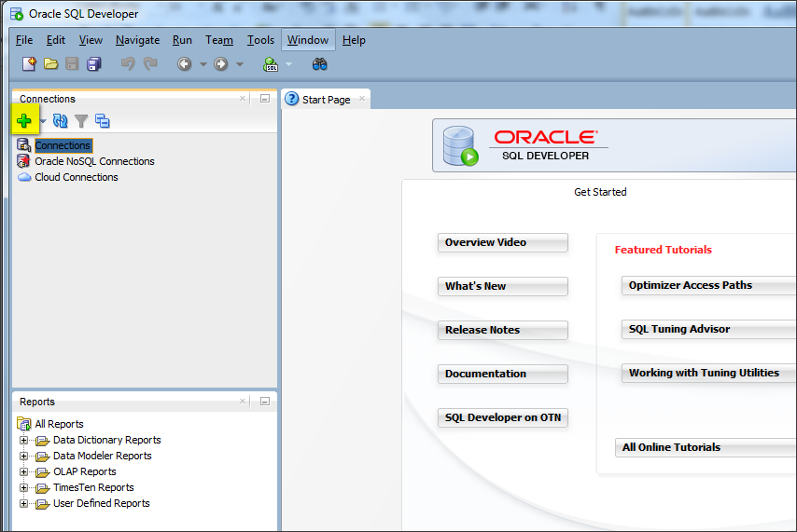

4. Click “+” symbol to add a new connection, after entering the data (*I’d suggest you simply copy and paste the configuration details instead of typing it, mistyping is usually the source of errors*), then try to click “**Test**” and the status should be “**success**”.

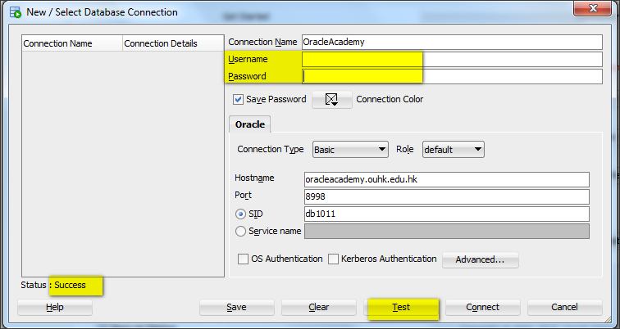

**Connection Name:** OracleAcademy

**Username:** i.e. s1234567 *(7-digit of your Student ID)*

**Password:** i.e. 12345678 *(8-digit of your Student ID)*

**Hostname:** oracleacademy.ouhk.edu.hk

**Port:** 8998

**SID:** db1011

**Pls note that your *account will be locked after six consecutive times of incorrect password input.***

After that click “**Connect**”:

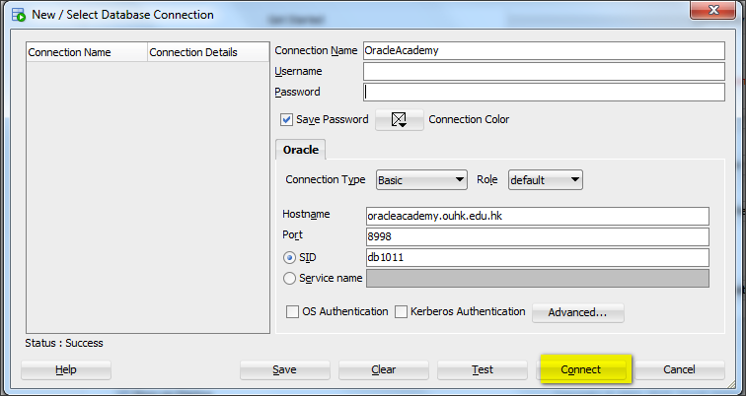

5. Now, expand the “Connection” and you should see the following:

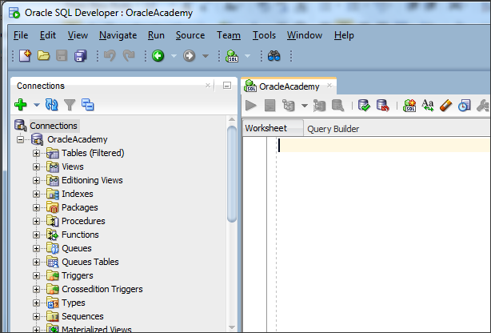

6. The following few steps will illustrate how to **create tables** and **view records** created:

Right click “Tables”, choose “New Table”, and then type in the following as:

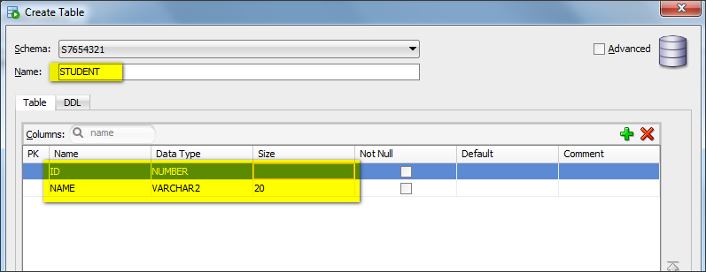

Double click table “ student” and the property tab will be shown in the right:

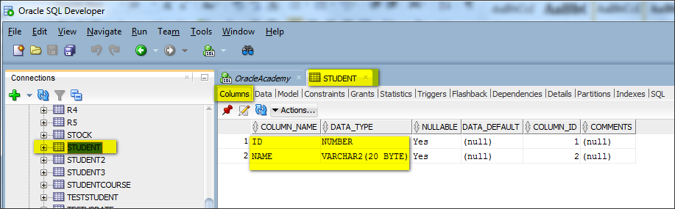

Type in the following under the tab “OracleAcademy”:

insert into student values (123, 'ben');

insert into student values (333, 'ben');

insert into student values (555, 'cat');

select * from student;

7. To run the queries, you may select each line or several lines, and then click the icon  for execution, or you can press **function key F5** to run as script. Examples as below:

To run a single SQL statement, highlight the statement, then press:

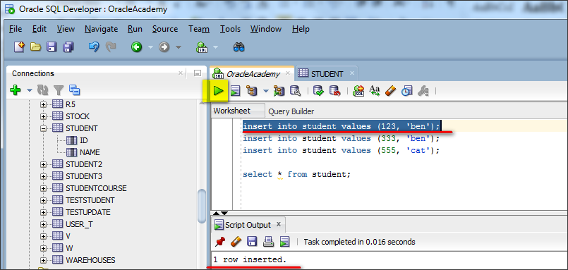

To run ***multiple*** SQL statement, highlight all the statements, then press:

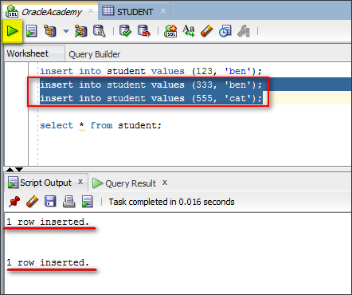

The following shows more SQL statements for practice (*don’t worry about the SQL syntax as we will discuss it few weeks later*):

select id from student;

select ID from student;

delete from student where ID = 333;

update student set name = 'man' where ID = 555;

8. Before closing the session, make sure you should ***save the changes*** to the database by clicking the icon  for commit action:

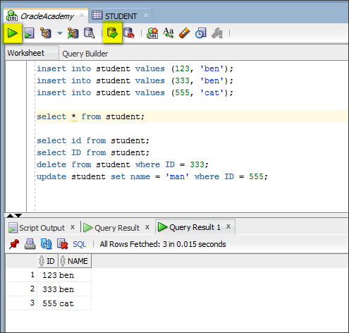

9. Press the ***refresh*** icon, after that, you can perform a quick view over the table properties, i.e. double click the table “student”:

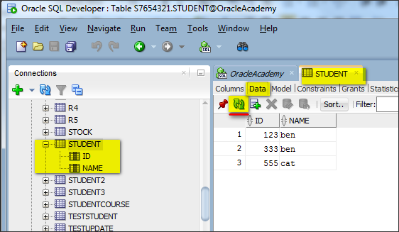

**[Part V] Appendix**

***Note: read this section ONLY if the installation of version 11g is failed!***

1. Download another version i.e. 19c:

<https://www.oracle.com/database/technologies/oracle-database-software-downloads.html>

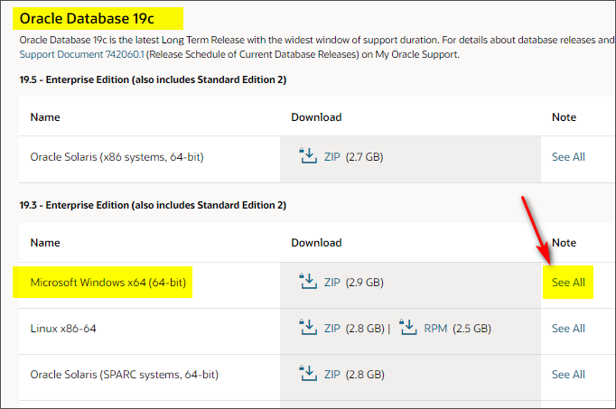

Download the ***client version*** only which is around 1GB in size:

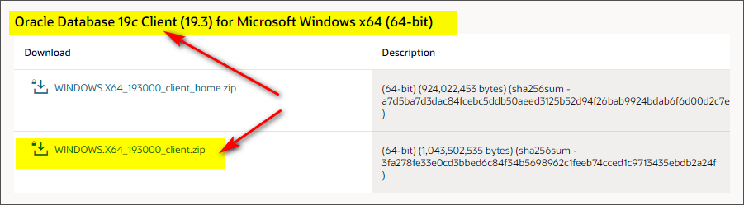

Please register in order to login to the Oracle official page to download the installer. Note, *this is NOT the student oracle account provided from OUHK in page 1, you need to create your own one here*.

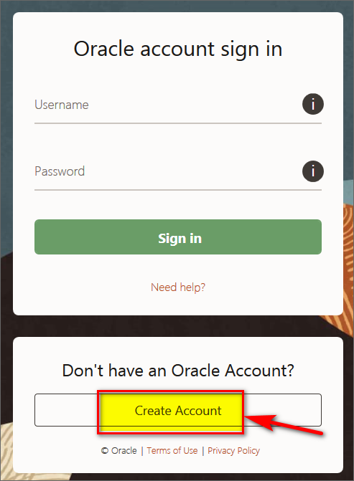

Enter your details:

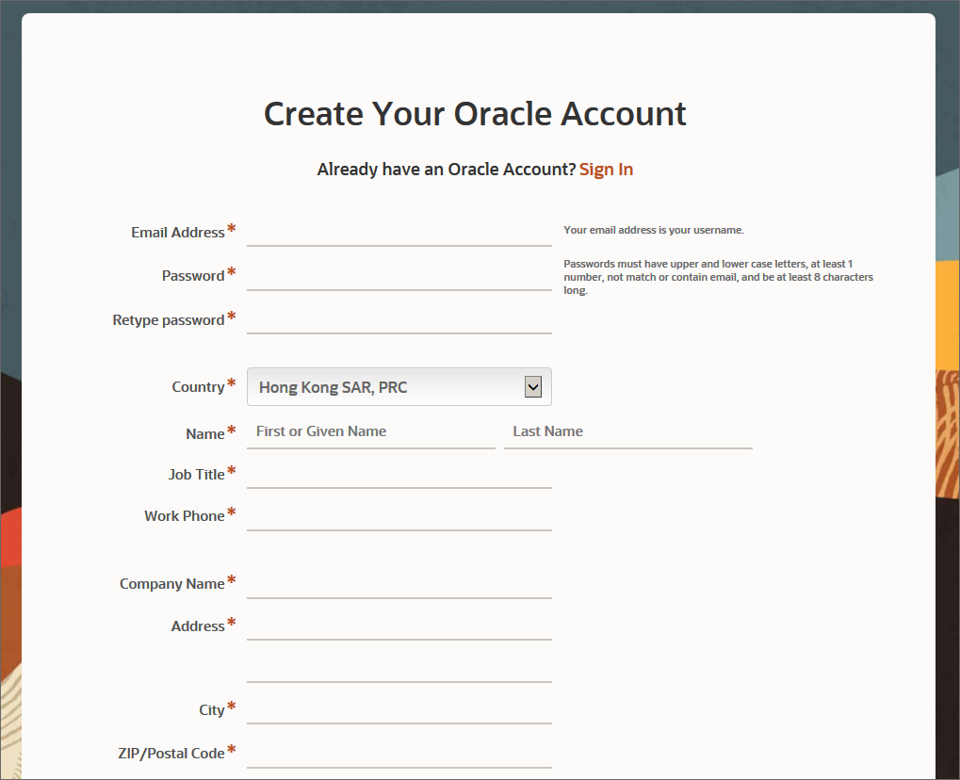

For some of you who are using ***Mac OS***, you may need to create a virtual partition of Win10 using Virtual Box (<https://www.virtualbox.org/> ) or VMWare (<https://www.vmware.com/products/fusion.html> ), etc.

After successful installation, you may open the database client from:

* + Go to ***Program -> Oracle-oraClient11g -> Application Development -> SQL Developer***
  + Then follow the same connection details as shown in **Page 1**