USB Speeds

the USB specification defines four speeds for a USB system: Low-Speed, Full-Speed, Hi-Speed, and SuperSpeed.

Newer hosts can always communicate with devices of lower speed. For example, a High-Speed Host can communicate with a Low-Speed device, but a Full-Speed Host cannot communicate with a High-Speed device.
Low-, Full-, and High-Speed devices are often advertised as 1.5 Mb/s, 12 Mb/s, and 480 Mb/s, respectively.
Low-Speed devices:
- Examples: keyboards, mice, and game peripherals
- Bus Rate: 1.5 Mb/s
- Maximum Effective Data Rate: 800 B/s
Full-Speed devices
- Examples: phones, audio devices, and compressed video
- Bus Rate: 12 Mb/s
- Maximum Effective Data Rate: 1.2 MB/s
Hi-speed devices
- Examples: video, imaging, and storage devices
- Bus Rate: 480 Mb/s
- Maximum Effective Data Rate: 53 MB/s
When a USB device is connected to a host, the speed of the device needs to be detected. This is done with pull-up resistors on the D+ or D- line.
=> A 1.5-kΩ pull-up on the D+ line indicates that the attached device is a Full-Speed device.
=> A 1.5-kΩ pull-up resistor on the D- line indicates the attached device is a Low-Speed device

Line States  Given that there are just 2 data lines to use, it is surprising just how many different conditions are signaled using them:  Detached  When no device is plugged in, the host will see both data lines low, as its 15 kohm resistors are pulling each data line low. | 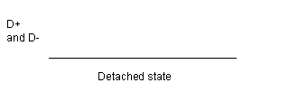
Attached  When the device is plugged in to the host, the host will see either D+ or D- go to a '1' level, and will know that a device has been plugged in.  The '1' level will be on D- for a low speed device, and D+ for a full (or high) speed device.  Idle  The state of the data lines when the pulled up line is high, and the other line is low, is called the idle state. This is the state of the lines before and after a packet is sent. | 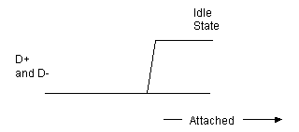

The pull-up resistor is essential to USB enumeration. Without the pull-up resistor, USB assumes that there is nothing attached to the bus. Some devices require an external pull-up resistor on the D+/D- line.
PSoC, however, implements the required pull-up resistor internal to the device, which eliminates the need for this external component.

All Hi-Speed devices are USB 2.0, but this is because Hi-Speed support was added with USB
2.0. The USB 2.0 specification includes Full- and Low-Speed devices as well.

These speeds also have an effect on the bit timing for USB signaling, such as the End of Packet (EOP) signal. A
Low-Speed and Full-Speed USB device will use a 48-MHz clock for the SIE and the other USB clocking purposes.
This 48-MHz clock and the bus speed is what will determine USB bit times:
Full-Speed: 48 MHz / 12 Mb/s = 4 clocks per bit time.
Low-Speed: 48 MHz / 1.5 Mb/s = 32 clocks per bit time.

USB Power

There are two device categories: bus powered and self powered.

Bus power is one of the many benefits of a USB design. It allows the device to sustain itself without the need for a bulky power supply either internally or externally because the device draws its power from the bus. The power available on the bus is either provided by the host or a hub.
Self-powered devices supply their own power with the use of an external power source such as a DC power adapter or a battery. A self-powered device needs a different set of considerations in a design.
The USB specification requires that self-powered devices monitor their V BUS line at all times. A device must remove power from its D+/D- pull-up resistor within a certain time frame of V BUS being removed.
The reason for this is to prevent back voltage upstream to the host or hub. Failing to meet this requirement can result in USB compliance testing failure. However, a self-powered hub does have the ability to draw up to 100 mA from the bus

USB Endpoints

In the USB specification, a device endpoint is a uniquely addressable portion of a USB device that is the source or sink of information in a communication flow between the host and device. The USB Enumeration and Configuration section describes a step in which the device responds to the default address. This occurs before other descriptor information such as the endpoint descriptors are read by the host later in the enumeration process.
During this enumeration sequence, a special set of endpoints are used for communication with the device. These special endpoints, collectively known as the Control Endpoint or Endpoint 0, are defined as Endpoint 0 IN and Endpoint 0 OUT. Even though Endpoint 0 IN and Endpoint 0 OUT are two endpoints, they look and act like one endpoint to the developer. Every USB device must support Endpoint 0. For this reason, Endpoint 0 does not require a separate descriptor.

The USB specification further defines four types of endpoints and sets the maximum packet size based on both the type and the supported device speed. Developers use the endpoint descriptor to identify the type of endpoint and maximum packet size based on their design requirements. The four types of endpoints and characteristics are:-
Control Endpoint – These endpoints support control transfers, which all devices must support. Control transfers send and receive device information across the bus. The advantage of control transfers is guaranteed accuracy.
Errors that occur are properly detected and the data is resent. Control transfers have a 10 percent reserved bandwidth on the bus in low and Full-Speed devices (20 percent at High-Speed) and give USB system level control.
Interrupt Endpoints – These endpoints support interrupt transfers. These transfers are used on devices that must use a high reliability method to communicate a small amount of data. This is commonly used in HID designs. The name of this transfer can be misleading. It is not truly an interrupt, but uses a polling rate. However, you get a guarantee that the host checks for data at a predictable interval. Interrupt transfers give guaranteed accuracy as errors are properly detected and transactions are retried at the next transaction.
Interrupt transfers have a guaranteed bandwidth of 90 percent on Low- and Full-Speed devices and 80 percent on High-Speed devices. This bandwidth is shared with isochronous endpoints.

Interrupt endpoint maximum packet size is a function of device speed.
High-Speed capable devices support a maximum packet size of 1024 byes.
Full-Speed capable devices support a maximum packet size of 64 bytes.
Low-Speed devices support a maximum packet size of 8 bytes.

Bulk Endpoints –These endpoints support bulk transfers, which are commonly used on devices that move relatively large amounts of data at highly variable times where the transfers can use any available bandwidth space. They are the most common transfer type for USB devices. Delivery time with a bulk transfer is variable because there is no set aside bandwidth for the transfer.
The delivery time varies depending on how much bandwidth on the bus is available, which makes the actual delivery time unpredictable. Bulk transfers give guaranteed accuracy because errors are properly detected and transactions are resent. Bulk transfers are useful in moving large amounts of data that are not time sensitive.
A bulk endpoint maximum packet size is a function of device speed.
High-Speed capable devices support a maximum BULK packet size of 512 bytes.
Full-Speed capable devices support a maximum packet size of 64-bytes.
Low-Speed devices do not support bulk transfer types.

Isochronous Endpoints – These endpoints support isochronous transfers, which are continuous, real-time transfers that have a pre-negotiated bandwidth. Isochronous transfers must support streams of error tolerant data because they do not have an error recovery mechanism or handshaking. Errors are detected through the CRC field, but not corrected.
With isochronous, you get the tradeoff of guaranteed delivery versus guaranteed accuracy. Streaming music or video are examples of an application that uses isochronous endpoints because the occasional missed data is ignored by the human ears and eyes.
Isochronous transfers have a guaranteed bandwidth of 90 percent on Low-and Full-Speed devices (80 percent on High-Speed devices) that is shared with interrupt endpoints.

High-Speed capable devices support a maximum packet size of 1024 bytes.
Full-Speed devices support a maximum packet size of 1023 bytes.
Low-Speed devices do not support isochronous transfer types.
There are special considerations with isochronous transfers. You generally want 3x buffering to ensure data is ready to go by having one actively transmitting buffer, another buffer loaded and ready to transfer, and a third buffer being actively loaded.

Communication Protocol:-

If you look at the USB communication from a time perspective, it contains a series of frames. Each frame consists of a Start of Frame (SOF) followed by one or more transactions. Each transaction is made up of a series of packets. A packet is preceded with a sync pattern and ends with an End of Packet (EOP) pattern.
At a minimum, a transaction has a token packet. Depending on the transaction, there may be one or more data packets and some transactions may or may not have a handshake packet.

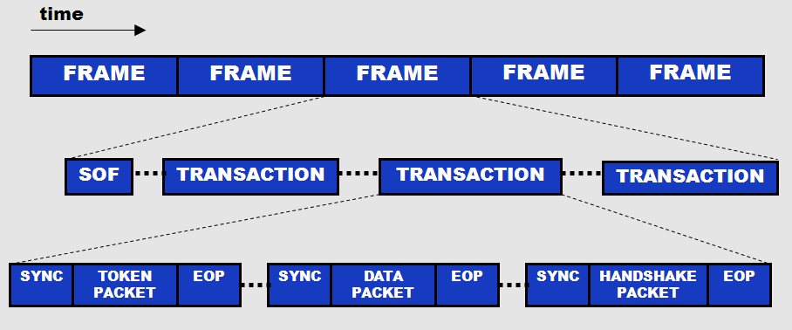

Packet ID (PID) – (8 bits: 4 type bits and 4 error check bits). These bits declare a transaction as an
IN/OUT/SETUP/SOF.
Optional Device Address – (7 bits: Max of 127 devices)
Optional Payload Data – (0 to 1023 bytes)
Optional Endpoint Address – (4 bits: Max of 16 endpoints). The USB specification supports up to 32 endpoints.
While 4 bits gives a maximum value of 16, we achieve 32 endpoints with an IN PID and an endpoint address between 1 and 16 and an OUT PID with an endpoint address between 1 and 16, giving a total of 32. Remember that this is the endpoint address, not the endpoint number.
Optional CRC (5 or 16 bits)

USB Descriptors

