Using the Watch function of PyScripter  
06/03/2014

The following script calculates the factorial of a given integer, which is the product of the integer and all positive integers below it:

|  |  |
| --- | --- |
| 1  2  3  4  5  6  7  8  9  10  11  12 | # This script calculates the factorial of a given  #  integer, which is the product of the integer and  #  all positive integers below it.    number = 5  multiplier = 1    while multiplier < number:      number *= multiplier      multiplier += 1    print number |

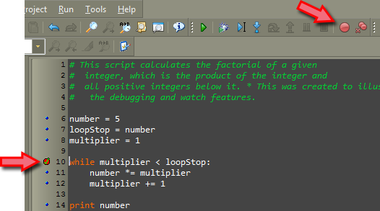To watch the variable, “multiplier” change while in the loop you need to let the debugger function know where to stop or pause. In this case stopping at the beginning of the loop would allow us to see each change before the loop runs again.

Either click the blue dot at the beginning of the line or place your cursor on the line and toggle the breakpoint button (F5).

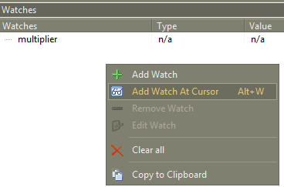

To set up a Watch on your variable, you must have the “Watches Window” open. View-> Debug Windows -> Watches. Place your cursor on the line with the variable (“multiplier”) and right click within the Watches Window, choose Add Watch at Cursor (Alt+W).

The final step is to step through the script and watch the variable change as it runs the loop. Select the debug button (F9) and your script should run once and stop at the break point or the beginning of the loop, just before it runs the loop again. You should see the value and type of your watch show its current state. Select the debug button again to resume (F9) and run another time (Notice the value change). In the case of this script, you should see the script complete after running (resuming) five times. 