Tutorial for XFoil

Download XFoil
--------------

Download XFoil from http://raphael.mit.edu/xfoil/ . It would be a good idea to download the documentation for future reference as well.

Installing XFoil
----------------

Copy the downloaded file to the directory where you want to install XFoil and run it.

Running Xfoil
-------------

XFoil is executed by going to the directory where it was installed and typing

% xfoil

Loading an Airfoil
------------------

The load or NACA command can used to load an airfoil into XFoil. In this tutorial we will be using a NACA 2412 airfoil. To load this airfoil type

XFOIL c> NACA 2412

Notice that XFoil will return some of the specifications for the airfoil, including the location and magnitude of the maximum thickness, maximum camber, and other parameters.

Cleaning the Airfoil Geometry
-----------------------------

It is a good idea to ensure that the airfoil loaded does not contain panels that create very sharp edges. The PANE command in XFoil smoothes out the airfoil geometry.

XFOIL c> pane

NOTE: The commands are not case sensitive

The OPER Sub-Level
------------------

Type

XFOIL c> OPER

This will produce the prompt

.OPERi c>

Type a “?" to see a list of available commands and a brief description of their use. This works on any level of XFoil.

In the OPER level this is what you will see after typing “?”

<cr> Return to Top Level
! Redo last ALFA,CLI,CL,ASEQ,CSEQ,VELS

Visc r Toggle Inviscid/Viscous mode
.VPAR Change BL parameter(s)
Re r Change Reynolds number
Mach r Change Mach number
Type i Change type of Mach,Re variation with CL
ITER Change viscous-solution iteration limit
INIT Toggle BL initialization flag

Alfa r Prescribe alpha
CLI r Prescribe inviscid CL
Cl r Prescribe CL
ASeq rrr Prescribe a sequence of alphas
CSeq rrr Prescribe a sequence of CLs

SEQP Toggle polar/Cp(x) sequence plot display
CINC Toggle minimum Cp inclusion in polar
HINC Toggle hinge moment inclusion in polar
Pacc i Toggle auto point accumulation to active polar
PGET f Read new polar from save file
PWRT i Write polar to save file
PSUM Show summary of stored polars
PLIS i List stored polar(s)
PDEL i Delete stored polar
PSOR i Sort stored polar
PPlo ii. Plot stored polar(s)
APlo ii. Plot stored airfoil(s) for each polar
ASET i Copy stored airfoil into current airfoil
PREM ir. Remove point(s) from stored polar
PPAX Change polar plot axis limits

RGET f Read new reference polar from file
RDEL i Delete stored reference polar

GRID Toggle Cp vs x grid overlay
CREF Toggle reference Cp data overlay
FREF Toggle reference CL,CD.. data display

CPx Plot Cp vs x
CPV Plot airfoil with pressure vectors (gee wiz)
.VPlo BL variable plots
.ANNO Annotate current plot
HARD Hardcopy current plot
SIZE r Change plot-object size
CPMI r Change minimum Cp axis annotation

BL i Plot boundary layer velocity profiles
BLC Plot boundary layer velocity profiles at cursor
BLWT r Change velocity profile scale weight

FMOM Calculate flap hinge moment and forces
FNEW rr Set new flap hinge point
VELS rr Calculate velocity components at a point
DUMP f Output Ue,Dstar,Theta,Cf vs s,x,y to file
CPWR f Output x vs Cp to file
CPMN Report minimum surface Cp
NAME s Specify new airfoil name
NINC Increment name version number

Notice that there are three columns, the first is the command, the second one gives an indication of other inputs the command needs. An " r " means that the command expects a real number, an " i " means that the command expects an integer, an " f " means that the command expects a filename, and an " s " that the command expects a string. If the input is not typed after the command XFoil will prompt the user.

XFoil Under Inviscid Mode
-------------------------
Notice the “i” next to “.OPER” on the prompt. This indicates that XFoil is in inviscid mode.

Type

.OPERi c> alfa 0

XFoil will find the flow around the airfoil for the given angle of attack, in this case, 0. Notice that a window pops up showing the pressure distribution, the section lift coefficient, the section moment coefficient, the angle of attack and the airfoil name.

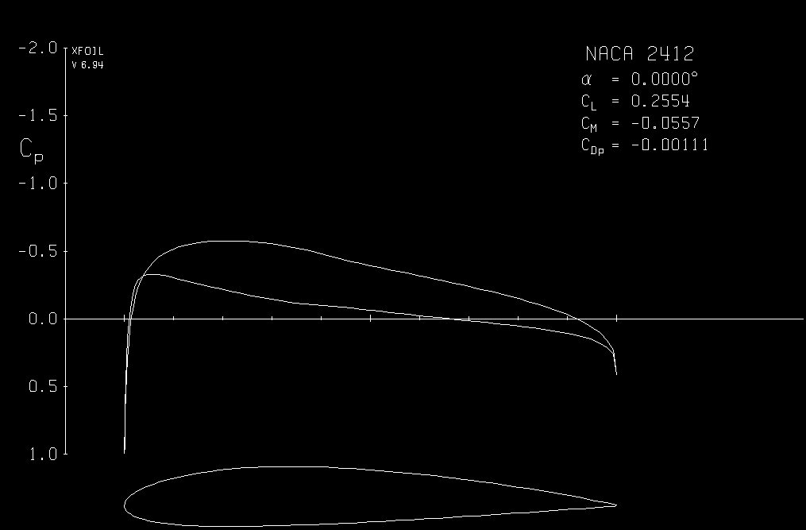
Figure 1. Cp Distribution at alpha = 0

Type

.OPERi c> cl 0.7

XFoil will find the angle of attack at which the current airfoil produces the section lift coefficient that has been input. Notice that XFoil once again plots the pressure distribution around the airfoil like it did previously.
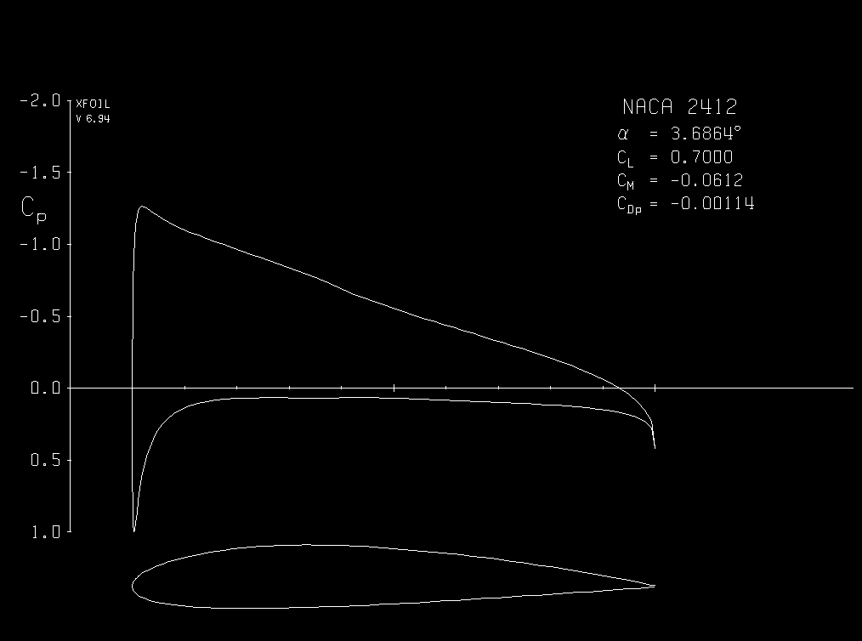
Figure 2. Pressure Distrubion at Cl = 0.6

Viscous Mode
------------

Type

.OPERi c> visc

This command will turn on the viscous mode. XFoil then prompts the user to input a Reynolds number. For this tutorial we will work with a low Reynolds number, type “3e6" at the prompt. Notice that a “v” will now appear next to “OPER” in the prompt to indicate viscous flow.

To find the flow around the airfoil at an angle of attack of zero degrees type

.OPERv c> alfa 0

Notice that now there seem to be two pressure distributions. The dashed lines represent the inviscid flow distribution. This provides an easy way to compare viscous and inviscid flow.

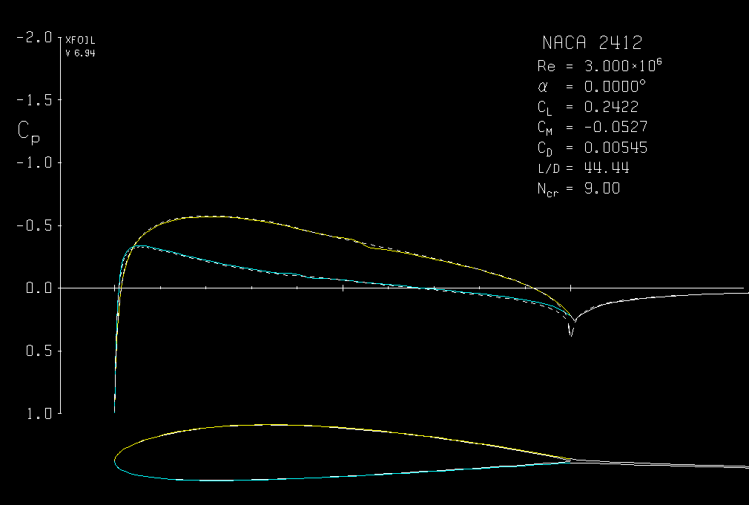
Figure 3. Viscous Flow Around an Airfoil

Notice also that the boundary layer is outlined around the airfoil. Furthermore, the coefficient of drag and the lift-to-drag ratio are also presented.

If you look at the command screen, the last iteration also provides more data about the airfoil:

Side 1 free transition at x/c = 0.5274 46
Side 2 free transition at x/c = 0.3940 38

6 rms: 0.1349E-04 max: 0.1462E-03 C at 38 2
a = 0.000 CL = 0.2422
Cm = -0.0527 CD = 0.00545 => CDf = 0.00466 CDp = 0.00079

It provides the point of transition to turbulent flow in the upper and lower surfaces. It also provides CDf and CDp, the friction drag and pressure drag respectively.

Getting a Hard Copy
-------------------

To get a copy in post script format of the displayed plot type

.OPERv c> hard

A copy will be produced on the XFoil directory under the filename plot.ps. You will not be able to open this file until you exit XFoil. However, any other files that you hardcopy will be appended to the file plot.ps.

Changing the number of iterations
---------------------------------

Type

.OPERv c> alfa 18

You will notice that XFoil does not converge. This is because it reached the maximum number of iterations. There are two different things that can be done. Type “!”, this command will tell XFoil to iterate some more. As you can see XFoil will not converge even after you do this once. You can keep typing “!” until XFoil converges or you can try changing the maximum number of iterations. Type

.OPERv c> iter

A prompt will ask you to enter the number of iterations, type “100”.

Then type

.OPERv c> alfa 18

You will notice that XFoil will converge after about 54 more iterations.

Changing the Cpmin
------------------

Notice that at an angle of attack of 18 degrees the minimum Cp is lower than -2, the default Cpmin. Type

.OPERv c> cpmn

This will display the minimum Cp distribution

Minimum Inviscid Cp =-17.2591 at x = 0.0004
Minimum Viscous Cp =-12.1387 at x = 0.0010

Type

.OPERv c> cpmi -18

To re-plot the Cp distribution type

.OPERv c> cpx

The Cp distribution should now look like this:

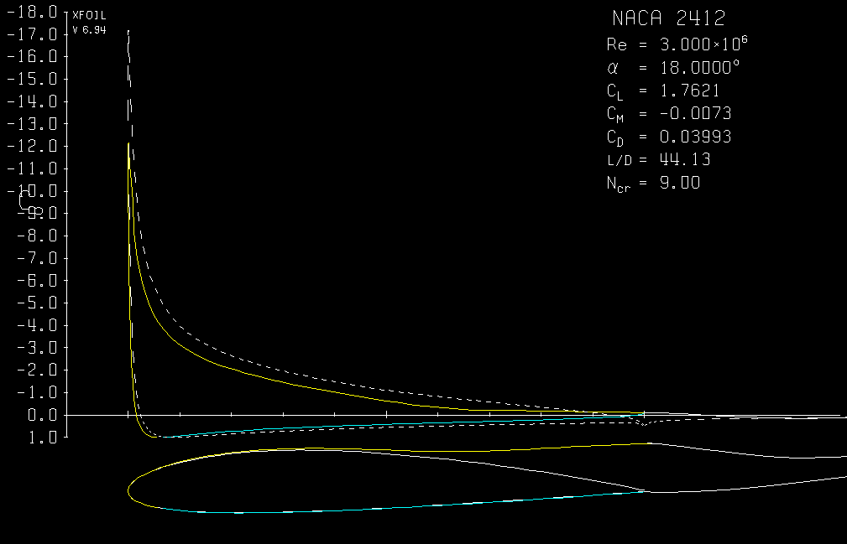
Figure 4. Flow Around an Airfoil at a High Alpha

Saving the Cp Distribution to a File
------------------------------------

Type

.OPERv c> cpwr

You will be prompted to enter a filename. Enter “naca2412@18.cp”. The file will be saved in text format and it is possible to use MATLAB to analyze the data.

Running XFoil for a Series of Angles of Attack
----------------------------------------------

Type

.OPERv c> alfa 0

Then

.OPERv c> pacc

This will create a file to which the section lift coefficient, the section drag coefficient, the upper and lower transition points and other data will be saved. This command also enables the auto point accumulation. You will be prompted to enter a filename for the newly created polar file. Type “naca2412.pol”. Press Enter when prompted for a polar dump filename.

Now type

.OPERva c> aseq 0 20 .5

This command will run XFoil for a series of angles of attack, from 0 to 20 degrees at 0.5 degree increments.

Type

.OPERva c> pacc

This will turn off the point accumulation.

The file “naca2412.pol” will be in a text format and can be read by MATLAB.

Changing the Point of Transition to Turbulent Flow
--------------------------------------------------

Type

.OPERv c> alfa 0

The last iteration will look like this:

Side 1 free transition at x/c = 0.5274 46
Side 2 free transition at x/c = 0.3940 38

3 rms: 0.8854E-04 max: 0.1737E-02 C at 38 2
a = 0.000 CL = 0.2422
Cm = -0.0527 CD = 0.00545 => CDf = 0.00466 CDp = 0.00079

Notice on the command window that the point of transition of the upper surface (Side 1) is at x/c = 0.5274. Let force transition at x/c = 0.1.

Type

.OPERv c> vpar

This command will move you into the VPAR sub-level

Type

..VPAR c> xtr 0.1 1

This command will force transition at x/c = 0.1 for the upper surface and x/c = 1 at the top surface (which is the same as free transition).

Press enter to move down to the OPER sub-level.

Type

.OPERv c> alfa 0

The last iteration will now look like this:

Side 1 forced transition at x/c = 0.1000 22
Side 2 free transition at x/c = 0.3824 37

3 rms: 0.6169E-05 max: 0.1369E-03 C at 37 2
a = 0.000 CL = 0.2238
Cm = -0.0499 CD = 0.00763 => CDf = 0.00630 CDp = 0.00133

Notice that transition now occurs at x/c = 0.1 like expected. You can also see the difference in the section drag coefficients.

Quitting XFoil
--------------

Press enter until you return to the top level, then type

XFOIL c> quit

