

Foundation Degree in Computing

Unit Title: Games Development

Semester No: 2

Assessment Number: 1

Assessment Type: Written Report

Due Date:

Marks Available 30

Marks Awarded _______________

This assignment counts toward 30% of the overall unit grade.

Contents

Game Genres 3

Action 3

Action-Adventure 3

Stealth 3

Survival Horror 4

Role-Playing game (RPG) 4

Strategy (RTS) 5

Turn-based Strategy 6

Massively Multiplayer Online (MMO) 6

Current Platforms and Trends 7

Introduction to my Game Concept, Theme and World Setting 8

Platform and Orientation 8

Graphic Design 8

Sound 9

Player Character 9

Non-Player Characters 9

Gameplay Problem Solving 9

Gameplay Difficulty 10

Gameplay Progression 10

Marketplace Competitors 10

Unique Selling Point 10

Storyboards and Design 11

Flowchart 12

References 13

Image Sources 13

# Game Genres

Video Game Genres are used to organise games based on their style of play / gameplay instead of their visual differences. However, it is becoming harder to differentiate some of the subgenres because many modern games have elements of multiple genres. Therefore, the following genres that I talk about may seem to appear a lot different from other sources, but are overall still correct.

## Action

Action would be considered one of the broadest genres as there are so many hybrids and subgenres. These types of games generally focus on challenging the player through hand-eye coordination and reaction. When one thinks of an action game, they would think of being able to do a lot of running and jumping. This links back to the class arcade style of games such as Street Fighter or even older games such as Pac-Man. Today’s Action games are becoming a lot more complex due to new technology, however the same core mechanics exist such as running jumping and attacking. A hybrid of ‘Action’ would be ‘Action-adventure’.

### Action-Adventure

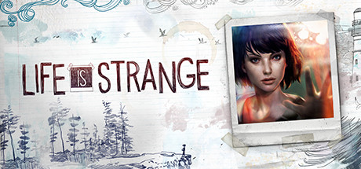Action-Adventure is the broadest of all game genres. As near all modern games can fall under this category. Examples would be, Call of Duty. This is seen as a First Person Shooter Action game, however there is more to the game than that, as there is a story to it and there is character progression (not quite as in-Depth as other games). Other Games such as DONTNOD Entertainments’ ‘Life Is Strange’ would be described as Action-Adventure as it is unclear as to what other Genre it would fit under. This game is the complete opposite of Call of Duty, instead it is story rich and relies on making choices and there is no Jumping or Attacking in this game either.

*Fig 1.1*

### Stealth

A Stealth game is a type of videogame that requires the player to use different stealth methods in order to avoid detection or alerting enemy NPCs throughout the game world. Some of the early games that introduced the stealth concept would be, Castle Wolfenstein and Metal Gear. Instead of the old methods of sneaking around crates and hiding up trees, you now have a lot more abilities and gadgets that turn this style of game a lot more Action focused. A lot of stealth games can have a naturally dark environment in order for the experience to feel immersive and suited towards the theme of sneaking, assassinating and thievery.

## Survival Horror

Survival Horror is one of the only genres defined not by their style of play and mechanics, but by the theme, atmosphere and subject. The main goal of this genre is to scare the player. Generally, if the player does not get scared, ranging from jump scares to feeling under constant threat, the gameplay may be considered as poor design. Survival Horror games always try to share similar components such as limited inventory or scarce resources. Suspense caused by an uneasy environment. A story (mostly dark) using journals or notes. The emphasis on feeling helpless (flee instead of fight) and Horror elements ranging from Demons to undead.

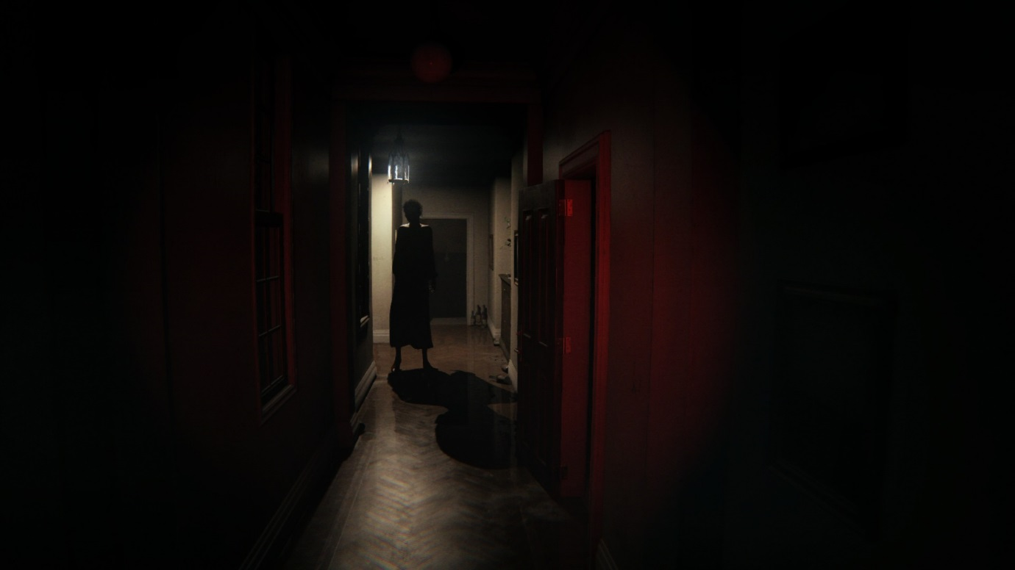Some of the most popular survival games, such as the ‘F.E.A.R’ series require the player to fight back against the antagonist using future tech and magic, however other games, such as ‘P.T (interactive ‘playable teaser’ for Silent Hills) require the player to work out puzzles whilst running and avoiding the antagonist.

*fig 1.2*

## Role-Playing game (RPG)

A Roleplaying game is a game were players are immerged into a world whilst adopting the role of a character. Roleplaying games have been around for a very long time, however the first instance of a modern roleplaying game was released in 1974 as a table-top game, ‘Dungeons and Dragons’. Roleplaying is a ‘*chance to be someone you’re not’* as stated by Epidiah Ravachol from Dig a Thousand Holes Publishing. Exploration is considered to be the core feature of many old and modern RPGs, as it is up to the player to discover as much of the new game world as possible. Combat in RPGs can vary from ‘Over-the-shoulder shooter’ (Third person shooter) to mouse clicking and keyboard mashing games such as the Diablo series. Character progression is always going to be an important part of the main story off an RPG, however, not all RPGs have this as a focus. A classic element of Roleplaying games is the ‘Choices with consequences’ mentality. Giving the player choices, ranging from game changing decisions to small skill or talent abilities allow the player to believe they are changing how the overall outcome will be.

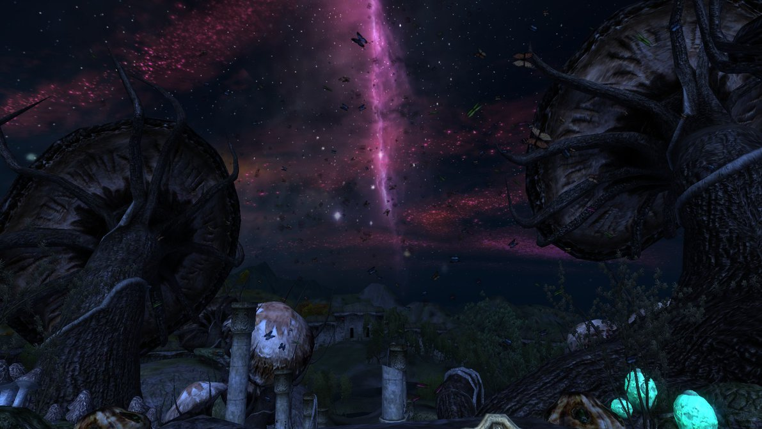

*Fig 1.3*

Games Such as ‘Elder Scrolls IV: Oblivion’ do a really good job of inheriting the majority of RPG elements and because of their unique fantasy setting and character progression they have created a game that will be a fan favourite for many years to come.

## Strategy (RTS)

The definition of an RTS or Real-Time strategy game is quite simple, as it is a strategy game that must take place in real time. These types of games add pressure. They are designed to take the control of pace out of the players hands, leaving the player having to make precise and fast decisions. RTS games need to have some sort of in game economy in order to control what the player can access. Without this, the player could have entire armies of units to control that could possibly complete the scenario or match within seconds. The economy’s’ form of currency could range from Fuel to gold depending on the game theme. The next requirement for an RTS is that they must be competitive in some way. These types of games are meant to be challenging, and players should be in direction competition with each other. Due to the fast pacing, the player would need to multitask, this can be managing their currency, deploying new units, ordering development of a new structure, or even scouting the enemy. A good example of a modern RTS game would be, ‘Tom Clancy’s EndWar’. This game has all the major elements, from a good economy, fast pace and challenging gameplay.

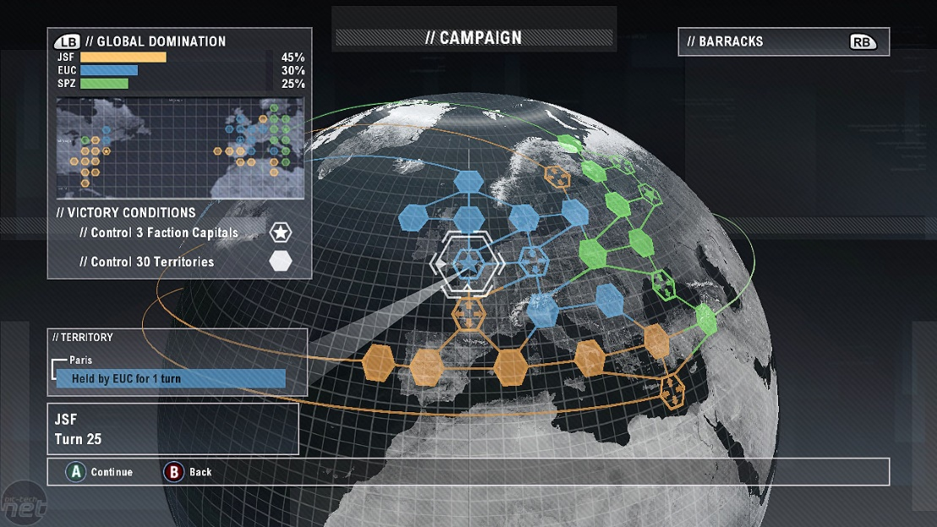

*Fig 1.4*

### Turn-based Strategy

Turn-based Strategy or TBS games are one of the oldest types of game. TSB games were popular in the form of tabletop games such as Warhammer, however board games such as chess and the popular Asian tabletop game ‘Go’ really show just how old this style of game is. In modern games, the player takes control over a unit / range of units and take turn-based steps in order to overthrow their opponents. In-heart it is very similar to RTS games, having to wait and plan out your next move would be the major difference. An example of an TBS game would be the ‘Shogun’ series were the user takes control of armies in attempt to exhaust the opponents’ numbers or morale to order to win.

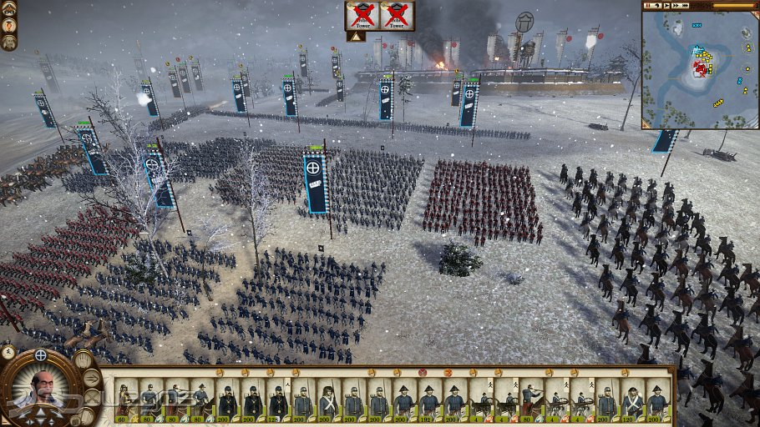

*Fig 1.5*

## Massively Multiplayer Online (MMO)

Massively multiplayer Online games are different from all other games in that they are normally played by hundreds / thousands of people at the one time in a ‘continually living game world’ (As described by geeksquad.co.uk). In order to hold these worlds, the games normally break them up into European and American servers or even ‘realms’ as used by the worldwide game ‘World of Warcraft. These realms can contain over 100,000 characters and come in a variety of languages to allow people from all across the world to play in their native tongue.

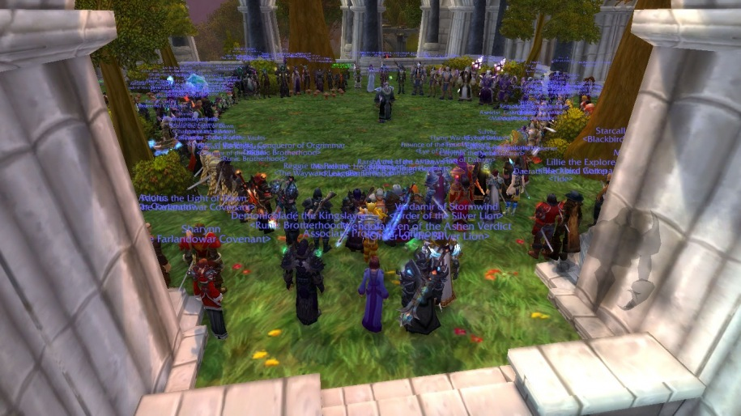MMO games are generally not aimed at single player as they try their best to promote players to join groups and experience the game in a social environment. The game world is constantly live and active, with its own economy (Depending on server) time and player bas, meaning that even when you quit the game it will still be online allowing others to play. MMOs can be anything from a first person shooter, such as Planetside 2, to arcade still fighting in DC Universe Online. The main gameplay elements include, questing, character progression / levelling, gearing, raiding or conquering bases or enemy objectives.

# Current Platforms and Trends

Over the years, there has been a huge amount of gaming consoles created by companies throughout the world. We are currently in the eighth generation of video game consoles. From 2012 to present, we have experienced a massive jump in the gaming scene. On November 2012, the Wii U was realised continued by the PlayStation 4 and Xbox One in November 2013. Gaming PCs have always been ahead of their time in terms of ultra-high definition and processing capability however a great majority of young gamers still prefer the dedicated gaming consoles (however these new generation consoles are starting to open different paths to new media such as streaming movies and listening to music online).

One of the major reasons why many young individuals enjoy playing game consoles compared to PCs is that ‘Computer gamers are in for the long haul’ according to Digital Trends. Xbox and PlayStation users would not be interested in coming back from school or work to spend hours on a simulator, they would rather turn on a game that can be loaded quickly, play quickly and have a good social interaction. On the other hand, you would generally not hear many PC gamers talk about getting the new FIFA.

# Introduction to my Game Concept, Theme and World Setting

The game which I am going to create is called ‘Ashbringer’. It will be created as a 2.5D game and will allow the user to play as a Righteous Paladin named Darion, who has to quest through a world of undead and plague to unlock the hidden power of his mighty blade. With the increasing power of the blade, more powerful foes will arrive to prevent the player from reaching his final goal, which is to slay Alexandros Mograine, the Skeleton King and rid the land of Karak from his evil undead plague. The Kingdom of Karak has turned dark and scarred, the undead plague has caused many of the locales to mutate, leaving only death and destruction in the path of the Righteous Paladin. As his legendary weapon, ‘Ashbringer’ begins to upgrade, the Righteous Paladin begins to bask in holy light in attempt to purge the land of evil.

The Horde of Undead are unstoppable and cannot be merely killed by any adventurer or warrior. This means that until the player gains full power and control over the Ashbringer he won’t be able to ‘remove’ the Non-Player characters from the game entirely, in fact, the undead will emerge back from the dead to take vengeance on the player unless he has entered hallowed ground (to progress to the next stage). The game ends after the Righteous Paladin fights and fails to totally defeat Alexandros Mograine the Skeleton King. Instead his legendary Ashbringer becomes Corrupted, resulting in him to become the successor of the Skeleton King, and finding out who he truly is.

# Platform and Orientation

Upon completion of the game, it will only be available for PC. If there turns out to be interest in this game, it will be converted and will be upgraded to the Windows Store, where the consumer can then download it onto their PC as well as Tablet or Mobile device. This game will only be available in Landscape on tablets and mobile devices (if released) and will be best played / viewed on wide screen monitors. It will not require a GPU and will only need a basic 2GB RAM on your PC. If released, it will originally only be available to Windows Phones and Tablets.

# Graphic Design

The game will be a 2.5D game with multiple background layers to add depth. It will be a very dark game, especially at the beginning, the only colours used will be black, grey (variations) and white. However, as the game progresses there will be more colour such as vibrant gold and green. Each checkpoint within the game will great the player with a golden glow (when the player steps onto hallowed ground the ground will glow with holy light, representing a new checkpoint). The art style is influenced from other games such as ‘Limbo’ and will go extremely well with the undead and plague theme.

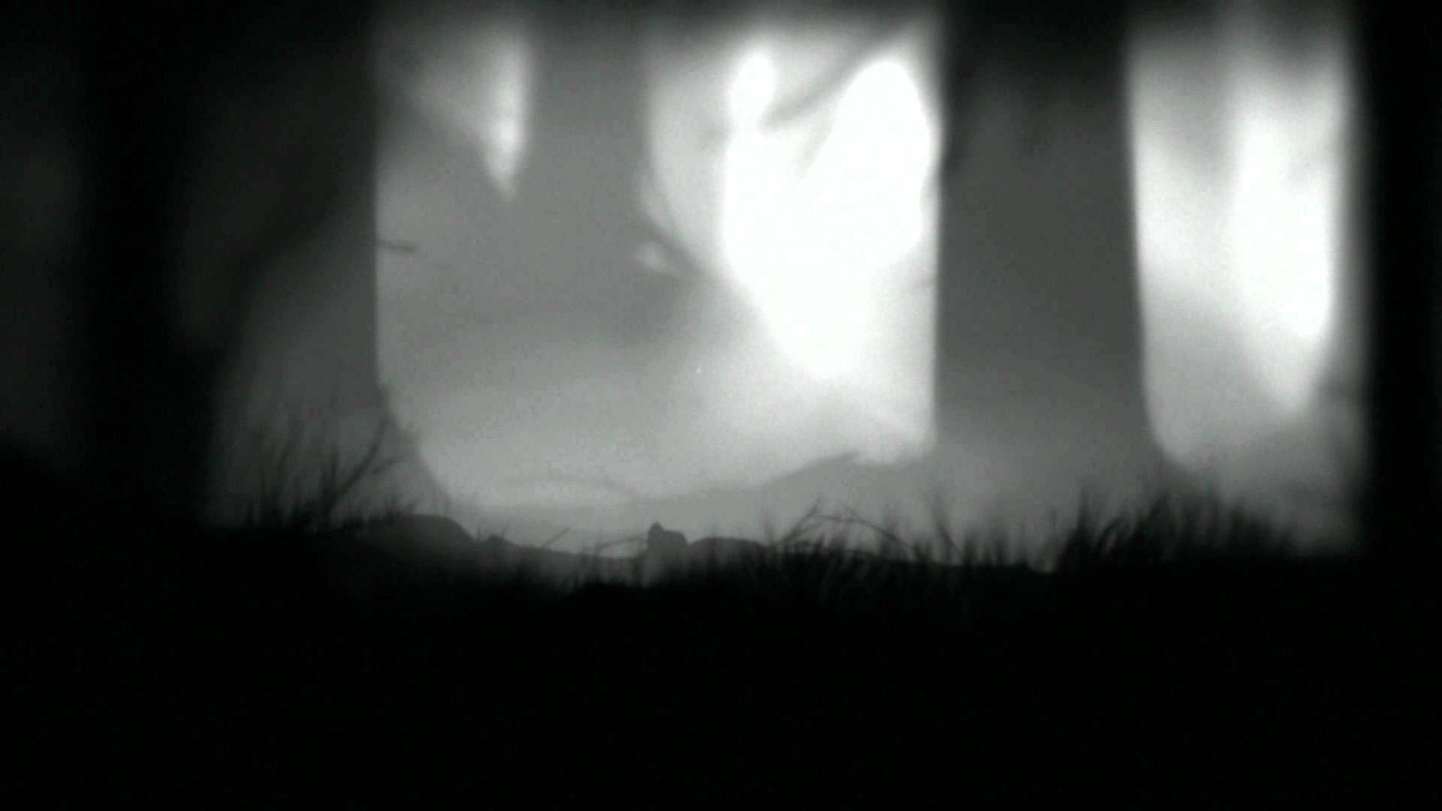

# Sound

The in-Game sound will consist of minimal music (Sad, dark yet elegant, as the land of Karak was once filled with life and was the main homeland of the Highborne, shrouded in arcane power and mystery). There will be a lot of atmospheric sounds, ranging from the wind, to the sound of the trees and leaves and even fire. The player will have minimal sound effects; he will only produce these sounds upon taking damage or dying. The players weapon, the Ashbringer, will have sounds which will generate upon doing damage to the enemy and when upgrading. The NPCs will be a bit noisier than the player and will drone and grunt whilst swinging their weapon and also when they are defeated. The Antagonist, Alexandros Mograine, will be voiced in the final encounter as well as the player. Examples of the in-game music can be found [Here](https://www.youtube.com/watch?v=X0UTcGvIbzU) and the elegant music can be found [Here](https://www.youtube.com/watch?v=sSBBxm3yTr0).

# Player Character

The player character has a limited movement speed and is not able to run or sprint, as he needs to conserve his energy for the battles ahead of him. He will only have one weapon throughout the game, the Ashbringer, and will be able to use more of its power as the game progresses. He will have two main damage abilities, the slash / strike with his blade and the ability to produce a small cone of light in the direction where he is facing that can stun or sometimes defeat NPCs. That special light ability will take up fatigue as well as jumping. It is up to the player to manage the Paladins health and fatigue wisely, as they are vital resources. The Player can also make use of the Paladin Healing ability; the only problem the Player has to look out for when using this ability is that it will heal the Player but will drain fatigue which may prevent the user from doing big damage to the NPCs. There is only one Player character, there is no choice to play as anyone else.

# Non-Player Characters

The non-player characters will have the same movement speed as the character (however they can go across swamped ground quicker. Their weapons vary from swords to axes to their fists. The bigger the weapon the more damage the player can receive. The basic mobs do not have any special abilities however the end boss, Mograine has an ability called ‘Blood Boil’ that the player has to dodge / avoid otherwise they will take a lot of damage. The basic mobs will not have many visual differences, except for the two races (undead Humans and undead Highborne).

# Gameplay Problem Solving

The Player will be tasked with having to survive against the undead plague, meaning that the player has to make sure that the Paladins health and fatigue remain fairly high throughout the game, as they will only be recovered upon stepping on hallowed ground. The Player will need to interact with objects that are located around the world in order to progress onto the next stage, these objects will range from tomes to ancient runes.

# Gameplay Difficulty

The difficulty level will scale with the increasing power of the Ashbringer. The NPCs will do the same attacking abilities, however there will be more NPCs clustered together. Aside from the basic Mobs, the end boss is impossible to kill. It is made to seem like the Player can kill him, however he has been cursed by more powerful being, resulting in the player to fail and be resurrected, resulting in the Ashbringer to become the ‘Corrupted Ashbringer’.

# Gameplay Progression

There is no ability to save the game and there are no levels to choose from. There will be points in the game where the Player steps onto hallowed ground, this will activate an Auto-Save and if the game is closed and re-opened, the Player will have the option to continue from where he left off. The games’ ending has been left open to allow for a second game to be developed as an extension.

# Marketplace Competitors

This game will not have many similar games in terms of objective, however there are some games currently in the market that have similar play styles such as Limbo. However, most platformers have similar elements to them.

# Unique Selling Point

This game has a great world and great characters, filled with lore and background stories. It has a beautiful soundtrack and atmosphere which you could sit and listen to for hours. There are no others games like this in terms of story and ending and would be a great experience for lovers of fantasy and platform games.

# Storyboards and Design

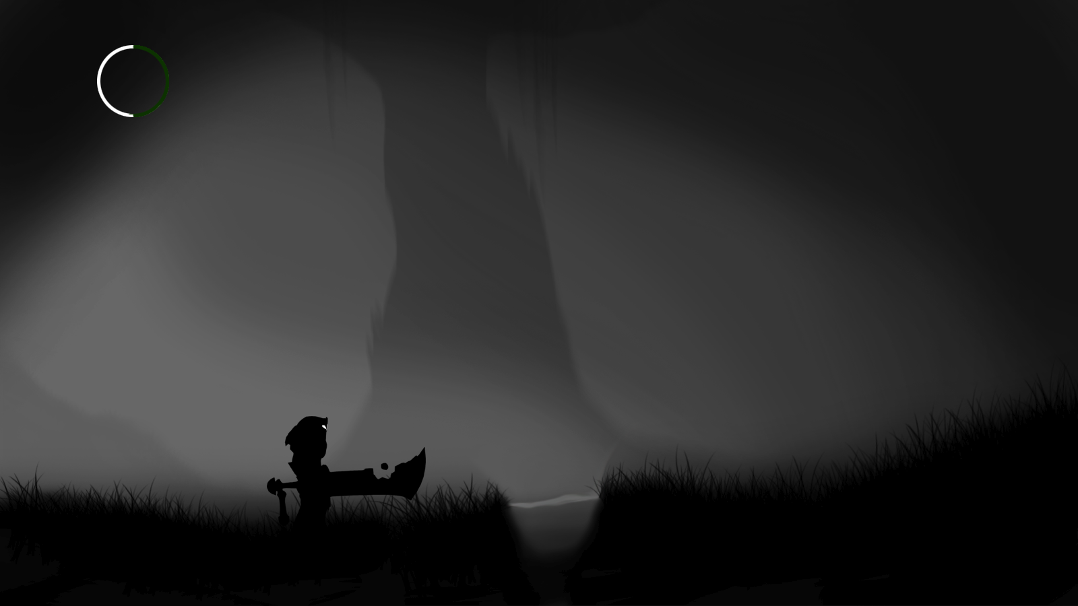

Player with a non-upgraded Ashbringer

Basic NPCS (Undead Humans)

Health bar = White  
Fatigue bar = Green

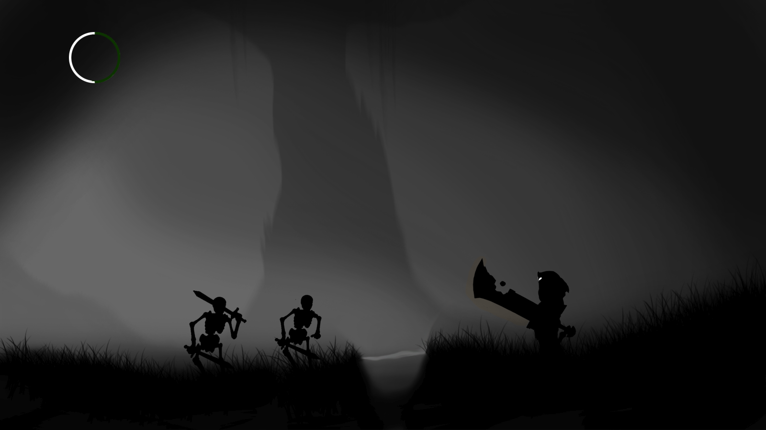

## Flowchart



# References

DigitalTrends. (n.d.). *The Line between Console and PC gamers*. Retrieved from digitaltrends.com: http://www.digitaltrends.com/computing/e3-2015-draws-the-line-between-console-and-pc-gamers/

GeekSquad. (n.d.). *What is an MMO*. Retrieved from geeksquad.co.uk: http://www.geeksquad.co.uk/articles/what-is-an-mmo

Lenhart, A., Jones, S., & Macgill, A. (2008, December). *Adults and Video Games*. Retrieved from pewinternet.org: http://www.pewinternet.org/2008/12/07/adults-and-video-games/

Ravachol, E. (n.d.). *What is a Roleplaying game*. Retrieved from dig1000holes.wordpress.com: https://dig1000holes.wordpress.com/what-is-a-roleplaying-game/

TvTropes. (n.d.). *Turn-Based Strategy*. Retrieved from tvtropes.org: http://tvtropes.org/pmwiki/pmwiki.php/Main/TurnBasedStrategy

Wayward. (2015, September 25). *What is a Real-Time Strategy Game?* Retrieved from waywardstrategist.com: http://waywardstrategist.com/2015/09/25/what-is-an-rts-game/

## Image Sources

Fig 1.1: <http://cdn.akamai.steamstatic.com/steam/apps/319630/header.jpg?t=1457032540>

Fig 1.2: <http://vignette2.wikia.nocookie.net/silent/images/2/20/P_T_Red_Lisa_01.jpg/revision/latest?cb=20140817213724>

Fig 1.3: <http://pre00.deviantart.net/8e3e/th/pre/f/2013/209/7/5/2013_07_22_00003_by_luckylukex3-d6flqzi.jpg>

Fig 1.4: <http://images.bit-tech.net/content_images/2008/06/tom-clancy-s-endwar-voice-on-preview/b3.jpg>

Fig 1.5: <http://i11a.3djuegos.com/juegos/8254/shogun_2_total_war__la_caida_de_los_samurai/fotos/set/shogun_2_total_war__la_caida_de_los_samurai-1963181.jpg>