Colin Morgan

Assignment 1

1-1

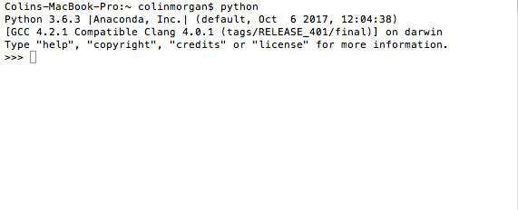

1-2

I already have TextWrangler from INFX501.

1-3

Downloaded Git (although I did have to update my OS, and it took hours and I may have already gotten, but forgotten), and my Githb is cmorga13.

1-4

Below is an example of experiments with command line, showing some history from 501 too:

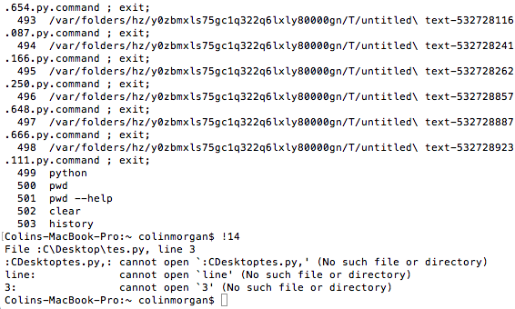

task 5 and 6, some errors, but I remembered this from last year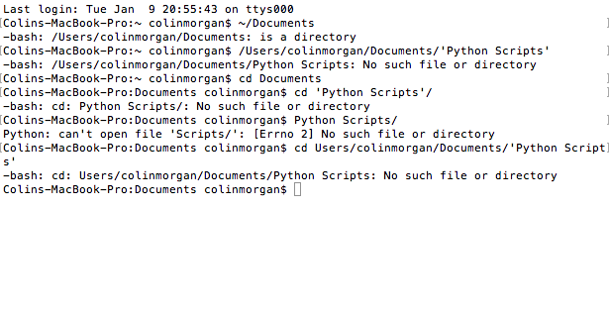

task 8

