Colin Morgan

Chapters 2 and 4 Exercises

2.1.

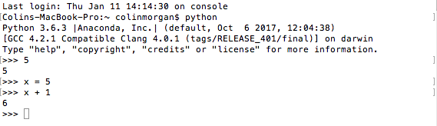

2.2.

2.3.

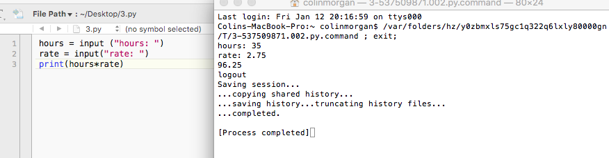

2.4.

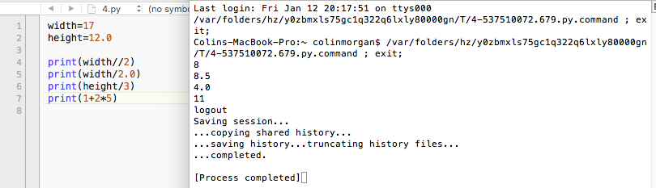

print(width//2) is an Integer.

print(width/2.0) is a Float.

print(height/3) is a Float.

print(1+2\*5) is an Integer.

2.5.

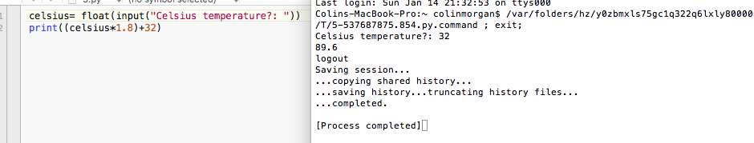

4.1.

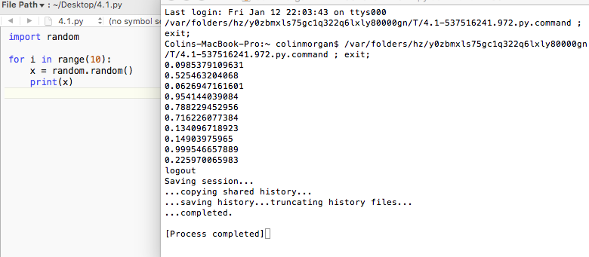

4.2.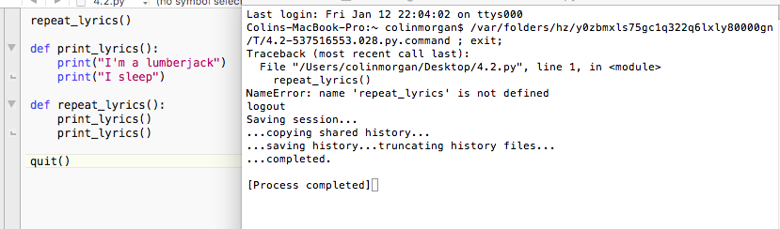

4.3.

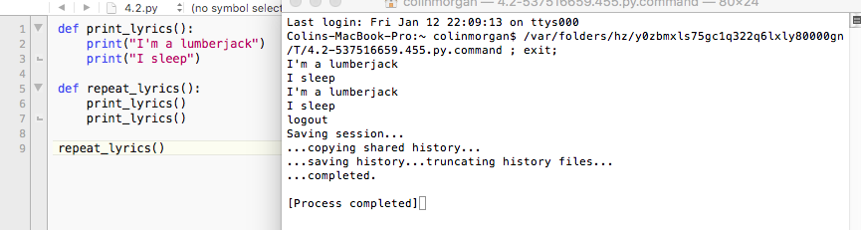

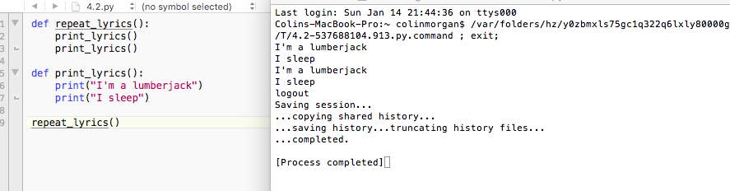

4.4.

D: def both indicates the start of a new function and that the following indented section of code is to be stored for latter.

4.5.

D: ABC Zap ABC

4.6. 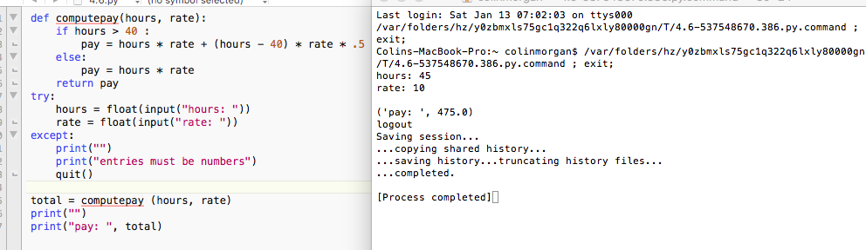

4.7.

