Colin Morgan

Chapters 3, 4, and 5

3.1

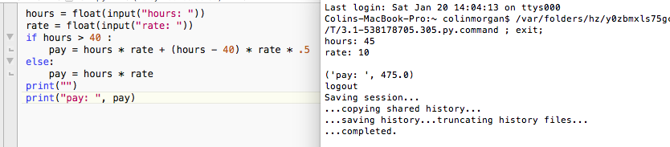

3.2

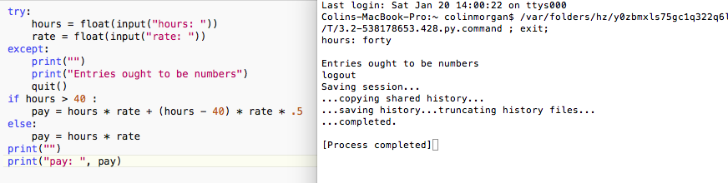

3.3

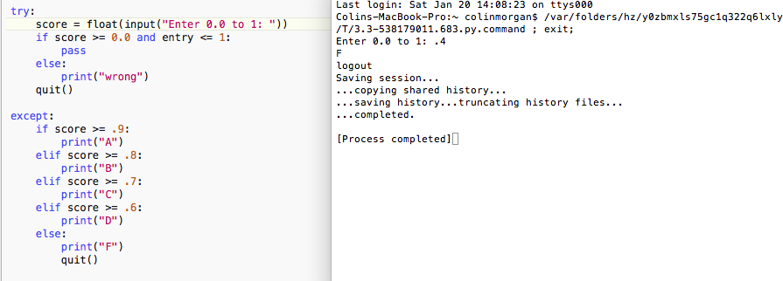

4.6. 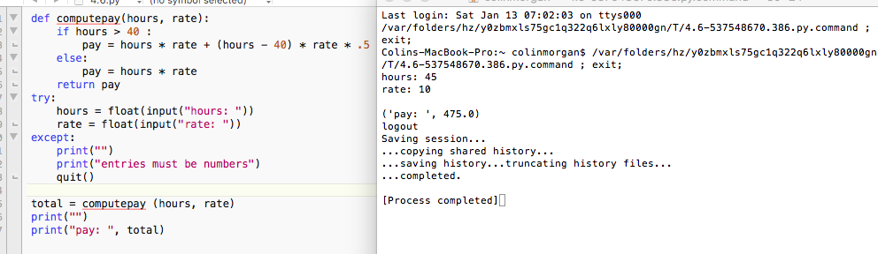

4.7.

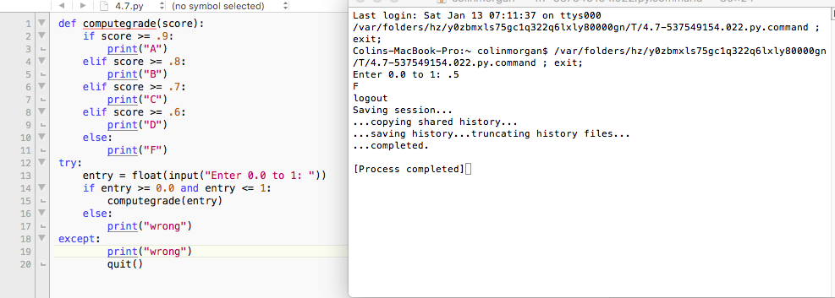

5.1

This one I’m not getting. How do I define “done”?

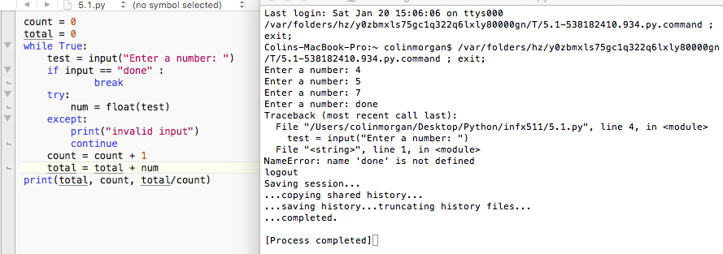

5.2

This one also I am suffering from the same problem.

