Colin Morgan

Exercises 6 and 7

6.1

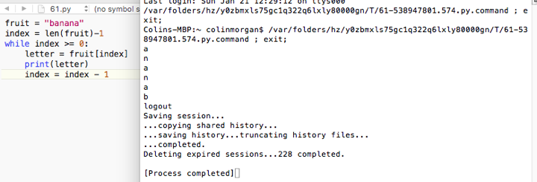

6.2

Slicing string without numbers on either side of colon just prints the string: fruit.

6.3

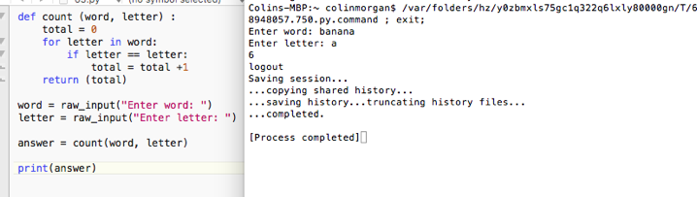

6.4

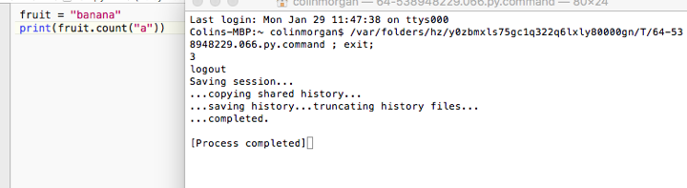

6.5

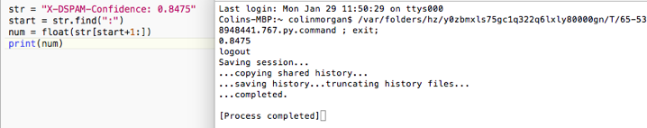

7.1

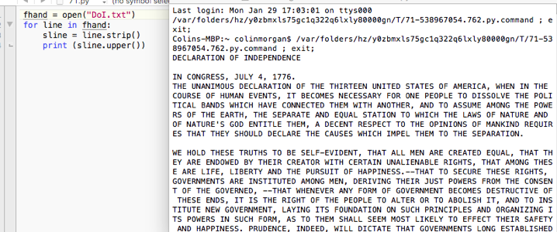

7.2

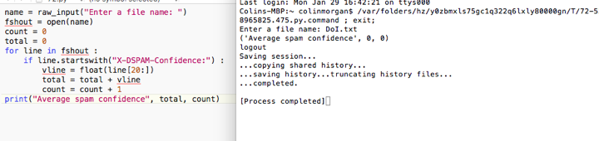

7.3

