How to contribute in
leJOS NXT tutorial

Versión 0.1
leJOS team
7-Nov-26

Index
Introduction 4
leJOS project 4
leJOS technologies 4
Java leJOS NXJ 5
How to contribute with leJOS tutorial? 7
The leJOS NXJ Tutorial 7
Tutorial’s Information Architecture 7
Auxiliary folders. 7
Tutorial Organization 8
The protocol 9
Web tools 9
Web IDE (Required) 9
CSS Editor (Optional) 9
Image/Video Editor (Optional) 10
SVN Client (Required) 10
Web Browsers (Required) 10
The leJOS tutorial Web Template 11
HTML fundamentals 12
How to update a section? 15
How to create a section? 15
¿How to add a new section? 15
F.A.Q. 17
How to download leJOS repository with Tortoise SVN Client. 17

Revision History
Name | Date | Reason For Changes | Version
Juan Antonio Breña Moral | 14/09/2008 | - | 0.1

Introduction

leJOS project
leJOS project is Open Source project designed to develop a JVM for Lego Mindstorms. A long the time the project has grown, developing others subprojects as: iCommand, PC API and Mobile API

leJOS technologies
leJOS project for Lego Mindstorms NXT develop and maintain the following subprojects:

- Java leJOS NXJ
- Java leJOS PC API
- Java leJOS Mobile API
- Java leJOS iCommand

In leJOS project exists 2 approaches about developing LEGO robots with Java leJOS.

- Develop your software in your NXT brick and collaborate with others environments (PC & Mobile)
  - NXJ
  - PC API
  - Mobile API
- Develop your software in your PC
  - iCommand

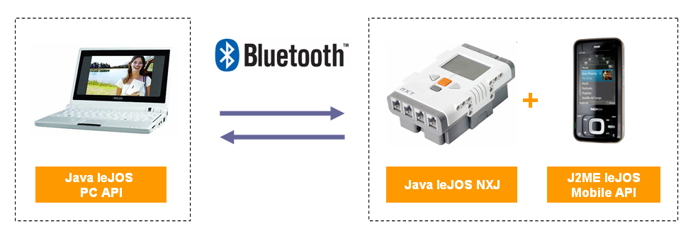
Approach 1

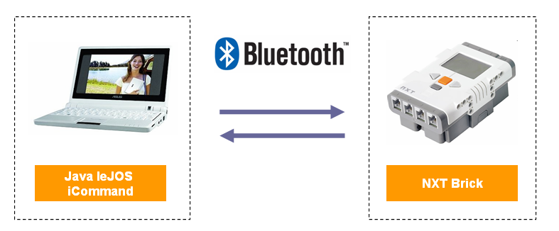
Approach 2

Java leJOS NXJ
leJOS NXJ is a Java programming environment for the LEGO MINDSTORMS NXT ®. It allows you to program LEGO ® robots in Java.

It consists of:

- Replacement firmware for the NXT that includes a Java Virtual Machine.
- A library of Java classes (classes.jar) that implement the leJOS NXJ Application Programming Interface (API).
- A linker for linking user Java classes with classes.jar to form a .binary file that can be uploaded and run on the NXT.
- PC tools for flashing the firmware, uploading programs, debugging, and many other functions.
- A PC API for writing PC programs that communicate with leJOS NXJ programs using Java streams over Bluetooth or USB, or using the LEGO Communications Protocol.
- Many sample programs

As leJOS is a firmware replacement, the new firmware leJOS NXJ firmware must be flashed onto the NXT, and will replace the standard LEGO MINDSTORMS firmware. This wipes out any files currently held on the LEGO firmware. The LEGO firmware can be restored using the LEGO supplied software.

leJOS is an open source project hosted in the sourceforge repository. It was originally created from the TinyVM project that implemented a Java VM for the LEGO Mindstorms RCX system. The RCX version of leJOS proved very popular with the LEGO Mindstorms Robotic Inventions Systems owners, and close to 200,000 downloads of all versions of leJOS have been done. The original author of TinyVM and the RCX version of leJOS was Jose Solorzano.

The NXT has given the leJOS development team the opportunity to greatly expand the capability of leJOS.

There are many advantages of using leJOS NXJ rather than the NXT-G or other programming environments for the NXT. These include:

- It uses the industry-standard Java language.
- It provides object-oriented programming.
- It is an open source project with many contributors.
- It allows you a choice of professional Integrated Development Environment such as Eclipse and Netbeans that support syntax directed editors and many other features.
- It has cross platform support – Windows, Linux, Mac OS X.
- It is much faster than NXT-G.
- It has full support for Bluetooth.
- It provides highly accurate motor control.
- It has advanced navigation support.
- It provides Behavior classes that support the subsumption architecture foe ease of programming of complex robot behaviors.
- It supports third party sensors.
- It supports remote monitoring and tracing of your leJOS NXJ program from the PC.
- It provides trigonometry and other Math functions
- It supports the J2ME LCD user Interface including many graphics functions.
- It supports multithreading.
- It supports listeners and events.
- It supports safe memory management with garbage collection
- It has USB support including Java streams over USB and USB debugging.
- It supports standard Java Communication streams
- It has a flash file system accessed by the standard java.io classes.
- It supports data logging and remote capturing of the logs.
- It has sound support including playing 8-bit WAV files
- It provides dozens of sample programs.
- It supports remote execution from the PC using iCommand.
- The Web site has online forums to help solve any problems you might have, to share projects ideas, and to communicate with the development team.
- It has telerobotics support via standard TCP/IP sockets.
- It supports NXT to NXT Bluetooth communications.
- It supports Bluetooth communication with other devices.
- It supports two-way communication with RCX via third party adapters such as the Mindsensors NRLink.
- It provides compatibility with Lego Communications Protocol, so that many tools that work with the standard LEGO firmware, also work with leJOS.
- It has an easy to use menu system.
- It is widely used by universities and other education establishments.
- It has computer Vision and speech support via iCommand.

How to contribute with leJOS tutorial?

The leJOS NXJ Tutorial
The leJOS NXT Tutorial, is a Web product developed to learn basic and advanced concepts with leJOS NXJ.

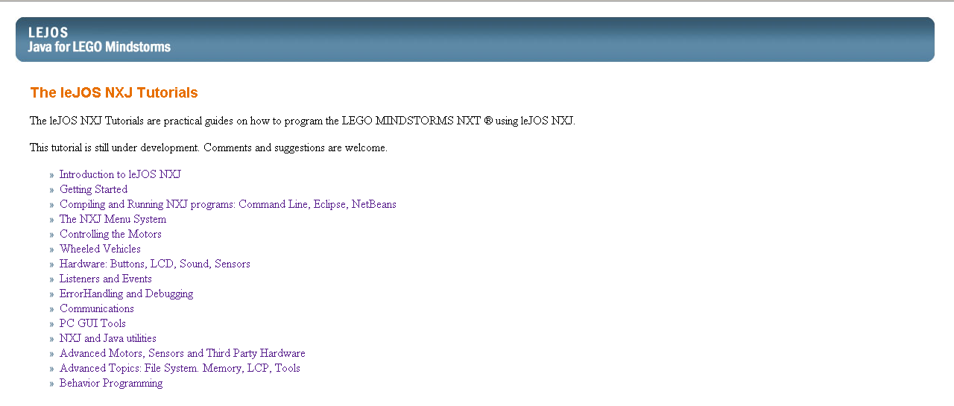

You can see the latest tutorial published on leJOS Website in the following URL:
http://lejos.sourceforge.net/nxt/nxj/tutorial/index.htm

Tutorial’s Information Architecture
The leJOS NXJ Tutorial has the following information architecture at the moment:

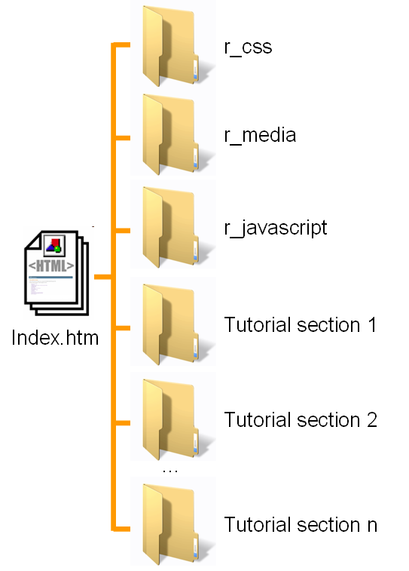

Auxiliary folders.
Every document in leJOS tutorial uses some auxiliary files stored in 3 folders:

- r_css
- r_media
- r_javascript

The folder r_css is used in the tutorial to store the css (cascade style sheet) files.
The folder r_media is used to store generic multimedia files. This folder supports the following technologies:

- r_media
  - images
  - flash
  - mp3
  - video

At the moment leJOS tutorial doesn’t need flash, mp3 and video, but the design of the information architecture supports future needs.
The folder r_javascript is used in the tutorial to store Javascript files

Tutorial Organization
The tutorial is organized by folders. Every folder represents the different concepts in Java leJOS technology. The main file in the tutorial is index.htm which links with the web documents stored in the folders.

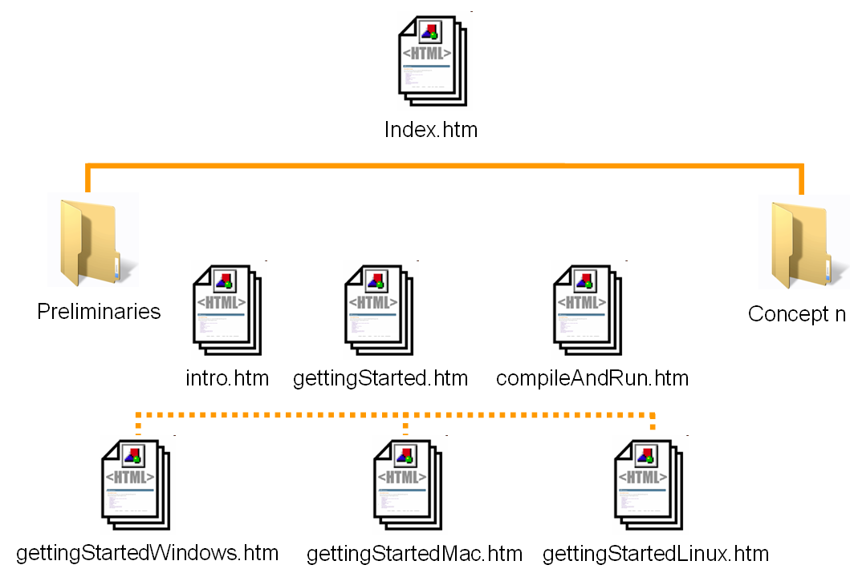

In previous graph, you can observe that the folder named “preliminaries” stores 3 concepts:

- Intro
- GettingStarted
- CompileAndRun

Besides if in the tutorial exists a concept which is so large to be written in a unique document, it is a good practice to split the ideas in different documents. You can see the idea in the web document gettingStarted which has 3 childs:

- GettingStarted
  - GettingStartedWindows
  - GettingStartedMac
  - GettingLinux

The protocol
leJOS team have developed a protocol to add your efforts in the project.

- Preliminaries
  - Create an account in leJOS project as leJOS Developer
  - Subscribe in leJOS Developer mailing list to share your ideas, comments, critics, problems and doubts
- Continous process
  - Send your proposals about leJOS tutorial using the Standard procedure, the leJOS Mailing List
  - If your proposal are approved by the community then
    - Create a new section in the tutorial
    - Update the published contents
  - Commit your changes in SVN
  - Send your advances about tutorial using the Mailing list
  - New advances on tutorial will be verified to publish on website

Every people in leJOS team can participate in the tutorial adding new concepts or updating the published concepts and if you read this doc and you aren’t a leJOS member then contact with leJOS team to help in this project.

Web tools
If you are going to create a new section or update published contents then you will need Web tools to create or edit the web documents. When you develop web products you will need tools to generate HTML Code, a tool to see CSS and finally if you are going to add multimedia in the contents then you will need Image/Video tools

- Web IDE
- CSS Editor
- Image/Video tools
- SVN Client
- Web browsers

Web IDE (Required)
Web IDE may be classified by your experience with HTML.
If you don’t have strong experience with HTML then we recommend:

- Adobe Dreamweaver
- Mozilla Seamonkey (Open Source)

If you have strong experience in web then we recommend:

- Eclipse IDE + Web Tools addon (Open Source)
- Notepad++ (Open Source)

CSS Editor (Optional)
This tool is not necessary but if you need to know what CSS styles is applied in your documents we recommend:

- Bradbury Top Style Lite (Free)
- Adobe Dreamweaver

Besides this tool could be interesting for any web author if you need to apply custom CSS style for a unique document in the tutorial.

Note: CSS file stored in r_css can’t be changed.

Image/Video Editor (Optional)
If you want to improve the quality of your contents, a nice idea is add images and videos into your web document. We recommend:

- Image
  - Adobe Fireworks 8
  - Adobe Photoshop
  - GIMP (Open Source)
- Video
  - Edition
    - Microsoft Movie Creator
    - Adobe Premiere
    - Google Picassa 3
  - Publishing
    - youtube

SVN Client (Required)
If you are going to contribute in leJOS project with your knowledge and experience then you will need a SVN Client to download latest project’s revision and update new changes in the project. We recommend:

- Tortoise SVN Client
- SVN Client for eclipse

Web Browsers (Required)
In the market exists several Web Browser and they don’t render HTML in the same way. leJOS tutorial Author should test their works in the following Web Browsers:

- Mozilla Firefox 3
- IE 6
- IE7

To elaborate previous list, we have analyzed web analytics from leJOS Web site in the period 2007-2008

leJOS Web Browsers Stat in 2007
If you notice, the 88.96% use Firefox and MSIE in 2007

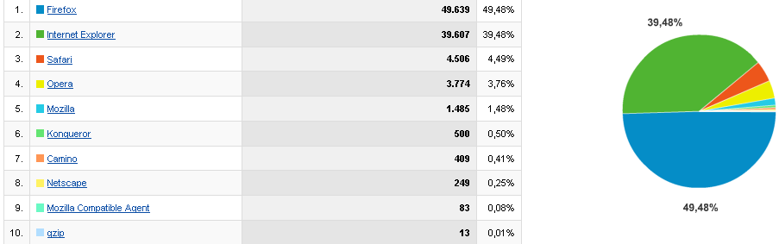

leJOS Web Browsers Stat in 2008 (01/01/2008 – 31/0872008)
If you notice, the 88.36% use Firefox and MSIE in 2007

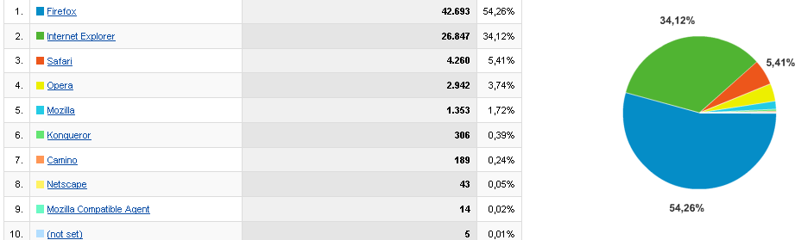

If we analyze this kind of browser in the same period, we observe that users who use Firefox likes version 2.x, but people who likes MSIE, use MSIE 7 60,66%

Firefox Statistics in 2008
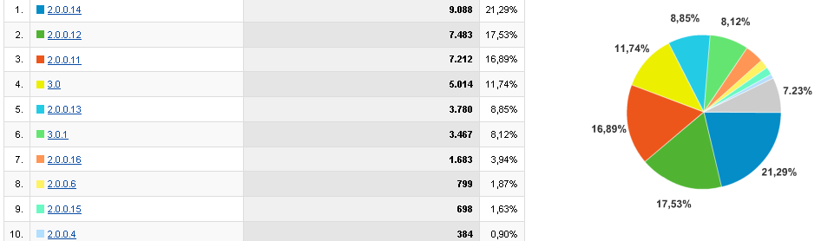

MSIE Statistics in 2008
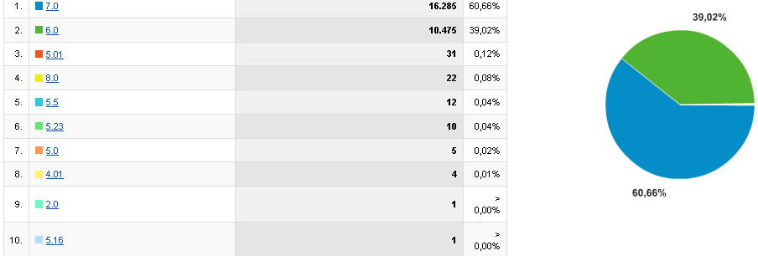

The leJOS tutorial Web Template
The leJOS tutorial Web Template is a web structure which uses the main ideas from every Java Tutorial Series.

This web template was designed in to achieve the following goals:

- Use Java Tutorial Look & Feel
- Easy to edit
- Be viewed by modern screens

Currently you can find leJOS tutorial Web template in the following path:

LOCAL LEJOS REPOSITORY PATH
/tutorial/webTemplate/template/tutorialTemplate.htm

Note: This template uses auxiliary folders: r_css, r_media & r_javascript and it has been designed to be stored in level 1. Not create folders to create level 2, it is not necessary.

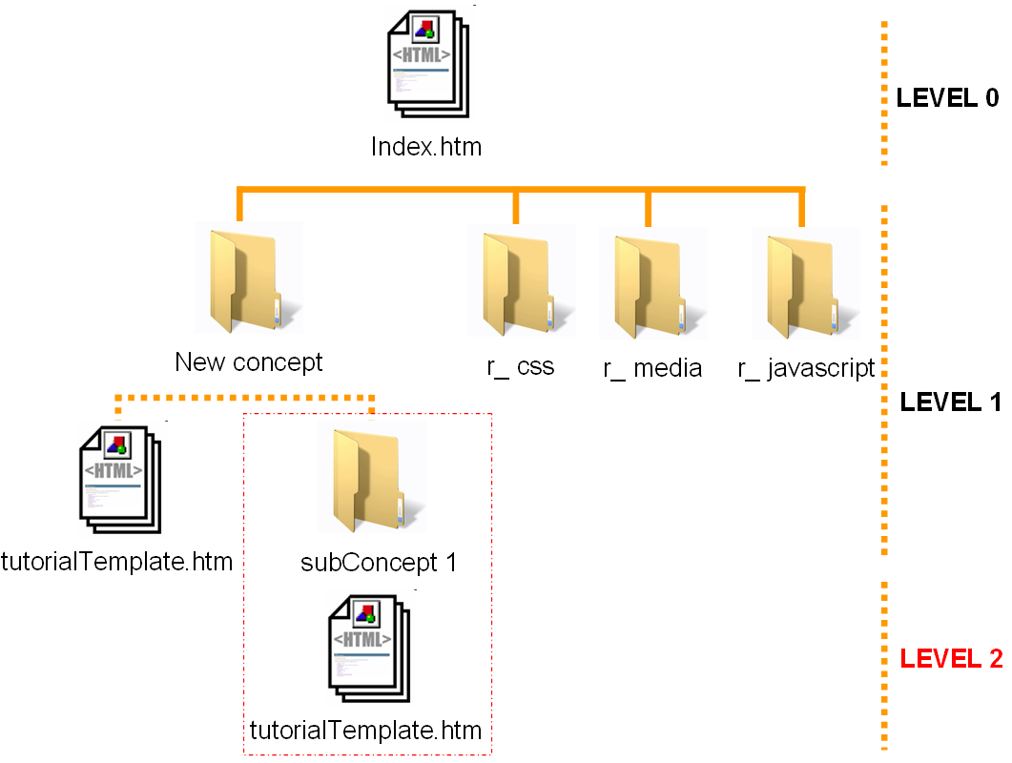

HTML fundamentals
Every Web document has 2 areas:

- Head
- Body

In head area, you will see web dependences and metadata.

<head>
<!-- METADATA -->
<title>Web Template Title</title>
<meta name="title" content="Web Template Title" />
<meta name="DC.Title" content="Web Template Title" />
<meta http-equiv="title" content="Web Template Title" />

<meta name="description" content="Web Template Description" />
<meta http-equiv="description" content="Web Template Description" />
<meta http-equiv="DC.Description" content="Web Template Description" />

<meta name="keywords" content="Java, leJOS, leJOS project, NXJ, NXJ Tutorial" />
<meta http-equiv="keywords" content="Java, leJOS, leJOS project, NXJ, NXJ Tutorial" />

<meta content='text/html; charset=UTF-8' http-equiv='Content-Type'/>
<meta name='VW96.objecttype' content='Document' />
<meta http-equiv='content-language' content='en'>
<meta name='DC.Language' SCHEME='RFC1766' CONTENT='English' />
<meta name='distribution' content='global' />
<meta name='resource-type' content='document' />

<!-- SEARCH ENGINE -->
<meta name='robots' content='all' />

<!-- AUTHOR METADATA -->
<meta name='Author' content='Juan Antonio Breña Moral' />

<!-- CSS -->
<link rel="stylesheet" href="../r_css/lejos-tutorial.css" type="text/css" />

<!-- ICON -->
<link rel="shortcut icon" href="../favicon.ico" type="image/x-icon" />
</head>

In this section is necessary to update:

- Title
- Description
- Author

Title
The title is a critic area in any web document. Update this HTML Codes

<title>Web Template Title</title>
<meta name="title" content="Web Template Title" />
<meta name="DC.Title" content="Web Template Title" />
<meta http-equiv="title" content="Web Template Title" />

The title is very useful for humans and search engine robots.

Description
The description is a critic area too.

<meta name="description" content="Web Template Description" />
<meta http-equiv="description" content="Web Template Description" />
<meta http-equiv="DC.Description" content="Web Template

The title is very useful for search engine robots.

Author
It is a good practice to write your name in any web document that you create or update.

<meta name='Author' content='Juan Antonio Breña Moral' />

If you update a published content and you are the creator, add your name too.

<meta name='Author' content='Author Creator' />
<meta name='Author' content='Author2' />

Once you have finished with head area in your web document then it is the moment to explain the body area, the area that anybody see in your favourite web browser

The body area has 2 areas:

- Left navigation system
- Content area

Note: In this doc we use Seamonkey in the examples.

If you open open tutorial template with your favorite web tool, you should see this image:

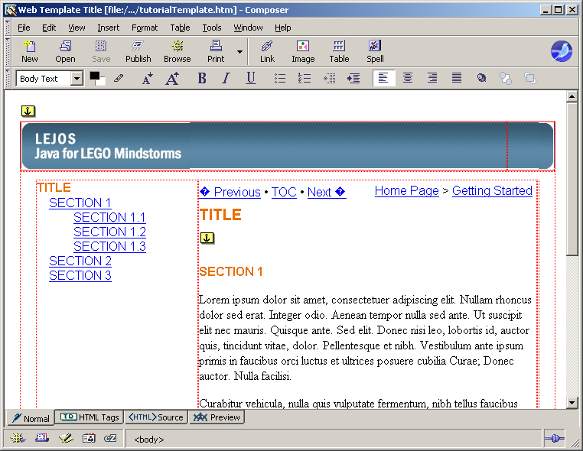

Left Navigation system
What is a Navigation System? Navigation system is a web tool coded into your web document to go quickly to any part of your web document. leJOS Team designed a CSS Styles to cover all scenarios.

In any left navigation system, it is necessary to write the title:
<div class="nolinkLESSON">TITLE</div>

Once you have the TITLE, write the sections using the following CSS Styles:

LEVEL1:

<div class="linkAHEAD"><a href="#1">SECTION 1</a></div>

LEVEL2:

<div class="linkAHEAD2"><a href="#2">SECTION 1.1</a></div>

If you master the structure the next concept is the links.

Every link in the left navigation system has 2 parts:

The link:
<div class="linkAHEAD"><a href="#linkExample">CLICK HERE TO GO TO SECTION1</a></div>

The section in your web document:
<a id="linkExample" name="1"></a><h4>SECTION 1</h4>

Content area
In the content area, any leJOS tutorial author has to update the following items:

- Navigation tool
- Breadcrumbs
- Title
- Contents

Navigation Tool
The navigation tool is:

The HTML code is:

<div class="NavBit">
<a target="_top" href="../Preliminaries/Intro.htm">«&nbsp;Previous</a>&nbsp;&#8226;&nbsp;<a href="../index.htm">TOC</a>&nbsp;&#8226;&nbsp;<a href="../Preliminaries/CompileAndRun.htm">Next&nbsp;»</a>
</div>

Update the path to previous concept and next concept.

Breadcrumbs
The breadcrumbs is:

The HTML code is:

<!-- DO NOT MANINPULATE -->
<div id="BreadCrumbs">
<a href="../index.htm" target="_top">Home Page</a>&gt;
<a href="#">Getting Started</a>
</div>

Title
It is necessary to edit the title.

The HTML code is:

<!-- CONTENT TITLE -->
<div id="PageTitle">TITLE</div>
<a id="1" name="1"></a><h4>SECTION 1</h4>

F.A.Q.
This section has been written to solve frequently problems for newbie members.

How to download leJOS repository with Tortoise SVN Client.
Once you have installed Tortoise SVN Client, Choose a place in your computer to download leJOS Repository and use contextual menu in windows you can see a new icons in your Windows Explorer:

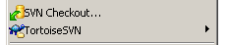

If you want to download all source code, click in the option SVN Checkout:

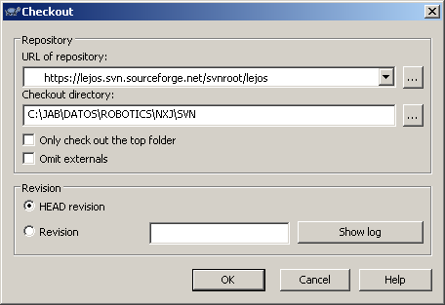

The repository URL is:
https://lejos.svn.sourceforge.net/svnroot/lejos

Select the folder where you want to download LeJOS project. Click in Ok Button to start to download then you will see a new window where you can see the files that you are downloading in your computer.

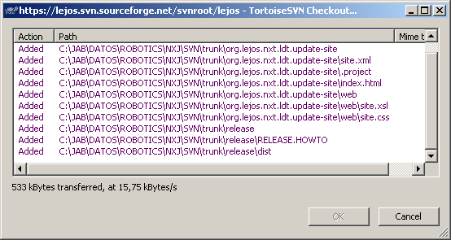

2. Tutorial. The tutorial needs updating to add sections on getting started on Linux and MAC OS X, to make use of the Windows installer more prominent in Getting started and to correct some other issues on the Getting Started pages. It also needs some fixes to links that do not work and some reformatting of pages. I am waiting on Juan Antonio's style guide and for some help with tidying up the HTML to make it editable before I can proceed with this.

Hi Juan Antonio,

Ignore my comments about OO - I now understand from Roger that it refers to Open Office. The Open Office HTML (while better than Word's) is not really editable and the inline styles are all over the place. I think we need to simplify the OO generated HTML so that it can much more easily be modified. Perhaps you can do some pages and I can do some others. It would still be useful to have your style guide before I do this.

One of the worst pieces of HTML is the floating boxed code examples that need a corresponding number of blank lines so that the later text does not wrap round the box. (I admit I was oriinally responsible for this in the Word document). This needs changing to put the boxed text inline in the HTML.. An example of the best way to do this in the style guide would be very useful to me.

Once we have simplified the HTML, Roger should still be able to edit it with Seamonkey or Komposer.

Lawrie

