Introduction
This document describes the internal specifications for the new Email Panel Count System, as described in the corresponding External Specifications document.

Architecture
The Email Panel Count System (epanCount) consists of 4 main programs (or source code repository projects):
- epanCount—the GUI used to create and view count requests,
- epanCountPrototype—the prototype for the epanCount GUI,
- epanCountLibrary—an API (used by the GUI) to process count requests,
- epanCountUpdate—the program run periodically to update PanelistSummary, the database table that counts are queried from.
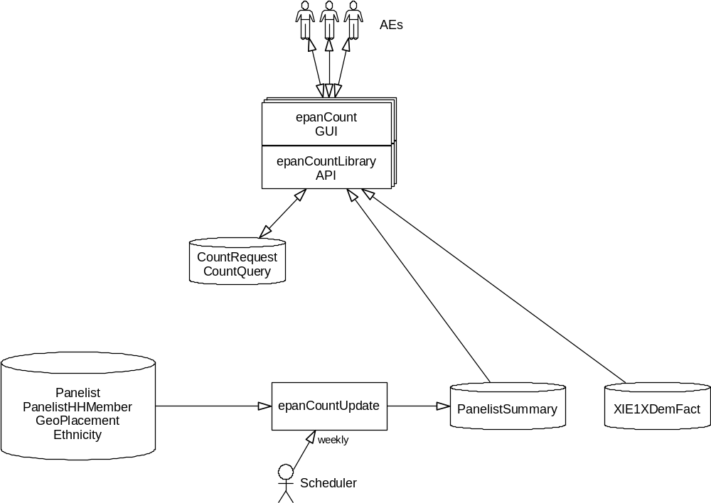

Phase I (Database Back End)
The first phase will release the back end process to create a copy of necessary panelist data for quick access.
The current Scheduling system will run an epanCountUpdate job weekly. At release time, a script will be run to insert the necessary information into the RecurJob and JobType tables (and any other database changes required). When executed, this program will drop and re-create the PanelistSummary table, along with its associated indexes and database statistics.
The program will require several new views, which will be created upon release of this phase. These views will be created in the DA_PROD (or QC) schema.
When run, the program will connect to the appropriate Oracle database (DEV for alpha and beta, and SPOT for release). It will log in under the username EPANCOUNT (or EPANCOUNTQC for beta) and will enable the new role SSI_Email_Count_Update.
It will create a new copy of the PanelistSummary table, under a staging name of PanelistSummaryNew. Meanwhile, note that any current processing using PanelistSummary will not be affected. Testing has shown that the table will consume about 3 ??? bytes per column per row. There are 38 ??? columns currently defined. There will be one row for each active US Panelist; as of today, this accounts for just under half of all the rows in the Panelist table (2.4 million out of 5.5 million). Currently the PanelistSummary table will consume about 252 ??? megabytes of disk space. For comparison purposes, note that the Panelist table alone currently consumes 1.2 gigabytes of data. The table will be created in the default tablespace. The program will not specify an initial extent size.
It will create new bitmap indexes on each column of the new table, except for the primary key column. Estimating the size of each bitmap index is nearly impossible; however, testing has shown that the amount of space taken up by all the indexes, currently, is less than 1 byte per column per row in the table. Currently the indexes consume about 73 ??? MB. For comparison purposes, note that the current (B-tree) index on the Panelist.incomeRangeID column alone consumes 97 MB. The indexes will be created in the default tablespace. The program will not specify an initial extent size.
The table and indexes will be created using the NOLOGGING option.
It will gather statistics for this table and indexes. The statistics will include histograms.
The creation of the table and index will use parallel processing.
The program will initially be set to run every Monday at 3:18 AM.
Once the staging table, index, and statistics are created, the program will drop the old table (and index and statistics), and rename the staging table to the real name, grant SELECT access to the new role SSI_Email_Count, and will therefore be available for use immediately, with only a short period of time during which the system would be unavailable. (Note that the client system will be designed to take this into account, and re-start the query should it ever be necessary).
Therefore this update process can be run at any time without causing logical errors (although it will consume resources). Note, however, that only one instance of the program can be run at a time. This will be enforced through the use of the standard Scheduler locking mechanism.

Pre-Phase II (API Library)
The next phase will be to create an API library (epanCountLibrary) that will process count requests, querying the above PanelistSummary table (and the XDemFact table).
[More to be specified.]

Phase II (Prototype GUI)
The first visible release of the new system will be a prototype GUI (epanCountPrototype). This piece of software will be written quickly, consuming a minimal amount of Software Dept. resources.
This prototype program will be written with the help of the Thinlet library. I have reviewed the licensing for this library and it seems appropriate for us to use it. The license is GNU Lesser General Public License (LGPL), and is available at http://www.gnu.org/copyleft/lesser.html for review. Our program will be designed to be a "work that uses the library," as defined in the LGPL.

Launching the Program
The user will access the program through a link provided to them in the email that announces the release of this phase of the project. Java Web Start will be used to deploy the program to the user’s PC.
Upon running the program, the user will enter their username and password, and the system will open a shared connection to SPOT (or DEV for alpha or beta). The connection will remain open until the user quits the program.
The main window will have two parts: the list of count requests on the left, and the criteria for one request (the current request) on the right.
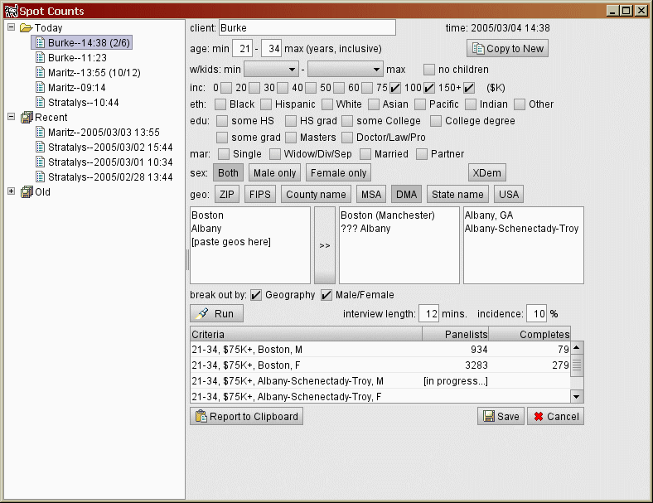
Figure 1--Prototype Main Window

Data Store
The program will allow the user to enter and view count requests. The request criteria, along with the actual count results, will be stored in new tables in the DA_PROD (or QC) schema: CountRequest and CountQuery. CountRequest will contain one row for each count request (one set of criteria). There can be many CountQuery rows for each CountRequest row. The CountQuery row contains information about each actual count for the associated request.
The application may cache the recent requests to ensure instantaneous access to them by the user.
[More to be specified.]

Phase III (Real GUI)
[More to be specified.]

