Woodfibre LNG Project
Project HSSE Transition & Operations Handover Plan
Document ID: PLN-HSSE-001 | Version: 2.0 (Joint Governance Review Edition) | Owner: Joint HSSE Steering Committee
[EXECUTIVE GOVERNANCE SUMMARY] This revised Project HSSE Transition Plan incorporates critical review recommendations to establish formal joint governance, sign-off blocks, safety responsibility transfer milestones, a dedicated HSSE Bridging Strategy (HSSE-BRG-001), program-by-program bridging mechanics (PTW, LOTO, SIMOPS, ERP, MOC), and heightened process safety / PSSR requirements for operational ownership by Woodfibre LNG Operations.

1.0 DOCUMENT APPROVAL & JOINT GOVERNANCE SIGN-OFF
This Project HSSE Transition Plan represents a binding, joint governance document between the EPC Contractor (CB&I), Commissioning & Start-Up (CSU), and the Owner's Operations Organization (Woodfibre LNG Management Ltd.). Progression between project execution phases shall not occur without formal authorization from all designated approval authorities below:
[REVIEW COMMENT #1 - JOINT OWNERSHIP] CRITICAL REVIEW RECOMMENDATION: The initial plan draft lacked formal sign-off from Woodfibre LNG Operations. Joint governance is mandatory. System handover, boundary control, and Permit to Work (PTW) transitions cannot proceed solely on construction endorsement; binding sign-off from the Operations Director and WLNG VP HSSE is required.

Approval Role | Name & Title | Organization | Signature & Date
EPC Construction Director | CB&I Construction Director | EPC Contractor (CB&I) | _____________________ ___/___/2026
Commissioning Manager | Project CSU Manager | Commissioning & Start-Up | _____________________ ___/___/2026
WLNG Operations Director | Director of Operations | Woodfibre LNG Management | _____________________ ___/___/2026
WLNG Vice President HSSE | VP / Director HSSE | Woodfibre LNG Management | _____________________ ___/___/2026

2.0 INTRODUCTION & CONTEXT
The Woodfibre LNG Project will transition through multiple execution phases including Construction, Mechanical Completion (MC), Pre-Commissioning, Commissioning, Ready for Start-up (RFSU), Start-up, and Performance Testing. During these phases, the nature of work, hazards, interfaces, and operational risks progressively change from traditional civil/construction activities to activities involving energized electrical systems, high-pressure fluids, rotating machinery, utility introduction, and hydrocarbons.
The purpose of this Project HSSE Transition Plan is to provide the governance framework for managing this transition while maintaining continuous Health, Safety, Security, and Environmental (HSSE) control throughout the Woodfibre LNG Project lifecycle.
3.0 SCOPE & APPLICABILITY
This plan applies to all COMPANY (Woodfibre LNG), CONTRACTOR (CB&I LLC - a McDermott COMPANY), SUBCONTRACTORS, Vendors, and Specialist Contractors engaged in activities at the Woodfibre LNG project site located 7 km southwest of Squamish, British Columbia.
The plan applies across all construction-controlled areas, commissioning-controlled areas, operational boundaries, and shared simultaneous operations (SIMOPS) interface zones.
4.0 SAFETY RESPONSIBILITY TRANSFER MILESTONES (EPC TO OWNER)
A core requirement of this plan is establishing clear, legally binding phase gate milestones when safety governance, s.118 Prime Contractor site authority, and Permit to Work administration formally transition from the EPC Contractor to Woodfibre LNG Operations.
[REVIEW COMMENT #2 - TRANSITION MILESTONES] REVIEW RECOMMENDATION: Define exact physical, functional, and legal milestone triggers for transfer of safety responsibility. Transfer of s.118 Prime Contractor duties must be formally documented with WorkSafeBC and BC Energy Regulator (BCER).

Figure 1: Woodfibre LNG Safety Responsibility Transfer Milestones
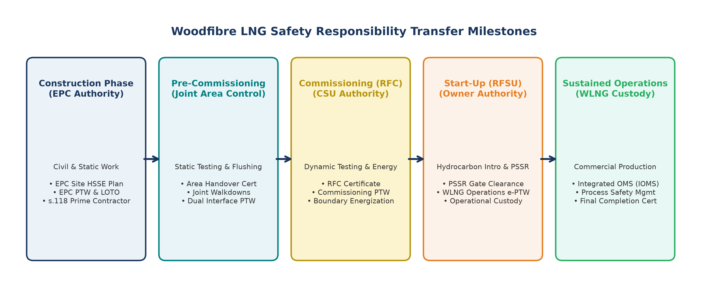

Phase Milestone | Transfer Trigger / Deliverable | Governing HSSE Authority | Control of Work System
Phase 1: Construction | Civil / Mechanical Installation | EPC Contractor (CB&I) | EPC Construction PTW & LOTO
Phase 2: Pre-Commissioning | Area Handover Cert (AHC) / Static Test | Joint EPC & CSU Team | Dual-Interface / Early Works PTW
Phase 3: Ready for Commissioning (RFC) | RFC Certificate & Boundary Lockout | Commissioning Manager (CSU) | Commissioning PTW & Boundary LOTO
Phase 4: Ready for Start-Up (RFSU) | PSSR Gate Clearance & Hydrocarbon Intro | Woodfibre LNG Operations | WLNG Operational e-PTW & Process LOTO
Phase 5: Sustained Operations | Final Acceptance & Commercial Ops | WLNG Operations Director | WLNG Integrated OMS (IOMS)

5.0 FORMAL HSSE BRIDGING STRATEGY & PRECEDENCE
To eliminate procedural gaps and conflicting instructions during phase overlaps, a formal **HSSE Bridging Document (HSSE-BRG-001)** shall be established between the EPC HSSE Management Plan (350106-HS-PL-000001) and the Woodfibre LNG Operations Management System (OMS).
[REVIEW COMMENT #3 - BRIDGING STRATEGY] REVIEW RECOMMENDATION: Include a clear precedence framework. During overlap, where procedures conflict, the higher-safety / operational integrity standard shall apply. Post-RFSU, WLNG Operations procedures hold absolute precedence.

Figure 2: Woodfibre LNG HSSE Program Bridging Architecture
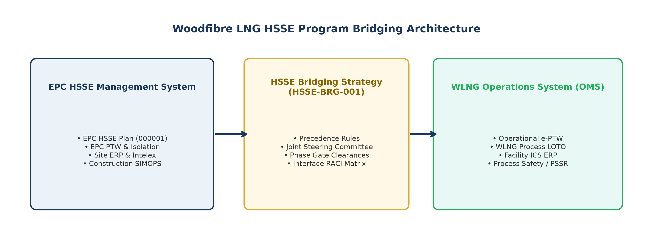

6.0 KEY PROGRAM BRIDGING MECHANICS
The following key HSE programs require explicit, program-by-program bridging mechanics during the transition:
[REVIEW COMMENT #4 - PROGRAM BRIDGING] REVIEW RECOMMENDATION: Detail specific bridging steps for PTW, LOTO, SIMOPS, ERP, MOC, and Environmental compliance. Avoid generic statements; specify exact system transitions.

HSE Program | EPC Construction Basis | Transition / Bridging Protocol | WLNG Operational Ownership
Permit to Work (PTW) | EPC Paper PTW (350106-HS-PR-000007) | Joint PTW Desk; Dual Sign-Off for SIMOPS | WLNG Enterprise e-PTW System
Energy Isolation (LOTO) | Construction Lockout Standard | Boundary Locks / Key Safe Handover | WLNG Process Energy Isolation Standard
SIMOPS Management | Construction Work Coordination | Daily Interface Meeting & SIMOPS Hazard Matrix | WLNG Operational SIMOPS Protocol
Emergency Response (ERP) | EPC Site ERP & Medical Clinic | Joint Incident Command; Shared Sirens | WLNG Facility Incident Command System
Management of Change (MOC) | EPC Design / Engineering MOC | Commissioning Field Change Request (FCR) | WLNG Operational MOC Procedure
Environmental Management | Construction Environmental Plan | Joint Spill / Effluent Handover Review | WLNG Operational EMP & BCER Permits
Incident Reporting | Intelex System (CB&I) | Cross-Notification within 2 Hours for SIF-p | WLNG Enterprise HSE Event System

7.0 ADDITIONAL REQUIREMENTS FOR OPERATIONAL OWNERSHIP
Transitioning into commissioning, dynamic testing, energization, and hydrocarbon introduction introduces major process safety hazards. The following additional requirements must be fulfilled prior to operational handover:
[REVIEW COMMENT #5 - OPERATIONAL READINESS & PSSR] REVIEW RECOMMENDATION: Mandate PSSR clearance of all Category A punch items, Safety Critical Element (SCE) technical integrity sign-offs, and WLNG Operations 24/7 Control Room readiness prior to introducing hydrocarbons.

Pre-Startup Safety Review (PSSR)
Mandatory 5-step PSSR verification covering physical alignment, operating procedures, training completion, HAZOP closeouts, and regulatory authorizations before fluid/hydrocarbon introduction.
Safety Critical Elements (SCE) Integrity
Formal verification and testing of performance standards for ESD valves, pressure relief systems, F&G detection, fire protection, and process containment.
Process Safety Management (PSM) Baseline
Complete closeout of all pre-commissioning HAZOP/LOPA recommendations, Management of Change (MOC) logs, and Alarm Rationalization reviews.
Shift Handover & Operational Competency
Verification that WLNG console and field operators possess required BC ticket qualifications, plant walkthrough certification, and formal shift logbook handover protocols.
8.0 TERMS AND DEFINITIONS
• ALARP: As Low As Reasonably Practicable — Risk level achieved when further risk reduction is disproportionate to benefit.
• Area Handover Certificate (AHC): Formal document transferring physical area control from Construction to Commissioning or Operations.
• Commissioning Authority: The designated organization having operational control of a system for commissioning activities.
• Dynamic Commissioning: Commissioning activities performed using live energy, utilities, process fluids, or hydrocarbons.
• PSSR: Pre-Startup Safety Review conducted before introducing hazardous energy or process fluids into a system.
• SIMOPS: Simultaneous Operations involving Construction, Pre-Commissioning, Commissioning, or Operations activities occurring in the same work area requiring coordinated risk management.
9.0 ROLES AND RESPONSIBILITIES
Responsibility for HSSE shall remain continuous throughout the transition. The transfer of system custody, work-area control, or Permit to Work authority shall not create any gap in accountability for personnel safety, process safety, security, environmental protection, or emergency response.
Project Director
Retains overall accountability for implementation of this HSSE Transition Plan; ensures transition is adequately resourced and schedule/commercial pressures do not override HSSE or process safety requirements.
Construction Director
Accountable for safe execution of all Construction-controlled activities; ensures systems are not presented for transfer until completion requirements are met; manages residual punch items under receiving control.
Commissioning Manager
Leads planning and coordination of HSSE arrangements for Pre-Commissioning, Commissioning, and Start-up; defines transition sequence; verifies completion certificates prior to custody acceptance; enforces commissioning boundaries.
Operations Manager
Defines operational readiness requirements; participates in walkdowns, PSSR, and RFSU acceptance; verifies operating procedures, isolations, and shift routines; accepts operational custody upon formal completion.
Project HSSE Manager
Provides independent HSSE oversight throughout transition; verifies PTW, isolation, and emergency arrangements as boundaries shift; conducts audits; retains authority to suspend unsafe work.
10.0 TRANSITION RESPONSIBILITY MATRIX (RACI)
Transition Activity / Scope | Construction Phase | Commissioning Phase | Operations Phase
Permit to Work (PTW) Control | Responsible (EPC) | Accountable / Responsible | Accountable (Handover)
SIMOPS Interface Management | Responsible | Accountable | Accountable
Isolation & Energy Control (LOTO) | Responsible (EPC) | Accountable / Responsible | Accountable
Emergency Response Execution | Responsible | Responsible | Accountable
Process Safety & PSSR Management | Consulted | Accountable | Accountable / Informed
System Custody & Area Access | Responsible (EPC) | Accountable (CSU) | Accountable (Ops)

