Woodfibre LNG
Consequence Management Procedure
Document ID: PROC-CM-001 | Version: 2.0 (Full Unabridged Approved Edition) | Owner: Director HSSE
[PROCEDURE EXECUTIVE SUMMARY] This unabridged version restores all 11 core sections, subsections 11.1 through 11.7, Appendices A (Tables A1–A11), and Appendix B (Life Saving Rules 1–9). Diagram 1 Box 2 has been updated to 'Apply Canadian Model' (A&D / Impairment Assessment), ultra-sharp 600 DPI graphic diagrams have been embedded, and native editable Word flowchart tables have been added.

1.0 POLICY STATEMENT
Woodfibre LNG is committed to maintaining a safe, respectful, and legally compliant workplace across all phases of construction, commissioning, and operations. All workers, supervisors, and employers must follow Woodfibre LNG rules, standards, Life Saving Rules (LSRs), and fitness-for-duty expectations that protect people, the environment, equipment, and the community.
This procedure establishes a consistent consequence management framework for all employers and contractors working under the Prime Contractor (Woodfibre LNG). It provides principles, behavioural definitions, and decision-making requirements for addressing unsafe behaviour, rule violations, substance-related issues, harassment, violence, security incidents, and misconduct.
Consequences under this procedure are applied fairly, consistently, and in compliance with Canadian labour law, WorkSafeBC legislation, the B.C. Human Rights Code, and the B.C. Personal Information Protection Act (PIPA).
2.0 PURPOSE
The purpose of this procedure is to:
- Define consistent behavioural expectations required to work on the Woodfibre LNG project.
- Apply fair, risk-informed, and defensible consequences based on worker behaviour, risk severity, and role.
- Reinforce Life Saving Rules and critical health, safety, and environmental controls.
- Provide clarity on roles of employers, the prime contractor, and the EPC.
- Support fitness-for-duty requirements using the Canadian Model for Providing a Safe Workplace.
- Establish clear expectations for site access, immediate removal, restrictions, and return-to-site (RTS) eligibility.
- Ensure compliance with the British Columbia (B.C.) Personal Information Protection Act (PIPA), the BC Human Rights Code, and WorkSafeBC legislation.
3.0 SCOPE
This procedure applies across all project phases (construction, commissioning, start-up, operations, maintenance, and decommissioning) to:
- All Woodfibre Management Ltd. employees, officers, and representatives.
- All workers performing work on project sites where Woodfibre LNG is Owner or Prime Contractor.
- All employers who have workers on site.
- The Prime Contractor and its representatives.
- The EPC contractor and subcontractors.
- All project phases including construction, commissioning, start-up, operations & maintenance, and decommissioning.
Exceptions or deviations must be approved in writing by Woodfibre LNG's Director of Occupational Health and Safety, in formal consultation with Human Resources and Legal representatives.
4.0 DEFINITIONS
4.1 Behaviour Types (Standardized Taxonomy)
All events subject to consequence evaluation must be categorized using the organization's standardized four-category behaviour model:
• Human Error: An unintentional mistake, slip, or lapse made while attempting to follow rules. Human error represents system or execution breakdown without conscious risk-taking intent.
• At-Risk Behaviour: A choice made where risk is not fully recognized, or where a shortcut is taken under the belief that the action is safe or low risk. Deviates from safe work practices but lacks conscious intent to ignore serious risk.
• Reckless Behaviour: A conscious choice to ignore a known safety rule, explicit procedure, or clear and serious hazard. The individual recognizes the risk but chooses to proceed regardless.
• Intentional Misconduct: Deliberate breaking of site rules, laws, or Life Saving Rules for personal gain, concealment, retaliation, sabotage, or harm.
4.2 Life Saving Rules (LSRs)
Life Saving Rules are critical controls designed to protect workers from high-consequence hazards. Breaches of LSRs involve elevated risk conditions and are evaluated using the Section 4.1 behaviour model. Mandatory CMC review applies to all LSR breaches classified as Reckless Behaviour or Intentional Misconduct.
4.3 Safety-Sensitive Positions
Construction Phase: A role is safety-sensitive if impairment could reasonably cause serious harm, equipment damage, loss of containment, or environmental impact (e.g., equipment operators, lifting/rigging, working at heights, electrical, confined spaces, marine interface, emergency response).
Commissioning & Operations Phase: A role is safety-sensitive if impairment could impact process control, energy isolation, loss of containment, marine loading, or emergency response (e.g., console operators, field operators, permit issuers, E&I technicians, marine berth operators).
5.0 EXPECTATIONS FOR WORKER CONDUCT
5.1 Behaviour Expectations
All individuals must follow Life Saving Rules, procedures, and safe-work practices; report hazards and incidents immediately; be fit for duty; respect all workers and the community; comply with alcohol and drug prohibitions; follow security protocols; and act honestly and transparently.
5.2 Zero Tolerance
Zero tolerance applies to: intentional Life Saving Rule breaches; theft, fraud, or falsification; violence, threats, or harassment; possession or use of illegal substances; retaliation against reporters; or deliberate interference with safety-critical equipment.
6.0 ROLES AND RESPONSIBILITIES
6.1 Supervisors
Responsibilities: Stop unsafe work, secure work areas, remove workers from immediate hazards, document observations factually, notify employer and PCR, and exercise the Duty to Inquire and Canadian Model assessments when impairment or health concerns arise.
Decision Authority: May order immediate work stoppage and immediate temporary removal from the work area / same-shift removal as a temporary risk-control measure. Supervisors have no authority to impose employment discipline or permanent site access restrictions.
6.2 Employer Representative
Responsibilities: Lead investigations into worker behaviour, classify behaviour using Section 4.1 taxonomy, apply employer discipline (coaching, warnings, suspension, termination), and manage duty-to-inquire and accommodation obligations.
Decision Authority: Final authority for employer employment discipline. Initial behaviour classification is determined by the employer, subject to CMC review and validation for cases triggering CMC oversight under Section 8.2.
6.3 Prime Contractor Representative (Director HSSE)
Responsibilities: Maintain overall site safety, govern site access privileges, act on recommendations from the CMC and Appeals Panel (CMAP), ensure consistency, and maintain PIPA-compliant records.
Decision Authority: Holds sole authority for site access privileges under s.118 of the Workers Compensation Act, including issuing temporary, long-term, or permanent site bans and authorizing Return to Site (RTS) eligibility.
6.4 Engineering, Procurement and Construction (EPC) Contractor
Responsibilities: Implement HSSE expectations, administer consequence processes on site on behalf of Prime Contractor, ensure subcontractor alignment, and participate actively in governance.
Decision Authority: Has no direct authority for employment discipline or site access, but exercises indirect influence through voting membership on the Consequence Management Committee (CMC).
6.5 Consequence Management Committee (CMC)
Responsibilities: Review complex or high-severity cases (SIF-p, Reckless/Intentional LSR breaches, repeat events), ensure interdisciplinary fairness, validate behaviour classification, and recommend site access and RTS conditions.
6.6 Appeals Panel (CMAP)
Responsibilities: Conduct independent reviews of appealed site access decisions to ensure procedural fairness, process compliance, and proportionality. CMAP determinations regarding site-access appeals are final within the organization's internal process.
6.7 Workers
Responsibilities: Follow Life Saving Rules, safe work practices, and respectful workplace standards; report hazards; comply with fitness-for-duty expectations; participate in investigations.
Table 1: Summary of Authorities for Consequence Management Decisions
Decision / Action | Supervisor | Employer Rep | Prime Contractor Rep (PCR) | CMC | Appeals Panel (CMAP)
Stop Work | X |  | X
Remove Worker from Area / Shift | X | X | X
Behaviour Classification |  | X (Primary) |  | Validates / Adjusts | Reviews Process
Employment Discipline |  | X (Sole)
Temporary Site Access Restriction |  |  | X (Sole)
Permanent Site Access Ban |  | Recommends | X (Sole) | Recommends
Return to Site (RTS) Approval |  | Requests | X (Sole) | Endorses (High Risk)
Final Appeal Determination |  |  | Enforces |  | X (Final Internal)

7.0 CONSEQUENCE MANAGEMENT SYSTEM
7.1 Principles: Guided by Fairness & Consistency, Proportionality, Regulatory Compliance, Separation of Functions, Risk-Informed Focus, Evidence-Based Decisions, and System Improvement Priority.
7.2 Behaviour Classification: Standardized four-category model (Human Error, At-Risk, Reckless, Intentional Misconduct).
7.3 Severity Matrix: Low, Moderate, High, Critical / SIF-p.
7.4 Safety-Sensitive Considerations: Heightened risk scrutiny for safety-sensitive roles.
7.5 Frequency Escalation Criteria: Standardized to 3+ occurrences within a 12-month period.
7.6 LSR Escalation Framework: Mandatory CMC review for Reckless or Intentional LSR breaches.
7.7 Duty to Inquire / Accommodate & Canadian Model: Employers must apply the Canadian Model for Providing a Safe Workplace and fulfill duty-to-inquire obligations prior to finalizing consequences.
7.8 When Not to Apply Consequences: Individual consequences are withheld when systemic or supervisory factors contributed.
7.9 Relationship Between Investigations and Consequence Management: Fact-finding precedes consequence determination for all SIF-p or disputed events.
8.0 GOVERNANCE AND OVERSIGHT (CMC & CMAP)
8.1 CMC Role: Interdisciplinary oversight body reviewing complex, high-severity, or disputed cases.
8.2 CMC Triggers: Mandatory for SIF-p events, Reckless/Intentional LSR breaches, 3+ repeat occurrences, or access restriction proposals.
8.3 CMC Decision Authority: Validates classification, recommends site access restrictions and RTS conditions.
8.4 CMC Workflow: Submission -> Pre-Screen -> Review -> Decision -> Documentation -> Communication -> Follow-Up.
8.5 CMC Composition: Chaired by Director HSSE (PCR); voting members: Director Construction/Ops, Director Indigenous & Community Affairs, EPC Site HSSE Manager, EPC Construction Manager. Quorum requires Chair + 3 voting members. Chair holds casting vote.
8.6 Appeals Process (CMAP): Independent appeal body evaluating procedural fairness and reasonableness.
8.7 CMAP Composition: Independent Senior Leader (Chair) + Independent Senior Manager. CMAP determinations regarding site access appeals are final within the internal process.
8.8 Quality Assurance: Periodic audit of CMC decisions and annual procedure reviews.
PROCESS FLOW & SWIMLANE RESPONSIBILITY DIAGRAMS
Figure 1: Consequence Management Process Flowchart (Ultra-Sharp 600 DPI)
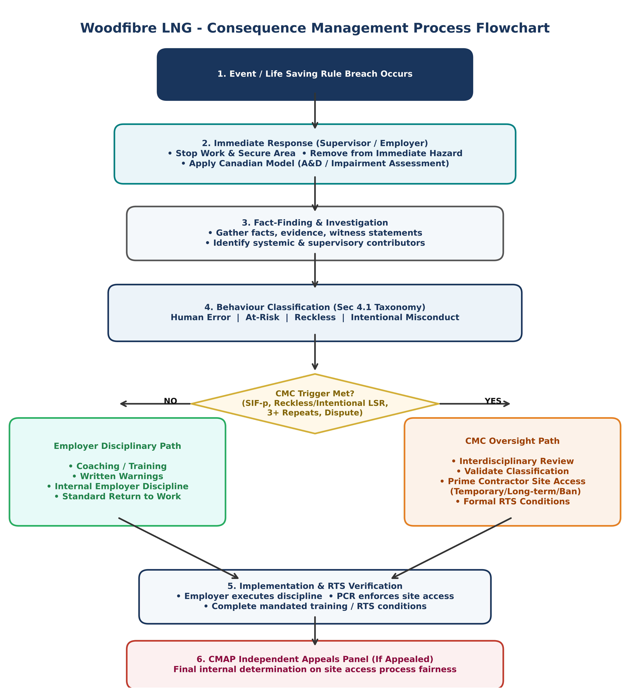

NATIVE EDITABLE WORD FLOWCHART TABLE (PROCESS STEPS)
The table below provides a 100% native, editable Word version of the Process Flowchart steps:
Step # | Process Phase | Key Actions & Controls | Responsible Authority
1 | Event / LSR Breach | Event occurs; hazard identified; immediate stop work initiated. | All Workers / Supervisor
2 | Immediate Response | Secure area; remove worker from hazard; Apply Canadian Model (A&D assessment). | Supervisor / Employer Rep
3 | Fact-Finding | Conduct investigation; gather evidence; identify systemic contributors. | Employer Rep / EPC
4 | Classification | Categorize behaviour under Sec 4.1 (Human Error, At-Risk, Reckless, Intentional). | Employer Rep (Primary)
5 | CMC Screening | Check trigger criteria (SIF-p, Reckless/Intentional LSR, 3+ repeats, dispute). | Prime Contractor Rep (PCR)
6A | Employer Path (No CMC) | Apply coaching, training, written warning, or internal employment discipline. | Employer Representative
6B | CMC Path (CMC Triggered) | Interdisciplinary review; validate classification; determine site access restrictions. | CMC Committee / PCR
7 | RTS Verification | Verify completion of mandated training, competency checks, and RTS plan. | PCR / Employer Rep
8 | Appeals (CMAP) | Independent review of procedural fairness; final internal determination. | CMAP Appeals Panel

Figure 2: Swimlane Responsibility Matrix (Ultra-Sharp 600 DPI)
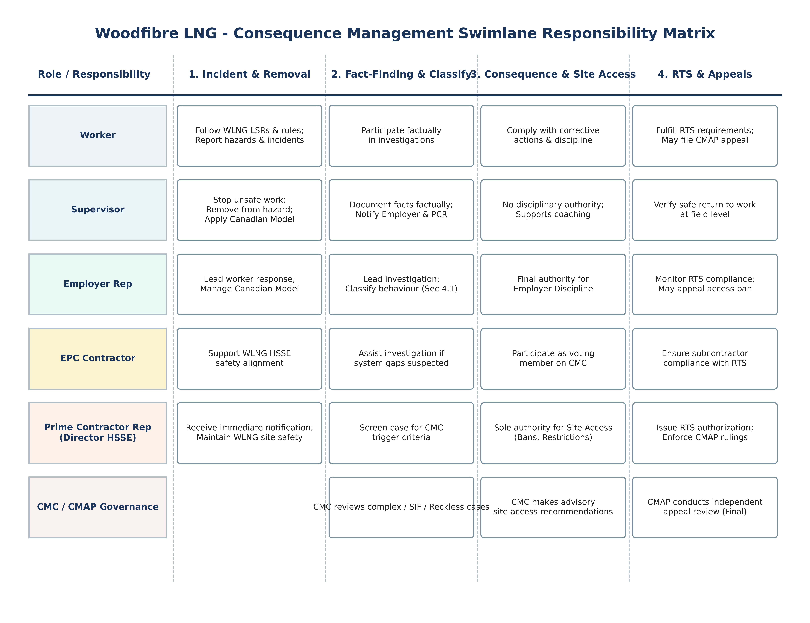

9.0 SITE ACCESS MANAGEMENT
9.1 Site Access Authority: Prime Contractor holds sole authority under s.118 Workers Compensation Act.
9.2 Immediate Removal Protocol: Risk-control measure following confirmed or suspected LSR breaches, impairment, or security concerns.
9.3 Temporary Restrictions: Conditional access, non-safety-sensitive reassignment, or suspension pending investigation.
9.4 Permanent Restrictions: Mandatory for deliberate Reckless/Intentional LSR breaches or sustained unsafe patterns.
9.5 Return to Site (RTS) Protocol: Mandates retraining, competency checks, and CMC approval for high-risk categories.
10.0 DOCUMENTATION & PRIVACY (PIPA COMPLIANCE)
10.1 Privacy Obligations: Strict compliance with B.C. PIPA; collect minimum necessary personal information.
10.2 Information Sharing Protocol: Permissible need-to-know sharing between PCR, EPC, CMC, and employer reps.
10.3 Recordkeeping Standards: Document factual findings, behaviour classification rationale, and RTS conditions.
10.4 Retention & Destruction Requirements: Secure retention in approved systems and permanent destruction post-retention schedule.
11.0 TRANSITION FROM CONSTRUCTION TO OPERATIONS
11.1 Increased Governance and Decision Rigor: Operational readiness demands formalized site-access controls and heightened decision rigor.
11.2 Alignment with Operational Safety Management Systems: Consequence management aligns with Woodfibre LNG Safety Management System (SMS), permit-to-work, and LOTO energy isolation standards.
11.3 Workforce and Role Expectations: Enhanced behavioural standards for safety-sensitive operations roles with reduced risk tolerance.
11.4 Contractor Integration: Operations-support contractors must fully adopt prime contractor consequence expectations.
11.5 Updating Governance Bodies: CMC composition expands to include Operations and Maintenance leadership.
11.6 Training and Change Management: Mandatory supervisor/employer training and workforce induction alignment.
11.7 System Review: Comprehensive pre-commissioning review of site-access governance, CMC performance, and privacy controls.
APPENDIX A: CONSEQUENCE MANAGEMENT TOOLS & MATRICES
Supervisors, employer representatives, and the CMC must use these operational matrices for all behavioural and site access determinations:
Table A1: Foundational Principles Summary
Principle | Application Guidance
Fairness & Consistency | Similar behaviours must result in similar consequences across all employers.
Proportionality | Consequences must reflect the severity, risk, and behaviour classification.
Risk Informed | Potential for SIF (SIF-p) must be evaluated in all cases.
Evidence-Based Outcomes | All decisions require documented facts and verified information.
Regulatory Compliance | Must align with WCA, WorkSafeBC OHSR, B.C. Human Rights Code, and PIPA.
System Improvement Priority | When systemic factors contribute, focus corrective actions on system controls.
Separation of Roles | Employers manage employment discipline; Prime Contractor manages site access.

Table A4: Behaviour x Severity Consequence Matrix
Behaviour Type | Low Severity | Moderate Severity | High Severity | Critical / SIF-p
Human Error | Coaching | Coaching + System Review | System Corrective Action | CMC Review if SIF-p
At-Risk Behaviour | Coaching / Training | Documented Action Plan | Elevated Consequence | CMC Review Required
Reckless Behaviour | Documented Consequence | Significant Consequence | CMC Review + Access Restriction | CMC Review + Long-term/Permanent Ban
Intentional Misconduct | Major Consequence | Major Consequence | CMC Review + Severe Restriction | CMC Review + Permanent Site Ban

Table A8: Impairment and A&D Trigger Table (Canadian Model)
Condition / Trigger | Required Action | Governance Guidance
Signs of Impairment | Remove from duty immediately; conduct fitness-for-duty assessment. | Apply Canadian Model for Providing a Safe Workplace.
Possession of Prohibited Substances | Immediate site removal; conduct fact-finding investigation. | Possession is a policy breach regardless of consumption.
Suspected Dependency / Medical Factor | Exercise Duty to Inquire; evaluate medical accommodation. | Align with B.C. Human Rights Code prior to discipline.
Confirmed Positive A&D Test | Employer discipline; Prime Contractor site access risk assessment. | Maintain strict PIPA personal privacy controls.

APPENDIX B: WOODFIBRE LIFE SAVING RULES (1 - 9)
• 1. Line of Fire: Stay out of paths where you can be struck, caught, or crushed. Position in safe zones.
• 2. Bypassing Safety Controls: Never disable or override safety systems without authorization and management of change.
• 3. Driving: Drive safely, within speed limits, manage fatigue, and follow defensive driving rules.
• 4. Energy Isolation: Prevent release of hazardous energy. Apply Lockout/Tagout and verify zero energy state.
• 5. Working at Height: Protect against falls. Use approved fall protection with 100% tie-off where required.
• 6. Confined Space Entry: Obtain authorization, verify atmospheric testing, and maintain active rescue oversight.
• 7. Hot Work: Control ignition sources. Secure hot-work permits, monitor flammables, and post fire watch.
• 8. Safe Mechanical Lifting: Prevent dropped loads. Use certified lifting equipment, plan lifts, and keep clear of loads.
• 9. Fit for Duty: Work only when physically and mentally fit. Report impairment, fatigue, or medication concerns.

