Woodfibre LNG Project
TRANSITIONAL SAFETY MANAGEMENT PLAN (TSMP)
Document ID: TSMP-PLN-001 | Version: 2.0 (Populated Execution Plan) | Owner: Joint Operations & HSSE Committee
[TSMP EXECUTION PLAN & GAP ANALYSIS] This Transitional Safety Management Plan (TSMP) is fully populated across all 10 sections of the Master Table of Contents. Each section explicitly contrasts the CURRENT STATE BASELINE against the TARGET DESIRED STATE to provide clear visibility on governance upgrades, bridging mechanisms, and operational handover requirements.

Figure 1: TSMP Governance Architecture (Current vs. Target State)
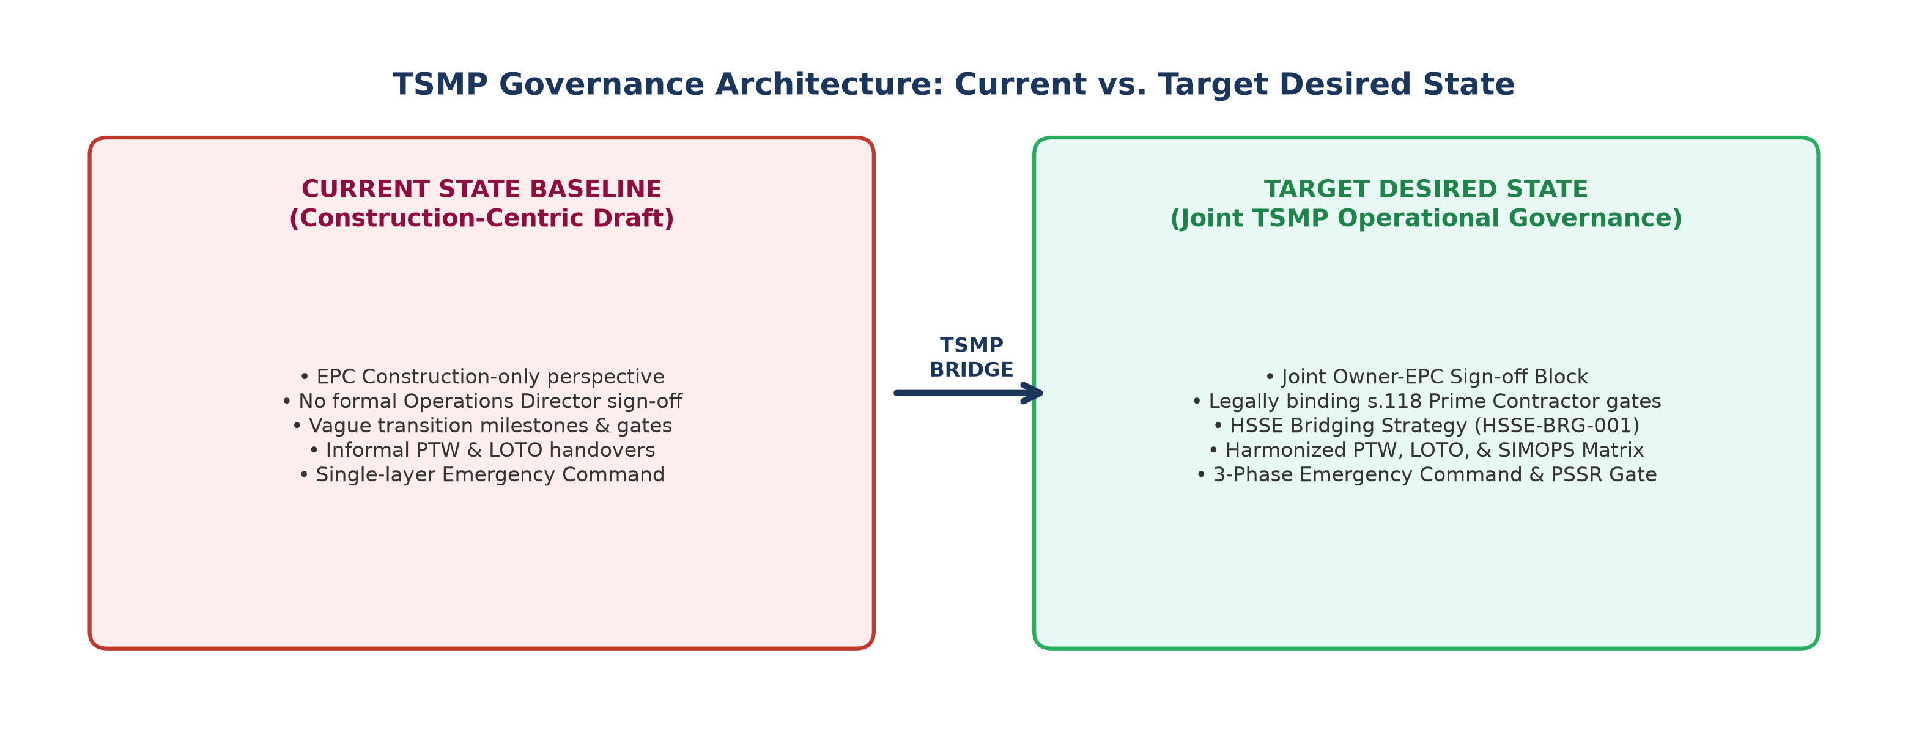

SECTION 1.0: PURPOSE, SCOPE & TRANSITION MILESTONES
1.1 Purpose & Execution Scope
1.1.1 Governance Bridge between EPC Construction Rules and Owner OSMM: Establishes a legally binding, operational bridge between EPC construction safety rules and the Woodfibre LNG Operations Safety Management System.
1.1.2 Lifecycle Phases: Governs progressive system transition through Mechanical Completion (MC) -> Pre-Commissioning -> Commissioning -> Ready for Start-Up (RFSU) -> Hydrocarbon Introduction -> Operational Acceptance.
1.2 Dispersed / Subsystem Turnover Execution Model
1.2.1 Non-Linear System Handover Strategy: Governs early turnover of non-linear utility systems (Instrument Air, Plant Nitrogen, High-Voltage Power) prior to main facility mechanical completion.
1.2.2 Interface Control: Establishes physical, visual, and administrative controls between energized subsystems and adjacent active construction footprints.
1.3 Statutory & Regulatory Approvals Gate
1.3.1 BCER Commissioning Consent & Testing Notifications: Mandates compliance with BC Energy Regulator consent gates prior to fluid/hydrocarbon introduction.
1.3.2 Technical Safety BC (TSBC) Operating Permits: Requires verified TSBC operating permits and inspector sign-offs before energizing electrical or boiler/pressure vessel equipment.
[GAP ANALYSIS - SEC 1.0] CURRENT VS. TARGET COMPARISON (SEC 1.0):
• Current Baseline: Vague phase transitions based solely on construction progress.
• Target TSMP State: Strict regulatory gates (BCER, TSBC, WorkSafeBC s.118) and non-linear utility handover controls.

SECTION 2.0: TRANSITIONAL ROLES, RESPONSIBILITIES & AUTHORITY MATRIX
2.1 WorkSafeBC Prime Contractor Governance during Transition
2.1.1 Owner Prime Contractor Overall Site Safety Authority: Woodfibre LNG retains overall s.118 Prime Contractor site safety authority.
2.1.2 Owner Safety Oversight Structure: Defines multi-employer safety oversight protocols between EPC, Subcontractors, and Owner teams.
2.2 EPC Contractor Oversight & Subcontractor Safety Alignment
2.2.1 EPC Construction Oversight Responsibilities on Un-Turned-Over Assets: EPC maintains direct execution authority over static construction areas.
2.2.2 Subcontractor Safety Alignment: Enforces mandatory compliance across all lower-tier subcontractors.
2.3 Owner Operations & Commissioning Team Authority
2.3.1 Commissioning Manager & Area Isolation Authority Powers: Holds absolute authority over boundary isolations and energized testing.
2.3.2 Operations Permit Issuing Authority: Sole authority for issuing permits on turned-over systems.
2.4 Interface & Authority Matrix (RACIS Chart)
2.4.1 System Handover RACIS Matrix: Establishes primary accountabilities across Construction, Commissioning, Operations, and EPC roles.
Transition Scope / Activity | Construction | Commissioning | WLNG Operations | EPC Contractor | Subcontractors
Area Handover Cert (AHC) | Responsible | Accountable | Consulted | Responsible | Informed
Boundary Lockout / Isolation | Support | Accountable | Consulted | Responsible | Informed
Commissioning PTW Issuance | Informed | Accountable | Consulted | Support | Informed
Operational PTW (Turned-Over) | Informed | Consulted | Accountable | Informed | Informed
PSSR Clearance & RFSU | Consulted | Responsible | Accountable | Support | Informed
Emergency Command (Phase 3) | Informed | Support | Accountable | Support | Informed

SECTION 3.0: CARE, CUSTODY, AND CONTROL (CCCC) & HANDOVER GATES
3.1 System Boundary Demarcation & Red Line Markings
3.1.1 Demarcation P&ID Drawings: System boundaries highlighted on color-coded P&IDs.
3.1.2 Physical Boundary Signs: Mandatory boundary flags, barricades, and live-system warning signs.
3.2 Joint System Walkdown & Punchlisting Protocol
3.2.1 Pre-Walkdown Verification: Verification of hydrotest, NDE, and flush records prior to walkdown.
3.2.2 Joint Walkdown Team Composition: Multidisciplinary team (Owner Ops, Engineering, EPC Quality).
3.3 Punchlist Categorization & Mandatory Closeout Gates
3.3.1 Category A Punch Items: Mandatory 100% closeout prior to Mechanical Completion / Testing.
3.3.2 Category B & C Items: Strict closure schedule prior to commodity introduction.
3.4 Transfer of Care, Custody, and Control (CCCC) Certificates
3.4.1 Certificate Sign-Off Workflow: Formal execution of MC, RFC, RFSU, and Operational Custody certificates.
3.4.2 Legal Asset Logging: Centralized legal tracking of asset custody transfer.
SECTION 4.0: TRANSITIONAL PERMIT TO WORK (PTW) PROTOCOL
4.1 Harmonized PTW Architecture
4.1.1 Retain EPC Permit Form Factor: Retains familiar EPC permit layout to prevent worker confusion during construction overlap.
4.1.2 Transfer Authority: Shifts permitting authority exclusively to WLNG Operations for turned-over systems.
4.2 Daily Scope-Specific Permitting Execution
4.2.1 Mandatory Shift to Daily Permits: Eliminates multi-day permits on live/turned-over assets.
4.2.2 Daily Permitting Workflows: Mandatory daily field risk assessments, gas testing, and Area Authority sign-offs.
4.3 Multi-Day 'Blanket Permit' Rules & Risk Screening
4.3.1 Low-Risk Work Scopes: Restricts multi-day permits strictly to non-intrusive, static civil work.
4.3.2 Exclusion Criteria: Absolute prohibition of blanket permits on live, energized, or pressurized systems.
4.4 PTW Interface & Cross-Boundary Permitting Controls
4.4.1 Cross-Boundary Dual Permitting: Work originating in construction zones impacting live systems requires dual PTW sign-off from both Construction and Operations Area Authorities.
SECTION 5.0: PHYSICAL, VISUAL & COMMUNICATION ISOLATION CONTROLS
5.1 Physical Energy Isolation (LOTO) Controls
5.1.1 Color-Coded Lock System: Operations Master Locks (Red) for system boundaries vs. Construction Locks (Blue).
5.1.2 Positive Isolation Standards: Mandatory blinds, blanks, and double-block & bleed isolations on process lines.
5.2 Visual Boundary Demarcation
5.2.1 High-Visibility Live Tags: Color-coded live system tags and danger signage.
5.2.2 Physical Valve Isolation: Cable and chain lockouts on Operations-controlled valves.
5.3 Advance 'Livening Up' Notification Schedule
5.3.1 7-Day Advance Notice: Mandatory site-wide broadcast map 7 days prior to energization.
5.3.2 48-Hour Re-Notification: Direct alignment with area supervisors.
5.3.3 24-Hour Final Warning: Physical siren/horn broadcast and final walkdown clearance.
5.4 Lockout/Tagout (LOTO) Custody Transfer Mechanics
5.4.1 Cutting Construction Locks: Formal removal protocol for construction locks under witness.
5.4.2 Master Lock Box Installation: Transfer to Operations central key safes.
SECTION 6.0: SIMOPS MANAGEMENT & MULTI-LAYERED FIELD ASSURANCE
6.1 SIMOPS Hazard Analysis: Daily SIMOPS risk matrix assessing construction work adjacent to energized utilities or process fluids.
6.2 Multi-Layered Assurance: Safety department field auditing, supervisory checklists, and stage-gate sign-offs.
SECTION 7.0: MANDATORY IN-PERSON TRANSITION ORIENTATION & COMPETENCY
7.1 Transition Orientation Mandate: 100% mandatory classroom orientation for all site personnel prior to plant energization; passing score required for badge re-authorization.
7.2 In-Person Delivery: Practical LOTO and PTW training.
7.3 Train-the-Trainer: Certified instructor qualification standards.
SECTION 8.0: MANAGEMENT OF CHANGE (MOC) ON TURNED-OVER ASSETS
8.1 Mandatory Triggers: Strict MOC required for pipe, instrument, logic, or valve changes on turned-over assets.
8.2 Joint MOC Review Committee: Multidisciplinary approval committee (Engineering, Operations, Commissioning, Safety).
8.3 Field Re-Testing Controls: Required re-testing and red-line drawing updates prior to re-commissioning.
SECTION 9.0: PRE-STARTUP SAFETY REVIEW (PSSR) & COMMODITY INTRODUCTION GATE
9.1 Pre-Commissioning Protocols: Controls for nitrogen purging, drying, and cryogenic tightness testing.
9.2 PSSR Gate Execution: Multidisciplinary 5-step field verification checklist and certificate sign-off.
9.3 Punchlist Closure Gate: Mandatory 100% closure of Category A, B, and C items before hydrocarbon introduction.
SECTION 10.0: PHASED EMERGENCY MANAGEMENT & ICS TRANSITION
10.1 Phase 1 (Construction): EPC Site ERP & Owner-managed medical provider.
10.2 Phase 2 (Commissioning): Unified Command Post with Dual Incident Commanders (Construction + Operations).
10.3 Phase 3 (Hydrocarbons): Sole WLNG Operations Incident Command System (ICS).

