1. **Inbox (Composing a message)**
   1. Input domain

The input domain for the composing a message includes the Course section, the message recipients (only available after selecting the Course section), the subject of the message, the body of the message, any attachments the user wants to add to the message, and the option to send a different message to each recipient (This option will not be covered in the test cases).

Most of the input domain can be partitioned (One for the subject, one for the attachments, etc.) except for selecting the message recipient because the user must select a course before they can select their recipients.

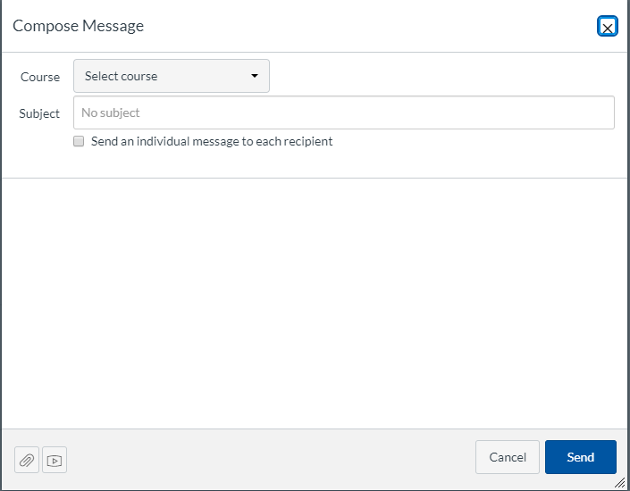

Figure 1: Before selecting a course

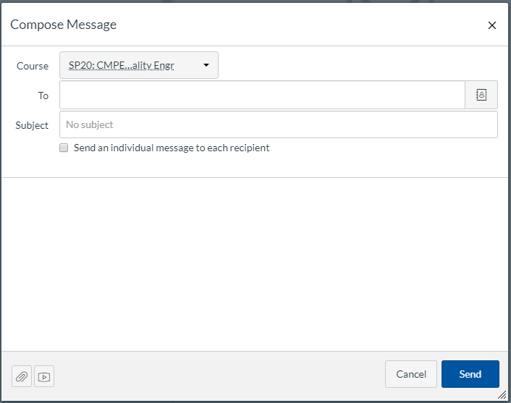

Figure 2: After selecting a course

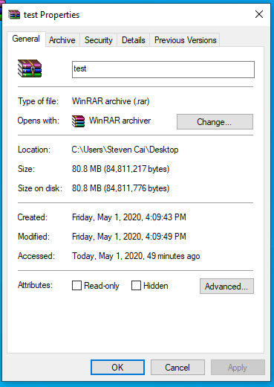

Figure 3: The attachment that will be used in all applicable tests.

* + 1. Course: The input domain is a selection from a list of courses that the user is currently enrolled in.
    2. To: The input domain is a selection from a list of users that are in the selected course.
    3. Subject: The input domain is a string input.
    4. Message Body: The input domain is a string input.
    5. Attachments: The input domain is a file either from the user’s files on canvas or on their computer.
  1. Test Cases

|  |  |  |  |  |
| --- | --- | --- | --- | --- |
| Test Case | Input | Expected Output | Actual Output | Test Pass/Fail? |
| 1 | Course: CMPE 187  To: (empty)  Subject: Test1  Message: Hello there  Attachments: (none) | Canvas will inform me that my recipient input is invalid. | See Figure 3. | Pass |
| 2 | Course: CMPE 187  To: Zelin Cai  Subject: Test2  Message: (empty)  Attachments: (none) | Canvas will send the message normally. | See Figure 4. | Fail |
| 3 | Course: CMPE 187  To: Zelin Cai  Subject: (empty)  Message: Test Case 3  Attachments: (none) | Canvas will send the message normally. | Canvas gave the message title “(No Title)”. See Figure 5. | Pass |
| 4 | Course: CMPE 187  To: Zelin Cai  Subject: Test4  Message: Testing Case 4  Attachments: A rar file around 80 MB | Canvas will inform me that the file is too big to attach to the message. | Canvas sent the message after about 10 minutes.  See Figure 6. | Fail |
| 5 | Course: (None)  To: (None)  Subject: Test5  Message: Testing Case 5  Attachments: (none) | Canvas will inform me that my course selection is invalid. | Canvas gave me the same output as Test Case 1. See Figure 7. | Fail |

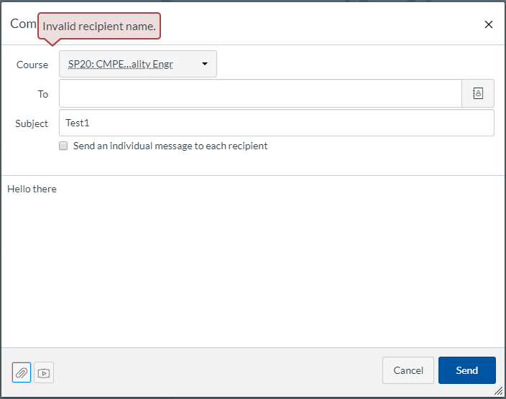

Figure 3: Test Case 1 Output

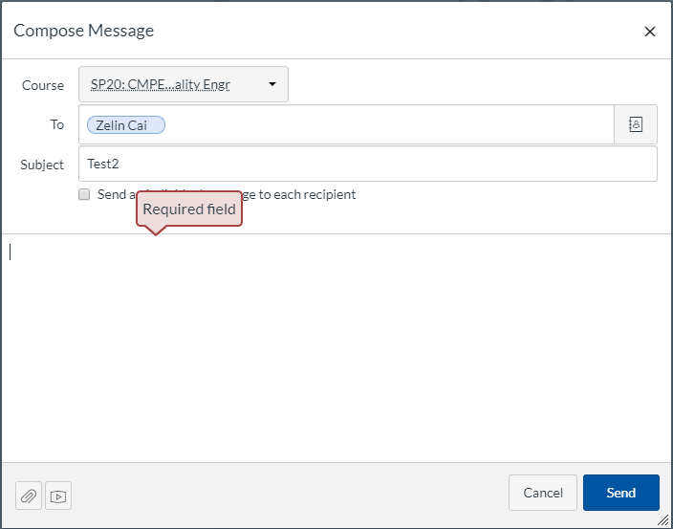

Figure 4: Test Case 2 Output

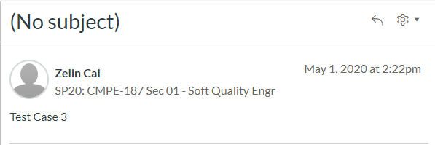

Figure 5: Test Case 3 Output

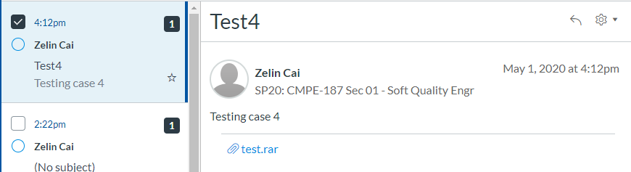

Figure 6: Test Case 4 Output

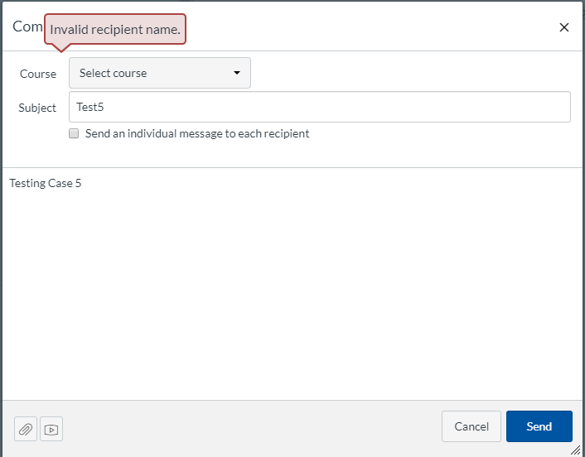

Figure 7: Test Case 5 Output

1. **ePortfolio (Managing portfolios)**
   1. Input Domains

The test cases will focus on creating and managing pages in an ePortfolio. This gives us a bigger input since creating a portfolio and a page in a portfolio take different inputs. The input domain for making a new ePortfolio online consists of the ePortfolio name and an option to make it public or not. When managing an ePortfolio page, the input domain includes the page name, rich text, HTML/embedded content, course submission (not testing this), image/file upload and the body for each of these inputs except image/file upload.

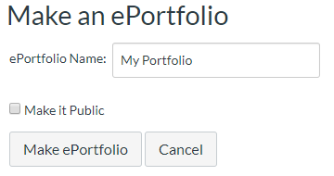

Figure 8: Creating an ePortfolio

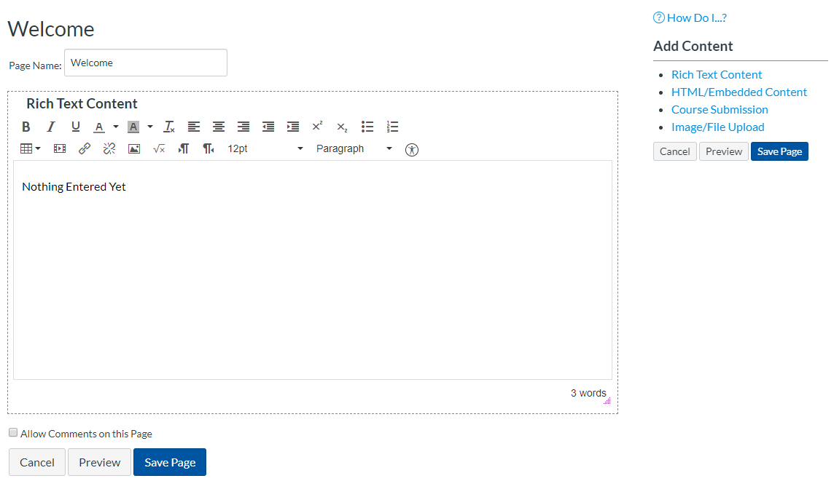

Figure 9: Creating a page inside an ePortfolio

* + 1. ePortfolio name: The input domain is a string input.
    2. Page name: The input domain is a string input.
    3. Rich text: The input domain is a string input.
    4. HTML/Embedded: The input domain is HTML code or something similar.
    5. Image/File: The input domain is either a image or file from the user’s files or computer.
  1. Test Cases

|  |  |  |  |  |
| --- | --- | --- | --- | --- |
| Test Case | Input | Expected Output | Actual Output | Test pass/fail? |
| 1 | ePortfolio name: (empty)  Page name: (N/A)  Rich text: (N/A)  HTML/Embedded: (N/A)  Image/File: (N/A) | Canvas will not create the portfolio if the name is empty. | See Figure 10. | Pass |
| 2 | ePortfolio name: test  Page name: (empty)  Rich text: Testing Case 2  HTML/Embedded: (empty)  Image/File: (none) | Canvas will tell me that a page title is required. | Canvas created the page without issues. See Figure 11. | Fail |
| 3 | ePortfolio name: test  Page name: Testing Case 3  Rich text: (empty)  HTML/Embedded: (empty)  Image/File: (none) | Canvas will create the page with only the title displayed. | Leaving the text blank reverts it back to its previous text. See Figure 12. | Fail |
| 4 | ePortfolio name: test  Page name: Testing Case 4  Rich text: (empty)  HTML/Embedded: “Definitely not HTML code.”  Image/File: (none) | Canvas will display nothing for this since it is not valid HTML code. | Canvas treated the input as rich text. See Figure 13. | Fail |
| 5 | ePortfolio name: test  Page name: Testing Case 5  Rich text: (empty)  HTML/Embedded: (empty)  Image/File: A .rar file about 80 MB. | Canvas will inform me that the image/file is too large to upload. | Canvas uploaded the file after a few minutes and was faster than sending the same file in a message. See Figure 14. | Fail |

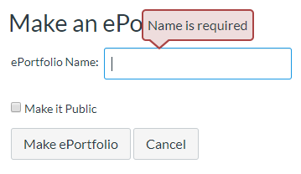

Figure 10: Test Case 1 Output

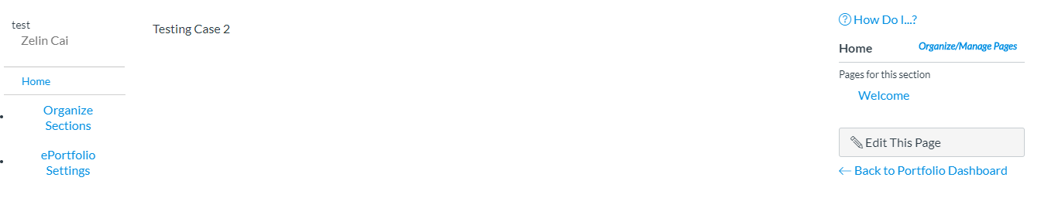

Figure 11: Test Case 2 Output

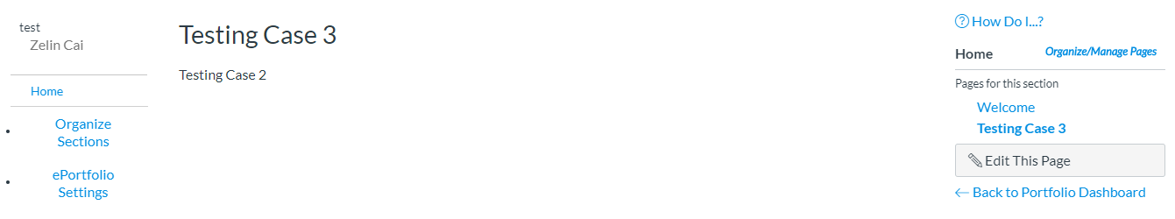

Figure 12: Test Case 3 Output

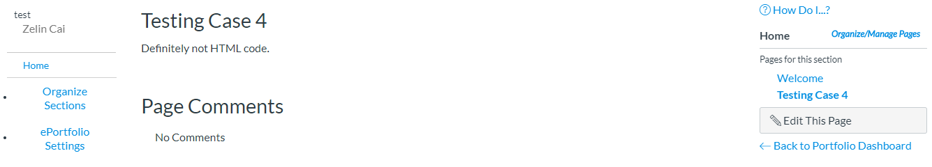

Figure 13: Test Case 4 Output

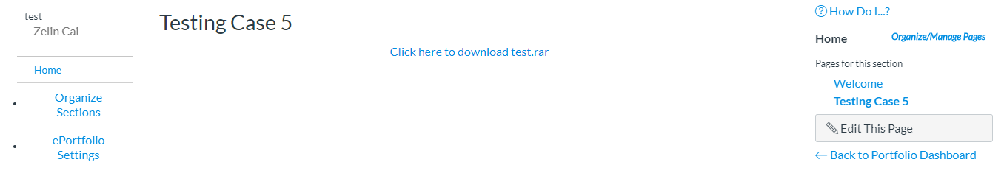Figure 14. Test Case 5 Output