**ExactCurrencyTestCases:**

The test cases we implemented here did not utilize any of the testing techniques we learned.

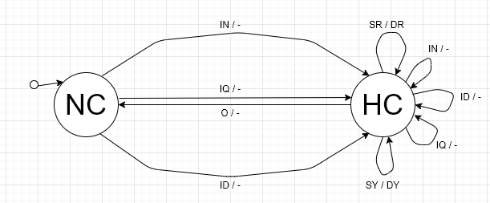

**States**

|  |  |  |
| --- | --- | --- |
| Abbreviation | Expanded Form | Meaning |
| NC | No currency | The machine has no currency. |
| HC | Has currency | The machine has some currency. |

**Transitions**

|  |  |
| --- | --- |
| Inputs | Outputs |
| IN: Insert nickel | DR: Dispense red gumball |
| ID: Insert dime | DY: Dispense yellow gumball |
| IQ: Insert quarter | -: No output |
| SR: Select red gumball |  |
| SY: Select yellow gumball |  |
| O: Out of currency |  |

**Revised Test Cases**

Note: The machine is assumed to have enough currency for these test cases.

|  |  |  |
| --- | --- | --- |
| Test Case | Test Sequence | Expected Output |
| 1 | <NC, IN / -, HC>  <HC, SR / DR, HC>  <HC, O / -, NC> | "Enjoy your red gumball" |
| 2 | <NC, ID / -, HC>  <HC, SY / DY, HC>  <HC, O / -, NC> | "Enjoy your yellow gumball" |
| 3 | <NC, IN / -, HC>  <HC, IN / -, HC>  <HC, SY/ DY, HC>  <HC, O / -, NC> | "Enjoy your yellow gumball" |
| 4 | <NC, IQ / -, HC>  <HC, SY/ DY, HC>  <HC, SR/ DR, HC>  <HC, SY/ DY, HC>  <HC, O / -, NC> | "Enjoy your yellow gumball"  "Enjoy your red gumball"  "Enjoy your yellow gumball" |