
EASYFOODS
CMPG 223 |
The ACCELATORS
GROUP 11

Contents

Group Members ...................................................................................................................................... 2
Updated ER diagram ………....................................................................................................................... 3
Physical Process mode .0.......................................................................................................................... 4
Class diagram……………………………… .......................................................................................................... 5
Physical Data Model …………………….......................................................................................................... 6

Group members
Surname and initials student number
Molelo TA 28969588
Mokoena MS 26913860
Setlatjile MM 31281613
Kutumela T 29865514
Mthiyane k 29621666

Updated ER diagram

Process model

Class diagram

Physical data model

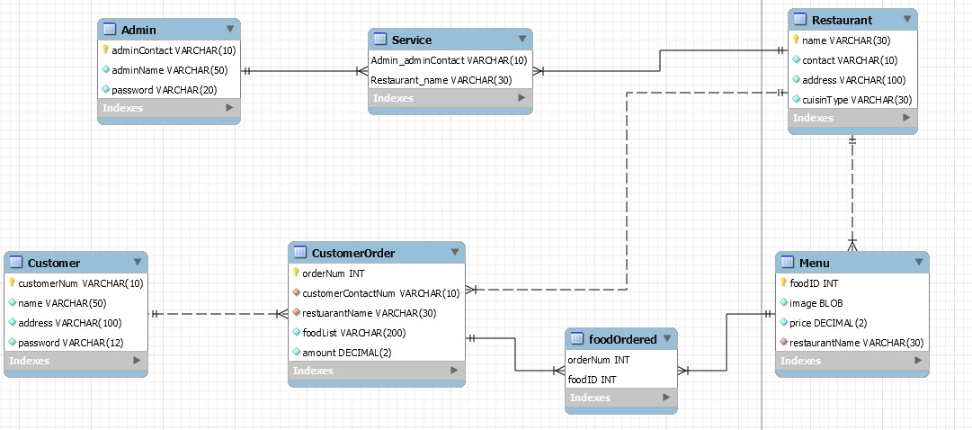

SQL for Creating the database and tables
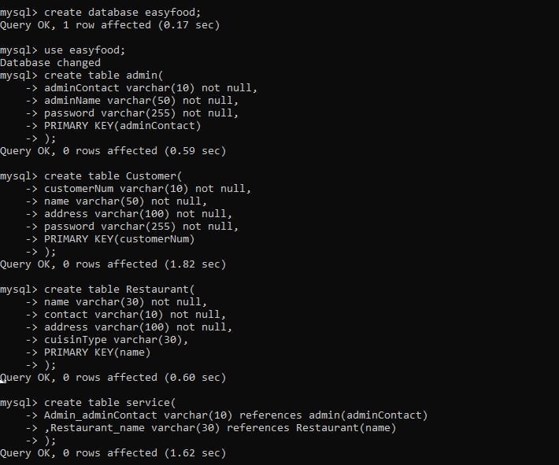

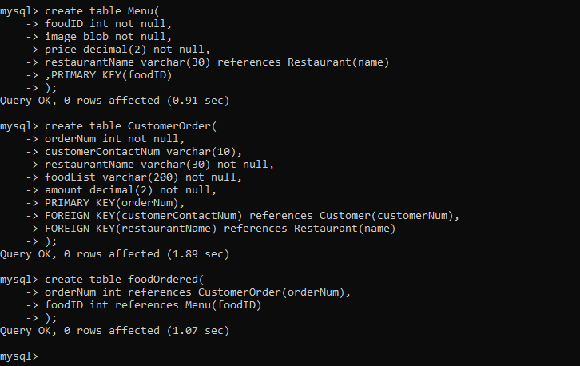

Maintaining tables (CRUD Functionality)

  - DATABASE CONNECTION
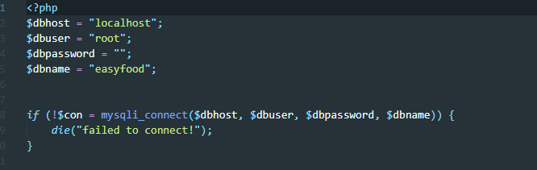

  - INSERTION QUERIES
1.
2. 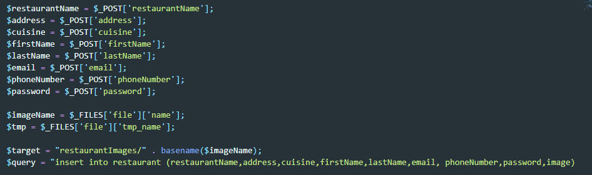
3.
4.
5.

  - UPDATE QUERY

  - SELECT QUERY
1.
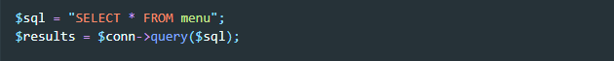
2.
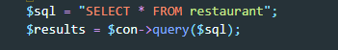
3.
4.
5.
6.
  - DELETE QUERY
1.
2.

SCREEN PRINTS OF REUSE OF CODE
- This is the main file used for declaring functions and reusing them on other files by calling them
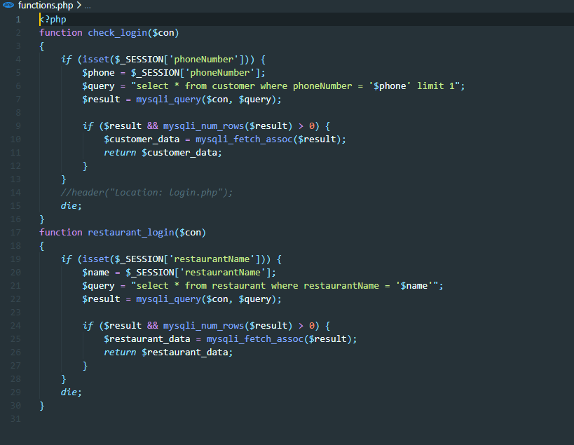

- File containing code used to connect to the database
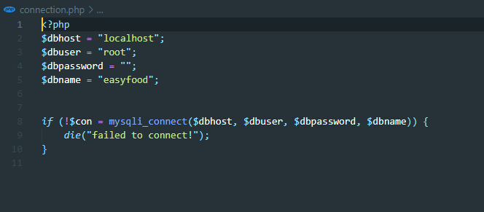

- Illustration of reusing code from connection file and functions file
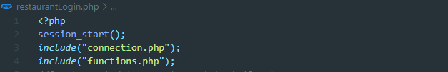
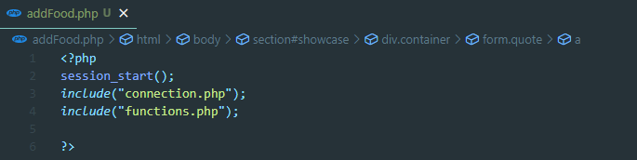
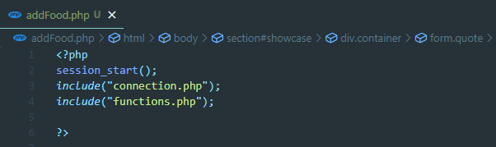
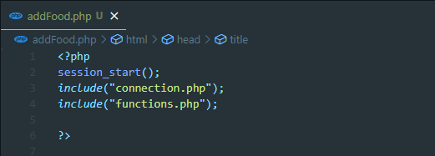
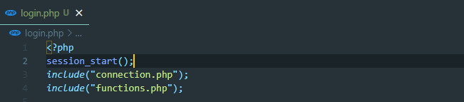
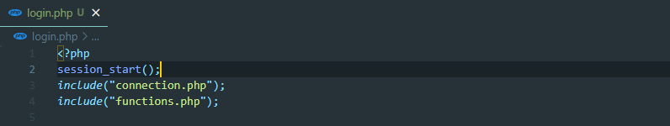
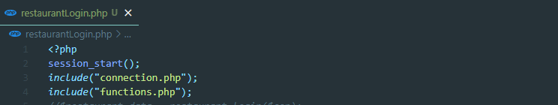
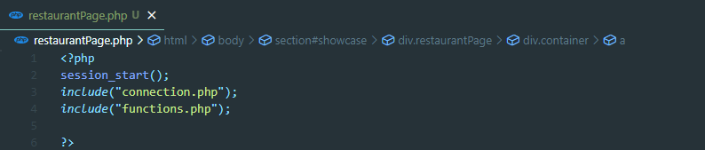
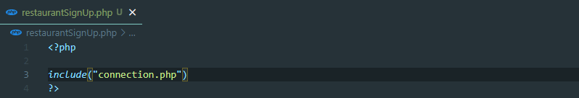
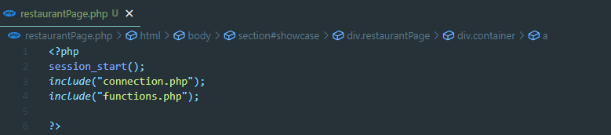
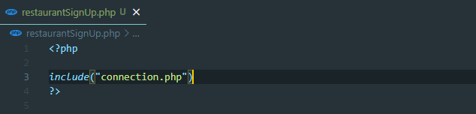
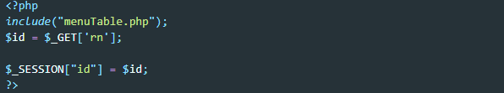

REPORTS

USER MANUAL

Step 1
The potential user has to visit the website’s home page and they will navigate.
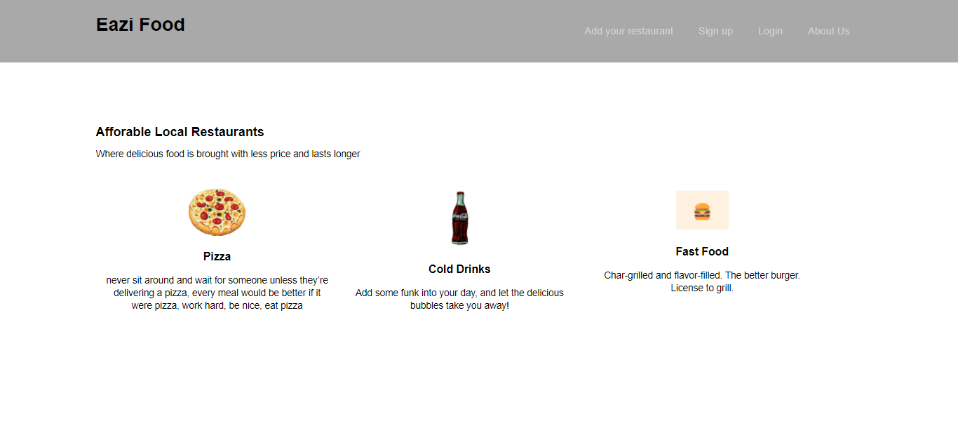
Step 2
The potential customer has to navigate to the sign-up link first as either a restaurant entity or individual.
- Customer Sign Up
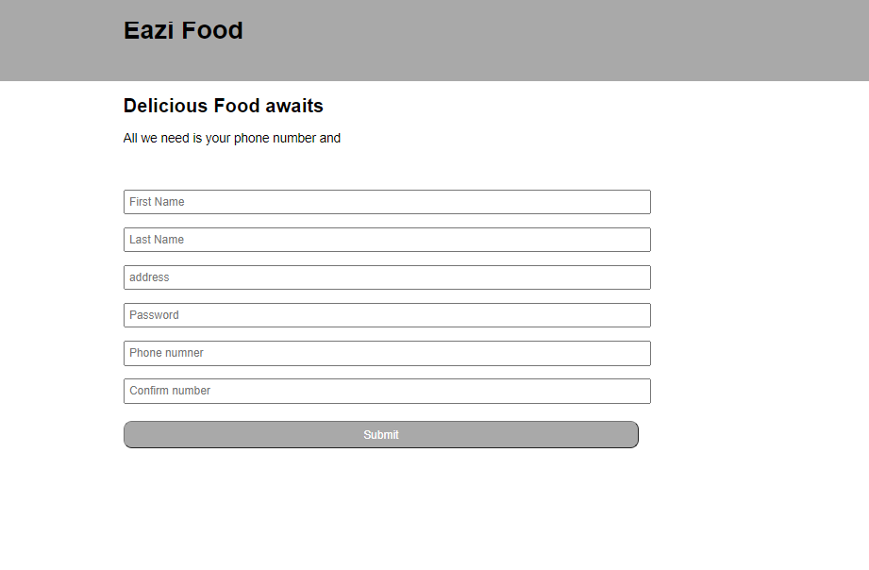
- Restaurant Sign Up
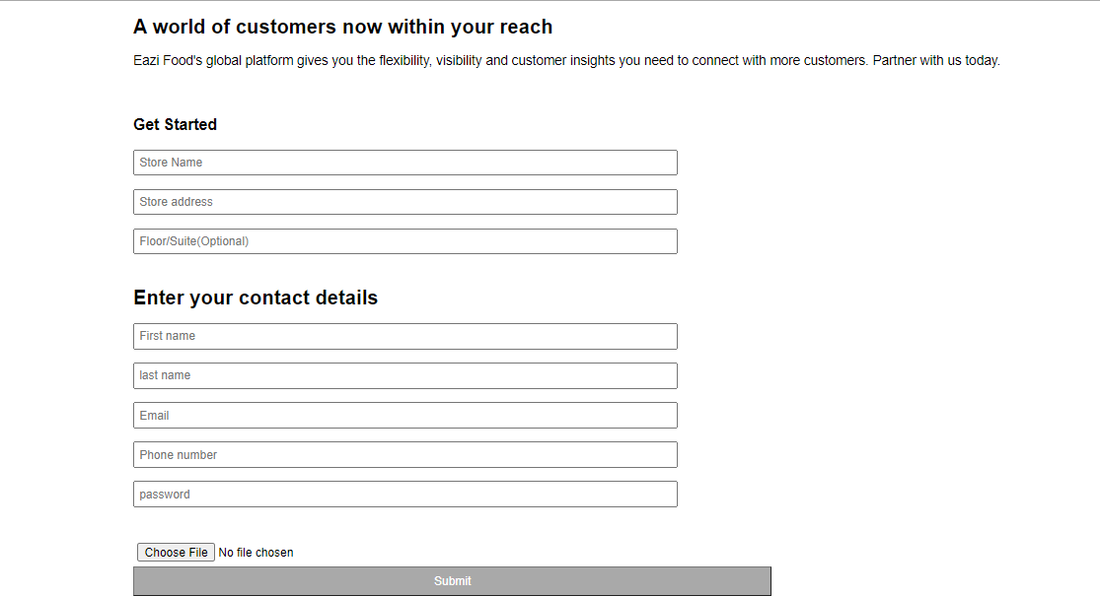

Step 3
If the user created their account successfully, they can login.
- Customer logs in using phone number and password.
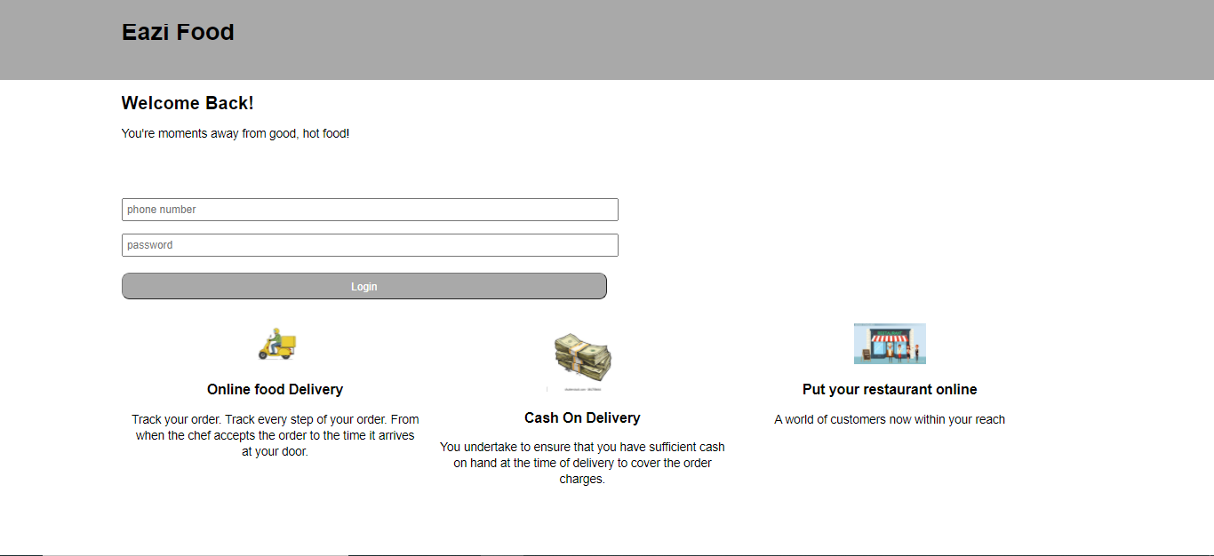

- Restaurant logs in using restaurant name and password.
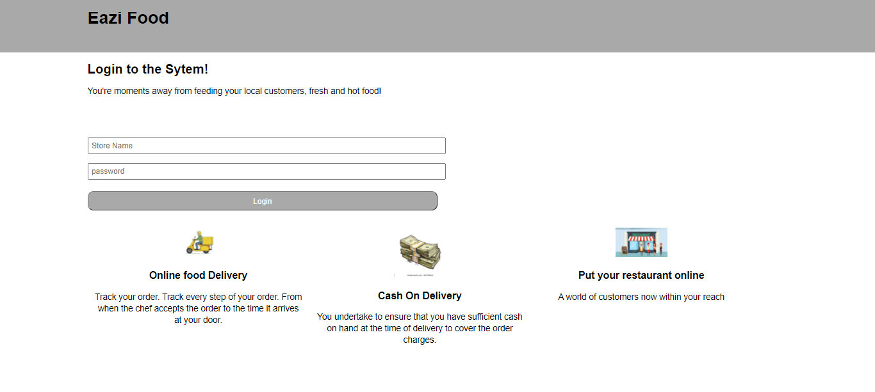

Step 4
- After the customer successfully logs in, they are navigated into the customer page which has local restaurants they can choose from to buy at.
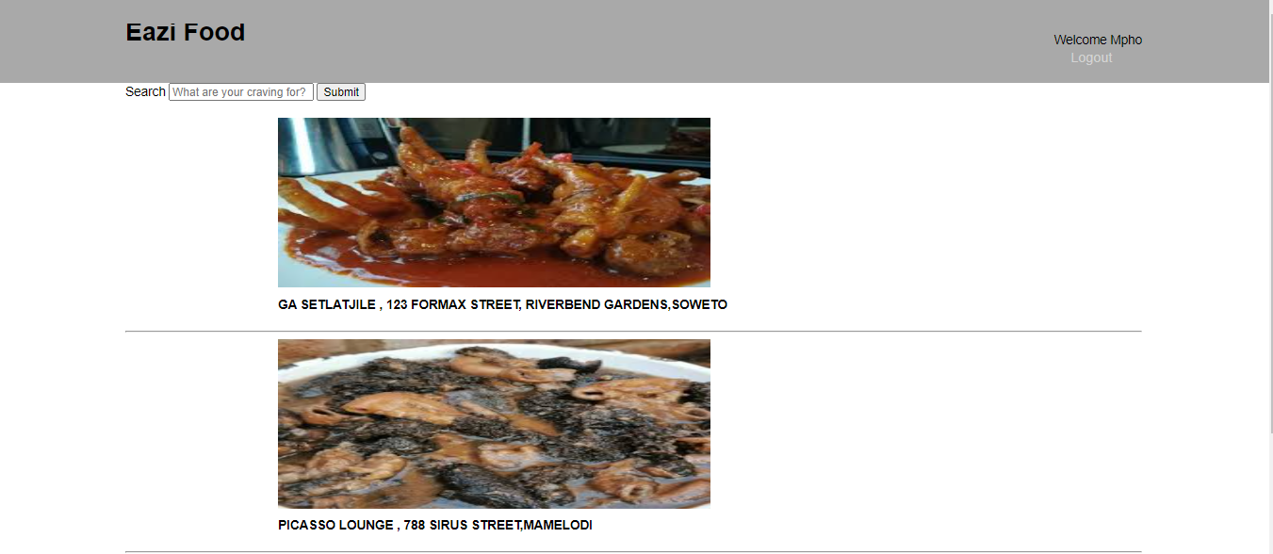
- After the restaurant successfully logs in, it is navigated into the restaurant page which has restaurant management interface.
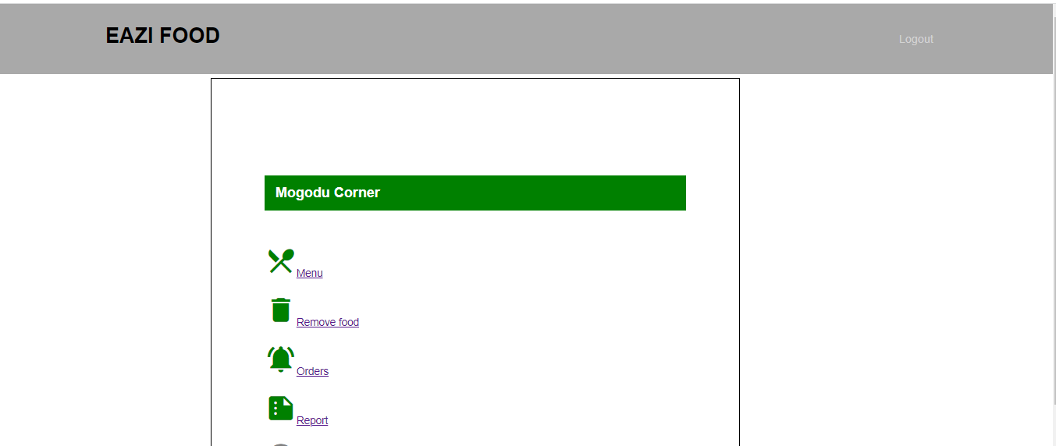
Step 5
- The restaurant admin can navigate to the menu to add or delete food.
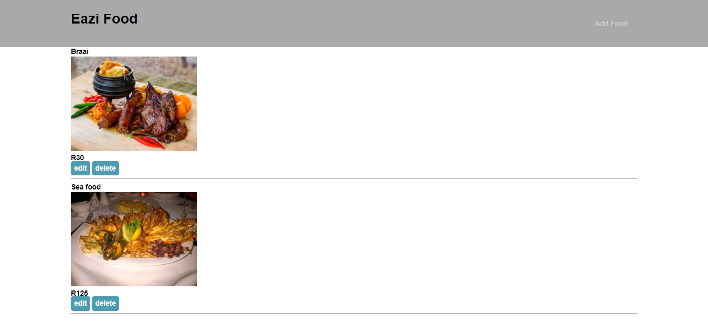

- Restaurant admin can delete food.
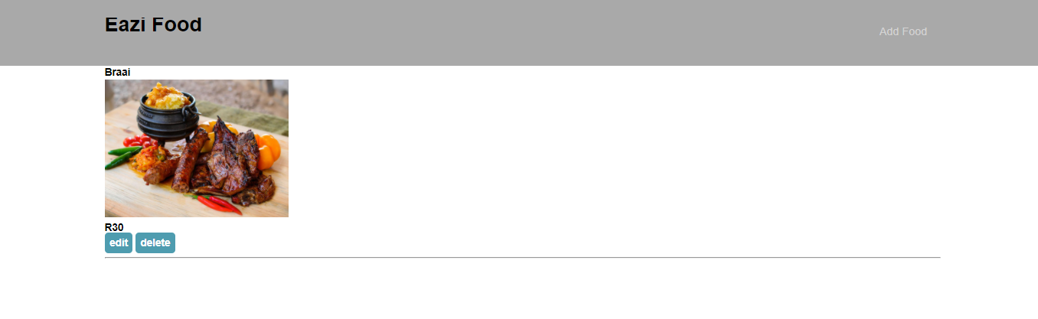
Step 6
- The restaurant admin can add food to the menu
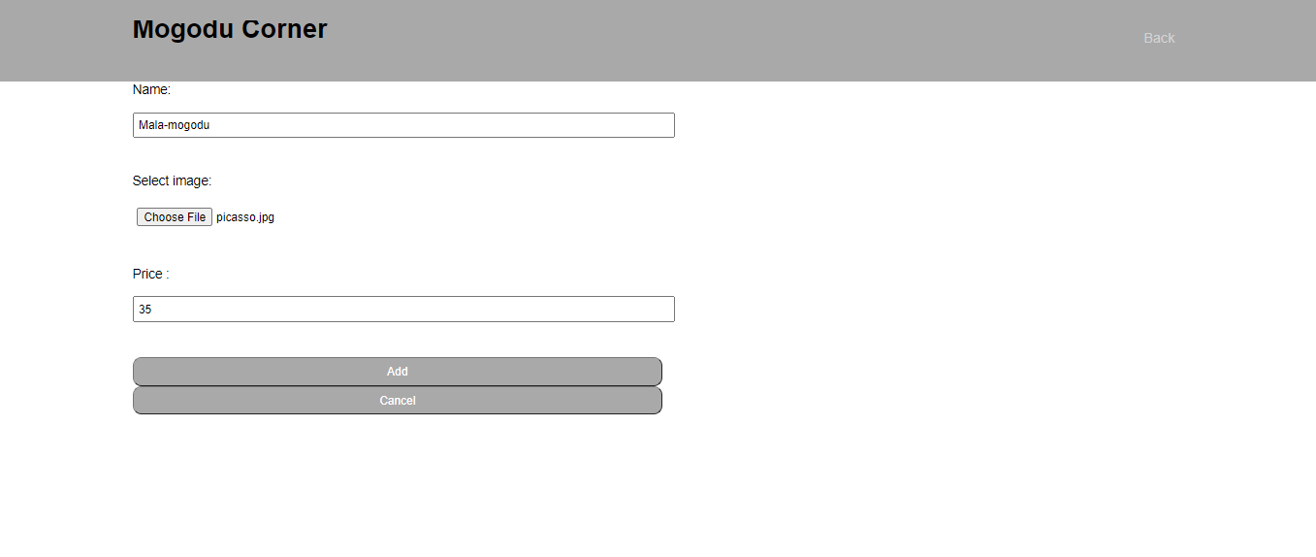

- The food added by the admin.
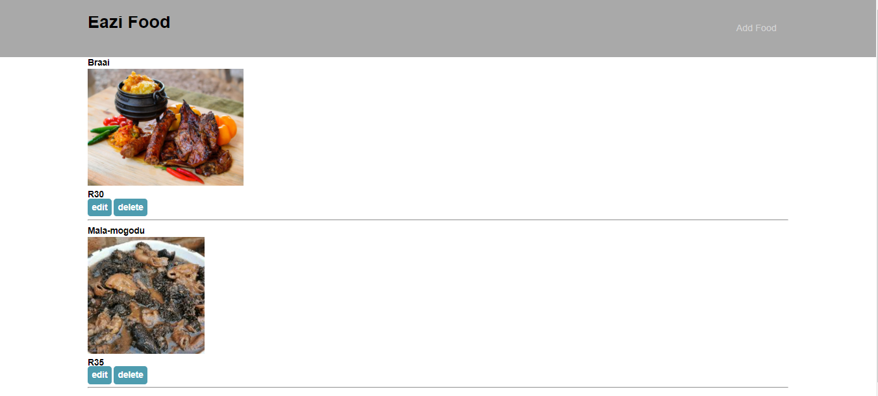

TECHNICAL REQUIREMENTS
- RAM: 500MB
- HDD: 5500 RPM
- PROCESSOR SPEED: 1GHz

