Assessing Air Quality for Bicycle Commuting in New York City
Researchers at Columbia University have begun a study to measure the quality of the air breathed by New York City's increasing population of commuters who travel by bicycle, and the effect this air has on riders' cardiovascular health.(1) Air quality is of special interest to anyone spending time outdoors in the city. The NYC Department of Health's Community Air Survey notes that one pollutant, PM_{2.5} (fine particles measuring less than 2.5 microns in diameter), is estimated to cause over 2,000 premature deaths in NYC. It also notes the deleterious effects of sulfur dioxide and nitrogen dioxide, which antagonize asthma and other respiratory diseases.(2)
The Columbia research team is enlisting volunteer cyclists to wear instruments for a five day period before, during and after their commutes. These sensors measure air pollutants, heart rate, respiration and blood pressure in conjunction with a smartphone app tracking time and location along their routes. This differentiates the study from other analyses of NYC air pollution, which rely on static measurements at fixed locations and do not include the effects of exertion of the riders, who can inhale more than ten times in volume what a person at rest can.(3)
It will be challenging to separate the effects of location from the different types of riders, some of whom are serious cyclists that ride long distances while others are less aggressive. The cost of the wearable devices (see Figure 1) limit the number that can be distributed. Participants will be chosen to give a wide range of measurements by location and route.(1)
The study has recently begun with its first group of participants. One rider interviewed in a radio report about the study credits her commuting for a 65-pound weight loss; however, she grew concerned upon learning her ride across the RFK Bridge (see Figure 2) takes her through highly polluted air on Randalls Island.(4) It is hoped that the study results will give policy makers information to provide or enforce healthier cycling infrastructure, and that it will give cyclists data to make informed decisions about the best routes and times for their commutes.
References
1. Help Map Bike-Commuting Air Quality. Accessed 13 September 2015. http://www.columbia.edu/cu/bike/
2. Kheirbak, Iyad, et al. The New York City Community Air Survey: Neighborhood Air Quality 2008-2013. 2015. http://www.nyc.gov/html/doh/downloads/pdf/environmental/comm-air-survey-08-13.pdf
3. Does Air Pollution Deflate Urban Bikers’ Health? Accessed 13 September 2015. http://www.sciencefriday.com/segment/09/11/2015/does-air-pollution-deflate-urban-bikers-health.html
4. Mogul, Fred. Bicycles, Breathing and Bridges: A Toxic Trio? Accessed 13 September 2015. http://www.wnyc.org/story/biology-teacher-reflects-bicycles-bridges-and-breathing/

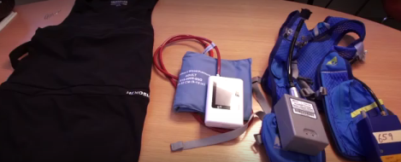Figure 1: Sensor vest used in the study (screen capture from embedded video in ref. (3))

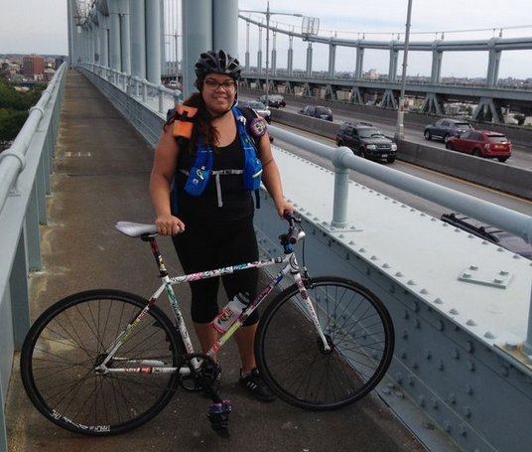Figure 2: Study participant Myrna Gatica wearing the sensor vest on the RFK Bridge (photo credit: Fred Mogul/WNYC; ref. (4))

