CMPS310
Project Milestone 2 – Group MNA

Instructor: Ms. Alaa Hussien
Theory Section No: L02
Lab Section No: B04
Submission date: 1st December 2025

Effort distribution
Nasser Almarri – 202008899 – L02 – Effort: 33.33%
Mohammed Alkuwari – 202204691 – L02 – Effort: 33.33%

Anas Elrahmani – 202203650 – L02 – Effort: 33.33%

Task 1.
1 introduction
This document provides the Design and Implementation of the Gulf Pearl University Library System according to the requirements specified in Milestone-2. The system will automate the various library operations like membership registration, borrowing of an item, returning, reservation, and integration with the university's existing systems.

- Use Case 1 - Register Member
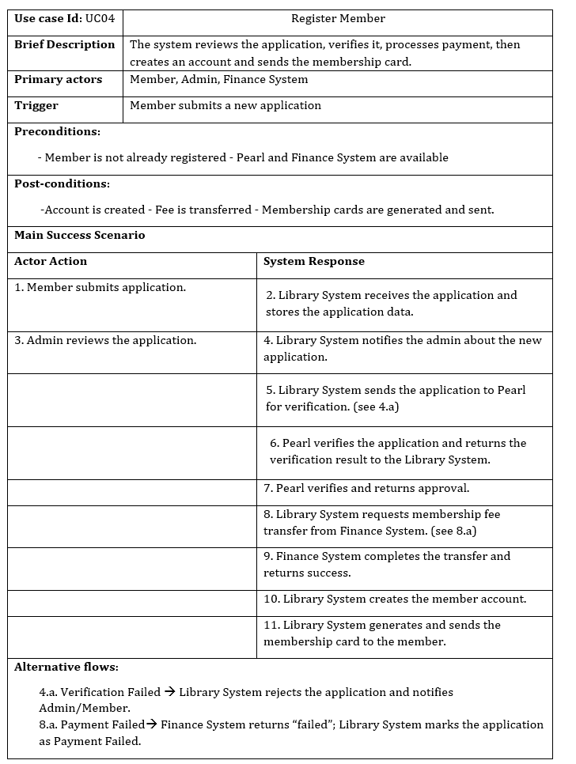

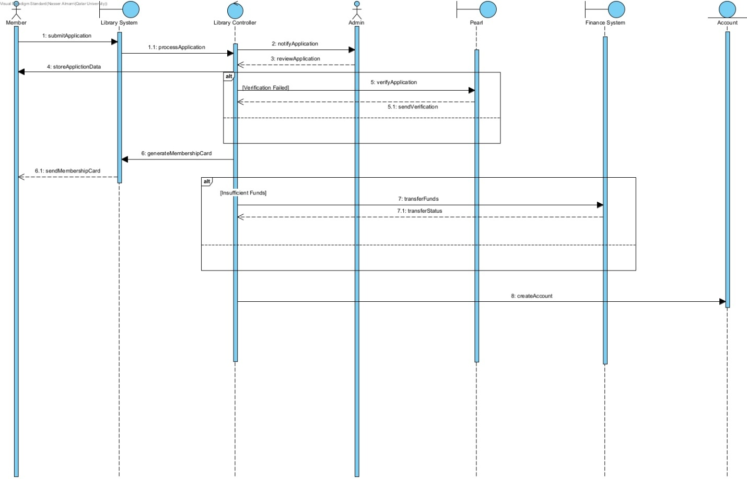

- Use Case 2 – Borrow Item

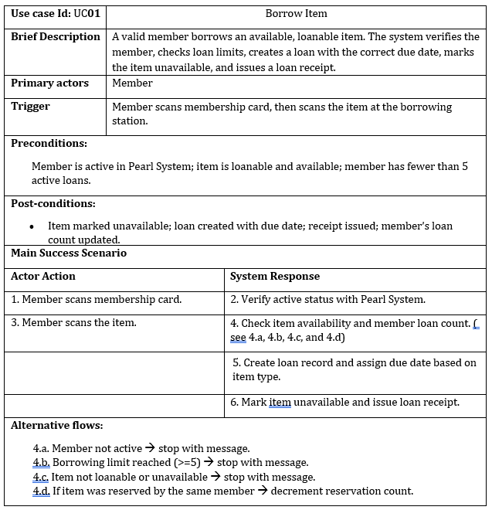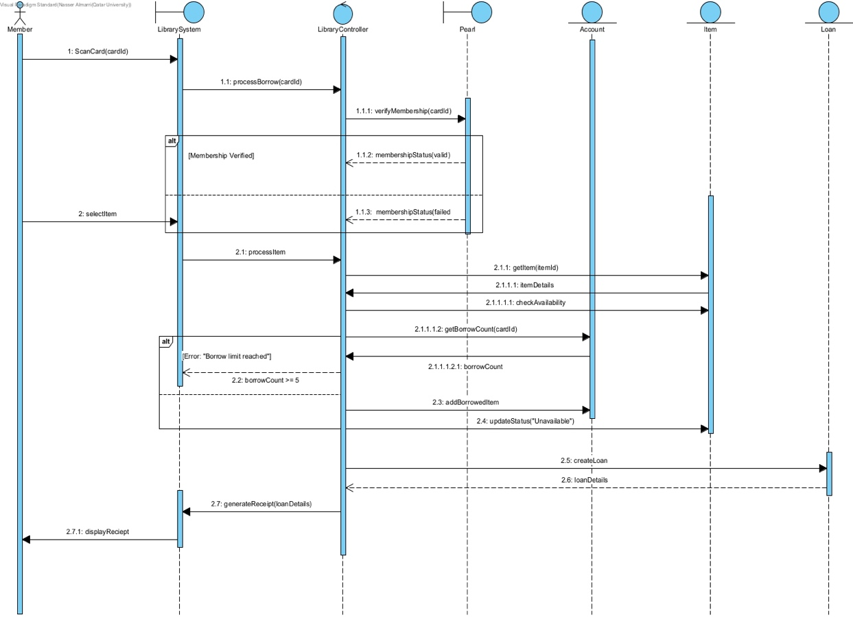

Task 2.

Part A: Constraints

1. Business Constraints
- Only currently registered Gulf Pearl University students or staff may become members, and their status must be authenticated through PearlSys.
- Membership is activated only after the QR 1500 deposit is successfully transferred from the member’s Finance_Account through FinanceSys.
- A member may borrow up to 5 items and reserve up to 3 items at any time.
- Loan periods are fixed: Books – 4 weeks, Digital Media – 1 week, Magazines – 2 weeks.
- Items overdue by more than 7 days must be included in the daily morning process for possible “Lost” status.

2. Technical Constraints
- The system must be integrated with PearlSys to confirm student or staff eligibility.
- The system must integrate with FinanceSys to process deposits, fines, and money transfers.
- The library system must operate as a plug-in to the existing registration system, which uses Google Firebase.
- Sensitive payment data may only be stored on the backend and must be encrypted.

3. Resource & Operational Constraints
- Only one new server is available for deployment.
- A maximum of three technical staff can be hired to support or maintain the system.
- The system must currently support around 400 concurrent requests and be able to scale to 1000 members over the next two years.

4. Process Constraints
- The system must run a scheduled job every day at 08:00 to detect overdue items and prepare potential lost-item cases for admin review.
- Every Member, Item, and Membership Card must have a unique identifier to maintain data consistency.

Part B: Quality Requirements (Non-Functional Requirements)

1. Performance
- At least 95% of borrow, return, and reservation operations must complete within 3 seconds under loads of up to 400 concurrent users.

2. Scalability
- Within two years, the system must support at least 1000 active members without major architectural redesign.
- Scaling should be achievable through configuration changes or hardware upgrades.

3. Security
- All Finance_Account data and payment transactions must be fully encrypted, protected by role-based access control, and never exposed on the client side.
- All communication with PearlSys and FinanceSys must occur over secure, encrypted channels.

4. Availability
- The system must maintain at least 99% availability during college operating hours (07:00–22:00).
- Backup and recovery mechanisms must restore the system within 1 hour, with no data loss exceeding 5 minutes.

5. Portability
- The system must run on major operating systems—Linux, Windows, macOS, iOS, and Unix without requiring code changes beyond configuration adjustments.

6. Interoperability
- At least 99% of verification and payment requests to PearlSys and FinanceSys should succeed under normal conditions.

7. Maintainability
- Changes to loan periods, fine amounts, or reservation limits should require updates to no more than two modules, without modifying the user interface or database structure.
- Adding new item types (e.g., “Thesis”) should not require changes to Borrow, Return, or Reserve processes.

8. Modularity
- System components must be loosely coupled so that changes to one module (e.g., fine calculation) do not affect unrelated modules.
- All communication with external systems must pass through dedicated interface classes.

Task 3.
3- Overview:
- In this task, we implemented the two use cases described in Appendix-B using Java. The program uses a graphical user interface (GUI) built with JavaFX and a controller class (LibrarySystem) to handle the logic. The main goal is to support the normal scenario of each use case and show how the user interacts with the system.

2- UC1 Implementation:
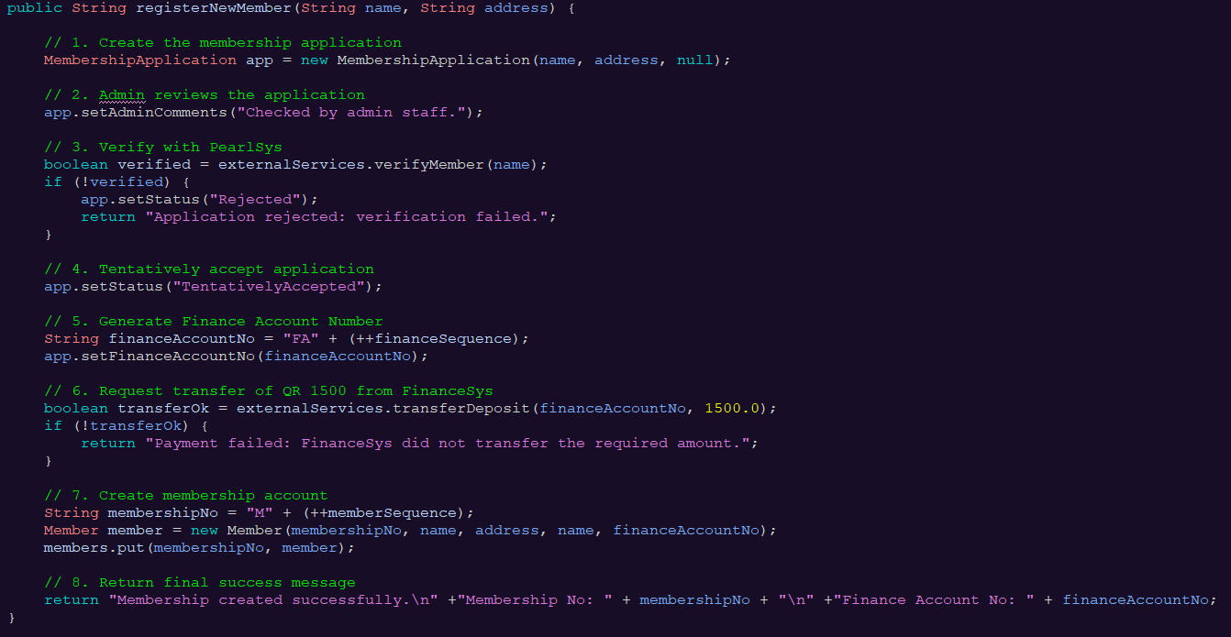

3- UC2 Implementation:
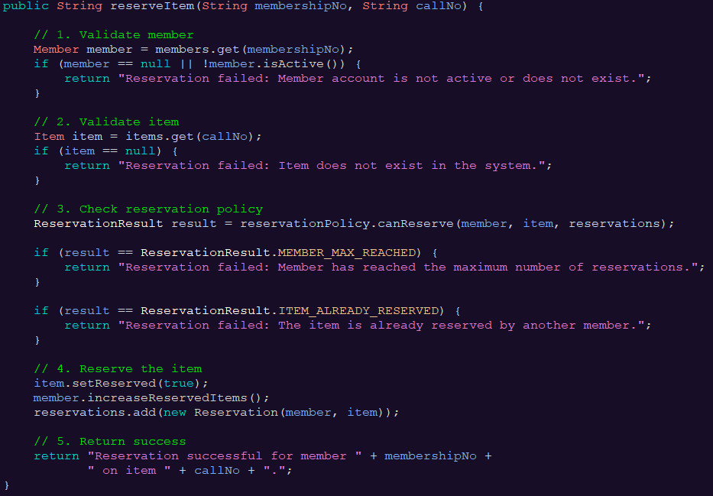

Task 4.

1- RegisterNewMember:
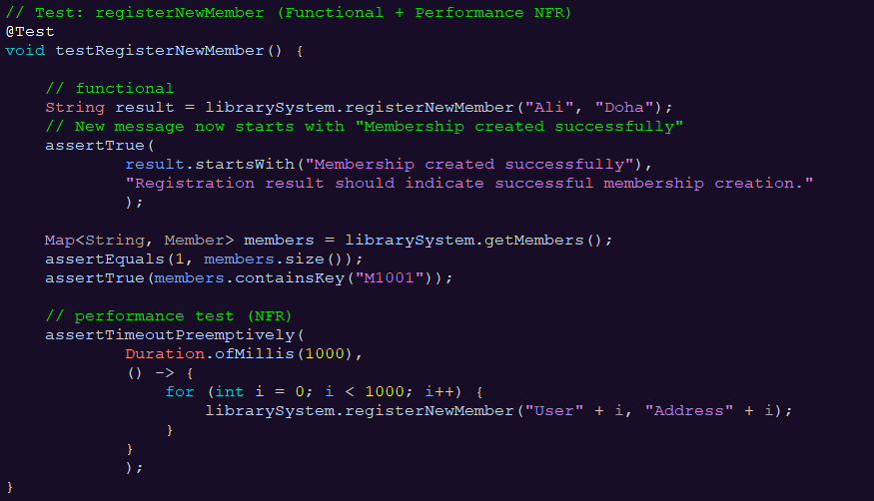

Tests:
- Successful registration
- Data added to members map
- Performance NFR (1000 registrations)

2- ReserveItem:
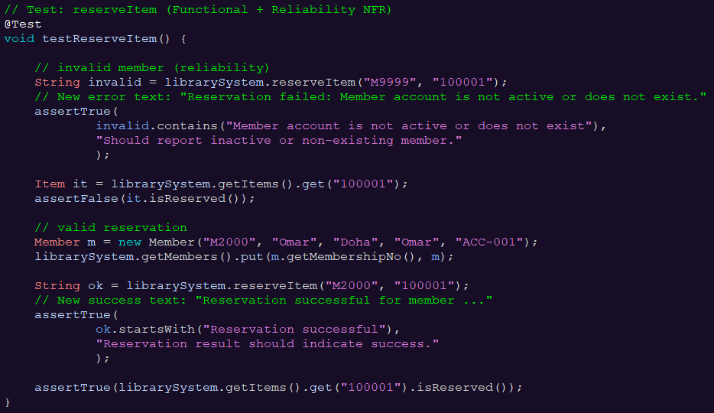

Tests:
- Invalid member
- Valid reservation
- Item becomes reserved
- Reservation added to system

3- getMembers:
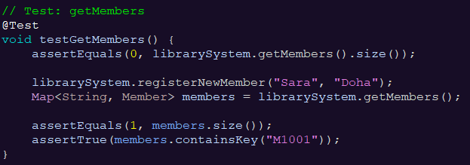
Tests:
- Initially empty
- After registration → size = 1
- Member ID exists

4- getItems:
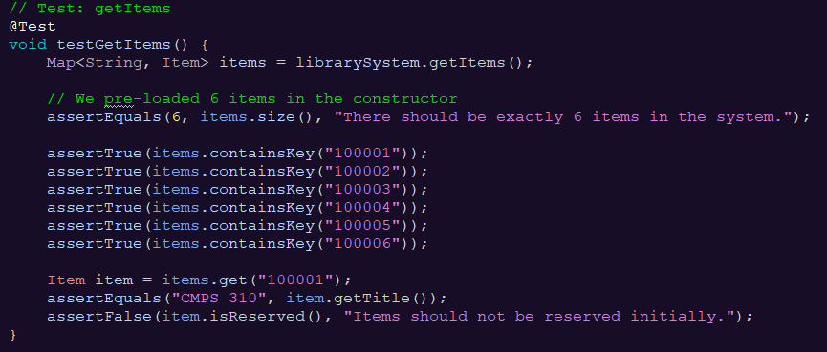
Tests:
- Items count = 6
- Correct titles
- Not reserved initially

5- getReservation:
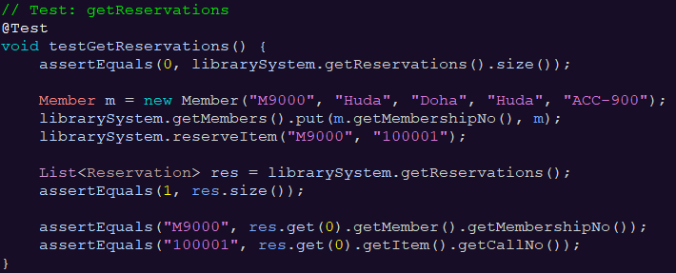

Tests:
- Initially empty
- After reservation size = 1
- Correct member ID and call number
6- listAvailableItems:
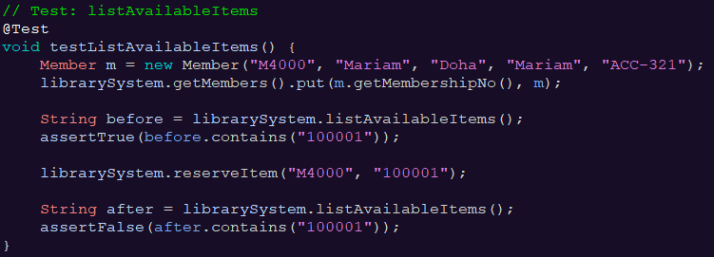

Tests:
- Item appears before reservation
- Does not appear after reservation
- Method returns correct text
7- listMembersWithReservations:
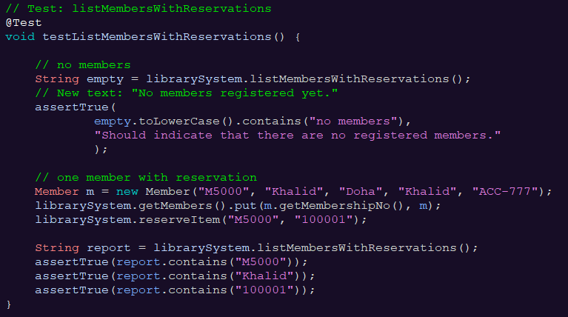
Tests:
- When no members “no members” message
- After reservation shows member name, ID, and item call number

Result:
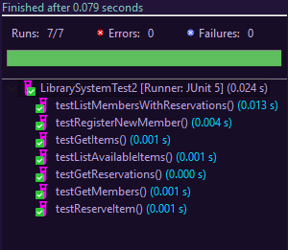
Task 5.
Implementing Two Design Patterns (Proxy & Facade)
In this task, I added two design patterns (Facade and Proxy) to the Library System project. Both patterns were applied to the part of the system that deals with the external university systems: PearlSys (for membership verification) and FinanceSys (for payment transfers).
The goal was to make the system easier to maintain and more organized.

1. Facade Pattern
The Library System needs to communicate with two different systems, but we don’t want the main code to deal with their internal details.
To simplify this, I created a class called ExternalServicesFacade, which acts as a single entry point for both operations:
- Verifying a member with PearlSys
- Transferring money with FinanceSys
Instead of calling each system separately, the Library System now calls just two simple methods:
verifyMember(name)
transferDeposit(account, amount)
This hides all complexity from the main system.
If the university changes PearlSys or FinanceSys in the future, we only need to update the Facade instead of touching the entire project.

2. Proxy Pattern
On top of the Facade, I added a Proxy class called ExternalServicesProxy.
This class sits between the Library System and the Facade.
The Proxy has two jobs:
- Control access to the external systems
-It can simulate that PearlSys or FinanceSys is unavailable
-It can block requests or allow them
- Log requests
-Every verification or payment request goes through the Proxy, so the system can log them automatically.
The Proxy and the Facade both implement the same interface, so the Library System doesn’t know the difference.
It just talks to the Proxy, and the Proxy decides how to handle the request.
This makes the system more flexible and easier to test.

3. How They Work Together
The final structure looks like this:
LibrarySystem Proxy Facade (PearlSys + FinanceSys)
So now:
- The Library System never talks to external systems directly
- The Proxy intercepts the call first
- Then the Facade forwards it to the real systems
This improves maintainability and makes the architecture cleaner.

4. Changes Made to the Code
The following files were added for Task 5:
- ExternalServices.java (interface)
- ExternalServicesFacade.java (Facade)
- ExternalServicesProxy.java (Proxy)
I also updated LibrarySystem.java to use:
ExternalServices externalServices = new ExternalServicesProxy();
No changes to the user interface or the JUnit tests were required.

5. Screenshots to Include
- The folder showing the added pattern classes
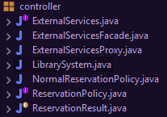
- Console output showing the Proxy logging external requests
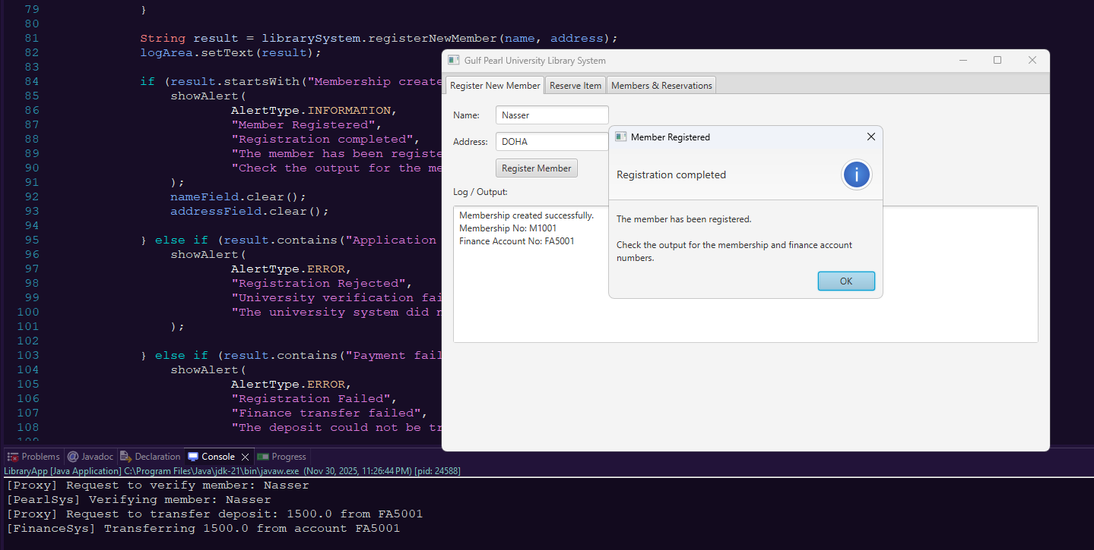

- The UI still working normally (registering a member, reserving an item)
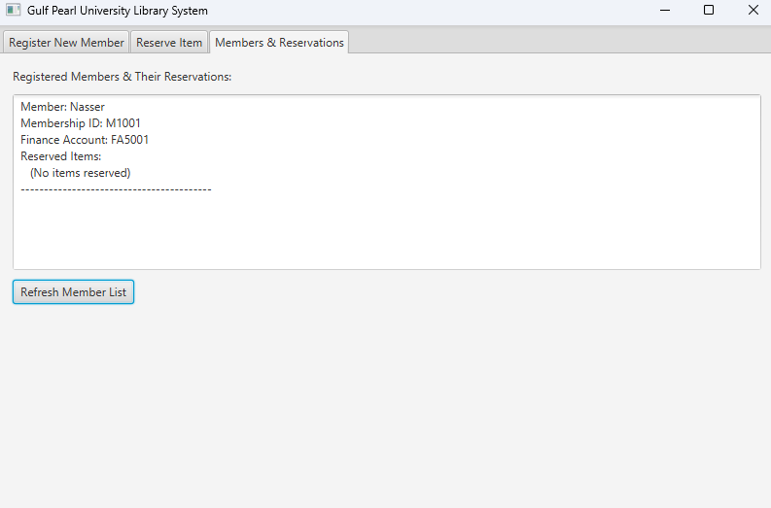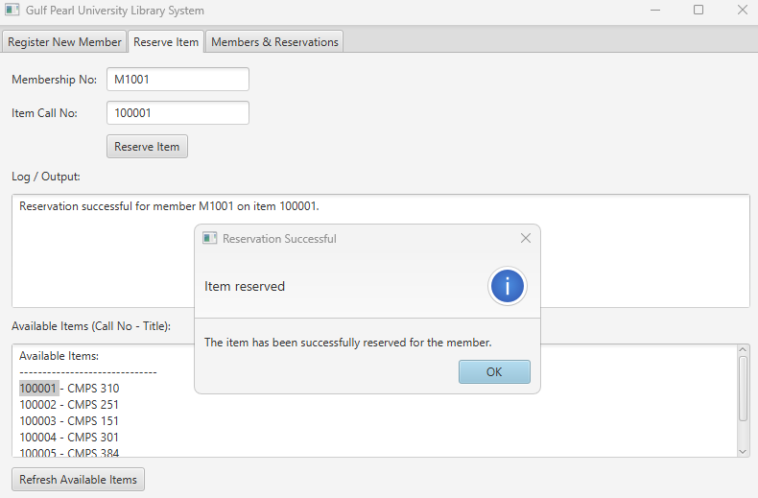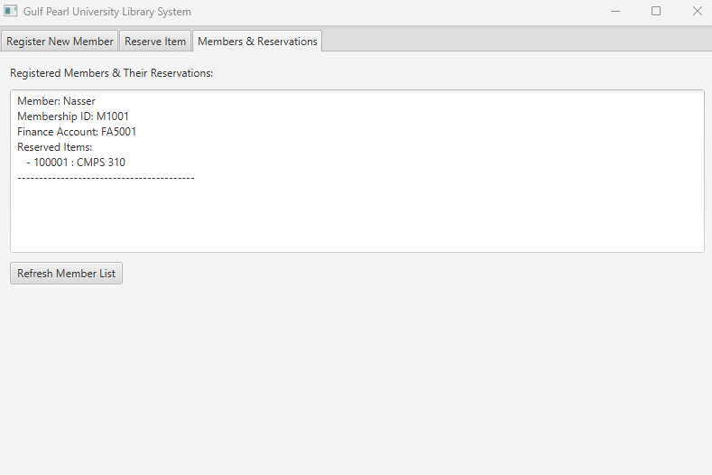

6. Summary
By adding the Proxy and Facade patterns, the Library System is now:
- Easier to maintain
- Easier to test
- Better organized
- Less dependent on the internal details of PearlSys and FinanceSys
These patterns improve the quality of the design and prepare the system for future expansion.

Task 6.
Constraints and Non-Functional Requirements (NFRs)
A. System Constraints
1. Business Constraints
- Only active, registered students or staff are allowed to become library members.
- Membership is activated only after QR 1500 is successfully transferred from the user’s FinanceSys account.
- Members may borrow up to 5 items and reserve up to 3 items at a time.
- Fixed loan periods:
- Books 4 weeks
- Digital Media 1 week
- Magazines 2 weeks
- Items overdue by more than 7 days must be processed in the daily 08:00 “Lost Item Check”.

2. Technical Constraints
- System must be integrated with PearlSys for membership verification.
- System must integrate with FinanceSys for deposits, fines, and money transfers.
- Sensitive finance data must be stored only in the backend and must be encrypted.

3. Resource & Operational Constraints
- Only one new server is available for deployment.
- Only three technical staff can be hired for maintenance.
- The system supports 400 concurrent requests now and must scale to 1000 active members within 3 years.

4. Process Constraints
- A scheduled task must run every day at 08:00 to detect overdue items.
- All Members, Items, and Membership Cards must have unique identifiers for consistency.

B. Non-Functional Requirements (Quality Requirements)
1. Performance
- The system must complete 90% of borrow/return/reserve operations within 3 seconds under normal load (up to 400 active users).

2. Scalability
- Within 3 years, the system should support 1000 active members without major architectural changes.
- Only hardware or configuration adjustments should be required.

3. Security
- All Finance_Account information must be encrypted and never exposed on the client side.
- All communication with PearlSys and FinanceSys must use secure, encrypted channels.
- Access to sensitive admin functions must use role-based access control.

4. Availability
- System availability during university hours (07:00 - 22:00) must be 99% or higher.
- Backup modules must allow recovery within 1 hour with a maximum of 5 minutes of data loss.

5. Portability
- The system must run on Windows and macOS without code changes (only configuration updates).

6. Interoperability
- At least 99% of verification and payment requests to PearlSys/FinanceSys should succeed under normal operation.
- Errors must be logged and handled without crashing the system.

7. Maintainability
- Changes to loan periods, reservation limits, or fine amounts should require editing no more than two modules.
- New item types for example: thesis, journals should be added without modifying Borrow/Return/Reserve workflows.

8. Modularity
- System components must be loosely coupled.
- External calls must only occur through dedicated interface classes (Proxy + Facade).
- Internal changes should not affect unrelated modules.

Github: https://github.com/cmps310-F24/milestone-2.git
