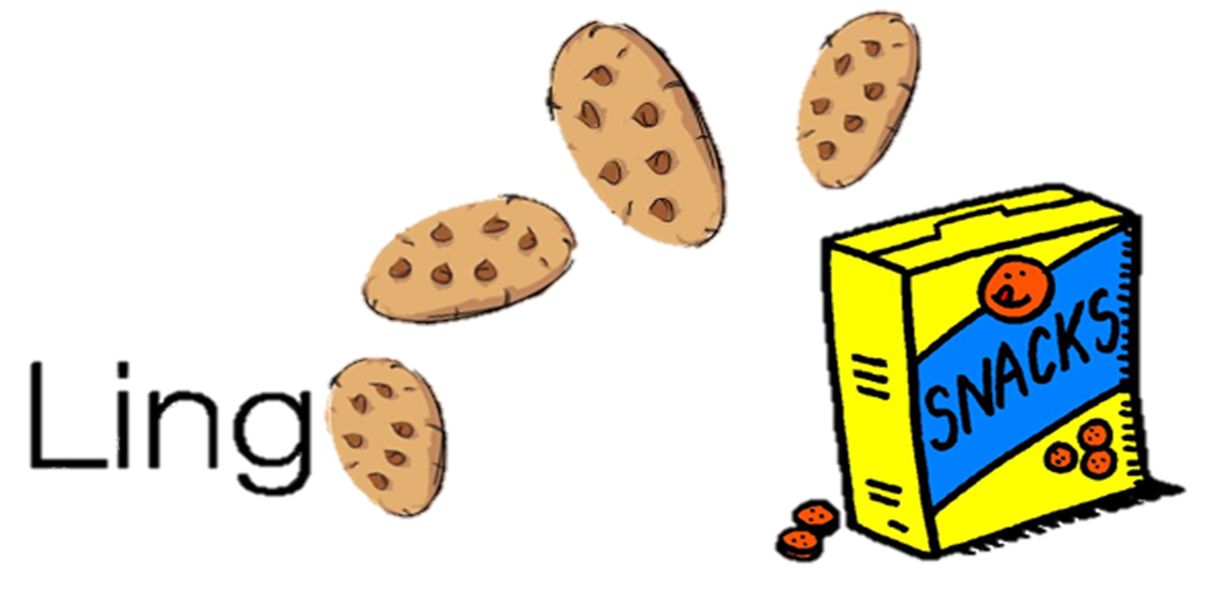 **CMPS 312 Project Phase 2 - LingoSnacks**





|  |  |
| --- | --- |
| **Group Id:** | G? |
| **Group Members:** | Student1 full name (StudentId)  Student2 full name (StudentId)  Student3 full name (StudentId)  **Emails:** student1@student.qu.edu.qa; student2@student.qu.edu.qa; student3@student.qu.edu.qa; |

**Grading Rubric - In the Functionality column please specify either: *Working (completed x%)*, *Not Working (completed x%)* or *Not done*.**

|  |  |  |  |  |
| --- | --- | --- | --- | --- |
| Criteria | % | Functionality* | Quality of the implementation | Score |
| **1) Cloud Firestore Database Design and Implementation**  Repositories to interact with Firestore | 50 |  |  |  |
| **2) Download a learning package and their associated media**  - Populate the database with the learning package data fetched from Cloud Firestore.  - Download Cloud Firestore media files associated with the package to the mobile device.  - If the downloaded package already exists in the local DB, sync the the local package with the online version.  - Record *Unscamble Sentence* and *Match Definition* scores in the local DB if no internet is available then push the recorded scores to Firestore when the internet connection is available. | 30 |  |  |  |
| **3) Signup and Signin using Firebase Authentication** | 10 |  |  |  |
| **4) Design and Testing Documentation**  **\* Design documentation:**  - 4 key lessons learned from Phase 1.  - MVVM architecture diagram.  - Firestore database schema diagram and SQLite database schema diagram.  **\* Testing documentation:** with evidence of working implementation using snapshots illustrating the results of your solution testing (you must use the provided template). | 10 |  |  |  |
| 6) **Discussion of the project contribution** of each team member [-10pts if not done] |  |  |  |  |
| **Total** | 100 |  |  |  |
| Copying and/or plagiarism or not being able to explain or answer questions about the implementation | -  100 |  |  |  |

**\* Possible grading for functionality** - ***Working*** (get 70% of the assigned grade), ***Not*** ***working*** (lose 40% of assigned grade and ***Not done*** (get 0). The remaining grade is assigned to the quality of the implementation.

In case your implementation is not working then 40% of the grade will be lost and the remaining 60% will be determined based on of the code quality and how close your solution to the working implementation.

Solution quality also includes meaningful naming of identifiers (according to Android naming conventions), no redundant code, simple and efficient design, clean implementation without unnecessary files/code, use of comments where necessary, proper code formatting and indentation.

**Marks will be reduced** forcode duplication, poor/inefficient coding practices, poor naming of identifiers, unclean/untidy submission, and unnecessary complex/poor user interface design.

# App Design

# 4 key lessons learned from Phase 1



# MVVM architecture diagram

# Firestore database schema diagram

# SQLite database schema diagram

# App Testing

# Login

# Sign Up

# List and search learning packages

# Rate Learning Package

# Delete Learning Package

# Add/Update Learning Package

# Download a learning package and their associated media

# Play Flash Cards

# Unscramble Sentences

# Match Word & Definition

# View Scores

# Summary of team member contributions