**CMPS 312 – Mobile Application Development**

**Midterm Practical Exam – 18 October 2021 (duration 2.5h)**

|  |  |
| --- | --- |
| Student Name (Student ID) | Mohamed Abdelmoety 201703976 |

**Testing Sheet**

**Screenshot1 Patient List Screen**

*\*paste your screenshot here\**

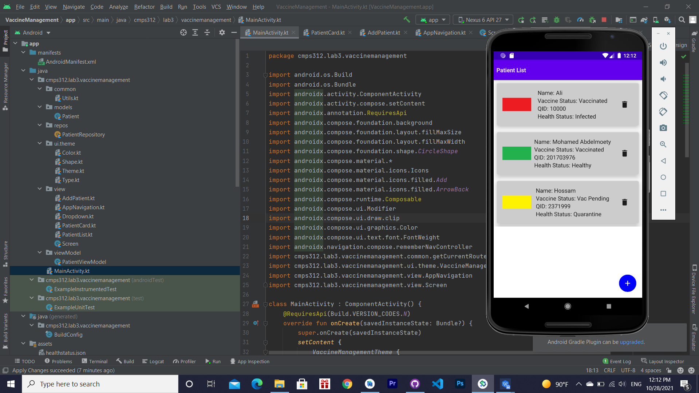

**Screenshot 2 Add Patient Screen**

*\*paste your screenshot here\**

