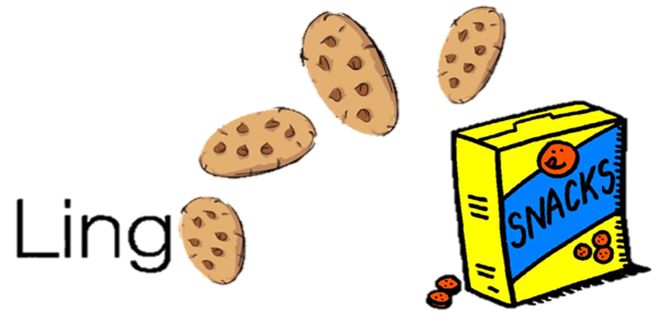 **CMPS 312 Project Phase 1**





|  |  |
| --- | --- |
| **Group Id:** | G? |
| **Group Members:** | Student1 full name (StudentId)  Student2 full name (StudentId)  Student3 full name (StudentId)  **Emails:** student1@student.qu.edu.qa; student2@student.qu.edu.qa; student3@student.qu.edu.qa; |

**Grading Rubric - In the Functionality column please specify either: *Working (completed x%)*, *Not Working (completed x%)* or *Not done*.**

|  |  |  |  |  |
| --- | --- | --- | --- | --- |
| Criteria | | % | Functionality* | Quality of the implementation |
| 1. Entities & Repositories Class Diagram. | | 5 |  |  |
| 2) Design and implementation | | **90** |  |  |
|  | S1 - Login | 5 |  |  |
| S2 - Sign Up | 7 |  |  |
| S3 - List and search learning packages | 12 |  |  |
| S4 - Play Flash Cards | 16 |  |  |
| S5 - Unscramble Sentences | 16 |  |  |
| S6 - Match Word & Definition | 16 |  |  |
| S7 - View Scores | 10 |  |  |
| S8 - Rate Learning Package | 8 |  |  |
| **5) Testing documentation** using screen shots illustrating the testing of UI and Repositories. | | 5 |  |  |
| 6) **Discussion of the project contribution** of each team member [-10pts if not done] | |  |  |  |
| **Total** | | 100 |  |  |
| Copying and/or plagiarism or not being able to explain or answer questions about the implementation | | -  100 |  |  |

**\* Possible grading for functionality** - ***Working*** (get 70% of the assigned grade), ***Not*** ***working*** (lose 40% of assigned grade and ***Not done*** (get 0). The remaining grade is assigned to the quality of the implementation.

In case your implementation is not working then 40% of the grade will be lost and the remaining 60% will be determined based on of the code quality and how close your solution to the working implementation.

Solution quality also includes meaningful naming of identifiers (according to Android naming conventions), no redundant code, simple and efficient design, clean implementation without unnecessary files/code, use of comments where necessary, proper code formatting and indentation.

**Marks will be reduced** forcode duplication, poor/inefficient coding practices, poor naming of identifiers, unclean/untidy submission, and unnecessary complex/poor user interface design.

# Entities Class Diagram

# Repositories Class Diagram

# User Interface Testing

# S1 - Login

# S2 - Sign Up

# S3 - List and search learning packages

# S4 - Play Flash Cards

# S5 - Unscramble Sentences

# S6 - Match Word & Definition

# S7 - View Scores

# S8 - Rate Learning Package

# Summary of team member contributions

|  |  |
| --- | --- |
| **Member** | **Contributions in terms of completed use cases / tasks** |
|  |  |
|  |  |
|  |  |