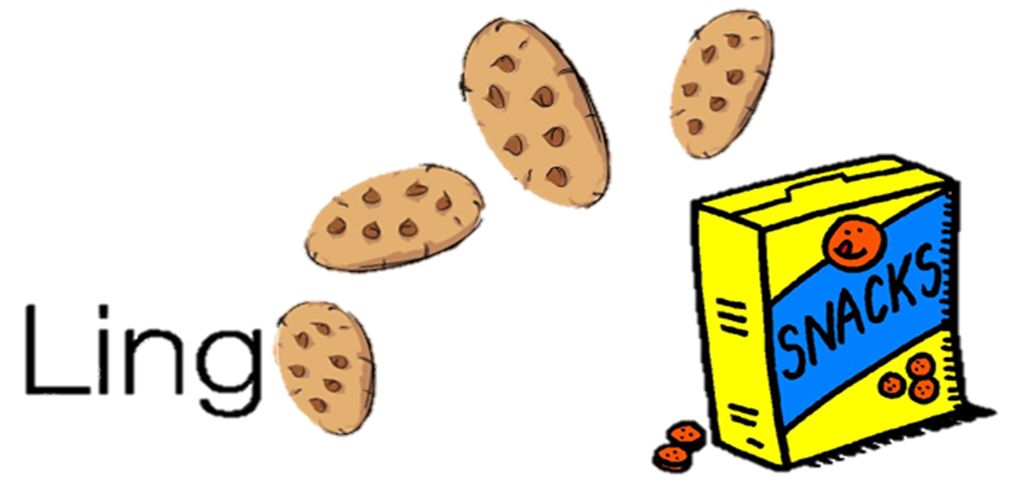 **CMPS 312 Project Phase 2 - Data Layer using Firestore, Firebase Storage and local SQLite Database**



|  |  |
| --- | --- |
| **Group Id:** | G? |
| **Group Members:** | Student1 full name (StudentId)  Student2 full name (StudentId)  Student3 full name (StudentId)  **Emails:** student1@student.qu.edu.qa; student2@student.qu.edu.qa; student3@student.qu.edu.qa; |

# Grading Rubric

**In the Functionality column please specify either: *Working (completed x%)*, *Not Working (completed x%)* or *Not done*.**

|  |  |  |  |  |
| --- | --- | --- | --- | --- |
| Criteria | | % | Functionality* | Quality of the implementation |
| - 3 key lessons learned from Phase 1  - Firestore database schema diagram  - SQLite database schema diagram | | 6 |  |  |
| 1) Signin using Firebase Authentication | | 4 |  |  |
| 2) Signup using Firebase Authentication | | 6 |  |  |
| **3) Data Layer Design and Implementation (60%)**  **|** Get / search learning packages | | 8 |  |  |
|  | Add/update learning package | 8 |  |  |
| Delete package (including deleting its associated media files from Firebase Storage) | 8 |  |  |
| Add package review | 4 |  |  |
| Get package reviews | 4 |  |  |
| Add score (after playing unscramble / match game) | 4 |  |  |
| Get scores | 4 |  |  |
| Attach an image/video from the gallery or take an image/video using the Camera (from the Learning Package Editor) and upload them to Firebase Storage | 15 |  |  |
| Init Firebase DB | 5 |  |  |
| **4) Download a learning package and their associated media**  - Populate the database with the learning package data fetched from Firestore.  - Download Firebase Storage media files associated with the package to the mobile device. Then update the Urls inside the package to point to local multi-media files (this update should be done in the local DB only).  - If the downloaded package already exists in the local DB, sync the local package with the online version.  - Record *Unscamble Sentence* and *Match Definition* scores in the local DB if no internet is available then push the recorded scores to Firestore when the internet connection is available. | | 20 |  |  |
| **5) Testing documentation** using screen shots illustrating the testing of UI and Repositories. | | 4 |  |  |
| 6) **Discussion of the project contribution** of each team member [-10pts if not done] | |  |  |  |
| **Total** | | 100 |  |  |
| Copying and/or plagiarism or not being able to explain or answer questions about the implementation | | -  100 |  |  |

**\* Possible grading for functionality** - ***Working*** (get 70% of the assigned grade), ***Not*** ***working*** (lose 40% of assigned grade and ***Not done*** (get 0). The remaining grade is assigned to the quality of the implementation.

In case your implementation is not working then 40% of the grade will be lost and the remaining 60% will be determined based on of the code quality and how close your solution to the working implementation.

Solution quality also includes meaningful naming of identifiers (according to Android naming conventions), no redundant code, simple and efficient design, clean implementation without unnecessary files/code, use of comments where necessary, proper code formatting and indentation.

**Marks will be reduced** forcode duplication, poor/inefficient coding practices, poor naming of identifiers, unclean/untidy submission, and unnecessary complex/poor user interface design.

# Three key lessons learned from Phase 1

*ToDo: List and briefly discuss 3* ***concrete and focused*** *technical skills you have learnt from phase 1 model solution compared to your submitted solution.*

# Firestore database schema diagram

*ToDo: Provide a diagram listing* ***the collections created and the structure (i.e., the fields) of each collection.***

# SQLite database schema diagram

*ToDo: Provide a diagram listing* ***the tables created and the structure (i.e., the fields) of each table.***

# Testing

*ToDo: Include screenshots from both the app and the Firestore Web UI or Database Inspector as evidence of a working solution.*

# Signin using Firebase Authentication

# Signup using Firebase Authentication

# Get / search learning packages

# Add/update learning package

# Delete learning package (including deleting its associated media files from Firebase Storage)

# Add package review

# Get package reviews

# Add score (after playing unscramble / match game)

# Get scores

# Attach an image/video from the gallery or take an image/video using the Camera (from the Learning Package Editor) and upload them to Firebase Storage

# Init Firebase DB

# Download a learning package and their associated media

# Summary of team member contributions

|  |  |
| --- | --- |
| **Member** | **Contributions in terms of completed use cases / tasks** |
|  |  |
|  |  |
|  |  |