**School Management System (SMS)**

**App**

* **Module 1 Admission Management**



**CMPS 350 Project Phase 1 – WebApp UI Design and Implementation**

|  |  |
| --- | --- |
| **Group Id:** | G2 |
| **Group Members:** | Amir, Faisal & Abdulla |

**Grading Rubric - In the Functionality column please specify either: *Working (completed x%)*, *Not Working (completed x%)* or *Not done*.**

|  |  |  |  |  |  |
| --- | --- | --- | --- | --- | --- |
|  | Criteria | % | Functionality* | Quality of the implementation | Grade |
| 1) Design the app Web UI and navigation (10%).  2) Implement the app Web UI and navigation using HTML, CSS and JavaScript (30%)  3) Implement the client-side data access repositories to read/write the app data from/to IndexedDB (40%) | | **80%** | ***Working (completed 100%)*** |  | 76 |
|  | Login | 5 | ***Working (completed 100%)*** | Excellent | 5 |
|  | Register applicant | 8 | ***Working (completed 100%)*** | Excellent | 8 |
|  | Update applicant | 5 | ***Working (completed 100%)*** | Very good and using the same form ad add. | 5 |
|  | Get applications (+ providing links to navigate to other functions) | 12 | ***Working (completed 100%)*** | Excellent | 12 |
|  | Add application | 10 | ***Working (completed 100%)*** | Excellent | 10 |
|  | Update application | 8 | ***Working (completed 100%)*** | Very good but forgets the gender. | 8 |
|  | View application | 6 | ***Working (completed 100%)*** | Very good but should allow viewing notes and attachments even for withdrawn applications. | 4 |
|  | Withdraw application | 5 | ***Working (completed 100%)*** | Excellent | 5 |
|  | Attachments (list, add, delete) | 9 | ***Working (completed 100%)*** | Excellent | 9 |
|  | Notes (list, add, delete) | 9 | ***Working (completed 100%)*** | Excellent except ‘not visible to parent feature not done’. | 8 |
|  | Tests (list, add, delete) | 6 | ***Working (completed 100%)*** | Test type should be a dropdown. | 5 |
|  | Applications summary report | 9 | ***Working (completed 70%)*** | - Report poor design, only showing the number of applications without status.  - Applications Summary Report should be a main menu option. | 8 |
|  | Overall App design and navigation  Overall code quality | 8 | ***Working (completed 100%)*** | Clean and modular implementation. | 8 |
| **4) Application Design:** Entities Class Diagram and the Repositories Class diagram. | | **8** | ***Working (completed 100%)*** | Good by with some issues. See comments added to the diagrams. | 7 |
| 5) Create test data JSON files for your module entities | | 6 | ***Working (completed 100%)*** | Excellent | 6 |
| **6) Testing documentation** using screen shots illustrating the testing results.  - Discussion of the project contribution of each team member. | | 6 | ***Working (completed 100%)*** | Excellent | 6 |
| **Total** | | 100 |  | Excellent work. | 95 |

**\* Possible grading for functionality** - ***Working*** (get 60% of the assigned grade), ***Not*** ***working*** (lose 40% of assigned grade and ***Not done*** (get 0). The remaining grade is assigned to the quality of the implementation.

In case your implementation is not working then 40% of the grade will be lost and the remaining 60% will be determined based on of the code quality and how close your solution to the working implementation.

Solution quality also includes meaningful naming of identifiers (according to Android naming conventions), no redundant code, simple and efficient design, clean implementation without unnecessary files/code, use of comments where necessary, proper code formatting and indentation.

**Marks will be reduced** for **code duplication**, poor/inefficient coding practices, poor naming of identifiers, unclean/untidy submission, and unnecessary complex/poor user interface design.

# Application Design

# Entities Class Diagram

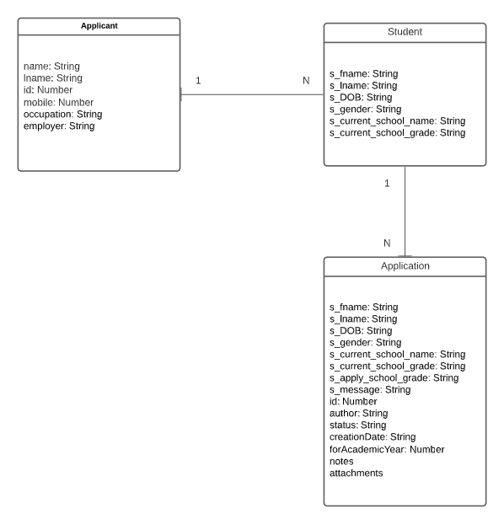

# Repositories Class Diagram

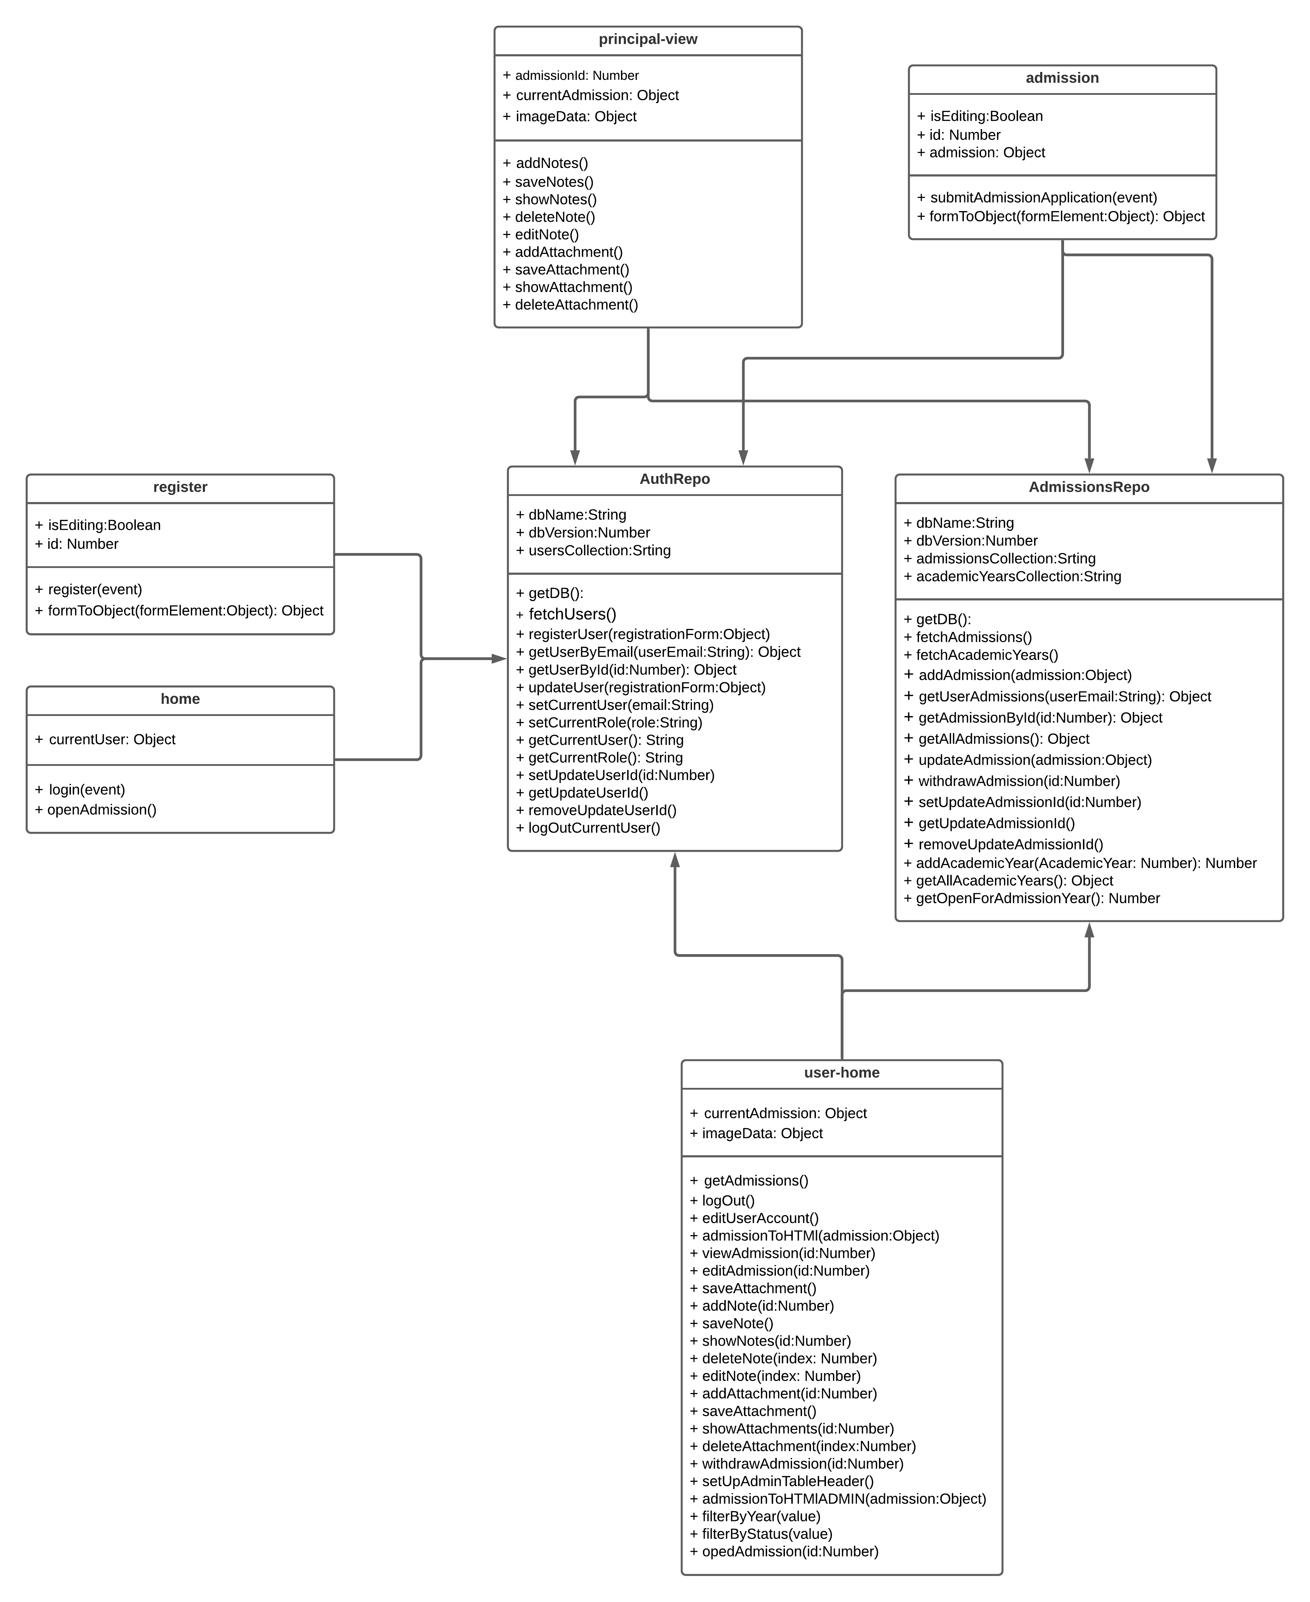

# App Testing

# Login

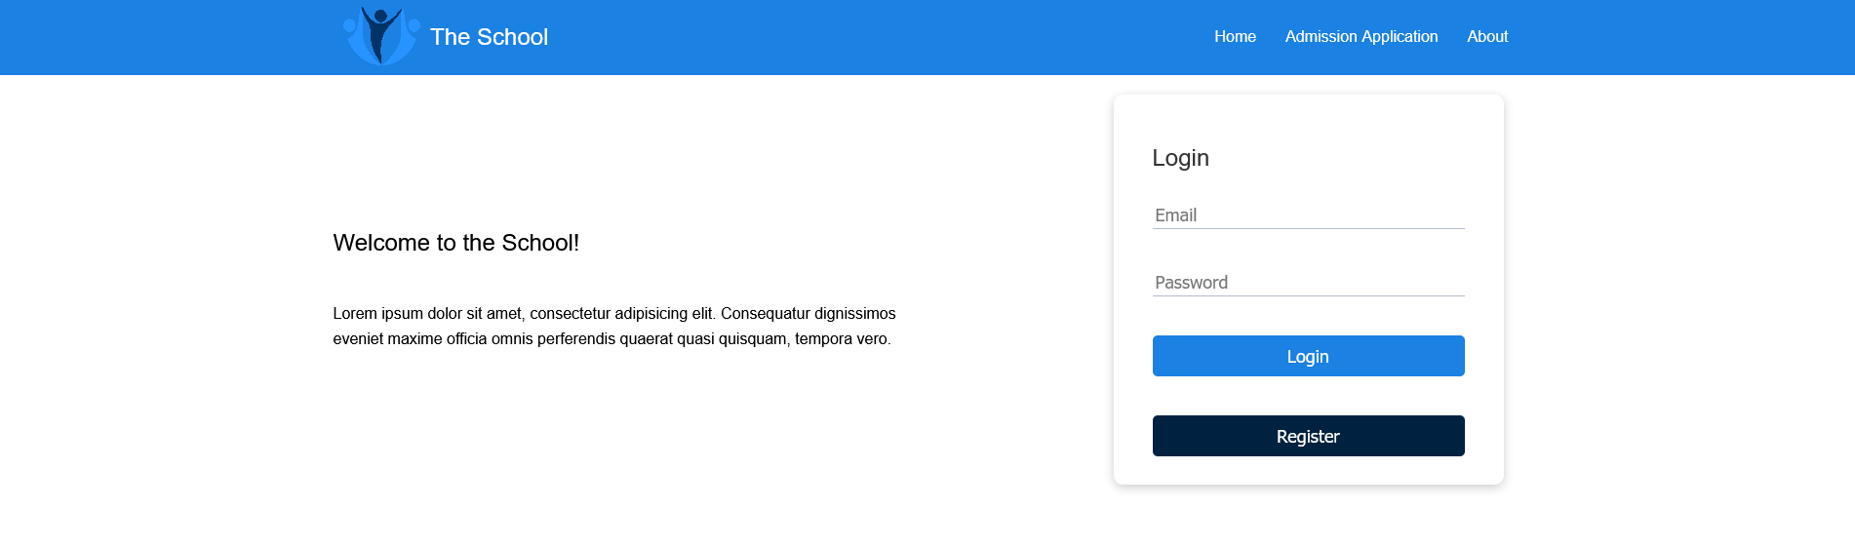

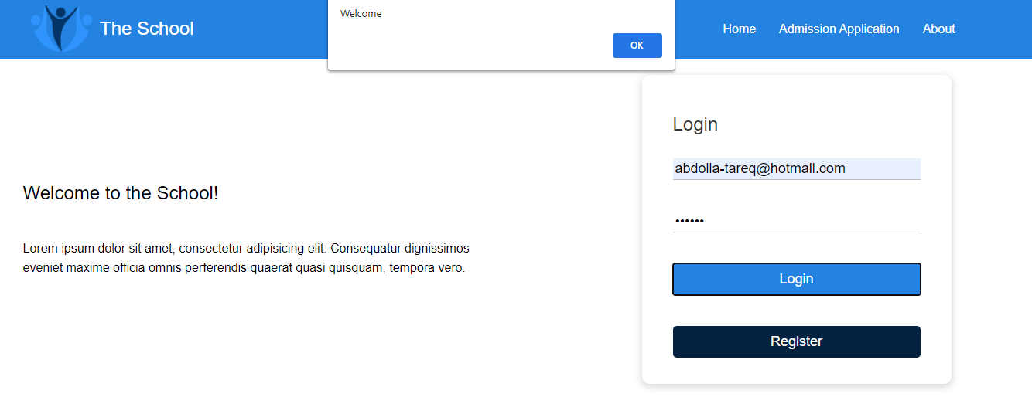

# Register applicant

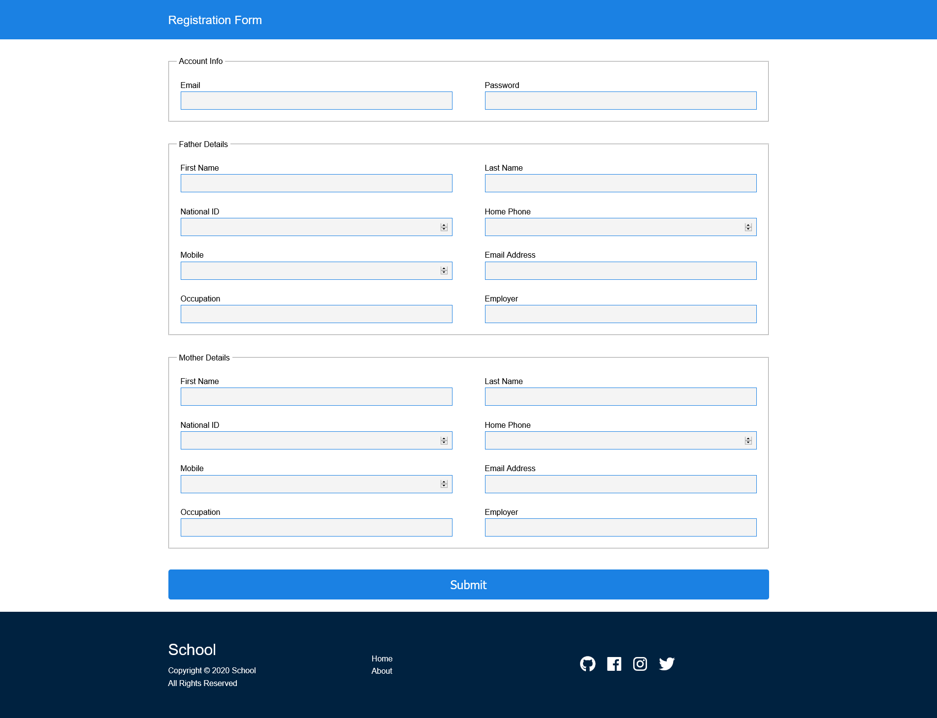

# Update applicant

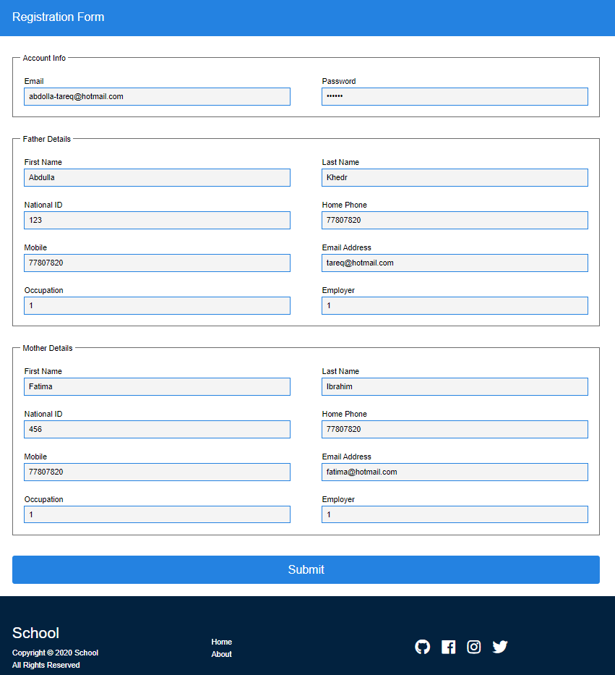

# Get applications (+ providing links to navigate other functions)

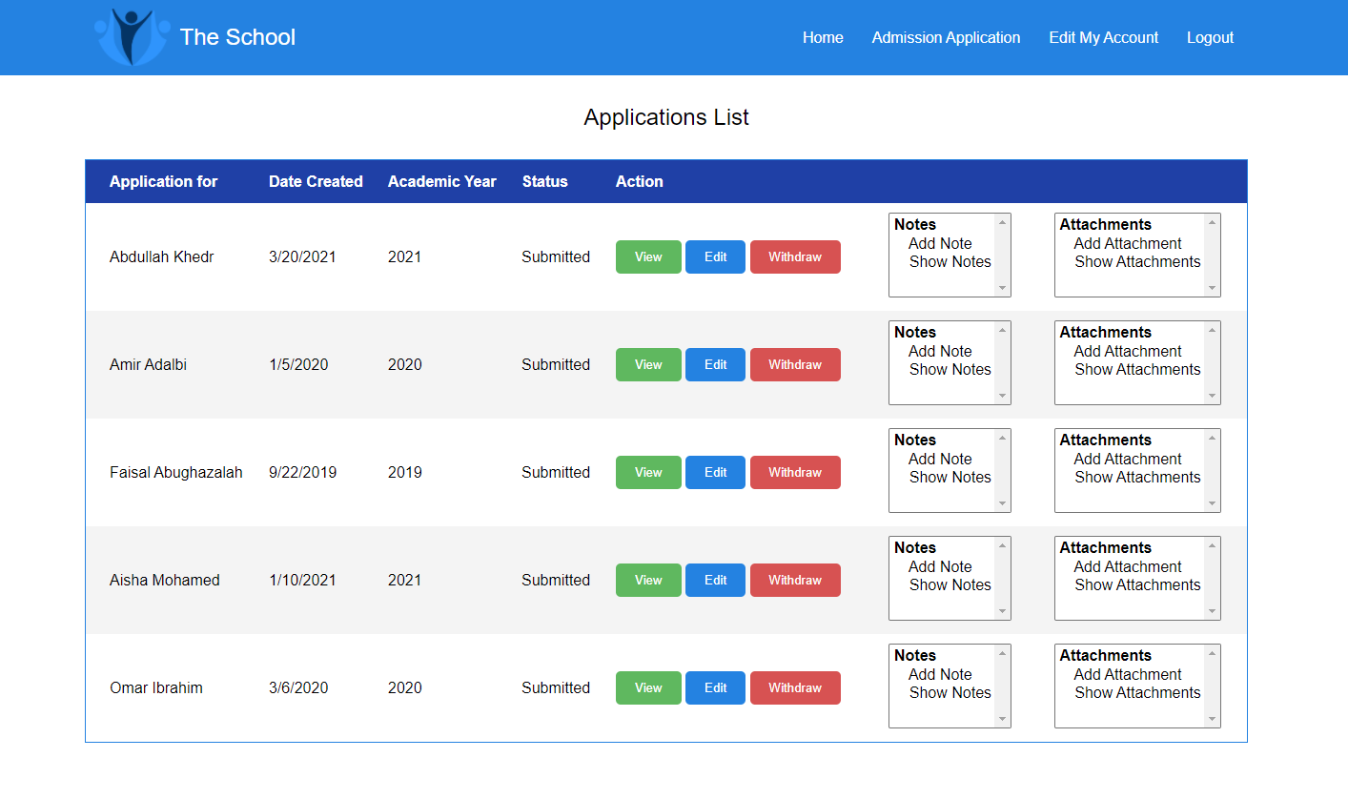

# Add application

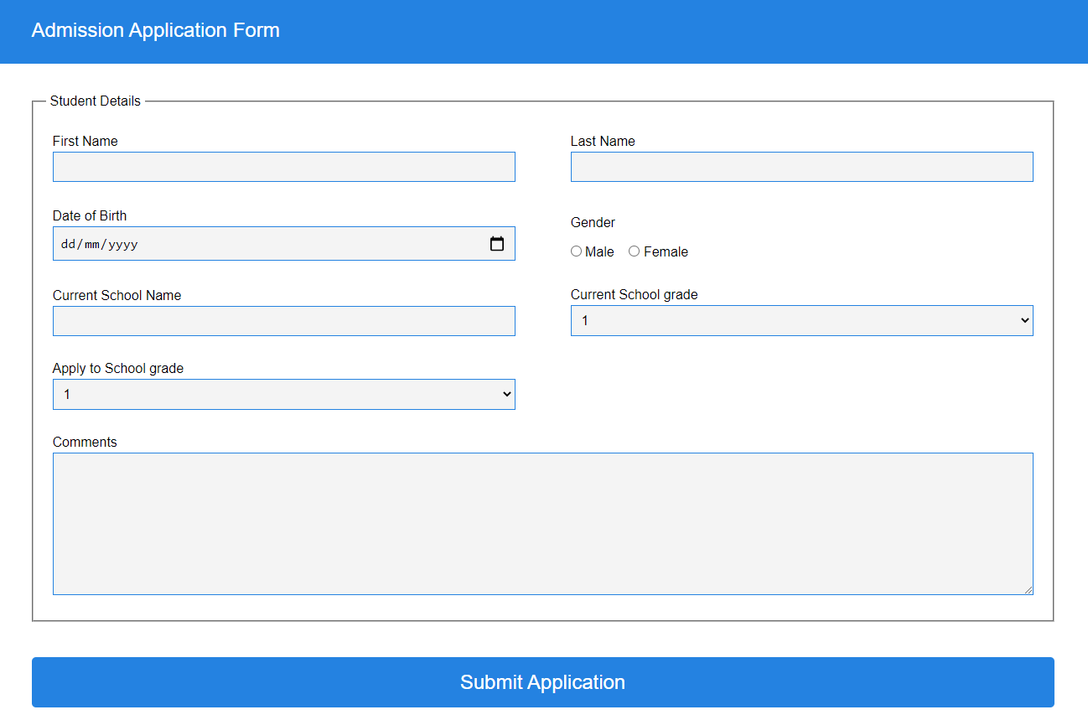

# Update application

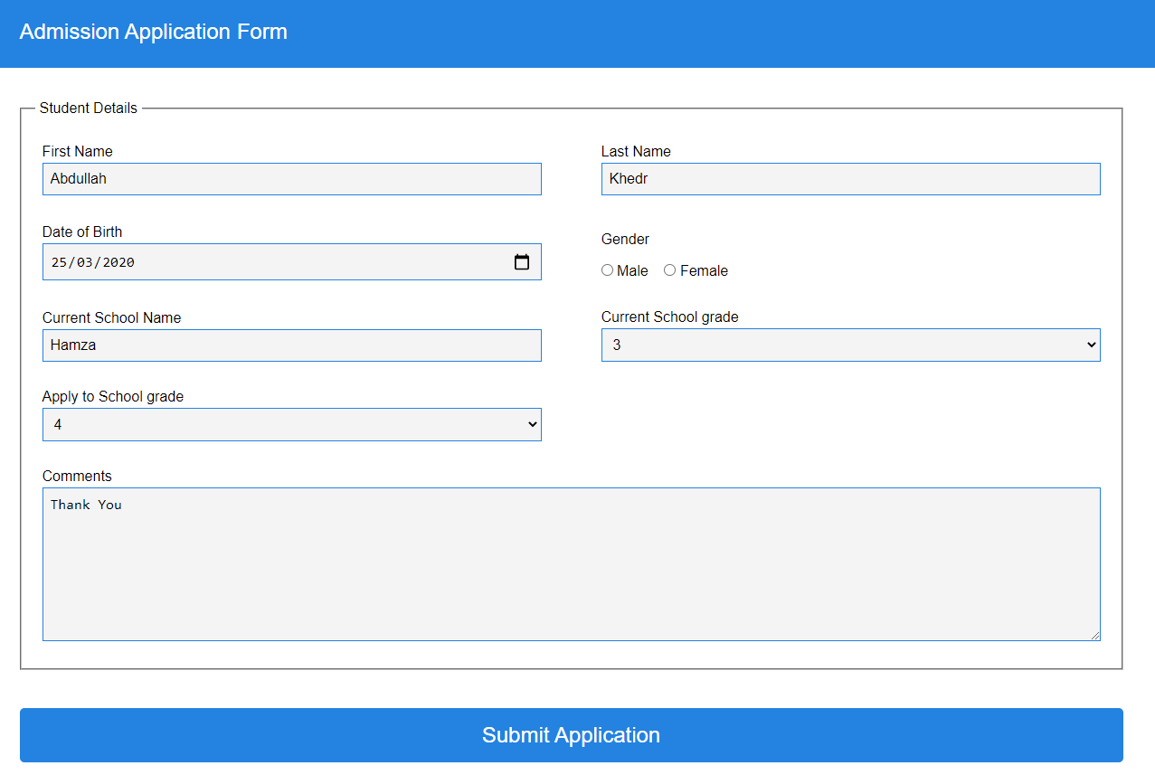

# View application

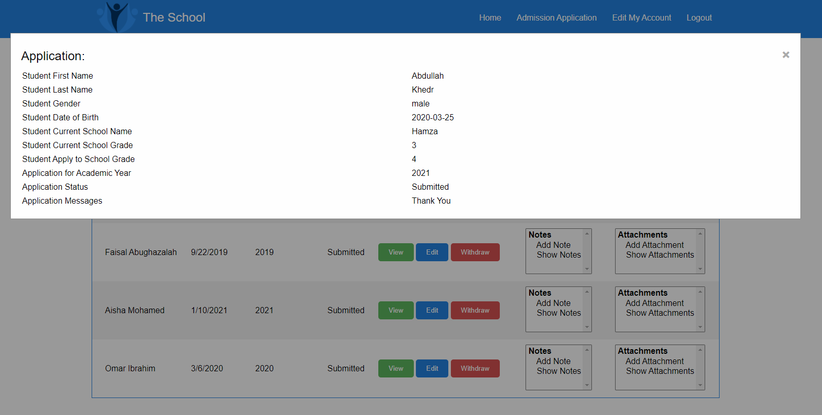

# Withdraw application

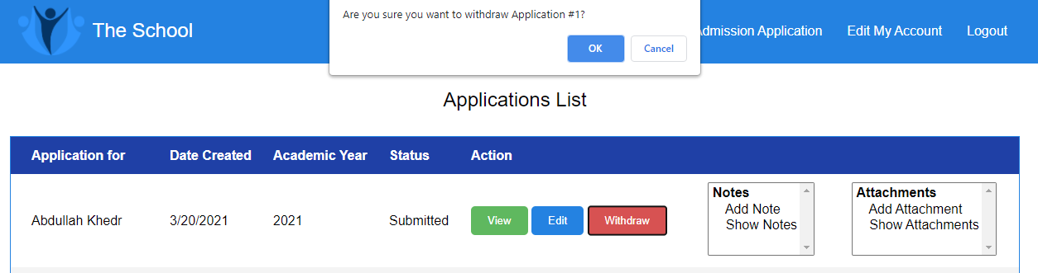

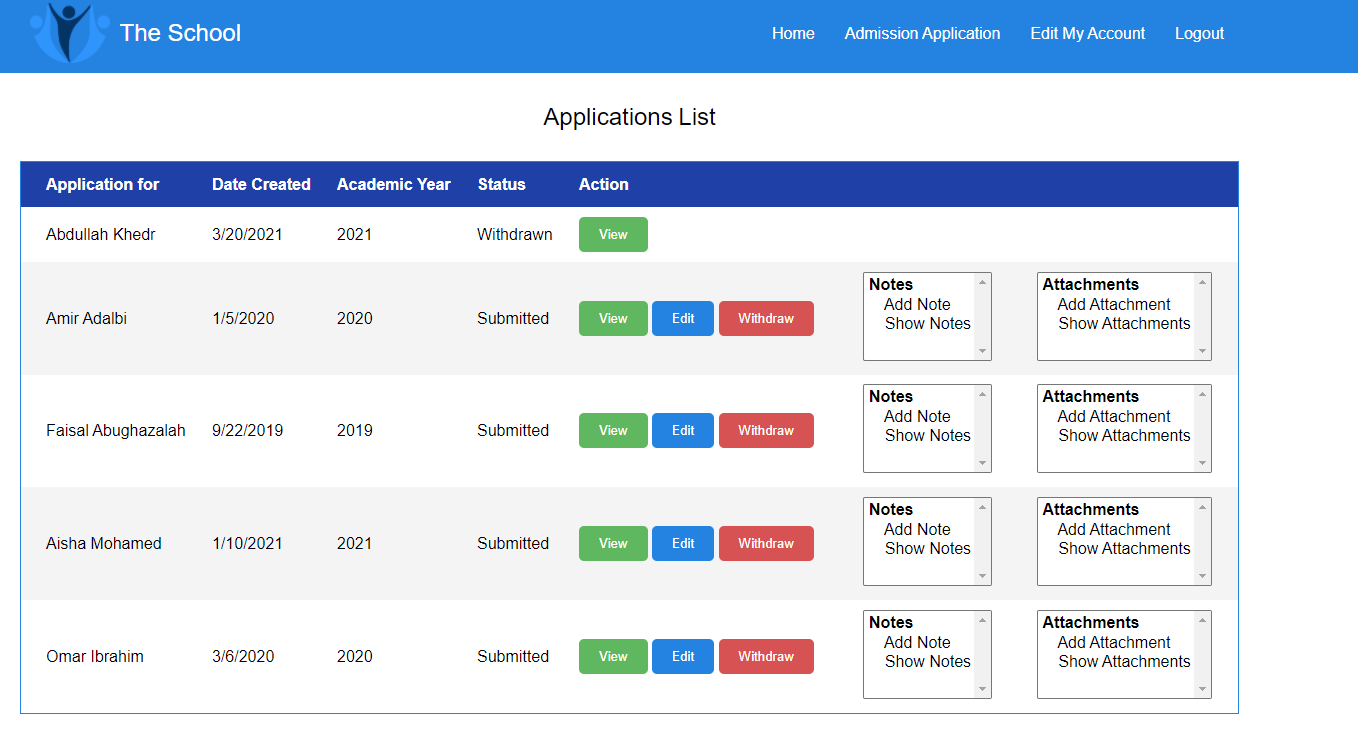

# Attachments (list, add, delete)

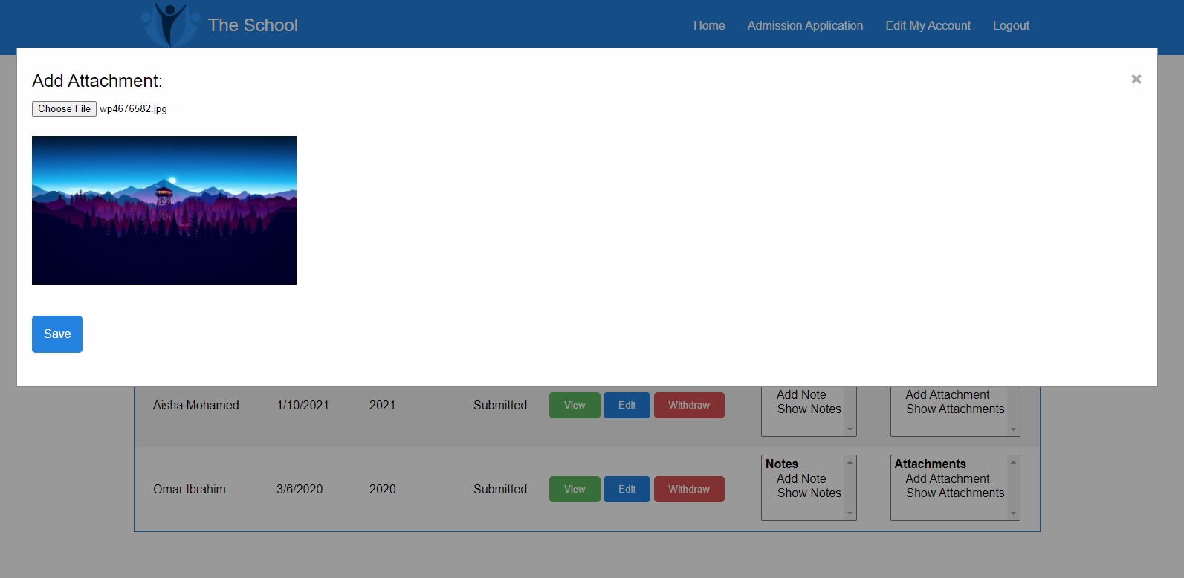

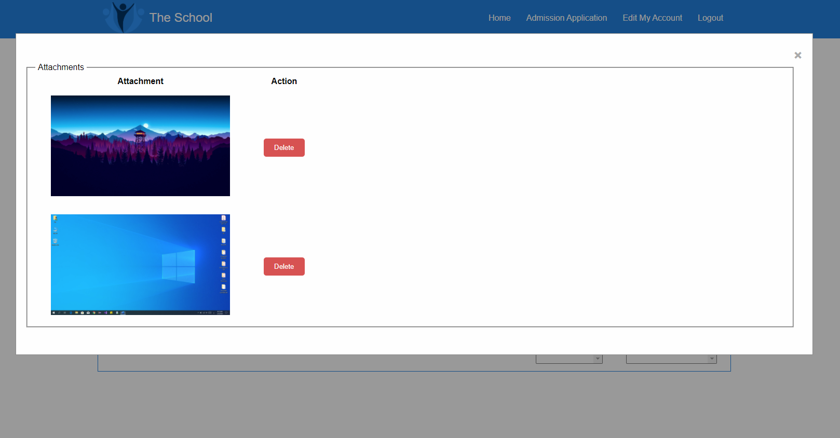

# Notes (list, add, delete)

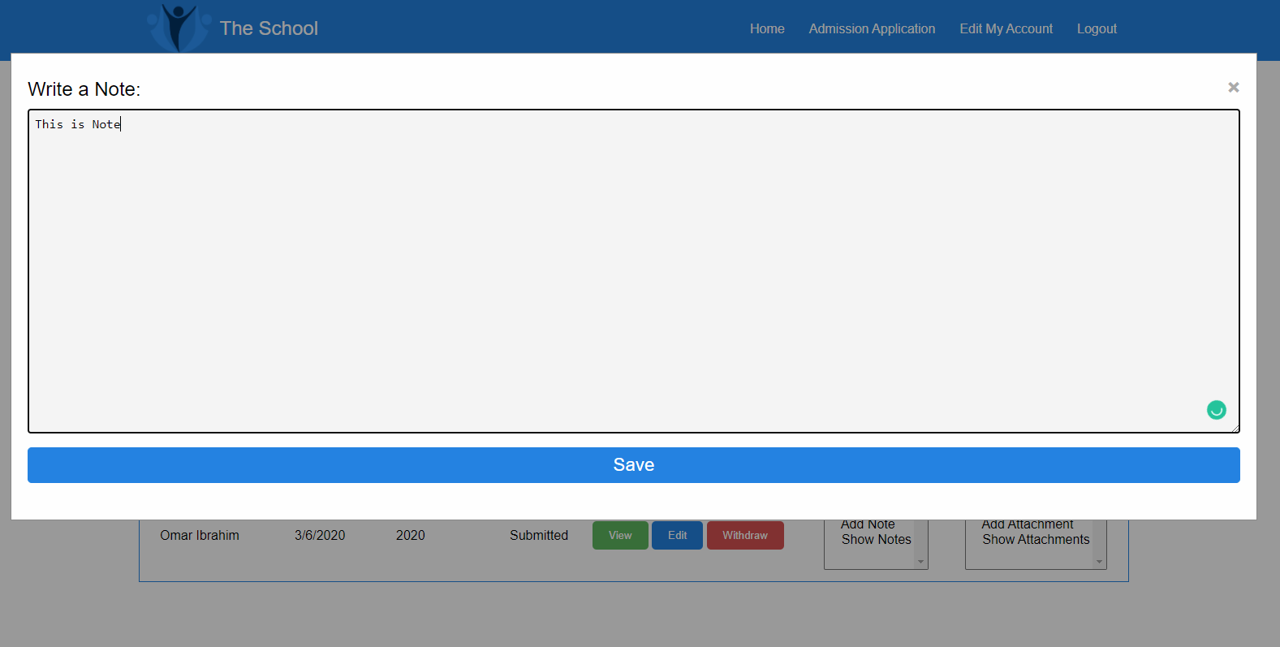

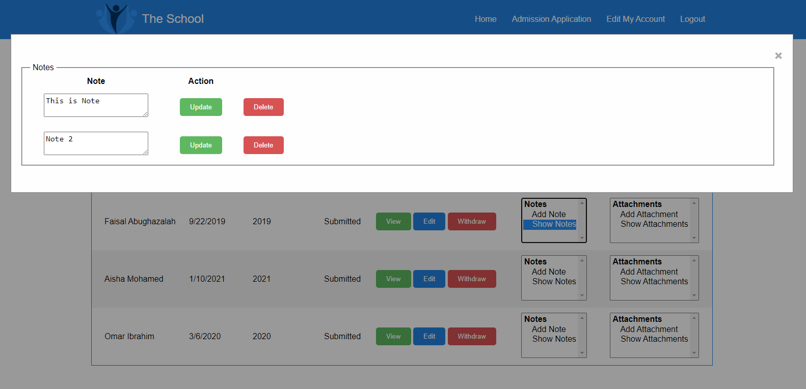

# Applications summary report

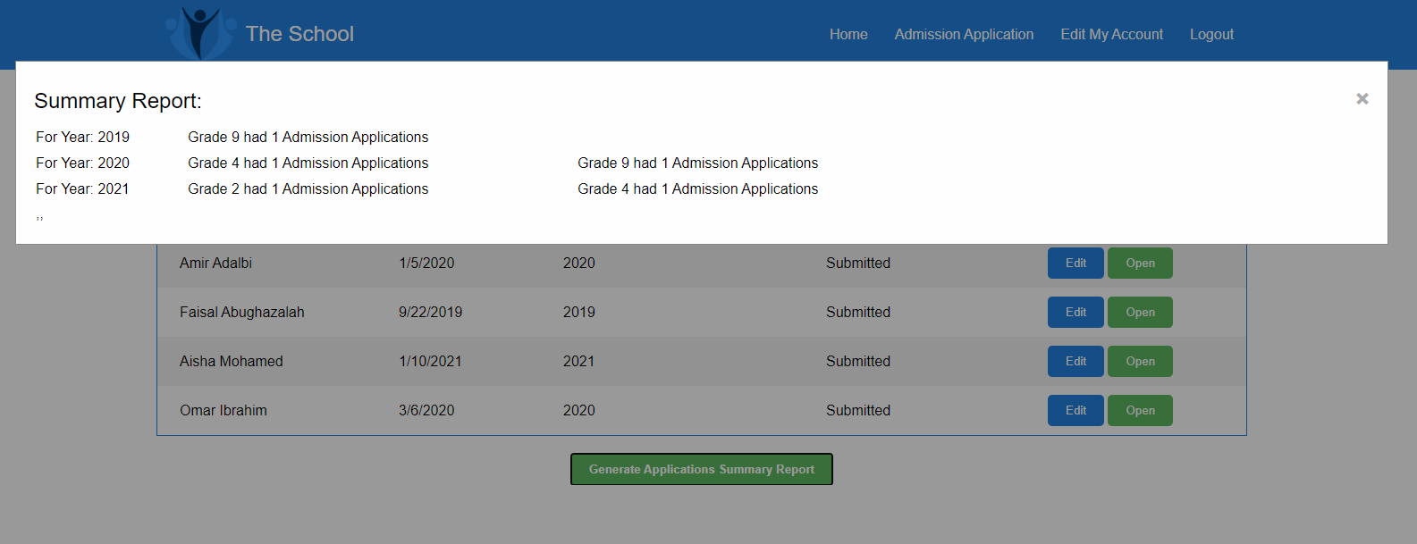

# Summary of team member contributions

The first phase of the project was implemented with the participation of all team members. First, we started with creating the required HTML pages. Then we did the appropriate CSS for it. After that, we created JavaScript repositories and added the necessary functions to it so it we can use the in the JavaScript file which was created right after the repositories.