**Q1:**

You have been asked to design a web application to take an RMA (Return Merchandise Authorization). The main form displays / captures the following information:

1. Customer enters a Serial Number into a text box.
2. Customer presses a “Submit” button – and is then presented with a confirmation number and an address to return the product.

Q1a: Please draw out some table (or tables) to hold this data.

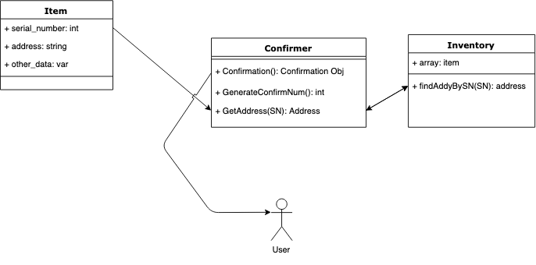

Q1b: Describe your design.

Overall, we want at least three separate data tables because the operations on each object is different. First, we have the “**Item**” table which contains all data associated with the item. This has the name, perhaps the price and other data, but for the purposes of this exercise it has just a serial number and an address to return to. This serial number is unique to the item, and that is what “**Confirmer**” needs to create a confirmation number and return an address. The Confirmer takes in the serial number, and passes it to the “**Inventory**” to find a data entry that contains the serial number, and the inventory returns the address needed to send. The confirmer then sends this back to the customer as a “Confirmation Object,” which includes a randomly generated confirmation number.

**Q2: Please do in one of the following languages: Python, Java, Javascript, C, C++**

Every email consists of a local name and a domain name, separated by the @ sign.

For example, in alice@viirtue.com, alice is the local name, and viirtue.com is the domain name.

Besides lowercase letters, these emails may contain '.'s or '+'s.

If you add periods ('.') between some characters in the local name part of an email address, mail sent there will be forwarded to the same address without dots in the local name. For example, "alice.z@viirtue.com" and "alicez@viirtue.com" forward to the same email address. (Note that this rule does not apply for domain names.)

If you add a plus ('+') in the local name, everything after the first plus sign will be ignored. This allows certain emails to be filtered, for example m.y+name@email.com will be forwarded to my@email.com. (Again, this rule does not apply for domain names.)

It is possible to use both of these rules at the same time.

Given a list of emails, we send one email to each address in the list. How many different addresses actually receive mails?

Example:

**Input**: ["[test.email+alex@viirtue.com](mailto:test.email+alex@leetcode.com)","test.e.mail+bob.cathy@viirtue.com","testemail+david@viir.tue.com"]

**Output**: 2

**Explanation**: "testemail@viirtue.com" and "testemail@viir.tue.com" actually receive mails

**Note**: Each emails[i] contains exactly one '@' character.

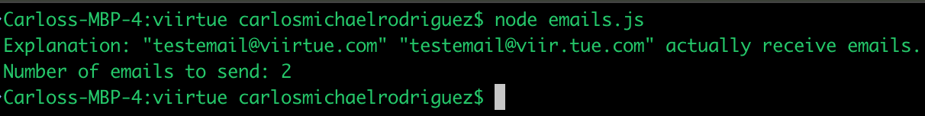***CM – please see attached file “emails.js” and run using node. Example output below***