## Explain the proposed solution of your project with a detailed problem statement

Our project is about time and crowd management in college canteen. Plenty of time is wasted in college canteens. People are investing a lot of time in waiting for food and they don’t have time to have it. People have to wait for getting tokens, then they have to rush to get food from the counter. Meanwhile lot of time is wasted. During this process of taking tokens and delivering the food, the server/workers have to rush here and there to supply food items to the students. All the students at time ask for their order to be delivered on limited number of people noting them down. It is really a hard task for the one who managing orders to handle everyone with their choices. While so many people miss use the tokens by taking a greater number of food items on a single token. Their will be a lot of food will be wasted due to lack of communication.

Based on the problem we thought of innovating a vending machine which vends food items in college canteens and also pre booking technology to decrease the food wastage in the canteens. .This vending machine consists of n number of containers each container has different food items and each container has a scanner . So, the one who wants the food should select the appropriate container and scan the card for food if there is money in the card the food will be dispensed into the plat and money will be credited into the manager/organization account. This consists of a bar code scanner which is used to money transactions this will decrease the time wastage in waiting for taking tokens in canteens. An application is provided for registration ,recharging ,prebooking food items .This will increase the communication between the customer and the canteen server.

## What is the focus that you want to achieve in technical terms for your project?

We want to decrease food wastage in the canteens. The food which is been wasted will be a boon to the poor people. We want to make rush free canteen with less time wastage. So, that the people can have their food happily without any mess. This benefits the canteen management a lot.

Our machine can serve at least five- six members in one minute this will decrease the time wastage and crowd. Due to automatic transaction of money the misusing of tokens will be stopped

## Mention the technologies you will be using as Frontend?

Java, HTM, php, CSS

## Mention the technologies you will be using as Backend?

MYSQL

## Will you be using any Framework/Platform to build your prototype/project?

Ionic

## The reason for choosing the above-mentioned technologies?

MYSQL is more flexible to use ,it helps me to manage contents easily .Ionic has all the functionality which is flexible to all android devices

## Mention the other digital equipment/hardware devices if you are using. (if any)

Arduino, IR sensor, DC motor, L298N Motor Drive, IR Bar Code scanner

## Draw and Explain the architecture of the proposed solution/product.

## 2.

1.Their will be n number of containers with n scanners to decrease the time consumption.

2. This describes the display , barcode scanner, and a blue bulb which indicates the empty cotainer.

3.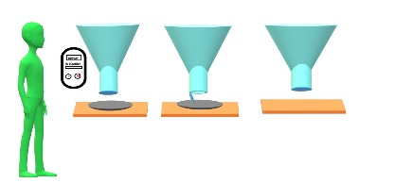 4.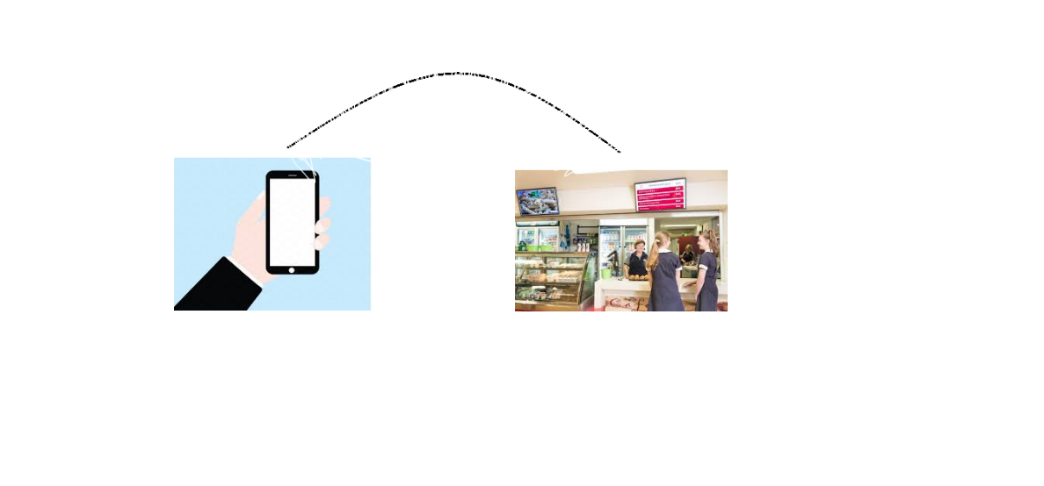

sufficient money in the ID card and also a plate should be placed. If not food will not be delivered.

Fig4: This describes the communication between the canteen and the user. Through a mobile app one can pre book the food.

## Draw and Explain your solution’s work flow with the help of a Flow-Chart for each type of user.

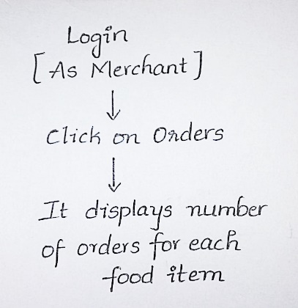 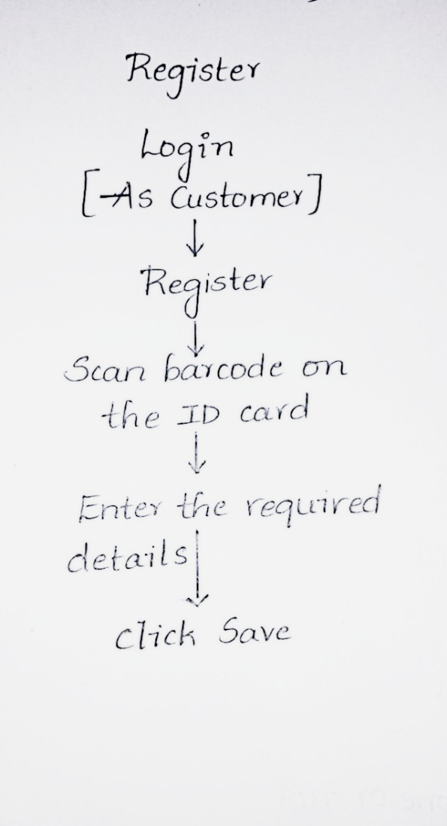

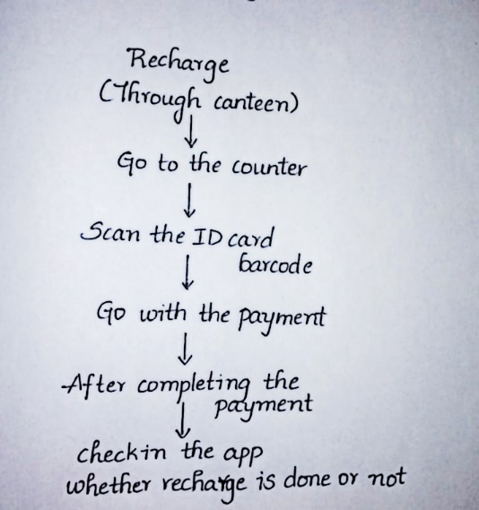 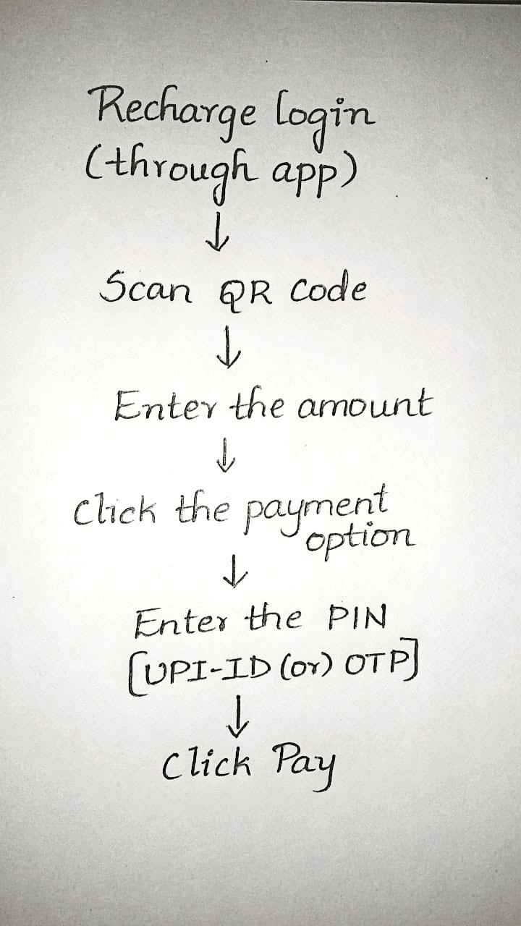

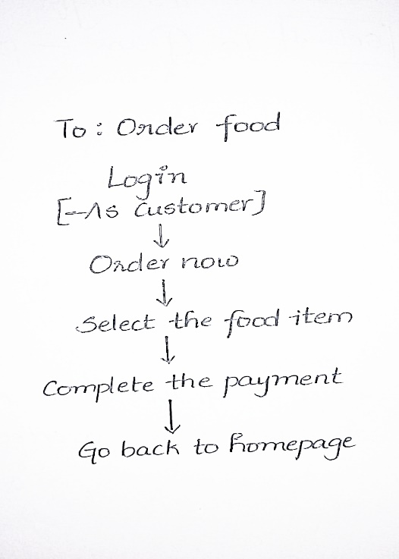

## 

## 

**Important Note: “The candidates’ personal data collected through this invitation serves only the specific purpose of the Semicolon Hackathon Event organized by SAP in the year 2018 and will be deleted after the event has been completed.”**