# Executive Summary

The Village of Dexter, MI contracted with INP Associates to create a new interface layout for their website, dextermi.gov. INP Associates found a number strengths with the current layout, but also many areas that require substantive change to achieve an efficient user centric experience.

This report is organized into four major sections, with an appendix containing screenshots of the current home page and subpage design. The sections are:

*Analysis of Current Interface*

* The current interface is deconstructed into component elements and the existing design is evaluated based on interface design principles.

*Redesigned Interface Wireframes*

* Digital wireframes showing placement and arrangement of interface elements are presented for both home page and subpage,

*Analysis of Interface Wireframes*

* Improvements in the proposed interface are discussed as well as how the new interface addresses limitations in the existing design.

*Implementation Options*

* Three layout approaches are provided with advantages and disadvantages discussed. A single layout recommendation is provided.
* Three local navigation approaches are provided with advantages and disadvantages discussed. A single local navigation recommendation is provided.

The redesigned interface offers a number of advantages over the existing design:

* The most useful content on the home page was brought above the fold and given a high contrast ratio.
* Consistency issues font typeface and size are addressed.
* Local navigation is made consistent across more platforms.
* Dead space has been eliminated in the header and along the sides.
* Causes of excessive page weights are identified and reduced.

# Analysis of Current Interface

# *Layout*

# The interface for Dextermi.gov (see Appendix A) uses a fixed with layout. The home page screen size is 1030 x 924. The site is center aligned. The height for the header and footer are 196 pixels and 178 pixels respectively.

# The whitespaces around the content area varies from page to page. The content area has white background in the current design. For example the home has very little space at the bottom, but the side margins are more generous.

# The global navigation is aligned horizontally placed at the bottom of the header. There is hover effect used to display a local navigation drop down select menu. Which was likely implemented using a combination of JavaScript and CSS.

# The home page features a prominent green sinuous wave pattern visually breaking the page creating a very strong ‘fold’ effect.

# *Color and Graphics*

# Much of the text and the background in header and footer are various shades of green. The footer text is yellowish green. The lower footer background is dark green. The bar above the footer is gray. The header uses light green for links at the top of the header. Contrast throughout the site is borderline and should be increased for maximum readability.

# Global navigation text is white with a grayish-green background. The local navigation drop down has black text above a light green background.

# The header graphics color scheme like much of the site features various shades of green. The file size of the header graphic alone is 22.8k. Large graphics increase page weights and negatively impact user experience.

# The content area uses mostly dark gray text on a white background. The headings in the content area are larger font sizes using a serif font. The content text a smaller font sized sans-serif font. The site should limit arbitrary differences in font typefaces.

# The lower portion of the home page has green headings on backgrounds, which are lighter shades of green. The lower area content text color is a darker gray. This section has less contrast than would generally be expected for good readability.

# The total number on the home page images is 59 according to <http://analyze.websiteoptimization.com/wso>. This is an inappropriately high number of images. Some of the images are at too high of resolution resulting in excessive download sizes and times.

# The site downloads large JavaScript libraries which aid to graphical style of the site. Script size of 114k is excessive considering a benchmark of 20k.

# *Interface Elements*

# Dextermi.gov website interface contains the following elements, which will be brought forward in some form (modifications are made to certain elements) into the redesigned interface:

# Header links to contact, calendar and forms

# Search text field and button

# HTML text global navigation

# ‘I want to’ selection drop down

# Welcome text heading

# Welcome text paragraph

# Graphics

# High resolution header

# Green sinuous fold

# Large high resolution image

# Various graphics for page utility such as navigation gradient

# Sub navigation hovering HTML menus

# Footer links to site map, site feedback and The Facebook.

# Level two pages and sub-pages has an additional local sidebar navigation.

# *Interface Design: Strengths*

# A number of strength were found in the current site interface such as a professional appearance and the coordinated color scheme.

# Though not extensively tested, the site did print well. The center aligned fixed pages printed out nicely when tested without exceeding the paper width.

# The site has some adherence to the Gestalt principles of organization. These principles inform site designers how to organize elements so users may easily build associations. Areas found consistent with Gestalt principles are detailed in the following table.

|  |  |
| --- | --- |
| Gestalt Principle | Element(s) |
| Proximity | Header links, global and local navigation are grouped. |
| Similarity | There is similarity among the navigation sub menus and in the side bar. |
| Enclosure | The header, footer, content area and side bar navigation all make use of the principle of enclosure. |

# The site has certain aspect with adherence to interface design principles. These aspects are tabulated below.

|  |  |
| --- | --- |
| Design Principle | Element(s) |
| Consistency | Header, footer, side bar, and global navigation are consistent among the site pages. |
| Focus and Contrast | The content areas have white backgrounds with dark lettering, which are examples of effective use of focus and contrast. |
| Aesthetics | The use of coordinated colors and high resolution images create a pleasant visual aesthetic. |

# *Interface Design: Areas for Improvement*

# Limitations in the current interface relate to a popup local menu upon mouse hover, inefficient use of screen real-estate. The site has issues related to alignment, contrast, white space, inconsistency among fonts, and as previously mentioned page weights.

# The submenus that appear when the mouse hovers over the global navigation pose a usability risk. In limited testing, the experience was not found to be consistent at various screen resolution and zoom settings. Specifically the sub menus occasionally disappeared when the mouse moved to select the lower menu items using Chrome on a PC. Further, reliance upon mouse hovering effects for important navigation is not appropriate for mobile touch screens, which have expanded beyond the mobile phone form factor. It is recommended that the local navigation should be restructured to address these issues.

# On the home page, the combination of a large header area and the sinuous wave image create a very strong yet very small area that is considered the ‘above fold’ area. The section has focus, but only contains a large image and some welcome text. It is recommended to expand the above fold screen real-estate, and to place content or links that are related to popular site topics.

# The site requires adherence with the Gestalt principles of organization as detailed in the following table.

|  |  |
| --- | --- |
| Gestalt Principle | Element(s) |
| Proximity | The spacing in the Village Calendar section on the home page does not create a proper grouping of event name and event date. |
| Similarity | There is lack of similarity between the navigation style and the ‘I want to’ drop down. |
| Continuity | The sub menus have misalignment (discontinuity) with the parent menu item. |
| Enclosure | There is a strong enclosing effect that groups Popular Links, Latest News and Village Calendar. These three groups are enclosed such that they appear as one group. |

# The site requires adherence to interface design principles. These aspects are tabulated below.

|  |  |
| --- | --- |
| Design Principle | Element(s) |
| Consistency | The fonts used are not consistent. Serif and sans serif fonts are used interchangeably. Font sizes are mixed in the “Did You Know?” section. |
| Contrast | In many areas the contrast is too low between the text and background colors. A minimum contrast ratio of 4.5:1 should be consistently applied throughout. |
| Alignment | Local navigation sub menus are not completely left aligned with the parent items. ‘I want to’ label is bottom aligned, while global navigation items are vertically center aligned.Each page content area is not aligned with the header and footer. There is an 80 pixel padding on the left and right sides. |
| Focus | The home page focus on an image and welcome text as previously mentioned is not a wise choice for prime home page screen space. |
| Negative Space | Along with creating alignment problems, the left and right negative space does not serve a purpose and only reduces important useable space.The ‘Contact Us’ page has large empty spaces due to no sidebar navigation to the extent that the page might appear only partially loaded.The home page welcome text has insufficient margin on the bottom. It appears to overlap with the sinuous wave image in some browsers. |

# 

# Redesigned Interface Wireframes

# *Home Page*

# A description...

# *Sub Page*

# A description...

# Analysis of Redesigned Interface

# The redesigned interface for Dextermi.gov offers a number of benefits over the existing design and addresses the limitations identified in the ‘Areas for Improvement’ section of this report. The home page requires substantial layout changes to increase the above the fold area. The following enhancements are proposed for the site:

# Eliminating the dead space of the left and right sides of the middle sections will increase prime content area on each page.

# The redesign addresses the usability concerns of the popup local menu upon mouse hover by suggesting alternate methods to achieve the desired benefit.

# The redesign increases the ‘above the fold’ area on the home page by lowering the green sinuous wave image, and placing the popular content above the image. The users will scan the page in an ‘F’ pattern when looking for specific information. By redesigning the home page according to standard design principles and the Gestalt principles of organization the users will find the information they desire more quickly

# Eye catching graphics can be placed below of the fold. When users are simply exploring the site, they will easily find the proposed image carousel placed below the green sinuous fold. If JavaScript is not enabled, the carousel will be replaced with a static image and description.

# Implementation Options

# *Layout Options*

# The redesigned Dextermi.gov interface can be implemented a few different ways, with each approach offering advantages and disadvantages.

# Approach L1: Fixed-Width, Left-Aligned

# The design could be coded in a left-aligned and entirely fixed-width fashion, using three rows of fixed width.

# The top-most row contains the logo, search box, global navigation buttons, local navigation links, and the stylized background image.

# The middle section (row) would contain the side bar with links for local navigation. It would also contain the content specific for the current page.

# The bottom row would contain addresses, phone and fax numbers, links to Facebook, and hours of operation.

# The advantage of this entirely fixed-width approach is that there is exact control over alignment of the elements within rows and the line lengths remain reasonable.

# This layout also remains balanced, because page elements retain the same relative positions when the window is resized or screen resolution is increased.

# The most significant disadvantage of an entirely fixed-width approach is that there will be a fair amount of ‘dead space’ to the right of the page at higher resolutions.

# Approach L2: Fixed-Width, Centered

# The second approach to coding this interface is substantially similar to the first approach, except that the entire design is centered on the page.

# This approach confers the benefits noted for Approach L1, while reducing the appearance of ‘dead space’ at higher resolutions by spreading the white space out to either side.

# Approach L3: Fixed-Width and Variable-Width Columns

# The third approach combines both fixed-width and variable-width elements.

# Each row would contain fixed-width that are left aligned these would include elements contain the logo and global navigation in the top row.

# Right aligned elements would also be fixed width. These include elements containing the search text box and the ‘I want to’ drop down select list.

# The middle row would have variable width elements which contain pictures and other content pertinent to the specific page. These elements would be sized according to the width of the browser window, expanding to fill the available window space.

# The benefits of this approach are that ‘dead space’ is no longer an issue, at higher resolutions more page content is visible, and printing should also not be an issue as long as the fixed-width columns are not too wide.

# The disadvantages are that the variable width elements could become misaligned. At higher resolutions line lengths could also become uncomfortably long.

# *Menu Options*

# The redesigned menu in the Dextermi.gov interface has the following options:

# Approach M1: Local popup menu when mouse is hovered

# This is the current implementation used on Dextermi.gov. When the mouse is hovering over the global navigation, a sub menu will appear to select the desired page.

# The advantage is that one can jump from one subpage to a subpage of another category.

# One disadvantage is that hover effects do not work well most touch screen computing devices. Another disadvantage is that these types of effects require JavaScript enabled on the browser. Finally, the libraries sometimes used for these types of effects can negatively affect loading times by increasing the page weight.

# Approach M2: Local popup menu when mouse is clicked

# This option is very similar M1 option, but the user most click the global heading to present the local sub menu popup.

# Advantages include supporting mobile devices, reducing the need for large JavaScript libraries as it can be implemented with standard URI links, and still allows users to jump from subpage to subpage among different categories.

# The disadvantage is that the user might expect to get to the category overview page upon clicking the category name.

# Approach M3: No local menu popup is presented.

# The third approach is a more traditional approach that was common in most pages a decade ago. When the user clicks the global navigation topic they are ushered to the overview page for the topic and presented the local subpage at that time.

# The disadvantage is that the user must process a new page full of information while scanning for the proper local navigation item. Many websites have moved away from this approach, but it’s still used extensively throughout the web.

# *Recommendations*

# Of the approaches described, the second layout approach (L2) is recommended. That approach helps keeps the page experience most consistent, while also splitting apart the dead space. Most pages on Dextermi.gov do not have extensive scrolling issues. Other techniques can be employed if scrolling is found to be an issue.

# Regarding the reimplementation of the local sub menus, the second approach M2 is the most recommended. It provides the necessary functionality of skipping among different category subpages while also supporting the ever growing number of touch screen devices.

# Appendix A

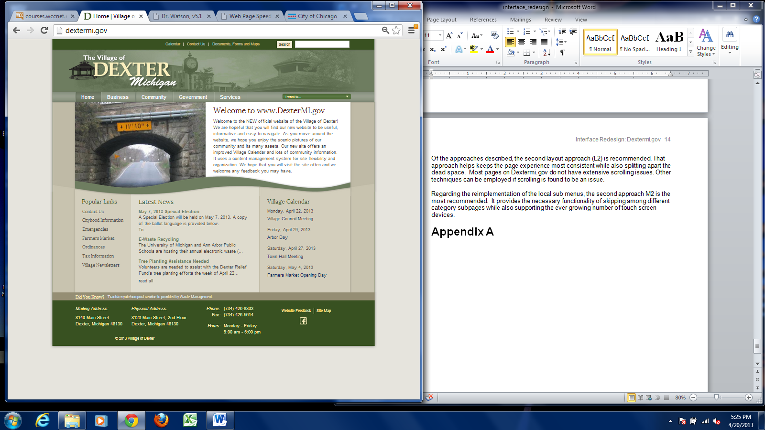

Figure : Current Home Page

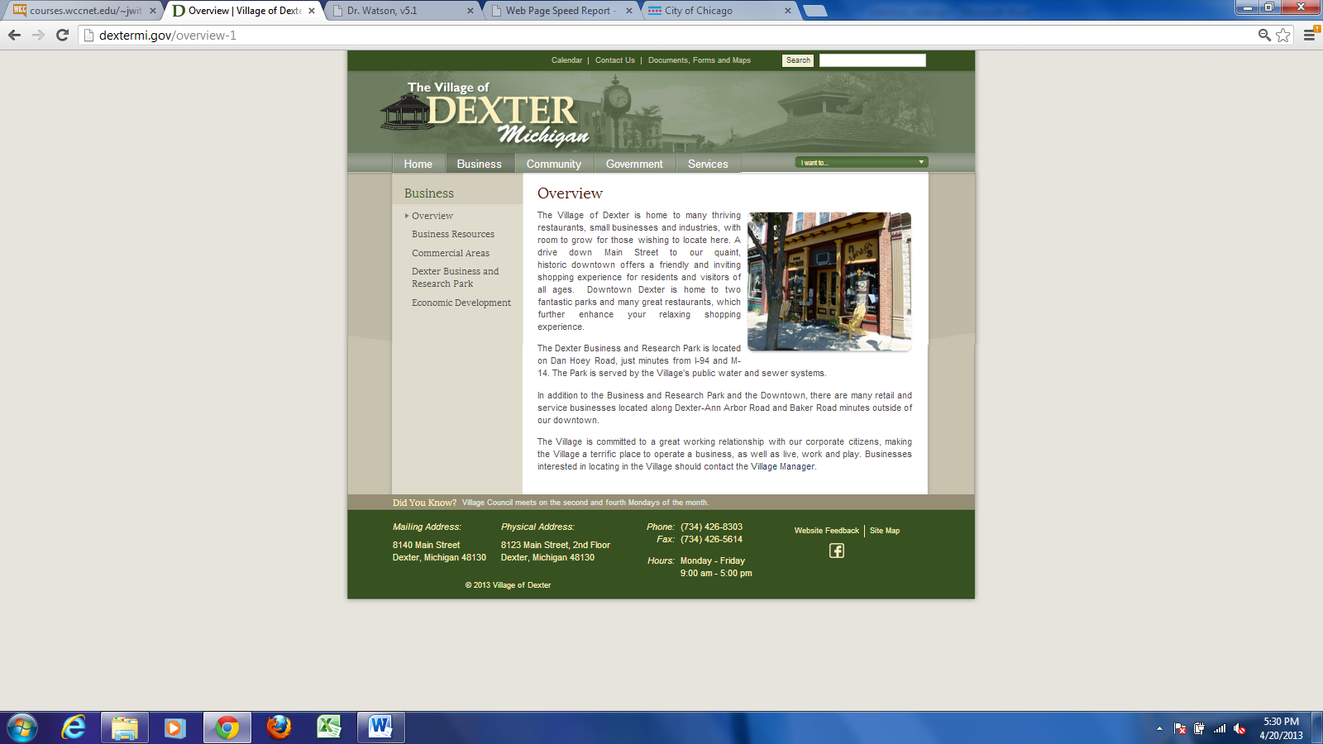

Figure : Current Subpage Example

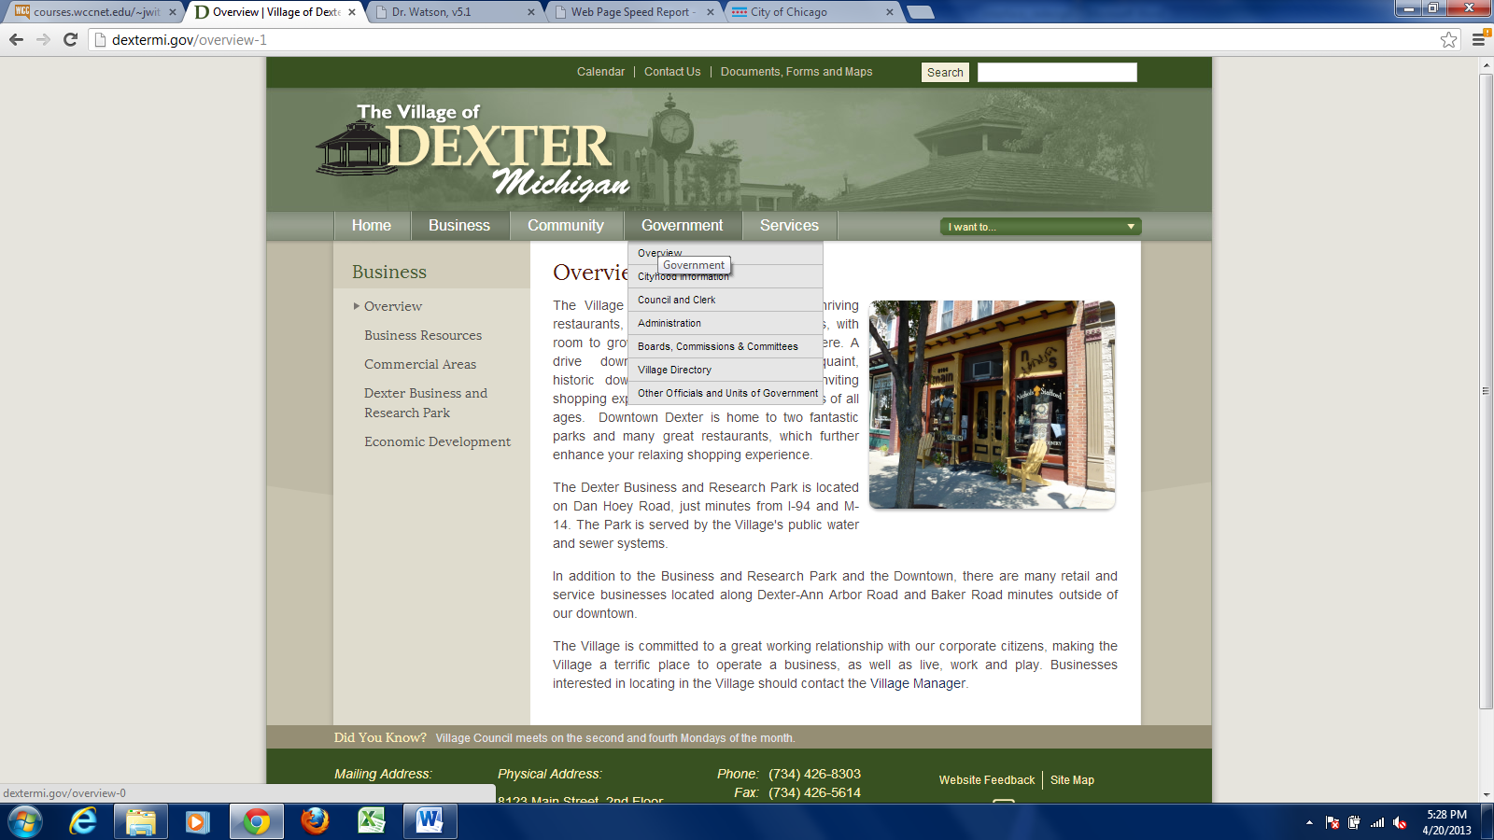

Figure : Current Local Navigation

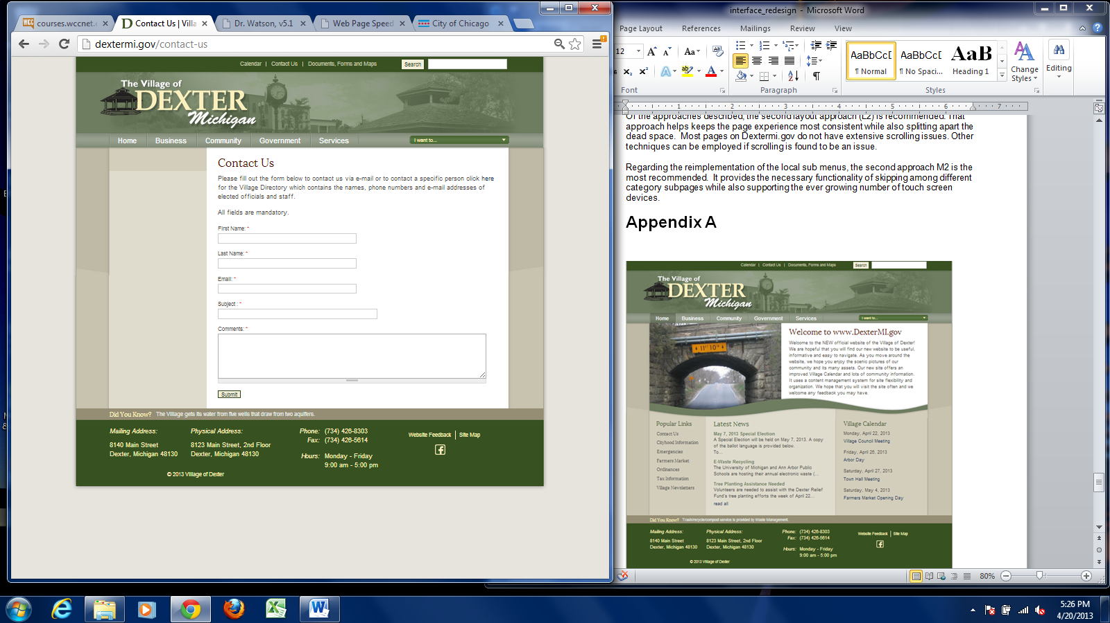

Figure : Current Contact Us Page