Clint Scott  
CSD310  
Module 6.2 Assignment: Movies: Setup  
4/20/25

1. **SHOW TABLES;**  
   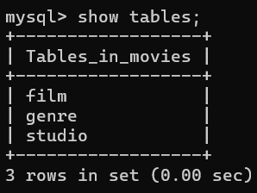
2. **mysql_test.py**  
   A screenshot of a computer

   AI-generated content may be incorrect.
   1. I used Colorama to add some color and make the output stand out a bit more.  
      