Clint Scott  
2025_0427  
CSD325 Advanced Python  
Module 9.2 Assignment – APIs

1. **API Tutorial - Status Code Screenshot**
2. **People In Space Screenshot**  
   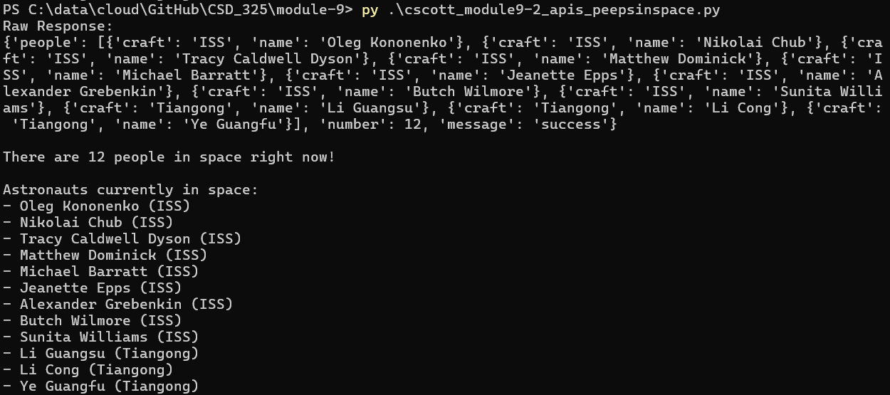
3. **D&D Magic User Spells (adding a second API one for fun… no raw data, too much to screenshot)**