TUTORIAL TO PARTICLE DETECTION AND CMS EVENT DISPLAY

CMS experiment at CERN has made available data for public use. This data can be visualised, for example, in an interactive Event Display which can be found from CERN Open Data Portal ([opendata.cern.ch](http://www.opendata.cern.ch/)). This document contains a tutorial to learn how to use the Event Display. You can find other documents from the portal associated to this document that contain classroom activities*. In each of these activities, instructions for teachers and a worksheet for students are included. This document will help you familiarize with the Event Display, different parts of the detector and particles detected in each part.

BASICS OF PARTICLE DETECTION

CHARGED PARTICLES MOVING IN A MAGNETIC FIELD

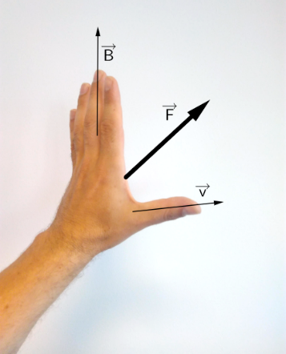If a charged particle is moving in an external magnetic field it feels a force perpendicular to both the direction of the field and the direction of movement, the Lorentz-Force.

There is an easy way to remember in which direction the force points by using your left hand: The fingers represent the magnetic field, pointing from palm to fingertips. If the particle carries a negative charge, e.g. an electron, and moves in the direction of the thumb, the palm pushes into the same direction as the force. For a positive particle, it’s the same way with the right hand.

In the picture below is shown tracks of three different particles. All particles are moving from left to right in a magnetic field pointing into the plane of the paper. The direction of the magnetic field is indicated by X inside a circle. (For the opposite direction we use a point inside the circle.)

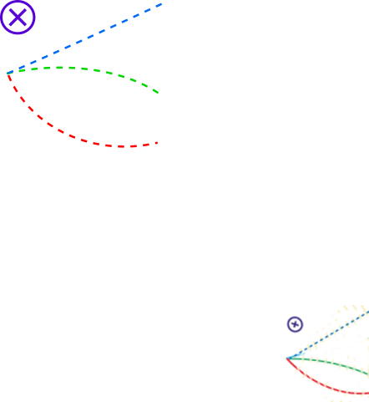The upper track goes in a straight line. The particle does not carry a charge, so it doesn’t feel the force.

The middle track is bent downwards. This particle carries a negative charge. The last track is bent upwards. This particle carries a positive charge.

The stronger the magnetic field *B* is and the slower the particle moves, the stronger the Lorentz-Force *FL* is, causing greater bending of the track.

PARTICLES

**Electron**

A stable elementary particle belonging to the *fermion* family of particles. It has an electrical charge of -1, while its antiparticle, the positron has an electrical charge of +1. An electron has a mass of approximatively 0.5 MeV /c².

**Photon**

A stable elementary particle belonging to the *boson* family of particles. A photon is massless with no electrical charge. It is the carrier of the electromagnetic force. It’s represented by Greek letter γ (gamma).

**Hadron**

A “heavy” composite particle made of two or more quarks. For example, protons and neutrons are in this category.

**Muon**

An elementary particle. It has an electrical charge of -1. Muon is a lepton with properties that are similar to those of an electron but 200 times more mass. It is represented by Greek letter µ (mu).

INTRODUCTION TO ACCELERATORS

The accelerator complex at CERN is a succession of machines that accelerate particles to increasingly higher energies. Each machine boosts energy of a beam of particles, before injecting the beam into the next machine in the sequence. In the Large Hadron Collider (LHC) – the last element in this chain – particle beams are accelerated up to the record energy of 6.5 TeV per beam (1TeV = 1012 eV; 1 eV = 1.602x10-19 Joule). [1]

In LHC protons circulate in two adjacent beam pipes. The beam in one pipe circulates clockwise while the beam in the other pipe circulates anticlockwise. It takes 4 minutes and 20 seconds to fill each LHC ring, and 20 minutes for the protons to reach their maximum energy. Beams circulate for many hours inside the LHC beam pipes under normal operating conditions. The two beams are brought into collision inside four experiments – ALICE, ATLAS, CMS and LHCb – where the total energy at the collision point is equal to 13 TeV. [1]

Particles produced in collisions travel normally straight, but in the presence of a magnetic field the paths of charged particles become curved. Electromagnets around particle detectors generate magnetic fields to exploit this effect. Physicists can calculate the momentum of a particle – a clue to its identity – from the curvature of its path: particles with high momentum travel in almost straight lines, whereas those with very low momentum move forward in tight spirals inside the detector. Modern particle detectors consist of layers of sub-detectors each designed to look for particular properties, or specific types of particle. [2]

WHAT IS CMS?

The Compact Muon Solenoid (CMS) is a general-purpose detector at the Large Hadron Collider (LHC). The CMS detector is built around a huge solenoid magnet to bend the paths of particles from collisions in the LHC. This takes the form of a cylindrical coil of superconducting cable that generates a field of 4 Tesla, about 100,000 times the magnetic field of the Earth. The complete detector is 21 meters long, 15 meters wide and 15 meters high. [3]

Just as hunters can identify animals from tracks in mud or snow, physicists identify subatomic particles from the traces they leave in detectors [2]. To better understand this, we give you some more information about detectors.

DETECTORS

**Tracker**

Tracking devices reveal the paths of electrically charged particles as they pass through and interact with suitable substances. Most tracking devices do not make particle tracks directly visible, but record tiny electrical signals that particles trigger as they move through the device. A computer program then reconstructs the recorded patterns of tracks. The innermost tracker is made entirely of silicon. [2]

**Calorimeter**

The electromagnetic calorimeter measures the energy that particles loose when they pass through it as they interact with the matter. Calorimeters can stop most known particles except muons and neutrinos. Hadron calorimeter measures the energy of *hadrons*, particles made of quarks and gluons. The electromagnetic calorimeter measures the energy electrons and photons. It is made of crystals connected to photodiodes. [2]

**Muon detector**

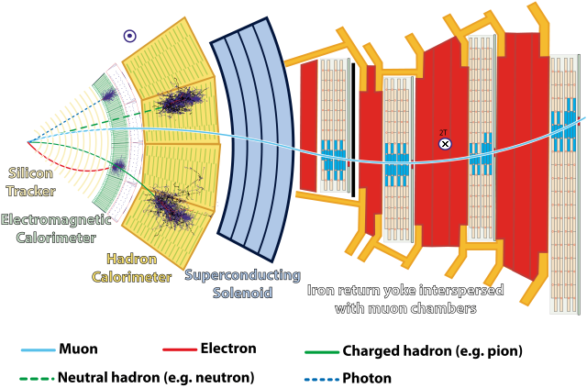Unlike most particles, muons are not stopped by any of CMS's calorimeters. Muon chambers are placed at the very edge of the CMS detector where muons are the only particles likely to be tracked. Detectors can trace muon’s path by tracking its position through multiple layers of muon detector and then combining the information with tracker measurements. [4]

**Note:** the muon above is an antimuon **µ+**, so the bending direction is opposite to the electron’s.

VISUALISATION OF EVENT

An event is a fundamental interaction that takes place when particles collide in the detector. In a particle physics event, incoming particles are scattered or destroyed and hundreds of new particles can be produced depending on the energy. Events detected by CMS can be visualised and examined using the Event Display which can be found from CERN Open Data Portal:

<http://opendata.cern.ch/visualise/events/CMS>.

Here are some basics about the functionalities of the top menu bar:

Open file

Initial orientation

Different axes

Zoom in/out

Navigate between events

Different projections

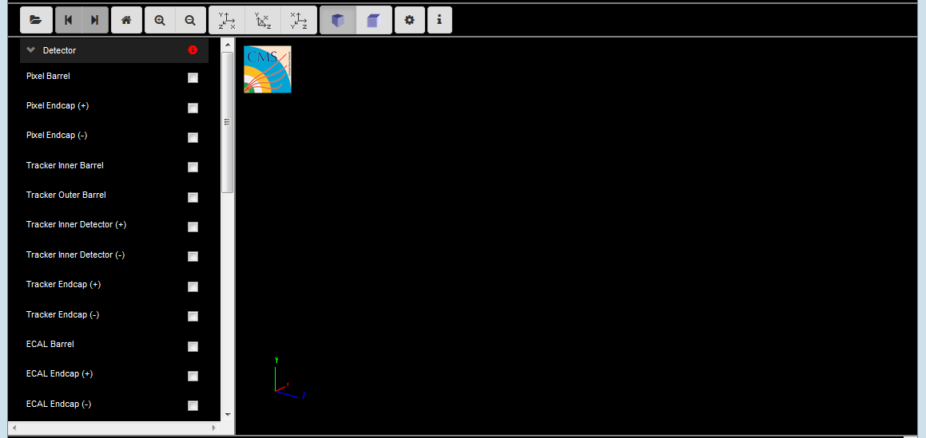

The menu on the left contains selections of the different detector parts and particles. Sections therein are described more precisely later on.

HOW TO OPEN A SET OF DATA

* Click the Open File button
* Following window will appear:

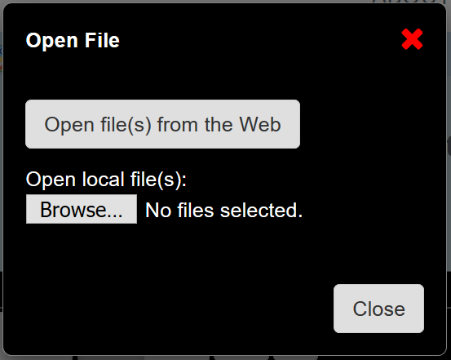

Select “Open file(s) from the Web”. These files are found in the CERN Open Data Portal.

* Within the folder “Education” you can find several interesting examples. As an example we are going to open the dimuon_0.ig file. Click the file, select an event and click “Load”.

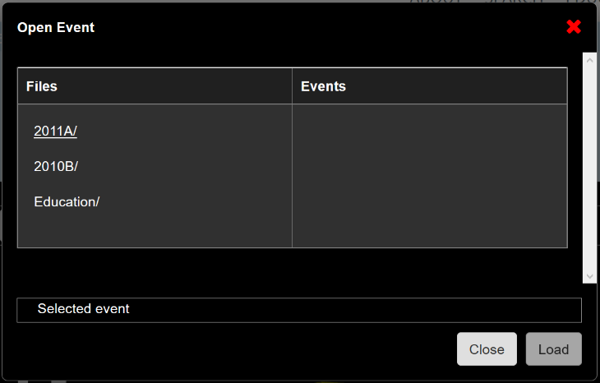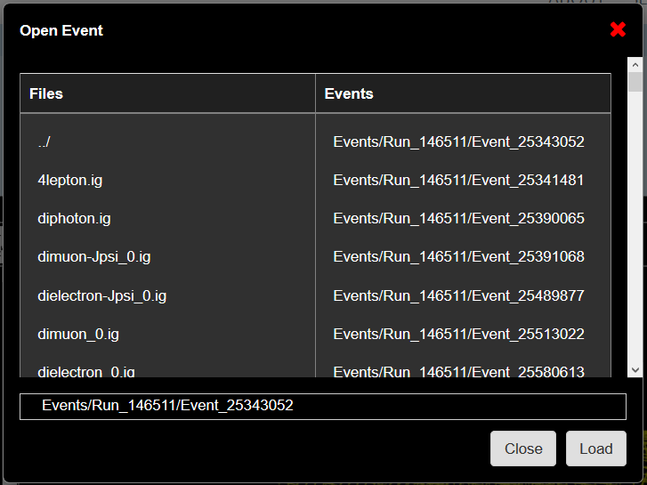

* 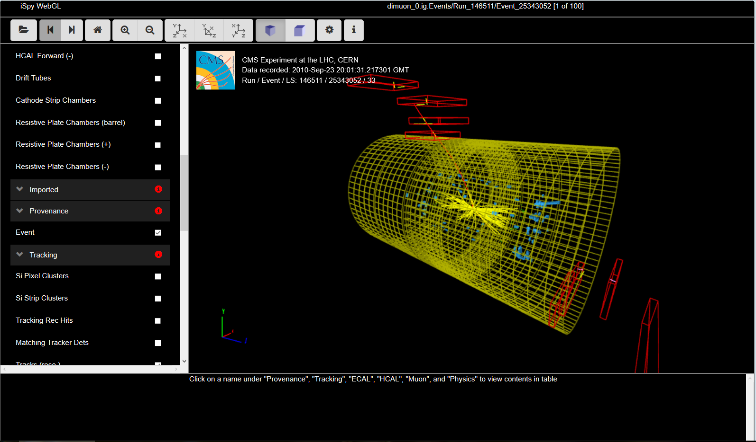The event will open up like this:

WHAT DO WE SEE

There is a menu on the left side of Event Display which has 8 submenus. The most interesting features are found under the Physics section and you can find short descriptions of the submenus at the end of this document (App. 1). You can try different selection outcomes by clicking the checkboxes of different sections. Short descriptions can be found by clicking the red info button of each submenu.

In this example, we are interested in an event with two muons. We can obtain information about the data associated with these two muons by using two different options:

1. Click the muon track in the Event Display and you will obtain a window as below

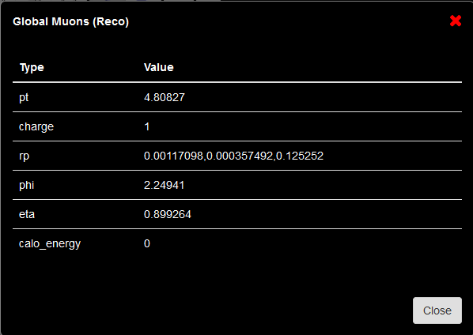

1. 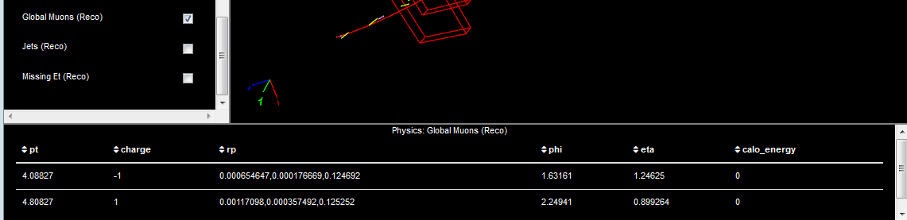Click the menu option Global Muons (Reco). Click the name, not the check box, and at the bottom of the Event Display a new table with data will appear (see below).

We are going to use this data for the classroom activities so take your time to familiarize with the detector parts, particles and the Event Display.

USING OTHER DATA SETS

There are different data sets you can open from the education folder. We have used the example of Z boson decay into two muons. Depending on the data set you open, the visualisation can differ and as mentioned earlier, not all submenus might be available for every event. This is related with the nature of the data and the time when it was acquired.

References

[1] <https://home.cern/about/accelerators>

[2] https://home.cern/about/how-detector-works

[3] <https://home.cern/about/experiments/cms>

[4] <http://cms.web.cern.ch/news/muon-detectors>

Appendix 1. Short descriptions of submenu contents

All menus are not necessarily available for each event depending on the particles detected in the event.

* **Detector:** Corresponds to the different detector parts which we have discussed earlier. Only the HCAL outer is selected as a default.
* **Imported**: Includes geometry models such as the beam pipe.
* **Provenance**: See the event information on the screen.
* **Tracking**: Shows different parts of the tracking system.
  + Si Pixel Clusters (red points)
  + Si Strip Clusters (red points)
  + Tracking Rec Hits: All particle hits in the tracker (yellow dots)
  + Matching Tracker Dets (yellow rectangles)
  + Tracks (rec.): Reconstructed particle tracks (yellow tracks)
* **ECAL:** Electromagnetic calorimeter
  + Barrel Rec Hits (green dots)
  + Preshower Rec. Hits : NA
  + Endcap Rec. Hits (green dots)
* **HCAL:** Hadronic calorimeter
  + Barrel Rec. Hits (Blue volumes)
  + Endcap Rec. Hits (Blue volumes)
  + Outer Rec. Hits (Blue volumes)
  + Forward Rec. Hits (Blue volumes)
* **Muon**
  + Matching Muon Chambers: Muon chambers that correspond to the reconstructed [muon](http://opendata.cern.ch/visualise/events/CMS)
  + CSC Segments: [Muon](http://opendata.cern.ch/visualise/events/CMS) track segments in Cathode Strip Chambers (pink segments)
  + RPC Rec. Hits: [Muon](http://opendata.cern.ch/visualise/events/CMS) hits in Resistive Plate Chambers (yellow segments)
  + DT Rec. Segments (4D): [Muon](http://opendata.cern.ch/visualise/events/CMS) track segments in Drift Tubes (yellow segments)
  + DT. Rec. Hits: Muon hits in Drift Tubes (green segments)
* **Physics**
  + Electron tracks: Reconstructed candidate electron tracks (green tracks)
  + Tracker Muons (Reco): Reconstructed muon tracks (red tracks)
  + Stand-alone Muons (Reco): Reconstructed [muon](http://opendata.cern.ch/visualise/events/CMS) track segments in [muon](http://opendata.cern.ch/visualise/events/CMS) chambers (red tracks)
  + Global Muons (Reco): Reconstructed complete [muon](http://opendata.cern.ch/visualise/events/CMS) tracks, combining tracker and stand-alone [muons](http://opendata.cern.ch/visualise/events/CMS) (red tracks)
  + Jets (Reco): collimated streams of particles in the ECAL and HCAL (yellow pyramids)
  + Missing Et (Reco): Reconstructed missing transverse energy. Is often interpreted as neutrinos.