# Particles and their detection

Aim: Let student familiarize with particles, basic principles of particle detection and how the charged particles move in a magnetic field. Introduce particle research at CERN by means of CMS experiment.

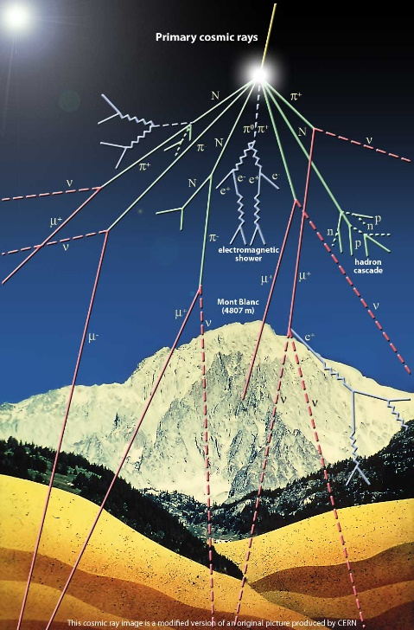Skills achieved: Ability to extract and apply information.

Earth is under constant bombardment of *cosmic rays:* particles from outer space. These high-energy particles are mainly protons (89 %) but also nuclei of helium (10 %) and heavier nuclei (1 %). When arriving at Earth, they collide with the nuclei of atoms in the upper atmosphere and create more particles which decay further. At the surface of the Earth, particles called muons pass through a volume size of a person’s head at the rate of one per second. [1]

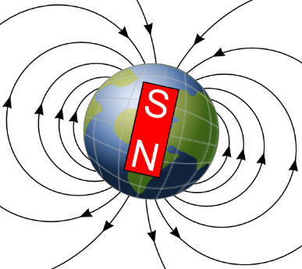One visible evidence of particles coming from outer space are northern lights (aurora). They are mainly observed in high latitude regions due to the shape of Earth’s magnetic field.

**Fig. 1** Cosmic rays

**Fig. 3** Earth’s magnetic field

**Fig. 2** Northern lights

At CERN, physicists and engineers study the fundamental structure of the universe and the particles it is made of. This is done by accelerating particles close to the speed of light and colliding them in controlled experiments. Even though we can’t see the tiny particles produced in collisions there are ways to detect them.

1. What particles can we detect?

**Electron** A stable elementary particle belonging to the *fermion* family of particles. It has an electrical charge of -1, while its antiparticle **positron** has an electrical charge of +1. An electron has a mass of approximatively 0.5 MeV /c².

**Photon** A stable elementary particle belonging to the *boson* family of particles. A photon is massless with no electrical charge. It is the carrier of the electromagnetic force. It’s represented by Greek letter γ (gamma).

**Hadron** A “heavy” composite particle made of two or more quarks. They can carry a charge or be neutral. For example, protons and neutrons belong to this category.

**Muon** An elementary particle. It has an electrical charge of -1. Muon is a lepton with properties that are similar to those of an electron but 200 times more mass. It is represented by Greek letter µ (mu). Muon’s antiparticle **antimuon** has an electrical charge of +1.

2. How can we detect particles?

There are different kinds of particle detectors but the basic principles are the same. The Compact Muon Solenoid (CMS) is a detector that uses a huge magnet to bend the paths of particles produced in proton-proton collisions.

**Tracker**

Tracking devices reveal the paths of electrically charged particles as they pass through and interact with suitable substances. Most tracking devices do not make particle tracks directly visible, but record tiny electrical signals that particles trigger as they move through the device. A computer program then reconstructs the recorded patterns of tracks. The innermost tracker is made entirely of silicon. [2]

**Calorimeter**

The electromagnetic calorimeter measures the energy that particles loose when they pass through it as they interact with the matter. Calorimeters can stop most known particles except muons and neutrinos. Hadron calorimeter measures the energy of *hadrons*, particles made of quarks and gluons. The electromagnetic calorimeter measures the energy of electrons and photons. It is made of crystals connected to photodiodes. [2]

**Muon detectors**

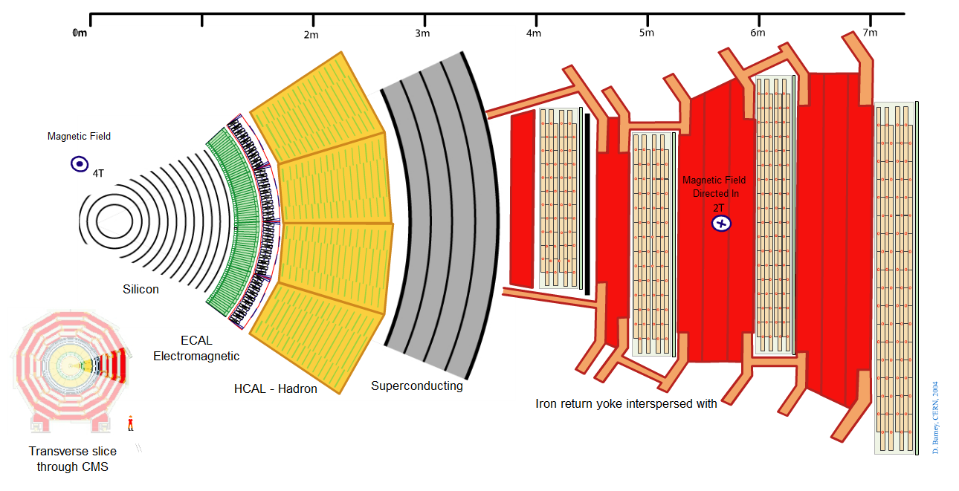Unlike most particles, muons are not stopped by any of CMS's calorimeters. Muon chambers are placed at the very edge of the CMS detector where muons are the only particles likely to be tracked. Muon’s path can be constructed by tracking its position through multiple layers of muon detectors and then combining the information with tracker measurements. [3]

**Fig. 4** Transverse slice of the CMS detector

3. How do particles move in a magnetic field?

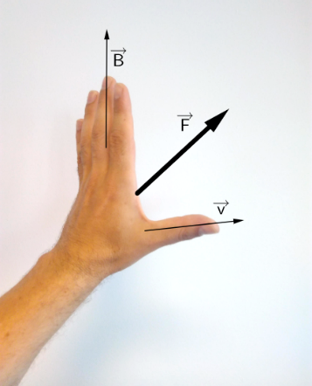If a charged particle is moving in an external magnetic field it feels a force perpendicular to both the direction of the field and the direction of movement, the Lorentz-Force.

There is an easy way to remember in which direction the force points by using your left hand: The fingers represent the magnetic field, pointing from palm to fingertips. If the particle carries a negative charge, e.g. an electron, and moves in the direction of the thumb, the palm pushes into the same direction as the force. For a positive particle, it’s the same way with the right hand.

**Fig. 5** Left-hand rule

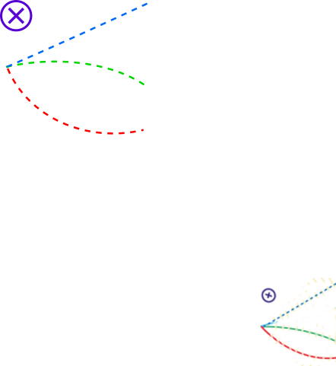In the picture below is shown tracks of three different particles. All particles are moving from left to right in a magnetic field pointing into the plane of the paper. The direction of the magnetic field is indicated by X inside a circle. (For the opposite direction we use a point inside the circle.)

The upper track goes in a straight line. The particle does not carry a charge, so it doesn’t feel the force.

The middle track is bent downwards. This particle carries a negative charge. The last track is bent upwards. This particle carries a positive charge.

**Fig. 6** Particle tracks

The stronger the magnetic field *B* is and the slower the particle moves, the stronger the Lorentz-Force *FL* is, causing greater bending of the track.

References:

[1] https://home.cern/about/physics/cosmic-rays-particles-outer-space (14.8.2017)

[2] https://home.cern/about/how-detector-works (14.8.2017)

[3] http://cms.web.cern.ch/news/muon-detectors (14.8.2017)

Fig. 1 CERN (modified)

Fig. 2 By Fairbanks Mike [CC BY 2.0], via Wikimedia Commons

Fig. 3 by Zureks (Own work) [CC0], via Wikimedia Commons (modified)

# WORKSHEET

**Detect a particle from its trajectory.** Note the directions of the magnetic fields.

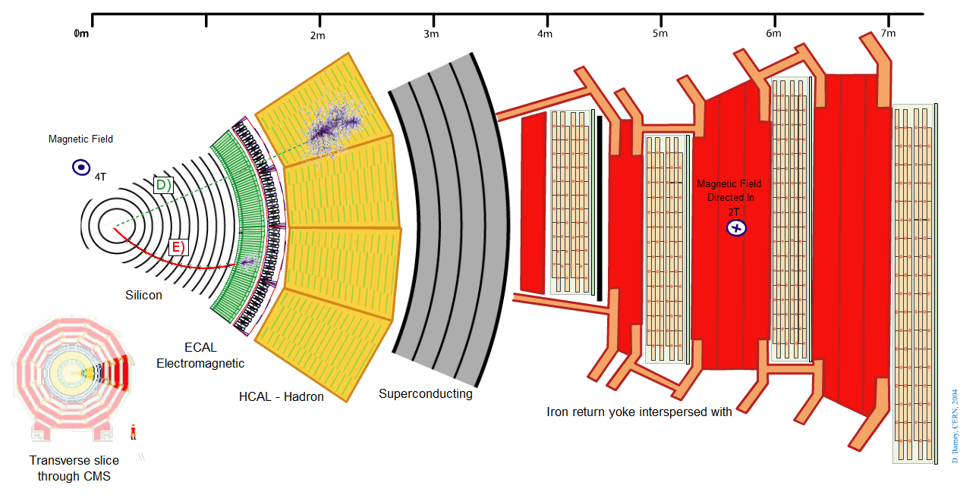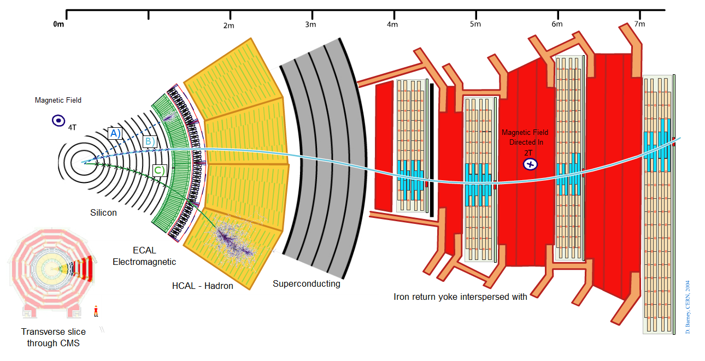

|  |  |
| --- | --- |
| **The track in the CMS detector** | **Which particle? Why?** |
| **A** | Photon. The track of the particle is a straight line (-> no charge) and it stops at the electromagnetic calorimeter. |
| **B** | Antimuon. The track bends first right and when the direction of the magnetic field changes it bends left so the particle must carry a positive charge. The particle passes through muon detectors. |
| **C** | Charged hadron (+). The track bends right (-> pos. charge) and it stops at the hadron calorimeter. |
| **D** | Neutral hadron. The track is a straight line (-> no charge) and it stops at the hadron calorimeter. |
| **E** | Electron. The track curves left (-> neg. charge) and it stops at the electromagnetic calorimeter. |

Check your answers here: <https://www.i2u2.org/elab/cms/graphics/CMS_Slice_elab.swf>

**Conclusions**

We can detect different kinds of particles with CMS. The first detector after the collision point is a high-precision tracker. At the electromagnetic calorimeter particles such as electrons and photons are absorbed. With hadron calorimeter we can detect neutral and charged hadrons. Muons travel through the whole detector leaving traces to several layers of detectors.