TUTORIAL AND CLASSROOM ACTIVITIES
What does this document contain?
CMS experiment at CERN has made available data for public use. This data can be visualized, for example, in an interactive visualizer that can be found in the Opendata portal in CERN (opendata.cern.ch). This document contains a tutorial to learn about the visualization display. You can find other documents from the portal associated to this document containing classroom activities. In each of these activities, instructions for the teacher are included and a worksheet to be used by the students during the lesson. It is important that you familiarize with the visualization display and the different parts of the detector and the particles detected in each part.
BASICS OF PARTICLE DETECTION
CHARGED PARTICLES MOVING IN A MAGNETIC FILED
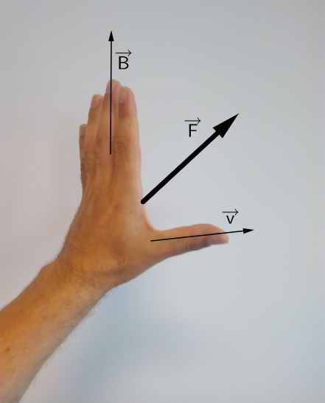
If a charged particle is moving in an external magnetic field it will feel a force perpendicular to both the direction of the field and the direction of movement, the Lorentz-Force.
There is an easy way to remember in which direction the force points by using your left hand: The fingers represent the magnetic field, pointing from north to south. If the particle carries a negative charge, e.g. an electron, and moves in the direction of the thumb, the palm pushes into the same direction of the force.
For a positive particle, it’s the same way with the right hand.
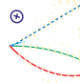
On the right you see the tracks of three different particles.
All are moving from left to right in a magnetic field pointing into the plane of the paper, which is represented by the circle with an X. (The opposite direction we use a circle with a point.)
The upper track goes in a straight line. The particle does not carry a charge, so it doesn’t feel a force.
The middle track is bent downwards. This particle carries a negative charge.
The last track is bent upwards. This particle carries a positive charge.
The stronger the magnetic field B or the slower the particle moves, the stronger the Lorentz-Force F_{L} and therefore the greater bending of the track.
PARTICLES

Electron
A stable elementary particle belonging to the «fermion» family of particles. It has an electrical charge of -1, while its anti particle, the positron has an electrical of +1. An electron has a mass of approximatively 0,5MeV /c².

Photon
A stable elementary particle belonging to the « boson » family of particles. A photon is massless with no electrical charge. It is the carrier of the electromagnetic force. It’s represented by the Greek letter γ (gamma).

Hadron
A “heavy” composite particle made of two or more quarks. For example, protons and neutrons are in this category.

Muon
An elementary particle. It has an electrical charge of -1. A muon is a lepton with properties that are similar to those of an electron but 200 times more mass. It is represented by the Greek letter µ (mu).

INTRODUCTION TO ACCELERATORS
The accelerator complex at CERN is a succession of machines that accelerate particles to increasingly higher energies. Each machine boosts energy of a beam of particles, before injecting the beam into the next machine in the sequence. In the Large Hadron Collider (LHC) – the last element in this chain – particle beams are accelerated up to the record energy of 6.5 TeV per beam. (1TeV = 10¹² eV; 1 eV = 1,602x10⁻¹⁹ Joule)
The protons are finally transferred to the two beam pipes of the LHC. The beam in one pipe circulates clockwise while the beam in the other pipe circulates anticlockwise. It takes 4 minutes and 20 seconds to fill each LHC ring, and 20 minutes for the protons to reach their maximum energy. Beams circulate for many hours inside the LHC beam pipes under normal operating conditions. The two beams are brought into collision inside four experiments – ALICE, ATLAS, CMS and LHCb – where the total energy at the collision point is equal to 13 TeV.
Particles produced in collisions normally travel in straight lines, but in the presence of a magnetic field, paths of charged particles become curved. Electromagnets around particle detectors generate magnetic fields to exploit this effect. Physicists can calculate the momentum of a particle – a clue to its identity – from the curvature of its path: particles with high momentum travel in almost straight lines, whereas those with very low momentum move forward in tight spirals inside the detector. Modern particle detectors consist of layers of sub-detectors each designed to look for particular properties, or specific types of particle.

WHAT IS CMS?
The Compact Muon Solenoid (CMS) is a general-detector at the large hadron collider (LHC). The CMS detector is built around a huge solenoid magnet to bend the paths of particles from collisions in the LHC. This takes the form of a cylindrical coil of superconducting cable that generates a field of 4 Tesla, about 100.000 times the magnetic field of the Earth. The complete detector is 21 meters long, 15 meters wide and 15 meters high [1].
Just as hunters can identify animals from tracks in mud or snow, physicists identify subatomic particles from the traces they leave in detectors. To understand this better, we give you some more information about detectors.

DETECTORS

Tracker
Tracking devices reveal the paths of electrically charged particles as they pass through and interact with suitable substances. Most tracking devices do not make particle tracks directly visible, but record tiny electrical signals that particles trigger as they move through the device. A computer program then reconstructs the recorded patterns of tracks. The tracker is made entirely of silicon.

Calorimeter
The electromagnetic calorimeter measures the energy of particles loses when they pass through, they interact with the electrically charges particles in matter. Hadron calorimeter measures the energy of « hadrons » particles made of quarks and gluons. Calorimeters can stop most known particles except muons and neutrinos. The electromagnetic calorimeter measures the energy electrons and photons. It is made of crystals connected to photodiodes.

Muon detector
Muons can penetrate many meters of iron without interacting and they can’t stop by any of CMS’ calorimeters and they are the only particles which interact with the muon detector.
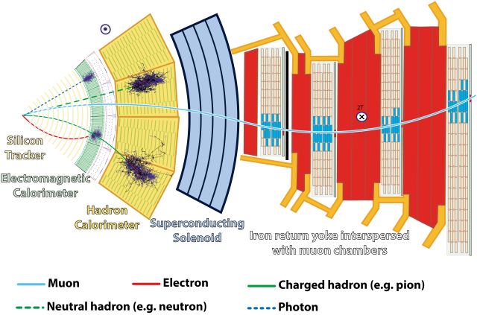
note: the Muon above is an Antimuon µ⁺, so it bends into the opposite direction the Electron does.
VISUALISATION OF DATA FROM CMS DETECTOR
VISUALISATION DISPLAY
The CMS visual display can be used to visualize data obtained in the CMS detector. It can be found here: http://opendata.cern.ch/visualise/events/CMS

Some basics about the functionalities of the top up buttons:
Open files
Initial orientation
Different axes
Navigate between events
Zoom in/zoom out
Basic information about the menu.
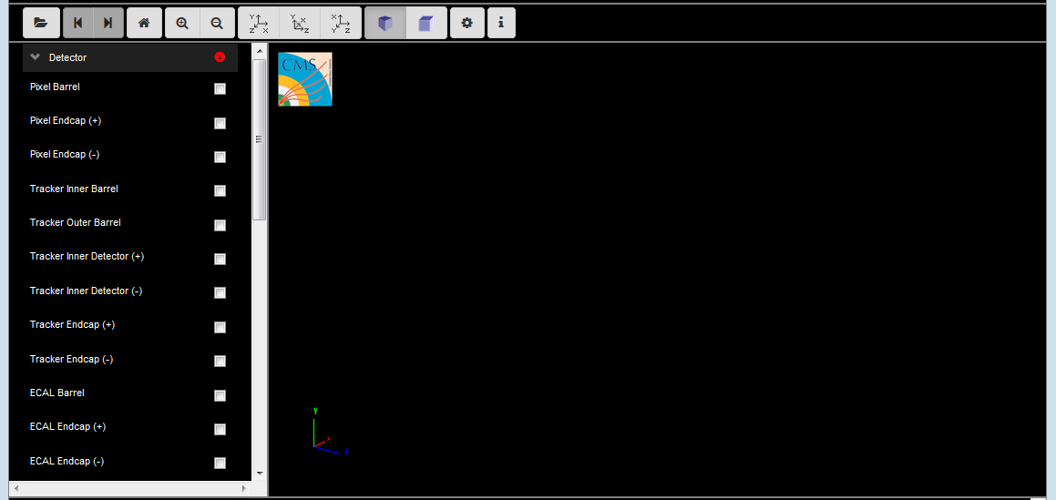
The menu on the left contains the different detector parts. Before starting using it, is important to be familiar with the different CMS detector parts and the function of each of them.

VISUALISATION OF AN EVENT
So, now we are ready to open an event and look at real data

What is an event?
An event is a fundamental interaction that takes place when particle collide in the detector. In a particle physics event incoming particles are scattered or destroyed and depending on the energy hundreds of particles can be produced. Events can be visualized and examined using the “visualize events” tool.
How to open a set of data:
- Click the open data button 
- This window will appear:
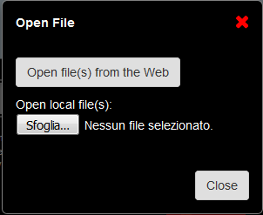

- Choose to open file(s) from the Web. These files are found in the Open data portal from CERN.

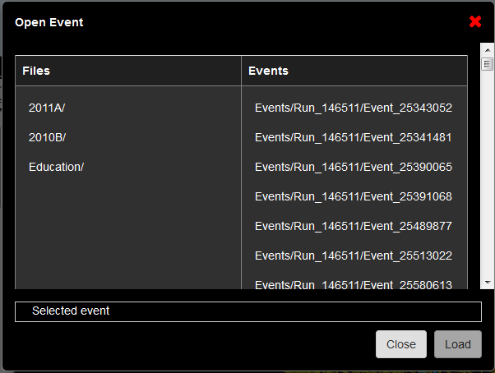

- Within the folder education you can find several interesting examples.
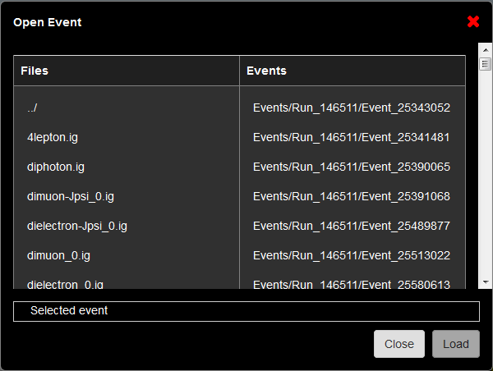
As an example we are going to open the dimuon_0.ig file. Click on the event and select “Load”.

Once is loaded, select “Close”. This is what you will see:
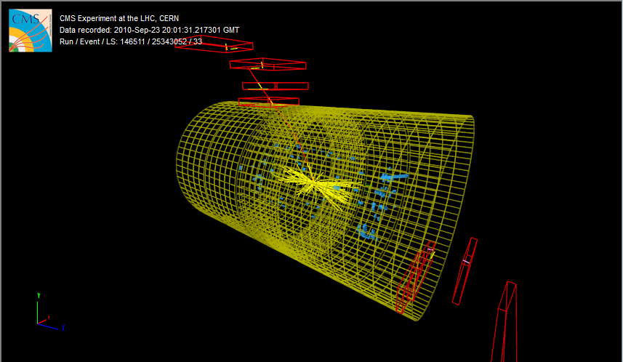

What do we see?
Let’s look at the left menu of the visualizer. There are 8 sub-menus:
- Detector: Corresponds to the different detector parts. We have learned all these parts previously. Only the HCAL outer is selected as a reference
- Imported: N.A.
- Provenance:
  - Event: see the event information in the screen.
- Tracking: Corresponds to the tracking system.
We obtain first the hits in the clusters. From these we can obtain the reconstructed tracking hits and the matching tracker Dets (detector), which will help us to obtain the reconstructed tracks. Try to select them and see how the clusters and reconstructed tracking hits look like in the detector.
  - Si Pixel Clusters: (red points)
  - Si Strip Clusters: (red points)
  - Tracking Rec Hits: (yellow dots)
  - Matching Tracker Dets: (yellow rectangles)
  - Tracks (rec.) (yellow tracks): Reconstructed tracks (selected) of electrons and photons
- ECAL
Reconstructed hits in the barrel and endcap ECAL detectors.
  - Barrel Rec Hits (Selected) (green dots)
  - Preshower Rec. Hits : NA
  - Endcap Rec. Hits (Selected) (green dots)
- HCAL
The reconstructed hits are shown in every part of the detector.
  - Barrel Rec. Hits (Selected) (Blue volumes)
  - Endcap Rec. Hits (Selected) (Blue volumes)
  - Outer Rec. Hits (Blue volumes)
  - Forward Rec. Hits (Blue volumes)
- Muon
  - Matching Muon Chambers (Selected): correspond to the reconstructed muons. (red empty volumes)
  - CSC Segments (Selected): Cathode strips chambers hits. (pink segments)
  - RPC Rec. Hits (Selected): Resistive plate chambers hits. (yellow segments)
  - DT Rec. Segments (4D) (Selected): Drift tubes reconstructed segments. (yellow segments)
  - DT. Rec. Hits: Drift tubes reconstructed hits. (green segments)
- Physics
  - Electron tracks: it will only appear in the menu if electrons have been found. (green tracks)
  - Tracker Muons (Reco) (Selected): Track of the muon in the tracker. (red tracks)
  - Stand-alone Muons (Reco): detection in the muon chambers. (red tracks)
  - Global Muons (Reco) (Selected): reconstructed track of the muons. (red tracks)
  - Jets(Reco): shower of particles in the ECAL and HCAL (yellow pyramids)
  - Missing Et (Reco): N.A.

In this event we are interested in the two muons. We can obtain information about the data associated with these two muons by using two different options.
- Clicking the muon track in the visualizer. You will obtain this window:
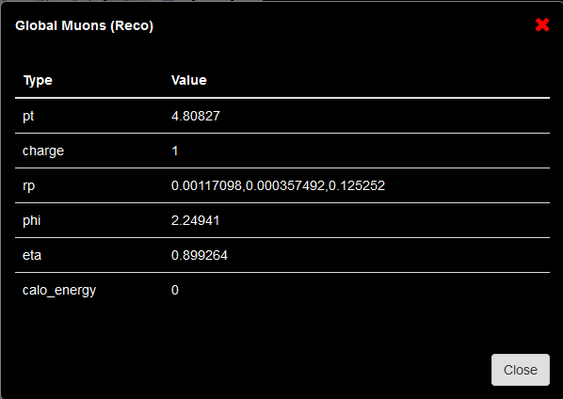
- By clicking the menu option Global Muons. Just click over the name and at the bottom of the visualizer a new table with the data will appear. It will look like this:
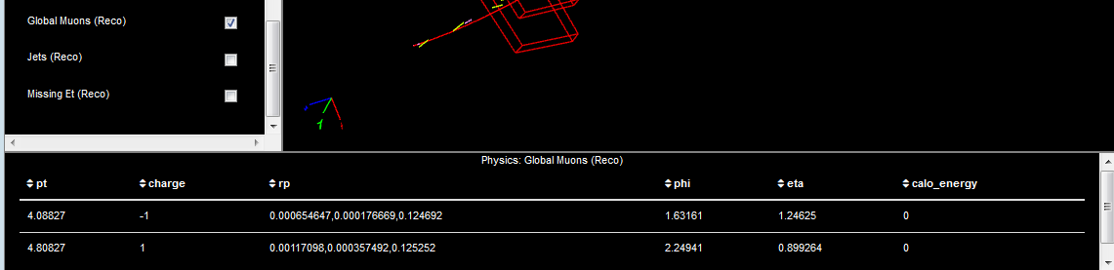
Click here!!

We are going to use this data for the classroom activities. Use time to familiarize with the different parts of the detector and the different particles hits and tracks.
General ideas for using other datasets:
There are different data sets you can open from the education folder. We have used the example of a Z boson decay into two muons. Depending on the data set you open, the visualization can be different and it can be that some of the options are not shown, as for example, the matching muon chambers. This is related with the nature of the data and the time when it was acquired.

References
[1] https://home.cern/about/experiments/cms

