First test

Table of Contents

# Executive summary

# Terms of reference

# Agenda and participant list

The agenda can be found in Annex 1 and the list of participants in Annex 2.

# Introduction

This part should include a background to the species, the workshop/exchange and what to expect to read about in the report.

# Methods

This report contains statistical analyses and comparisons of age readings in the form of tables and graphical plots.

First, an overview of participating age readers and the samples are presented.

Before each table or plot there is a short explanation of it. This text is thought as a help to understand the tables/plot and can just be deleted in the final output report. The document can be edited just like any other .docx file. New text can be added, additional pictures can be included and the tables edited. If some tables which are presently in the annexes need to be moved to the body of the report this is also possible. Only the plots cannot be changed.

In the first part of analysis are presented the tables and plots from the Guus Eltink Excel sheet ‘Age Reading Comparisons’ **(Eltink, A.T.G.W. 2000)**. The order and numbering of tables and plots are the same as in the excel sheet. Tables 6.1 - 6.4 from the ‘Age Reading Comparisons’ sheet are not outputted since these are merely used to do calculations for the other tables.

**Pecentage Agreement**

In here will go some text and an equation.

**Co-efficient of Variation (CV)**

The table presents the cv per modal age and reader. The cv’s are calculated as the ratio between the standard deviation (σ) and mean value (μ) per reader and modal age:

$$CV=\frac{σ}{μ}⋅100\%$$

To the table is also added the CV of all readers combined per modal age and a weighted mean of the CV per reader. Finally a rank value is added per reader, where the reader with the lowest weighted mean is assigned with a rank and so forth (in the situation of ties between two weighted means will every tied element be assigned to the lowest rank. This is the procedure for all ties methods when assigning ranks).

**Average Percentage Error (APE)**

APE was calculated based on the method outlined by Beamish & Fournier (1981). This method is not independent of fish age and thus provides a better estimate of precision. As the calculations of both CV and APE pose problems if the mean age is close to 0, all observations for which modal age was 0 were omitted from the CV and APE calculations.

The average percentage error is calculated per image as:

$$APE=\frac{100\%}{n}\sum_{i=1}^{n}{|}\frac{a_{i}−\overline{a}}{\overline{a}}|$$

where $a_{i}$ is the age reading of reader $i$ and $\overline{a}$ is the mean of all readings from 1 to $n$.

**Age error matricx (AEM)**

Age error matrices (AEM) were produced following procedures outlined by WKSABCAL (2014) where the matrix shows the proportion of each modal age mis-aged as other ages. The sum of each row is 1, which equals 100%. The age data was analysed twice, the first time all readers were included and the second time only the “advanced” readers were included. If a reader is “advanced” then they are considered well trained and they provide ages for stock assessment or similar purposes. When the AEM is compiled for assessment purposes it uses only those readers who provide age data for the stock assessment in that specific area.

**Otolith Growth Analysis**

SmartDots provides a measure of distance between the annotations made by the readers and thus provides a measure of growth increment width. This data is used to establish growth curves for each fish and for each reader.

# Analysis of age calibration exercise (ToR?)

## Overview of samples and readers

**Table X:** Overview of samples used for the xxx exchange.

|  |  |  |  |  |
| --- | --- | --- | --- | --- |
| **ICES area** | **Year** | **Quarter** | **Length range** | **Number of samples** |
| 27.4.a | 2014 | 4 | 100-185 mm | 93 |
| 27.4.a | 2016 | 3 | 130-190 mm | 87 |

**Table X:** Reader overview.

|  |  |
| --- | --- |
| **Reader code** | **Expertise** |
| R99 FR | 0 |
| R03 DK | 1 |
| R07 DK | 1 |
| R09 GB-SCT | 0 |
| R08 GB-SCT | 0 |
| R06 NO | 1 |
| R02 NO | 1 |
| R04 GB-SCT | 1 |
| R01 NO | 1 |
| R05 NO | 1 |
| R02 DE | 1 |
| R03 GB | 1 |
| R04 NL | 0 |
| R01 DE | 1 |
| R05 FR | 0 |

## Results

### All readers

**All samples included**

Those writing the report put TEXT here describing the results.

The overall percentage agreement based on modal ages for all readers is 6%, with an overall CV of 94.9%. The APE is 4.2%.

**Table X:** Coefficient of Variation (CV) table presents the CV per modal age and reader, the CV of all readers combined per modal age and a weighted mean of the CV per reader. A rank is also assigned to each reader.

|  |  |  |  |  |  |  |  |  |  |  |  |  |  |  |  |  |
| --- | --- | --- | --- | --- | --- | --- | --- | --- | --- | --- | --- | --- | --- | --- | --- | --- |
| **Modal age** | **R01 DE** | **R01 NO** | **R02 DE** | **R02 NO** | **R03 DK** | **R03 GB** | **R04 GB-SCT** | **R04 NL** | **R05 FR** | **R05 NO** | **R06 NO** | **R07 DK** | **R08 GB-SCT** | **R09 GB-SCT** | **R99 FR** | **All** |
| 0 | - | - | - | - | - | - | - | - | - | - | - | - | - | - | - | **-** |
| 1 | 0 % | 21 % | 0 % | 22 % | 0 % | 0 % | - | 0 % | 0 % | 40 % | 21 % | 26 % | 36 % | 0 % | 0 % | **3 %** |
| 2 | 9 % | 19 % | 0 % | 19 % | 34 % | 0 % | 0 % | 0 % | 0 % | 21 % | 11 % | 0 % | 13 % | 26 % | 19 % | **10 %** |
| 3 | 0 % | - | 0 % | - | - | 0 % | - | 0 % | 0 % | - | - | - | - | - | - | **0 %** |
| **Weighted Mean** | **3.1 %** | **20.0 %** | **0.0 %** | **20.4 %** | **12.0 %** | **0.0 %** | **0.0 %** | **0.0 %** | **0.0 %** | **31.5 %** | **15.9 %** | **13.4 %** | **24.3 %** | **13.8 %** | **8.7 %** | **NaN %** |
| *Rank* | *6* | *12* | *1* | *13* | *8* | *1* | *1* | *1* | *1* | *15* | *11* | *9* | *14* | *10* | *7* | ***-*** |

The percentage agreement per reader per modal age tells how large part of the readings that are equal to the modal age. The weighted mean including at the bottom of the table is weighted according to number of age readings. A rank is also assigned to each reader.

**Table X:** Percentage agreement (PA) table represents the PA per modal age and reader, the PA of all readers combined per modal age and a weighted mean of the PA per reader. A rank is also assgned to each reader.

|  |  |  |  |  |  |  |  |  |  |  |  |  |  |  |  |  |
| --- | --- | --- | --- | --- | --- | --- | --- | --- | --- | --- | --- | --- | --- | --- | --- | --- |
| **Modal age** | **R99 FR** | **R03 DK** | **R07 DK** | **R09 GB-SCT** | **R08 GB-SCT** | **R06 NO** | **R02 NO** | **R04 GB-SCT** | **R01 NO** | **R05 NO** | **R02 DE** | **R03 GB** | **R04 NL** | **R01 DE** | **R05 FR** | **All** |
| 0 | - | - | - | - | - | - | - | - | - | - | - | - | - | - | - | **-** |
| 1 | 78 % | 135 % | 42 % | 111 % | 44 % | 37 % | Inf % | 0 % | 35 % | 86 % | 275 % | 208 % | 344 % | 275 % | 128 % | **97 %** |
| 2 | 100 % | 38 % | 77 % | 73 % | 100 % | 70 % | 1900 % | 0 % | 58 % | 65 % | 136 % | 130 % | 194 % | 132 % | 89 % | **90 %** |
| 3 | 0 % | NaN % | 0 % | NaN % | NaN % | 0 % | NaN % | 0 % | 0 % | NaN % | Inf % | Inf % | Inf % | Inf % | Inf % | **100 %** |
| **Weighted Mean** | **84.9 %** | **85.4 %** | **53.5 %** | **90.0 %** | **64.3 %** | **48.2 %** | **1900.0 %** | **0.0 %** | **42.5 %** | **76.5 %** | **202.4 %** | **170.8 %** | **268.8 %** | **200.0 %** | **110.3 %** | **94.2 %** |
| *Rank* | *9* | *8* | *12* | *7* | *11* | *13* | *1* | *15* | *14* | *10* | *3* | *5* | *2* | *4* | *6* | ***-*** |

The relative bias is the difference between the mean age (per modal age per reader) and modal age. As for the previous tables, a combined bias for all readers and weighted means are calculated and finally a rank is assigned to each reader.

**Table X:** Relative bias table represents the relative bias per modal age per reader, the relative bias of all readers combined per modal age and a weighted mean of the relative bias per reader. A rank is also assigned to each reader.

|  |  |  |  |  |  |  |  |  |  |  |  |  |  |  |  |  |
| --- | --- | --- | --- | --- | --- | --- | --- | --- | --- | --- | --- | --- | --- | --- | --- | --- |
| **Modal age** | **R01 DE** | **R01 NO** | **R02 DE** | **R02 NO** | **R03 DK** | **R03 GB** | **R04 GB-SCT** | **R04 NL** | **R05 FR** | **R05 NO** | **R06 NO** | **R07 DK** | **R08 GB-SCT** | **R09 GB-SCT** | **R99 FR** | **All** |
| 0 | NA % | NA % | NA % | NA % | NA % | NA % | NA % | NA % | NA % | NA % | NA % | NA % | NA % | NA % | NA % | **NA %** |
| 1 | 0.00 % | 0.05 % | 0.00 % | 0.06 % | 0.00 % | 0.00 % | NaN % | 0.00 % | 0.00 % | 0.18 % | 0.05 % | 0.08 % | 0.25 % | 0.00 % | 0.00 % | **NaN %** |
| 2 | 0.03 % | 0.05 % | 0.00 % | -0.14 % | -0.47 % | 0.00 % | 2.00 % | 0.00 % | 0.00 % | 0.35 % | -0.05 % | 0.00 % | -0.06 % | -0.27 % | -0.03 % | **0.09 %** |
| 3 | 0.00 % | NaN % | 0.00 % | NaN % | NaN % | 0.00 % | NaN % | 0.00 % | 0.00 % | NaN % | NaN % | NaN % | NaN % | NaN % | NaN % | **NaN %** |
| **Weighted Mean** | **0.01** | **0.05** | **0.00** | **-0.05** | **-0.17** | **0.00** | **2.00** | **0.00** | **0.00** | **0.26** | **-0.00** | **0.04** | **0.10** | **-0.14** | **-0.01** | **0.04** |
| *Rank* | *6* | *9* | *1* | *10* | *13* | *1* | *15* | *1* | *1* | *14* | *5* | *8* | *11* | *12* | *7* | ***-*** |

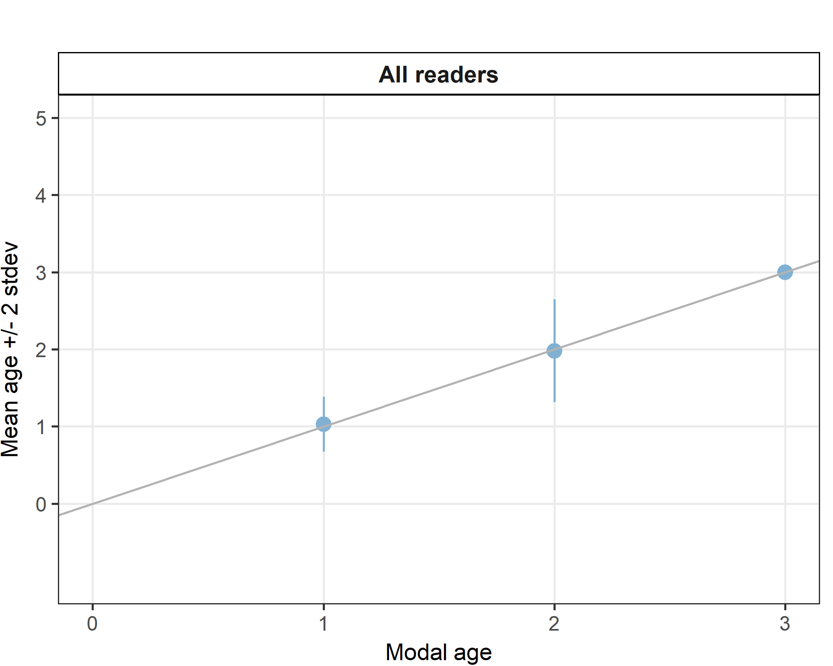

**Figure X:**: Age bias plot for all readers. Mean age recorded +/- 2 stdev of each reader and all readers combined are plotted against modal age. The estimated man age corresponds to modal age, if the estimated mean age is on the 1:1 equilibrium line (solid line). Relative bias is the age difference between estimated mean age and modal age.

For each pair that is being compared, the differences between the readings per image are found and the frequency of each occurring difference is obtained. A rank value is calculated for the positive and the negative differences (R+ and R- in the Guus Eltink sheet). The value with the smallest rank is then used to calculate a z-value that determines the level of bias (not clear from Guus Eltink sheet how the equations are defined..).

**Table X:** Inter reader bias test. The Inter-reader bias test gives probability of bias between readers and with modal age. - = no sign of bias (p>0.05), * = possibility of bias (0.01<p<0.05), * * = certainty of bias (p<0.01)

|  |  |  |  |  |  |  |  |  |  |  |  |  |  |  |  |
| --- | --- | --- | --- | --- | --- | --- | --- | --- | --- | --- | --- | --- | --- | --- | --- |
| **Comparison** | **R01 DE** | **R01 NO** | **R02 DE** | **R02 NO** | **R03 DK** | **R03 GB** | **R04 GB-SCT** | **R04 NL** | **R05 FR** | **R05 NO** | **R06 NO** | **R07 DK** | **R08 GB-SCT** | **R09 GB-SCT** | **R99 FR** |
| **R01 DE** | . | . | - | . | . | - | . | - | - | . | . | . | . | . | . |
| **R01 NO** | . | . | . | - | . | . | - | . | . | ** | - | - | - | * | - |
| **R02 DE** | - | . | . | . | . | . | . | . | . | . | . | . | . | . | . |
| **R02 NO** | . | - | . | . | . | . | - | . | . | ** | - | - | - | - | - |
| **R03 DK** | . | . | . | . | . | . | . | . | . | - | - | - | - | . | * |
| **R03 GB** | - | . | . | . | . | . | . | . | . | . | . | . | . | . | . |
| **R04 GB-SCT** | . | - | . | - | . | . | . | . | . | - | - | - | - | - | - |
| **R04 NL** | - | . | . | . | . | . | . | . | . | . | . | . | . | . | . |
| **R05 FR** | - | . | . | . | . | . | . | . | . | . | . | . | . | . | . |
| **R05 NO** | . | ** | . | ** | - | . | - | . | . | . | ** | * | - | ** | ** |
| **R06 NO** | . | - | . | - | - | . | - | . | . | ** | . | - | - | * | - |
| **R07 DK** | . | - | . | - | - | . | - | . | . | * | - | . | - | * | - |
| **R08 GB-SCT** | . | - | . | - | - | . | - | . | . | - | - | - | . | * | - |
| **R09 GB-SCT** | . | * | . | - | . | . | - | . | . | ** | * | * | * | . | * |
| **R99 FR** | . | - | . | - | * | . | - | . | . | ** | - | - | - | * | . |
| **Modal age** | - | - | . | - | * | . | - | . | . | ** | - | - | - | * | - |

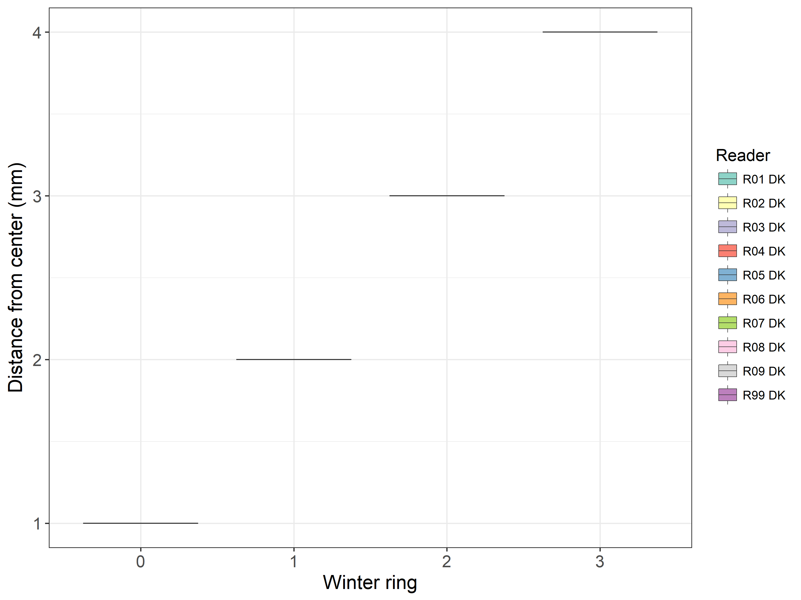

**Table X:** Plot of average distance from the centre to the winter rings for all readers. The boxes represent the mean, upper and lower box boundaries of the interquartile range, whiskers represent the minimum and maximum values and the dots represent the outliers.

**Results by area (or stock?)**

**Table X:** Number of age readings per strata. (area or stock?)

|  |  |  |
| --- | --- | --- |
| **Modal age** | **27.4.a** | **Total** |
| 0 | - | **-** |
| 1 | 110 | **110** |
| 2 | 69 | **69** |
| 3 | 1 | **1** |
| **Total** | **180** | **180** |
| *Total %* | *100%* | ***100%*** |

**Table X:** CV per strata. (area or stock?)

|  |  |  |
| --- | --- | --- |
| **Modal age** | **X27.4.a** | **All** |
| 0 | - | **-** |
| 1 | 3 % | **3 %** |
| 2 | 10 % | **10 %** |
| 3 | 0 % | **0 %** |
| **Weighted Mean** | **6 %** | **6 %** |

**Table X:** Percentage Agreement per strata. (area or stock?)

|  |
| --- |
| NA |
| NA |

**Table X:** Relative Bias per strata. (area or stock?)

|  |  |  |
| --- | --- | --- |
| **Modal age** | **X27.4.a** | **Mean bias** |
| 0 | - | **-** |
| 1 | 0.03 | **0.03** |
| 2 | -0.02 | **-0.02** |
| 3 | 0.00 | **0.00** |
| **Weighted Mean** | **0.01** | **0.01** |

**Results by month**

**Table X:** Number of age readings per month.

|  |  |  |  |  |  |  |  |  |  |  |  |  |  |
| --- | --- | --- | --- | --- | --- | --- | --- | --- | --- | --- | --- | --- | --- |
| **Modal age** | **Jan** | **Feb** | **Mar** | **Apr** | **May** | **Jun** | **Jul** | **Aug** | **Sep** | **Oct** | **Nov** | **Dec** | **Total** |
| 0 | - | - | - | - | - | - | - | - | - | - | - | - | **-** |
| 1 | - | - | - | - | - | - | - | 55 | 0 | 23 | 32 | - | **110** |
| 2 | - | - | - | - | - | - | - | 23 | 8 | 17 | 21 | - | **69** |
| 3 | - | - | - | - | - | - | - | 1 | 0 | 0 | 0 | - | **1** |
| **Total** | **0** | **0** | **0** | **0** | **0** | **0** | **0** | **79** | **8** | **40** | **53** | **0** | **180** |
| *Total %* | *0%* | *0%* | *0%* | *0%* | *0%* | *0%* | *0%* | *44%* | *4%* | *22%* | *29%* | *0%* | ***100%*** |

**Table X:** CV per month.

|  |  |  |  |  |  |  |  |  |  |  |  |  |  |
| --- | --- | --- | --- | --- | --- | --- | --- | --- | --- | --- | --- | --- | --- |
| **Modal age** | **Jan** | **Feb** | **Mar** | **Apr** | **May** | **Jun** | **Jul** | **Aug** | **Sep** | **Oct** | **Nov** | **Dec** | **All** |
| 0 | - | - | - | - | - | - | - | - | - | - | - | - | **-** |
| 1 | - | - | - | - | - | - | - | 0 % | - | 8 % | 7 % | - | **3 %** |
| 2 | - | - | - | - | - | - | - | 1 % | 0 % | 23 % | 15 % | - | **10 %** |
| 3 | - | - | - | - | - | - | - | 0 % | - | - | - | - | **0 %** |
| **Weighted Mean** | **-** | **-** | **-** | **-** | **-** | **-** | **-** | **0 %** | **0 %** | **14 %** | **10 %** | **-** | **6 %** |

**Table X:** Percentage agreement per month.

|  |
| --- |
| NA |
| NA |

**Table X:** Relative bias per month.

|  |  |  |  |  |  |  |  |  |  |  |  |  |  |
| --- | --- | --- | --- | --- | --- | --- | --- | --- | --- | --- | --- | --- | --- |
| **Modal age** | **Jan** | **Feb** | **Mar** | **Apr** | **May** | **Jun** | **Jul** | **Aug** | **Sep** | **Oct** | **Nov** | **Dec** | **Mean bias** |
| 0 | - | - | - | - | - | - | - | - | - | - | - | - | **-** |
| 1 | - | - | - | - | - | - | - | 0.00 | - | 0.05 | 0.07 | - | **0.03** |
| 2 | - | - | - | - | - | - | - | 0.01 | 0 | -0.10 | 0.01 | - | **-0.02** |
| 3 | - | - | - | - | - | - | - | 0.00 | - | - | - | - | **0.00** |
| **Weighted Mean** | **-** | **-** | **-** | **-** | **-** | **-** | **-** | **0.00** | **0** | **-0.01** | **0.05** | **-** | **0.01** |

### Advanced readers

**All samples included**

**Table X:** Coefficient of Variation (CV) table presents the CV per modal age and advanced reader, the CV of all advanced readers combined per modal age and a weighted mean of the CV per reader. A rank is also assigned to each reader.

|  |  |  |  |  |  |  |  |  |  |  |  |
| --- | --- | --- | --- | --- | --- | --- | --- | --- | --- | --- | --- |
| **Modal age** | **R01 DE** | **R01 NO** | **R02 DE** | **R02 NO** | **R03 DK** | **R03 GB** | **R04 GB-SCT** | **R05 NO** | **R06 NO** | **R07 DK** | **All** |
| 0 | - | - | - | - | - | - | - | - | - | - | **-** |
| 1 | 0 % | 0 % | 0 % | 0 % | 0 % | 0 % | - | 40 % | 22 % | 20 % | **2 %** |
| 2 | 9 % | 18 % | 0 % | 18 % | 27 % | 0 % | 0 % | 21 % | 15 % | 0 % | **8 %** |
| 3 | 0 % | - | 0 % | - | - | 0 % | - | - | - | - | **0 %** |
| **Weighted Mean** | **3.1 %** | **9.8 %** | **0.0 %** | **10.6 %** | **7.1 %** | **0.0 %** | **0.0 %** | **30.7 %** | **18.1 %** | **9.8 %** | **NaN %** |
| *Rank* | *4* | *7* | *1* | *8* | *5* | *1* | *1* | *10* | *9* | *6* | ***-*** |

**Table X:** Percentage agreement (PA) table represents the PA per modal age and reader, advanced the PA of all advanced readers combined per modal age and a weighted mean of the PA per reader. A rank is also assgned to each reader.

|  |  |  |  |  |  |  |  |  |  |  |  |
| --- | --- | --- | --- | --- | --- | --- | --- | --- | --- | --- | --- |
| **Modal age** | **R03 DK** | **R07 DK** | **R06 NO** | **R02 NO** | **R04 GB-SCT** | **R01 NO** | **R05 NO** | **R02 DE** | **R03 GB** | **R01 DE** | **All** |
| 0 | - | - | - | - | - | - | - | - | - | - | **-** |
| 1 | 56 % | 121 % | 33 % | 100 % | 0 % | 37 % | Inf % | 204 % | 274 % | 229 % | **98 %** |
| 2 | 27 % | 109 % | 70 % | 87 % | 0 % | 63 % | 1600 % | 125 % | 130 % | 121 % | **90 %** |
| 3 | 0 % | NaN % | 0 % | NaN % | NaN % | 0 % | NaN % | Inf % | Inf % | Inf % | **100 %** |
| **Weighted Mean** | **45.3 %** | **114.6 %** | **45.3 %** | **92.5 %** | **0.0 %** | **45.8 %** | **1600.0 %** | **166.7 %** | **195.2 %** | **175.0 %** | **95.0 %** |
| *Rank* | *8* | *5* | *8* | *6* | *10* | *7* | *1* | *4* | *2* | *3* | ***-*** |

**Table X:** Relative bias table represents the relative bias per modal age and advanced reader, the relative bias of all advanced readers combined per modal age and a weighted mean of the relative bias per reader. A rank is also assigned to each reader.

|  |  |  |  |  |  |  |  |  |  |  |  |
| --- | --- | --- | --- | --- | --- | --- | --- | --- | --- | --- | --- |
| **Modal age** | **R01 DE** | **R01 NO** | **R02 DE** | **R02 NO** | **R03 DK** | **R03 GB** | **R04 GB-SCT** | **R05 NO** | **R06 NO** | **R07 DK** | **All** |
| 0 | NA % | NA % | NA % | NA % | NA % | NA % | NA % | NA % | NA % | NA % | **NA %** |
| 1 | 0.00 % | 0.00 % | 0.00 % | 0.00 % | 0.00 % | 0.00 % | NaN % | 0.15 % | 0.05 % | 0.04 % | **NaN %** |
| 2 | 0.03 % | 0.05 % | 0.00 % | -0.13 % | -0.27 % | 0.00 % | 2.00 % | 0.33 % | -0.09 % | 0.00 % | **0.19 %** |
| 3 | 0.00 % | NaN % | 0.00 % | NaN % | NaN % | 0.00 % | NaN % | NaN % | NaN % | NaN % | **NaN %** |
| **Weighted Mean** | **0.01** | **0.03** | **0.00** | **-0.07** | **-0.07** | **0.00** | **2.00** | **0.23** | **-0.03** | **0.02** | **0.08** |
| *Rank* | *3* | *6* | *1* | *8* | *7* | *1* | *10* | *9* | *5* | *4* | ***-*** |

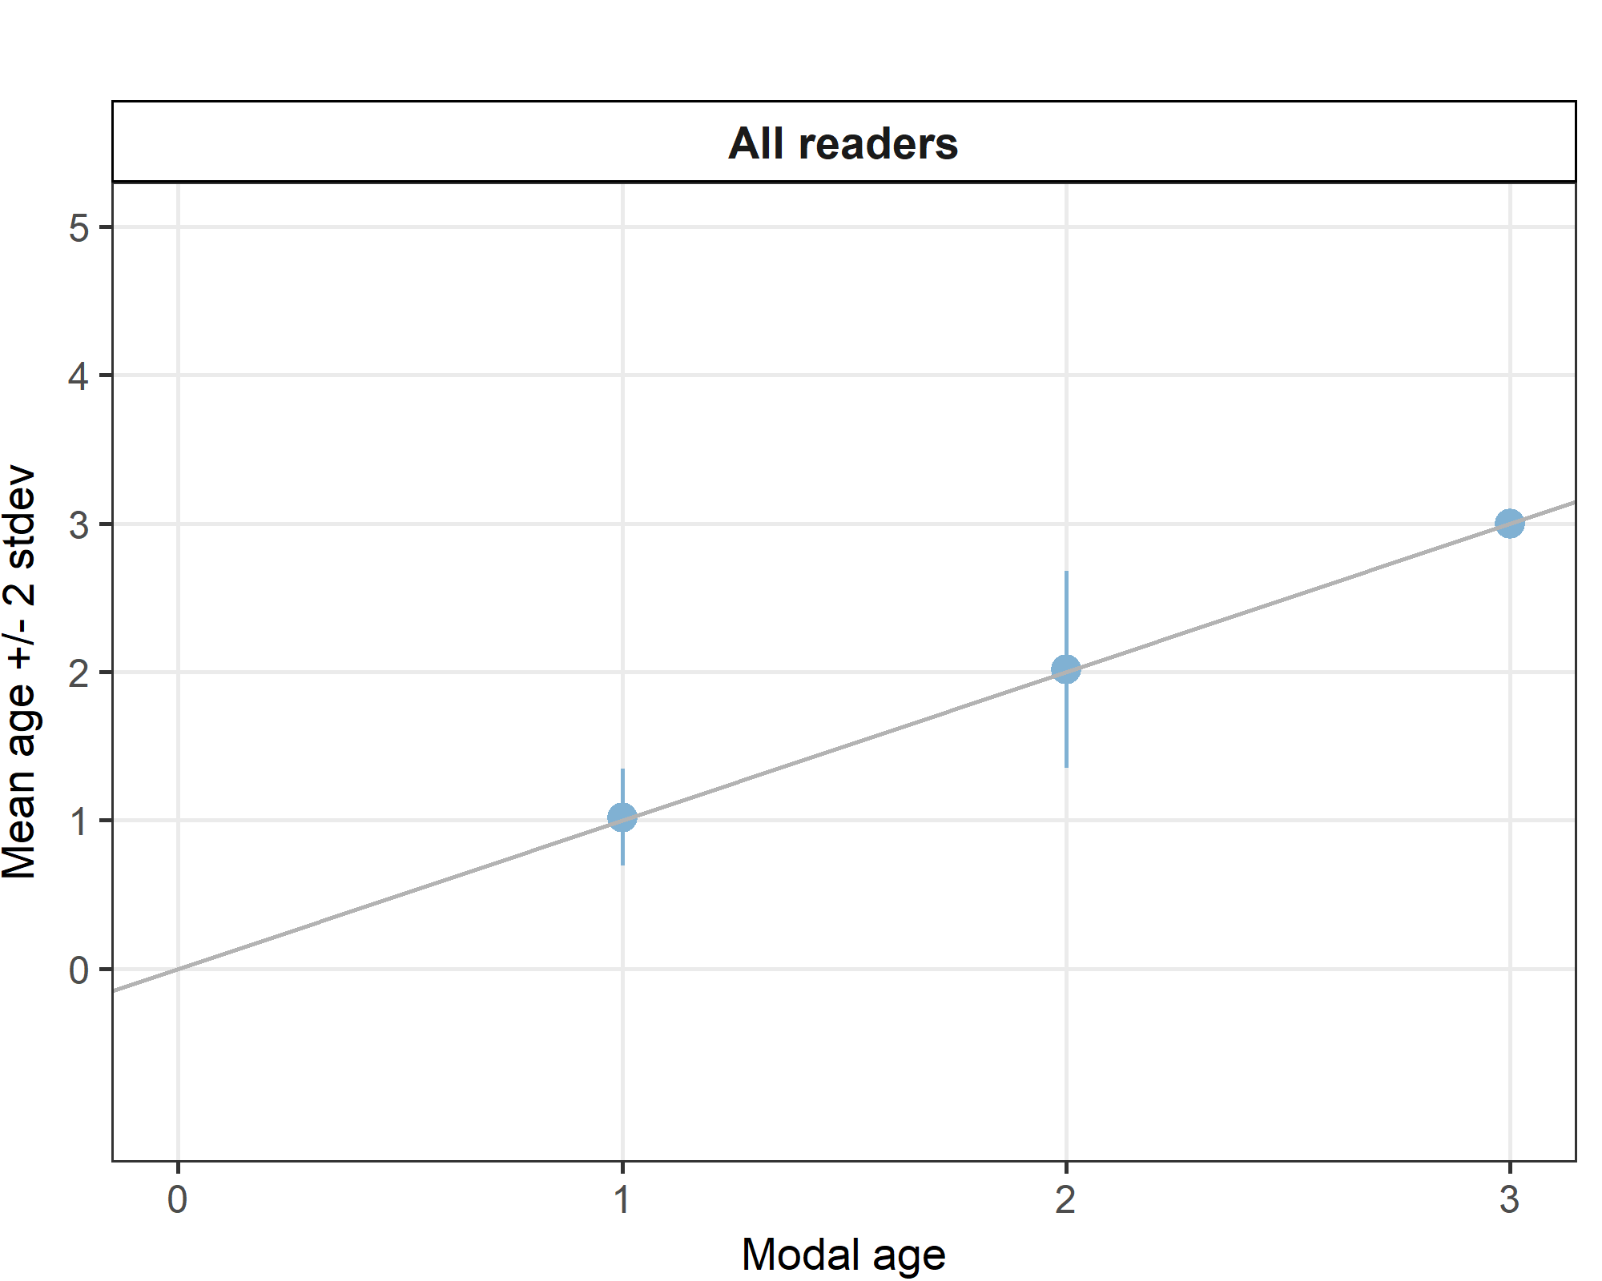

**Figure X:** Age bias plot for advanced readers.

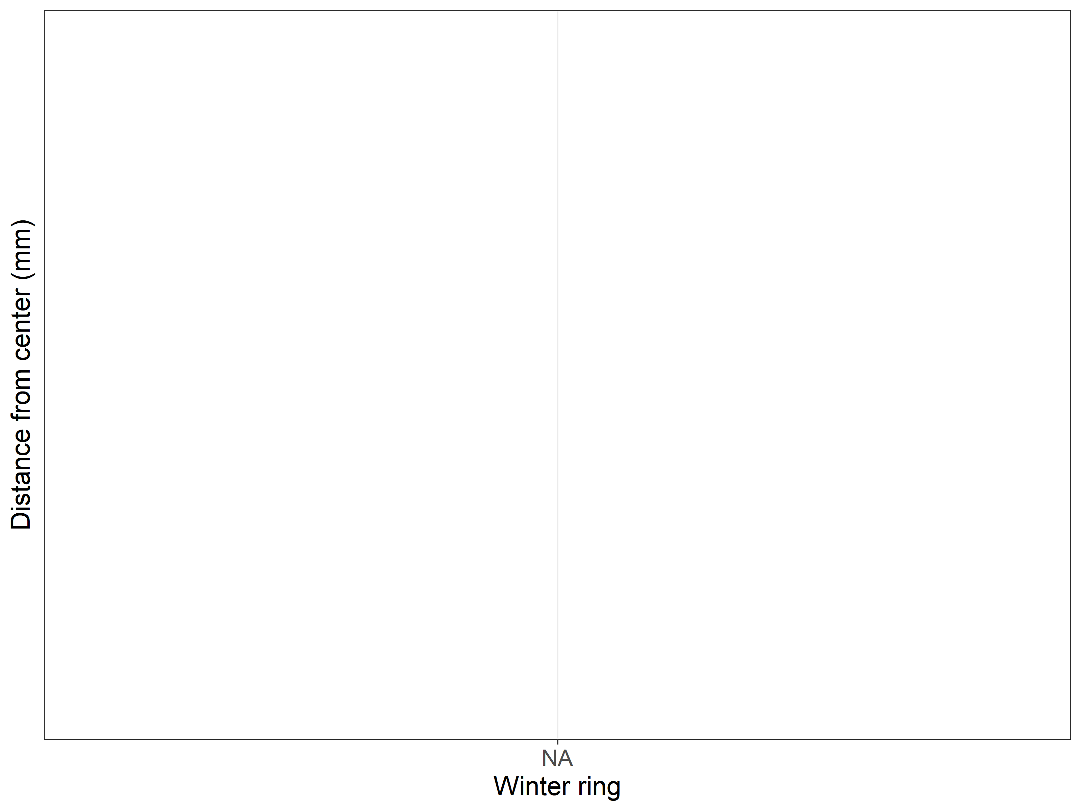

**Results by area (or stock)**

**Table X:** Number of age readings per strata for advanced readers.

|  |  |  |
| --- | --- | --- |
| **Modal age** | **27.4.a** | **Total** |
| 0 | - | **-** |
| 1 | 106 | **106** |
| 2 | 64 | **64** |
| 3 | 1 | **1** |
| **Total** | **171** | **171** |
| *Total %* | *100%* | ***100%*** |

**Table X:** CV per strata.

|  |  |  |
| --- | --- | --- |
| **Modal age** | **X27.4.a** | **All** |
| 0 | - | **-** |
| 1 | 2 % | **2 %** |
| 2 | 8 % | **8 %** |
| 3 | 0 % | **0 %** |
| **Weighted Mean** | **4 %** | **4 %** |

**Table X:** Percentage Agreement per strata.

|  |
| --- |
| NA |
| NA |

**Table X:** Relative Bias per strata.

|  |  |  |
| --- | --- | --- |
| **Modal age** | **X27.4.a** | **Mean bias** |
| 0 | - | **-** |
| 1 | 0.02 | **0.02** |
| 2 | 0.02 | **0.02** |
| 3 | 0.00 | **0.00** |
| **Weighted Mean** | **0.02** | **0.02** |

Age error matrices are calculated per area and only based on the age readings of the advanced readers.

**Table X:** Age error matrix (AEM) for area 27.4.a. The AEM shows the proportional distribution of age readings for each modal age. Age column should sum to one but due to rounding there might be small deviations in some cases. Only advanced readers are used. Only advanced readers are used for calculating the AEM.

|  |  |  |  |  |  |
| --- | --- | --- | --- | --- | --- |
| **Modal age** | **0** | **1** | **2** | **3** | **4** |
| **Age 0** | - | - | - | - | - |
| **Age 1** | - | 0.983278 | 0.041284 | - | - |
| **Age 2** | - | 0.013378 | 0.903670 | - | - |
| **Age 3** | - | 0.003344 | 0.050459 | 1 | - |
| **Age 4** | - | - | 0.004587 | - | - |

**Results by month**

**Table X:** Number of age readings per month for advanced readers.

|  |  |  |  |  |  |  |  |  |  |  |  |  |  |
| --- | --- | --- | --- | --- | --- | --- | --- | --- | --- | --- | --- | --- | --- |
| **Modal age** | **Jan** | **Feb** | **Mar** | **Apr** | **May** | **Jun** | **Jul** | **Aug** | **Sep** | **Oct** | **Nov** | **Dec** | **Total** |
| 0 | - | - | - | - | - | - | - | - | - | - | - | - | **-** |
| 1 | - | - | - | - | - | - | - | 55 | 0 | 21 | 30 | - | **106** |
| 2 | - | - | - | - | - | - | - | 23 | 8 | 12 | 21 | - | **64** |
| 3 | - | - | - | - | - | - | - | 1 | 0 | 0 | 0 | - | **1** |
| **Total** | **0** | **0** | **0** | **0** | **0** | **0** | **0** | **79** | **8** | **33** | **51** | **0** | **171** |
| *Total %* | *0%* | *0%* | *0%* | *0%* | *0%* | *0%* | *0%* | *46%* | *5%* | *19%* | *30%* | *0%* | ***100%*** |

**Table X:** CV per month.

|  |  |  |  |  |  |  |  |  |  |  |  |  |  |
| --- | --- | --- | --- | --- | --- | --- | --- | --- | --- | --- | --- | --- | --- |
| **Modal age** | **Jan** | **Feb** | **Mar** | **Apr** | **May** | **Jun** | **Jul** | **Aug** | **Sep** | **Oct** | **Nov** | **Dec** | **All** |
| 0 | - | - | - | - | - | - | - | - | - | - | - | - | **-** |
| 1 | - | - | - | - | - | - | - | 0 % | - | 13 % | 2 % | - | **2 %** |
| 2 | - | - | - | - | - | - | - | 1 % | 0 % | 18 % | 16 % | - | **8 %** |
| 3 | - | - | - | - | - | - | - | 0 % | - | - | - | - | **0 %** |
| **Weighted Mean** | **-** | **-** | **-** | **-** | **-** | **-** | **-** | **0 %** | **0 %** | **15 %** | **8 %** | **-** | **4 %** |

**Table X:** Percentage agreement per month.

|  |
| --- |
| NA |
| NA |

**Table X:** Relative bias per month.

|  |  |  |  |  |  |  |  |  |  |  |  |  |  |
| --- | --- | --- | --- | --- | --- | --- | --- | --- | --- | --- | --- | --- | --- |
| **Modal age** | **Jan** | **Feb** | **Mar** | **Apr** | **May** | **Jun** | **Jul** | **Aug** | **Sep** | **Oct** | **Nov** | **Dec** | **Mean bias** |
| 0 | - | - | - | - | - | - | - | - | - | - | - | - | **-** |
| 1 | - | - | - | - | - | - | - | 0.00 | - | 0.06 | 0.03 | - | **0.02** |
| 2 | - | - | - | - | - | - | - | 0.01 | 0 | 0.00 | 0.04 | - | **0.02** |
| 3 | - | - | - | - | - | - | - | 0.00 | - | - | - | - | **0.00** |
| **Weighted Mean** | **-** | **-** | **-** | **-** | **-** | **-** | **-** | **0.00** | **0** | **0.04** | **0.03** | **-** | **0.02** |

## Discussion

## Conclusion

# Other ToRs

# References

# Annex 1. Agenda

# Annex 2. List of participants

**Table X:** Participants list.

|  |  |  |  |
| --- | --- | --- | --- |
| **Reader code** | **Institution** | **Country** | **Expertise** |
| R99 FR | - | FRANCE | 0 |
| R03 DK | - | DENMARK | 1 |
| R07 DK | - | DENMARK | 1 |
| R09 GB-SCT | - | Scotland | 0 |
| R08 GB-SCT | - | Scotland | 0 |
| R06 NO | - | NORWAY | 1 |
| R02 NO | - | NORWAY | 1 |
| R04 GB-SCT | - | Scotland | 1 |
| R01 NO | - | NORWAY | 1 |
| R05 NO | - | NORWAY | 1 |
| R02 DE | - | GERMANY | 1 |
| R03 GB | - | UNITED KINGDOM | 1 |
| R04 NL | - | NETHERLANDS | 0 |
| R01 DE | - | GERMANY | 1 |
| R05 FR | - | FRANCE | 0 |

# Annex 3. Additional results

## Results all readers

**Data Overview**

**Table X:** Summary of statistics; PA (%), CV (%) and APE (%).

|  |  |  |
| --- | --- | --- |
| **Mean CV %** | **Mean PA %** | **Mean APE %** |
| 94.9 | 6.036 | 4.15 |

**Table X:** Data overview including modal age and statistics per sample.

|  |  |  |  |  |  |  |  |  |  |  |  |  |  |  |  |  |  |  |  |  |  |  |  |
| --- | --- | --- | --- | --- | --- | --- | --- | --- | --- | --- | --- | --- | --- | --- | --- | --- | --- | --- | --- | --- | --- | --- | --- |
| **Sample** | **Length (mm)** | **Sex** | **Catch date** | **ICES area** | **R01 DE** | **R01 NO** | **R02 DE** | **R02 NO** | **R03 DK** | **R03 GB** | **R04 GB-SCT** | **R04 NL** | **R05 FR** | **R05 NO** | **R06 NO** | **R07 DK** | **R08 GB-SCT** | **R09 GB-SCT** | **R99 FR** | **Modal age** | **PA %** | **CV %** | **APE %** |
| 535 | 170 | U | 2014-10-25 | 27.4.a | - | - | - | - | 1 | - | - | - | - | - | - | - | - | - | 2 | 2 | 50 | 47 | 33 |
| 536 | 175 | U | 2014-10-25 | 27.4.a | - | - | - | - | 1 | - | - | - | - | - | - | - | - | - | 1 | 1 | 100 | 0 | 0 |
| 537 | 175 | U | 2014-10-25 | 27.4.a | - | - | - | - | 2 | - | - | - | - | - | - | - | - | - | 2 | 2 | 100 | 0 | 0 |
| 538 | 175 | U | 2014-10-25 | 27.4.a | - | - | - | - | - | - | - | - | - | - | - | - | - | - | 2 | 2 | 100 | - | 0 |
| 539 | 180 | U | 2014-10-25 | 27.4.a | - | - | - | - | - | - | - | - | - | - | - | - | - | - | 2 | 2 | 100 | - | 0 |
| 545 | 135 | U | 2014-11-01 | 27.4.a | - | - | - | - | - | - | - | - | - | - | - | - | - | - | 1 | 1 | 100 | - | 0 |
| 546 | 140 | U | 2014-11-01 | 27.4.a | - | - | - | - | 1 | - | - | - | - | - | - | 1 | - | - | 1 | 1 | 100 | 0 | 0 |
| 547 | 140 | U | 2014-11-01 | 27.4.a | - | - | - | - | - | - | - | - | - | - | - | 1 | - | - | 1 | 1 | 100 | 0 | 0 |
| 548 | 140 | U | 2014-11-01 | 27.4.a | - | - | - | - | - | - | - | - | - | - | - | 1 | - | - | 1 | 1 | 100 | 0 | 0 |
| 549 | 145 | U | 2014-11-01 | 27.4.a | - | - | - | - | - | - | - | - | - | - | - | 1 | - | - | 1 | 1 | 100 | 0 | 0 |
| 550 | 145 | U | 2014-11-01 | 27.4.a | - | - | - | - | 1 | - | - | - | - | - | - | 1 | - | - | 1 | 1 | 100 | 0 | 0 |
| 551 | 145 | U | 2014-11-01 | 27.4.a | - | - | - | - | 1 | - | - | - | - | - | - | 1 | - | - | 1 | 1 | 100 | 0 | 0 |
| 552 | 150 | U | 2014-11-01 | 27.4.a | - | - | - | - | - | - | - | - | - | - | - | 1 | - | - | 1 | 1 | 100 | 0 | 0 |
| 553 | 150 | U | 2014-11-01 | 27.4.a | - | - | - | - | - | - | - | - | - | - | - | 1 | - | - | 1 | 1 | 100 | 0 | 0 |
| 554 | 155 | U | 2014-11-01 | 27.4.a | - | - | - | - | 1 | - | - | - | - | - | - | - | - | - | 1 | 1 | 100 | 0 | 0 |
| 555 | 155 | U | 2014-11-01 | 27.4.a | - | - | - | - | 1 | - | - | - | - | - | - | - | - | - | 1 | 1 | 100 | 0 | 0 |
| 556 | 160 | U | 2014-11-01 | 27.4.a | - | - | - | - | - | - | - | - | - | - | - | - | - | - | 1 | 1 | 100 | - | 0 |
| 557 | 160 | U | 2014-11-01 | 27.4.a | - | - | - | - | 1 | - | - | - | - | - | - | - | - | - | 1 | 1 | 100 | 0 | 0 |
| 558 | 165 | U | 2014-11-01 | 27.4.a | - | - | - | - | 1 | - | - | - | - | - | - | - | - | - | 1 | 1 | 100 | 0 | 0 |
| 559 | 165 | U | 2014-11-01 | 27.4.a | - | - | - | - | 1 | - | - | - | - | - | - | - | - | - | 2 | 2 | 50 | 47 | 33 |
| 560 | 165 | U | 2014-11-01 | 27.4.a | - | - | - | - | 1 | - | - | - | - | - | - | 2 | - | - | 2 | 2 | 67 | 35 | 27 |
| 561 | 170 | U | 2014-11-01 | 27.4.a | - | - | - | - | 1 | - | - | - | - | - | - | - | - | - | 1 | 1 | 100 | 0 | 0 |
| 562 | 170 | U | 2014-11-01 | 27.4.a | - | - | - | - | 1 | - | - | - | - | - | - | - | - | - | 2 | 2 | 50 | 47 | 33 |
| 563 | 175 | U | 2014-11-01 | 27.4.a | - | - | - | - | 1 | - | - | - | - | - | - | 2 | - | - | 1 | 1 | 67 | 43 | 33 |
| 564 | 180 | U | 2014-11-01 | 27.4.a | - | - | - | - | 2 | - | - | - | - | - | - | - | - | - | 2 | 2 | 100 | 0 | 0 |
| 565 | 180 | U | 2014-11-01 | 27.4.a | - | - | - | - | 2 | - | - | - | - | - | - | - | - | - | 2 | 2 | 100 | 0 | 0 |
| 566 | 180 | U | 2014-11-01 | 27.4.a | - | - | - | - | 2 | - | - | - | - | - | - | - | - | - | 2 | 2 | 100 | 0 | 0 |
| 567 | 185 | U | 2014-11-01 | 27.4.a | - | - | - | - | 2 | - | - | - | - | - | - | - | - | - | 2 | 2 | 100 | 0 | 0 |
| 568 | 185 | U | 2014-11-01 | 27.4.a | - | - | - | - | 2 | - | - | - | - | - | - | - | - | - | 2 | 2 | 100 | 0 | 0 |
| 581 | 135 | U | 2014-10-25 | 27.4.a | - | - | - | - | - | - | - | - | - | - | - | - | - | - | 1 | 1 | 100 | - | 0 |
| 582 | 140 | U | 2014-10-25 | 27.4.a | - | - | - | - | - | - | - | - | - | - | - | - | - | - | 1 | 1 | 100 | - | 0 |
| 583 | 140 | U | 2014-10-25 | 27.4.a | - | - | - | - | - | - | - | - | - | - | - | - | - | - | 1 | 1 | 100 | - | 0 |
| 584 | 145 | U | 2014-10-25 | 27.4.a | - | - | - | - | - | - | - | - | - | - | - | - | - | - | 1 | 1 | 100 | - | 0 |
| 585 | 150 | U | 2014-10-25 | 27.4.a | - | - | - | - | - | - | - | - | - | - | - | - | - | - | 1 | 1 | 100 | - | 0 |
| 586 | 150 | U | 2014-10-25 | 27.4.a | - | - | - | - | 1 | - | - | - | - | - | - | - | - | - | 1 | 1 | 100 | 0 | 0 |
| 587 | 155 | U | 2014-10-25 | 27.4.a | - | - | - | - | 1 | - | - | - | - | - | - | 2 | - | - | 2 | 2 | 67 | 35 | 27 |
| 588 | 155 | U | 2014-10-25 | 27.4.a | - | - | - | - | 1 | - | - | - | - | - | - | - | - | - | 1 | 1 | 100 | 0 | 0 |
| 589 | 155 | U | 2014-10-25 | 27.4.a | - | - | - | - | 1 | - | - | - | - | - | - | - | - | - | 1 | 1 | 100 | 0 | 0 |
| 590 | 160 | U | 2014-10-25 | 27.4.a | - | - | - | - | 1 | - | - | - | - | - | - | - | - | - | 1 | 1 | 100 | 0 | 0 |
| 591 | 160 | U | 2014-10-25 | 27.4.a | - | - | - | - | 1 | - | - | - | - | - | - | - | - | - | 2 | 2 | 50 | 47 | 33 |
| 592 | 170 | U | 2014-10-25 | 27.4.a | - | - | - | - | 1 | - | - | - | - | - | - | - | - | - | 2 | 2 | 50 | 47 | 33 |
| 593 | 170 | U | 2014-10-25 | 27.4.a | - | 2 | - | 2 | - | - | 4 | - | - | 3 | 2 | 2 | 2 | 2 | 2 | 2 | 78 | 30 | 22 |
| 594 | 175 | U | 2014-10-25 | 27.4.a | - | 2 | - | 1 | - | - | - | - | - | 2 | 2 | 2 | - | 1 | 1 | 2 | 57 | 34 | 31 |
| 595 | 175 | U | 2014-10-25 | 27.4.a | - | 2 | - | 2 | - | - | - | - | - | 2 | 2 | 2 | 2 | 2 | 2 | 2 | 100 | 0 | 0 |
| 596 | 175 | U | 2014-10-25 | 27.4.a | - | 2 | - | 2 | 2 | - | - | - | - | 3 | 2 | 2 | 2 | 2 | 2 | 2 | 89 | 16 | 9 |
| 597 | 180 | U | 2014-10-25 | 27.4.a | - | 2 | - | 2 | 2 | - | - | - | - | 2 | 2 | 2 | 2 | 2 | 2 | 2 | 100 | 0 | 0 |
| 598 | 105 | U | 2014-11-01 | 27.4.a | - | - | - | - | - | - | - | - | - | 1 | - | 1 | 1 | - | - | 1 | 100 | 0 | 0 |
| 599 | 105 | U | 2014-11-01 | 27.4.a | - | - | - | - | - | - | - | - | - | 1 | - | 1 | - | - | - | 1 | 100 | 0 | 0 |
| 600 | 105 | U | 2014-11-01 | 27.4.a | - | - | - | - | - | - | - | - | - | 1 | - | 1 | 1 | - | - | 1 | 100 | 0 | 0 |
| 601 | 110 | U | 2014-11-01 | 27.4.a | - | - | - | - | - | - | - | - | - | 1 | - | - | - | - | - | 1 | 100 | - | 0 |
| 602 | 120 | U | 2014-11-01 | 27.4.a | - | - | - | - | - | - | - | - | - | 1 | - | 1 | - | - | - | 1 | 100 | 0 | 0 |
| 603 | 135 | U | 2014-11-01 | 27.4.a | - | 1 | - | 1 | 1 | - | - | - | - | 1 | 1 | 1 | 1 | 1 | 1 | 1 | 100 | 0 | 0 |
| 604 | 140 | U | 2014-11-01 | 27.4.a | - | 1 | - | 1 | - | - | - | - | - | 1 | 1 | - | - | 1 | - | 1 | 100 | 0 | 0 |
| 605 | 140 | U | 2014-11-01 | 27.4.a | - | 1 | - | 1 | 1 | - | - | - | - | 1 | 1 | - | 1 | 1 | 1 | 1 | 100 | 0 | 0 |
| 606 | 140 | U | 2014-11-01 | 27.4.a | - | 1 | - | 1 | 1 | - | - | - | - | 1 | 1 | - | 2 | 1 | 1 | 1 | 88 | 31 | 19 |
| 607 | 145 | U | 2014-11-01 | 27.4.a | - | 1 | - | 1 | 1 | - | - | - | - | 1 | 1 | - | 2 | 1 | 1 | 1 | 88 | 31 | 19 |
| 608 | 145 | U | 2014-11-01 | 27.4.a | - | 1 | - | 1 | - | - | - | - | - | 1 | 1 | - | 2 | 1 | 1 | 1 | 86 | 33 | 21 |
| 609 | 145 | U | 2014-11-01 | 27.4.a | - | 1 | - | 1 | - | - | - | - | - | 1 | 1 | - | - | 1 | - | 1 | 100 | 0 | 0 |
| 610 | 150 | U | 2014-11-01 | 27.4.a | - | 1 | - | 1 | 1 | - | - | - | - | 1 | 1 | - | - | 1 | 1 | 1 | 100 | 0 | 0 |
| 611 | 150 | U | 2014-11-01 | 27.4.a | - | 1 | - | 1 | 1 | - | - | - | - | 1 | 1 | - | - | 1 | 1 | 1 | 100 | 0 | 0 |
| 612 | 155 | U | 2014-11-01 | 27.4.a | - | 2 | - | 2 | - | - | - | - | - | 3 | 2 | 2 | - | 1 | 2 | 2 | 71 | 29 | 14 |
| 613 | 155 | U | 2014-11-01 | 27.4.a | - | 1 | - | 2 | - | - | - | - | - | 2 | 2 | 2 | 2 | 1 | 1 | 2 | 63 | 32 | 29 |
| 614 | 160 | U | 2014-11-01 | 27.4.a | - | 1 | - | 1 | 1 | - | - | - | - | 2 | 2 | - | - | 1 | 1 | 1 | 71 | 38 | 32 |
| 615 | 160 | U | 2014-11-01 | 27.4.a | - | 2 | - | 2 | - | - | - | - | - | 2 | 2 | 2 | 2 | 2 | 3 | 2 | 88 | 17 | 10 |
| 616 | 165 | U | 2014-11-01 | 27.4.a | - | 2 | - | 2 | - | - | - | - | - | 2 | 2 | 2 | 2 | 2 | - | 2 | 100 | 0 | 0 |
| 617 | 165 | U | 2014-11-01 | 27.4.a | - | - | - | 2 | - | - | - | - | - | 2 | 2 | 2 | - | 1 | 2 | 2 | 83 | 22 | 15 |
| 618 | 165 | U | 2014-11-01 | 27.4.a | - | 2 | - | 2 | - | - | - | - | - | 2 | 2 | - | 2 | 2 | - | 2 | 100 | 0 | 0 |
| 619 | 170 | U | 2014-11-01 | 27.4.a | - | 2 | - | 2 | - | - | - | - | - | 3 | 2 | 2 | 2 | 2 | 2 | 2 | 88 | 17 | 10 |
| 620 | 170 | U | 2014-11-01 | 27.4.a | - | 2 | - | 2 | - | - | - | - | - | 2 | 2 | 2 | 2 | 2 | 2 | 2 | 100 | 0 | 0 |
| 621 | 175 | U | 2014-11-01 | 27.4.a | - | 2 | - | 2 | - | - | - | - | - | 2 | 1 | - | - | 1 | 1 | 1 | 50 | 37 | 33 |
| 622 | 180 | U | 2014-11-01 | 27.4.a | - | 2 | - | 2 | - | - | - | - | - | 2 | 2 | 2 | - | 2 | 2 | 2 | 100 | 0 | 0 |
| 623 | 180 | U | 2014-11-01 | 27.4.a | - | 2 | - | 2 | - | - | - | - | - | 3 | 2 | 2 | 2 | 2 | 2 | 2 | 88 | 17 | 10 |
| 624 | 180 | U | 2014-11-01 | 27.4.a | - | 3 | - | 2 | - | - | - | - | - | 3 | 2 | - | - | 2 | 3 | 2 | 50 | 22 | 20 |
| 625 | 185 | U | 2014-11-01 | 27.4.a | - | 2 | - | 2 | - | - | - | - | - | 2 | 2 | 2 | 2 | 2 | 2 | 2 | 100 | 0 | 0 |
| 626 | 185 | U | 2014-11-01 | 27.4.a | - | 3 | - | 2 | - | - | - | - | - | 3 | 2 | 2 | 2 | 2 | 2 | 2 | 75 | 21 | 17 |
| 631 | 100 | U | 2014-10-25 | 27.4.a | - | - | - | - | - | - | - | - | - | 1 | - | 1 | - | - | - | 1 | 100 | 0 | 0 |
| 634 | 105 | U | 2014-10-25 | 27.4.a | - | - | - | - | - | - | - | - | - | 1 | - | - | - | - | - | 1 | 100 | - | 0 |
| 635 | 105 | U | 2014-10-25 | 27.4.a | - | - | - | - | - | - | - | - | - | - | - | 1 | - | - | - | 1 | 100 | - | 0 |
| 636 | 105 | U | 2014-10-25 | 27.4.a | - | - | - | - | - | - | - | - | - | 1 | - | 1 | 1 | - | - | 1 | 100 | 0 | 0 |
| 637 | 110 | U | 2014-10-25 | 27.4.a | - | - | - | - | - | - | - | - | - | 2 | - | 2 | - | - | - | 2 | 100 | 0 | 0 |
| 638 | 135 | U | 2014-10-25 | 27.4.a | - | 1 | - | - | 1 | - | - | - | - | 1 | 1 | 2 | 2 | 1 | 1 | 1 | 75 | 37 | 30 |
| 639 | 135 | U | 2014-10-25 | 27.4.a | - | 1 | - | - | 1 | - | - | - | - | 1 | 1 | 1 | 1 | 1 | 1 | 1 | 100 | 0 | 0 |
| 640 | 140 | U | 2014-10-25 | 27.4.a | - | 1 | - | 1 | 1 | - | - | - | - | 1 | 1 | 1 | 1 | 1 | 1 | 1 | 100 | 0 | 0 |
| 641 | 140 | U | 2014-10-25 | 27.4.a | - | 1 | - | 1 | 1 | - | - | - | - | 1 | 1 | 1 | 1 | 1 | 1 | 1 | 100 | 0 | 0 |
| 642 | 145 | U | 2014-10-25 | 27.4.a | - | 1 | - | 1 | 1 | - | - | - | - | 1 | 1 | 1 | 1 | 1 | 1 | 1 | 100 | 0 | 0 |
| 643 | 150 | U | 2014-10-25 | 27.4.a | - | 1 | - | 1 | 1 | - | - | - | - | 1 | 1 | 1 | 1 | 1 | 1 | 1 | 100 | 0 | 0 |
| 644 | 150 | U | 2014-10-25 | 27.4.a | - | 2 | - | 1 | - | - | - | - | - | 2 | 1 | 2 | - | 1 | 2 | 2 | 57 | 34 | 31 |
| 645 | 155 | U | 2014-10-25 | 27.4.a | - | 1 | - | 1 | - | - | - | - | - | 3 | 1 | - | - | 1 | - | 1 | 80 | 64 | 46 |
| 646 | 155 | U | 2014-10-25 | 27.4.a | - | 1 | - | 1 | - | - | - | - | - | 1 | 1 | 1 | 1 | 1 | 1 | 1 | 100 | 0 | 0 |
| 647 | 155 | U | 2014-10-25 | 27.4.a | - | 1 | - | 1 | - | - | - | - | - | 2 | 1 | 1 | 1 | 1 | 1 | 1 | 88 | 31 | 19 |
| 648 | 160 | U | 2014-10-25 | 27.4.a | - | 2 | - | 1 | - | - | - | - | - | 2 | 2 | 2 | 1 | 1 | 1 | 2 | 50 | 36 | 33 |
| 649 | 160 | U | 2014-10-25 | 27.4.a | - | 2 | - | 2 | - | - | - | - | - | 3 | 2 | 2 | 2 | 2 | 2 | 2 | 88 | 17 | 10 |
| 650 | 170 | U | 2014-10-25 | 27.4.a | - | 2 | - | 2 | - | - | - | - | - | 2 | 2 | 2 | 2 | 2 | 2 | 2 | 100 | 0 | 0 |
| 763 | 180 | F | 2016-09-01 | 27.4.a | 2 | - | 2 | - | - | 2 | - | 2 | 2 | - | - | - | - | - | - | 2 | 100 | 0 | 0 |
| 764 | 170 | M | 2016-09-01 | 27.4.a | 2 | - | 2 | - | - | 2 | - | 2 | 2 | - | - | - | - | - | - | 2 | 100 | 0 | 0 |
| 765 | 160 | F | 2016-09-01 | 27.4.a | 2 | - | 2 | - | - | 2 | - | 2 | 2 | - | - | - | - | - | - | 2 | 100 | 0 | 0 |
| 766 | 190 | F | 2016-09-01 | 27.4.a | 2 | - | - | - | - | 2 | - | 2 | 2 | - | - | - | - | - | - | 2 | 100 | 0 | 0 |
| 767 | 150 | M | 2016-09-01 | 27.4.a | 2 | - | 2 | - | - | 2 | - | 2 | 2 | - | - | - | - | - | - | 2 | 100 | 0 | 0 |
| 768 | 150 | M | 2016-09-01 | 27.4.a | 2 | - | 2 | - | - | 2 | - | 2 | 2 | - | - | - | - | - | - | 2 | 100 | 0 | 0 |
| 769 | 160 | F | 2016-09-01 | 27.4.a | 2 | - | 2 | - | - | 2 | - | 2 | 2 | - | - | - | - | - | - | 2 | 100 | 0 | 0 |
| 770 | 180 | M | 2016-09-01 | 27.4.a | 2 | - | 2 | - | - | - | - | 2 | 2 | - | - | - | - | - | - | 2 | 100 | 0 | 0 |
| 773 | 150 | F | 2016-08-25 | 27.4.a | 1 | - | 1 | - | - | 1 | - | 1 | 1 | - | - | - | - | - | - | 1 | 100 | 0 | 0 |
| 774 | 150 | M | 2016-08-25 | 27.4.a | 1 | - | 1 | - | - | 1 | - | 1 | 1 | - | - | - | - | - | - | 1 | 100 | 0 | 0 |
| 775 | 140 | M | 2016-08-25 | 27.4.a | 1 | - | 1 | - | - | 1 | - | 1 | 1 | - | - | - | - | - | - | 1 | 100 | 0 | 0 |
| 776 | 140 | M | 2016-08-25 | 27.4.a | 1 | - | 1 | - | - | 1 | - | 1 | 1 | - | - | - | - | - | - | 1 | 100 | 0 | 0 |
| 777 | 160 | F | 2016-08-25 | 27.4.a | 1 | - | 1 | - | - | 1 | - | 1 | 1 | - | - | - | - | - | - | 1 | 100 | 0 | 0 |
| 778 | 160 | F | 2016-08-25 | 27.4.a | 1 | - | 1 | - | - | 1 | - | 1 | 1 | - | - | - | - | - | - | 1 | 100 | 0 | 0 |
| 779 | 170 | F | 2016-08-25 | 27.4.a | 2 | - | 2 | - | - | 2 | - | 2 | 2 | - | - | - | - | - | - | 2 | 100 | 0 | 0 |
| 780 | 130 | F | 2016-08-25 | 27.4.a | 1 | - | 1 | - | - | 1 | - | 1 | 1 | - | - | - | - | - | - | 1 | 100 | 0 | 0 |
| 781 | 180 | F | 2016-08-25 | 27.4.a | 2 | - | 2 | - | - | 2 | - | 2 | 2 | - | - | - | - | - | - | 2 | 100 | 0 | 0 |
| 782 | 150 | F | 2016-08-25 | 27.4.a | 1 | - | 1 | - | - | 1 | - | 1 | 1 | - | - | - | - | - | - | 1 | 100 | 0 | 0 |
| 783 | 150 | F | 2016-08-25 | 27.4.a | 1 | - | 1 | - | - | - | - | 1 | 1 | - | - | - | - | - | - | 1 | 100 | 0 | 0 |
| 784 | 140 | F | 2016-08-25 | 27.4.a | 1 | - | 1 | - | - | 1 | - | 1 | 1 | - | - | - | - | - | - | 1 | 100 | 0 | 0 |
| 785 | 130 | M | 2016-08-25 | 27.4.a | 1 | - | 1 | - | - | 1 | - | 1 | 1 | - | - | - | - | - | - | 1 | 100 | 0 | 0 |
| 786 | 140 | M | 2016-08-25 | 27.4.a | 1 | - | 1 | - | - | 1 | - | 1 | 1 | - | - | - | - | - | - | 1 | 100 | 0 | 0 |
| 787 | 130 | M | 2016-08-25 | 27.4.a | 1 | - | 1 | - | - | 1 | - | 1 | 1 | - | - | - | - | - | - | 1 | 100 | 0 | 0 |
| 788 | 160 | M | 2016-08-25 | 27.4.a | 1 | - | 1 | - | - | 1 | - | 1 | 1 | - | - | - | - | - | - | 1 | 100 | 0 | 0 |
| 789 | 140 | M | 2016-08-25 | 27.4.a | 1 | - | 1 | - | - | 1 | - | 1 | 1 | - | - | - | - | - | - | 1 | 100 | 0 | 0 |
| 790 | 150 | M | 2016-08-25 | 27.4.a | 1 | - | 1 | - | - | 1 | - | 1 | 1 | - | - | - | - | - | - | 1 | 100 | 0 | 0 |
| 791 | 170 | F | 2016-08-25 | 27.4.a | 1 | - | 1 | - | - | 1 | - | 1 | 1 | - | - | - | - | - | - | 1 | 100 | 0 | 0 |
| 792 | 140 | M | 2016-08-25 | 27.4.a | 1 | - | 1 | - | - | 1 | - | 1 | 1 | - | - | - | - | - | - | 1 | 100 | 0 | 0 |
| 793 | 170 | F | 2016-08-25 | 27.4.a | 2 | - | 2 | - | - | 2 | - | 2 | 2 | - | - | - | - | - | - | 2 | 100 | 0 | 0 |
| 794 | 150 | F | 2016-08-25 | 27.4.a | 1 | - | 1 | - | - | 1 | - | 1 | 1 | - | - | - | - | - | - | 1 | 100 | 0 | 0 |
| 795 | 160 | M | 2016-08-25 | 27.4.a | 1 | - | 1 | - | - | 1 | - | 1 | 1 | - | - | - | - | - | - | 1 | 100 | 0 | 0 |
| 796 | 160 | M | 2016-08-25 | 27.4.a | 2 | - | 2 | - | - | 2 | - | 2 | 2 | - | - | - | - | - | - | 2 | 100 | 0 | 0 |
| 797 | 190 | F | 2016-08-26 | 27.4.a | 3 | - | 3 | - | - | 3 | - | 3 | 3 | - | - | - | - | - | - | 3 | 100 | 0 | 0 |
| 798 | 180 | F | 2016-08-26 | 27.4.a | 2 | - | 2 | - | - | 2 | - | 2 | 2 | - | - | - | - | - | - | 2 | 100 | 0 | 0 |
| 799 | 160 | M | 2016-08-26 | 27.4.a | 2 | - | 2 | - | - | 2 | - | 2 | 2 | - | - | - | - | - | - | 2 | 100 | 0 | 0 |
| 800 | 180 | F | 2016-08-26 | 27.4.a | 2 | - | 2 | - | - | 2 | - | 2 | 2 | - | - | - | - | - | - | 2 | 100 | 0 | 0 |
| 801 | 160 | M | 2016-08-26 | 27.4.a | 2 | - | 2 | - | - | 2 | - | 2 | 2 | - | - | - | - | - | - | 2 | 100 | 0 | 0 |
| 802 | 170 | M | 2016-08-26 | 27.4.a | 3 | - | 2 | - | - | 2 | - | 2 | 2 | - | - | - | - | - | - | 2 | 80 | 20 | 15 |
| 803 | 170 | M | 2016-08-26 | 27.4.a | 2 | - | 2 | - | - | 2 | - | 2 | 2 | - | - | - | - | - | - | 2 | 100 | 0 | 0 |
| 804 | 150 | F | 2016-08-26 | 27.4.a | 1 | - | 1 | - | - | 1 | - | 1 | 1 | - | - | - | - | - | - | 1 | 100 | 0 | 0 |
| 805 | 150 | M | 2016-08-26 | 27.4.a | 1 | - | 1 | - | - | 1 | - | 1 | 1 | - | - | - | - | - | - | 1 | 100 | 0 | 0 |
| 806 | 190 | F | 2016-08-26 | 27.4.a | 2 | - | 2 | - | - | 2 | - | 2 | 2 | - | - | - | - | - | - | 2 | 100 | 0 | 0 |
| 807 | 140 | M | 2016-08-26 | 27.4.a | 1 | - | 1 | - | - | 1 | - | 1 | 1 | - | - | - | - | - | - | 1 | 100 | 0 | 0 |
| 808 | 130 | M | 2016-08-26 | 27.4.a | 1 | - | 1 | - | - | 1 | - | 1 | 1 | - | - | - | - | - | - | 1 | 100 | 0 | 0 |
| 809 | 140 | F | 2016-08-26 | 27.4.a | 1 | - | 1 | - | - | 1 | - | 1 | 1 | - | - | - | - | - | - | 1 | 100 | 0 | 0 |
| 810 | 130 | M | 2016-08-26 | 27.4.a | 1 | - | 1 | - | - | 1 | - | 1 | 1 | - | - | - | - | - | - | 1 | 100 | 0 | 0 |
| 811 | 170 | F | 2016-08-26 | 27.4.a | 2 | - | 2 | - | - | 2 | - | 2 | 2 | - | - | - | - | - | - | 2 | 100 | 0 | 0 |
| 812 | 150 | F | 2016-08-26 | 27.4.a | 1 | - | 1 | - | - | 1 | - | 1 | 1 | - | - | - | - | - | - | 1 | 100 | 0 | 0 |
| 815 | 170 | F | 2016-08-29 | 27.4.a | 1 | - | 1 | - | - | 1 | - | 1 | 1 | - | - | - | - | - | - | 1 | 100 | 0 | 0 |
| 816 | 150 | M | 2016-08-29 | 27.4.a | 1 | - | 1 | - | - | 1 | - | 1 | 1 | - | - | - | - | - | - | 1 | 100 | 0 | 0 |
| 817 | 130 | M | 2016-08-29 | 27.4.a | 1 | - | 1 | - | - | 1 | - | 1 | 1 | - | - | - | - | - | - | 1 | 100 | 0 | 0 |
| 818 | 160 | F | 2016-08-29 | 27.4.a | 1 | - | 1 | - | - | 1 | - | 1 | 1 | - | - | - | - | - | - | 1 | 100 | 0 | 0 |
| 819 | 160 | F | 2016-08-29 | 27.4.a | 1 | - | 1 | - | - | - | - | 1 | 1 | - | - | - | - | - | - | 1 | 100 | 0 | 0 |
| 820 | 150 | F | 2016-08-29 | 27.4.a | 1 | - | 1 | - | - | 1 | - | 1 | 1 | - | - | - | - | - | - | 1 | 100 | 0 | 0 |
| 821 | 180 | F | 2016-08-29 | 27.4.a | 2 | - | 2 | - | - | 2 | - | 2 | 2 | - | - | - | - | - | - | 2 | 100 | 0 | 0 |
| 822 | 140 | M | 2016-08-29 | 27.4.a | 1 | - | 1 | - | - | 1 | - | 1 | 1 | - | - | - | - | - | - | 1 | 100 | 0 | 0 |
| 823 | 170 | F | 2016-08-29 | 27.4.a | 2 | - | 2 | - | - | 2 | - | 2 | 2 | - | - | - | - | - | - | 2 | 100 | 0 | 0 |
| 824 | 140 | M | 2016-08-29 | 27.4.a | 1 | - | 1 | - | - | 1 | - | 1 | 1 | - | - | - | - | - | - | 1 | 100 | 0 | 0 |
| 825 | 130 | M | 2016-08-29 | 27.4.a | 1 | - | 1 | - | - | - | - | 1 | 1 | - | - | - | - | - | - | 1 | 100 | 0 | 0 |
| 828 | 140 | M | 2016-08-30 | 27.4.a | 1 | - | 1 | - | - | 1 | - | 1 | 1 | - | - | - | - | - | - | 1 | 100 | 0 | 0 |
| 829 | 150 | F | 2016-08-30 | 27.4.a | 1 | - | 1 | - | - | 1 | - | 1 | 1 | - | - | - | - | - | - | 1 | 100 | 0 | 0 |
| 830 | 150 | M | 2016-08-30 | 27.4.a | 1 | - | 1 | - | - | 1 | - | 1 | 1 | - | - | - | - | - | - | 1 | 100 | 0 | 0 |
| 831 | 140 | F | 2016-08-30 | 27.4.a | 1 | - | 1 | - | - | 1 | - | 1 | 1 | - | - | - | - | - | - | 1 | 100 | 0 | 0 |
| 832 | 160 | F | 2016-08-30 | 27.4.a | 2 | - | 2 | - | - | 2 | - | 2 | 2 | - | - | - | - | - | - | 2 | 100 | 0 | 0 |
| 833 | 130 | F | 2016-08-30 | 27.4.a | 1 | - | 1 | - | - | 1 | - | 1 | 1 | - | - | - | - | - | - | 1 | 100 | 0 | 0 |
| 834 | 130 | F | 2016-08-30 | 27.4.a | 1 | - | 1 | - | - | 1 | - | 1 | 1 | - | - | - | - | - | - | 1 | 100 | 0 | 0 |
| 835 | 160 | F | 2016-08-30 | 27.4.a | 1 | - | 1 | - | - | 1 | - | 1 | 1 | - | - | - | - | - | - | 1 | 100 | 0 | 0 |
| 836 | 140 | M | 2016-08-31 | 27.4.a | 1 | - | 1 | - | - | 1 | - | 1 | 1 | - | - | - | - | - | - | 1 | 100 | 0 | 0 |
| 837 | 150 | M | 2016-08-31 | 27.4.a | 1 | - | 1 | - | - | 1 | - | 1 | 1 | - | - | - | - | - | - | 1 | 100 | 0 | 0 |
| 838 | 150 | F | 2016-08-31 | 27.4.a | 1 | - | 1 | - | - | 1 | - | 1 | 1 | - | - | - | - | - | - | 1 | 100 | 0 | 0 |
| 839 | 140 | M | 2016-08-31 | 27.4.a | 1 | - | 1 | - | - | 1 | - | 1 | 1 | - | - | - | - | - | - | 1 | 100 | 0 | 0 |
| 840 | 170 | M | 2016-08-31 | 27.4.a | 2 | - | 2 | - | - | 2 | - | 2 | 2 | - | - | - | - | - | - | 2 | 100 | 0 | 0 |
| 841 | 160 | F | 2016-08-31 | 27.4.a | - | - | 2 | - | - | 2 | - | 2 | 2 | - | - | - | - | - | - | 2 | 100 | 0 | 0 |
| 842 | 170 | F | 2016-08-31 | 27.4.a | 2 | - | 2 | - | - | 2 | - | 2 | 2 | - | - | - | - | - | - | 2 | 100 | 0 | 0 |
| 843 | 160 | F | 2016-08-31 | 27.4.a | 1 | - | 1 | - | - | 1 | - | 1 | 1 | - | - | - | - | - | - | 1 | 100 | 0 | 0 |
| 844 | 180 | F | 2016-08-31 | 27.4.a | 2 | - | 2 | - | - | 2 | - | 2 | 2 | - | - | - | - | - | - | 2 | 100 | 0 | 0 |
| 845 | 130 | M | 2016-08-31 | 27.4.a | 1 | - | 1 | - | - | 1 | - | 1 | 1 | - | - | - | - | - | - | 1 | 100 | 0 | 0 |
| 846 | 180 | F | 2016-08-31 | 27.4.a | 2 | - | 2 | - | - | 2 | - | 2 | 2 | - | - | - | - | - | - | 2 | 100 | 0 | 0 |
| 847 | 130 | M | 2016-08-31 | 27.4.a | 1 | - | 1 | - | - | 1 | - | 1 | 1 | - | - | - | - | - | - | 1 | 100 | 0 | 0 |
| 850 | 140 | M | 2016-08-31 | 27.4.a | 1 | - | 1 | - | - | 1 | - | 1 | 1 | - | - | - | - | - | - | 1 | 100 | 0 | 0 |
| 851 | 150 | F | 2016-08-31 | 27.4.a | 1 | - | 1 | - | - | 1 | - | 1 | 1 | - | - | - | - | - | - | 1 | 100 | 0 | 0 |
| 852 | 140 | M | 2016-08-31 | 27.4.a | 1 | - | 1 | - | - | 1 | - | 1 | 1 | - | - | - | - | - | - | 1 | 100 | 0 | 0 |
| 853 | 150 | F | 2016-08-31 | 27.4.a | 1 | - | 1 | - | - | 1 | - | 1 | 1 | - | - | - | - | - | - | 1 | 100 | 0 | 0 |
| 854 | 170 | F | 2016-08-31 | 27.4.a | 2 | - | 2 | - | - | 2 | - | 2 | 2 | - | - | - | - | - | - | 2 | 100 | 0 | 0 |
| 855 | 160 | M | 2016-08-31 | 27.4.a | 2 | - | 2 | - | - | 2 | - | 2 | 2 | - | - | - | - | - | - | 2 | 100 | 0 | 0 |
| 856 | 130 | M | 2016-08-31 | 27.4.a | 1 | - | 1 | - | - | 1 | - | 1 | 1 | - | - | - | - | - | - | 1 | 100 | 0 | 0 |
| 857 | 170 | F | 2016-08-31 | 27.4.a | 2 | - | 2 | - | - | 2 | - | 2 | 2 | - | - | - | - | - | - | 2 | 100 | 0 | 0 |

**Table X:** Number of age readings table gives an overview of number of readings per reader and modal age. The total numbers of readings per reader and per modal age are summarized at the end of the table.

|  |  |  |  |  |  |  |  |  |  |  |  |  |  |  |  |  |
| --- | --- | --- | --- | --- | --- | --- | --- | --- | --- | --- | --- | --- | --- | --- | --- | --- |
| **Modal age** | **R01 DE** | **R01 NO** | **R02 DE** | **R02 NO** | **R03 DK** | **R03 GB** | **R04 GB-SCT** | **R04 NL** | **R05 FR** | **R05 NO** | **R06 NO** | **R07 DK** | **R08 GB-SCT** | **R09 GB-SCT** | **R99 FR** | **Total** |
| 0 | - | - | - | - | - | - | - | - | - | - | - | - | - | - | - | **-** |
| 1 | 55 | 20 | 55 | 18 | 27 | 52 | 0 | 55 | 55 | 28 | 20 | 25 | 16 | 20 | 43 | **489** |
| 2 | 30 | 21 | 30 | 22 | 15 | 30 | 1 | 31 | 31 | 23 | 22 | 23 | 16 | 22 | 35 | **352** |
| 3 | 1 | 0 | 1 | 0 | 0 | 1 | 0 | 1 | 1 | 0 | 0 | 0 | 0 | 0 | 0 | **5** |
| **Total** | **86** | **41** | **86** | **40** | **42** | **83** | **1** | **87** | **87** | **51** | **42** | **48** | **32** | **42** | **78** | **846** |

**Table X:** Overall ranking of readers combines the ranking valuesof table 2.2, 2.3 and 2.4 and a total rank is assigned based on the individual ranking results of the three tables.

|  |  |  |  |  |  |  |  |  |  |  |  |  |  |  |  |
| --- | --- | --- | --- | --- | --- | --- | --- | --- | --- | --- | --- | --- | --- | --- | --- |
| **Ranking** | **R01 DE** | **R01 NO** | **R02 DE** | **R02 NO** | **R03 DK** | **R03 GB** | **R04 GB-SCT** | **R04 NL** | **R05 FR** | **R05 NO** | **R06 NO** | **R07 DK** | **R08 GB-SCT** | **R09 GB-SCT** | **R99 FR** |
| Coefficient of Variation | 6 | 12 | 1 | 13 | 8 | 1 | 1 | 1 | 1 | 15 | 11 | 9 | 14 | 10 | 7 |
| Percentage agreement | 4 | 14 | 3 | 1 | 8 | 5 | 15 | 2 | 6 | 10 | 13 | 12 | 11 | 7 | 9 |
| Relative bias | 6 | 9 | 1 | 10 | 13 | 1 | 15 | 1 | 1 | 14 | 5 | 8 | 11 | 12 | 7 |
| **Total** | **5** | **13** | **2** | **7** | **8** | **3** | **12** | **1** | **4** | **15** | **8** | **8** | **14** | **8** | **6** |

**Table X:** Age composition by reader gives a summary of number of readings per reader.

|  |  |  |  |  |  |  |  |  |  |  |  |  |  |  |  |  |
| --- | --- | --- | --- | --- | --- | --- | --- | --- | --- | --- | --- | --- | --- | --- | --- | --- |
| **Age** | **R01 DE** | **R01 NO** | **R02 DE** | **R02 NO** | **R03 DK** | **R03 GB** | **R04 GB-SCT** | **R04 NL** | **R05 FR** | **R05 NO** | **R06 NO** | **R07 DK** | **R08 GB-SCT** | **R09 GB-SCT** | **R99 FR** | **All** |
| 0 | 0 | 0 | 0 | 0 | 0 | 0 | 0 | 0 | 0 | 0 | 0 | 0 | 0 | 0 | 0 | **0** |
| 1 | 55 | 20 | 55 | 20 | 34 | 52 | 0 | 55 | 55 | 24 | 20 | 23 | 13 | 26 | 46 | **498** |
| 2 | 29 | 19 | 30 | 20 | 8 | 30 | 0 | 31 | 31 | 18 | 22 | 25 | 19 | 16 | 30 | **328** |
| 3 | 2 | 2 | 1 | 0 | 0 | 1 | 0 | 1 | 1 | 9 | 0 | 0 | 0 | 0 | 2 | **19** |
| 4 | 0 | 0 | 0 | 0 | 0 | 0 | 1 | 0 | 0 | 0 | 0 | 0 | 0 | 0 | 0 | **1** |
| **Total** | **86** | **41** | **86** | **40** | **42** | **83** | **1** | **87** | **87** | **51** | **42** | **48** | **32** | **42** | **78** | **846** |

**Table X:** Mean length at age per reader is calculated per reader and age (not modal age) and for all readers combined per age. A weighted mean is also given.

|  |  |  |  |  |  |  |  |  |  |  |  |  |  |  |  |  |
| --- | --- | --- | --- | --- | --- | --- | --- | --- | --- | --- | --- | --- | --- | --- | --- | --- |
| **Age** | **R01 DE** | **R01 NO** | **R02 DE** | **R02 NO** | **R03 DK** | **R03 GB** | **R04 GB SCT** | **R04 NL** | **R05 FR** | **R05 NO** | **R06 NO** | **R07 DK** | **R08 GB SCT** | **R09 GB SCT** | **R99 FR** | **Total** |
| 0 | - | - | - | - | - | - | - | - | - | - | - | - | - | - | - | **-** |
| 1 | 145 mm | 146 mm | 145 mm | 149 mm | 154 mm | 145 mm | - | 145 mm | 145 mm | 131 mm | 146 mm | 133 mm | 136 mm | 150 mm | 150 mm | **144 mm** |
| 2 | 170 mm | 169 mm | 169 mm | 171 mm | 180 mm | 170 mm | - | 170 mm | 170 mm | 164 mm | 170 mm | 165 mm | 165 mm | 173 mm | 172 mm | **170 mm** |
| 3 | 180 mm | 183 mm | 190 mm | - | - | 190 mm | - | 190 mm | 190 mm | 170 mm | - | - | - | - | 170 mm | **183 mm** |
| 4 | - | - | - | - | - | - | 170 mm | - | - | - | - | - | - | - | - | **170 mm** |
| **Weighted Mean** | **154 mm** | **159 mm** | **154 mm** | **160 mm** | **159 mm** | **154 mm** | **170 mm** | **154 mm** | **154 mm** | **150 mm** | **159 mm** | **150 mm** | **153 mm** | **159 mm** | **159 mm** | **155 mm** |

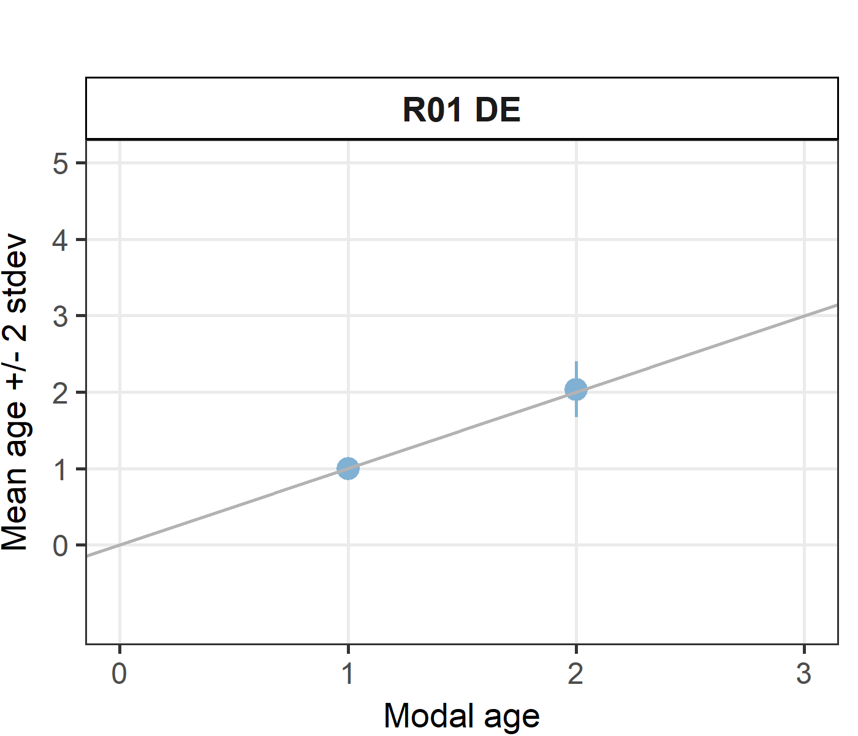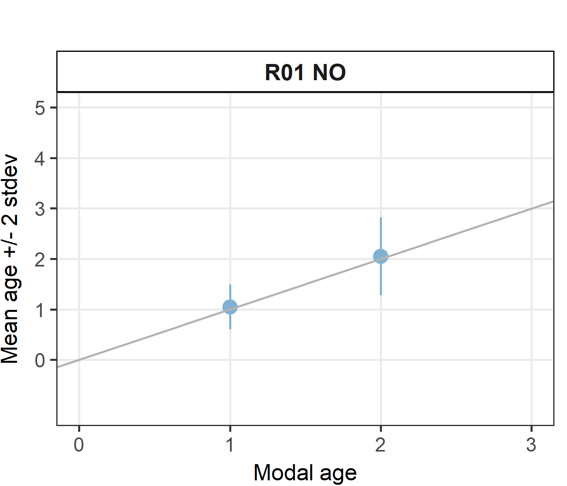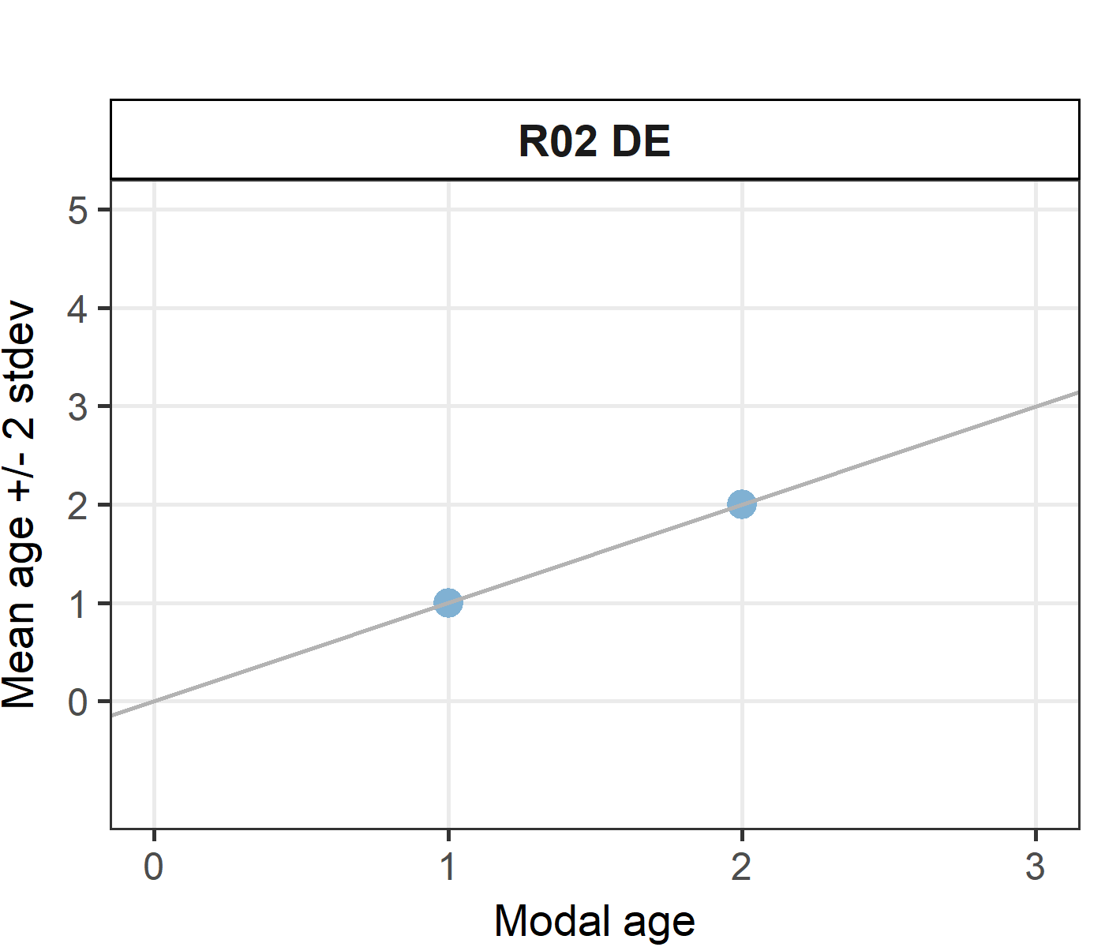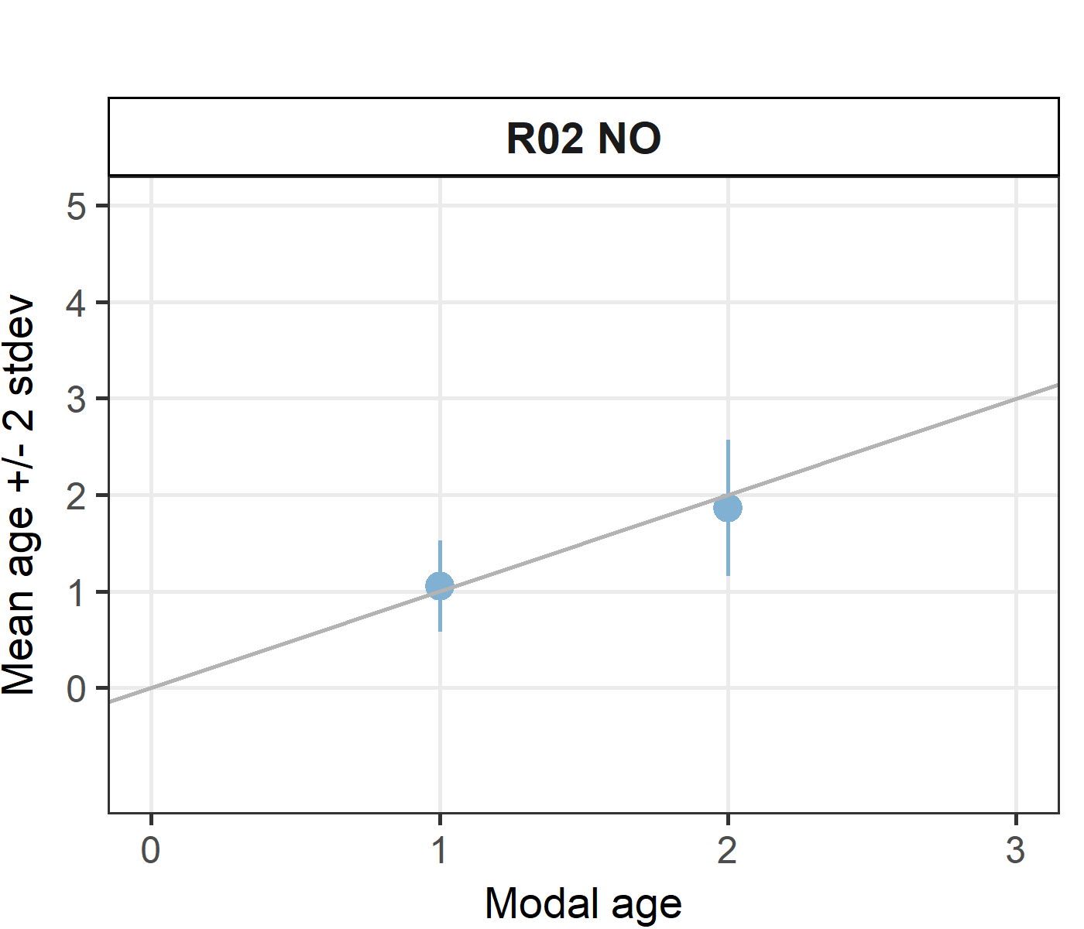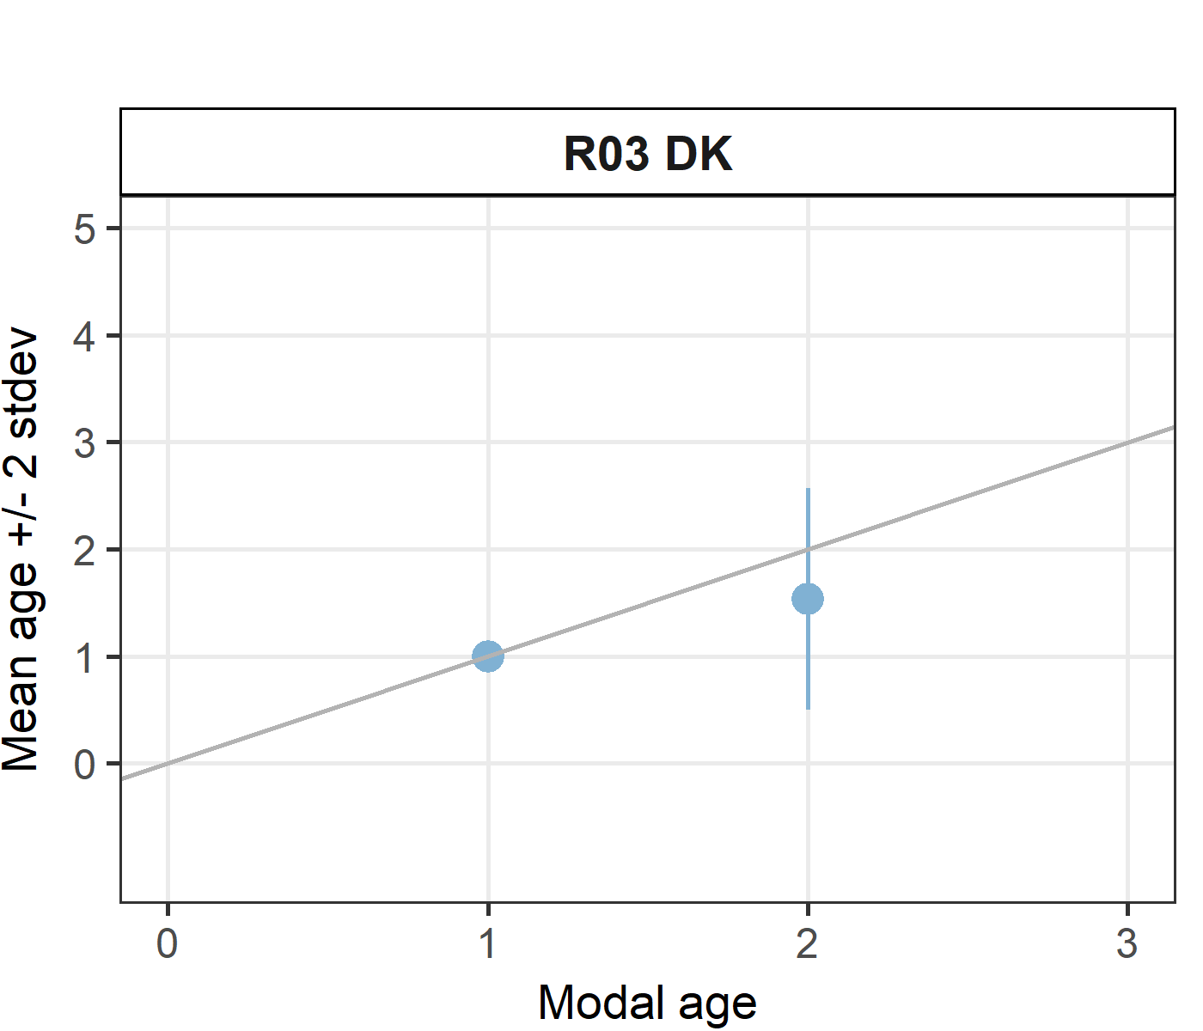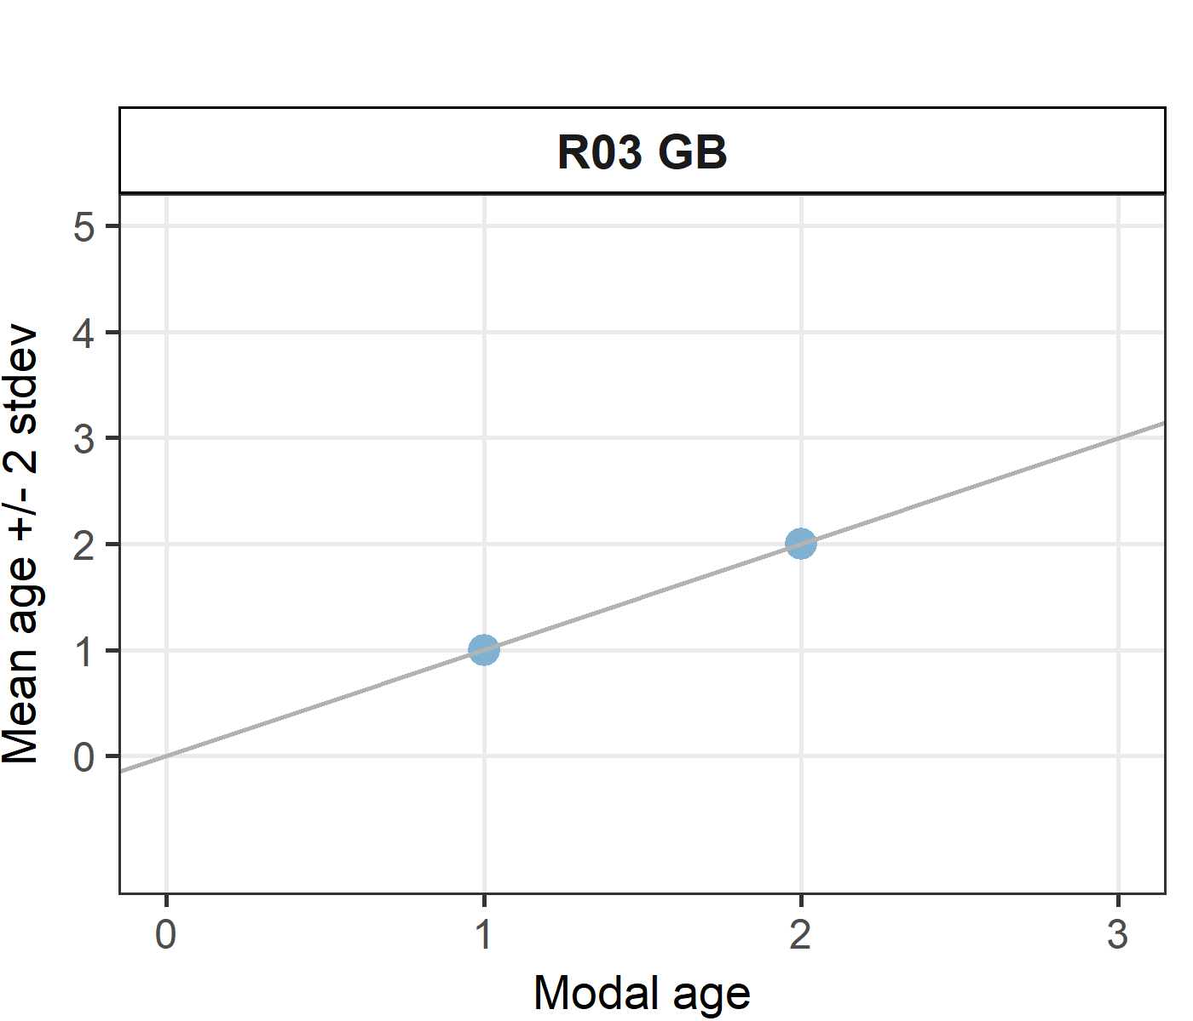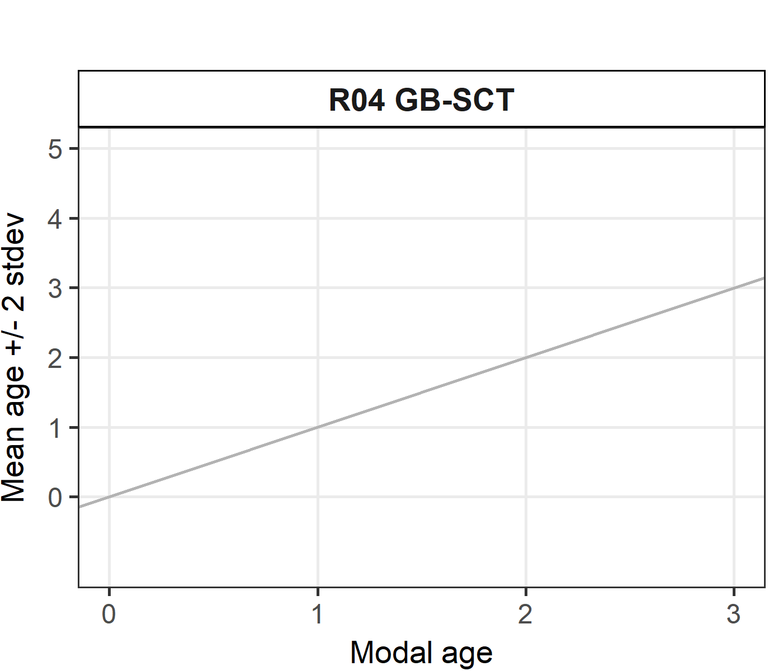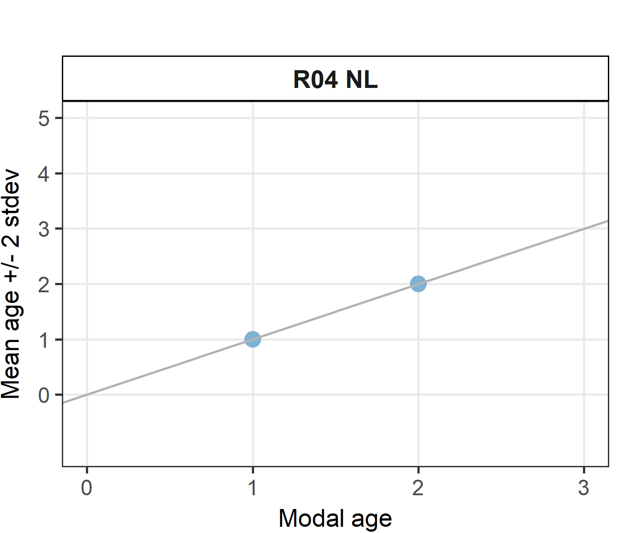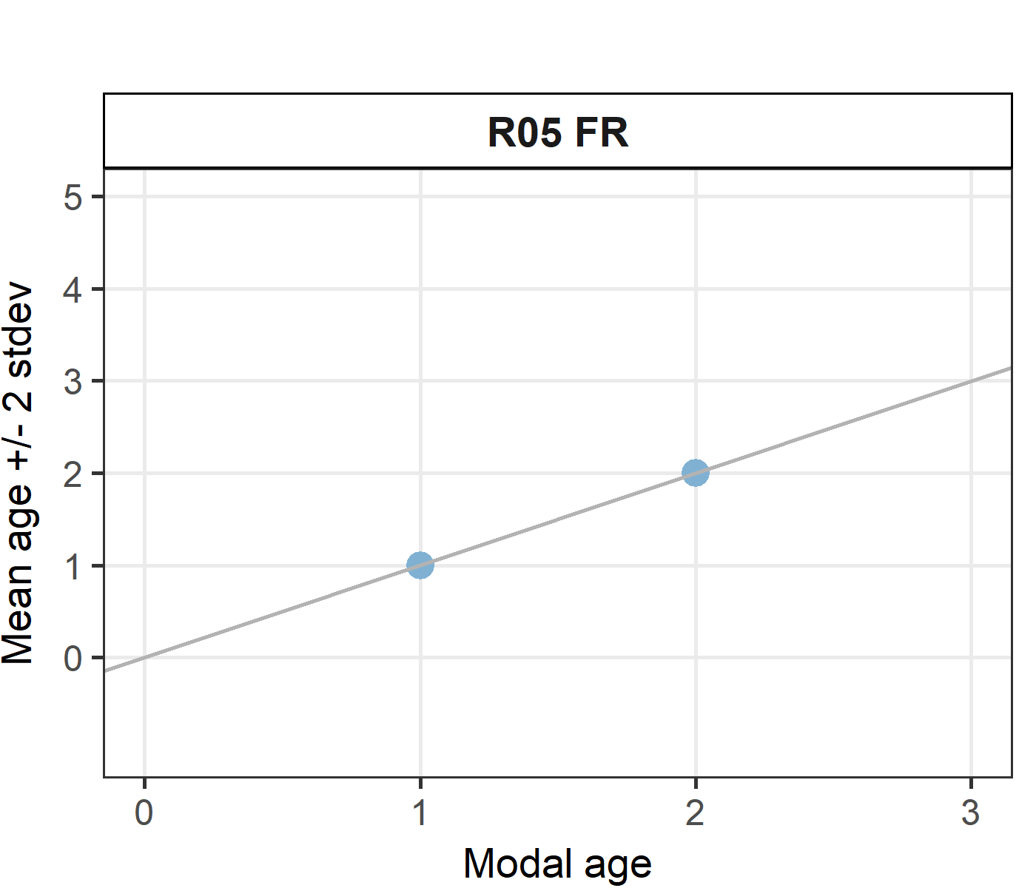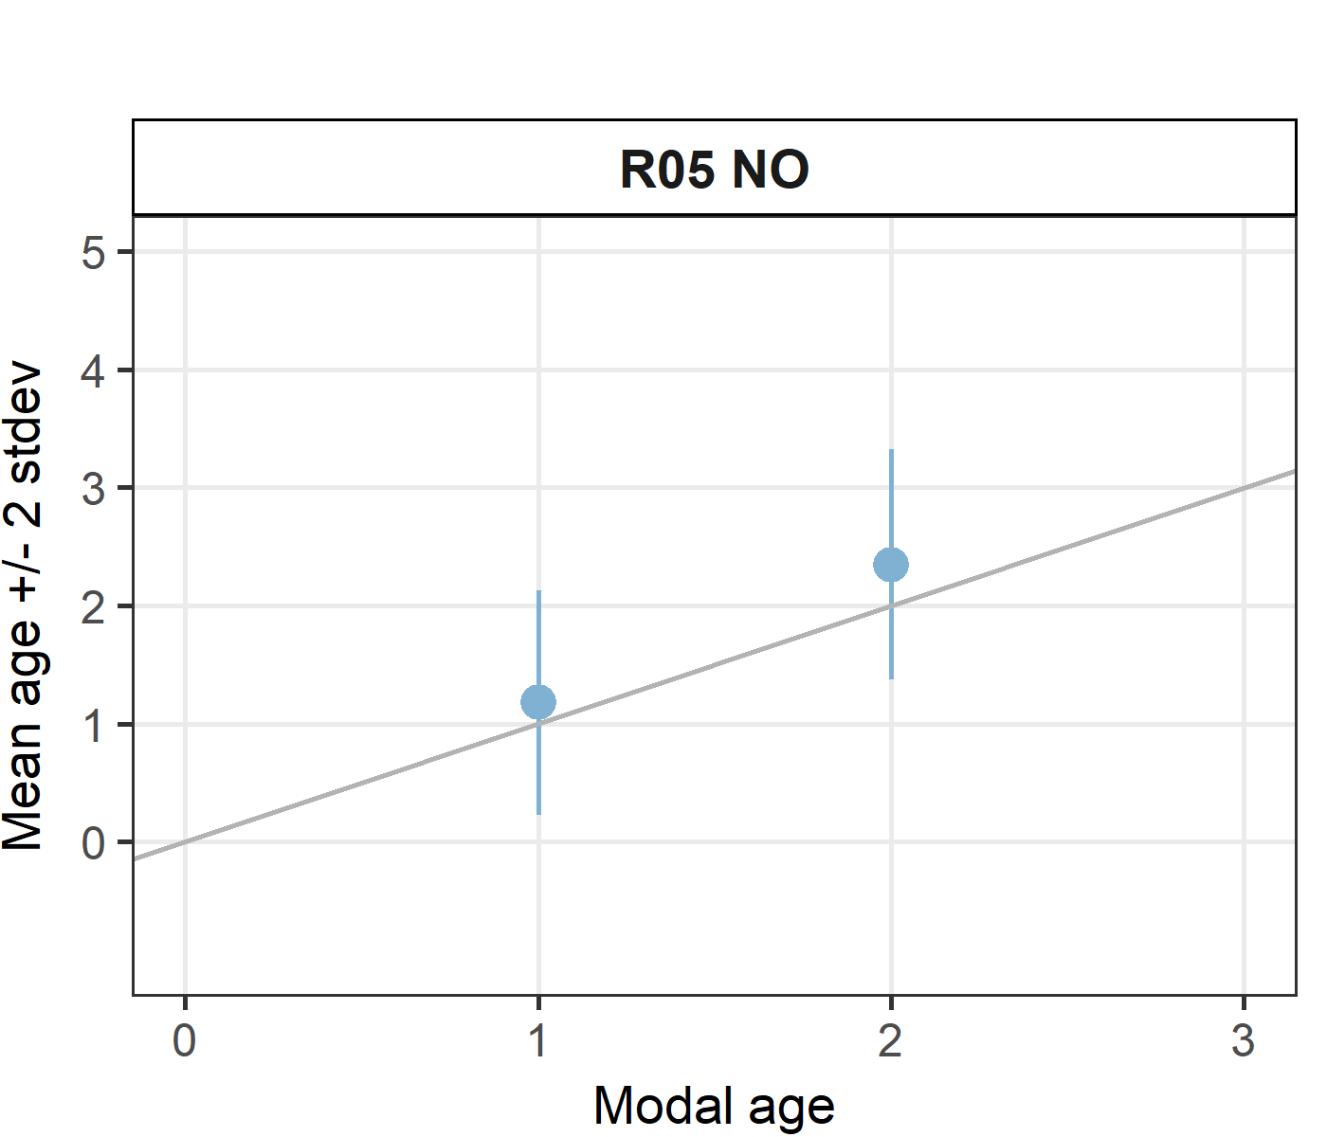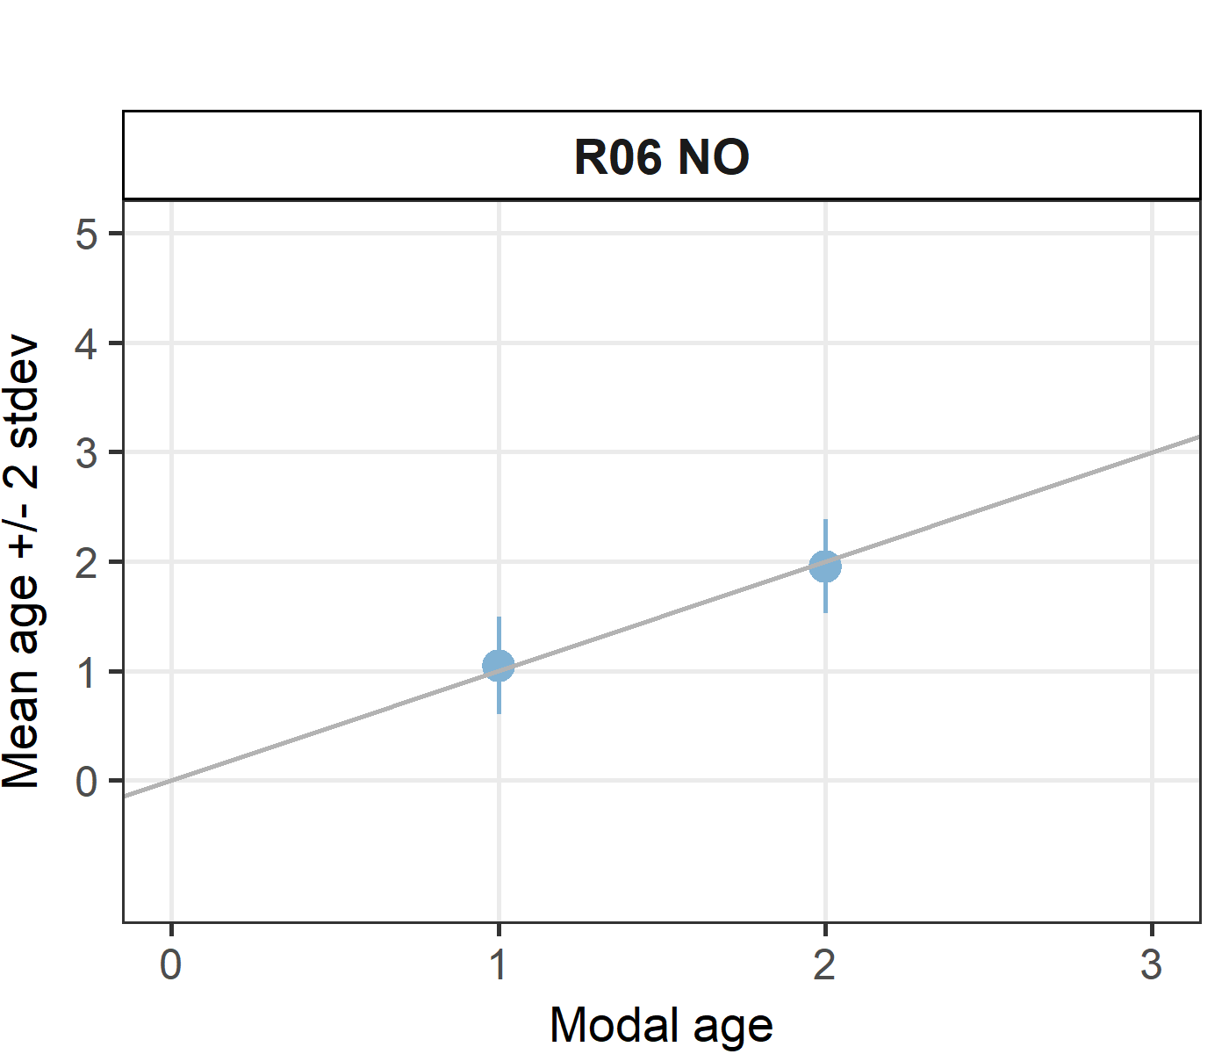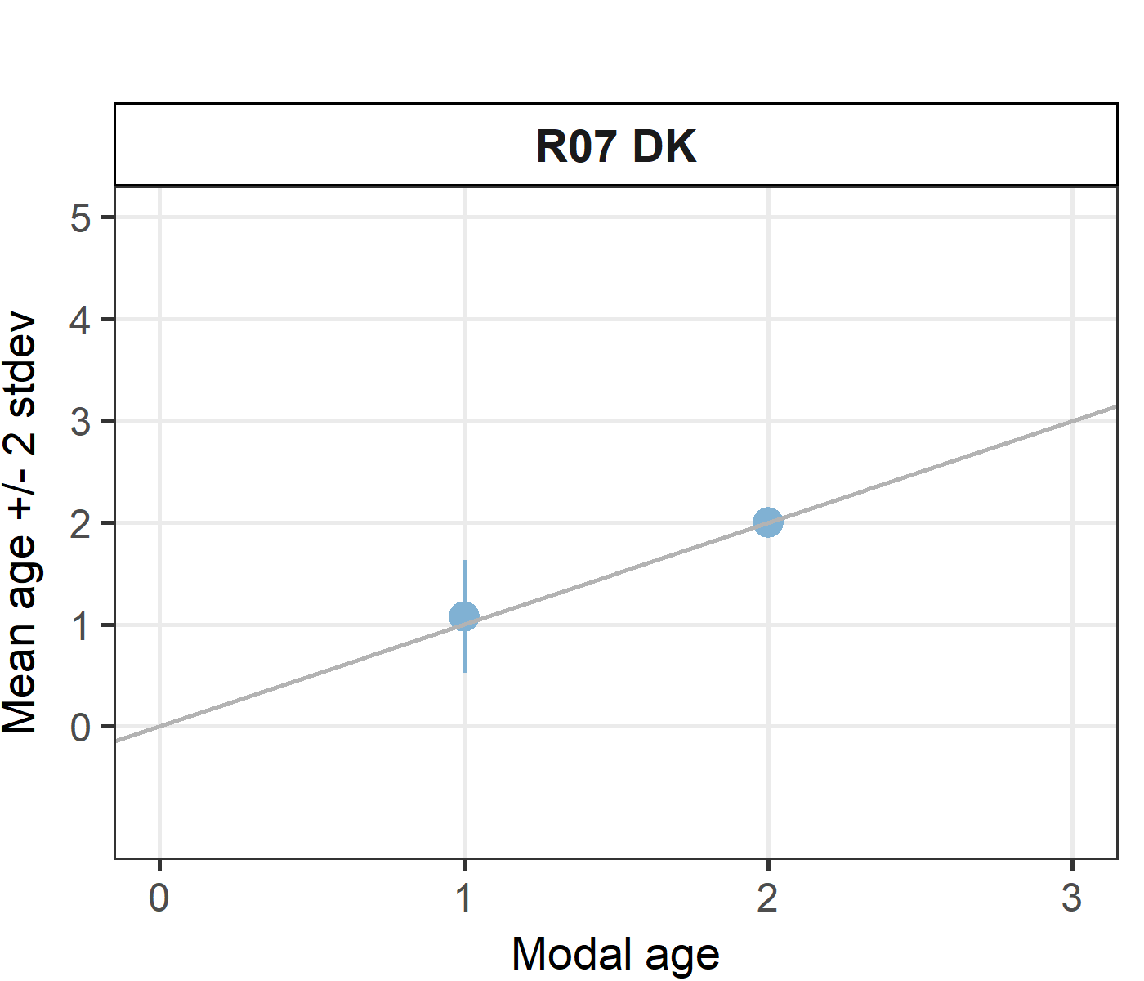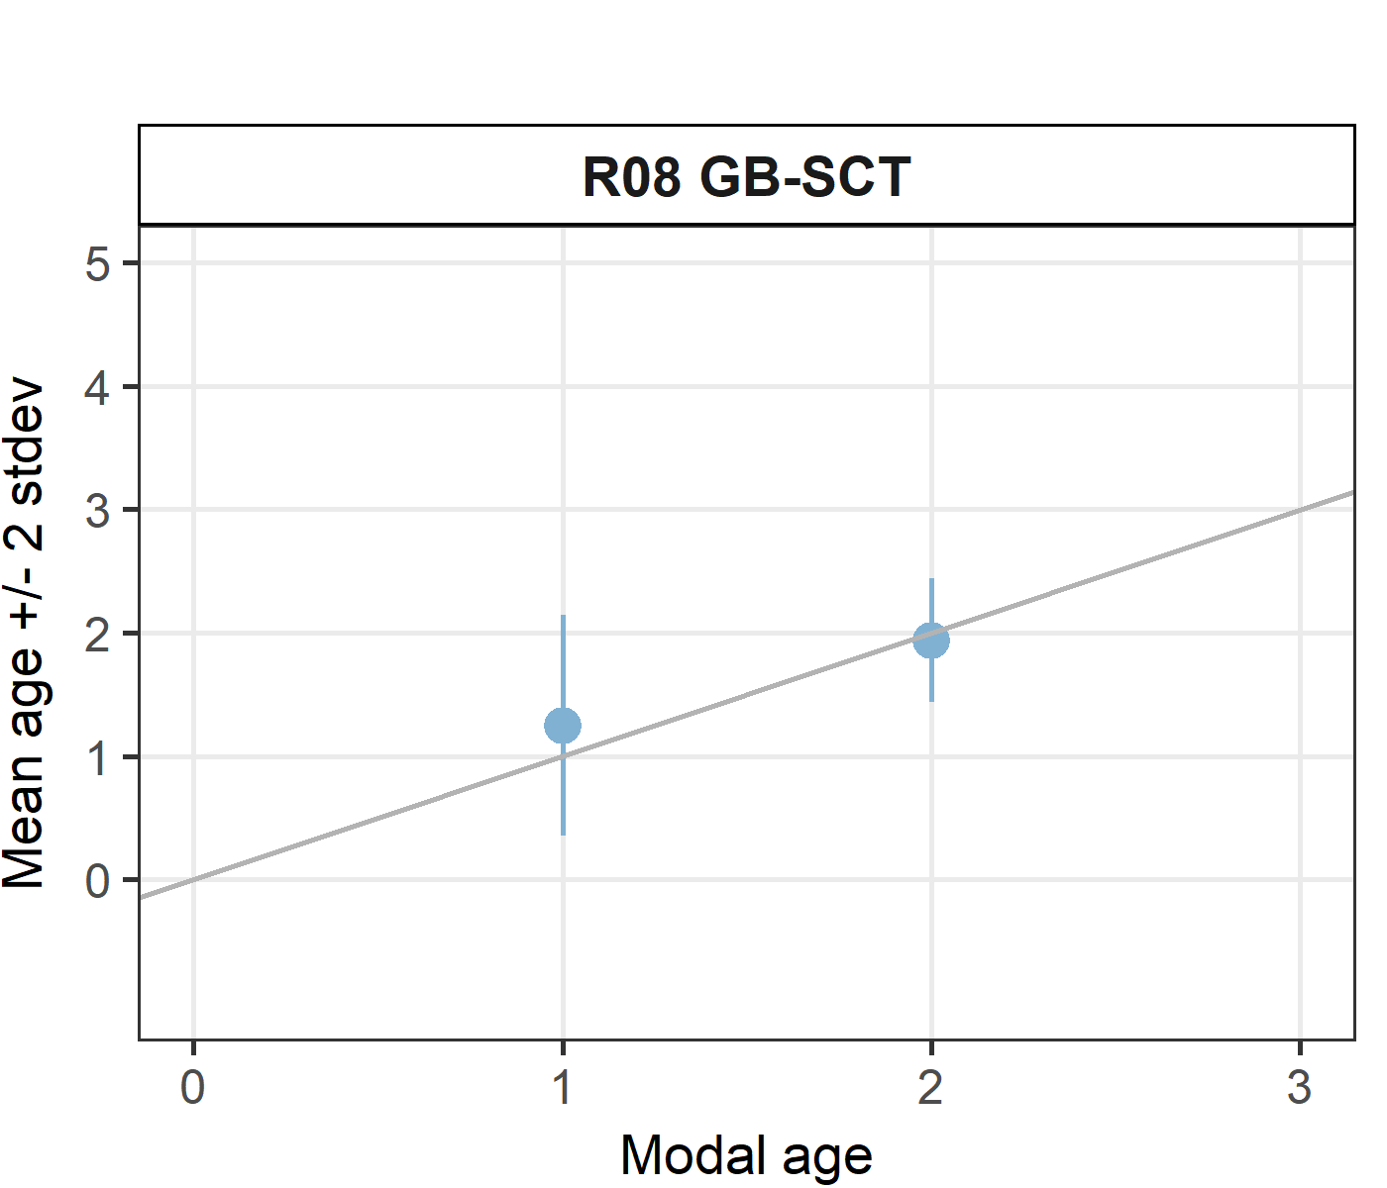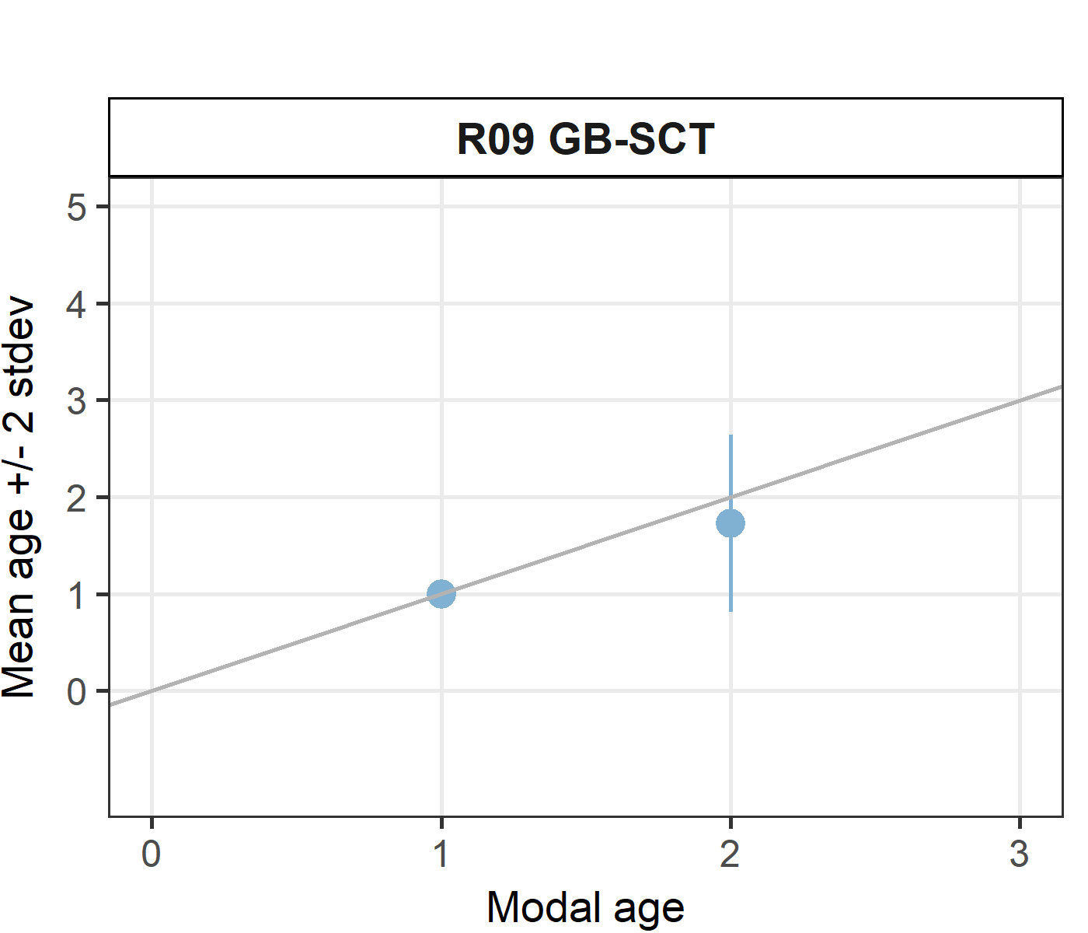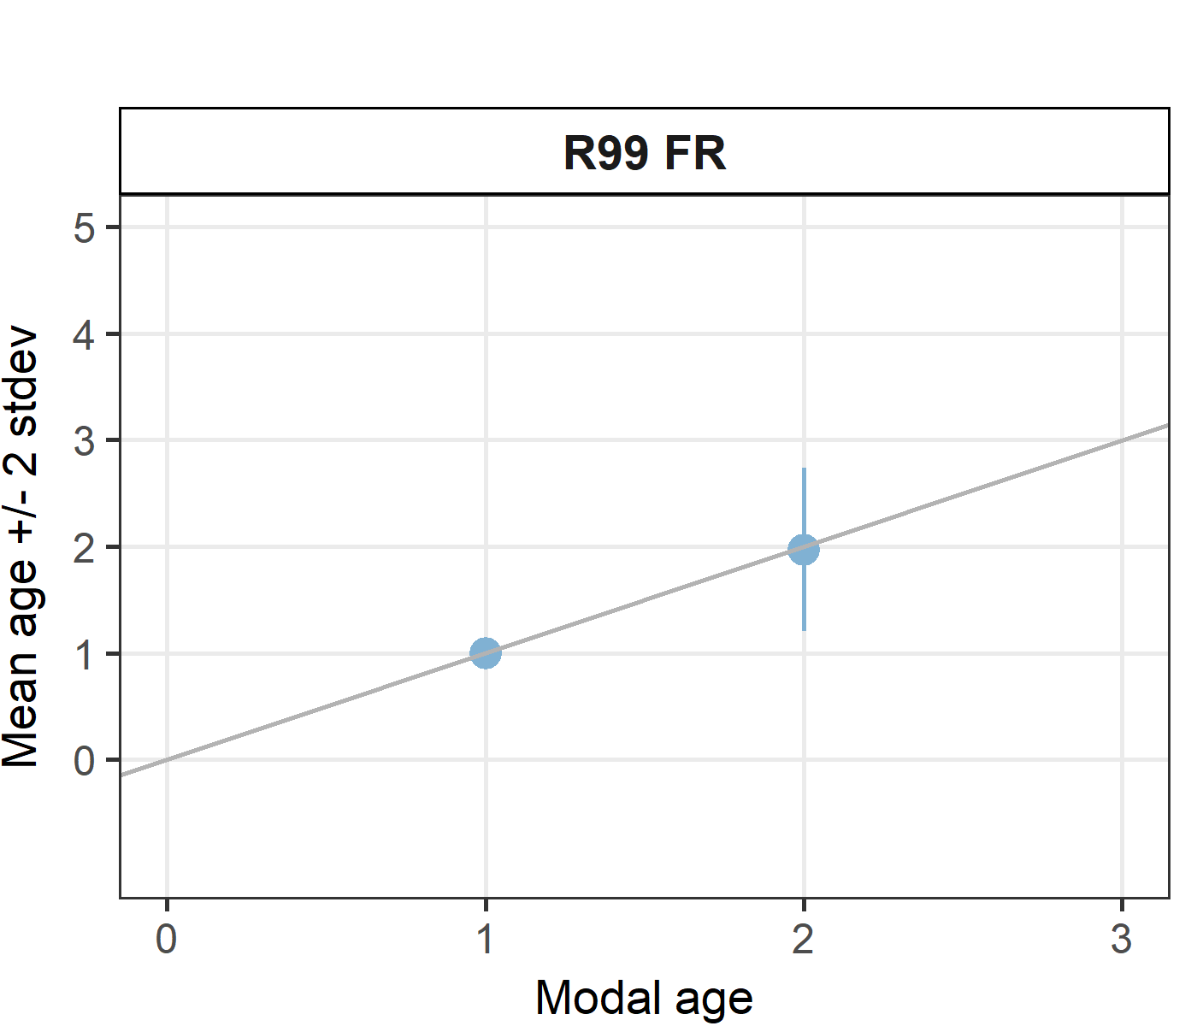

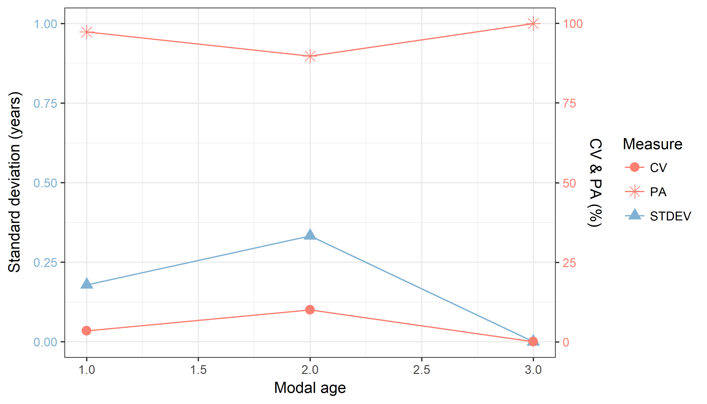

**Figure X:** CV, PA and (STDEV (standard deviation) are plotted against modal age

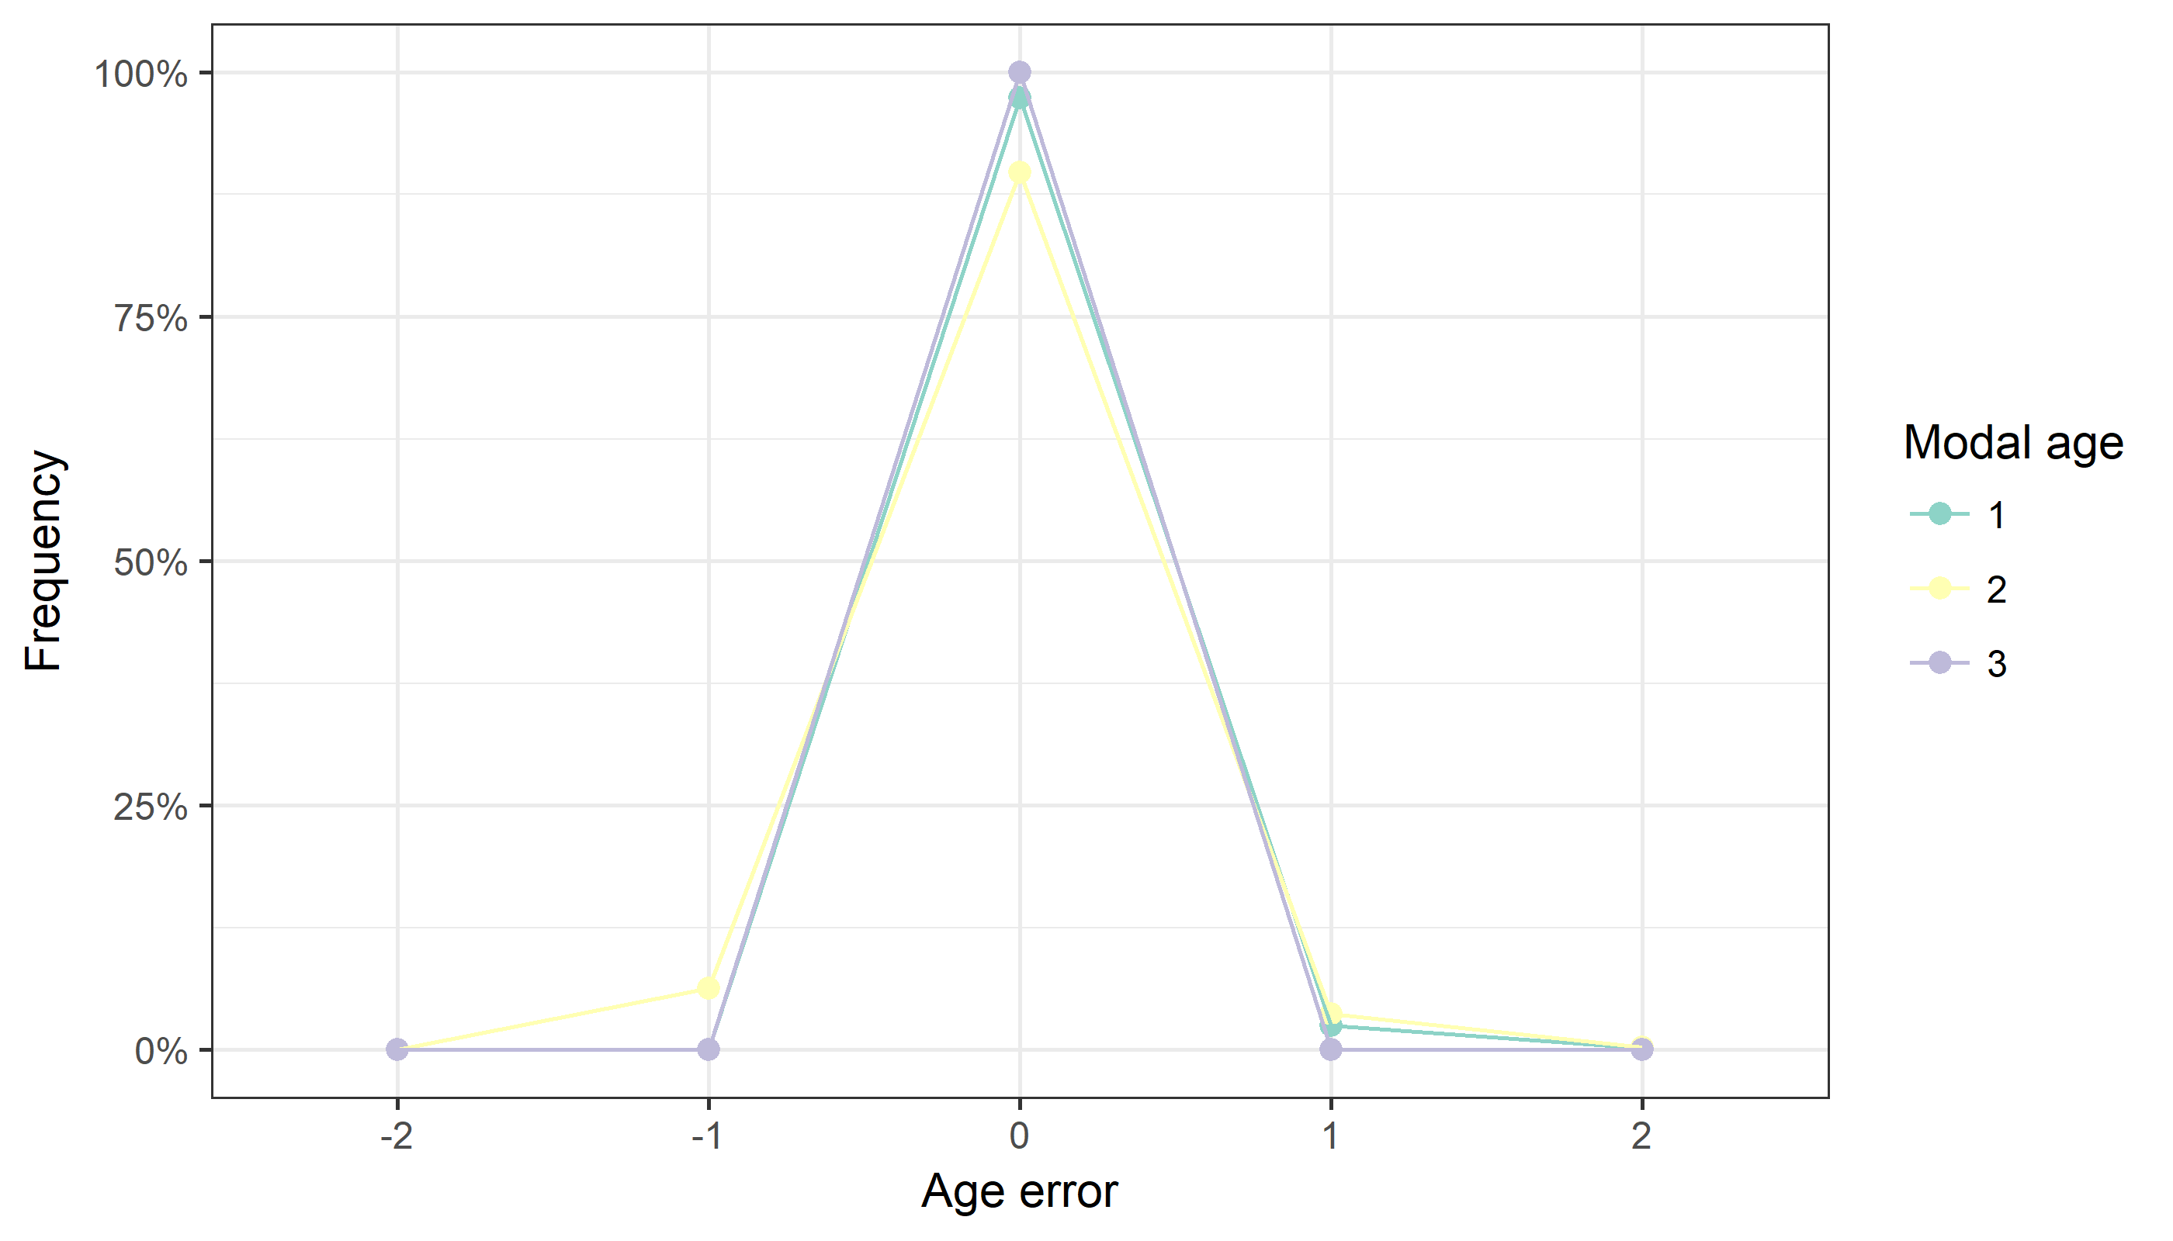

**Figure X:** The distribution of the age reading errors in percentage by modal age as observed from the whole group of age readers in an age reading comparison to modal age. The achieved precision in age reading by MODAL age group is shown by the spread of the age readings errors. There appears to be no relative bias, if the age reading errors are normally distributed. The distributions are skewed, if relative bias occurs.

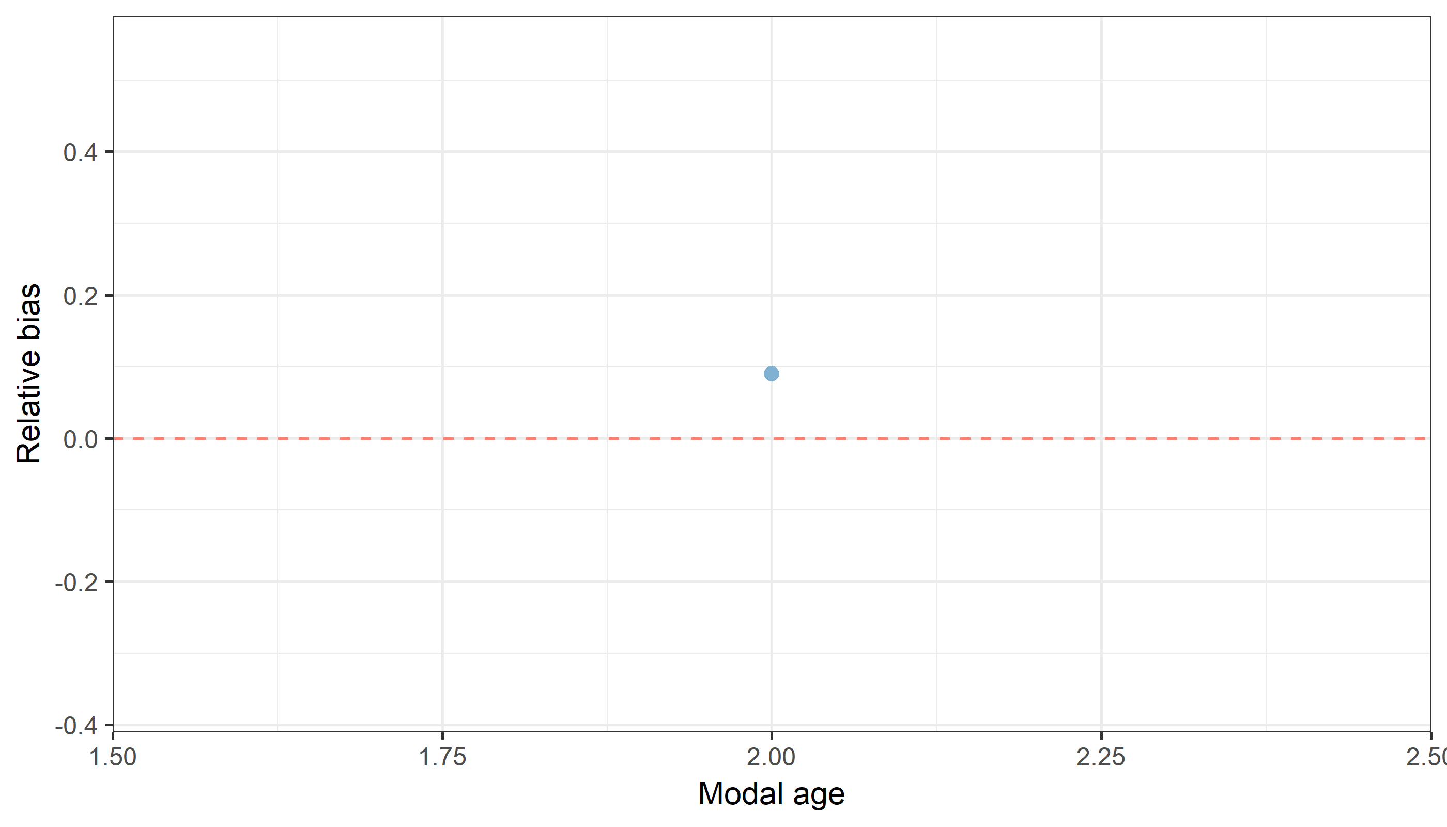

**Figure X:** The relative bias by modal age as estimated by all age readers combined.

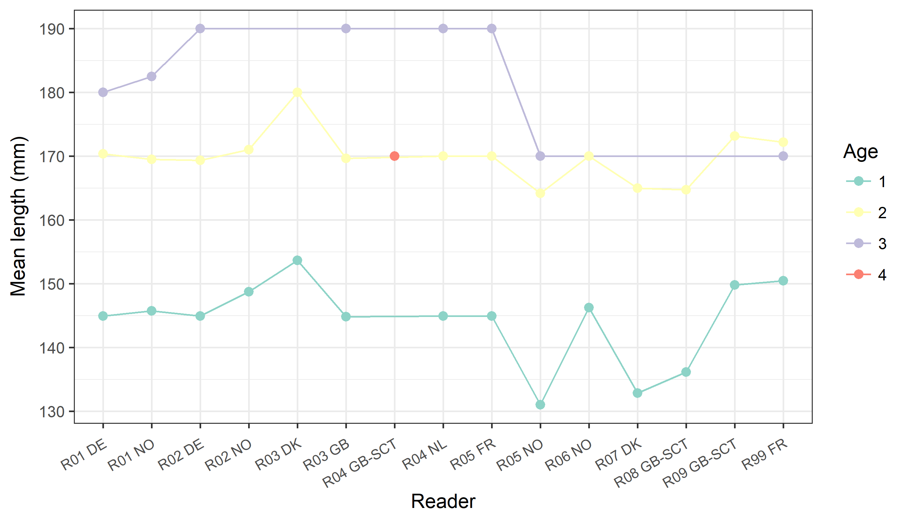

**Figure X:** The mean length at age as estimated by each age reader.

## Results Advanced readers

**All samples included**

**Data Overview**

**Table X:** Summary of statistics; PA (%), CV (%) and APE (%) based on advanced readers only.

|  |  |  |
| --- | --- | --- |
| **Mean CV %** | **Mean PA %** | **Mean APE %** |
| 96.3 | 4.7 | 2.9 |

**Table X:** Data overview including modal age and statistics per sample for advanced readerws only.

|  |  |  |  |  |  |  |  |  |  |  |  |  |  |  |  |  |  |  |
| --- | --- | --- | --- | --- | --- | --- | --- | --- | --- | --- | --- | --- | --- | --- | --- | --- | --- | --- |
| **Sample** | **Length (mm)** | **Sex** | **Catch date** | **ICES area** | **R01 DE** | **R01 NO** | **R02 DE** | **R02 NO** | **R03 DK** | **R03 GB** | **R04 GB-SCT** | **R05 NO** | **R06 NO** | **R07 DK** | **Modal age** | **PA %** | **CV %** | **APE %** |
| 535 | 170 | U | 2014-10-25 | 27.4.a | - | - | - | - | 1 | - | - | - | - | - | 1 | 100 | - | 0 |
| 536 | 175 | U | 2014-10-25 | 27.4.a | - | - | - | - | 1 | - | - | - | - | - | 1 | 100 | - | 0 |
| 537 | 175 | U | 2014-10-25 | 27.4.a | - | - | - | - | 2 | - | - | - | - | - | 2 | 100 | - | 0 |
| 546 | 140 | U | 2014-11-01 | 27.4.a | - | - | - | - | 1 | - | - | - | - | 1 | 1 | 100 | 0 | 0 |
| 547 | 140 | U | 2014-11-01 | 27.4.a | - | - | - | - | - | - | - | - | - | 1 | 1 | 100 | - | 0 |
| 548 | 140 | U | 2014-11-01 | 27.4.a | - | - | - | - | - | - | - | - | - | 1 | 1 | 100 | - | 0 |
| 549 | 145 | U | 2014-11-01 | 27.4.a | - | - | - | - | - | - | - | - | - | 1 | 1 | 100 | - | 0 |
| 550 | 145 | U | 2014-11-01 | 27.4.a | - | - | - | - | 1 | - | - | - | - | 1 | 1 | 100 | 0 | 0 |
| 551 | 145 | U | 2014-11-01 | 27.4.a | - | - | - | - | 1 | - | - | - | - | 1 | 1 | 100 | 0 | 0 |
| 552 | 150 | U | 2014-11-01 | 27.4.a | - | - | - | - | - | - | - | - | - | 1 | 1 | 100 | - | 0 |
| 553 | 150 | U | 2014-11-01 | 27.4.a | - | - | - | - | - | - | - | - | - | 1 | 1 | 100 | - | 0 |
| 554 | 155 | U | 2014-11-01 | 27.4.a | - | - | - | - | 1 | - | - | - | - | - | 1 | 100 | - | 0 |
| 555 | 155 | U | 2014-11-01 | 27.4.a | - | - | - | - | 1 | - | - | - | - | - | 1 | 100 | - | 0 |
| 557 | 160 | U | 2014-11-01 | 27.4.a | - | - | - | - | 1 | - | - | - | - | - | 1 | 100 | - | 0 |
| 558 | 165 | U | 2014-11-01 | 27.4.a | - | - | - | - | 1 | - | - | - | - | - | 1 | 100 | - | 0 |
| 559 | 165 | U | 2014-11-01 | 27.4.a | - | - | - | - | 1 | - | - | - | - | - | 1 | 100 | - | 0 |
| 560 | 165 | U | 2014-11-01 | 27.4.a | - | - | - | - | 1 | - | - | - | - | 2 | 2 | 50 | 47 | 33 |
| 561 | 170 | U | 2014-11-01 | 27.4.a | - | - | - | - | 1 | - | - | - | - | - | 1 | 100 | - | 0 |
| 562 | 170 | U | 2014-11-01 | 27.4.a | - | - | - | - | 1 | - | - | - | - | - | 1 | 100 | - | 0 |
| 563 | 175 | U | 2014-11-01 | 27.4.a | - | - | - | - | 1 | - | - | - | - | 2 | 2 | 50 | 47 | 33 |
| 564 | 180 | U | 2014-11-01 | 27.4.a | - | - | - | - | 2 | - | - | - | - | - | 2 | 100 | - | 0 |
| 565 | 180 | U | 2014-11-01 | 27.4.a | - | - | - | - | 2 | - | - | - | - | - | 2 | 100 | - | 0 |
| 566 | 180 | U | 2014-11-01 | 27.4.a | - | - | - | - | 2 | - | - | - | - | - | 2 | 100 | - | 0 |
| 567 | 185 | U | 2014-11-01 | 27.4.a | - | - | - | - | 2 | - | - | - | - | - | 2 | 100 | - | 0 |
| 568 | 185 | U | 2014-11-01 | 27.4.a | - | - | - | - | 2 | - | - | - | - | - | 2 | 100 | - | 0 |
| 586 | 150 | U | 2014-10-25 | 27.4.a | - | - | - | - | 1 | - | - | - | - | - | 1 | 100 | - | 0 |
| 587 | 155 | U | 2014-10-25 | 27.4.a | - | - | - | - | 1 | - | - | - | - | 2 | 2 | 50 | 47 | 33 |
| 588 | 155 | U | 2014-10-25 | 27.4.a | - | - | - | - | 1 | - | - | - | - | - | 1 | 100 | - | 0 |
| 589 | 155 | U | 2014-10-25 | 27.4.a | - | - | - | - | 1 | - | - | - | - | - | 1 | 100 | - | 0 |
| 590 | 160 | U | 2014-10-25 | 27.4.a | - | - | - | - | 1 | - | - | - | - | - | 1 | 100 | - | 0 |
| 591 | 160 | U | 2014-10-25 | 27.4.a | - | - | - | - | 1 | - | - | - | - | - | 1 | 100 | - | 0 |
| 592 | 170 | U | 2014-10-25 | 27.4.a | - | - | - | - | 1 | - | - | - | - | - | 1 | 100 | - | 0 |
| 593 | 170 | U | 2014-10-25 | 27.4.a | - | 2 | - | 2 | - | - | 4 | 3 | 2 | 2 | 2 | 67 | 33 | 27 |
| 594 | 175 | U | 2014-10-25 | 27.4.a | - | 2 | - | 1 | - | - | - | 2 | 2 | 2 | 2 | 80 | 25 | 18 |
| 595 | 175 | U | 2014-10-25 | 27.4.a | - | 2 | - | 2 | - | - | - | 2 | 2 | 2 | 2 | 100 | 0 | 0 |
| 596 | 175 | U | 2014-10-25 | 27.4.a | - | 2 | - | 2 | 2 | - | - | 3 | 2 | 2 | 2 | 83 | 19 | 13 |
| 597 | 180 | U | 2014-10-25 | 27.4.a | - | 2 | - | 2 | 2 | - | - | 2 | 2 | 2 | 2 | 100 | 0 | 0 |
| 598 | 105 | U | 2014-11-01 | 27.4.a | - | - | - | - | - | - | - | 1 | - | 1 | 1 | 100 | 0 | 0 |
| 599 | 105 | U | 2014-11-01 | 27.4.a | - | - | - | - | - | - | - | 1 | - | 1 | 1 | 100 | 0 | 0 |
| 600 | 105 | U | 2014-11-01 | 27.4.a | - | - | - | - | - | - | - | 1 | - | 1 | 1 | 100 | 0 | 0 |
| 601 | 110 | U | 2014-11-01 | 27.4.a | - | - | - | - | - | - | - | 1 | - | - | 1 | 100 | - | 0 |
| 602 | 120 | U | 2014-11-01 | 27.4.a | - | - | - | - | - | - | - | 1 | - | 1 | 1 | 100 | 0 | 0 |
| 603 | 135 | U | 2014-11-01 | 27.4.a | - | 1 | - | 1 | 1 | - | - | 1 | 1 | 1 | 1 | 100 | 0 | 0 |
| 604 | 140 | U | 2014-11-01 | 27.4.a | - | 1 | - | 1 | - | - | - | 1 | 1 | - | 1 | 100 | 0 | 0 |
| 605 | 140 | U | 2014-11-01 | 27.4.a | - | 1 | - | 1 | 1 | - | - | 1 | 1 | - | 1 | 100 | 0 | 0 |
| 606 | 140 | U | 2014-11-01 | 27.4.a | - | 1 | - | 1 | 1 | - | - | 1 | 1 | - | 1 | 100 | 0 | 0 |
| 607 | 145 | U | 2014-11-01 | 27.4.a | - | 1 | - | 1 | 1 | - | - | 1 | 1 | - | 1 | 100 | 0 | 0 |
| 608 | 145 | U | 2014-11-01 | 27.4.a | - | 1 | - | 1 | - | - | - | 1 | 1 | - | 1 | 100 | 0 | 0 |
| 609 | 145 | U | 2014-11-01 | 27.4.a | - | 1 | - | 1 | - | - | - | 1 | 1 | - | 1 | 100 | 0 | 0 |
| 610 | 150 | U | 2014-11-01 | 27.4.a | - | 1 | - | 1 | 1 | - | - | 1 | 1 | - | 1 | 100 | 0 | 0 |
| 611 | 150 | U | 2014-11-01 | 27.4.a | - | 1 | - | 1 | 1 | - | - | 1 | 1 | - | 1 | 100 | 0 | 0 |
| 612 | 155 | U | 2014-11-01 | 27.4.a | - | 2 | - | 2 | - | - | - | 3 | 2 | 2 | 2 | 80 | 20 | 15 |
| 613 | 155 | U | 2014-11-01 | 27.4.a | - | 1 | - | 2 | - | - | - | 2 | 2 | 2 | 2 | 80 | 25 | 18 |
| 614 | 160 | U | 2014-11-01 | 27.4.a | - | 1 | - | 1 | 1 | - | - | 2 | 2 | - | 1 | 60 | 39 | 34 |
| 615 | 160 | U | 2014-11-01 | 27.4.a | - | 2 | - | 2 | - | - | - | 2 | 2 | 2 | 2 | 100 | 0 | 0 |
| 616 | 165 | U | 2014-11-01 | 27.4.a | - | 2 | - | 2 | - | - | - | 2 | 2 | 2 | 2 | 100 | 0 | 0 |
| 617 | 165 | U | 2014-11-01 | 27.4.a | - | - | - | 2 | - | - | - | 2 | 2 | 2 | 2 | 100 | 0 | 0 |
| 618 | 165 | U | 2014-11-01 | 27.4.a | - | 2 | - | 2 | - | - | - | 2 | 2 | - | 2 | 100 | 0 | 0 |
| 619 | 170 | U | 2014-11-01 | 27.4.a | - | 2 | - | 2 | - | - | - | 3 | 2 | 2 | 2 | 80 | 20 | 15 |
| 620 | 170 | U | 2014-11-01 | 27.4.a | - | 2 | - | 2 | - | - | - | 2 | 2 | 2 | 2 | 100 | 0 | 0 |
| 621 | 175 | U | 2014-11-01 | 27.4.a | - | 2 | - | 2 | - | - | - | 2 | 1 | - | 2 | 75 | 29 | 21 |
| 622 | 180 | U | 2014-11-01 | 27.4.a | - | 2 | - | 2 | - | - | - | 2 | 2 | 2 | 2 | 100 | 0 | 0 |
| 623 | 180 | U | 2014-11-01 | 27.4.a | - | 2 | - | 2 | - | - | - | 3 | 2 | 2 | 2 | 80 | 20 | 15 |
| 624 | 180 | U | 2014-11-01 | 27.4.a | - | 3 | - | 2 | - | - | - | 3 | 2 | - | 2 | 50 | 23 | 20 |
| 625 | 185 | U | 2014-11-01 | 27.4.a | - | 2 | - | 2 | - | - | - | 2 | 2 | 2 | 2 | 100 | 0 | 0 |
| 626 | 185 | U | 2014-11-01 | 27.4.a | - | 3 | - | 2 | - | - | - | 3 | 2 | 2 | 2 | 60 | 23 | 20 |
| 631 | 100 | U | 2014-10-25 | 27.4.a | - | - | - | - | - | - | - | 1 | - | 1 | 1 | 100 | 0 | 0 |
| 634 | 105 | U | 2014-10-25 | 27.4.a | - | - | - | - | - | - | - | 1 | - | - | 1 | 100 | - | 0 |
| 635 | 105 | U | 2014-10-25 | 27.4.a | - | - | - | - | - | - | - | - | - | 1 | 1 | 100 | - | 0 |
| 636 | 105 | U | 2014-10-25 | 27.4.a | - | - | - | - | - | - | - | 1 | - | 1 | 1 | 100 | 0 | 0 |
| 637 | 110 | U | 2014-10-25 | 27.4.a | - | - | - | - | - | - | - | 2 | - | 2 | 2 | 100 | 0 | 0 |
| 638 | 135 | U | 2014-10-25 | 27.4.a | - | 1 | - | - | 1 | - | - | 1 | 1 | 2 | 1 | 80 | 37 | 27 |
| 639 | 135 | U | 2014-10-25 | 27.4.a | - | 1 | - | - | 1 | - | - | 1 | 1 | 1 | 1 | 100 | 0 | 0 |
| 640 | 140 | U | 2014-10-25 | 27.4.a | - | 1 | - | 1 | 1 | - | - | 1 | 1 | 1 | 1 | 100 | 0 | 0 |
| 641 | 140 | U | 2014-10-25 | 27.4.a | - | 1 | - | 1 | 1 | - | - | 1 | 1 | 1 | 1 | 100 | 0 | 0 |
| 642 | 145 | U | 2014-10-25 | 27.4.a | - | 1 | - | 1 | 1 | - | - | 1 | 1 | 1 | 1 | 100 | 0 | 0 |
| 643 | 150 | U | 2014-10-25 | 27.4.a | - | 1 | - | 1 | 1 | - | - | 1 | 1 | 1 | 1 | 100 | 0 | 0 |
| 644 | 150 | U | 2014-10-25 | 27.4.a | - | 2 | - | 1 | - | - | - | 2 | 1 | 2 | 2 | 60 | 34 | 30 |
| 645 | 155 | U | 2014-10-25 | 27.4.a | - | 1 | - | 1 | - | - | - | 3 | 1 | - | 1 | 75 | 67 | 50 |
| 646 | 155 | U | 2014-10-25 | 27.4.a | - | 1 | - | 1 | - | - | - | 1 | 1 | 1 | 1 | 100 | 0 | 0 |
| 647 | 155 | U | 2014-10-25 | 27.4.a | - | 1 | - | 1 | - | - | - | 2 | 1 | 1 | 1 | 80 | 37 | 27 |
| 648 | 160 | U | 2014-10-25 | 27.4.a | - | 2 | - | 1 | - | - | - | 2 | 2 | 2 | 2 | 80 | 25 | 18 |
| 649 | 160 | U | 2014-10-25 | 27.4.a | - | 2 | - | 2 | - | - | - | 3 | 2 | 2 | 2 | 80 | 20 | 15 |
| 650 | 170 | U | 2014-10-25 | 27.4.a | - | 2 | - | 2 | - | - | - | 2 | 2 | 2 | 2 | 100 | 0 | 0 |
| 763 | 180 | F | 2016-09-01 | 27.4.a | 2 | - | 2 | - | - | 2 | - | - | - | - | 2 | 100 | 0 | 0 |
| 764 | 170 | M | 2016-09-01 | 27.4.a | 2 | - | 2 | - | - | 2 | - | - | - | - | 2 | 100 | 0 | 0 |
| 765 | 160 | F | 2016-09-01 | 27.4.a | 2 | - | 2 | - | - | 2 | - | - | - | - | 2 | 100 | 0 | 0 |
| 766 | 190 | F | 2016-09-01 | 27.4.a | 2 | - | - | - | - | 2 | - | - | - | - | 2 | 100 | 0 | 0 |
| 767 | 150 | M | 2016-09-01 | 27.4.a | 2 | - | 2 | - | - | 2 | - | - | - | - | 2 | 100 | 0 | 0 |
| 768 | 150 | M | 2016-09-01 | 27.4.a | 2 | - | 2 | - | - | 2 | - | - | - | - | 2 | 100 | 0 | 0 |
| 769 | 160 | F | 2016-09-01 | 27.4.a | 2 | - | 2 | - | - | 2 | - | - | - | - | 2 | 100 | 0 | 0 |
| 770 | 180 | M | 2016-09-01 | 27.4.a | 2 | - | 2 | - | - | - | - | - | - | - | 2 | 100 | 0 | 0 |
| 773 | 150 | F | 2016-08-25 | 27.4.a | 1 | - | 1 | - | - | 1 | - | - | - | - | 1 | 100 | 0 | 0 |
| 774 | 150 | M | 2016-08-25 | 27.4.a | 1 | - | 1 | - | - | 1 | - | - | - | - | 1 | 100 | 0 | 0 |
| 775 | 140 | M | 2016-08-25 | 27.4.a | 1 | - | 1 | - | - | 1 | - | - | - | - | 1 | 100 | 0 | 0 |
| 776 | 140 | M | 2016-08-25 | 27.4.a | 1 | - | 1 | - | - | 1 | - | - | - | - | 1 | 100 | 0 | 0 |
| 777 | 160 | F | 2016-08-25 | 27.4.a | 1 | - | 1 | - | - | 1 | - | - | - | - | 1 | 100 | 0 | 0 |
| 778 | 160 | F | 2016-08-25 | 27.4.a | 1 | - | 1 | - | - | 1 | - | - | - | - | 1 | 100 | 0 | 0 |
| 779 | 170 | F | 2016-08-25 | 27.4.a | 2 | - | 2 | - | - | 2 | - | - | - | - | 2 | 100 | 0 | 0 |
| 780 | 130 | F | 2016-08-25 | 27.4.a | 1 | - | 1 | - | - | 1 | - | - | - | - | 1 | 100 | 0 | 0 |
| 781 | 180 | F | 2016-08-25 | 27.4.a | 2 | - | 2 | - | - | 2 | - | - | - | - | 2 | 100 | 0 | 0 |
| 782 | 150 | F | 2016-08-25 | 27.4.a | 1 | - | 1 | - | - | 1 | - | - | - | - | 1 | 100 | 0 | 0 |
| 783 | 150 | F | 2016-08-25 | 27.4.a | 1 | - | 1 | - | - | - | - | - | - | - | 1 | 100 | 0 | 0 |
| 784 | 140 | F | 2016-08-25 | 27.4.a | 1 | - | 1 | - | - | 1 | - | - | - | - | 1 | 100 | 0 | 0 |
| 785 | 130 | M | 2016-08-25 | 27.4.a | 1 | - | 1 | - | - | 1 | - | - | - | - | 1 | 100 | 0 | 0 |
| 786 | 140 | M | 2016-08-25 | 27.4.a | 1 | - | 1 | - | - | 1 | - | - | - | - | 1 | 100 | 0 | 0 |
| 787 | 130 | M | 2016-08-25 | 27.4.a | 1 | - | 1 | - | - | 1 | - | - | - | - | 1 | 100 | 0 | 0 |
| 788 | 160 | M | 2016-08-25 | 27.4.a | 1 | - | 1 | - | - | 1 | - | - | - | - | 1 | 100 | 0 | 0 |
| 789 | 140 | M | 2016-08-25 | 27.4.a | 1 | - | 1 | - | - | 1 | - | - | - | - | 1 | 100 | 0 | 0 |
| 790 | 150 | M | 2016-08-25 | 27.4.a | 1 | - | 1 | - | - | 1 | - | - | - | - | 1 | 100 | 0 | 0 |
| 791 | 170 | F | 2016-08-25 | 27.4.a | 1 | - | 1 | - | - | 1 | - | - | - | - | 1 | 100 | 0 | 0 |
| 792 | 140 | M | 2016-08-25 | 27.4.a | 1 | - | 1 | - | - | 1 | - | - | - | - | 1 | 100 | 0 | 0 |
| 793 | 170 | F | 2016-08-25 | 27.4.a | 2 | - | 2 | - | - | 2 | - | - | - | - | 2 | 100 | 0 | 0 |
| 794 | 150 | F | 2016-08-25 | 27.4.a | 1 | - | 1 | - | - | 1 | - | - | - | - | 1 | 100 | 0 | 0 |
| 795 | 160 | M | 2016-08-25 | 27.4.a | 1 | - | 1 | - | - | 1 | - | - | - | - | 1 | 100 | 0 | 0 |
| 796 | 160 | M | 2016-08-25 | 27.4.a | 2 | - | 2 | - | - | 2 | - | - | - | - | 2 | 100 | 0 | 0 |
| 797 | 190 | F | 2016-08-26 | 27.4.a | 3 | - | 3 | - | - | 3 | - | - | - | - | 3 | 100 | 0 | 0 |
| 798 | 180 | F | 2016-08-26 | 27.4.a | 2 | - | 2 | - | - | 2 | - | - | - | - | 2 | 100 | 0 | 0 |
| 799 | 160 | M | 2016-08-26 | 27.4.a | 2 | - | 2 | - | - | 2 | - | - | - | - | 2 | 100 | 0 | 0 |
| 800 | 180 | F | 2016-08-26 | 27.4.a | 2 | - | 2 | - | - | 2 | - | - | - | - | 2 | 100 | 0 | 0 |
| 801 | 160 | M | 2016-08-26 | 27.4.a | 2 | - | 2 | - | - | 2 | - | - | - | - | 2 | 100 | 0 | 0 |
| 802 | 170 | M | 2016-08-26 | 27.4.a | 3 | - | 2 | - | - | 2 | - | - | - | - | 2 | 67 | 25 | 19 |
| 803 | 170 | M | 2016-08-26 | 27.4.a | 2 | - | 2 | - | - | 2 | - | - | - | - | 2 | 100 | 0 | 0 |
| 804 | 150 | F | 2016-08-26 | 27.4.a | 1 | - | 1 | - | - | 1 | - | - | - | - | 1 | 100 | 0 | 0 |
| 805 | 150 | M | 2016-08-26 | 27.4.a | 1 | - | 1 | - | - | 1 | - | - | - | - | 1 | 100 | 0 | 0 |
| 806 | 190 | F | 2016-08-26 | 27.4.a | 2 | - | 2 | - | - | 2 | - | - | - | - | 2 | 100 | 0 | 0 |
| 807 | 140 | M | 2016-08-26 | 27.4.a | 1 | - | 1 | - | - | 1 | - | - | - | - | 1 | 100 | 0 | 0 |
| 808 | 130 | M | 2016-08-26 | 27.4.a | 1 | - | 1 | - | - | 1 | - | - | - | - | 1 | 100 | 0 | 0 |
| 809 | 140 | F | 2016-08-26 | 27.4.a | 1 | - | 1 | - | - | 1 | - | - | - | - | 1 | 100 | 0 | 0 |
| 810 | 130 | M | 2016-08-26 | 27.4.a | 1 | - | 1 | - | - | 1 | - | - | - | - | 1 | 100 | 0 | 0 |
| 811 | 170 | F | 2016-08-26 | 27.4.a | 2 | - | 2 | - | - | 2 | - | - | - | - | 2 | 100 | 0 | 0 |
| 812 | 150 | F | 2016-08-26 | 27.4.a | 1 | - | 1 | - | - | 1 | - | - | - | - | 1 | 100 | 0 | 0 |
| 815 | 170 | F | 2016-08-29 | 27.4.a | 1 | - | 1 | - | - | 1 | - | - | - | - | 1 | 100 | 0 | 0 |
| 816 | 150 | M | 2016-08-29 | 27.4.a | 1 | - | 1 | - | - | 1 | - | - | - | - | 1 | 100 | 0 | 0 |
| 817 | 130 | M | 2016-08-29 | 27.4.a | 1 | - | 1 | - | - | 1 | - | - | - | - | 1 | 100 | 0 | 0 |
| 818 | 160 | F | 2016-08-29 | 27.4.a | 1 | - | 1 | - | - | 1 | - | - | - | - | 1 | 100 | 0 | 0 |
| 819 | 160 | F | 2016-08-29 | 27.4.a | 1 | - | 1 | - | - | - | - | - | - | - | 1 | 100 | 0 | 0 |
| 820 | 150 | F | 2016-08-29 | 27.4.a | 1 | - | 1 | - | - | 1 | - | - | - | - | 1 | 100 | 0 | 0 |
| 821 | 180 | F | 2016-08-29 | 27.4.a | 2 | - | 2 | - | - | 2 | - | - | - | - | 2 | 100 | 0 | 0 |
| 822 | 140 | M | 2016-08-29 | 27.4.a | 1 | - | 1 | - | - | 1 | - | - | - | - | 1 | 100 | 0 | 0 |
| 823 | 170 | F | 2016-08-29 | 27.4.a | 2 | - | 2 | - | - | 2 | - | - | - | - | 2 | 100 | 0 | 0 |
| 824 | 140 | M | 2016-08-29 | 27.4.a | 1 | - | 1 | - | - | 1 | - | - | - | - | 1 | 100 | 0 | 0 |
| 825 | 130 | M | 2016-08-29 | 27.4.a | 1 | - | 1 | - | - | - | - | - | - | - | 1 | 100 | 0 | 0 |
| 828 | 140 | M | 2016-08-30 | 27.4.a | 1 | - | 1 | - | - | 1 | - | - | - | - | 1 | 100 | 0 | 0 |
| 829 | 150 | F | 2016-08-30 | 27.4.a | 1 | - | 1 | - | - | 1 | - | - | - | - | 1 | 100 | 0 | 0 |
| 830 | 150 | M | 2016-08-30 | 27.4.a | 1 | - | 1 | - | - | 1 | - | - | - | - | 1 | 100 | 0 | 0 |
| 831 | 140 | F | 2016-08-30 | 27.4.a | 1 | - | 1 | - | - | 1 | - | - | - | - | 1 | 100 | 0 | 0 |
| 832 | 160 | F | 2016-08-30 | 27.4.a | 2 | - | 2 | - | - | 2 | - | - | - | - | 2 | 100 | 0 | 0 |
| 833 | 130 | F | 2016-08-30 | 27.4.a | 1 | - | 1 | - | - | 1 | - | - | - | - | 1 | 100 | 0 | 0 |
| 834 | 130 | F | 2016-08-30 | 27.4.a | 1 | - | 1 | - | - | 1 | - | - | - | - | 1 | 100 | 0 | 0 |
| 835 | 160 | F | 2016-08-30 | 27.4.a | 1 | - | 1 | - | - | 1 | - | - | - | - | 1 | 100 | 0 | 0 |
| 836 | 140 | M | 2016-08-31 | 27.4.a | 1 | - | 1 | - | - | 1 | - | - | - | - | 1 | 100 | 0 | 0 |
| 837 | 150 | M | 2016-08-31 | 27.4.a | 1 | - | 1 | - | - | 1 | - | - | - | - | 1 | 100 | 0 | 0 |
| 838 | 150 | F | 2016-08-31 | 27.4.a | 1 | - | 1 | - | - | 1 | - | - | - | - | 1 | 100 | 0 | 0 |
| 839 | 140 | M | 2016-08-31 | 27.4.a | 1 | - | 1 | - | - | 1 | - | - | - | - | 1 | 100 | 0 | 0 |
| 840 | 170 | M | 2016-08-31 | 27.4.a | 2 | - | 2 | - | - | 2 | - | - | - | - | 2 | 100 | 0 | 0 |
| 841 | 160 | F | 2016-08-31 | 27.4.a | - | - | 2 | - | - | 2 | - | - | - | - | 2 | 100 | 0 | 0 |
| 842 | 170 | F | 2016-08-31 | 27.4.a | 2 | - | 2 | - | - | 2 | - | - | - | - | 2 | 100 | 0 | 0 |
| 843 | 160 | F | 2016-08-31 | 27.4.a | 1 | - | 1 | - | - | 1 | - | - | - | - | 1 | 100 | 0 | 0 |
| 844 | 180 | F | 2016-08-31 | 27.4.a | 2 | - | 2 | - | - | 2 | - | - | - | - | 2 | 100 | 0 | 0 |
| 845 | 130 | M | 2016-08-31 | 27.4.a | 1 | - | 1 | - | - | 1 | - | - | - | - | 1 | 100 | 0 | 0 |
| 846 | 180 | F | 2016-08-31 | 27.4.a | 2 | - | 2 | - | - | 2 | - | - | - | - | 2 | 100 | 0 | 0 |
| 847 | 130 | M | 2016-08-31 | 27.4.a | 1 | - | 1 | - | - | 1 | - | - | - | - | 1 | 100 | 0 | 0 |
| 850 | 140 | M | 2016-08-31 | 27.4.a | 1 | - | 1 | - | - | 1 | - | - | - | - | 1 | 100 | 0 | 0 |
| 851 | 150 | F | 2016-08-31 | 27.4.a | 1 | - | 1 | - | - | 1 | - | - | - | - | 1 | 100 | 0 | 0 |
| 852 | 140 | M | 2016-08-31 | 27.4.a | 1 | - | 1 | - | - | 1 | - | - | - | - | 1 | 100 | 0 | 0 |
| 853 | 150 | F | 2016-08-31 | 27.4.a | 1 | - | 1 | - | - | 1 | - | - | - | - | 1 | 100 | 0 | 0 |
| 854 | 170 | F | 2016-08-31 | 27.4.a | 2 | - | 2 | - | - | 2 | - | - | - | - | 2 | 100 | 0 | 0 |
| 855 | 160 | M | 2016-08-31 | 27.4.a | 2 | - | 2 | - | - | 2 | - | - | - | - | 2 | 100 | 0 | 0 |
| 856 | 130 | M | 2016-08-31 | 27.4.a | 1 | - | 1 | - | - | 1 | - | - | - | - | 1 | 100 | 0 | 0 |
| 857 | 170 | F | 2016-08-31 | 27.4.a | 2 | - | 2 | - | - | 2 | - | - | - | - | 2 | 100 | 0 | 0 |

**Table X:** Number of age readings table gives an overview of numberof age readings per advanced reader and modal age. The total numbers of readings per reader and per modal age are summarized at the end of the table.

|  |  |  |  |  |  |  |  |  |  |  |  |
| --- | --- | --- | --- | --- | --- | --- | --- | --- | --- | --- | --- |
| **Modal age** | **R01 DE** | **R01 NO** | **R02 DE** | **R02 NO** | **R03 DK** | **R03 GB** | **R04 GB-SCT** | **R05 NO** | **R06 NO** | **R07 DK** | **Total** |
| 0 | - | - | - | - | - | - | - | - | - | - | **-** |
| 1 | 55 | 19 | 55 | 17 | 31 | 52 | 0 | 27 | 19 | 24 | **299** |
| 2 | 30 | 22 | 30 | 23 | 11 | 30 | 1 | 24 | 23 | 24 | **218** |
| 3 | 1 | 0 | 1 | 0 | 0 | 1 | 0 | 0 | 0 | 0 | **3** |
| **Total** | **86** | **41** | **86** | **40** | **42** | **83** | **1** | **51** | **42** | **48** | **520** |

**Table X:** Overall ranking of advanced readers.

|  |  |  |  |  |  |  |  |  |  |  |
| --- | --- | --- | --- | --- | --- | --- | --- | --- | --- | --- |
| **Ranking** | **R01 DE** | **R01 NO** | **R02 DE** | **R02 NO** | **R03 DK** | **R03 GB** | **R04 GB-SCT** | **R05 NO** | **R06 NO** | **R07 DK** |
| Coefficient of Variation | 4 | 7 | 1 | 8 | 5 | 1 | 1 | 10 | 9 | 6 |
| Percentage agreement | 3 | 7 | 4 | 6 | 8 | 2 | 10 | 1 | 8 | 5 |
| Relative bias | 3 | 6 | 1 | 8 | 7 | 1 | 10 | 9 | 5 | 4 |
| **Total** | **3** | **5** | **2** | **9** | **5** | **1** | **8** | **5** | **9** | **4** |

**Table X:** Age composition by advanced reader.

|  |  |  |  |  |  |  |  |  |  |  |  |
| --- | --- | --- | --- | --- | --- | --- | --- | --- | --- | --- | --- |
| **Age** | **R01 DE** | **R01 NO** | **R02 DE** | **R02 NO** | **R03 DK** | **R03 GB** | **R04 GB-SCT** | **R05 NO** | **R06 NO** | **R07 DK** | **All** |
| 0 | 0 | 0 | 0 | 0 | 0 | 0 | 0 | 0 | 0 | 0 | **0** |
| 1 | 55 | 20 | 55 | 20 | 34 | 52 | 0 | 24 | 20 | 23 | **303** |
| 2 | 29 | 19 | 30 | 20 | 8 | 30 | 0 | 18 | 22 | 25 | **201** |
| 3 | 2 | 2 | 1 | 0 | 0 | 1 | 0 | 9 | 0 | 0 | **15** |
| 4 | 0 | 0 | 0 | 0 | 0 | 0 | 1 | 0 | 0 | 0 | **1** |
| **Total** | **86** | **41** | **86** | **40** | **42** | **83** | **1** | **51** | **42** | **48** | **520** |

**Table X:** Mean length at age by advanced reader.

|  |  |  |  |  |  |  |  |  |  |  |  |
| --- | --- | --- | --- | --- | --- | --- | --- | --- | --- | --- | --- |
| **Age** | **R01 DE** | **R01 NO** | **R02 DE** | **R02 NO** | **R03 DK** | **R03 GB** | **R04 GB SCT** | **R05 NO** | **R06 NO** | **R07 DK** | **Total** |
| 0 | - | - | - | - | - | - | - | - | - | - | **-** |
| 1 | 145 mm | 146 mm | 145 mm | 149 mm | 154 mm | 145 mm | - | 131 mm | 146 mm | 133 mm | **144 mm** |
| 2 | 170 mm | 169 mm | 169 mm | 171 mm | 180 mm | 170 mm | - | 164 mm | 170 mm | 165 mm | **170 mm** |
| 3 | 180 mm | 183 mm | 190 mm | - | - | 190 mm | - | 170 mm | - | - | **183 mm** |
| 4 | - | - | - | - | - | - | 170 mm | - | - | - | **170 mm** |
| **Weighted Mean** | **154 mm** | **159 mm** | **154 mm** | **160 mm** | **159 mm** | **154 mm** | **170 mm** | **150 mm** | **159 mm** | **150 mm** | **155 mm** |

**Table X:** Inter reader bias test for advanced readers.

|  |  |  |  |  |  |  |  |  |  |  |
| --- | --- | --- | --- | --- | --- | --- | --- | --- | --- | --- |
| **Comparison** | **R01 DE** | **R01 NO** | **R02 DE** | **R02 NO** | **R03 DK** | **R03 GB** | **R04 GB-SCT** | **R05 NO** | **R06 NO** | **R07 DK** |
| **R01 DE** | . | . | - | . | . | - | . | . | . | . |
| **R01 NO** | . | . | . | - | . | . | - | ** | - | - |
| **R02 DE** | - | . | . | . | . | . | . | . | . | . |
| **R02 NO** | . | - | . | . | . | . | - | ** | - | - |
| **R03 DK** | . | . | . | . | . | . | . | - | - | - |
| **R03 GB** | - | . | . | . | . | . | . | . | . | . |
| **R04 GB-SCT** | . | - | . | - | . | . | . | - | - | - |
| **R05 NO** | . | ** | . | ** | - | . | - | . | ** | * |
| **R06 NO** | . | - | . | - | - | . | - | ** | . | - |
| **R07 DK** | . | - | . | - | - | . | - | * | - | . |
| **Modal age** | - | - | . | - | - | . | - | ** | - | - |

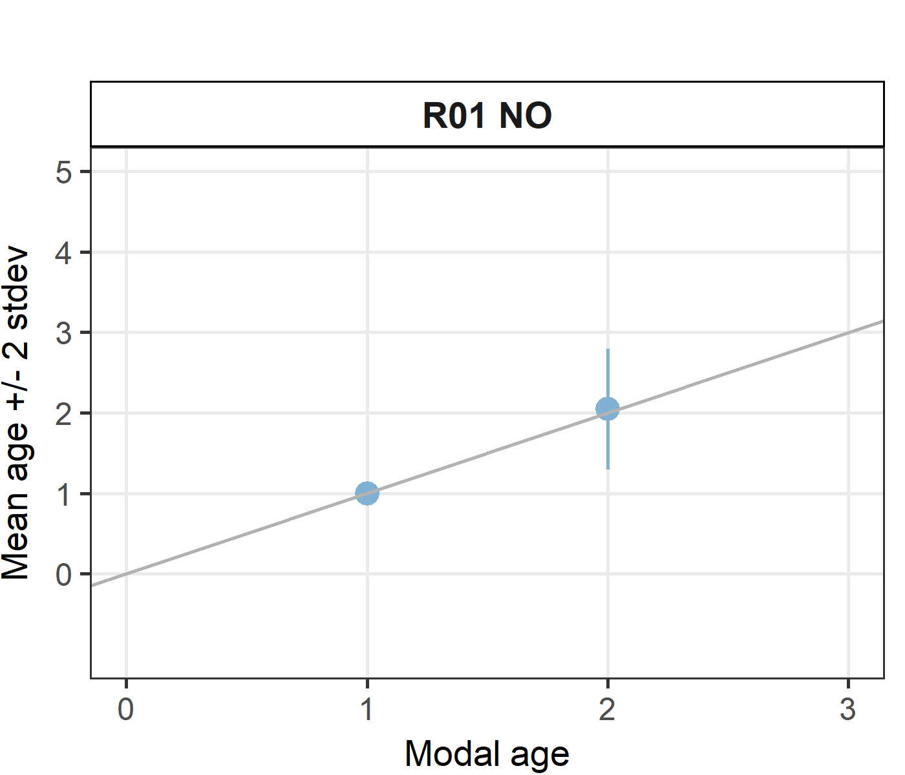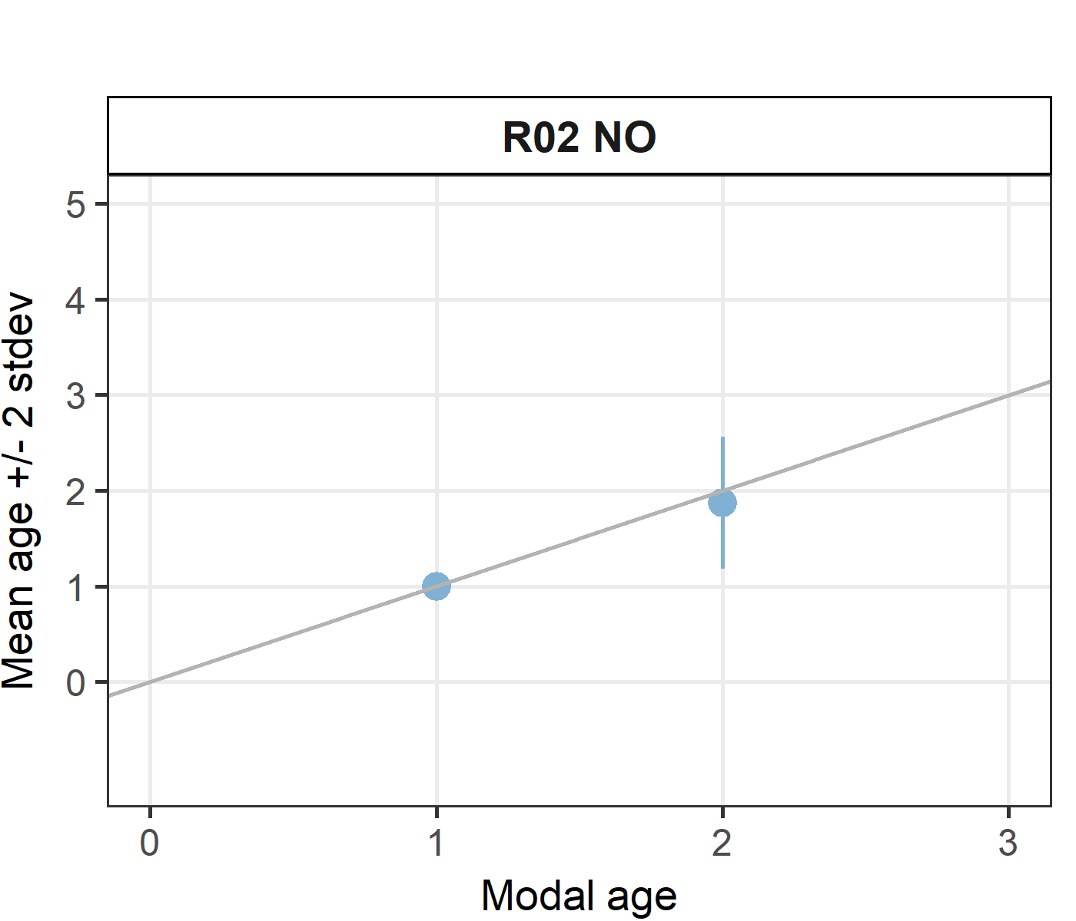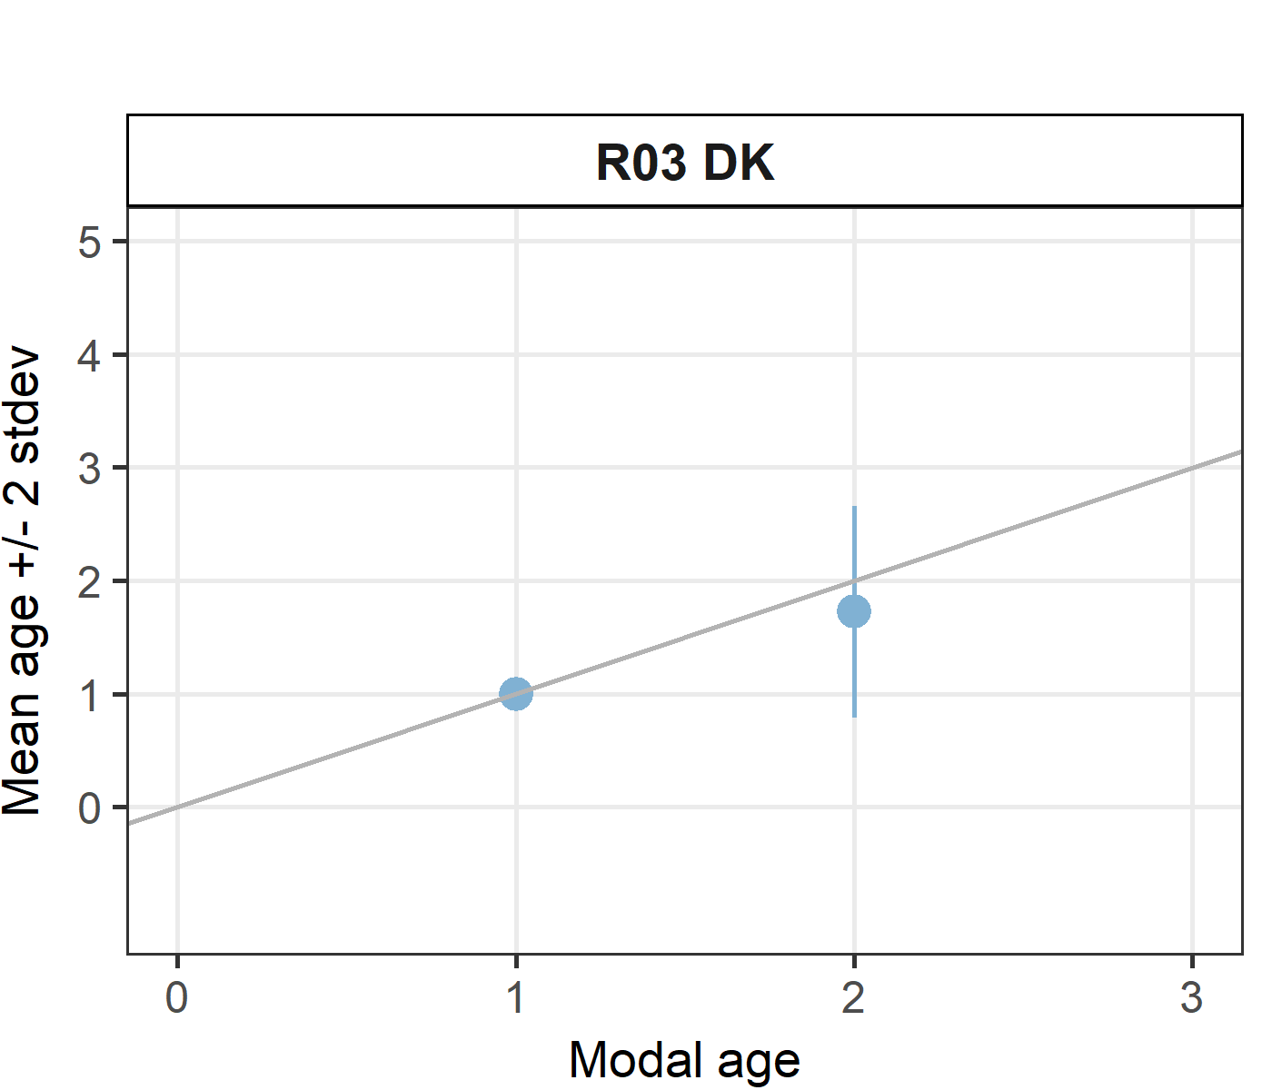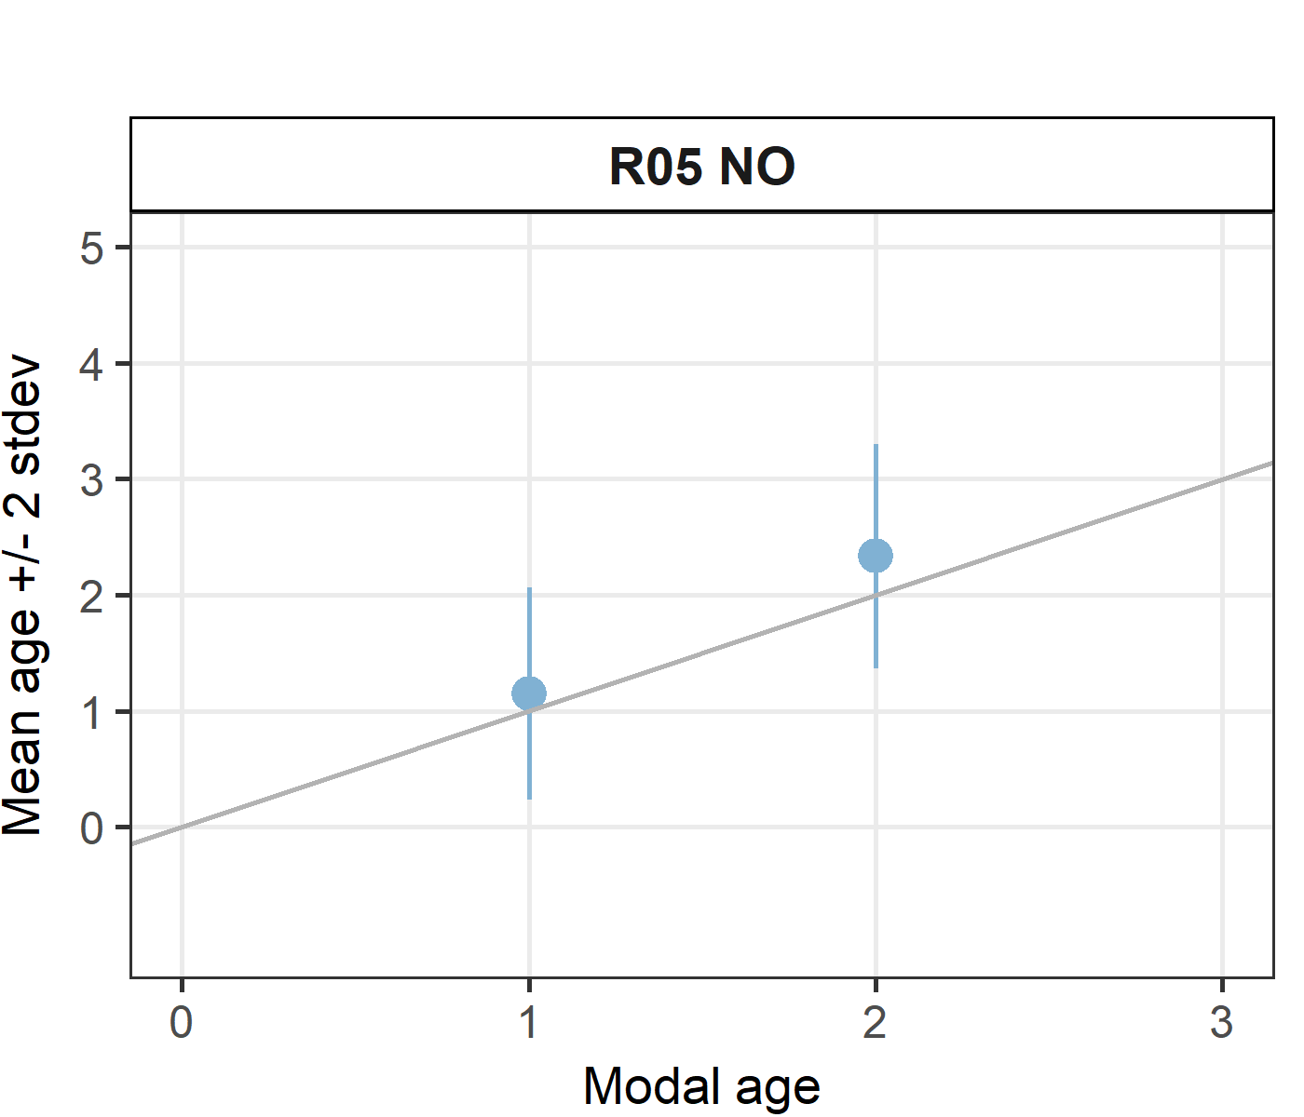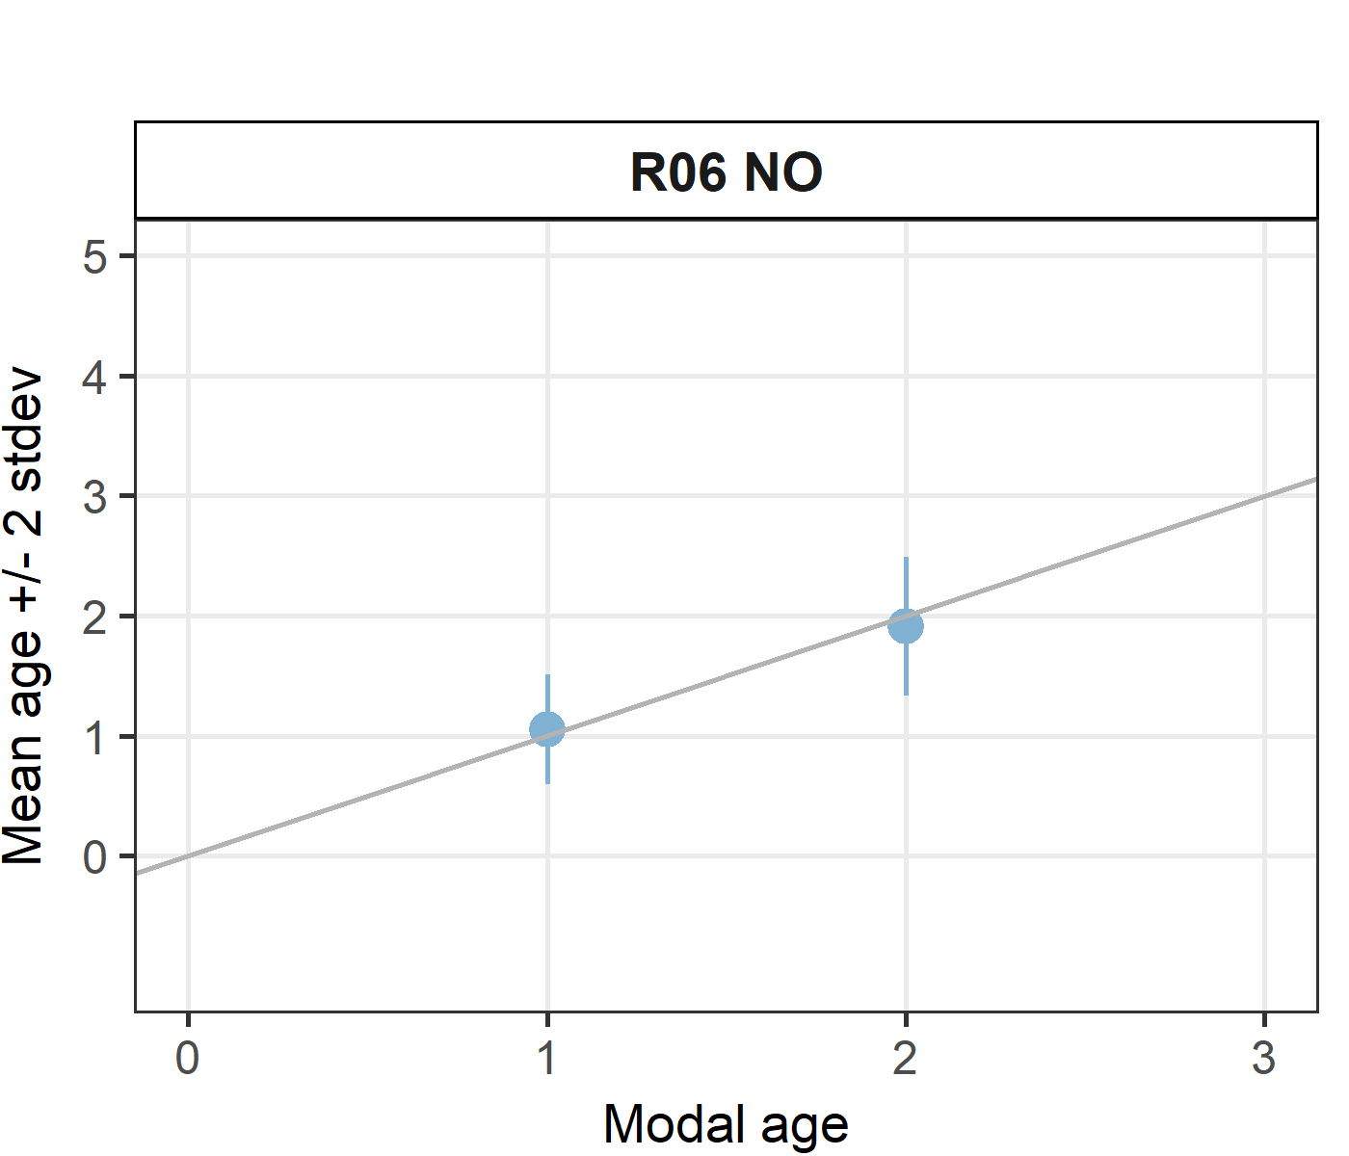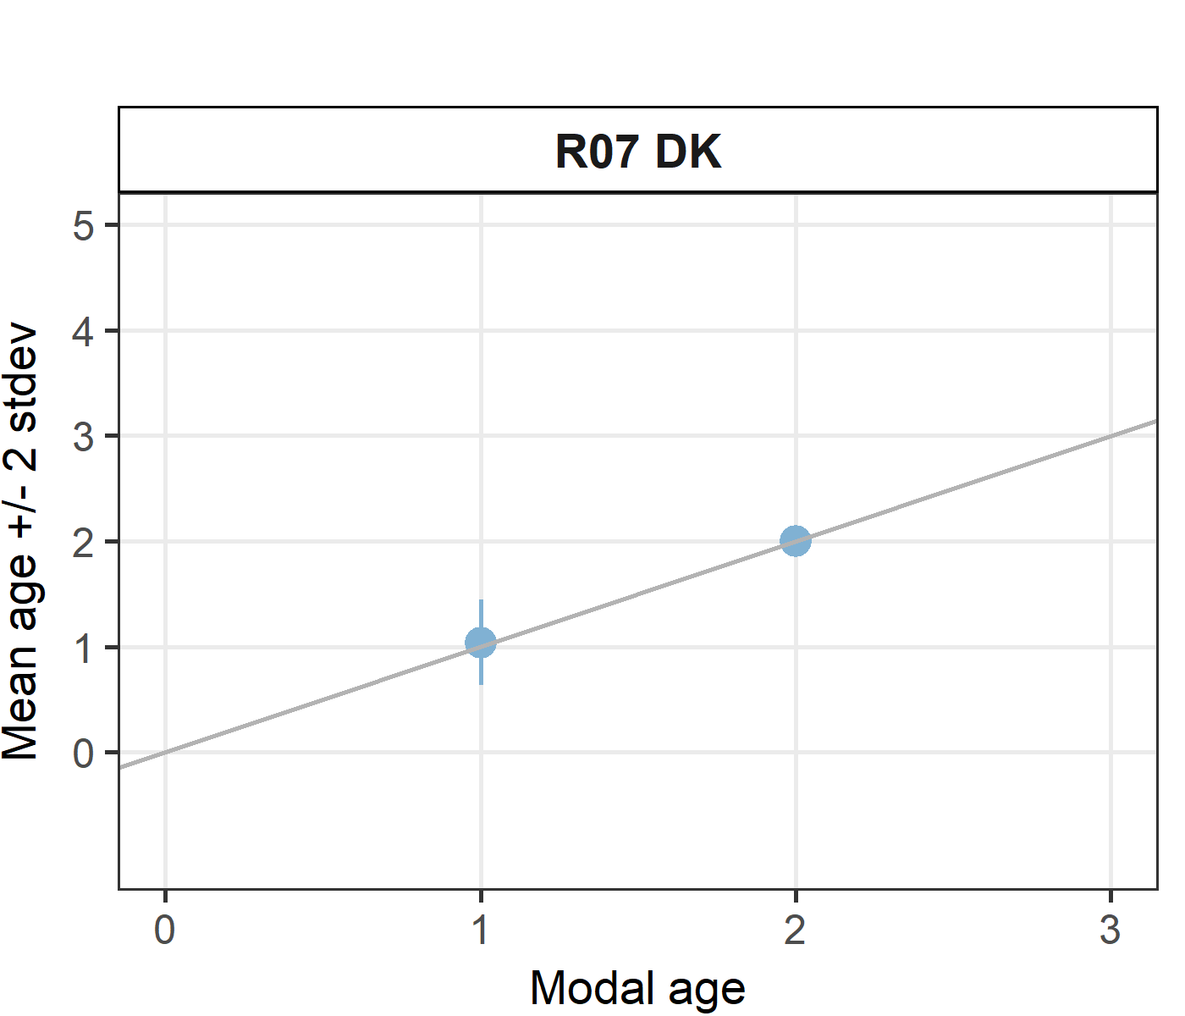

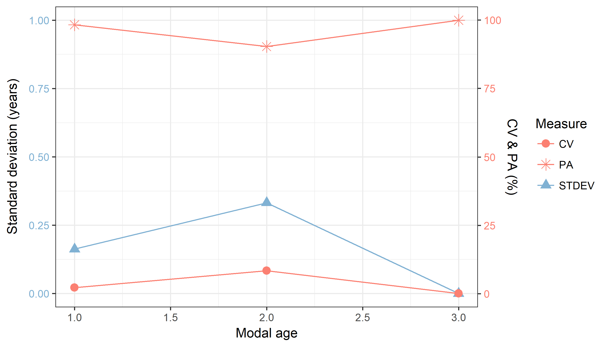

**Figure X:** CV, PA and (STDEV (standard deviation) are plotted against modal age

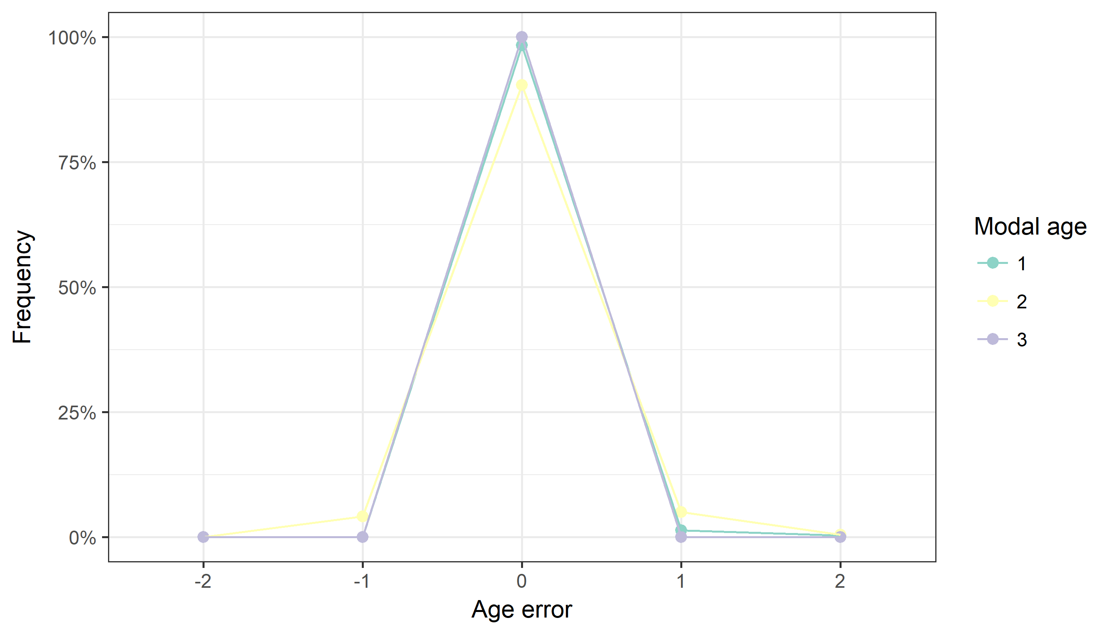

**Figure X:** The distribution of the age reading errors in percentage by modal age as observed from the advanced age readers in an age reading comparison to modal age. The achieved precision in age reading by modal age group is shown by the spread of the age readings errors. There appears to be no relative bias, if the age reading errors are normally distributed. The distributions are skewed, if relative bias occurs.

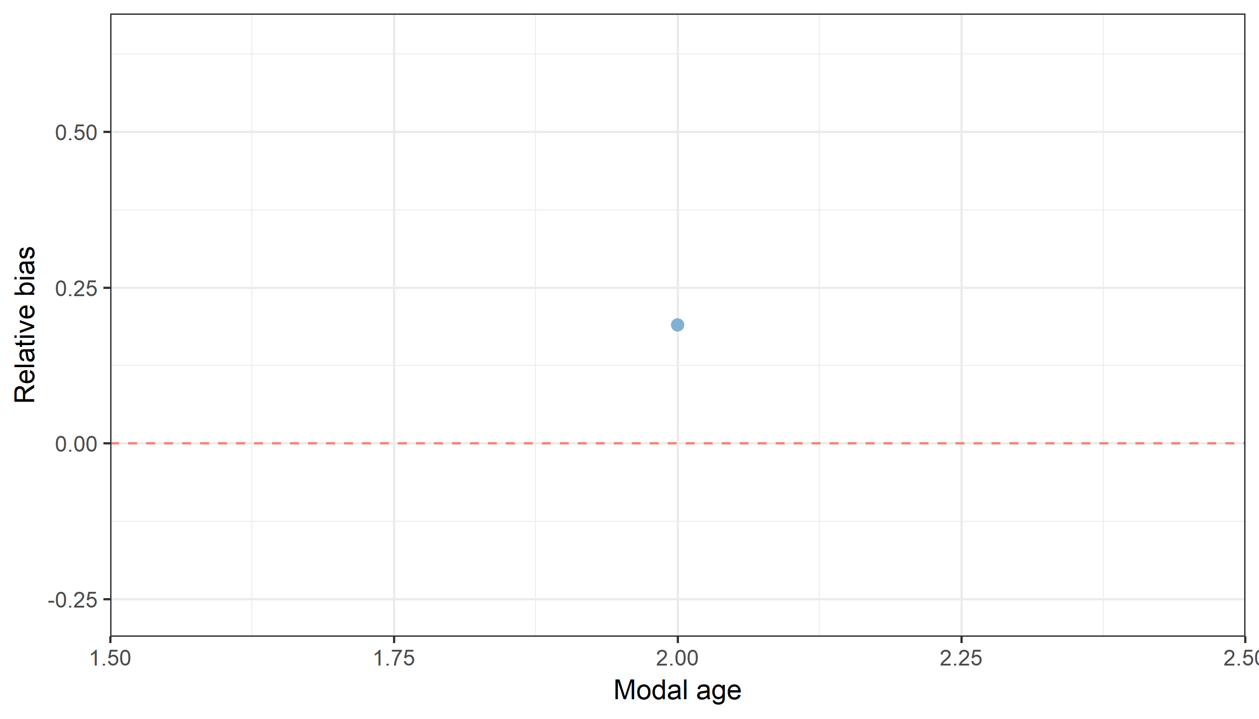

**Figure X:** The relative bias by modal age as estimated by all age readers combined.

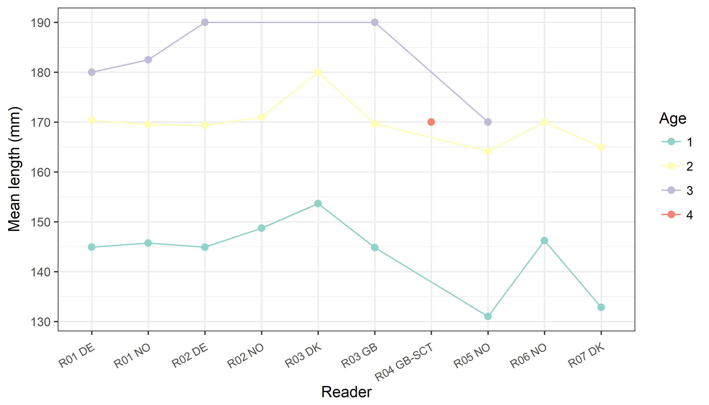

**Figure X:** The mean length at age as estimated by each age reader only including advanced readers.

# Annex 4. ToRs for next meeting

# Annex 5. Recommendations

# Annex 6. Report specific annexes