Otolith Exchange Analysis for Sprat in Area 3A

Table of Contents

# Executive summary

# Terms of reference

# Agenda and participant list

The agenda can be found in Annex 1 and the list of participants in Annex 2.

# Introduction

This part should include a background to the species, the workshop/exchange and what to expect to read about in the report.

# Methods

This report contains statistical analyses and comparisons of age readings in the form of tables and graphical plots.

First, an overview of participating age readers and the samples are presented.

Before each table or plot there is a short explanation of it. This text is thought as a help to understand the tables/plot and can just be deleted in the final output report. The document can be edited just like any other .docx file. New text can be added, additional pictures can be included and the tables edited. If some tables which are presently in the annexes need to be moved to the body of the report this is also possible. Only the plots cannot be changed.

In the first part of analysis are presented the tables and plots from the Guus Eltink Excel sheet ‘Age Reading Comparisons’ **(Eltink, A.T.G.W. 2000)**. The order and numbering of tables and plots are the same as in the excel sheet. Tables 6.1 - 6.4 from the ‘Age Reading Comparisons’ sheet are not outputted since these are merely used to do calculations for the other tables.

**Pecentage Agreement**

In here will go some text and an equation.

**Co-efficient of Variation (CV)**

The table presents the cv per modal age and reader. The cv’s are calculated as the ratio between the standard deviation (σ) and mean value (μ) per reader and modal age:

$$CV=\frac{σ}{μ}⋅100\%$$

To the table is also added the CV of all readers combined per modal age and a weighted mean of the CV per reader. Finally a rank value is added per reader, where the reader with the lowest weighted mean is assigned with a rank and so forth (in the situation of ties between two weighted means will every tied element be assigned to the lowest rank. This is the procedure for all ties methods when assigning ranks).

**Average Percentage Error (APE)**

APE was calculated based on the method outlined by Beamish & Fournier (1981). This method is not independent of fish age and thus provides a better estimate of precision. As the calculations of both CV and APE pose problems if the mean age is close to 0, all observations for which modal age was 0 were omitted from the CV and APE calculations.

The average percentage error is calculated per image as:

$$APE=\frac{100\%}{n}\sum_{i=1}^{n}{|}\frac{a_{i}−\overline{a}}{\overline{a}}|$$

where $a_{i}$ is the age reading of reader $i$ and $\overline{a}$ is the mean of all readings from 1 to $n$.

**Age error matricx (AEM)**

Age error matrices (AEM) were produced following procedures outlined by WKSABCAL (2014) where the matrix shows the proportion of each modal age mis-aged as other ages. The sum of each row is 1, which equals 100%. The age data was analysed twice, the first time all readers were included and the second time only the “advanced” readers were included. If a reader is “advanced” then they are considered well trained and they provide ages for stock assessment or similar purposes. When the AEM is compiled for assessment purposes it uses only those readers who provide age data for the stock assessment in that specific area.

**Otolith Growth Analysis**

SmartDots provides a measure of distance between the annotations made by the readers and thus provides a measure of growth increment width. This data is used to establish growth curves for each fish and for each reader.

# Analysis of age calibration exercise (ToR?)

## Overview of samples and readers

**Table X:** Overview of samples used for the xxx exchange.

|  |  |  |  |  |
| --- | --- | --- | --- | --- |
| **ICES area** | **Year** | **Quarter** | **Length range** | **Number of samples** |
| IIIaN | 2015 | Q4 | 100-160 mm | 25 |
| IIIaN | 2016 | Q1 | 70-125 mm | 14 |
| IIIaS | 2013 | Q1 | 90-145 mm | 15 |
| IIIaS | 2014 | Q2 | 80-105 mm | 8 |
| IIIaS | 2014 | Q3 | 75 mm | 1 |
| IIIaS | 2015 | Q3 | 95-140 mm | 11 |
| IIIaS | 2015 | Q4 | 75-150 mm | 14 |
| IIIaS | 2016 | Q1 | 85-140 mm | 12 |

**Table X:** Reader overview.

|  |  |
| --- | --- |
| **Reader code** | **Expertise** |
| R01 GBR | Trainee |
| R04 SWE | Expert |
| R02 DNK | Expert |
| R10 NOR | Trainee |
| R05 NOR | Trainee |
| R12 DNK | Expert |
| R08 DEU | Trainee |
| R06 NOR | Trainee |
| R03 SWE | Expert |
| R07 IRL | Trainee |

## Results

### All readers

**All samples included**

Those writing the report put TEXT here describing the results.

The overall percentage agreement based on modal ages for all readers is 21.6%, with an overall CV of 79.7%. The APE is 15.7%.

**Table X:** Coefficient of Variation (CV) table presents the CV per modal age and reader, the CV of all readers combined per modal age and a weighted mean of the CV per reader. A rank is also assigned to each reader.

|  |  |  |  |  |  |  |  |  |  |  |  |
| --- | --- | --- | --- | --- | --- | --- | --- | --- | --- | --- | --- |
| **Modal age** | **R01 GBR** | **R02 DNK** | **R03 SWE** | **R04 SWE** | **R05 NOR** | **R06 NOR** | **R07 IRL** | **R08 DEU** | **R10 NOR** | **R12 DNK** | **All** |
| 0 | - | - | - | - | - | - | - | - | - | - | **-** |
| 1 | 41 % | 0 % | 15 % | 0 % | 18 % | 18 % | 40 % | 23 % | 26 % | 46 % | **21 %** |
| 2 | 25 % | 22 % | 29 % | 32 % | 37 % | 33 % | 37 % | 35 % | 29 % | 41 % | **22 %** |
| 3 | 18 % | 9 % | 19 % | 9 % | 20 % | 35 % | 11 % | 20 % | 26 % | 23 % | **21 %** |
| 4 | 42 % | 0 % | 12 % | 12 % | 0 % | 0 % | 0 % | 55 % | 16 % | 10 % | **28 %** |
| **Weighted Mean** | **31.6 %** | **9.4 %** | **20.2 %** | **14.0 %** | **19.8 %** | **22.5 %** | **31.4 %** | **28.8 %** | **26.1 %** | **38.1 %** | **NaN %** |
| *Rank* | *9* | *1* | *4* | *2* | *3* | *5* | *8* | *7* | *6* | *10* | ***-*** |

The percentage agreement per reader per modal age tells how large part of the readings that are equal to the modal age. The weighted mean including at the bottom of the table is weighted according to number of age readings. A rank is also assigned to each reader.

**Table X:** Percentage agreement (PA) table represents the PA per modal age and reader, the PA of all readers combined per modal age and a weighted mean of the PA per reader. A rank is also assgned to each reader.

|  |  |  |  |  |  |  |  |  |  |  |  |
| --- | --- | --- | --- | --- | --- | --- | --- | --- | --- | --- | --- |
| **Modal age** | **R01 GBR** | **R02 DNK** | **R03 SWE** | **R04 SWE** | **R05 NOR** | **R06 NOR** | **R07 IRL** | **R08 DEU** | **R10 NOR** | **R12 DNK** | **All** |
| 0 | 100 % | 100 % | 100 % | 100 % | 100 % | 100 % | 100 % | 100 % | 100 % | 50 % | **95 %** |
| 1 | 54 % | 100 % | 98 % | 100 % | 97 % | 97 % | 83 % | 95 % | 93 % | 86 % | **90 %** |
| 2 | 84 % | 79 % | 74 % | 68 % | 57 % | 14 % | 57 % | 72 % | 76 % | 68 % | **72 %** |
| 3 | 75 % | 92 % | 83 % | 92 % | 60 % | 0 % | 90 % | 67 % | 67 % | 75 % | **71 %** |
| 4 | 17 % | 100 % | 67 % | 67 % | 0 % | 0 % | 100 % | 17 % | 50 % | 83 % | **56 %** |
| **Weighted Mean** | **66.7 %** | **91.0 %** | **85.0 %** | **85.0 %** | **82.0 %** | **63.3 %** | **82.0 %** | **78.1 %** | **81.0 %** | **77.0 %** | **79.7 %** |
| *Rank* | *9* | *1* | *2* | *2* | *4* | *10* | *4* | *7* | *6* | *8* | ***-*** |

The relative bias is the difference between the mean age (per modal age per reader) and modal age. As for the previous tables, a combined bias for all readers and weighted means are calculated and finally a rank is assigned to each reader.

**Table X:** Relative bias table represents the relative bias per modal age per reader, the relative bias of all readers combined per modal age and a weighted mean of the relative bias per reader. A rank is also assigned to each reader.

|  |  |  |  |  |  |  |  |  |  |  |  |
| --- | --- | --- | --- | --- | --- | --- | --- | --- | --- | --- | --- |
| **Modal age** | **R01 GBR** | **R02 DNK** | **R03 SWE** | **R04 SWE** | **R05 NOR** | **R06 NOR** | **R07 IRL** | **R08 DEU** | **R10 NOR** | **R12 DNK** | **All** |
| 0 | 0.0 | 0.0 | 0.0 | 0.0 | 0.0 | 0.0 | 0.0 | 0.0 | 0.0 | 0.5 | **0.0** |
| 1 | 0.5 | 0.0 | 0.0 | 0.0 | 0.0 | 0.0 | 0.0 | 0.0 | 0.0 | 0.1 | **0.1** |
| 2 | -0.1 | 0.2 | 0.3 | 0.3 | -0.1 | -0.9 | -0.1 | -0.3 | 0.0 | 0.4 | **0.0** |
| 3 | -0.1 | 0.1 | 0.2 | 0.1 | -0.4 | -1.5 | -0.1 | -0.2 | 0.1 | 0.4 | **-0.1** |
| 4 | -1.5 | 0.0 | 0.3 | 0.3 | -1.0 | -2.0 | 0.0 | -1.5 | -0.5 | 0.2 | **-0.6** |
| **Weighted Mean** | **0.1** | **0.1** | **0.2** | **0.2** | **-0.1** | **-0.4** | **0.0** | **-0.3** | **0.0** | **0.3** | **0.0** |
| *Rank* | *3.0* | *4.0* | *7.0* | *6.0* | *5.0* | *10.0* | *1.0* | *8.0* | *2.0* | *9.0* | ***-*** |

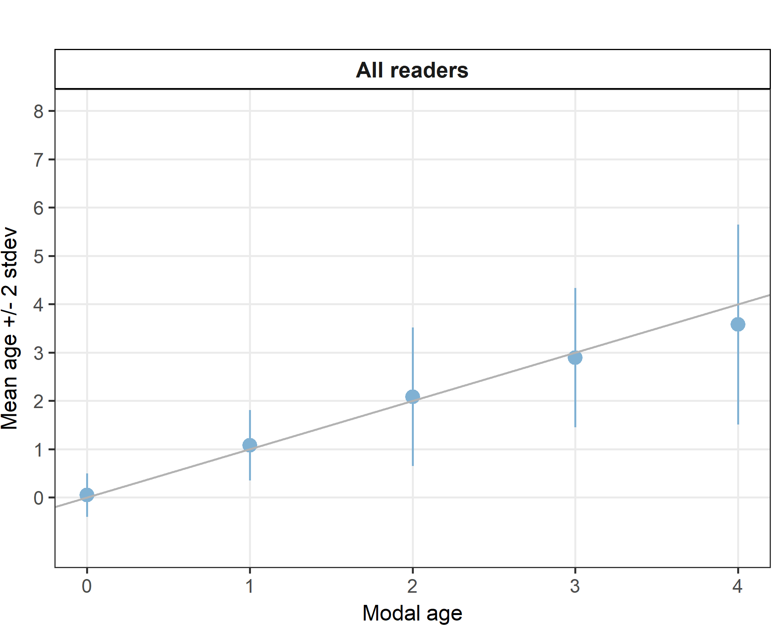

**Figure X:**: Age bias plot for all readers. Mean age recorded +/- 2 stdev of each reader and all readers combined are plotted against modal age. The estimated man age corresponds to modal age, if the estimated mean age is on the 1:1 equilibrium line (solid line). Relative bias is the age difference between estimated mean age and modal age.

For each pair that is being compared, the differences between the readings per image are found and the frequency of each occurring difference is obtained. A rank value is calculated for the positive and the negative differences (R+ and R- in the Guus Eltink sheet). The value with the smallest rank is then used to calculate a z-value that determines the level of bias (not clear from Guus Eltink sheet how the equations are defined..).

**Table X:** Inter reader bias test. The Inter-reader bias test gives probability of bias between readers and with modal age. - = no sign of bias (p>0.05), * = possibility of bias (0.01<p<0.05), * * = certainty of bias (p<0.01)

|  |  |  |  |  |  |  |  |  |  |  |
| --- | --- | --- | --- | --- | --- | --- | --- | --- | --- | --- |
| **Comparison** | **R01 GBR** | **R02 DNK** | **R03 SWE** | **R04 SWE** | **R05 NOR** | **R06 NOR** | **R07 IRL** | **R08 DEU** | **R10 NOR** | **R12 DNK** |
| **R01 GBR** | . | - | - | - | ** | ** | ** | ** | - | - |
| **R02 DNK** | - | . | - | - | ** | ** | - | ** | * | ** |
| **R03 SWE** | - | - | . | - | ** | ** | * | ** | ** | * |
| **R04 SWE** | - | - | - | . | ** | ** | * | ** | ** | * |
| **R05 NOR** | ** | ** | ** | ** | . | ** | - | - | * | ** |
| **R06 NOR** | ** | ** | ** | ** | ** | . | ** | ** | ** | ** |
| **R07 IRL** | ** | - | * | * | - | ** | . | - | - | ** |
| **R08 DEU** | ** | ** | ** | ** | - | ** | - | . | ** | ** |
| **R10 NOR** | - | * | ** | ** | * | ** | - | ** | . | ** |
| **R12 DNK** | - | ** | * | * | ** | ** | ** | ** | ** | . |
| **Modal age** | - | ** | ** | ** | - | ** | - | ** | - | ** |

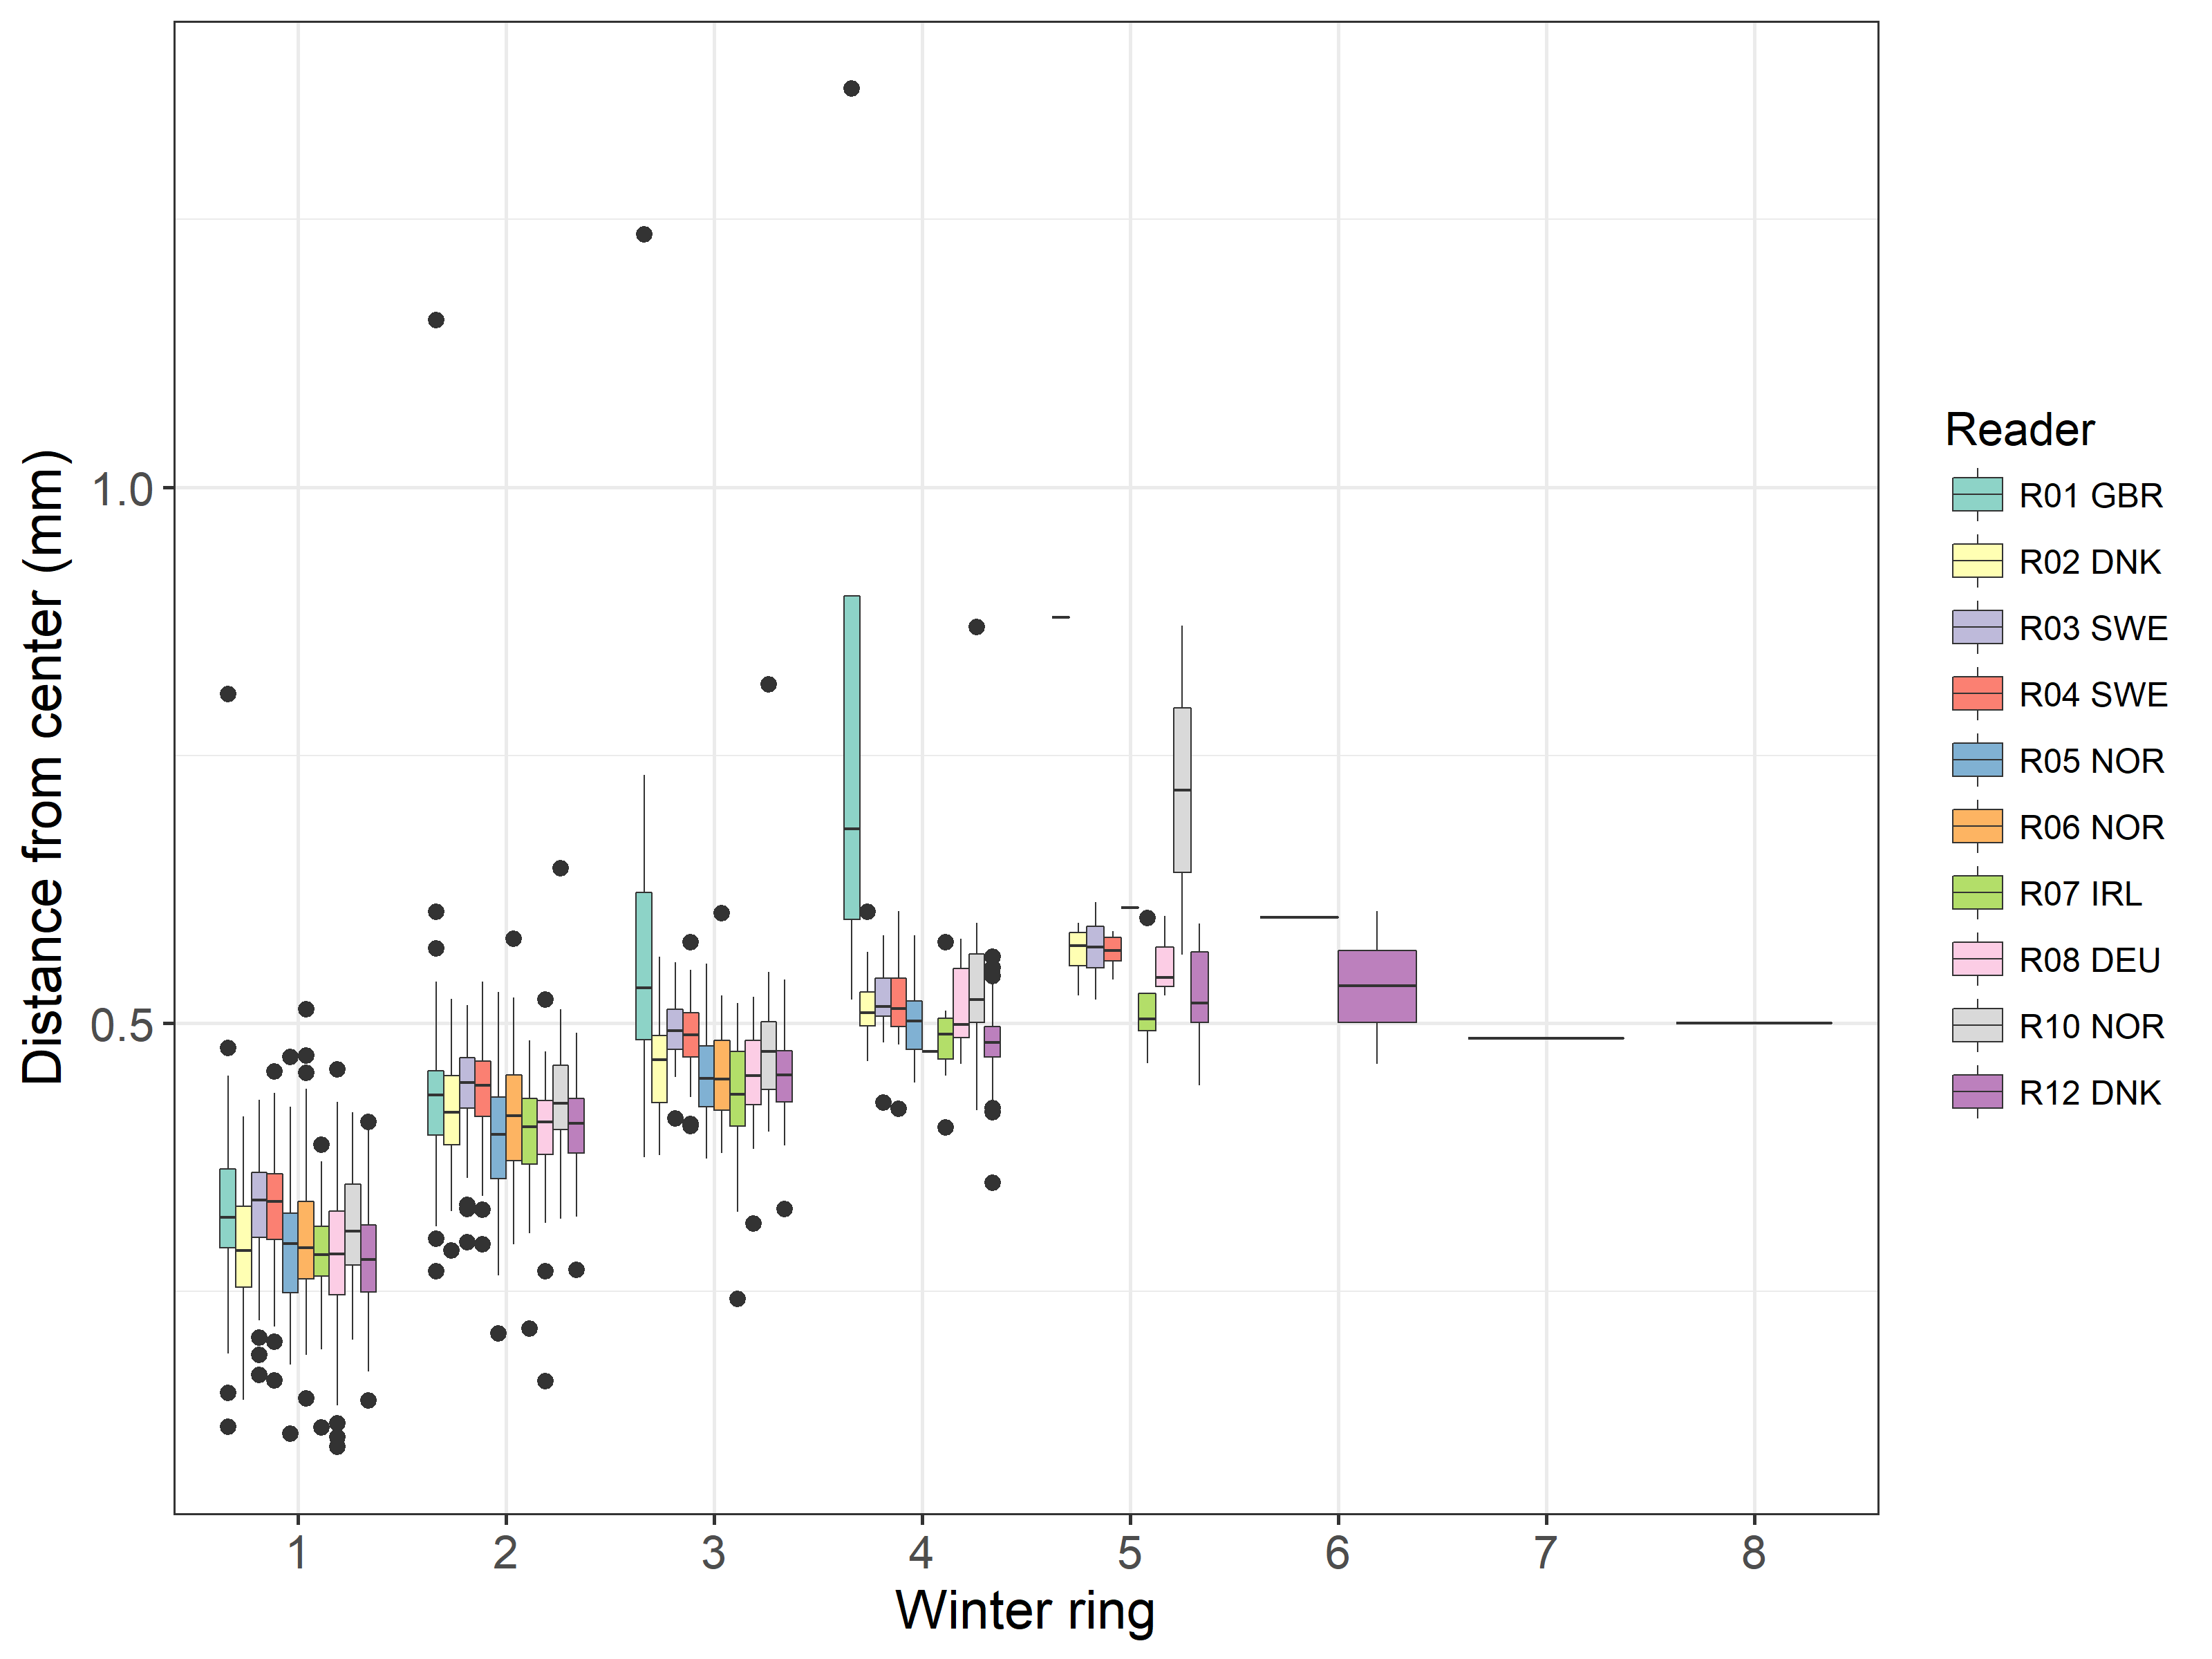

**Table X:** Plot of average distance from the centre to the winter rings for all readers. The boxes represent the mean, upper and lower box boundaries of the interquartile range, whiskers represent the minimum and maximum values and the dots represent the outliers.

**Results by area (or stock?)**

**Table X:** Number of age readings per strata. (area or stock?)

|  |  |  |  |
| --- | --- | --- | --- |
| **Modal age** | **IIIaN** | **IIIaS** | **Total** |
| 0 | 0 | 2 | **2** |
| 1 | 14 | 28 | **42** |
| 2 | 21 | 17 | **38** |
| 3 | 1 | 11 | **12** |
| 4 | 3 | 3 | **6** |
| **Total** | **39** | **61** | **100** |
| *Total %* | *39%* | *61%* | ***100%*** |

**Table X:** CV per strata. (area or stock?)

|  |  |  |  |
| --- | --- | --- | --- |
| **Modal age** | **IIIaN** | **IIIaS** | **All** |
| 0 | - | - | **-** |
| 1 | 14 % | 24 % | **21 %** |
| 2 | 19 % | 26 % | **22 %** |
| 3 | 12 % | 22 % | **21 %** |
| 4 | 28 % | 28 % | **28 %** |
| **Weighted Mean** | **18 %** | **23 %** | **21 %** |

**Table X:** Percentage Agreement per strata. (area or stock?)

|  |
| --- |
| NA |
| NA |

**Table X:** Relative Bias per strata. (area or stock?)

|  |  |  |  |
| --- | --- | --- | --- |
| **Modal age** | **IIIaN** | **IIIaS** | **Mean bias** |
| 0 | - | 0.0 | **0.0** |
| 1 | 0.1 | 0.1 | **0.1** |
| 2 | 0.0 | 0.2 | **0.1** |
| 3 | 0.1 | -0.1 | **-0.1** |
| 4 | -0.7 | -0.2 | **-0.4** |
| **Weighted Mean** | **0.0** | **0.1** | **0.0** |

**Results by month**

**Table X:** Number of age readings per month.

|  |  |  |  |  |  |  |  |  |  |  |  |  |  |
| --- | --- | --- | --- | --- | --- | --- | --- | --- | --- | --- | --- | --- | --- |
| **Modal age** | **Jan** | **Feb** | **Mar** | **Apr** | **May** | **Jun** | **Jul** | **Aug** | **Sep** | **Oct** | **Nov** | **Dec** | **Total** |
| 0 | 0 | - | - | - | - | 0 | 0 | 0 | 0 | 0 | - | 2 | **2** |
| 1 | 3 | - | - | - | - | 8 | 1 | 1 | 5 | 18 | - | 6 | **42** |
| 2 | 26 | - | - | - | - | 0 | 0 | 2 | 2 | 8 | - | 0 | **38** |
| 3 | 9 | - | - | - | - | 0 | 0 | 0 | 1 | 2 | - | 0 | **12** |
| 4 | 3 | - | - | - | - | 0 | 0 | 0 | 0 | 3 | - | 0 | **6** |
| **Total** | **41** | **0** | **0** | **0** | **0** | **8** | **1** | **3** | **8** | **31** | **0** | **8** | **100** |
| *Total %* | *41%* | *0%* | *0%* | *0%* | *0%* | *8%* | *1%* | *3%* | *8%* | *31%* | *0%* | *8%* | ***100%*** |

**Table X:** CV per month.

|  |  |  |  |  |  |  |  |  |  |  |  |  |  |
| --- | --- | --- | --- | --- | --- | --- | --- | --- | --- | --- | --- | --- | --- |
| **Modal age** | **Jan** | **Feb** | **Mar** | **Apr** | **May** | **Jun** | **Jul** | **Aug** | **Sep** | **Oct** | **Nov** | **Dec** | **All** |
| 0 | - | - | - | - | - | - | - | - | - | - | - | - | **-** |
| 1 | 12 % | - | - | - | - | 31 % | 96 % | 59 % | 14 % | 15 % | - | 15 % | **21 %** |
| 2 | 17 % | - | - | - | - | - | - | 30 % | 34 % | 32 % | - | - | **22 %** |
| 3 | 20 % | - | - | - | - | - | - | - | 29 % | 23 % | - | - | **21 %** |
| 4 | 28 % | - | - | - | - | - | - | - | - | 28 % | - | - | **28 %** |
| **Weighted Mean** | **18 %** | **-** | **-** | **-** | **-** | **31 %** | **96 %** | **39 %** | **21 %** | **21 %** | **-** | **11 %** | **21 %** |

**Table X:** Percentage agreement per month.

|  |
| --- |
| NA |
| NA |

**Table X:** Relative bias per month.

|  |  |  |  |  |  |  |  |  |  |  |  |  |  |
| --- | --- | --- | --- | --- | --- | --- | --- | --- | --- | --- | --- | --- | --- |
| **Modal age** | **Jan** | **Feb** | **Mar** | **Apr** | **May** | **Jun** | **Jul** | **Aug** | **Sep** | **Oct** | **Nov** | **Dec** | **Mean bias** |
| 0 | - | - | - | - | - | - | - | - | - | - | - | 0 | **0.0** |
| 1 | 0.1 | - | - | - | - | 0.1 | -0.3 | 0.3 | 0.1 | 0.1 | - | 0 | **0.1** |
| 2 | 0.2 | - | - | - | - | - | - | -0.4 | -0.1 | 0.0 | - | - | **0.1** |
| 3 | -0.1 | - | - | - | - | - | - | - | -0.6 | 0.4 | - | - | **-0.1** |
| 4 | -0.2 | - | - | - | - | - | - | - | - | -0.7 | - | - | **-0.4** |
| **Weighted Mean** | **0.1** | **-** | **-** | **-** | **-** | **0.1** | **-0.3** | **-0.1** | **0.0** | **0.0** | **-** | **0** | **0.0** |

### Advanced readers

**All samples included**

**Table X:** Coefficient of Variation (CV) table presents the CV per modal age and advanced reader, the CV of all advanced readers combined per modal age and a weighted mean of the CV per reader. A rank is also assigned to each reader.

|  |  |  |  |  |  |
| --- | --- | --- | --- | --- | --- |
| **Modal age** | **R02 DNK** | **R03 SWE** | **R04 SWE** | **R12 DNK** | **All** |
| 0 | - | - | - | - | **-** |
| 1 | 0 % | 15 % | 0 % | 46 % | **7 %** |
| 2 | 0 % | 13 % | 19 % | 16 % | **7 %** |
| 3 | 8 % | 14 % | 15 % | 18 % | **8 %** |
| 4 | 10 % | 9 % | 9 % | 26 % | **8 %** |
| 5 | 0 % | 0 % | 35 % | 0 % | **17 %** |
| **Weighted Mean** | **2.1 %** | **13.3 %** | **9.6 %** | **28.7 %** | **NaN %** |
| *Rank* | *1* | *3* | *2* | *4* | ***-*** |

**Table X:** Percentage agreement (PA) table represents the PA per modal age and reader, advanced the PA of all advanced readers combined per modal age and a weighted mean of the PA per reader. A rank is also assgned to each reader.

|  |  |  |  |  |  |
| --- | --- | --- | --- | --- | --- |
| **Modal age** | **R02 DNK** | **R03 SWE** | **R04 SWE** | **R12 DNK** | **All** |
| 0 | 100 % | 100 % | 100 % | 50 % | **88 %** |
| 1 | 100 % | 98 % | 100 % | 86 % | **96 %** |
| 2 | 100 % | 93 % | 86 % | 90 % | **92 %** |
| 3 | 94 % | 83 % | 78 % | 78 % | **83 %** |
| 4 | 86 % | 86 % | 86 % | 86 % | **86 %** |
| 5 | 0 % | 100 % | 50 % | 100 % | **63 %** |
| **Weighted Mean** | **96.0 %** | **93.0 %** | **90.0 %** | **85.0 %** | **91.0 %** |
| *Rank* | *1* | *2* | *3* | *4* | ***-*** |

**Table X:** Relative bias table represents the relative bias per modal age and advanced reader, the relative bias of all advanced readers combined per modal age and a weighted mean of the relative bias per reader. A rank is also assigned to each reader.

|  |  |  |  |  |  |
| --- | --- | --- | --- | --- | --- |
| **Modal age** | **R02 DNK** | **R03 SWE** | **R04 SWE** | **R12 DNK** | **All** |
| 0 | 0.0 | 0.0 | 0.0 | 0.5 | **0.1** |
| 1 | 0.0 | 0.0 | 0.0 | 0.1 | **0.0** |
| 2 | 0.0 | 0.0 | 0.0 | 0.0 | **0.0** |
| 3 | -0.1 | 0.1 | 0.1 | 0.3 | **0.1** |
| 4 | -0.1 | 0.1 | 0.1 | 0.4 | **0.1** |
| 5 | -1.0 | 0.0 | -1.0 | 0.0 | **-0.5** |
| **Weighted Mean** | **0.0** | **0.0** | **0.0** | **0.2** | **0.0** |
| *Rank* | *3.0* | *2.0* | *1.0* | *4.0* | ***-*** |

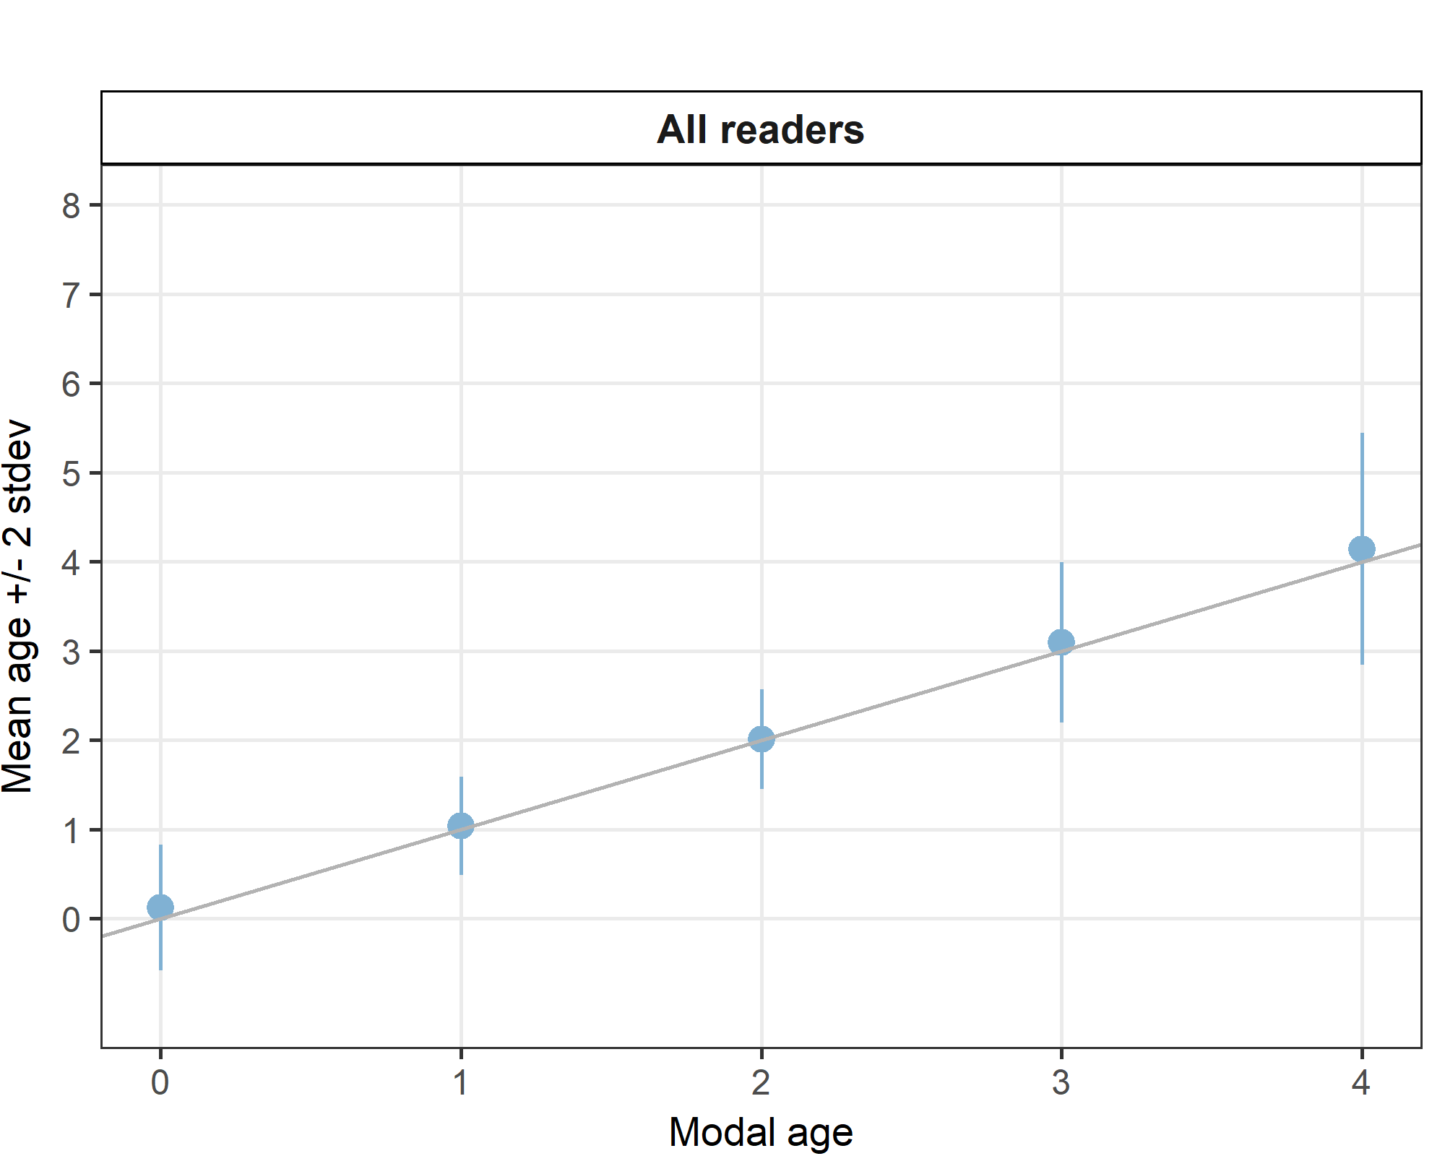

**Figure X:** Age bias plot for advanced readers.

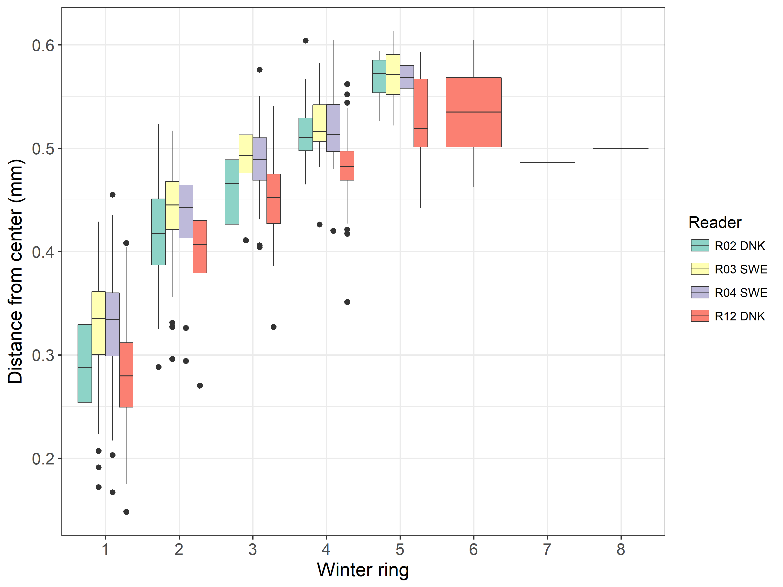

**Results by area (or stock)**

**Table X:** Number of age readings per strata for advanced readers.

|  |  |  |  |
| --- | --- | --- | --- |
| **Modal age** | **IIIaN** | **IIIaS** | **Total** |
| 0 | 0 | 2 | **2** |
| 1 | 14 | 28 | **42** |
| 2 | 19 | 10 | **29** |
| 3 | 3 | 15 | **18** |
| 4 | 3 | 4 | **7** |
| 5 | 0 | 2 | **2** |
| **Total** | **39** | **61** | **100** |
| *Total %* | *39%* | *61%* | ***100%*** |

**Table X:** CV per strata.

|  |  |  |  |
| --- | --- | --- | --- |
| **Modal age** | **IIIaN** | **IIIaS** | **All** |
| 0 | - | - | **-** |
| 1 | 4 % | 9 % | **7 %** |
| 2 | 7 % | 8 % | **7 %** |
| 3 | 18 % | 7 % | **8 %** |
| 4 | 0 % | 15 % | **8 %** |
| 5 | - | 17 % | **17 %** |
| **Weighted Mean** | **6 %** | **9 %** | **8 %** |

**Table X:** Percentage Agreement per strata.

|  |
| --- |
| NA |
| NA |

**Table X:** Relative Bias per strata.

|  |  |  |  |
| --- | --- | --- | --- |
| **Modal age** | **IIIaN** | **IIIaS** | **Mean bias** |
| 0 | - | 0.1 | **0.1** |
| 1 | 0 | 0.0 | **0.0** |
| 2 | 0 | 0.0 | **0.0** |
| 3 | 0 | 0.1 | **0.1** |
| 4 | 0 | 0.2 | **0.1** |
| 5 | - | -0.5 | **-0.5** |
| **Weighted Mean** | **0** | **0.0** | **0.0** |

Age error matrices are calculated per area and only based on the age readings of the advanced readers.

**Table X:** Age error matrix (AEM) for area IIIaS. The AEM shows the proportional distribution of age readings for each modal age. Age column should sum to one but due to rounding there might be small deviations in some cases. Only advanced readers are used. Only advanced readers are used for calculating the AEM.

|  |  |  |  |  |  |  |  |  |
| --- | --- | --- | --- | --- | --- | --- | --- | --- |
| **Modal age** | **0** | **1** | **2** | **3** | **4** | **5** | **6** | **7** |
| **Age 0** | 0.9 | 0 | - | - | - | - | - | - |
| **Age 1** | 0.1 | 1 | 0.0 | - | - | - | - | - |
| **Age 2** | - | 0 | 0.9 | 0.0 | - | - | - | - |
| **Age 3** | - | 0 | 0.0 | 0.9 | 0.1 | 0.1 | - | - |
| **Age 4** | - | - | - | 0.1 | 0.8 | 0.2 | - | - |
| **Age 5** | - | - | - | 0.0 | 0.1 | 0.6 | - | - |
| **Age 6** | - | - | - | - | - | - | - | - |
| **Age 7** | - | - | - | - | 0.1 | - | - | - |

**Table X:** Age error matrix (AEM) for area IIIaN. The AEM shows the proportional distribution of age readings for each modal age. Age column should sum to one but due to rounding there might be small deviations in some cases. Only advanced readers are used. Only advanced readers are used for calculating the AEM.

|  |  |  |  |  |  |
| --- | --- | --- | --- | --- | --- |
| **Modal age** | **0** | **1** | **2** | **3** | **4** |
| **Age 0** | - | - | - | - | - |
| **Age 1** | - | 1 | 0.0 | - | - |
| **Age 2** | - | 0 | 0.9 | 0.2 | - |
| **Age 3** | - | 0 | 0.0 | 0.7 | - |
| **Age 4** | - | - | - | 0.2 | 1 |

**Results by month**

**Table X:** Number of age readings per month for advanced readers.

|  |  |  |  |  |  |  |  |  |  |  |  |  |  |
| --- | --- | --- | --- | --- | --- | --- | --- | --- | --- | --- | --- | --- | --- |
| **Modal age** | **Jan** | **Feb** | **Mar** | **Apr** | **May** | **Jun** | **Jul** | **Aug** | **Sep** | **Oct** | **Nov** | **Dec** | **Total** |
| 0 | 0 | - | - | - | - | 0 | 0 | 0 | 0 | 0 | - | 2 | **2** |
| 1 | 3 | - | - | - | - | 8 | 1 | 1 | 5 | 18 | - | 6 | **42** |
| 2 | 20 | - | - | - | - | 0 | 0 | 2 | 1 | 6 | - | 0 | **29** |
| 3 | 12 | - | - | - | - | 0 | 0 | 0 | 2 | 4 | - | 0 | **18** |
| 4 | 4 | - | - | - | - | 0 | 0 | 0 | 0 | 3 | - | 0 | **7** |
| 5 | 2 | - | - | - | - | 0 | 0 | 0 | 0 | 0 | - | 0 | **2** |
| **Total** | **41** | **0** | **0** | **0** | **0** | **8** | **1** | **3** | **8** | **31** | **0** | **8** | **100** |
| *Total %* | *41%* | *0%* | *0%* | *0%* | *0%* | *8%* | *1%* | *3%* | *8%* | *31%* | *0%* | *8%* | ***100%*** |

**Table X:** CV per month.

|  |  |  |  |  |  |  |  |  |  |  |  |  |  |
| --- | --- | --- | --- | --- | --- | --- | --- | --- | --- | --- | --- | --- | --- |
| **Modal age** | **Jan** | **Feb** | **Mar** | **Apr** | **May** | **Jun** | **Jul** | **Aug** | **Sep** | **Oct** | **Nov** | **Dec** | **All** |
| 0 | - | - | - | - | - | - | - | - | - | - | - | - | **-** |
| 1 | 0 % | - | - | - | - | 8 % | 67 % | 0 % | 8 % | 5 % | - | 7 % | **7 %** |
| 2 | 6 % | - | - | - | - | - | - | 19 % | 0 % | 7 % | - | - | **7 %** |
| 3 | 6 % | - | - | - | - | - | - | - | 0 % | 20 % | - | - | **8 %** |
| 4 | 15 % | - | - | - | - | - | - | - | - | 0 % | - | - | **8 %** |
| 5 | 17 % | - | - | - | - | - | - | - | - | - | - | - | **17 %** |
| **Weighted Mean** | **7 %** | **-** | **-** | **-** | **-** | **8 %** | **67 %** | **13 %** | **5 %** | **7 %** | **-** | **5 %** | **8 %** |

**Table X:** Percentage agreement per month.

|  |
| --- |
| NA |
| NA |

**Table X:** Relative bias per month.

|  |  |  |  |  |  |  |  |  |  |  |  |  |  |
| --- | --- | --- | --- | --- | --- | --- | --- | --- | --- | --- | --- | --- | --- |
| **Modal age** | **Jan** | **Feb** | **Mar** | **Apr** | **May** | **Jun** | **Jul** | **Aug** | **Sep** | **Oct** | **Nov** | **Dec** | **Mean bias** |
| 0 | - | - | - | - | - | - | - | - | - | - | - | 0.1 | **0.1** |
| 1 | 0.0 | - | - | - | - | 0.1 | -0.2 | 0.0 | 0 | 0.1 | - | 0.0 | **0.0** |
| 2 | 0.0 | - | - | - | - | - | - | -0.2 | 0 | 0.1 | - | - | **0.0** |
| 3 | 0.1 | - | - | - | - | - | - | - | 0 | 0.2 | - | - | **0.1** |
| 4 | 0.2 | - | - | - | - | - | - | - | - | 0.0 | - | - | **0.1** |
| 5 | -0.5 | - | - | - | - | - | - | - | - | - | - | - | **-0.5** |
| **Weighted Mean** | **0.0** | **-** | **-** | **-** | **-** | **0.1** | **-0.2** | **-0.2** | **0** | **0.1** | **-** | **0.1** | **0.0** |

## Discussion

## Conclusion

# Other ToRs

# References

# Annex 1. Agenda

# Annex 2. List of participants

**Table X:** Participants list.

|  |  |  |  |
| --- | --- | --- | --- |
| **Reader code** | **Institution** | **Country** | **Expertise** |
| R01 GBR | The Agri-Food & Biosciences Institute (UK) | United Kingdom | Trainee |
| R04 SWE | Swedish Board of Fisheries (Sweden) | Sweden | Expert |
| R02 DNK | DTU Aqua | Denmark | Expert |
| R10 NOR | Institute of Marine Research (Norway) | Norway | Trainee |
| R05 NOR | Institute of Marine Research (Norway) | Norway | Trainee |
| R12 DNK | Reykjavik | Denmark | Expert |
| R08 DEU | Johann Heinrich von ThÃ¼nen Institute (Germany) | Germany | Trainee |
| R06 NOR | Institute of Marine Research (Norway) | Norway | Trainee |
| R03 SWE | Swedish Board of Fisheries (Sweden) | Sweden | Expert |
| R07 IRL | Guest | Ireland | Trainee |

# Annex 3. Additional results

## Results all readers

**Data Overview**

**Table X:** Summary of statistics; PA (%), CV (%) and APE (%).

|  |  |  |
| --- | --- | --- |
| **Mean CV %** | **Mean PA %** | **Mean APE %** |
| 79.7 | 21.6 | 15.7 |

**Table X:** Data overview including modal age and statistics per sample.

|  |  |  |  |  |  |  |  |  |  |  |  |  |  |  |  |  |  |  |
| --- | --- | --- | --- | --- | --- | --- | --- | --- | --- | --- | --- | --- | --- | --- | --- | --- | --- | --- |
| **Sample** | **Length (mm)** | **Sex** | **Catch date** | **ICES area** | **R01 GBR** | **R02 DNK** | **R03 SWE** | **R04 SWE** | **R05 NOR** | **R06 NOR** | **R07 IRL** | **R08 DEU** | **R10 NOR** | **R12 DNK** | **Modal age** | **PA %** | **CV %** | **APE %** |
| 6698256.jpg | 89 | U | 18/01/2013 | IIIaS | 1 | 1 | 1 | 1 | 1 | - | 2 | 1 | 2 | 1 | 1 | 78 | 36 | 28 |
| 6698257.jpg | 129 | U | 18/01/2013 | IIIaS | 3 | 3 | 3 | 3 | 2 | 1 | 3 | 3 | 3 | 3 | 3 | 80 | 25 | 18 |
| 6698258.jpg | 137 | U | 18/01/2013 | IIIaS | 3 | 3 | 3 | 3 | 2 | 1 | 3 | 3 | 3 | 3 | 3 | 80 | 25 | 18 |
| 6698259.jpg | 137 | U | 18/01/2013 | IIIaS | 2 | 3 | 3 | 3 | 1 | 1 | 2 | 2 | 2 | 3 | 2 | 40 | 36 | 29 |
| 6698260.jpg | 139 | U | 18/01/2013 | IIIaS | 3 | 3 | 3 | 3 | 3 | 2 | 3 | 3 | 3 | 3 | 3 | 90 | 11 | 6 |
| 6698261.jpg | 126 | U | 18/01/2013 | IIIaS | 3 | 3 | 3 | 3 | 2 | 2 | 3 | 3 | 3 | 3 | 3 | 80 | 15 | 11 |
| 6698262.jpg | 132 | U | 18/01/2013 | IIIaS | 3 | 4 | 5 | 3 | 3 | 1 | 2 | 3 | 4 | 5 | 3 | 40 | 38 | 29 |
| 6698263.jpg | 125 | U | 18/01/2013 | IIIaS | 2 | 3 | 3 | 3 | 3 | 2 | 3 | 3 | 3 | 3 | 3 | 80 | 15 | 11 |
| 6698264.jpg | 134 | U | 18/01/2013 | IIIaS | 2 | 3 | 4 | 4 | 2 | 1 | 3 | 2 | 3 | 4 | 2 | 30 | 37 | 30 |
| 6698268.jpg | 130 | U | 18/01/2013 | IIIaS | 3 | 4 | 4 | 4 | 3 | 2 | 4 | 3 | 4 | 4 | 4 | 60 | 20 | 17 |
| 6698269.jpg | 145 | U | 18/01/2013 | IIIaS | 2 | 4 | 4 | 4 | 3 | 1 | 2 | 2 | 3 | 7 | 2 | 30 | 53 | 39 |
| 6698270.jpg | 135 | U | 18/01/2013 | IIIaS | 2 | 2 | 3 | 3 | 2 | 2 | 2 | 2 | 2 | 4 | 2 | 70 | 29 | 23 |
| 6698280.jpg | 125 | U | 18/01/2013 | IIIaS | 2 | 3 | 4 | 4 | 2 | 1 | 2 | 2 | 4 | 3 | 2 | 40 | 39 | 33 |
| 6698281.jpg | 132 | U | 18/01/2013 | IIIaS | 3 | 3 | 3 | 3 | 3 | 2 | 3 | 2 | 3 | 3 | 3 | 80 | 15 | 11 |
| 6698282.jpg | 129 | U | 18/01/2013 | IIIaS | 3 | 3 | 3 | 3 | 3 | 2 | 3 | 3 | 3 | 3 | 3 | 90 | 11 | 6 |
| 6932318.jpg | 102 | U | 10/06/2014 | IIIaS | 1 | 1 | 1 | 1 | 1 | 1 | 1 | 1 | 1 | 1 | 1 | 100 | 0 | 0 |
| 6932319.jpg | 105 | U | 10/06/2014 | IIIaS | 2 | 1 | 1 | 1 | 1 | 1 | 1 | 1 | 1 | 1 | 1 | 90 | 29 | 16 |
| 6932320.jpg | 85 | U | 10/06/2014 | IIIaS | 3 | 1 | 1 | 1 | 1 | 1 | 1 | 1 | 1 | 3 | 1 | 80 | 60 | 46 |
| 6932321.jpg | 87 | U | 10/06/2014 | IIIaS | 3 | 1 | 1 | 1 | 1 | 1 | 2 | 1 | 1 | 1 | 1 | 80 | 52 | 37 |
| 6932322.jpg | 90 | U | 10/06/2014 | IIIaS | 2 | 1 | 1 | 1 | 1 | 1 | 1 | 1 | 1 | 1 | 1 | 90 | 29 | 16 |
| 6932323.jpg | 80 | U | 10/06/2014 | IIIaS | 2 | 1 | 1 | 1 | 1 | 1 | 0 | 1 | 1 | 1 | 1 | 80 | 47 | 20 |
| 6932324.jpg | 84 | U | 10/06/2014 | IIIaS | 2 | 1 | 1 | 1 | 1 | 1 | 1 | 1 | 1 | 1 | 1 | 90 | 29 | 16 |
| 6932325.jpg | 81 | U | 10/06/2014 | IIIaS | 1 | 1 | 1 | 1 | 1 | 1 | 1 | 1 | 1 | 1 | 1 | 100 | 0 | 0 |
| 6941185.jpg | 75 | U | 05/07/2014 | IIIaS | 2 | 1 | 1 | 1 | 1 | 1 | 0 | 0 | 0 | 0 | 1 | 50 | 96 | 80 |
| 7187385.jpg | 149 | U | 15/10/2015 | IIIaS | 4 | 3 | 4 | 3 | 3 | 1 | 3 | 4 | 5 | 5 | 3 | 40 | 34 | 26 |
| 7187386.jpg | 120 | U | 15/10/2015 | IIIaS | 2 | 1 | 1 | 1 | 2 | 1 | 1 | 1 | 1 | 1 | 1 | 80 | 35 | 27 |
| 7187387.jpg | 116 | U | 15/10/2015 | IIIaS | 2 | 1 | 1 | 1 | 1 | 1 | 2 | 1 | 2 | 2 | 1 | 60 | 37 | 34 |
| 7187388.jpg | 110 | U | 15/10/2015 | IIIaS | 1 | 1 | 1 | 1 | 1 | 1 | 1 | 1 | 1 | 1 | 1 | 100 | 0 | 0 |
| 7187393.jpg | 107 | U | 15/10/2015 | IIIaS | 1 | 1 | 1 | 1 | 1 | 1 | 1 | 1 | 1 | 1 | 1 | 100 | 0 | 0 |
| 7187394.jpg | 100 | U | 15/10/2015 | IIIaS | 1 | 1 | 1 | 1 | 1 | 1 | 1 | 1 | 1 | 1 | 1 | 100 | 0 | 0 |
| 7188165.jpg | 100 | U | 20/10/2015 | IIIaN | 2 | 1 | 1 | 1 | 1 | 1 | 1 | 1 | 1 | 1 | 1 | 90 | 29 | 16 |
| 7188166.jpg | 106 | U | 20/10/2015 | IIIaN | 1 | 1 | 1 | 1 | 1 | 1 | 1 | 1 | 1 | 1 | 1 | 100 | 0 | 0 |
| 7188167.jpg | 110 | U | 20/10/2015 | IIIaN | 1 | 1 | 1 | 1 | 1 | 1 | 1 | 1 | 1 | 1 | 1 | 100 | 0 | 0 |
| 7188168.jpg | 115 | U | 20/10/2015 | IIIaN | 2 | 1 | 1 | 1 | 1 | 1 | 1 | 1 | 1 | 1 | 1 | 90 | 29 | 16 |
| 7188169.jpg | 120 | U | 20/10/2015 | IIIaN | 2 | 1 | 1 | 1 | 1 | 1 | 1 | 1 | 1 | 1 | 1 | 90 | 29 | 16 |
| 7188170.jpg | 127 | U | 20/10/2015 | IIIaN | 2 | 1 | 2 | 1 | - | 1 | 1 | - | 1 | 3 | 1 | 63 | 50 | 42 |
| 7188171.jpg | 103 | U | 20/10/2015 | IIIaN | 1 | 1 | 1 | 1 | 1 | 1 | 1 | 1 | 1 | 1 | 1 | 100 | 0 | 0 |
| 7188172.jpg | 106 | U | 20/10/2015 | IIIaN | 1 | 1 | 1 | 1 | 1 | 1 | 1 | 1 | 1 | 1 | 1 | 100 | 0 | 0 |
| 7188173.jpg | 110 | U | 20/10/2015 | IIIaN | 2 | 1 | 1 | 1 | 1 | 1 | 1 | 1 | 1 | 1 | 1 | 90 | 29 | 16 |
| 7188174.jpg | 115 | U | 20/10/2015 | IIIaN | 2 | 1 | 1 | 1 | 1 | - | 1 | 1 | 1 | 1 | 1 | 89 | 30 | 18 |
| 7190462.jpg | 138 | U | 24/09/2015 | IIIaS | 2 | 3 | 3 | 3 | 2 | 1 | 1 | 2 | 2 | 3 | 2 | 40 | 36 | 29 |
| 7190468.jpg | 110 | U | 24/09/2015 | IIIaS | 1 | 1 | 1 | 1 | 1 | 1 | 1 | - | 1 | 1 | 1 | 100 | 0 | 0 |
| 7190469.jpg | 115 | U | 24/09/2015 | IIIaS | 2 | 1 | 1 | 1 | 1 | 2 | 1 | 1 | 1 | 1 | 1 | 80 | 35 | 27 |
| 7190470.jpg | 127 | U | 24/09/2015 | IIIaS | 2 | 3 | 3 | 3 | 2 | 1 | 3 | 2 | 2 | 3 | 3 | 50 | 29 | 25 |
| 7190486.jpg | 95 | U | 24/09/2015 | IIIaS | 2 | 1 | 1 | 1 | 1 | 1 | 1 | 1 | 1 | 2 | 1 | 80 | 35 | 27 |
| 7190487.jpg | 130 | U | 24/09/2015 | IIIaS | 2 | 2 | 2 | 2 | 1 | 1 | 1 | 2 | 1 | 2 | 2 | 60 | 32 | 30 |
| 7190488.jpg | 101 | U | 24/09/2015 | IIIaS | 1 | 1 | 1 | 1 | 1 | 1 | 1 | 1 | 1 | 1 | 1 | 100 | 0 | 0 |
| 7190495.jpg | 118 | U | 24/09/2015 | IIIaS | 1 | 1 | 1 | 1 | 1 | 1 | 1 | 1 | 1 | 1 | 1 | 100 | 0 | 0 |
| 7216512.jpg | 98 | U | 14/12/2015 | IIIaS | 1 | 1 | 1 | 1 | 1 | 1 | - | 1 | 1 | 2 | 1 | 89 | 30 | 18 |
| 7216513.jpg | 95 | U | 14/12/2015 | IIIaS | 1 | 1 | 1 | 1 | - | - | - | 1 | 1 | 1 | 1 | 100 | 0 | 0 |
| 7216514.jpg | 96 | U | 14/12/2015 | IIIaS | 1 | 1 | 1 | 1 | - | - | - | 1 | 1 | 1 | 1 | 100 | 0 | 0 |
| 7216515.jpg | 102 | U | 14/12/2015 | IIIaS | 1 | 1 | 1 | 1 | - | - | - | 1 | 1 | 1 | 1 | 100 | 0 | 0 |
| 7216516.jpg | 102 | U | 14/12/2015 | IIIaS | 1 | 1 | 1 | 1 | - | - | - | 1 | 1 | 1 | 1 | 100 | 0 | 0 |
| 7216517.jpg | 103 | U | 14/12/2015 | IIIaS | 2 | 1 | 1 | 1 | - | - | - | 0 | 1 | 1 | 1 | 71 | 58 | 29 |
| Com’15_N_29.jpg | 120 | U | 26/10/2015 | IIIaN | 1 | 1 | 1 | 1 | - | - | - | 1 | 1 | 1 | 1 | 100 | 0 | 0 |
| Com’15_N_30.jpg | 135 | U | 26/10/2015 | IIIaN | 2 | 2 | 2 | 2 | - | - | - | 2 | 2 | 2 | 2 | 100 | 0 | 0 |
| Com’15_N_31.jpg | 130 | U | 26/10/2015 | IIIaN | 0 | 2 | 2 | 2 | - | - | - | 0 | 2 | 2 | 2 | 71 | 68 | 57 |
| Com’15_N_32.jpg | 140 | U | 26/10/2015 | IIIaN | 3 | 3 | 3 | 3 | - | - | - | 3 | 3 | 4 | 3 | 86 | 12 | 8 |
| Com’15_N_33.jpg | 115 | U | 26/10/2015 | IIIaN | 1 | 1 | 1 | 1 | - | - | - | 1 | 1 | 1 | 1 | 100 | 0 | 0 |
| Com’15_N_41.jpg | 120 | U | 26/10/2015 | IIIaN | 1 | 1 | 1 | 1 | - | - | - | 1 | 1 | 1 | 1 | 100 | 0 | 0 |
| Com’15_N_42.jpg | 140 | U | 26/10/2015 | IIIaN | 2 | 3 | 2 | 2 | - | - | - | 1 | 2 | 3 | 2 | 57 | 32 | 23 |
| Com’15_N_43.jpg | 150 | U | 26/10/2015 | IIIaN | 2 | 3 | 3 | 3 | - | - | - | 2 | 2 | 4 | 2 | 43 | 28 | 23 |
| Com’15_N_44.jpg | 145 | U | 26/10/2015 | IIIaN | 1 | 2 | 2 | 2 | - | - | - | 2 | 2 | 2 | 2 | 86 | 20 | 13 |
| Com’15_N_45.jpg | 155 | U | 26/10/2015 | IIIaN | 2 | 4 | 4 | 4 | - | - | - | 3 | 3 | 4 | 4 | 57 | 23 | 19 |
| Com’15_N_46.jpg | 140 | U | 26/10/2015 | IIIaN | 2 | 2 | 2 | 2 | - | - | - | 1 | 1 | 2 | 2 | 71 | 28 | 24 |
| Com’15_N_56.jpg | 150 | U | 26/10/2015 | IIIaN | 2 | 4 | 4 | 4 | - | - | - | 3 | 3 | 4 | 4 | 57 | 23 | 19 |
| Com’15_N_57.jpg | 160 | U | 26/10/2015 | IIIaN | 1 | 4 | 4 | 4 | - | - | - | 2 | 3 | 4 | 4 | 57 | 39 | 31 |
| Com’15_N_58.jpg | 135 | U | 26/10/2015 | IIIaN | 1 | 2 | 2 | 2 | - | - | - | 2 | 1 | 3 | 2 | 57 | 37 | 26 |
| Com’15_N_59.jpg | 130 | U | 26/10/2015 | IIIaN | 1 | 2 | 2 | 2 | - | - | - | - | 1 | 3 | 2 | 50 | 41 | 30 |
| IBTS’15_S_34.jpg | 135 | U | 28/08/2015 | IIIaS | 2 | 2 | 1 | 1 | - | - | - | 0 | 1 | 2 | 2 | 43 | 59 | 48 |
| IBTS’15_S_35.jpg | 115 | U | 28/08/2015 | IIIaS | 3 | 1 | 1 | 1 | - | - | - | 1 | 1 | 1 | 1 | 86 | 59 | 38 |
| IBTS’15_S_36.jpg | 130 | U | 28/08/2015 | IIIaS | 2 | 2 | 2 | 2 | - | - | - | 2 | 2 | 2 | 2 | 100 | 0 | 0 |
| IBTS’16_N_1.jpg | 115 | U | 27/01/2016 | IIIaN | 2 | 2 | 2 | 2 | - | - | - | 2 | 2 | 1 | 2 | 86 | 20 | 13 |
| IBTS’16_N_2.jpg | 115 | U | 27/01/2016 | IIIaN | 2 | 2 | 2 | 2 | - | - | - | 2 | 2 | 2 | 2 | 100 | 0 | 0 |
| IBTS’16_N_20.jpg | 100 | U | 27/01/2016 | IIIaN | 2 | 2 | 2 | 2 | - | - | - | 2 | 2 | 2 | 2 | 100 | 0 | 0 |
| IBTS’16_N_21.jpg | 70 | U | 27/01/2016 | IIIaN | 2 | 2 | 2 | 2 | - | - | - | 1 | 2 | 2 | 2 | 86 | 20 | 13 |
| IBTS’16_N_22.jpg | 80 | U | 27/01/2016 | IIIaN | 2 | 2 | 2 | 2 | - | - | - | 1 | 2 | 2 | 2 | 86 | 20 | 13 |
| IBTS’16_N_23.jpg | 125 | U | 27/01/2016 | IIIaN | 2 | 2 | 2 | 1 | - | - | - | 1 | 2 | 2 | 2 | 71 | 28 | 24 |
| IBTS’16_N_24.jpg | 75 | U | 27/01/2016 | IIIaN | 2 | 2 | 2 | 2 | - | - | - | 2 | 2 | 2 | 2 | 100 | 0 | 0 |
| IBTS’16_N_3.jpg | 125 | U | 27/01/2016 | IIIaN | 2 | 2 | 2 | 2 | - | - | - | 2 | 2 | 2 | 2 | 100 | 0 | 0 |
| IBTS’16_N_39.jpg | 85 | U | 27/01/2016 | IIIaN | 2 | 2 | 2 | 2 | - | - | - | 1 | 2 | 2 | 2 | 86 | 20 | 13 |
| IBTS’16_N_4.jpg | 100 | U | 27/01/2016 | IIIaN | 2 | 2 | 2 | 3 | - | - | - | 2 | 2 | 2 | 2 | 86 | 18 | 11 |
| IBTS’16_N_40.jpg | 120 | U | 27/01/2016 | IIIaN | 2 | 2 | 2 | 2 | - | - | - | 2 | 2 | 2 | 2 | 100 | 0 | 0 |
| IBTS’16_N_41.jpg | 120 | U | 27/01/2016 | IIIaN | 3 | 2 | 2 | 2 | - | - | - | 2 | 2 | 2 | 2 | 86 | 18 | 11 |
| IBTS’16_N_5.jpg | 120 | U | 27/01/2016 | IIIaN | 2 | 2 | 2 | 2 | - | - | - | 2 | 2 | 2 | 2 | 100 | 0 | 0 |
| IBTS’16_N_6.jpg | 90 | U | 27/01/2016 | IIIaN | - | 1 | 1 | 1 | - | - | - | 1 | 1 | 1 | 1 | 100 | 0 | 0 |
| IBTS’16_S_52.jpg | 105 | U | 27/01/2016 | IIIaS | 2 | 2 | 2 | 2 | - | - | - | 2 | 2 | 2 | 2 | 100 | 0 | 0 |
| IBTS’16_S_53.jpg | 135 | U | 27/01/2016 | IIIaS | 3 | 3 | 3 | 4 | - | - | - | 2 | 2 | 3 | 3 | 57 | 24 | 17 |
| IBTS’16_S_54.jpg | 125 | U | 27/01/2016 | IIIaS | 2 | 3 | 3 | 4 | - | - | - | 2 | 2 | 3 | 2 | 43 | 28 | 23 |
| IBTS’16_S_80.jpg | 130 | U | 27/01/2016 | IIIaS | 3 | 2 | 2 | 3 | - | - | - | - | 2 | 2 | 2 | 67 | 22 | 19 |
| IBTS’16_S_82.jpg | 140 | U | 27/01/2016 | IIIaS | 3 | 4 | 5 | 5 | - | - | - | 4 | 4 | 5 | 4 | 43 | 18 | 14 |
| IBTS’16_S_83.jpg | 125 | U | 27/01/2016 | IIIaS | 2 | 2 | 3 | 2 | - | - | - | 2 | 2 | 2 | 2 | 86 | 18 | 11 |
| IBTS’16_S_86.jpg | 85 | U | 27/01/2016 | IIIaS | 1 | 1 | 1 | 1 | - | - | - | 1 | 1 | 1 | 1 | 100 | 0 | 0 |
| IBTS’16_S_87.jpg | 110 | U | 27/01/2016 | IIIaS | 2 | 2 | 2 | 2 | - | - | - | 2 | 2 | 2 | 2 | 100 | 0 | 0 |
| IBTS’16_S_88.jpg | 115 | U | 27/01/2016 | IIIaS | 2 | 2 | 2 | 2 | - | - | - | 1 | 1 | 2 | 2 | 71 | 28 | 24 |
| IBTS’16_S_89.jpg | 135 | U | 27/01/2016 | IIIaS | 4 | 4 | 5 | 5 | - | - | - | 0 | 4 | 4 | 4 | 57 | 46 | 29 |
| IBTS’16_S_90.jpg | 120 | U | 27/01/2016 | IIIaS | 2 | 2 | 2 | 2 | - | - | - | 1 | 2 | 2 | 2 | 86 | 20 | 13 |
| IBTS’16_S_91.jpg | 105 | U | 27/01/2016 | IIIaS | 2 | 2 | 2 | 2 | - | - | - | 2 | 2 | 2 | 2 | 100 | 0 | 0 |

**Table X:** Number of age readings table gives an overview of number of readings per reader and modal age. The total numbers of readings per reader and per modal age are summarized at the end of the table.

|  |  |  |  |  |  |  |  |  |  |  |  |
| --- | --- | --- | --- | --- | --- | --- | --- | --- | --- | --- | --- |
| **Modal age** | **R01 GBR** | **R02 DNK** | **R03 SWE** | **R04 SWE** | **R05 NOR** | **R06 NOR** | **R07 IRL** | **R08 DEU** | **R10 NOR** | **R12 DNK** | **Total** |
| 0 | 2 | 2 | 2 | 2 | 2 | 2 | 2 | 2 | 2 | 2 | **20** |
| 1 | 41 | 42 | 42 | 42 | 30 | 29 | 30 | 40 | 42 | 42 | **380** |
| 2 | 38 | 38 | 38 | 38 | 7 | 7 | 7 | 36 | 38 | 38 | **285** |
| 3 | 12 | 12 | 12 | 12 | 10 | 10 | 10 | 12 | 12 | 12 | **114** |
| 4 | 6 | 6 | 6 | 6 | 1 | 1 | 1 | 6 | 6 | 6 | **45** |
| **Total** | **99** | **100** | **100** | **100** | **50** | **49** | **50** | **96** | **100** | **100** | **844** |

**Table X:** Overall ranking of readers combines the ranking valuesof table 2.2, 2.3 and 2.4 and a total rank is assigned based on the individual ranking results of the three tables.

|  |  |  |  |  |  |  |  |  |  |  |
| --- | --- | --- | --- | --- | --- | --- | --- | --- | --- | --- |
| **Ranking** | **R01 GBR** | **R02 DNK** | **R03 SWE** | **R04 SWE** | **R05 NOR** | **R06 NOR** | **R07 IRL** | **R08 DEU** | **R10 NOR** | **R12 DNK** |
| Coefficient of Variation | 9 | 1 | 4 | 2 | 3 | 5 | 8 | 7 | 6 | 10 |
| Percentage agreement | 9 | 1 | 2 | 2 | 4 | 10 | 4 | 7 | 6 | 8 |
| Relative bias | 3 | 4 | 7 | 6 | 5 | 10 | 1 | 8 | 2 | 9 |
| **Total** | **7** | **1** | **4** | **2** | **3** | **9** | **4** | **8** | **6** | **10** |

**Table X:** Age composition by reader gives a summary of number of readings per reader.

|  |  |  |  |  |  |  |  |  |  |  |  |
| --- | --- | --- | --- | --- | --- | --- | --- | --- | --- | --- | --- |
| **Age** | **R01 GBR** | **R02 DNK** | **R03 SWE** | **R04 SWE** | **R05 NOR** | **R06 NOR** | **R07 IRL** | **R08 DEU** | **R10 NOR** | **R12 DNK** | **All** |
| 0 | 3 | 2 | 2 | 2 | 2 | 2 | 4 | 7 | 3 | 2 | **29** |
| 1 | 26 | 42 | 42 | 44 | 31 | 39 | 27 | 46 | 45 | 38 | **380** |
| 2 | 52 | 30 | 29 | 26 | 9 | 8 | 8 | 30 | 33 | 29 | **254** |
| 3 | 16 | 18 | 16 | 17 | 8 | 0 | 10 | 11 | 13 | 18 | **127** |
| 4 | 2 | 8 | 8 | 9 | 0 | 0 | 1 | 2 | 5 | 9 | **44** |
| 5 | 0 | 0 | 3 | 2 | 0 | 0 | 0 | 0 | 1 | 3 | **9** |
| 6 | 0 | 0 | 0 | 0 | 0 | 0 | 0 | 0 | 0 | 0 | **0** |
| 7 | 0 | 0 | 0 | 0 | 0 | 0 | 0 | 0 | 0 | 1 | **1** |
| **Total** | **99** | **100** | **100** | **100** | **50** | **49** | **50** | **96** | **100** | **100** | **844** |

**Table X:** Mean length at age per reader is calculated per reader and age (not modal age) and for all readers combined per age. A weighted mean is also given.

|  |  |  |  |  |  |  |  |  |  |  |  |
| --- | --- | --- | --- | --- | --- | --- | --- | --- | --- | --- | --- |
| **Age** | **R01 GBR** | **R02 DNK** | **R03 SWE** | **R04 SWE** | **R05 NOR** | **R06 NOR** | **R07 IRL** | **R08 DEU** | **R10 NOR** | **R12 DNK** | **Total** |
| 0 | 94 mm | 76 mm | 76 mm | 76 mm | 76 mm | 76 mm | 77 mm | 104 mm | 75 mm | 74 mm | **80 mm** |
| 1 | 109 mm | 103 mm | 103 mm | 104 mm | 103 mm | 111 mm | 108 mm | 104 mm | 107 mm | 103 mm | **106 mm** |
| 2 | 116 mm | 117 mm | 116 mm | 116 mm | 130 mm | 129 mm | 121 mm | 125 mm | 117 mm | 114 mm | **120 mm** |
| 3 | 125 mm | 134 mm | 133 mm | 133 mm | 135 mm | - | 133 mm | 136 mm | 139 mm | 129 mm | **133 mm** |
| 4 | 142 mm | 143 mm | 144 mm | 140 mm | - | - | 130 mm | 145 mm | 132 mm | 143 mm | **140 mm** |
| 5 | - | - | 136 mm | 138 mm | - | - | - | - | 149 mm | 140 mm | **141 mm** |
| 6 | - | - | - | - | - | - | - | - | - | - | **-** |
| 7 | - | - | - | - | - | - | - | - | - | 145 mm | **145 mm** |
| **Weighted Mean** | **116 mm** | **115 mm** | **115 mm** | **115 mm** | **112 mm** | **113 mm** | **113 mm** | **115 mm** | **115 mm** | **115 mm** | **115 mm** |

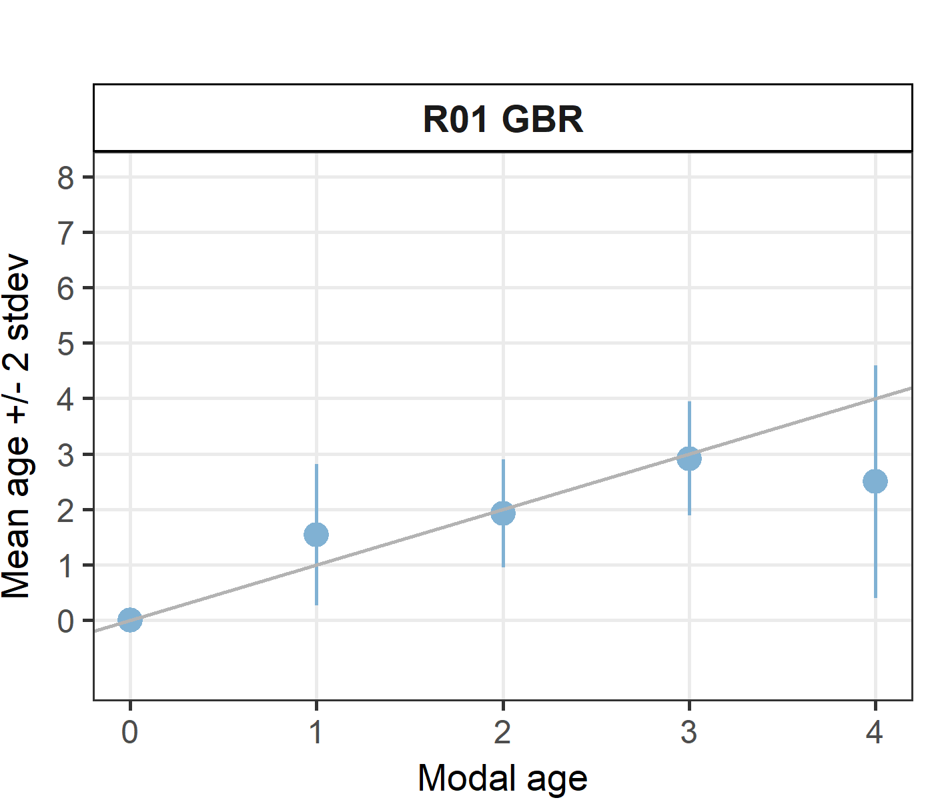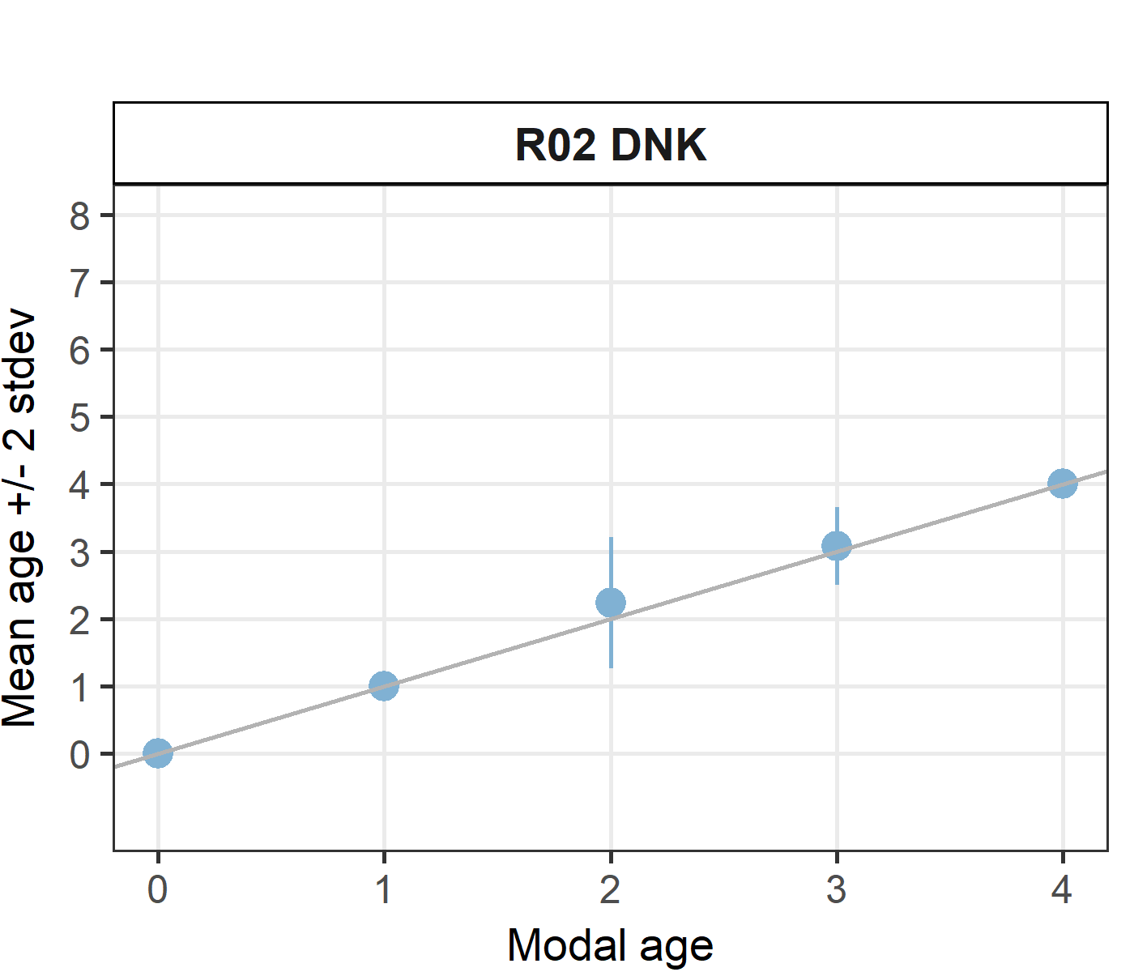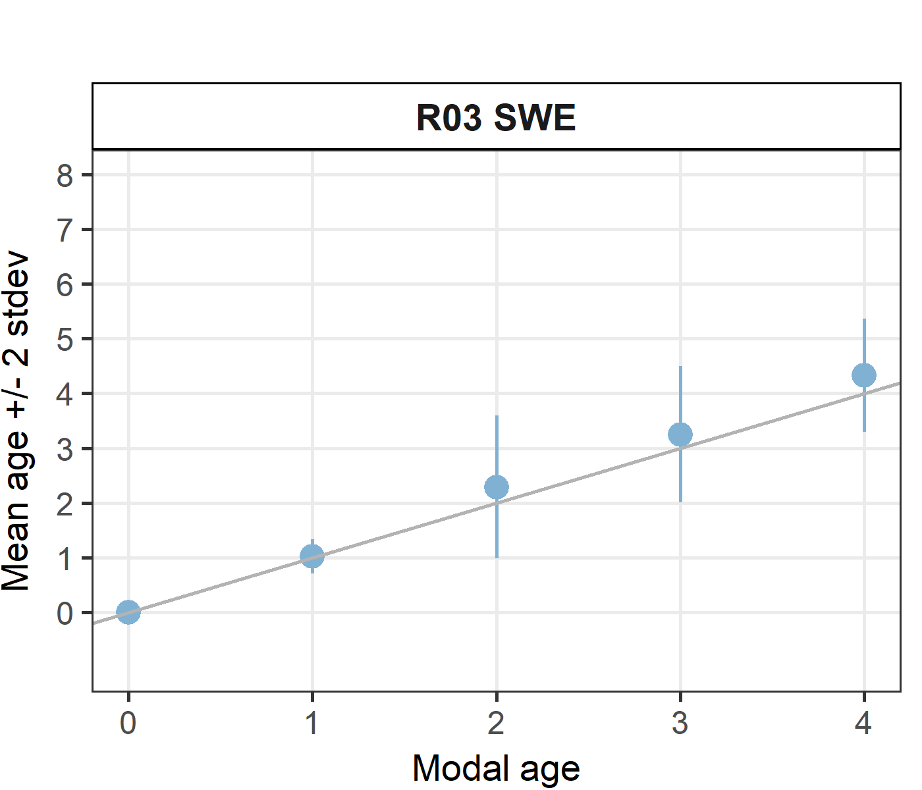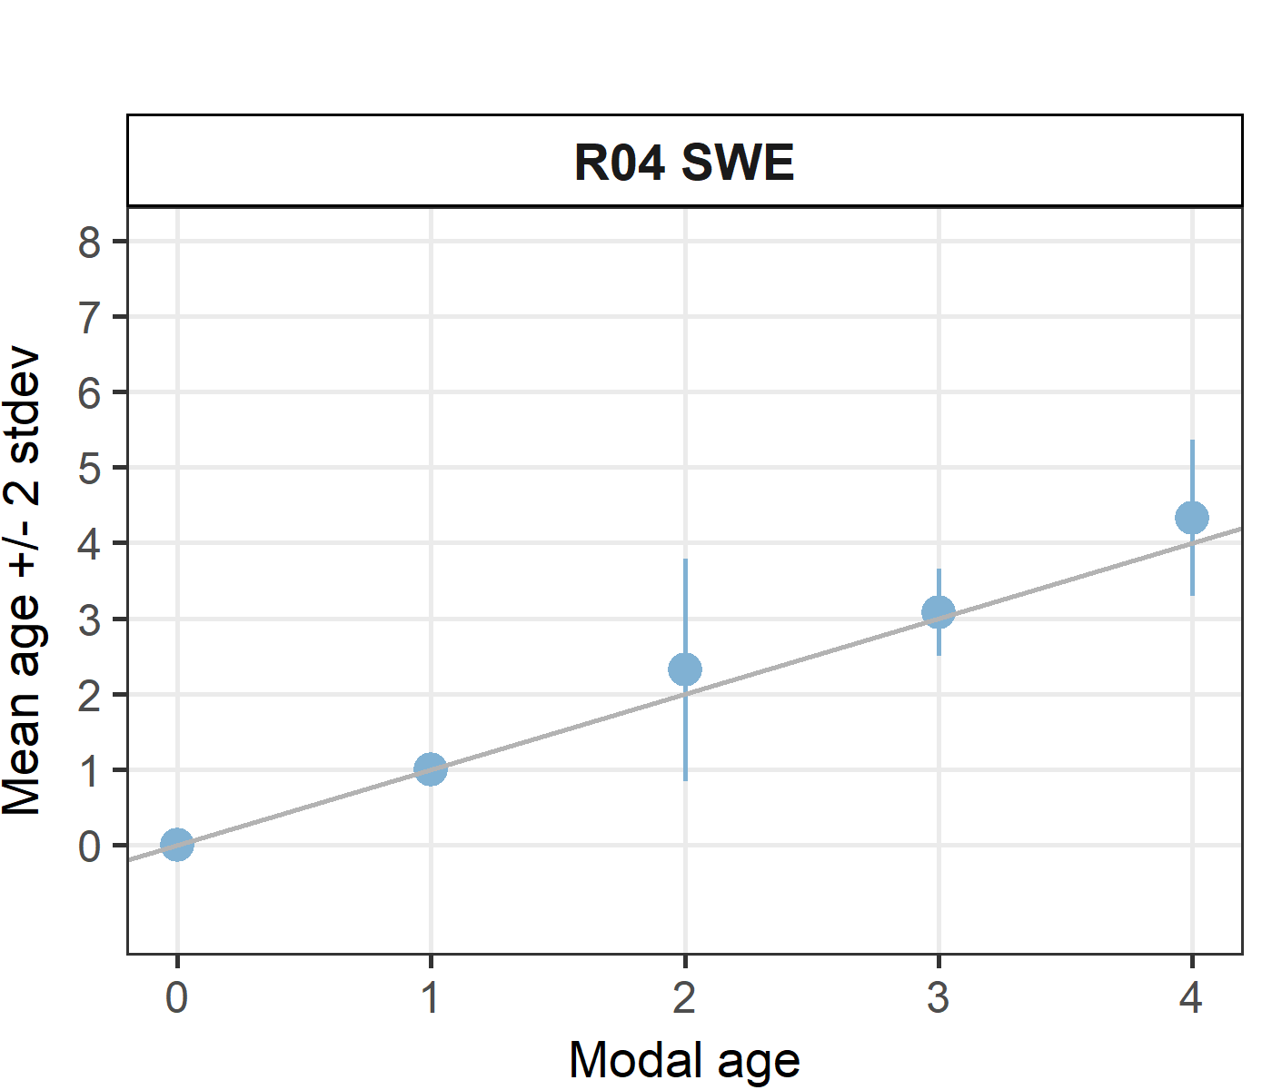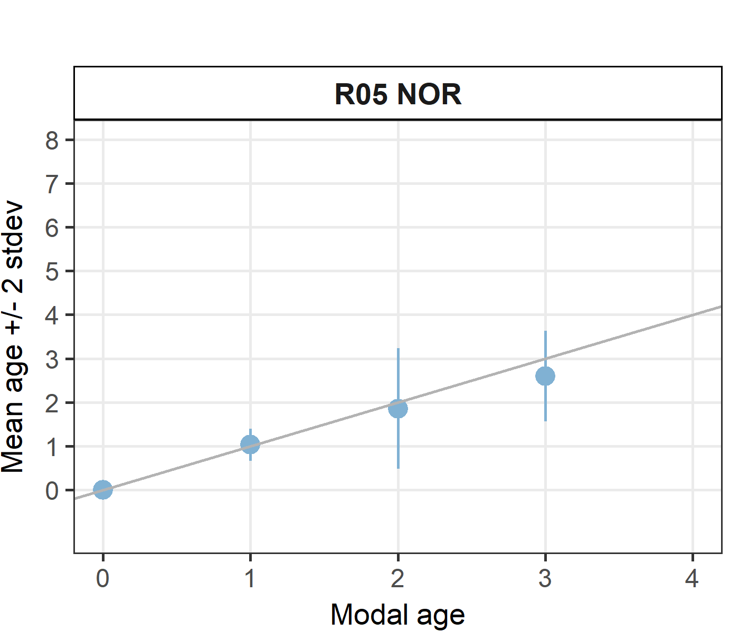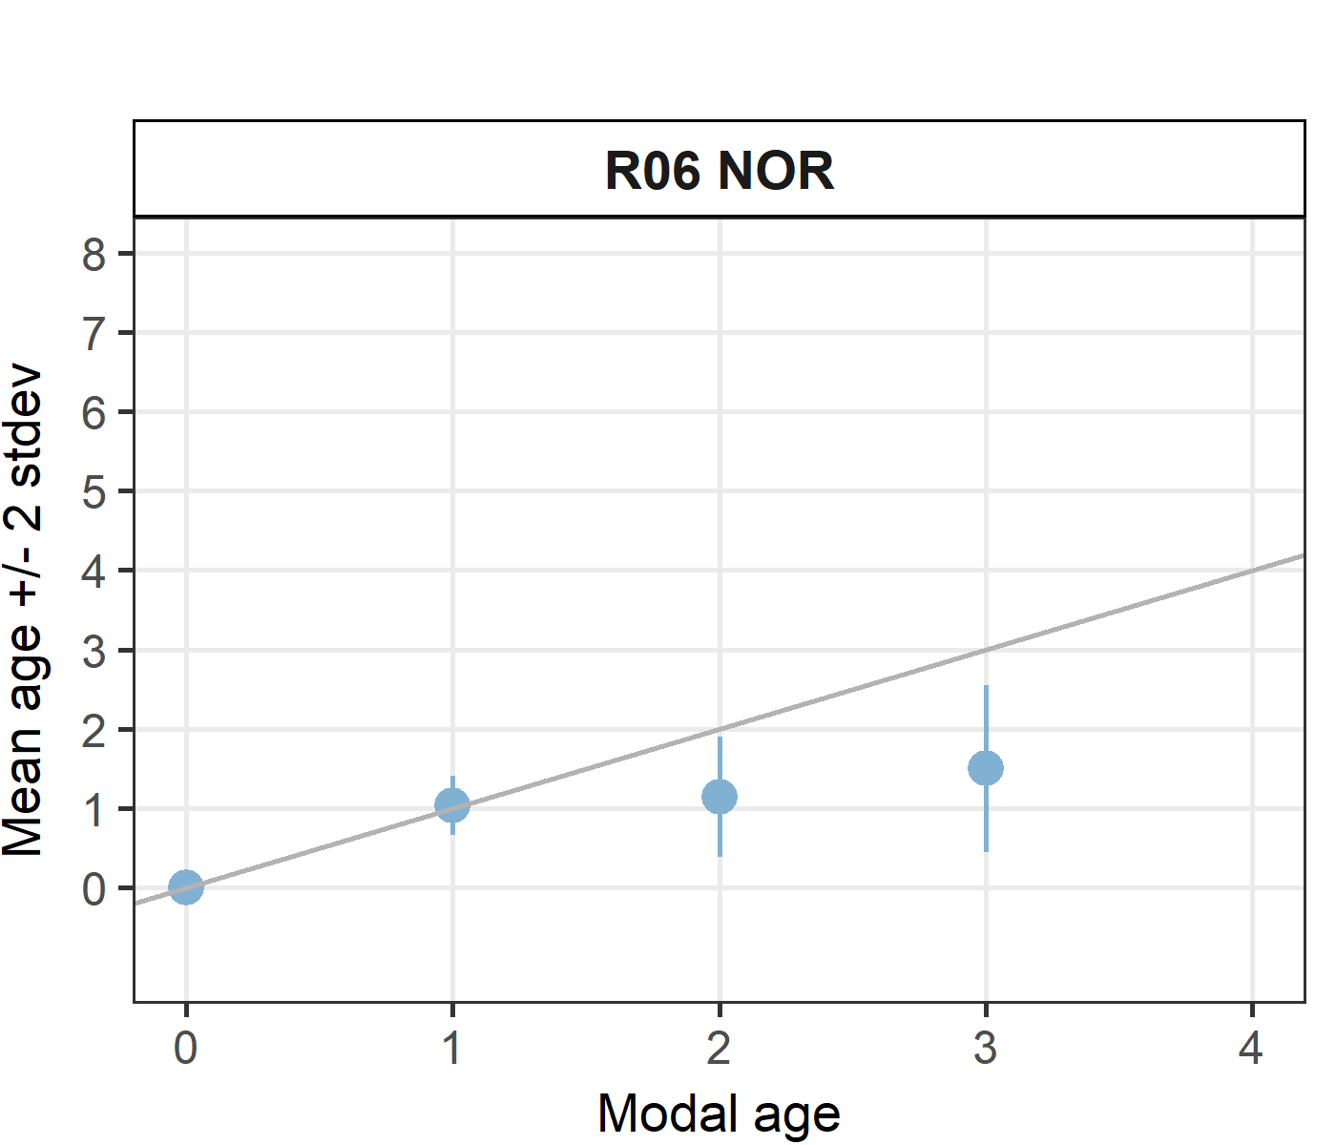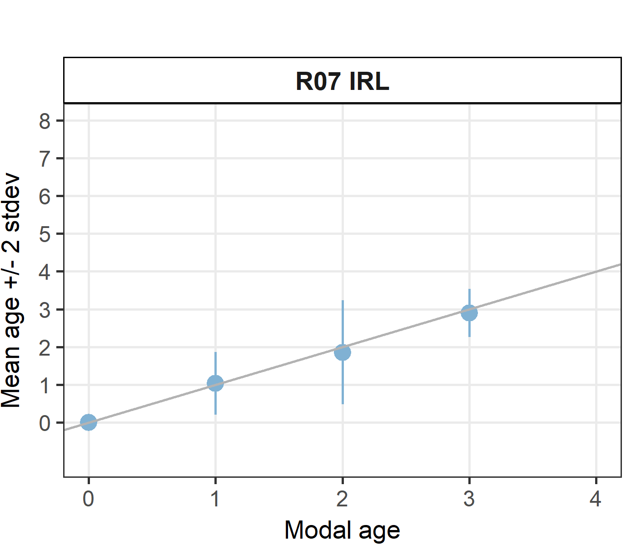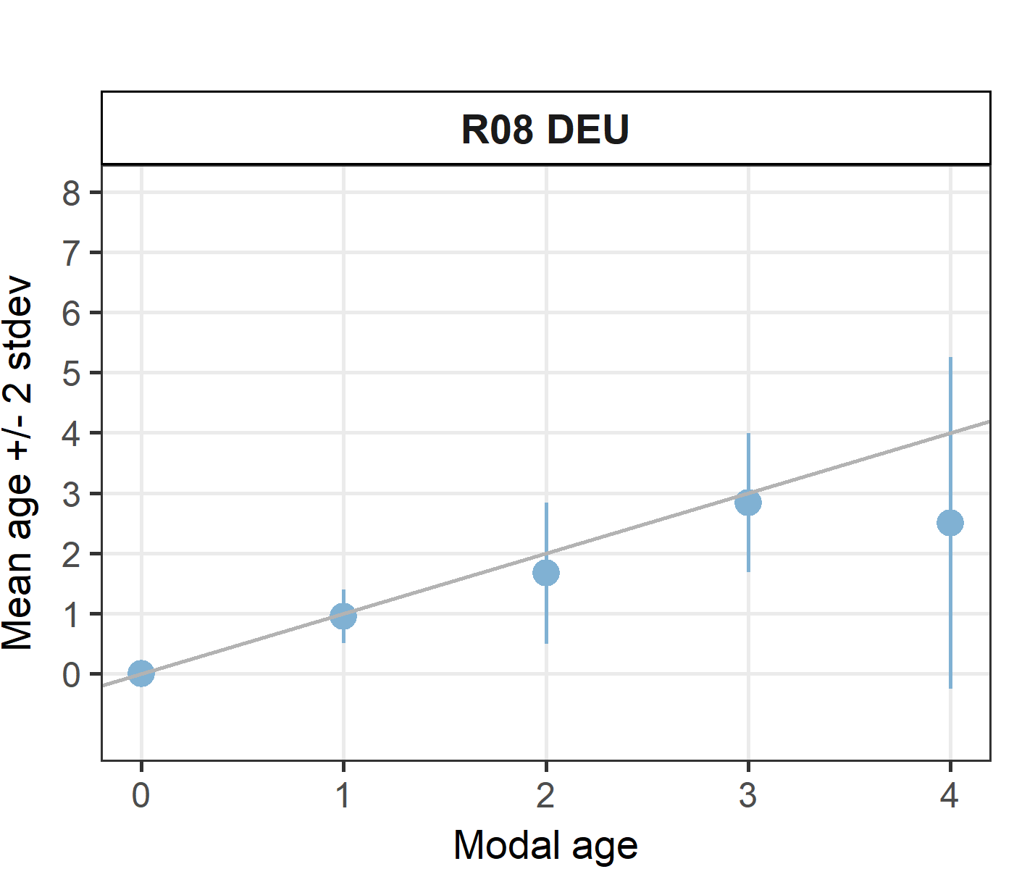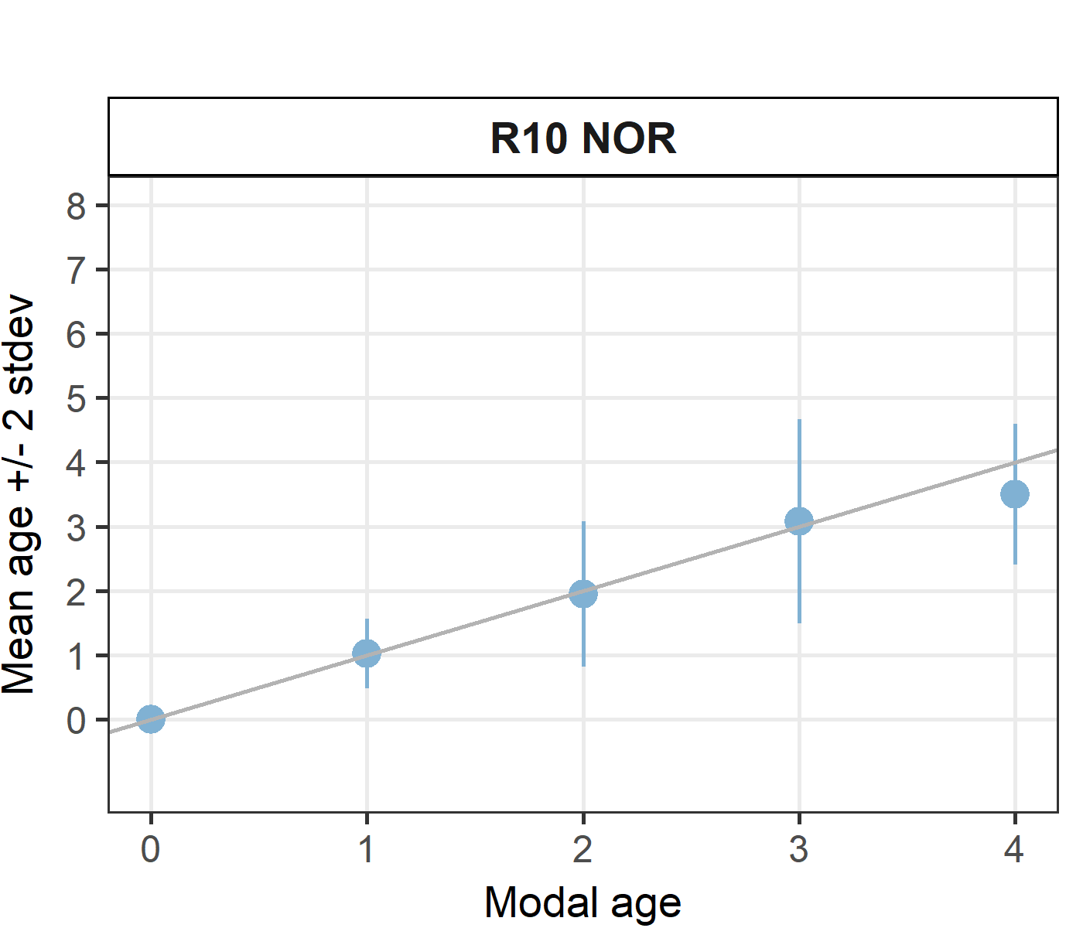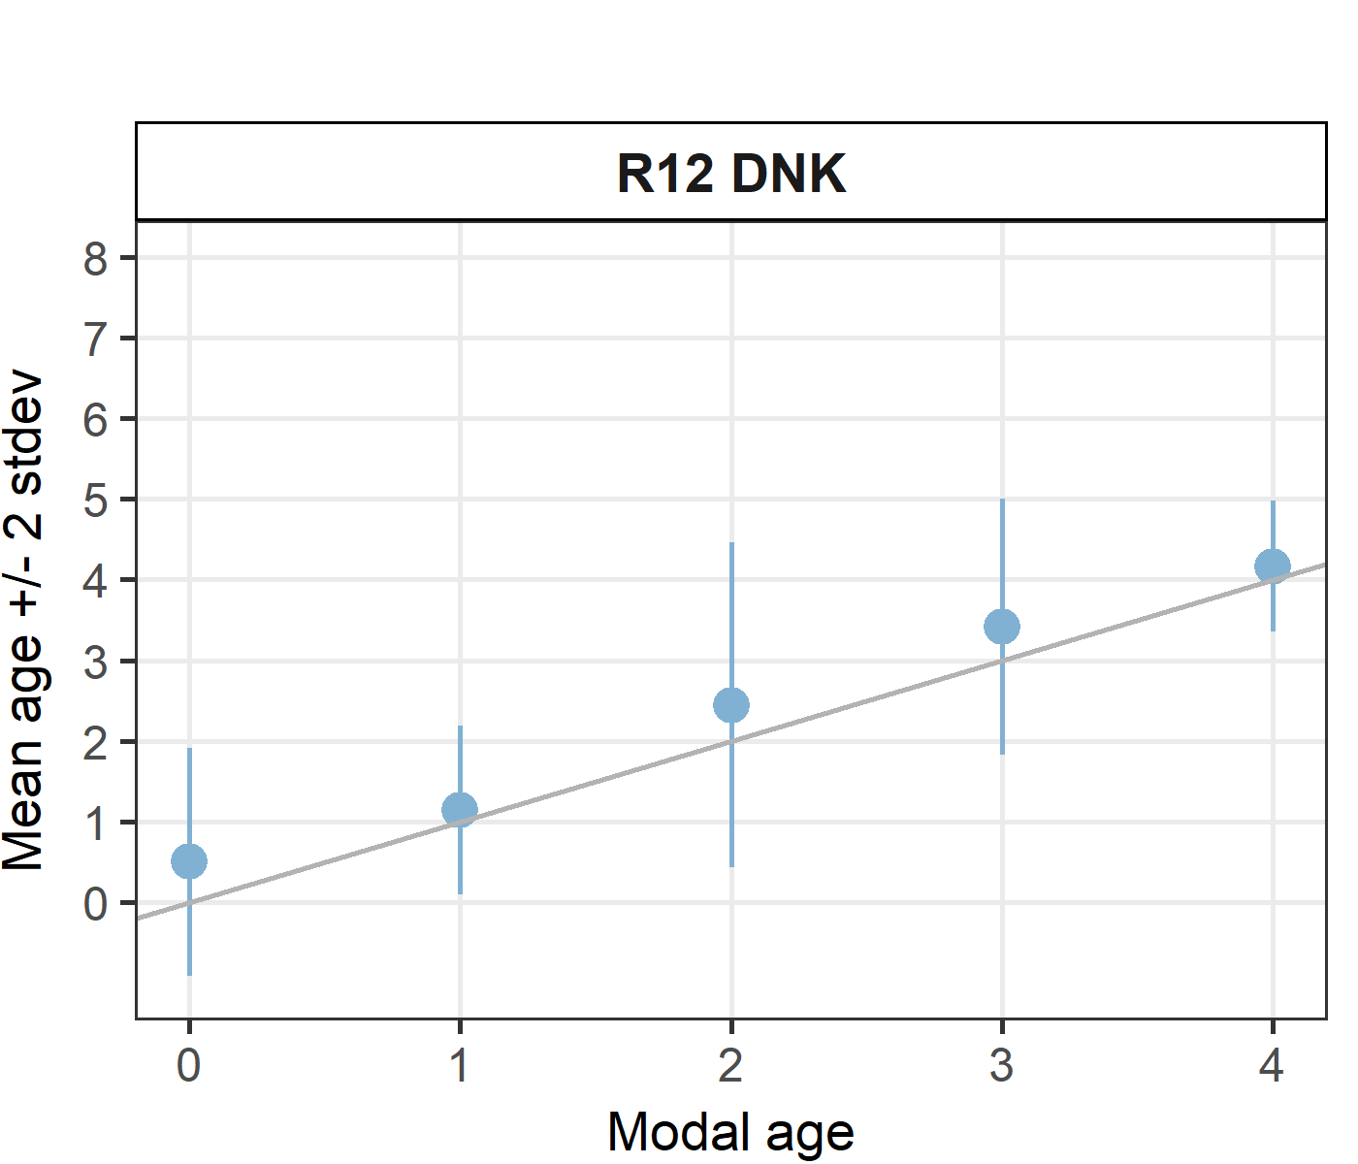

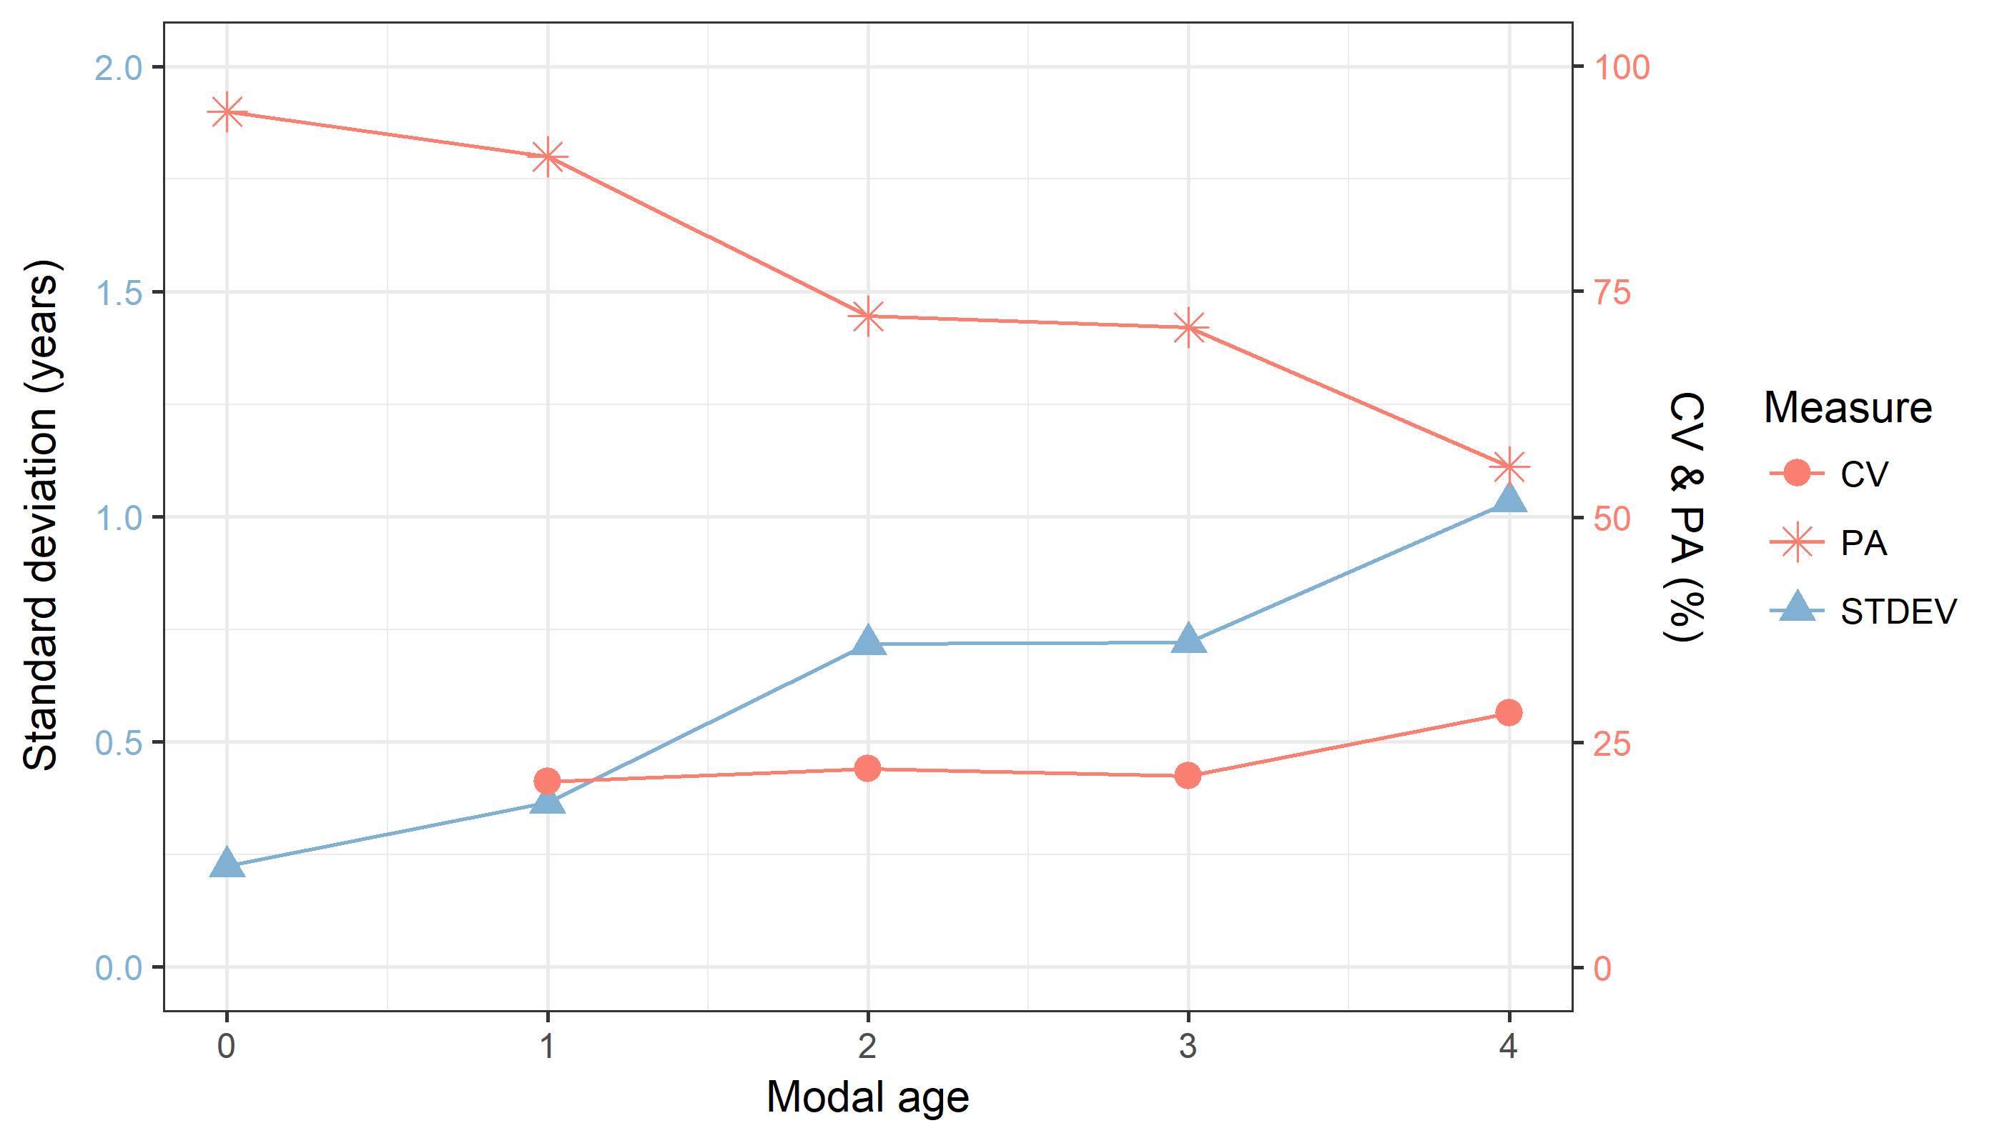

**Figure X:** CV, PA and (STDEV (standard deviation) are plotted against modal age

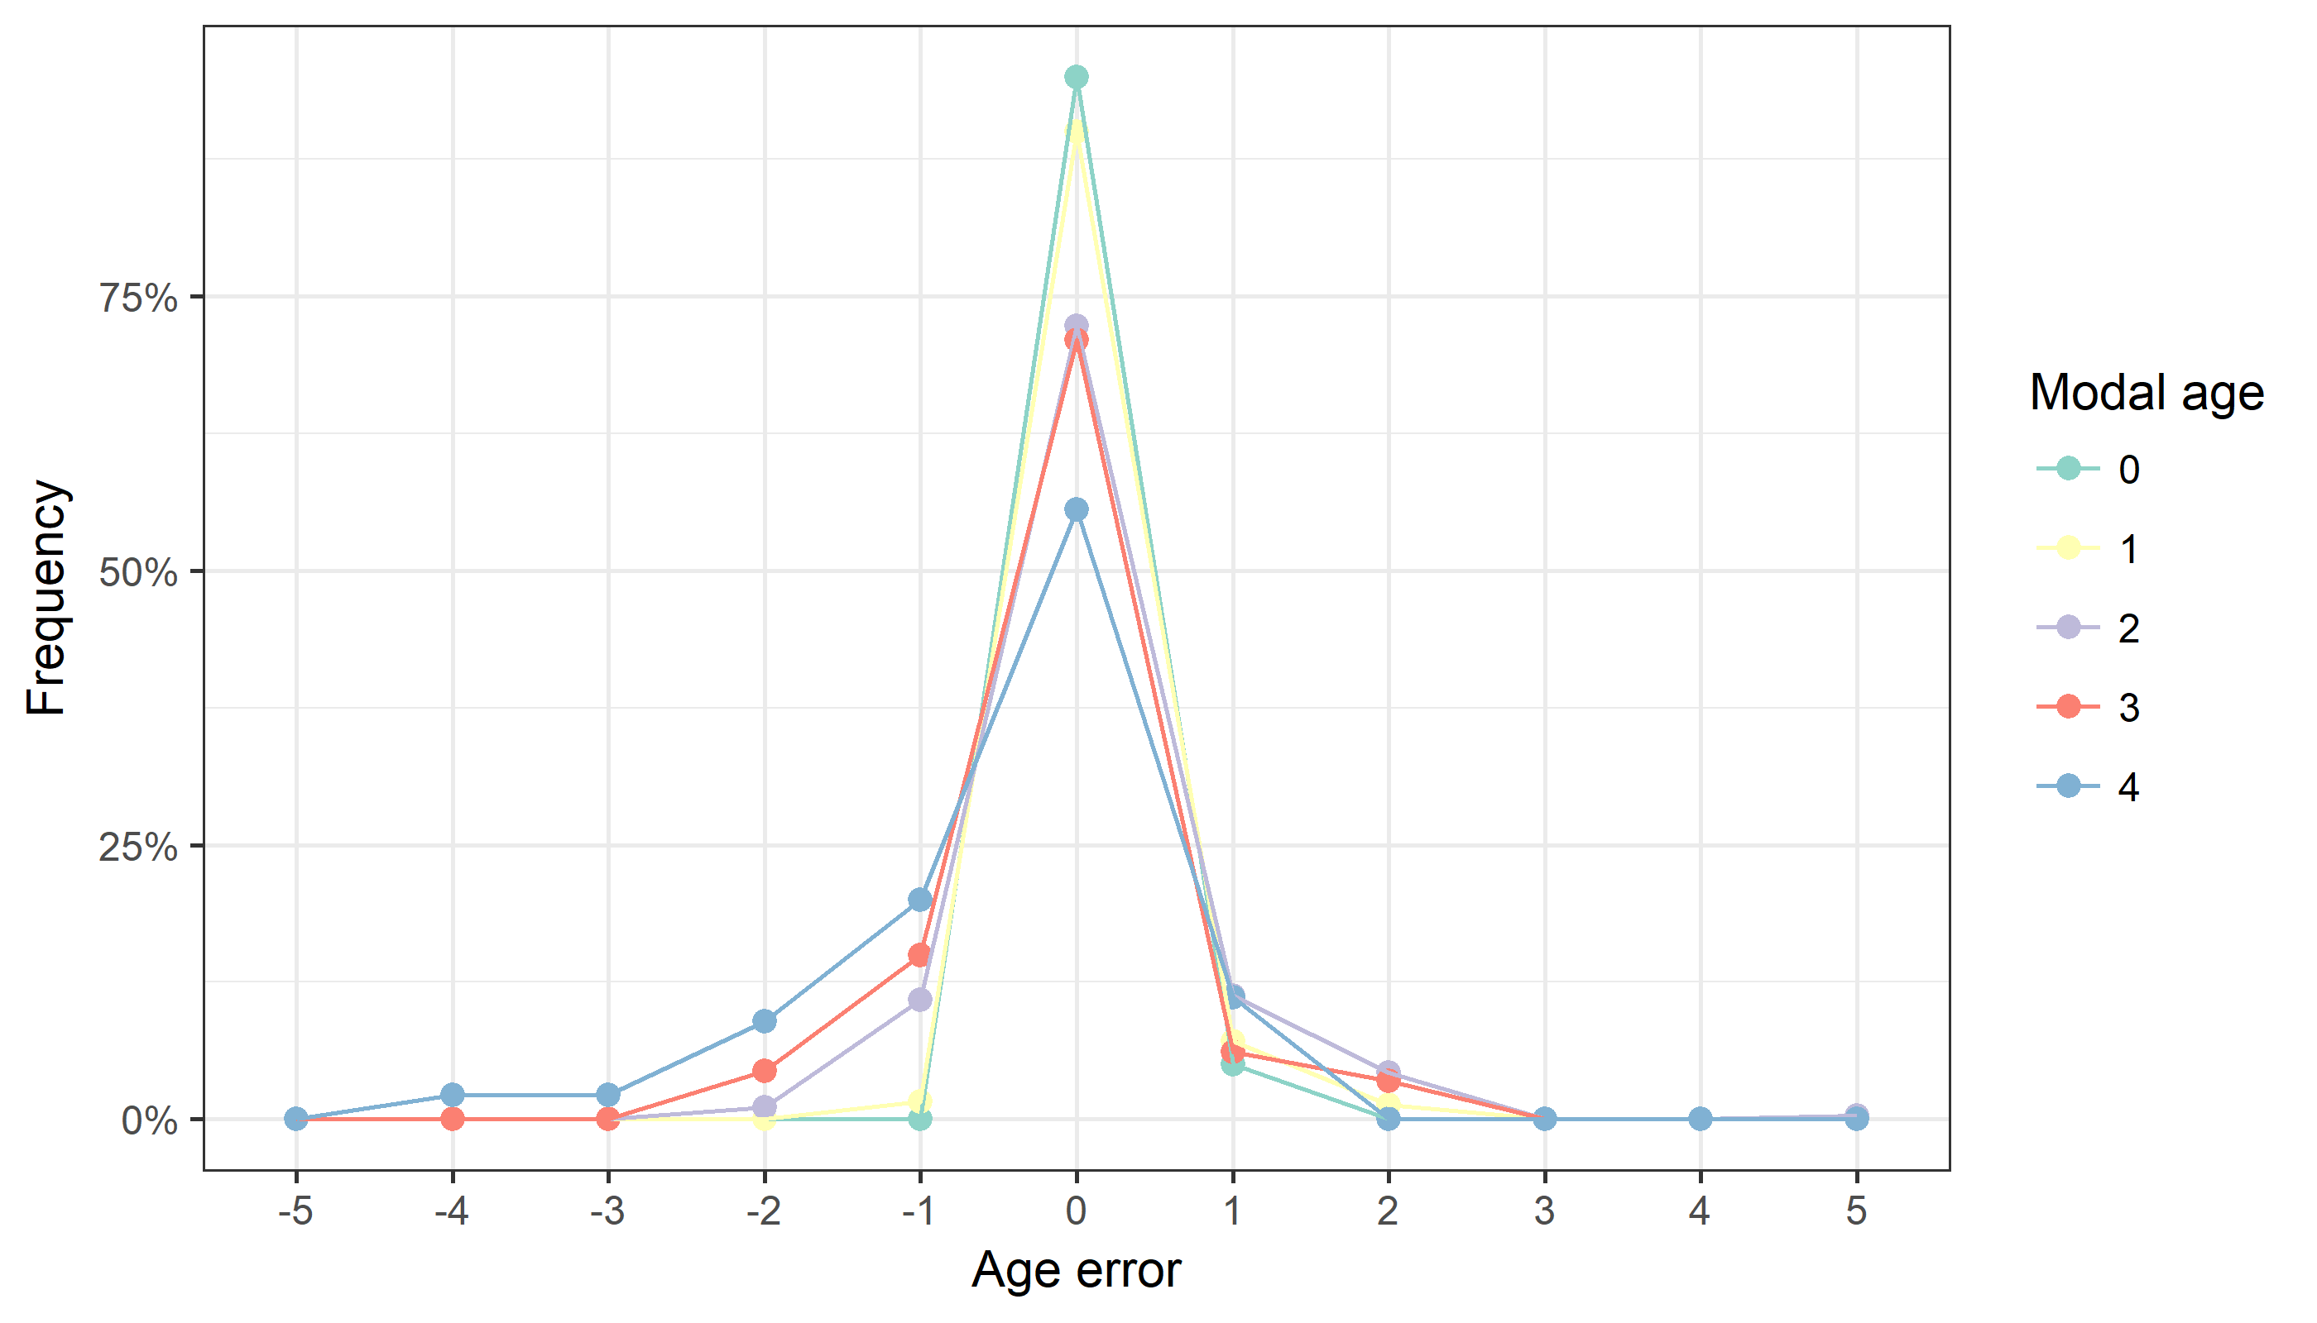

**Figure X:** The distribution of the age reading errors in percentage by modal age as observed from the whole group of age readers in an age reading comparison to modal age. The achieved precision in age reading by MODAL age group is shown by the spread of the age readings errors. There appears to be no relative bias, if the age reading errors are normally distributed. The distributions are skewed, if relative bias occurs.

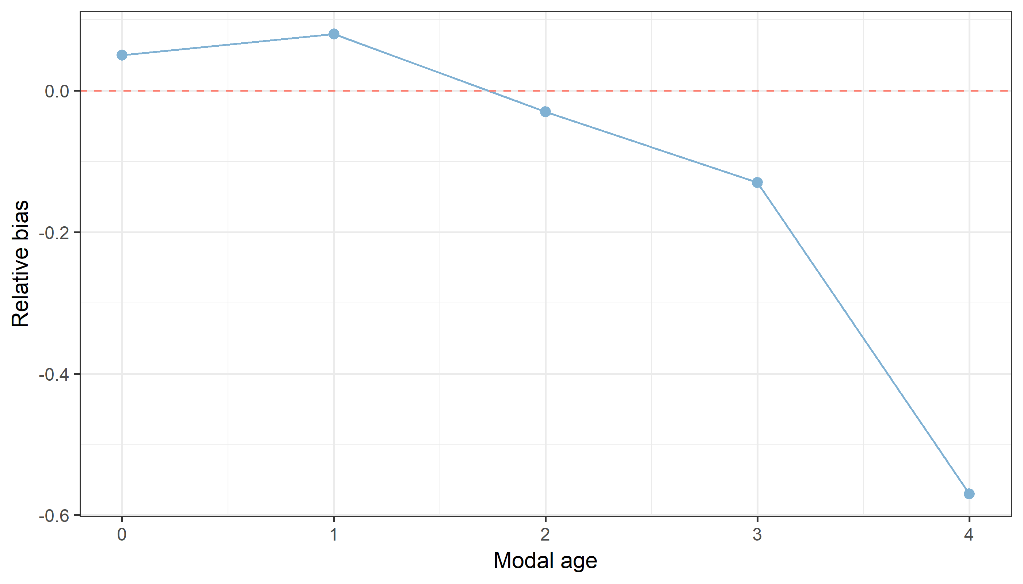

**Figure X:** The relative bias by modal age as estimated by all age readers combined.

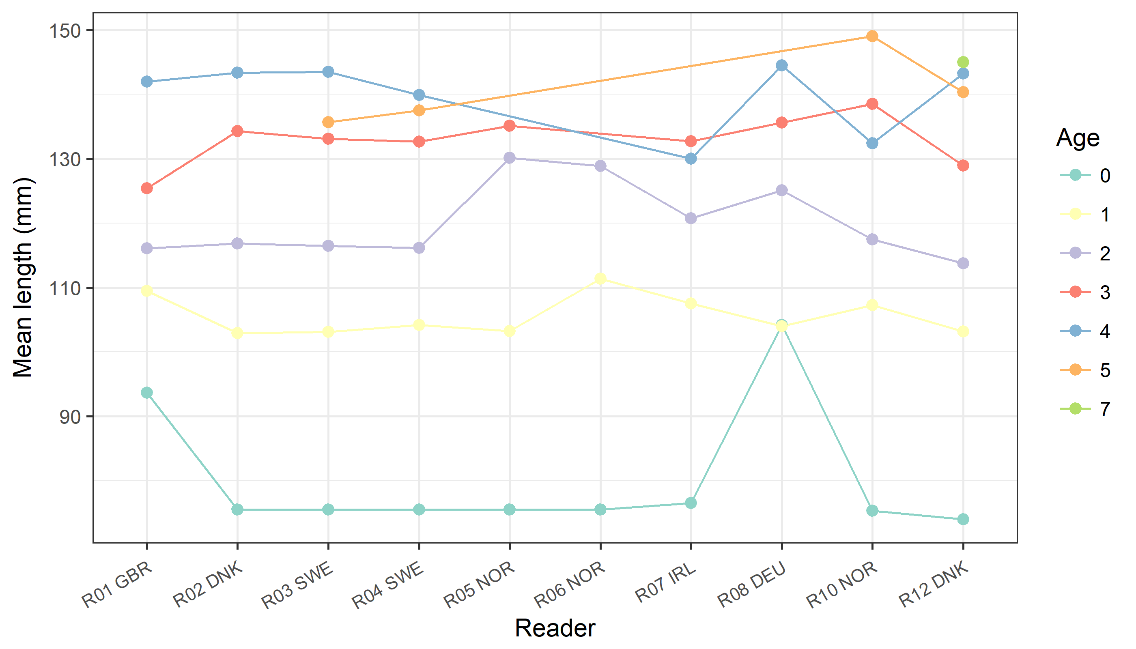

**Figure X:** The mean length at age as estimated by each age reader.

## Results Advanced readers

**All samples included**

**Data Overview**

**Table X:** Summary of statistics; PA (%), CV (%) and APE (%) based on advanced readers only.

|  |  |  |
| --- | --- | --- |
| **Mean CV %** | **Mean PA %** | **Mean APE %** |
| 91.1 | 7.7 | 5.9 |

**Table X:** Data overview including modal age and statistics per sample for advanced readerws only.

|  |  |  |  |  |  |  |  |  |  |  |  |  |
| --- | --- | --- | --- | --- | --- | --- | --- | --- | --- | --- | --- | --- |
| **Sample** | **Length (mm)** | **Sex** | **Catch date** | **ICES area** | **R02 DNK** | **R03 SWE** | **R04 SWE** | **R12 DNK** | **Modal age** | **PA %** | **CV %** | **APE %** |
| 6698256.jpg | 89 | U | 18/01/2013 | IIIaS | 1 | 1 | 1 | 1 | 1 | 100 | 0 | 0 |
| 6698257.jpg | 129 | U | 18/01/2013 | IIIaS | 3 | 3 | 3 | 3 | 3 | 100 | 0 | 0 |
| 6698258.jpg | 137 | U | 18/01/2013 | IIIaS | 3 | 3 | 3 | 3 | 3 | 100 | 0 | 0 |
| 6698259.jpg | 137 | U | 18/01/2013 | IIIaS | 3 | 3 | 3 | 3 | 3 | 100 | 0 | 0 |
| 6698260.jpg | 139 | U | 18/01/2013 | IIIaS | 3 | 3 | 3 | 3 | 3 | 100 | 0 | 0 |
| 6698261.jpg | 126 | U | 18/01/2013 | IIIaS | 3 | 3 | 3 | 3 | 3 | 100 | 0 | 0 |
| 6698262.jpg | 132 | U | 18/01/2013 | IIIaS | 4 | 5 | 3 | 5 | 5 | 50 | 23 | 18 |
| 6698263.jpg | 125 | U | 18/01/2013 | IIIaS | 3 | 3 | 3 | 3 | 3 | 100 | 0 | 0 |
| 6698264.jpg | 134 | U | 18/01/2013 | IIIaS | 3 | 4 | 4 | 4 | 4 | 75 | 13 | 10 |
| 6698268.jpg | 130 | U | 18/01/2013 | IIIaS | 4 | 4 | 4 | 4 | 4 | 100 | 0 | 0 |
| 6698269.jpg | 145 | U | 18/01/2013 | IIIaS | 4 | 4 | 4 | 7 | 4 | 75 | 32 | 24 |
| 6698270.jpg | 135 | U | 18/01/2013 | IIIaS | 2 | 3 | 3 | 4 | 3 | 50 | 27 | 17 |
| 6698280.jpg | 125 | U | 18/01/2013 | IIIaS | 3 | 4 | 4 | 3 | 3 | 50 | 16 | 14 |
| 6698281.jpg | 132 | U | 18/01/2013 | IIIaS | 3 | 3 | 3 | 3 | 3 | 100 | 0 | 0 |
| 6698282.jpg | 129 | U | 18/01/2013 | IIIaS | 3 | 3 | 3 | 3 | 3 | 100 | 0 | 0 |
| 6932318.jpg | 102 | U | 10/06/2014 | IIIaS | 1 | 1 | 1 | 1 | 1 | 100 | 0 | 0 |
| 6932319.jpg | 105 | U | 10/06/2014 | IIIaS | 1 | 1 | 1 | 1 | 1 | 100 | 0 | 0 |
| 6932320.jpg | 85 | U | 10/06/2014 | IIIaS | 1 | 1 | 1 | 3 | 1 | 75 | 67 | 50 |
| 6932321.jpg | 87 | U | 10/06/2014 | IIIaS | 1 | 1 | 1 | 1 | 1 | 100 | 0 | 0 |
| 6932322.jpg | 90 | U | 10/06/2014 | IIIaS | 1 | 1 | 1 | 1 | 1 | 100 | 0 | 0 |
| 6932323.jpg | 80 | U | 10/06/2014 | IIIaS | 1 | 1 | 1 | 1 | 1 | 100 | 0 | 0 |
| 6932324.jpg | 84 | U | 10/06/2014 | IIIaS | 1 | 1 | 1 | 1 | 1 | 100 | 0 | 0 |
| 6932325.jpg | 81 | U | 10/06/2014 | IIIaS | 1 | 1 | 1 | 1 | 1 | 100 | 0 | 0 |
| 6941185.jpg | 75 | U | 05/07/2014 | IIIaS | 1 | 1 | 1 | 0 | 1 | 75 | 67 | 50 |
| 7187385.jpg | 149 | U | 15/10/2015 | IIIaS | 3 | 4 | 3 | 5 | 3 | 50 | 26 | 20 |
| 7187386.jpg | 120 | U | 15/10/2015 | IIIaS | 1 | 1 | 1 | 1 | 1 | 100 | 0 | 0 |
| 7187387.jpg | 116 | U | 15/10/2015 | IIIaS | 1 | 1 | 1 | 2 | 1 | 75 | 40 | 30 |
| 7187388.jpg | 110 | U | 15/10/2015 | IIIaS | 1 | 1 | 1 | 1 | 1 | 100 | 0 | 0 |
| 7187393.jpg | 107 | U | 15/10/2015 | IIIaS | 1 | 1 | 1 | 1 | 1 | 100 | 0 | 0 |
| 7187394.jpg | 100 | U | 15/10/2015 | IIIaS | 1 | 1 | 1 | 1 | 1 | 100 | 0 | 0 |
| 7188165.jpg | 100 | U | 20/10/2015 | IIIaN | 1 | 1 | 1 | 1 | 1 | 100 | 0 | 0 |
| 7188166.jpg | 106 | U | 20/10/2015 | IIIaN | 1 | 1 | 1 | 1 | 1 | 100 | 0 | 0 |
| 7188167.jpg | 110 | U | 20/10/2015 | IIIaN | 1 | 1 | 1 | 1 | 1 | 100 | 0 | 0 |
| 7188168.jpg | 115 | U | 20/10/2015 | IIIaN | 1 | 1 | 1 | 1 | 1 | 100 | 0 | 0 |
| 7188169.jpg | 120 | U | 20/10/2015 | IIIaN | 1 | 1 | 1 | 1 | 1 | 100 | 0 | 0 |
| 7188170.jpg | 127 | U | 20/10/2015 | IIIaN | 1 | 2 | 1 | 3 | 1 | 50 | 55 | 43 |
| 7188171.jpg | 103 | U | 20/10/2015 | IIIaN | 1 | 1 | 1 | 1 | 1 | 100 | 0 | 0 |
| 7188172.jpg | 106 | U | 20/10/2015 | IIIaN | 1 | 1 | 1 | 1 | 1 | 100 | 0 | 0 |
| 7188173.jpg | 110 | U | 20/10/2015 | IIIaN | 1 | 1 | 1 | 1 | 1 | 100 | 0 | 0 |
| 7188174.jpg | 115 | U | 20/10/2015 | IIIaN | 1 | 1 | 1 | 1 | 1 | 100 | 0 | 0 |
| 7190462.jpg | 138 | U | 24/09/2015 | IIIaS | 3 | 3 | 3 | 3 | 3 | 100 | 0 | 0 |
| 7190468.jpg | 110 | U | 24/09/2015 | IIIaS | 1 | 1 | 1 | 1 | 1 | 100 | 0 | 0 |
| 7190469.jpg | 115 | U | 24/09/2015 | IIIaS | 1 | 1 | 1 | 1 | 1 | 100 | 0 | 0 |
| 7190470.jpg | 127 | U | 24/09/2015 | IIIaS | 3 | 3 | 3 | 3 | 3 | 100 | 0 | 0 |
| 7190486.jpg | 95 | U | 24/09/2015 | IIIaS | 1 | 1 | 1 | 2 | 1 | 75 | 40 | 30 |
| 7190487.jpg | 130 | U | 24/09/2015 | IIIaS | 2 | 2 | 2 | 2 | 2 | 100 | 0 | 0 |
| 7190488.jpg | 101 | U | 24/09/2015 | IIIaS | 1 | 1 | 1 | 1 | 1 | 100 | 0 | 0 |
| 7190495.jpg | 118 | U | 24/09/2015 | IIIaS | 1 | 1 | 1 | 1 | 1 | 100 | 0 | 0 |
| 7216512.jpg | 98 | U | 14/12/2015 | IIIaS | 1 | 1 | 1 | 2 | 1 | 75 | 40 | 30 |
| 7216513.jpg | 95 | U | 14/12/2015 | IIIaS | 1 | 1 | 1 | 1 | 1 | 100 | 0 | 0 |
| 7216514.jpg | 96 | U | 14/12/2015 | IIIaS | 1 | 1 | 1 | 1 | 1 | 100 | 0 | 0 |
| 7216515.jpg | 102 | U | 14/12/2015 | IIIaS | 1 | 1 | 1 | 1 | 1 | 100 | 0 | 0 |
| 7216516.jpg | 102 | U | 14/12/2015 | IIIaS | 1 | 1 | 1 | 1 | 1 | 100 | 0 | 0 |
| 7216517.jpg | 103 | U | 14/12/2015 | IIIaS | 1 | 1 | 1 | 1 | 1 | 100 | 0 | 0 |
| Com’15_N_29.jpg | 120 | U | 26/10/2015 | IIIaN | 1 | 1 | 1 | 1 | 1 | 100 | 0 | 0 |
| Com’15_N_30.jpg | 135 | U | 26/10/2015 | IIIaN | 2 | 2 | 2 | 2 | 2 | 100 | 0 | 0 |
| Com’15_N_31.jpg | 130 | U | 26/10/2015 | IIIaN | 2 | 2 | 2 | 2 | 2 | 100 | 0 | 0 |
| Com’15_N_32.jpg | 140 | U | 26/10/2015 | IIIaN | 3 | 3 | 3 | 4 | 3 | 75 | 15 | 12 |
| Com’15_N_33.jpg | 115 | U | 26/10/2015 | IIIaN | 1 | 1 | 1 | 1 | 1 | 100 | 0 | 0 |
| Com’15_N_41.jpg | 120 | U | 26/10/2015 | IIIaN | 1 | 1 | 1 | 1 | 1 | 100 | 0 | 0 |
| Com’15_N_42.jpg | 140 | U | 26/10/2015 | IIIaN | 3 | 2 | 2 | 3 | 3 | 50 | 23 | 20 |
| Com’15_N_43.jpg | 150 | U | 26/10/2015 | IIIaN | 3 | 3 | 3 | 4 | 3 | 75 | 15 | 12 |
| Com’15_N_44.jpg | 145 | U | 26/10/2015 | IIIaN | 2 | 2 | 2 | 2 | 2 | 100 | 0 | 0 |
| Com’15_N_45.jpg | 155 | U | 26/10/2015 | IIIaN | 4 | 4 | 4 | 4 | 4 | 100 | 0 | 0 |
| Com’15_N_46.jpg | 140 | U | 26/10/2015 | IIIaN | 2 | 2 | 2 | 2 | 2 | 100 | 0 | 0 |
| Com’15_N_56.jpg | 150 | U | 26/10/2015 | IIIaN | 4 | 4 | 4 | 4 | 4 | 100 | 0 | 0 |
| Com’15_N_57.jpg | 160 | U | 26/10/2015 | IIIaN | 4 | 4 | 4 | 4 | 4 | 100 | 0 | 0 |
| Com’15_N_58.jpg | 135 | U | 26/10/2015 | IIIaN | 2 | 2 | 2 | 3 | 2 | 75 | 22 | 17 |
| Com’15_N_59.jpg | 130 | U | 26/10/2015 | IIIaN | 2 | 2 | 2 | 3 | 2 | 75 | 22 | 17 |
| IBTS’15_S_34.jpg | 135 | U | 28/08/2015 | IIIaS | 2 | 1 | 1 | 2 | 2 | 50 | 38 | 33 |
| IBTS’15_S_35.jpg | 115 | U | 28/08/2015 | IIIaS | 1 | 1 | 1 | 1 | 1 | 100 | 0 | 0 |
| IBTS’15_S_36.jpg | 130 | U | 28/08/2015 | IIIaS | 2 | 2 | 2 | 2 | 2 | 100 | 0 | 0 |
| IBTS’16_N_1.jpg | 115 | U | 27/01/2016 | IIIaN | 2 | 2 | 2 | 1 | 2 | 75 | 29 | 21 |
| IBTS’16_N_2.jpg | 115 | U | 27/01/2016 | IIIaN | 2 | 2 | 2 | 2 | 2 | 100 | 0 | 0 |
| IBTS’16_N_20.jpg | 100 | U | 27/01/2016 | IIIaN | 2 | 2 | 2 | 2 | 2 | 100 | 0 | 0 |
| IBTS’16_N_21.jpg | 70 | U | 27/01/2016 | IIIaN | 2 | 2 | 2 | 2 | 2 | 100 | 0 | 0 |
| IBTS’16_N_22.jpg | 80 | U | 27/01/2016 | IIIaN | 2 | 2 | 2 | 2 | 2 | 100 | 0 | 0 |
| IBTS’16_N_23.jpg | 125 | U | 27/01/2016 | IIIaN | 2 | 2 | 1 | 2 | 2 | 75 | 29 | 21 |
| IBTS’16_N_24.jpg | 75 | U | 27/01/2016 | IIIaN | 2 | 2 | 2 | 2 | 2 | 100 | 0 | 0 |
| IBTS’16_N_3.jpg | 125 | U | 27/01/2016 | IIIaN | 2 | 2 | 2 | 2 | 2 | 100 | 0 | 0 |
| IBTS’16_N_39.jpg | 85 | U | 27/01/2016 | IIIaN | 2 | 2 | 2 | 2 | 2 | 100 | 0 | 0 |
| IBTS’16_N_4.jpg | 100 | U | 27/01/2016 | IIIaN | 2 | 2 | 3 | 2 | 2 | 75 | 22 | 17 |
| IBTS’16_N_40.jpg | 120 | U | 27/01/2016 | IIIaN | 2 | 2 | 2 | 2 | 2 | 100 | 0 | 0 |
| IBTS’16_N_41.jpg | 120 | U | 27/01/2016 | IIIaN | 2 | 2 | 2 | 2 | 2 | 100 | 0 | 0 |
| IBTS’16_N_5.jpg | 120 | U | 27/01/2016 | IIIaN | 2 | 2 | 2 | 2 | 2 | 100 | 0 | 0 |
| IBTS’16_N_6.jpg | 90 | U | 27/01/2016 | IIIaN | 1 | 1 | 1 | 1 | 1 | 100 | 0 | 0 |
| IBTS’16_S_52.jpg | 105 | U | 27/01/2016 | IIIaS | 2 | 2 | 2 | 2 | 2 | 100 | 0 | 0 |
| IBTS’16_S_53.jpg | 135 | U | 27/01/2016 | IIIaS | 3 | 3 | 4 | 3 | 3 | 75 | 15 | 12 |
| IBTS’16_S_54.jpg | 125 | U | 27/01/2016 | IIIaS | 3 | 3 | 4 | 3 | 3 | 75 | 15 | 12 |
| IBTS’16_S_80.jpg | 130 | U | 27/01/2016 | IIIaS | 2 | 2 | 3 | 2 | 2 | 75 | 22 | 17 |
| IBTS’16_S_82.jpg | 140 | U | 27/01/2016 | IIIaS | 4 | 5 | 5 | 5 | 5 | 75 | 11 | 8 |
| IBTS’16_S_83.jpg | 125 | U | 27/01/2016 | IIIaS | 2 | 3 | 2 | 2 | 2 | 75 | 22 | 17 |
| IBTS’16_S_86.jpg | 85 | U | 27/01/2016 | IIIaS | 1 | 1 | 1 | 1 | 1 | 100 | 0 | 0 |
| IBTS’16_S_87.jpg | 110 | U | 27/01/2016 | IIIaS | 2 | 2 | 2 | 2 | 2 | 100 | 0 | 0 |
| IBTS’16_S_88.jpg | 115 | U | 27/01/2016 | IIIaS | 2 | 2 | 2 | 2 | 2 | 100 | 0 | 0 |
| IBTS’16_S_89.jpg | 135 | U | 27/01/2016 | IIIaS | 4 | 5 | 5 | 4 | 4 | 50 | 13 | 11 |
| IBTS’16_S_90.jpg | 120 | U | 27/01/2016 | IIIaS | 2 | 2 | 2 | 2 | 2 | 100 | 0 | 0 |
| IBTS’16_S_91.jpg | 105 | U | 27/01/2016 | IIIaS | 2 | 2 | 2 | 2 | 2 | 100 | 0 | 0 |

**Table X:** Number of age readings table gives an overview of numberof age readings per advanced reader and modal age. The total numbers of readings per reader and per modal age are summarized at the end of the table.

|  |  |  |  |  |  |
| --- | --- | --- | --- | --- | --- |
| **Modal age** | **R02 DNK** | **R03 SWE** | **R04 SWE** | **R12 DNK** | **Total** |
| 0 | 2 | 2 | 2 | 2 | **8** |
| 1 | 42 | 42 | 42 | 42 | **168** |
| 2 | 29 | 29 | 29 | 29 | **116** |
| 3 | 18 | 18 | 18 | 18 | **72** |
| 4 | 7 | 7 | 7 | 7 | **28** |
| 5 | 2 | 2 | 2 | 2 | **8** |
| **Total** | **100** | **100** | **100** | **100** | **400** |

**Table X:** Overall ranking of advanced readers.

|  |  |  |  |  |
| --- | --- | --- | --- | --- |
| **Ranking** | **R02 DNK** | **R03 SWE** | **R04 SWE** | **R12 DNK** |
| Coefficient of Variation | 1 | 3 | 2 | 4 |
| Percentage agreement | 1 | 2 | 3 | 4 |
| Relative bias | 3 | 2 | 1 | 4 |
| **Total** | **1** | **3** | **2** | **4** |

**Table X:** Age composition by advanced reader.

|  |  |  |  |  |  |
| --- | --- | --- | --- | --- | --- |
| **Age** | **R02 DNK** | **R03 SWE** | **R04 SWE** | **R12 DNK** | **All** |
| 0 | 2 | 2 | 2 | 2 | **8** |
| 1 | 42 | 42 | 44 | 38 | **166** |
| 2 | 30 | 29 | 26 | 29 | **114** |
| 3 | 18 | 16 | 17 | 18 | **69** |
| 4 | 8 | 8 | 9 | 9 | **34** |
| 5 | 0 | 3 | 2 | 3 | **8** |
| 6 | 0 | 0 | 0 | 0 | **0** |
| 7 | 0 | 0 | 0 | 1 | **1** |
| **Total** | **100** | **100** | **100** | **100** | **400** |

**Table X:** Mean length at age by advanced reader.

|  |  |  |  |  |  |
| --- | --- | --- | --- | --- | --- |
| **Age** | **R02 DNK** | **R03 SWE** | **R04 SWE** | **R12 DNK** | **Total** |
| 0 | 76 mm | 76 mm | 76 mm | 74 mm | **75 mm** |
| 1 | 103 mm | 103 mm | 104 mm | 103 mm | **103 mm** |
| 2 | 117 mm | 116 mm | 116 mm | 114 mm | **116 mm** |
| 3 | 134 mm | 133 mm | 133 mm | 129 mm | **132 mm** |
| 4 | 143 mm | 144 mm | 140 mm | 143 mm | **142 mm** |
| 5 | - | 136 mm | 138 mm | 140 mm | **138 mm** |
| 6 | - | - | - | - | **-** |
| 7 | - | - | - | 145 mm | **145 mm** |
| **Weighted Mean** | **115 mm** | **115 mm** | **115 mm** | **115 mm** | **115 mm** |

**Table X:** Inter reader bias test for advanced readers.

|  |  |  |  |  |
| --- | --- | --- | --- | --- |
| **Comparison** | **R02 DNK** | **R03 SWE** | **R04 SWE** | **R12 DNK** |
| **R02 DNK** | . | - | - | ** |
| **R03 SWE** | - | . | - | * |
| **R04 SWE** | - | - | . | * |
| **R12 DNK** | ** | * | * | . |
| **Modal age** | - | - | - | ** |

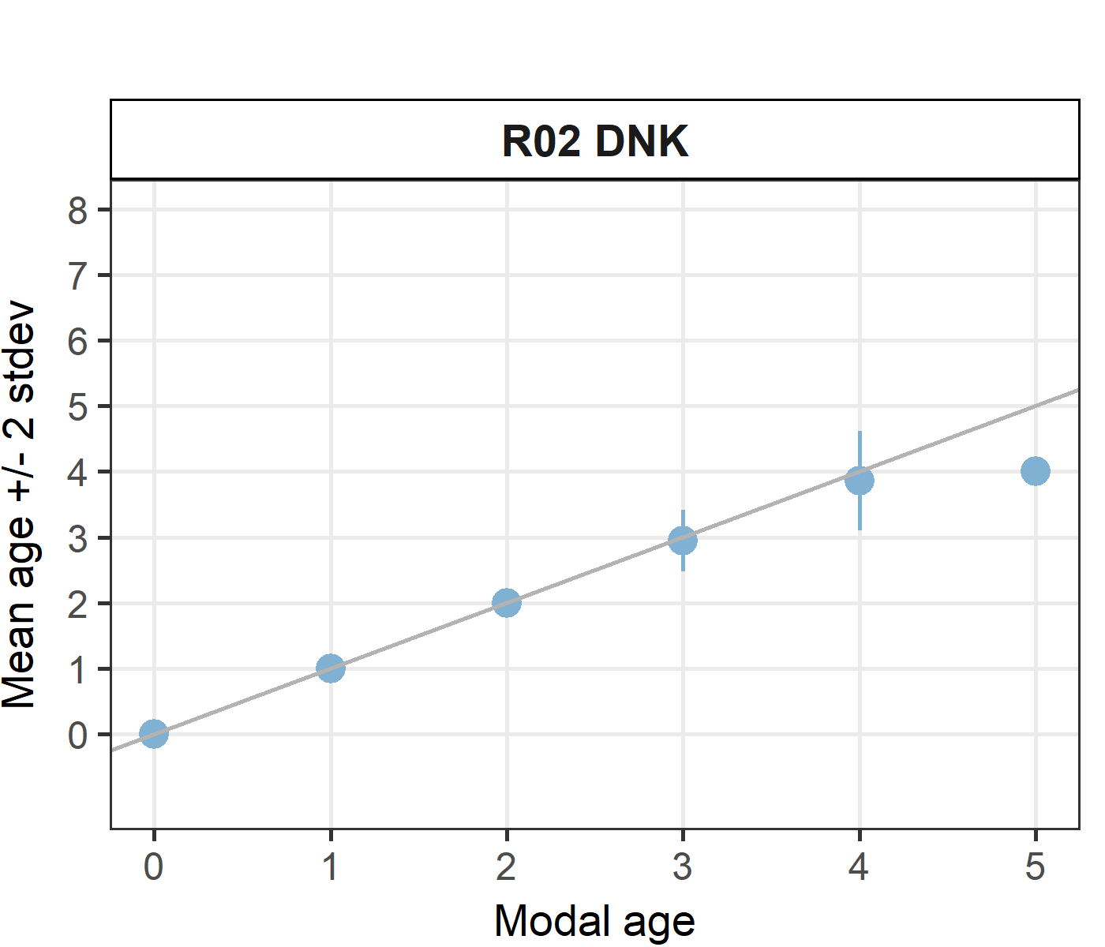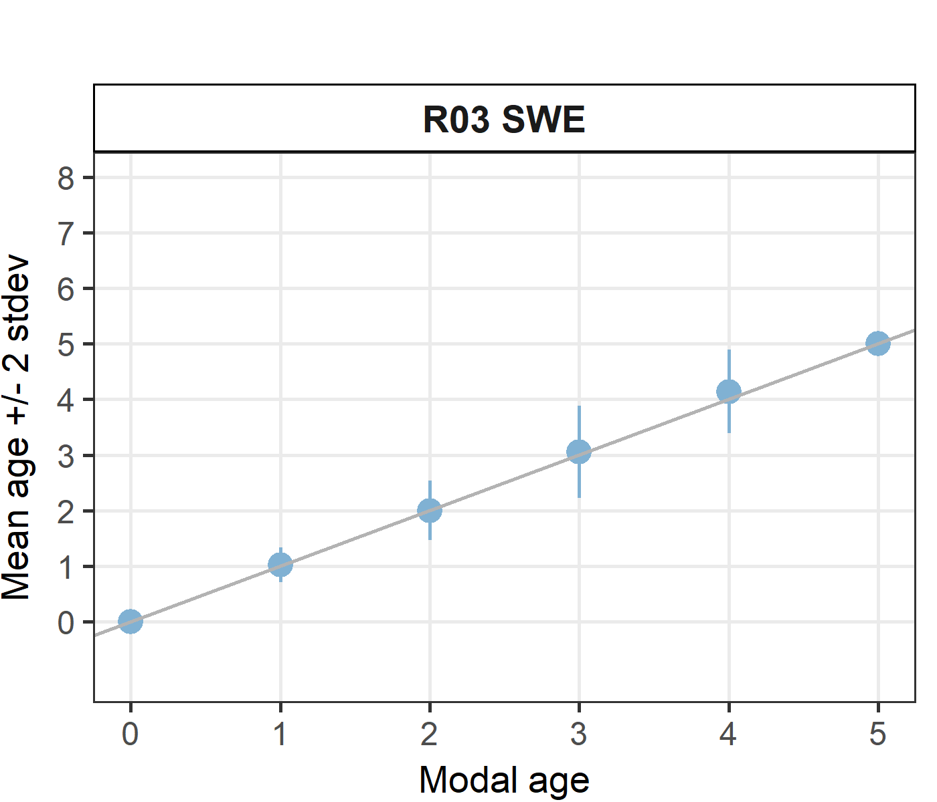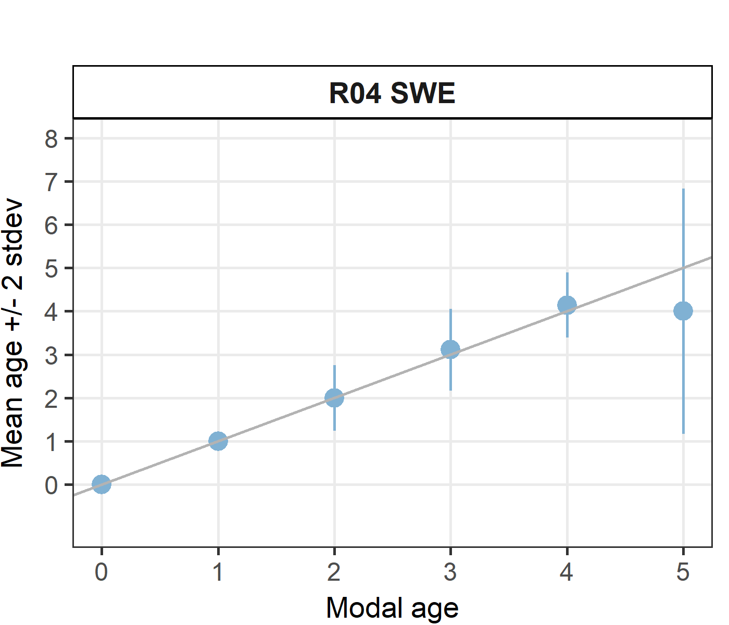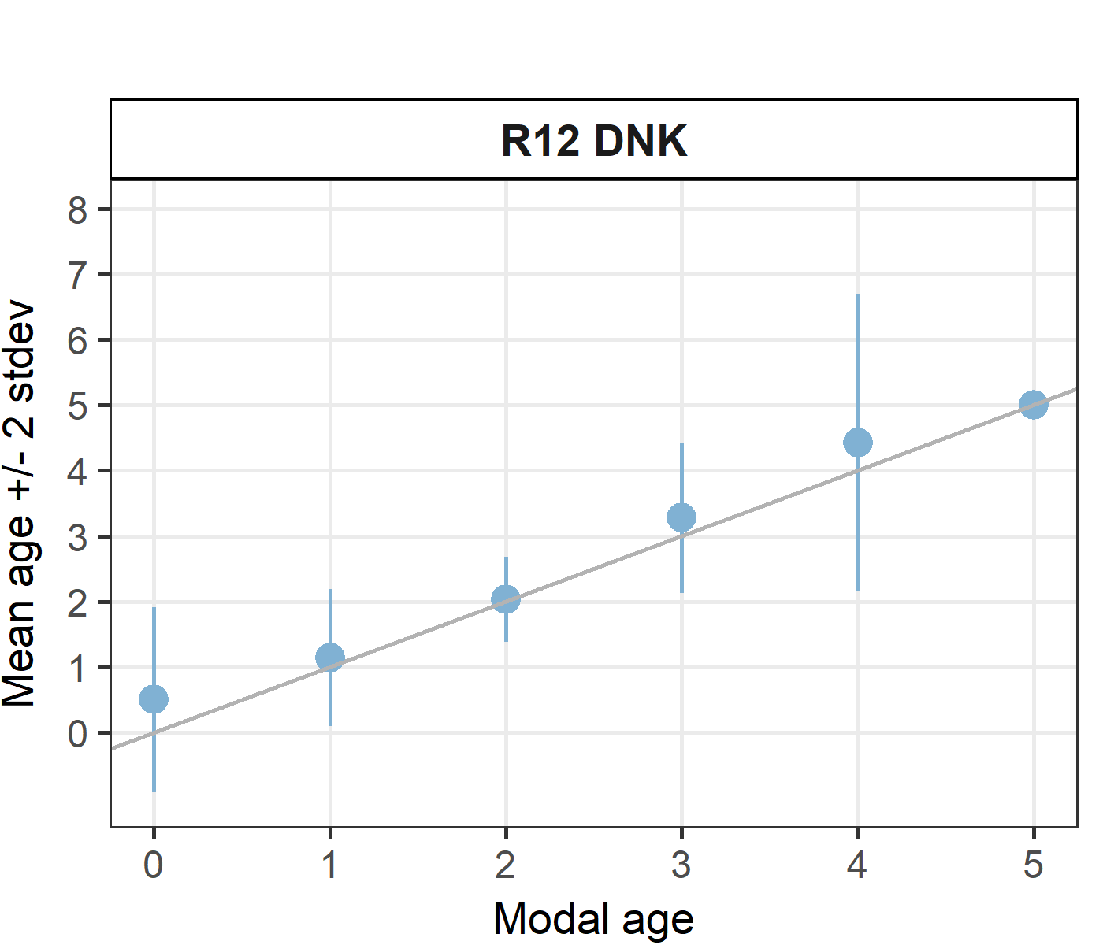

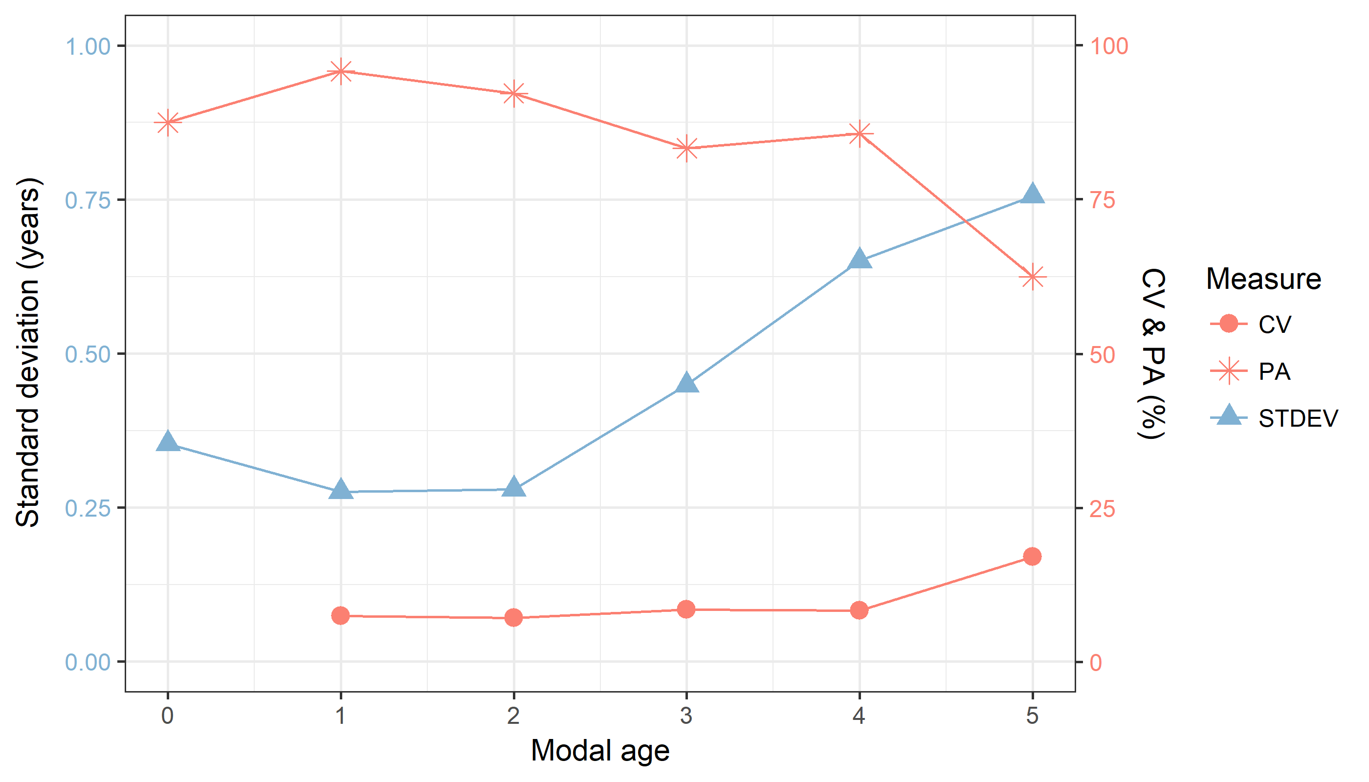

**Figure X:** CV, PA and (STDEV (standard deviation) are plotted against modal age

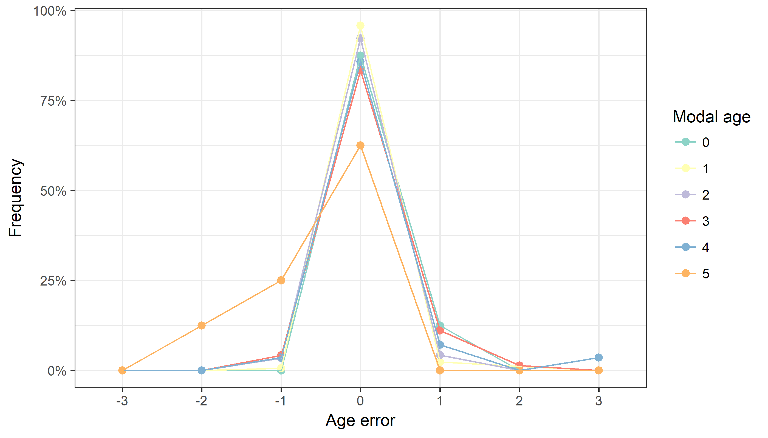

**Figure X:** The distribution of the age reading errors in percentage by modal age as observed from the advanced age readers in an age reading comparison to modal age. The achieved precision in age reading by modal age group is shown by the spread of the age readings errors. There appears to be no relative bias, if the age reading errors are normally distributed. The distributions are skewed, if relative bias occurs.

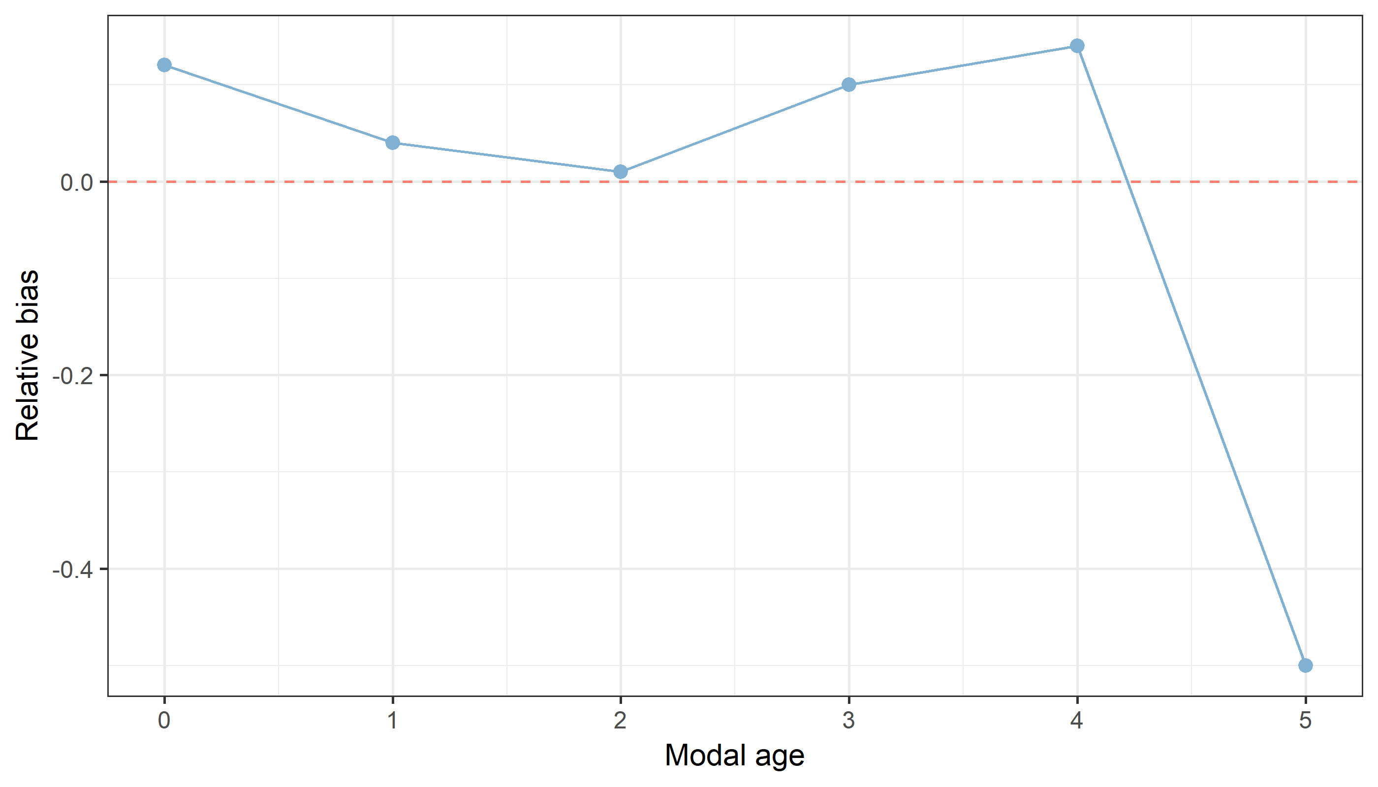

**Figure X:** The relative bias by modal age as estimated by all age readers combined.

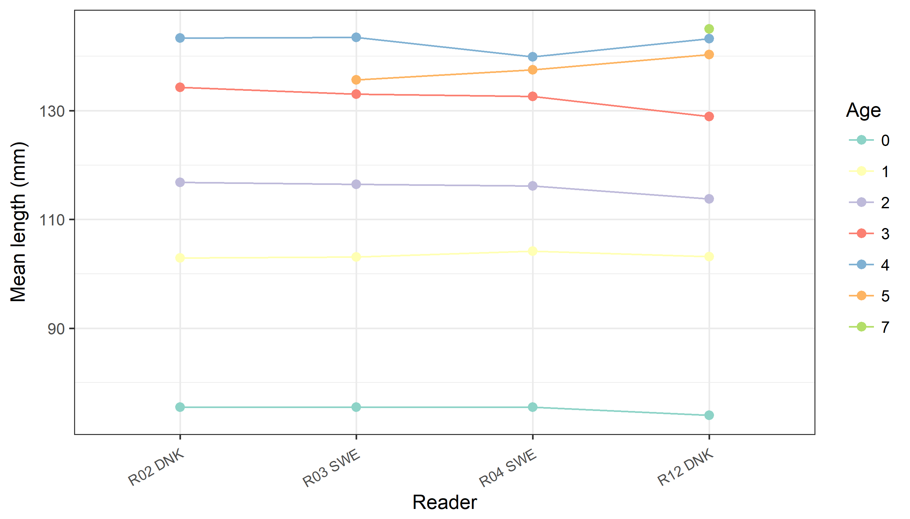

**Figure X:** The mean length at age as estimated by each age reader only including advanced readers.

# Annex 4. ToRs for next meeting

# Annex 5. Recommendations

# Annex 6. Report specific annexes