**Camera Arm Control - MZIRBC20**

**Meeting and Update Notes**

**10/15: Sandesh Banskota**

Purchased Hardware:

- Servo-Arm: <https://www.adafruit.com/product/1967?gclid=EAIaIQobChMI_4H3zKaB5QIVhK7ICh2JmAAJEAQYByABEgLSl_D_Bw>

- ELP USB Camera Module

Parts to Explore:

1. Mediating Micro Controller (with CAN):

a. Teensy 3.2

2. CAN Transceiver to Read from CAN Bus

* <https://www.mouser.com/>
* Clarify as to if CAN transceiver is needed on both the microcontroller side and the computer side

Rough System Model:

Servo-Arm <==Power and Control Input==> Micro-Controller (decipher CAN messages and send input to servo arm) <===CAN BUS===> NVIDIA JETSON (ECU)

**10/18: Sandesh Banskota**

**Hardware to Purchase:**

**- 12 V Desk Power Supply**

* [**https://www.amazon.com/KORAD-KD3005D-Precision-Adjustable-Regulated/dp/B00FPU6G4E/ref=sr\_1\_1?keywords=power+supply+with+limits&qid=1571410411&s=hi&sr=1-1**](https://www.amazon.com/KORAD-KD3005D-Precision-Adjustable-Regulated/dp/B00FPU6G4E/ref=sr_1_1?keywords=power+supply+with+limits&qid=1571410411&s=hi&sr=1-1)
* **[https://www.amazon.com/Switching-Regulated-Temperature-Protection-Alligator/dp/B07JQXQ8S5/ref=cm\_cr\_arp\_d\_product\_top?ie=UTF8#detail-bullets](https://www.amazon.com/Switching-Regulated-Temperature-Protection-Alligator/dp/B07JQXQ8S5/ref=cm_cr_arp_d_product_top?ie=UTF8" \l "detail-bullets)**

**- 24 – 12 V Converter for Drone**

* **Linear Regulator vs Buck Converter**
  + **Linear Regulator is less efficient and generates heat. Doesn’t produce electromagnetic interference**
  + **Buck converter is efficient and doesn’t produce as much heat. However, it produces EMF**
* **Yazhe suggests that in the past even the EMF generated from the camera has caused issues. Therefore, it is likely better to buy linear regulator over buck converter.**
* **Power usage of the jetson can range from:**
  + **Voltage Range = 5.5 V-19.6 V**
  + **Power Range = 7.5 W – 15 W**
  + **Current consumption: Up to 1.5 A**
* **Yazhe thinks I should also get a buck converter just in case:**
  + **https://www.digikey.com/product-detail/en/texas-instruments/LM2576T-12-NOPB/LM2576T-12-NOPB-ND/149008**
* **The following linear converters can work:**
  + **https://www.digikey.com/product-detail/en/microchip-technology/MIC29300-12WT/576-1118-ND/771587 (buy multiple just in case)**

**- USB mini-hub**

* **https://cdn-shop.adafruit.com/product-files/2991/FE1.1s+Data+Sheet+(Rev.+1.0).pdf**

**- Microcontroller**

* **This needs to be a microcontroller with CAN Bus covered**
  + **Options are Teensy 3.2:**
    - [**https://www.digikey.com/product-detail/en/sparkfun-electronics/DEV-13736/1568-1231-ND/5721426**](https://www.digikey.com/product-detail/en/sparkfun-electronics/DEV-13736/1568-1231-ND/5721426) **(buy two just in case, if we have enough money?)**

**- Tranceiver**

* **Although the CAN reader within the microcontroller and jetson can read CAN messages, they can’t write onto the bus without a tranceiver**
* [**https://www.digikey.com/product-detail/en/microchip-technology/MCP2562-E-P/MCP2562-E-P-ND/4079966?utm\_adgroup=Integrated%20Circuits&slid=&gclid=EAIaIQobChMIt8-KzNCm5QIVBeXICh3x3gJ9EAAYASAAEgKZIPD\_BwE**](https://www.digikey.com/product-detail/en/microchip-technology/MCP2562-E-P/MCP2562-E-P-ND/4079966?utm_adgroup=Integrated Circuits&slid=&gclid=EAIaIQobChMIt8-KzNCm5QIVBeXICh3x3gJ9EAAYASAAEgKZIPD_BwE) **(4 of these just in case)**

**10/20/19: Sandesh Banskota**

**Powering the Jetson:**

* **Use a buck converter to efficiently step down the voltage from 24 to 12 V, then use a linear regulator to ensure a cleaner power supply. Not sure how the Jetson handles this. This might be the best way to go.**
* **I will use the LM2576T-12 as the buck converter, and then use the linear regulator.**

**Yazhe also told me to buy wires and supplies. Here are some supplies needed for fabrication:**

* **Perfboards + Screw Terminal**
  + [**https://www.amazon.com/Miuzei-Including-Prototype-Connector-Terminal/dp/B07PS4VCDD/ref=sxbs\_sxwds-stvp?crid=XWLKEZAFCETA&keywords=perfboard+prototyping+board&pd\_rd\_i=B07PS4VCDD&pd\_rd\_r=6c2e6307-f847-47e4-9e4b-cdb665a406e5&pd\_rd\_w=HrCrJ&pd\_rd\_wg=Hb2zT&pf\_rd\_p=a6d018ad-f20b-46c9-8920-433972c7d9b7&pf\_rd\_r=VKJ2X8HSSNEXH3RYZ9CR&qid=1571586941&sprefix=perfboard%2Caps%2C166**](https://www.amazon.com/Miuzei-Including-Prototype-Connector-Terminal/dp/B07PS4VCDD/ref=sxbs_sxwds-stvp?crid=XWLKEZAFCETA&keywords=perfboard+prototyping+board&pd_rd_i=B07PS4VCDD&pd_rd_r=6c2e6307-f847-47e4-9e4b-cdb665a406e5&pd_rd_w=HrCrJ&pd_rd_wg=Hb2zT&pf_rd_p=a6d018ad-f20b-46c9-8920-433972c7d9b7&pf_rd_r=VKJ2X8HSSNEXH3RYZ9CR&qid=1571586941&sprefix=perfboard%2Caps%2C166)
* **Jumper Wires**
  + [**https://www.amazon.com/TUOFENG-Wire-Solid-different-colored-spools/dp/B07G2JWYDW/ref=sr\_1\_27?keywords=jumper%2Bwires&qid=1571587344&s=industrial&sr=1-27&th=1**](https://www.amazon.com/TUOFENG-Wire-Solid-different-colored-spools/dp/B07G2JWYDW/ref=sr_1_27?keywords=jumper%2Bwires&qid=1571587344&s=industrial&sr=1-27&th=1)

**10/24/2019: Sandesh Banskota**

Powering the Jetson:

* Looked over potential circuit for the buck converters integration

Software:

* Installed Arduino and Teensyduino

**10/25/2019: Sandesh Banskota**

Accomplished:

* Soldered Teensy to headers
* Completed wiring to servo arm for testing
* Configured Teensy and Teensyduino to get code to run

TODO:

* Get Servo Arm Moving

**10/28/2019: Sandesh Banskota**

Accomplished:

* Debugged the wiring harness and got the arm to move.
* Servo library does not work for moving arm? Or does it?

TODO:

* Improve code to add functionality such as manual movement.
* Create a strategy

**11/14/2019: Sandesh Banskota**

Accomplished:

* Soldered another teensy
* Set up CAN bus with tranceiver.
* Tried to test CAN bus with original code using FlexCan library but did not work
* Create diagram for electrical system

TODO:

* Create strategy for getting CAN to work
* Look for an oscilloscope for the lab
* Order actual terminating resistor.
* Order capacitor to reduce noise in power.

**11/15/2019: Sandesh Banskota**

Accomplished:

* Got new parts ordered

**11/20/2019: Sandesh Banskota**

Accomplished:

* I got CAN communication between the two teensies and displayed the messages live on the serial monitor.
* Some things to note is that one of the teensies is not able to send messages. I might have messed up the pin.
* The standby pin on the CAN tranceiver needs to be grounded in order to allow full CAN communication.
* I also figured out that the code is relatively simple.

TODO:

* Get the CAN bit to Servo PWM control figured out.
* Utilize the new hardware to cleanup things.
* Get the power supply connectors ready to be powered from both wall and also from battery/linear regulator/etc – VERY important
* Start figuring out the algorithm for object following.

**12/03/2019:**

Accomplished:

* Utilized both the linear regulator and buck convertor for a power circuit.
* I might just only use a buck convertor for now – so I should get the parts ordered to make the noise minimum:

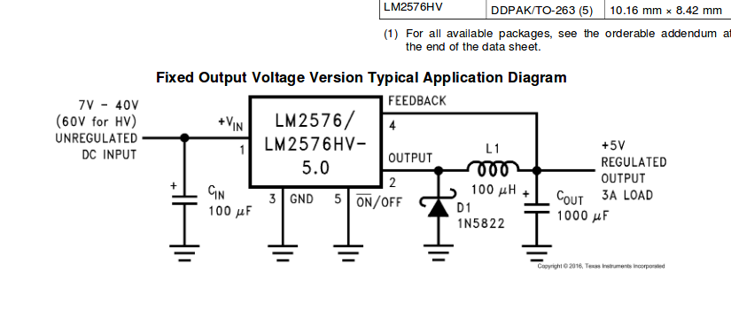

* Put the orders in for: 100 microfarad cap,