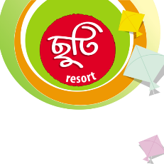

**Chuti Resort Gazipur**

Chuti Resort, Sukundi, Amtoli, Joydebpur.

**ROOM TARIFF**

|  |  |  |  |  |
| --- | --- | --- | --- | --- |
| **TYPE** | **No of Room** | **Pax Per Room** | **Rate Per Room (BDT)** | **Net Rate Per Room (BDT)** |
| **ROYAL SUITE** | 01 | 04 | 16,000++ | 20,240 |
| **EXECUTIVE SUITE** | 02 | 02 | 8,000++ | 10,120 |
| **FAMILY SUITE** | 04 | 03 | 8,500++ | 10,735 |
| **PRIVILEGED SUITE** | 01 | 02 | 6,500++ | 8,222 |
| **PLATINUM KING** | 01 | 02 | 7,500++ | 9,487 |
| **PREMIUM TWIN** | 11 | 02 | 7,000++ | 8,855 |
| **SUPER DELUXE** | 02 | 02 | 6,500++ | 8,222 |
| **TOTAL** | **22** | **50** |  |  |

*** Please note that our Check-in Times 10:00 pm & Check-out Times 12:00 noon. For late check out after 12.30pm 50% (half day) room charge would be applicable.

*** Early check in and late checkouts subject to availability.

**SERVICE  INCLUDED:**

¤ Complimentary breakfast for night staying guest only.  
¤ Swimming Pool  
¤ High-Speed Internet  
¤ Under 04 year’s child accommodation is complementary with family  
¤ Country Boating facility, Kids Zone, Playground.

**SERVICE EXCLUDED:**

¤ Extra Bed BTD 1500/- ++ per bed.  
¤ Live Boul Song Could be arranged (Prior booking is required) and would be charged.  
¤ Stage, Decoration and any others services (if required) that are not mention here would also be charged separately as per authorize tariff.