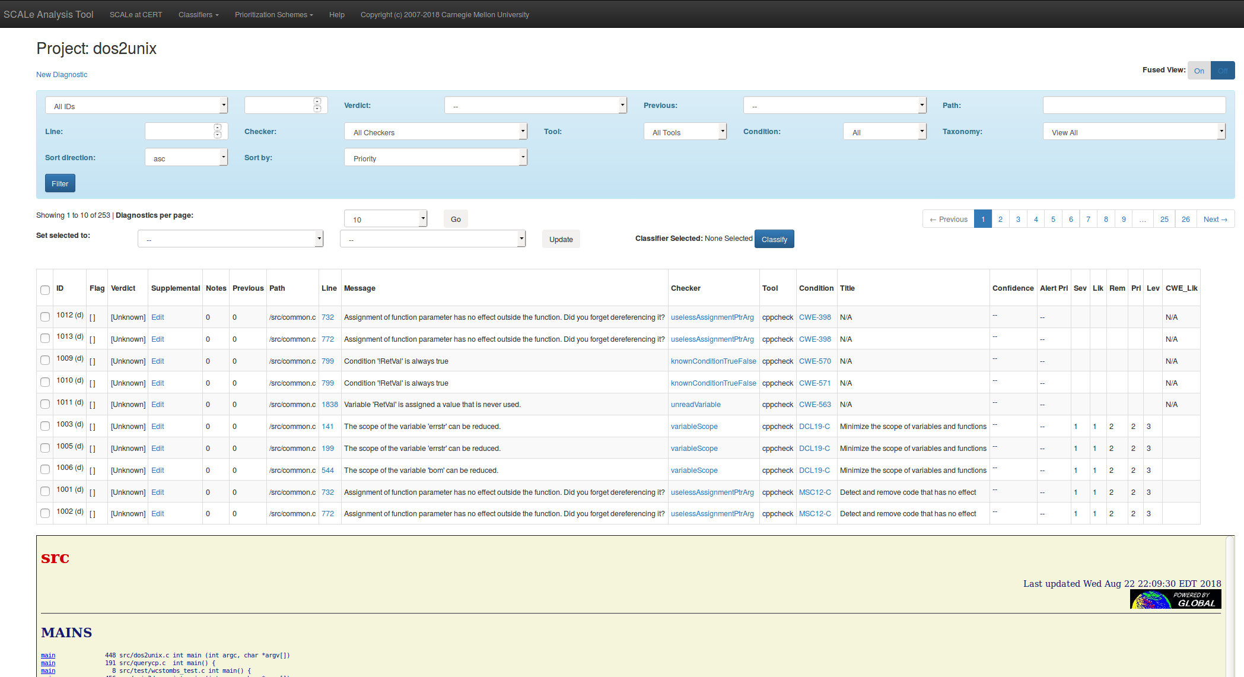

**Middle Menu**

**Top Menu**

**Source Code Viewer**

**Alert List**

**Alert Filters**