|  |  |  |  |
| --- | --- | --- | --- |
| Volume 2 | Issue 5  Aug. 1, 2018   |  |  | | --- | --- | | Maddie’s Note: | What’s up everyone! This issue will be a preview of the ASA events coming up this year, as well as a look at all the fun things our members did over the summer!! (ft. some of my border doodles ☺) Board Introduction For all of our new members, here is an introduction to your current board members!    If you need anything or have any questions about ASA or the events coming up, feel free to contact any of the members. Our social media chair, Janice, will also be posting overviews of each member on Instagram, so be sure to follow us at @cmu_asa! | | ASA Summer Newsletter |
| Sept. 2nd, 2018 | OLDPThe official Labor Day party of 2018 is here! Spend the holiday partying it up with your friends at Club Xtaza. Don’t miss it; it is one of the most iconic moments of every young ASA member’s CMU experience.     Here is the beautiful banner designed by your Design Chair, Vicky! Thai Tea Fundraiser Come support us by buying some delicious Thai Iced Tea in the UC! If you just want to help out, that’s okay too – just contact a board member. |

|  |  |
| --- | --- |
| Summer 2018 | Summer Activities!Our members did a plethora of amazing things over the summer all around the world, so let’s take a look at what a few of us did!Jade Ahn Image may contain: Jade Jungsoo Ahn, smiling, outdoor  This past summer, I worked in the CERLAB with two graduate students. In my group, we designed a wall climbing robot for inspection purposes on ships. Using magnets, we were able to build a segment of the robot that can move freely in 90 degree concave and convex angles as well as 180 degree platforms. I also was the CMU Pre-College RA, which allowed me to meet and mentor high school students. |

|  |  |
| --- | --- |
| Summer 2018 | Andy Shen Image may contain: one or more people and outdoor  I interned at a semiconductor IP solutions firm here in Pittsburgh as a software engineer and was also an orientation counselor!! Eugene Choi https://scontent.fagc1-2.fna.fbcdn.net/v/t1.15752-9/41959054_266317614222435_654523930391871488_n.jpg?_nc_cat=108&oh=310465b3a793642472b0229cb04d3581&oe=5C6271AB  Two summers ago, I visited Korea to reconnect with the culture and the language. There I met people from all over the world, who I still talk to today. We went all around Korea and met hundreds of people and did tons of activities! |

# Jeffrey Chiu

 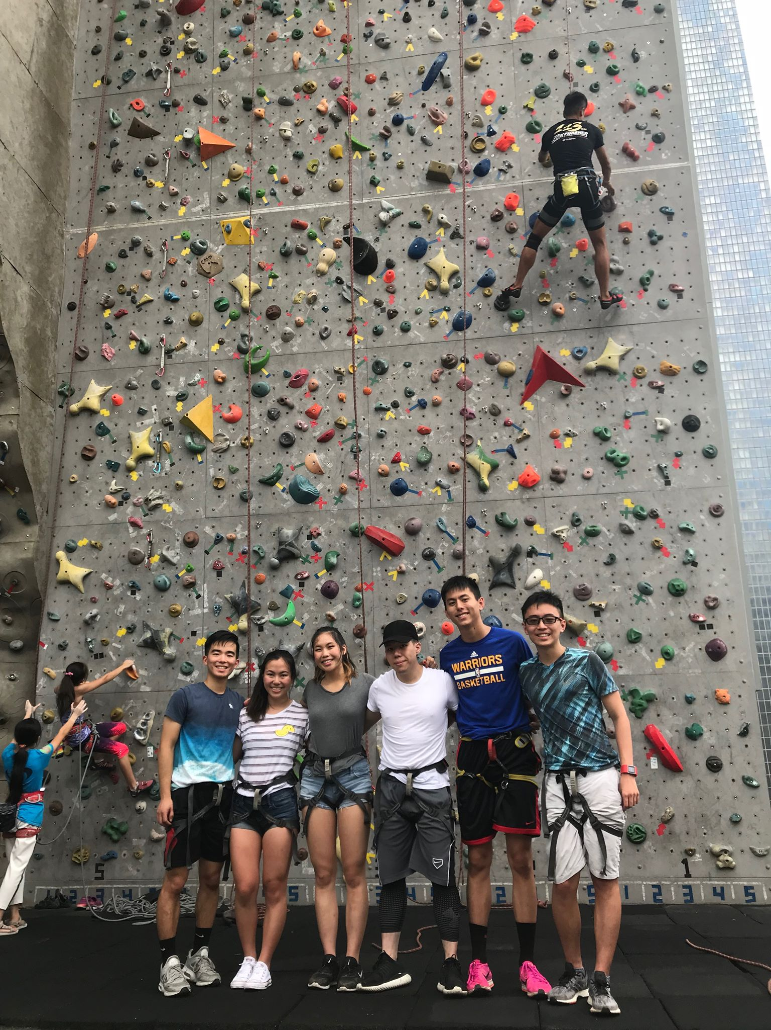



I spent the last 6 weeks of my summer working in Taiwan! I have extended family that lives in Taiwan so I've been there before, but this was my first time going back alone, without family. I was able to explore a lot of different places and experience a lot of new things in Taiwan that I haven't done before, and it was really fun to spend the summer in a foreign country!

Thanks for reading and stay supa tight,

Mads