Revision History
Date | Version | Description | Author
07/03/2014 | 1.00 | First version | Umut Uzgur
08/03/2014 | 1.01 | Corrections | Çelebi Murat
09/03/2014 | 2.00 | Information updated, charts added  Needs: Overview needs to be written, Proofing | Uğur Özkan

TABLE OF CONTENTS

Revision History 1
1 Identification 3
1.1 Document overview 3
1.2 Abbreviations 3
1.2.1 Abbreviations 3
1.3 References 3
1.3.1 Project References 3
2 Software Development Activities 3
2.1 Software development process 3
2.1.1 Overview of process phases 3
2.1.2 Technical documentation 4
2.1.3 Deliverables: 4
2.2 Software development tools 4
2.2.1 Workstation 4
2.2.2 Requirements management and documentation 4
2.2.3 Software Design 4
2.2.4 Coding and automated tests 4
2.2.5 Configuration management 5
2.3 Software development rules and standards 5
3 Responsibilities 5
3.1 Activities and responsibilities 5
4 Risk Assessment 6
4.1 Risk Analysis & Planning 6

Identification

Document overview
This document contains the software development plan of software Twitter Desktop Streamer.

Abbreviations

Abbreviations
TDS: Twitter Desktop Streamer
GUI: Graphical User Interface
API: Application Program Interface
SRS: Software Requirements Specification

References

Project References

# | Document Identifier | Document Title
[R1] | ID | Add your documents references.  One line per document

Software Development Activities
The section lists and describes the software development activities of TDS software development project.

Software development process
The software development process chosen for the project is the Waterfall programming model.
The waterfall programming model was chosen for the reasons below:
- TDS is a small project
- Control is needed for every step of TDS
- Coordination is required for TDS
- Need to save time and effort for TDS
- Need to keep knowledge if team members leave before TDS is completed
Based on above reasons, Waterfall Programming Model is the best candidate for TDS.

Overview of process phase s
- Requirements Specification : Document which contains complete description of project that user wants and constraints on design and implementation
- Software Design : Planning a software solution based on the constraints came from SRS
- Implementation : Bringing together the components (I.e. Code implementation)
- Testing : Appling series of different cases on product in order to prove its correctness
- Deployment : Making the product available to users, combining databases
- Maintenance : Modification of the software after release

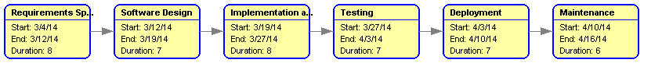
Figure 1: Software Development Phases with Duration
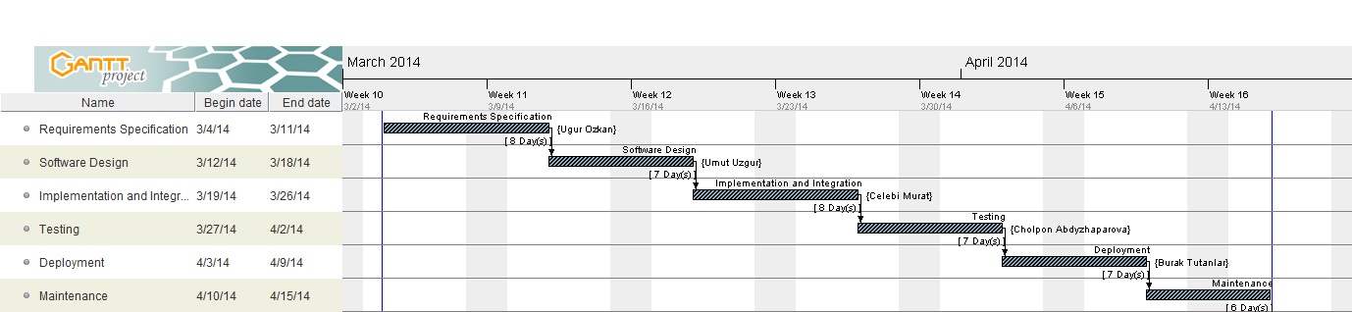
Figure 2: Development Phases with Coordinators

Technical documentation
The following documentation is produced during the design phases:
- Software specification: SRS, IRS, STP,
- Software detailed conception: updated SRS, SDD, IDD, updated STP, STD
- Coding and unit tests: STR of unit tests
- Software tests phases: STR, VDD.

Deliverables:
The following items are delivered at the end of the process:
- Technical documentation (SRS, STP, SDD, STR, SDP),
- Working system
- User documentation: user guide, administration procedures and installation procedure,
- Software and its configuration files.
- Github records
- Bug Files

Software development tools

Workstation
- Ubuntu (13.10), Windows (7 & 8), Mac

Requirements management and documentation
- Gantt Project : Used when preparing charts
- Github, Dropbox: Used as storage
- MS Word, LibreOffice : Used when preparing documents
- Gmail : Used for communication

Software Design
- ObjectAid UML Generator, Argo UML : Used for software design and graphs

Coding and automated tests
- Eclipse Standard Kepler 4.3.2 Version : Codes were written on Eclipse
- Subversive-SVN Team Provider 1.1.2 : Used when committing files to Github
- JAVA : Programming language
- Twitter JAVA API : Used when integrating Twitter to the project
- JUnit : Used for testing

Configuration management
- Github, SVN: Revision control based storage (https://github.com/cmurat/CS320-Project) Hierarchical folder system used (I.e. Documents and Implementation separated).
- Bugzilla: Web-based general-purpose bug-tracker. Used for testing and keeping track of the status of bugs/issues
- Task Focused Interface :

Software development rules and standards
Following rules were applied:
- We avoided code smells and excessive use of comments.
- Naming
  - Use readable & meaningful names (e.g. password)
  - Use Camel Notation (e.g. userName)
  - Class and Interface names have to start with uppercase letters (e.g. MouseListener)
  - Use all uppercase names with underscore for constants (e.g. MAX_NUMBER)
  - Methods should have verb or verb phrases (e.g. fetchTweets() )
  - Classes should have name or name phrases (e.g. User, Tweet)
- Functions
  - Functions should do only one thing.
  - Line numbers should be between 4-20 but not more than 20.
  - Parameters should not exceed 3.
  - No duplication
- Comments
  - Refactor code instead of writing comment for it
  - Use comments for warning, usage and TODO
  - Don’t use redundant comments

- We used hierarchical folder system.
- Documents and implementations separated.
- Same naming convention is used as code implementation.

- Structural organization is applied.
- Every week there were at least one meeting
- Everybody had a specific role beside helping the others
- Codes/Documents should be submitted at least 8 hours before the meeting

Responsibilities

Activities and responsibilities

Activity | Responsibility | Comment
Project management | Çelebi Murat | Responsible for organization and progress of the project
Analysis and documentation | Uğur Özkan | Responsible for keeping track of information, analyzing information and writing necessary documents
Setting up the Development tools | Çelebi Murat | Responsible for setting the suitable environment
Software Development | Umut Uzgur,  Cholpon Abdyzhaparova | Responsible for developing the software
GUI Design | Burak Tutanlar,  Uğur Özkan | Responsible for GUI
Testing | Cholpon Abdyzharova,  Umut Uzgur | Responsible for testing the project
Maintenance | Çelebi Murat,  Burak Tutanlar | Responsible for maintaining the system after all processes complete

Besides the responsibilities above, every person has to contribute to every stage of the development. Below distribution of workloads among different phases of the project is shown with respect to people.
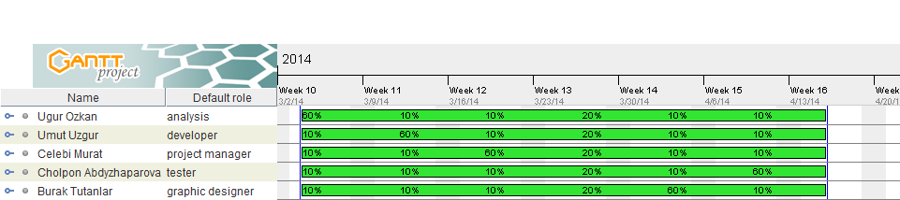
Figure 3 : Resources and workloads

Risk Assessment

Risk Analysis & Planning
Risk | Probability | Effect | Strategy
Time required to finish the project is underestimated | Low | Serious | Increasing working hours
API is not compatible with expectations | Low | Very Serious | Find another API
Team member withdrawing from CS320 | Low | Tolerable | Reorganize team so that there is more overlap of work and people therefore understand each other’s jobs.
Size of the software is underestimated | Moderate | Serious | Increasing working hours
Change in regulatory policies of the Turkish government over Internet | Moderate | Serious | Using VPN services.

