Revision History
Date | Version | Description | Author
15/03/2014 | v1.00 | User Requirements Added | Umut Uzgur
15/03/2014 | v1.01 | User Requirements Updated | Burak Tutanlar
15/03/2014 | v2.00 | Conventions Added, System Requirements Added | Çelebi Murat,  Cholpon Abdyzhaparova
16/03/2014 | v2.01 | Requirements Organized | Çelebi Murat
17/03/2014 | v2.02 | Requirements Updated | Umut Uzgur,  Çelebi Murat
18/03/2014 | v2.03 | Requirements updated, typos fixed | Uğur Özkan
18/03/2014 | v2.04 | Conventions updated, requirements reviewed | Burak Tutanlar
18/03/2014 | v2.05 | Non-functional requirements added | Cholpon Abdyzhaparova
18/03/2014 | v2.06 | Charts and Introduction part added | Çelebi Murat
18/03/2014 | v2.07 | System overview added | Uğur Özkan

TABLE OF CONTENTS
Revision History 1
1 INTRODUCTION 3
1.1 Document overview 3
1.2 System overview 3
1.3 Abbreviations 3
1.4 References 3
1.5 Conventions 3
2 REQUIREMENTS 5
2.1 User Requirements Specification 5
2.2 System Architecture 9
2.3 Use Cases and Usage Scenarios 11
2.4 System Requirements Specification 11

INTRODUCTION

Document overview
This Software Requirements Specification document contains the following information about Twitter Desktop Streamer Project:
- User Requirement Specifications: Describes the services provided for the user, both functional and non-functional requirements are included.
- System Architecture: Presents a high-level overview of the anticipated system architecture, showing the distribution of functions across system modules.
- Use Case and Usage Scenarios: relevant UML use case diagrams and sequence diagrams that depict the usage scenarios of the system.
- User Requirement Specifications: Describes the functional and nonfunctional requirements in more detail.

System overview
Twitter Desktop Streamer is an all-in-one interface where users organize and build timelines, searches and more. Twitter Desktop Streamer works with Twitter by allowing users to send and receive tweets and view profiles.

Abbreviations
TDS: Twitter Desktop Streamer
SRS: Software Requirements Specifications
ID: Identification Key

References
# | Document Identifier | Document Title
1 | Doc #1 | Software Development Plan

Conventions
User requirements listed in this document are constructed according to the following structure:
User Requirement Id
User Requirement title
User Requirement description

User Requirement version

Example:
SRS-TDS-000
Title of XXX-000 requirement
Description of XXX-000 requirement

Version of XXX-000

Every system requirement id includes the id of the corresponding user requirement as a prefix.
System requirements listed in this document are constructed according to the following structure:
System Requirement Id
System Requirement title
System Requirement function
System Requirement description
System Requirement inputs
System Requirement source
System Requirement outputs

System Requirement version

Example:
SRS-TDS-000.1
Title of TDS-000.1 system requirement, which is related to the user requirement TDS-000

Function:
Description:
Inputs:
Source:
Outputs:
VX.X

REQUIREMENTS

User Requirements Specification
SRS-TDS-001
TDS Login

TDS shall provide a procedure to users to login with their Twitter account. (TDS generates a link for authentication purposes.User needs to follow the link and continue authentication process in webpage. In the webpage user needs to provide its username and password. If username and password are correct, the website generates a key, which user needs to write into TDS. When user inputs the key into TDS the authentication process is completed and user is redirected to home page)

V1.0
SRS-TDS-002
TDS Timeline Display

TDS shall allow users to see their timelines

V1.0
SRS-TDS-003
TDS Mention Display

TDS shall allow users to see their mentions

V1.0
SRS-TDS-004
TDS Profile Display

TDS shall allow users to see other users' public profiles

V1.0
SRS-TDS-005
TDS Search

TDS shall allow users to search for tweets and other users

V1.0

SRS-TDS-006
TDS Tweet Options

TDS shall allow users to favorite or retweet tweets

V1.0
SRS-TDS-007
TDS Profile Settings

TDS shall allow users to change their profile pictures and profile names

V1.0
SRS-TDS-08
TDS Post Tweet

TDS shall allow users to post tweets

V1.0
SRS-TDS-09
TDS Delete Tweet

TDS shall allow users to delete tweets

V1.0
SRS-TDS-010
TDS Send Message

TDS shall allow users to send direct messages

V1.0
SRS-TDS-011
TDS Display Messages

TDS shall allow users to see their direct messages

V1.0
SRS-TDS-012
TDS Follow

TDS shall allow users to follow other users

V1.0
SRS-TDS-013
TDS Unfollow

TDS shall allow users to unfollow other users

V1.0
SRS-TDS-014
TDS Delete Authentication

TDS shall allow users to delete their authentication information

V1.0

Non-Functional Requirements:
SRS-TDS-015
Timeline refresh

TDS should refresh the timeline in every 30 seconds

V1.0

SRS-TDS-016
Direct Message Limit

Maximum number of Direct Messages per day is 250

V1.0
SRS-TDS-017
Tweet Post Limit

Maximum number of Tweets per day is 1000

V1.0

SRS-TDS-018
Changes in account email

Maximum number in account email is 4 per hour

V1.0

System Architecture

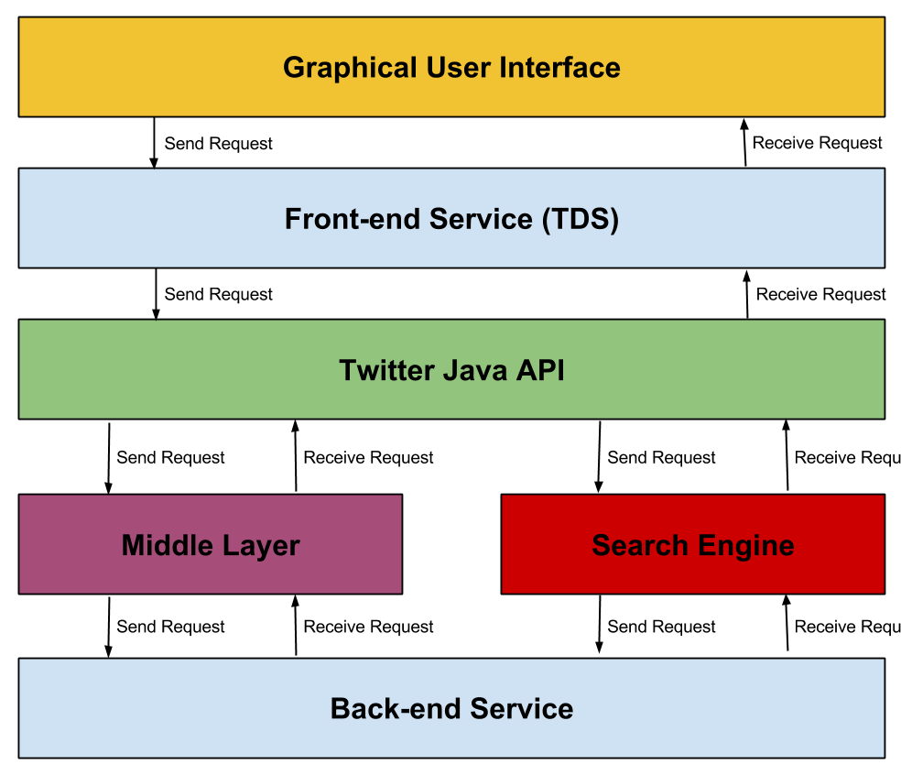
Figure 1: System Architecture
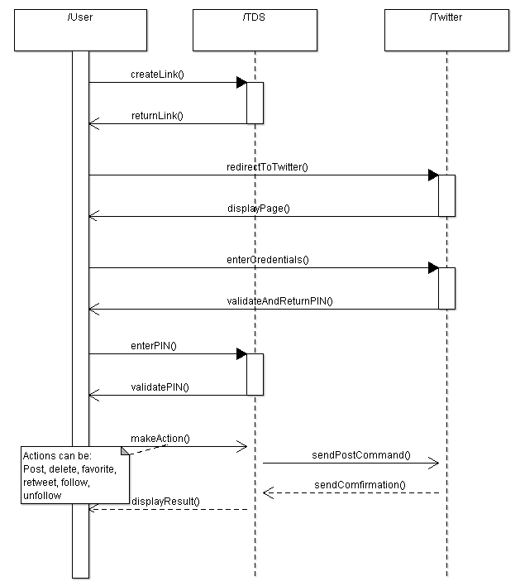
Figure 2: Sequence Diagram

Use Cases and Usage Scenarios
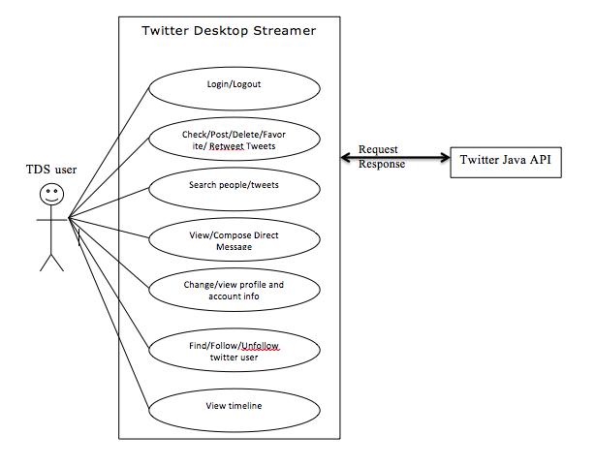
Figure 3: Use Case Diagram

System Requirements Specification
SRS-TDS-001.1
Generate Link

Function: Link Generation
Description: Generating link for application authentication
Inputs: Consumer Key, Consumer Secret
Source: Program Memory
Outputs: Hyperlink
V1.0

SRS-TDS-001.2
Authentication

Function: Wait for key
Description: Wait for the proper authentication key to be entered
Inputs: Authentication key
Source: User
Outputs: None
V1.3

SRS-TDS-002.1
Timeline Request

Function: Request User Timeline
Description: TDS shall send a request to Twitter’s streaming API to get the user’s timeline
Inputs: User-ID of the user
Source: Program Memory
Outputs: None
V1.0

SRS-TDS-002.2
Acquire Timeline

Function: Retrieve Response for User Timeline
Description: TDS shall receive a response from Twitter’s streaming API containing user’s timeline
Inputs: None
Source: None
Outputs: User’s timeline
V1.0

SRS-TDS-002.3
Display Timeline

Function: Load Recent Tweets
Description: Loading tweets exist in user’s timeline
Inputs: A collection of the most recent Tweets in user’s timeline
Source: TDS Memory
Outputs: User’s timeline
V1.1
SRS-TDS-003.1
Mention Request

Function: Request Mentions
Description: TDS shall send a request to Twitter’s streaming API to get user’s mentions
Inputs: User-ID of the user
Source: Program Memory
Outputs: None
V1.0

SRS-TDS-003.2
Acquire Mentions

Function: Retrieve Response for User Mentions
Description: TDS shall receive a response from Twitter’s streaming API containing user’s mentions
Inputs: None
Source: None
Outputs: User’s mentions
V1.0

SRS-TDS-003.3
Display Mentions

Function: Load Mentions
Description: Loading mentions exist in user’s timeline
Inputs: A collection of the mentions
Source: TDS Memory
Outputs: User’s mentions
V1.1

SRS-TDS-004.1
Profile Request

Function: Request User Profile
Description: TDS shall send a request to Twitter’s streaming API to get the user’s profile
Inputs: User-ID of the user
Source: Program Memory
Outputs: None
V1.0

SRS-TDS-004.2
Acquire Profile

Function: Retrieve Response for User Profile
Description: TDS shall receive a response from Twitter’s streaming API containing user’s profile
Inputs: None
Source: None
Outputs: User’s profile
V1.0

SRS-TDS-004.3
Display Profile

Function: Load Profile
Description: Loading user profile
Inputs: Parsed information of user profile
Source: TDS Memory
Outputs: User’s profile
V1.1

SRS-TDS-005.1
Send Query

Function: Send Query
Description: TDS shall send a query to Twitter’s streaming API to get the searched information
Inputs: Search Keyword
Source: User
Outputs: None
V1.0

SRS-TDS-005.2
Acquire Results

Function: Retrieve Response
Description: TDS shall receive a response from Twitter’s streaming API containing result of the query
Inputs: None
Source: None
Outputs: Query result
V1.0

SRS-TDS-005.3
Display Query Result

Function: Load Result
Description: Loading query result
Inputs: Parsed query result
Source: TDS Memory
Outputs: User names or tweets
V1.1

SRS-TDS-006.1
Favorite Tweet

Function: Marking tweets favorite
Description: TDS should enable the user to review tweets and mark them favorite
Inputs: Tweet ID
Source: TDS
Outputs: None
V1.0

SRS-TDS-006.2
Retweet

Function: Retweeting.
Description: TDS should enable the user to review tweets and retweet them.
Inputs: Tweet ID
Source: TDS
Outputs: None
V1.0

SRS-TDS-007.1
Profile Settings

Function: Changing profile information of the user
Description: User will be able to change the profile settings
Input: String and/or picture
Source: User or computer
Output: None
V1.0

SRS-TDS-008.1
Post Tweet

Function: Get tweet input from user and post it into user`s twitter account.
Description: TDS shall allow the user to post tweets.
Inputs: String input (max 140 characters) or/and picture
Source: User
Outputs: None
V1.1

SRS-TDS-009.1
Delete Tweet

Function: Deleting selected tweet from user account
Description: TDS should enable the user to delete tweet from user account
Inputs: Tweet ID
Source: TDS
Outputs: None
V1.0

SRS-TDS-010.1
Send Message

Function: Composing and sending direct messages to other twitter users
Description: TDS should enable the user to compose and send direct messages to other twitter user
Inputs: String
Source: User
Outputs: None
V1.0

SRS-TDS-011.1
Request Messages

Function: Request list of direct messages
Description: TDS should enable the user to review direct messages sent to/received from other users
Inputs: User ID
Source: TDS
Outputs: None
V1.0

SRS-TDS-011.2
Receive Messages

Function: Receive Messages
Description: TDS shall get the direct messages of the user
Inputs: None
Source: None
Outputs: List of Messages
V1.0

SRS-TDS-011.3
Display Messages

Function: Display Messages
Description: TDS shall display the messages of the user
Inputs: List messages
Source: TDS
Outputs: None
V1.0
SRS-TDS-012.1
Follow Users

Function: Following other Twitter users
Description: TDS should enable the user to find other twitter users and follow them by clicking follow button
Inputs: User ID
Source: TDS
Outputs: None
V1.0

SRS-TDS-013.1
Unfollow Users

Function: Unfollowing other twitter users
Description: TDS should enable the user to unfollow followed people by clicking unfollow button
Inputs: User ID
Source: TDS
Outputs: None
V1.0

SRS-TDS-014.1
Delete Credentials

Function: Delete credentials
Description: User will be able to delete their credential contained within TDS
Input: User ID
Source: TDS
Output: None
V1.0

