Twitter iPhone Client
CS 430
Requirements Specification
February 15th, 2011

Sean Adams
Ryan Colosimo
Nathan Gladysz
James Smith

Table of Contents
Table of Contents 2
1.0 Introduction 4
1.1 Goals and Objectives 4
1.2 Statement of Scope 4
1.3 Software Context 5
1.4 Major Constraints 5
2.0 Usage Scenario 5
2.1 User Profiles 5
2.2 Use-Cases 6
2.3 Special usage considerations 8
3.0 Data Model and Description 8
3.1 Data Description 8
3.1.1 Data Objects 8
3.1.2 Relationships 9
3.1.3 Complete data model 10
3.1.4 Data Dictionary 11
4.0 Functional Model and Description 11
4.1 Functional Descriptions 11
4.1.1 Login 11
4.1.2 Logout 11
4.1.3 Display Feed 11
4.1.4 Compose Message 11
4.1.5 Insert Image 12
4.1.6 Take Photo 12
4.1.7 Insert Audio Clip 12
4.1.8 Display Mentions 12
4.1.9 Search 13
4.1.10 Display Direct Messages 13
4.1.11 Display Trending Topics 13
4.1.12 Display Preferences 13
4.2 Software Interface Description 13
4.2.1 External machine interfaces 13
4.2.2 External system interfaces 13
4.2.3 Human interface 14
4.3 Control flow description 14
5.0 Behavioral Model and Description 14
5.1 Description of Software Behavior 14
5.1.1 Events 14
5.1.2 States 15
6.0 Restrictions, Limitations and Constraints 16
7.0 Validation Criteria 16
7.1 Classes of tests 17
7.1.1 Incorrect username 17
7.1.2 Incorrect password 17
7.1.3 Invalid Tweet entered 17
7.1.4 Invalid search entered 17
7.2 Expected software response 17
7.2.1 Incorrect username/incorrect password 17
7.2.2 Invalid Tweet entered 17
7.2.3 Invalid search entered 17
7.3 Performance bounds 18

1.0 Introduction
This document is for the purpose of introducing and explaining the Twitter Client for the iPhone. This application will provide the user with a way to use their normal Twitter web interface from a dedicated iPhone application so that the user can quickly and easily get up to date with their favorite social network. Since every iPhone comes preinstalled with an app store application, we will possibly be offering the app for download by its completion. The application will be running on top of the iOS which is run on every iPhone and will therefore need to adhere to iOS specific environment capabilities and/or restrictions.

1.1 Goals and Objectives
This iPhone application’s goal is to enable the user to be able to quickly and easily check, write, and browse their personal Tweets from their current Twitter user account. Not only do we want the application to be a fully functional client but to also be visually appealing, intuitive, and helpful.

1.2 Statement of Scope
The scope of this project will mainly be within the realm of the Twitter API that we will be using. The inputs for the application will originate from both the user as they type in tweets and search engines and also from the Twitter database as it sends the user their friends’ updates and other user specific information. Outputs will include the application interface as it displays the information to the user and data uploads generated by the user to the Twitter database. The majority of the applications data processing will be text display, sending, and receiving.

1.3 Software Context
Ultimately this software project is in the context of a commercial product even though it could have applications for business strategy and marketing. With that in mind we must make it a priority to appeal to the current culture’s tastes and needs. Even though there are no set requirements from a stakeholder, if the application does not appeal to the general iPhone owner browsing the app store then no one will buy it making the app worthless.

1.4 Major Constraints
Apple’s app store has some set requirements that any application that is submitted to be sold must meet. This does put some restrictions on what libraries of code we can use; however, any restrictions the app store has will most likely not affect our final product. The only other possible source of constraint would be the Twitter API; however, it is reportedly very complete and functional so we should have no problem with providing the services we want with it.

2.0 Usage Scenario

2.1 User Profiles
Given the fact that iOS applications are not interoperable with any other OS, any user will necessarily be an iPhone owner. Amongst the iPhone owner crowd, there is only one type of user for this application. This is because Twitter users have only one mode of user activity. Ultimately, the person using the app will be any individual with ownership of a personal or corporate Twitter account who wishes to use Twitter’s social networking capabilities easily in the palm of their hand.

2.2 Use-Cases
Figure 1 shows the use case diagram of the interaction between the app and the iPhone user. Figure 2 shows the interaction between the application and the Twitter data base.
Twitter App
Login/Logout

iPhone user
Check/Post Tweets
View Trending Topics
View Private Messages
View/Change Settings
View Who To Follow

Search

Twitter DB

Retrieve Profile Pages

App System
Auto Retrieve Recent Tweets

Auto Retrieve Messages
Retrieve Trending Topics Page

Send Messages

Retrieve/Set Settings

Send Follow Request
Authentication

2.3 Special usage considerations
The only requirements besides having an iPhone will be having a Twitter account and internet access.

3.0 Data Model and Description

3.1 Data Description
The Twitter client will use several different data objects while in operation. The data objects that are while used inside the Application will be the main driving force of the client. They will provide all the information the user wants to see based on what he or she inputs.

3.1.1 Data Objects
The User – The user is the main data object of the client’s system. The user will log into the client by supplying a username and password. If the user does not already have a Twitter account, then they will have to create one in order to log into the client. After logging in, the user will then be able to use a search box for any anything they may want to search for, or they can enter a new Tweet for their own account. The user will also be able to select who to follow, and whether or not to allow someone to follow them.
User’s Twitter Page - The user’s Twitter page is an important data object in regards to the client. This is where all the users Tweets are displayed and also the list of whom he or she is following or who is following them. As the user enters new Tweets or someone tags his or her name in a Tweet, the page will change. The new page must be updated every time a change occurs.
Tweet – A Tweet is another data object. A Tweet will be input by the user of the client. A Tweet can be any sort of text as long as it is under the maximum number of characters allowed per Tweet. A newly entered Tweet will appear on the user’s Twitter page upon submission.
Other Twitter Pages – Other pages on Twitter are also data objects. The user will be able to access other pages by either searching or clicking a linked page on their page. The client would not be appealing if only the user’s page could be accessed, so ability to access other pages is essential. A trending topics page will be very useful to the user because it will keep them up to date on what is popular.

3.1.2 Relationships
Figure 3 in section 3.1.3 shows the relationships between the data objects of the Twitter client. The user will enter a Tweet that can be seen by themselves and anyone who is following them. If the user is tagged in a tweet it will immediately be viewable by the user. The user has the ability to search for other Twitter pages by using a search box.

3.1.3 Complete data model
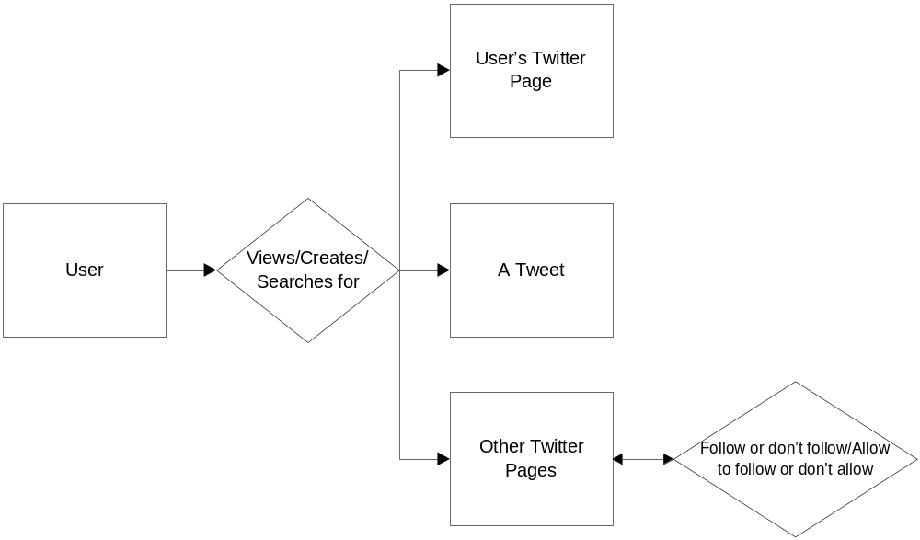

3.1.4 Data Dictionary
The Twitter client will store data only in one location. The only data that will be stored will be the user’s username and password to increase ease of access. The tweets that the user enters and the tweets that the user is tagged in will all be handled by the Twitter API that we will be working with. The searches that the user submits do not need to be saved, so they will not be.

4.0 Functional Model and Description
The following section will describe the major functions which make up the Twitter client. This section will also include interface and user interaction descriptions.

4.1 Functional Descriptions
This section will discuss the various functions within the Twitter client.

4.1.1 Login
A user will enter his/her credentials into the proper fields and the user will be logged into the Twitter system. User will be given option to remember credentials so further input at startup is not necessary.

4.1.2 Logout
When the user clicks logout all personal data will be removed and all program data will be wiped. The user’s password will be removed and the user will be forced to re-enter their credentials at next startup.

4.1.3 Display Feed
Once the user has successfully logged into the Twitter system, the users Twitter feed will be displayed on the screen. The number of previous data displayed will be preset by the user in the preferences pane.

4.1.4 Compose Message
A new view will display and show a composition window with various rich text and multimedia options. The user can then enter his/her tweet and submit it to the Twitter system. The tweet will be immediately displayed on the users feed.

4.1.5 Insert Image
When in the composition window, the user will be prompted with an image picker which will allow the user to insert an image from the users device.

4.1.6 Take Photo
When in the composition windows, the camera display will be shown and once the image is taken, the user will be given the option to keep re-taking. If the user keeps the photo it will be used in the composition window, if the user selects re-take, the photo will be deleted and the camera display will be shown again.

4.1.7 Insert Audio Clip
The user will be prompted to insert existing voice memo or take a new voice memo.

4.1.7a Insert Existing
The user will be prompted with a clip picker so the user may select a pre-existing clip on their device.

4.1.7b Record New
The user will be shown the voice memo window in which he/she may record a new voice memo. The user will then have the option to hear the voice memo before submitting. Once listened to, the user may select keep or re-record. If the user decides to keep the memo, the memo will be inserted into the composition window. If the user decided to re-record, the memo will be removed and the user will be shown the voice memo window again.

4.1.8 Display Mentions
This function will display all mentions of the users handle (or username) in the Twitter system.

4.1.9 Search
This function will display a search window in which the user can search for specific words in Tweets. The window will also offer the ability to search for users on Twitter.

4.1.10 Display Direct Messages
This window will display the users Direct Message (or DM) inbox. This function will also allow the user to compose a new message, delete current messages, and read existing messages in greater detail.

4.1.11 Display Trending Topics
This function will display topics which are currently trending on twitter. The order of the topics will be determined by the items rise in popularity over a given timeline.

4.1.12 Display Preferences
This function will display a preferences view which will contain various settings which the user may change based on preference.

4.2 Software Interface Description
The Twitter client will be run only on iOS devices and will have only one interface. Although the device may run on iOS devices with greater screen resolution, the application will be designed for the iPhone/iPod Touch.

4.2.1 External machine interfaces
The Twitter client will run natively on all iOS devices, including the iPod touch and iPad. The client will be designed specifically for the iPhone/iPod Touch but it will retain the same functionality on the iPad.

4.2.2 External system interfaces
The Twitter client will rely heavily on the Twitter API for retrieval of user data. The client must work closely with the Twitter systems to authenticate and deliver content. The client will be designed to work with the latest API available and compatibility is guaranteed with and iOS device running the latest version of iOS.

4.2.3 Human interface
The client will utilize a common design theme throughout the entire system. The application will contain multiple views, each of which will serve some primary function. Each of these interfaces will differ only in content, but will maintain similar design themes. The interface will utilize a fluid and robust interface, it will be easy to understand and will not require a tutorial for first-use (although one will be provided).

4.3 Control flow description
The control flow for the system is presented with reference to Section 5.0 of this document.

5.0 Behavioral Model and Description
A description of the behavior of the software is presented.

5.1 Description of Software Behavior
A detailed description of major events and states is presented in the following section.

5.1.1 Events

A listing of events (control, items) that will cause behavioral change within the system is presented as follows:

5.1.1.1 User Creates Twitter Account

New user creates a Twitter account to log into the application

5.1.1.2 Login

User with existing account, or a newly created one, enters his or her credentials to log into the application and subsequently Twitter. App then authenticates user.

5.1.1.3 Tweet button is pressed
When a user selects tweet, a user input box is generated in which he or she can compose a 140 character tweet.

5.1.1.4 View Trending Topics is pressed

When a user selects this option current trending topics on Twitter are displayed.

5.1.1.5 View Direct Messages is pressed

This action displays personal, direct, direct messages for the user.

5.1.2 States

5.1.2.1 Authenticate User

Using OAth, application verifies user credentials.

5.1.2.2 Retrieve Tweets
Upon logging in to the application, or after a preset amount of time, tweets are retrieved from twitter using the API.

5.1.2.3 Post Tweet
User’s tweet is posted to twitter using the API.

5.1.2.4 Display Tweets Timeline

This default state of the application display the user’s twitter time line.

A listing of states (modes of behavior) that will results as a consequence of events is presented.

6.0 Restrictions, Limitations and Constraints

As developers of a Twitter client for an iPhone, we are restricted, limited and constrained by Twitter’s “Developer Rules of the Road” – as well as Apple’s iPhone development policies. Such limitations, restrictions and constraints can be summarized as follows.

“Using the Twitter API and Twitter Content are subject to certain limitations on access, calls, and use of the Twitter API as set forth on dev.twitter.com or as otherwise provided to us by Twitter. “

As a Twitter service our software must not “surprise users”, create or distribute spam, protect and respect user privacy, and ” be a good partner to twitter”. We must follow the display guidelines. As a part of complying with Twitter’s principle of not creating or distributing spam we must abide by Twitter’s spam and automation rules. Furthermore we must not enable or support the publication of links to malicious content or pornography or other obscene images. We must clearly disclose what we are doing with information collected from users. Furthermore, we must not facilitate or encourage the publishing of private or confidential information.

End users must log into Twitter using OAuth. New users, users without a Twitter account, must have the opportunity to create a new account provided by the twitter. We “must clearly display the end user's Twitter identity. Twitter identity includes visible display of the end user's avatar, Twitter user name, and a Twitter "t" mark.”
We must: “respect user content -- Tweets may be used in advertisements, not as advertisements” and “respect user experience -- build your service around the timeline, not in the timeline.” A user’s permission is required to use their Tweet on a commercial durable good or product - or within an advertisement, that implies the sponsorship or endorsement.

7.0 Validation Criteria
This section lists the various tests that will be conducted on the software. The tests are done to ensure the software is working properly, and how it will handle possible errors that may occur.

7.1 Classes of tests

7.1.1 Incorrect username
This error occurs when the user inputs an incorrect username when prompted.

7.1.2 Incorrect password
This error occurs when the user input an incorrect password when prompted.

7.1.3 Invalid Tweet entered
This error occurs when the user enters a blank Tweet or a Tweet that contains too many characters.

7.1.4 Invalid search entered
This error occurs when the user incorrectly enters a search.

7.2 Expected software response

7.2.1 Incorrect username/incorrect password
If the user enters an incorrect username or password while logging in, an error message will appear saying, “Incorrect login information”, and the user will be prompted to enter them again.

7.2.2 Invalid Tweet entered
If the user enters a null Tweet, an error message will appear saying, “No text entered”, and the user will be asked to enter a Tweet. If the user enters a Tweet that contains too many characters, an error message appear saying, “Too many characters entered”, and the user will be asked to decrease the number of characters in the Tweet.

7.2.3 Invalid search entered
If the user enters a search that produces no results, an error message will appear saying “No results found”, and the user will be prompted to search again.

7.3 Performance bounds
A major bound on the performance of the Twitter client is speed of the application. The speed of the application will depend on the network that is available in the user’s location. There are areas that the user will not be connected to a network, and when the user is in these certain areas the application will not work at all. The performance of the application is bounded by speed, and the performance will be better in locations that have high speed network connection. Performance will be subpar in locations with a low speed network connection.

