Revision History
Date | Version | Description | Author
07/03/2014 | 1.00 | First version | Umut Uzgur
08/03/2014 | 1.01 | Corrections | Çelebi Murat
09/03/2014 | 2.00 | Information updated, charts added  Needs: Overview needs to be written, Proofing | Uğur Özkan
10/03/2014 | 2.01 | Software overview reviewed and updated | Burak Tutanlar
10/03/2014 | 2.02 | Abbreviations added, Coding standards updated | Umut Uzgur
10/03/2014 | 2.03 | Information updated, style & design fixed  Needs: Mac version(2.2.1), Task Focused UI info(2.2.6), Folder hierarchy picture(2.3), new Gantt Chart (3.1), Proofing | Uğur Özkan
11/03/2014 | 2.04 | Risk Analysis & Planning updated  Workstations updated  Task Focused Interface canceled  Needs: workstation specifications | Burak Tutanlar
11/03/2014 | 2.05 | Charts are added.  Workstation specs are added.  Description v2.04 updated. | Çelebi Murat
11/03/2014 | 2.06 | Charts were added, style issues fixed, typos fixed. | Uğur Özkan
11/03/2014 | 2.07 | Abbreviations were updated. Risk analysis & Activities and Responsibly Table were updated. Typos fixed. | Cholpon Abdyzhaparova
11/03/2014 | 2.08 | Staff Allocation Chart added. | Uğur Özkan
11/03/2014 | 2.09 | Tasks chart added. | Çelebi Murat

TABLE OF CONTENTS

1 Identification 3
1.1 Document overview 3
1.2 Abbreviations 3
1.2.1 Abbreviations 3
1.3 References 3
1.3.1 Project References 3
2 Software Development Activities 3
2.1 Software development process 3
2.1.1 Overview of process phases 3
2.1.2 Technical documentation 5
2.1.3 Deliverables: 5
2.2 Software development tools 5
2.2.1 Workstation 5
2.2.2 Target System 5
2.2.3 Requirements management and documentation 5
2.2.4 Software Design 5
2.2.5 Coding and automated tests 5
2.2.6 Configuration management 5
2.3 Software development rules and standards 6
3 Responsibilities 6
3.1 Activities and responsibilities 6
4 Risk Assessment 8
4.1 Risk Analysis 8
4.2 Risk Planning 8

Identification

Document overview
This Software Development Plan contains the following information about Twitter Desktop Streamer Project:
- Software Development Process – explains development schedule, defines the major phases, technical documentations and deliverables.
- Software Development Tools – explains the workstations to development, management and documentation requirements, software design tools, coding & testing tools and management tools for configurations.
- Activities and Responsibilities – describes the organizational structure of the team.
- Risk Analysis & Planning – describes the estimated risks, risk analysis and the possible solution strategies as suitable precautions.

Abbreviations

Abbreviations

TDS: Twitter Desktop Streamer
GUI: Graphical User Interface
API: Application Program Interface
SRS: Software Requirements Specification
SDP: Software Development Plan
STP: Software Test Plan
SDD: Software Design Document
STR: Software Test Report
OS: Operating System
SDK: Software Development Kit

References

Project References

# | Document Identifier | Document Title
[R1] | ID | Add your documents references.  One line per document

Software Development Activities
The section lists and describes the software development activities of TDS software development project.

Software development process
The software development process chosen for the project is the Waterfall programming model.
The waterfall-programming model was chosen for the requirements of the course.

Overview of process phases
- Requirements Specification: Document which contains complete description of project that user want and constraints on design and implementation
- Software Design: Planning a software solution based on the constraints came from SRS
- Implementation: Bringing together the components (i.e. Code implementation)
- Testing: Applying series of different cases on product in order to prove its correctness
- Deployment: Making the product available to users, combining databases
- Maintenance: Modification of the software after release

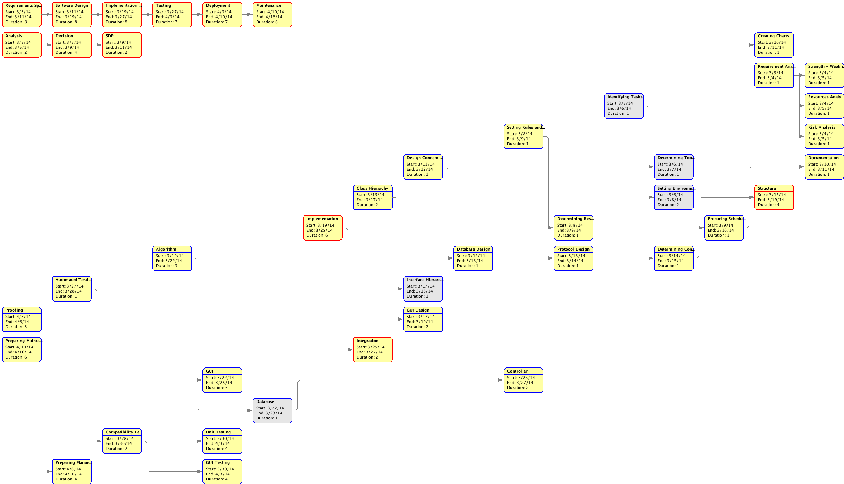

Figure 1: Software Development Phases According to Starting Time.

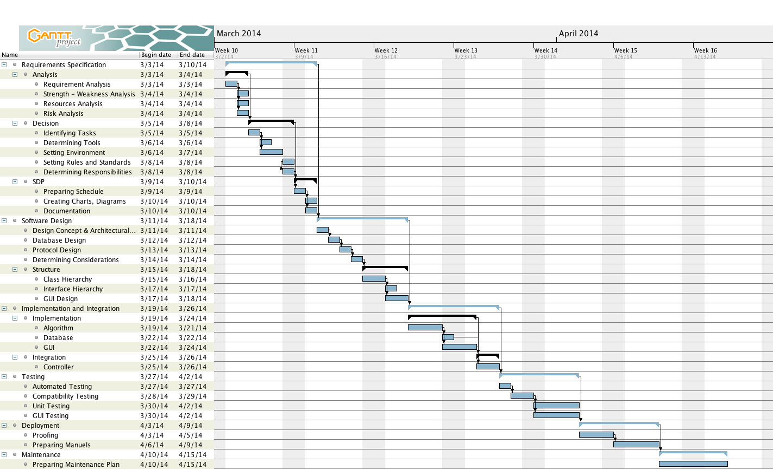
Figure 2: Development Phases

Technical documentation
The following documentation is produced during the design phases:
- Software specification: SRS
- Software detailed conception: updated SRS, SDD, updated STP
- Coding and unit tests: STR of unit tests
- Software tests phases: STR

Deliverables:
The following items are delivered at the end of the process:
- Technical documentation (SRS, STP, SDD, STR, SDP),
- User documentation: user guide, administration procedures and installation procedure,
- Software and its configuration files.
- Github records
- Bug Files

Software development tools

Workstation
- HP – HP 650, Intel Pentium CPU B960 @ 2.20GHz, 4GB RAM, Ubuntu 13.10
- HP – HP 650, Intel Pentium CPU B960 @ 2.20GHz, 4GB RAM, Windows 7
- HP – HP 650, Intel Pentium CPU B960 @ 2.20GHz, 4GB RAM, Windows 8.1
- Toshiba – Satellite C640, Intel Core i5 CPU @ 2.30GHz, 4GB RAM Windows 7
- Apple – MacBook Pro – Intel Core i7 @ 2.5 GHz, 8 GB RAM, OS X 10.8.5

Target System
All OS that is compatible with Java SDK 6.

Requirements management and documentation
- Gantt Project: Used when preparing charts (Gantt Project Home Page)
- Github, Dropbox: Used as a storage
- MS Word (2010 & 2013), LibreOffice (v4.1.3.2): Used for preparing documents
- Gmail: Used for communication

Software Design
- ObjectAid UML Generator, Argo UML: Used for software design and graphs

Coding and automated tests
- Eclipse Standard Kepler (4.3.2 Version): Codes were written on Eclipse
- Subversive-SVN Team Provider 1.1.2: Used when committing files to Github
- JAVA: Programming language
- Twitter JAVA API: Used when integrating Twitter to the project
- JUnit: Used for testing

Configuration management
- GitHub, SVN: Revision control based storage (GitHub Project Page) Hierarchical folder system used (I.e. Documents and Implementation separated).
- GitHub Issue Tracker: Web-based general-purpose issue-tracker. Used for testing and keeping track of the status of bugs/issues

Software development rules and standards
Following rules will be applied:
- Coding criteria will be followed as which is described in the following link
  - Coding Criteria
- We use folder system as follows:
  - Documents and implementations are separated.
  - Same naming convention is used as code implementation.
- Structural organization is applied.
  - Every week there will be at least one meeting
  - Everybody has a specific role beside helping the others
  - Codes/Documents will be submitted at least 8 hours before the meeting

Responsibilities

Activities and responsibilities

Activity | Responsibility | Comment
Project management | Çelebi Murat | Responsible for organization and progress of the project
Analysis and documentation | Uğur Özkan | Responsible for keeping track of information, analyzing information and writing necessary documents
Setting up the Development tools | Çelebi Murat | Responsible for setting up suitable environments
Software Development | Umut Uzgur,  Cholpon Abdyzhaparova | Responsible for developing the software
GUI Design | Burak Tutanlar,  Uğur Özkan | Responsible for GUI development & design
Testing | Cholpon Abdyzharova,  Umut Uzgur | Responsible for testing the project
Maintenance | Çelebi Murat,  Burak Tutanlar | Responsible for maintaining the system after all processes complete

Besides the responsibilities above, every person has to contribute to every stage of the development. Below distribution of workloads among different phases of the project is shown with respect to people.

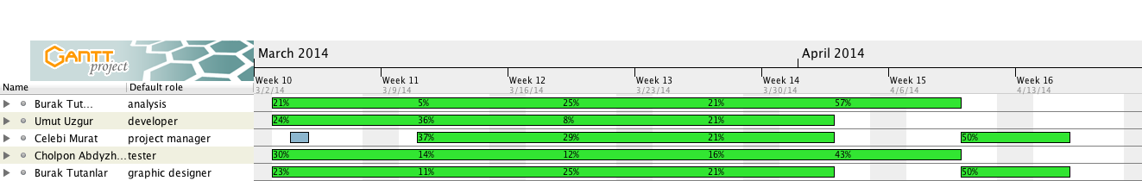
Figure 3: Resources and workloads

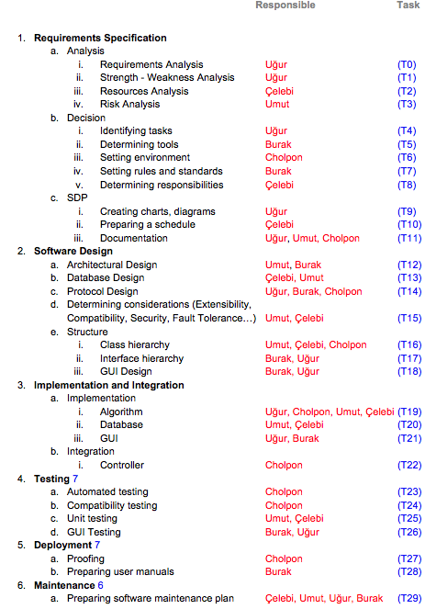
Figure 4: Tasks

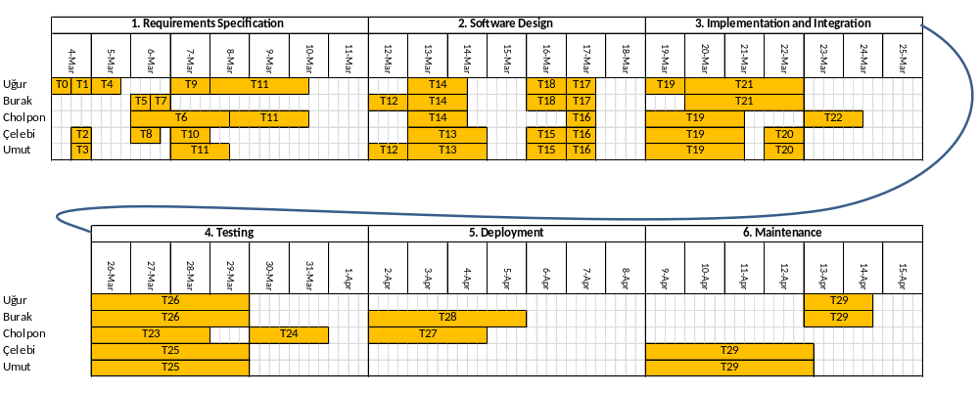

Figure 5: Staff Allocation Chart

Risk Assessment

Risk Analysis
Risk Type | Risk | Prob. | Effect
Estimation | Time required to finish the project is underestimated | Low | Serious
Technology | API is not compatible with expectations | Low | Very Serious
People | Team member withdrawing from CS320 | Low | Tolerable
Estimation | Size of the software is underestimated | Moderate | Serious
Policy | Change in regulatory policies of the Turkish government over Internet | Moderate | Serious
People | Required training for staff is not available | Low | Moderate
Requirements | Changes in requirements, which require major design rework, are proposed. | Moderate | Moderate

Risk Planning
Risk | Strategy
Time required to finish the project is underestimated | Increasing working hours
API is not compatible with expectations | Find another API
Team member withdrawing from CS320 | Reorganize team so that there is more overlap of work and people therefore understand each other’s jobs.
Size of the software is underestimated | Increasing working hours
Change in regulatory policies of the Turkish government over Internet | Using VPN services.
Required training for staff is not available | Modify the organization structure and schedule accordingly or provide necessary documentation for fast training
Changes to requirements that require major design rework are proposed. | Derive traceability information to assess requirements change impact; maximize information hiding in the design

